Task 4: Mini Project — Smart Industrial Automation Grid
Robotics & Automation Internship — Progree

1. Executive Summary & Grid Architecture
This mini-project presents the end-to-end design and control architecture of an automated Industrial Smart Conveyor Sorting Grid. The system integrates ultrasonic height sensing, inductive metal proximity detection, and a high-speed motorized servo sorting diverter gate, coupled with an edge telemetry logging interface.
- Controller: Programmable Logic Controller (PLC) / Microcontroller (Arduino Uno/Mega)
- Sensors: HC-SR04 Ultrasonic Sensor, Inductive Proximity Sensor, TCS3200 Color Sensor
- Actuators: 12V High-Torque DC Conveyor Motor (PWM modulated), MG996R Sortation Servo Gate
- Edge Telemetry: JSON serial packet streaming to Master Station Logger

2. Production Line Assembly Workflow
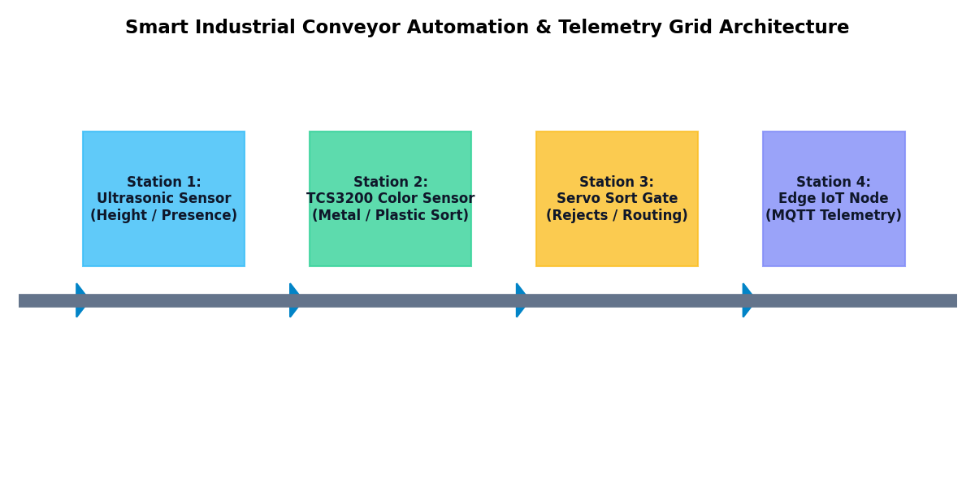

- Step 1 (Ingestion): Raw components enter on the motorized conveyor belt running at nominal 140 PWM speed.
- Step 2 (Dimension Check): Ultrasonic sensor measures distance to determine component presence and height.
- Step 3 (Material/Color Classification): Proximity sensor tests for ferrous metal vs. plastic packaging.
- Step 4 (Automated Sortation): Servo gate actuates (60° deflection) to route metal items into Bin A while allowing plastic items to proceed to Line B.
- Step 5 (Failsafe Jam Detection): If distance < 2.0 cm or sensor blocked for > 2 seconds, conveyor automatically halts (PWM=0) and triggers emergency red alert beacon.

3. Embedded Control & Failsafe Code
Complete control sequencing logic implemented with failsafes:
// Progree Robotics & Automation - Task 4
// Smart Conveyor PLC Logic & Edge Telemetry Controller
#include <Servo.h>
const int TRIG_PIN = 7;
const int ECHO_PIN = 8;
const int PROXIMITY_PIN = 2;
const int CONVEYOR_MOTOR_PWM = 9;
const int SERVO_GATE_PIN = 10;
const int LED_STATUS_OK = 11;
const int LED_FAILSAFE = 12;
Servo sortGate;
void setup() {
pinMode(TRIG_PIN, OUTPUT);
pinMode(ECHO_PIN, INPUT);
pinMode(PROXIMITY_PIN, INPUT_PULLUP);
pinMode(CONVEYOR_MOTOR_PWM, OUTPUT);
pinMode(LED_STATUS_OK, OUTPUT);
pinMode(LED_FAILSAFE, OUTPUT);
sortGate.attach(SERVO_GATE_PIN);
sortGate.write(0);
Serial.begin(115200);
}
long measureDistance() {
digitalWrite(TRIG_PIN, LOW);
delayMicroseconds(2);
digitalWrite(TRIG_PIN, HIGH);
delayMicroseconds(10);
digitalWrite(TRIG_PIN, LOW);
long duration = pulseIn(ECHO_PIN, HIGH, 25000);
return (duration == 0) ? 999 : (duration * 0.034 / 2);
}
void loop() {
long distance = measureDistance();
bool objectDetected = (distance > 2 && distance < 15);
bool isMetal = (digitalRead(PROXIMITY_PIN) == LOW);
if (objectDetected) {
digitalWrite(LED_STATUS_OK, HIGH);
digitalWrite(LED_FAILSAFE, LOW);
analogWrite(CONVEYOR_MOTOR_PWM, 180);
if (isMetal) {
sortGate.write(60);
Serial.println("{"part": "METAL_PART", "action": "DIVERTER_A"}");
} else {
sortGate.write(0);
Serial.println("{"part": "PLASTIC_PART", "action": "STANDARD_LINE"}");
}
delay(1500);
sortGate.write(0);
} else if (distance < 2) {
analogWrite(CONVEYOR_MOTOR_PWM, 0);
digitalWrite(LED_STATUS_OK, LOW);
digitalWrite(LED_FAILSAFE, HIGH);
Serial.println("{"part": "JAM_ERROR", "action": "EMERGENCY_STOP"}");
delay(1000);
} else {
analogWrite(CONVEYOR_MOTOR_PWM, 140);
}
delay(100);
}

4. Edge Communication & Master Telemetry Logger
Telemetry packets are serialized in real-time JSON format and archived for SCADA/MES analytics:
# Progree Robotics & Automation — Task 4
# Edge IoT Telemetry Receiver & CSV Logger
import json
import csv
import datetime
def simulate_telemetry_stream():
sample_packets = [
{"timestamp": datetime.datetime.now().isoformat(), "part": "PLASTIC_PART", "distance_cm": 8.4, "action": "STANDARD_LINE", "conveyor_rpm": 120},
{"timestamp": datetime.datetime.now().isoformat(), "part": "METAL_PART", "distance_cm": 6.2, "action": "DIVERTER_A", "conveyor_rpm": 120},
{"timestamp": datetime.datetime.now().isoformat(), "part": "JAM_ERROR", "distance_cm": 1.2, "action": "EMERGENCY_STOP", "conveyor_rpm": 0}
]
csv_file = "telemetry_production_log.csv"
with open(csv_file, "w", newline="") as f:
writer = csv.DictWriter(f, fieldnames=["timestamp", "part", "distance_cm", "action", "conveyor_rpm"])
writer.writeheader()
for p in sample_packets:
writer.writerow(p)
print(f"Logged {len(sample_packets)} telemetry packets into {csv_file}")
if __name__ == "__main__":
simulate_telemetry_stream()

