
PRODUCT SHOWCASE | CURRENT WORKFLOW

MIST: from request to dissemination
A guided, screenshot-led journey through secure access, human routing, team delivery, quality control and Customer acceptance.
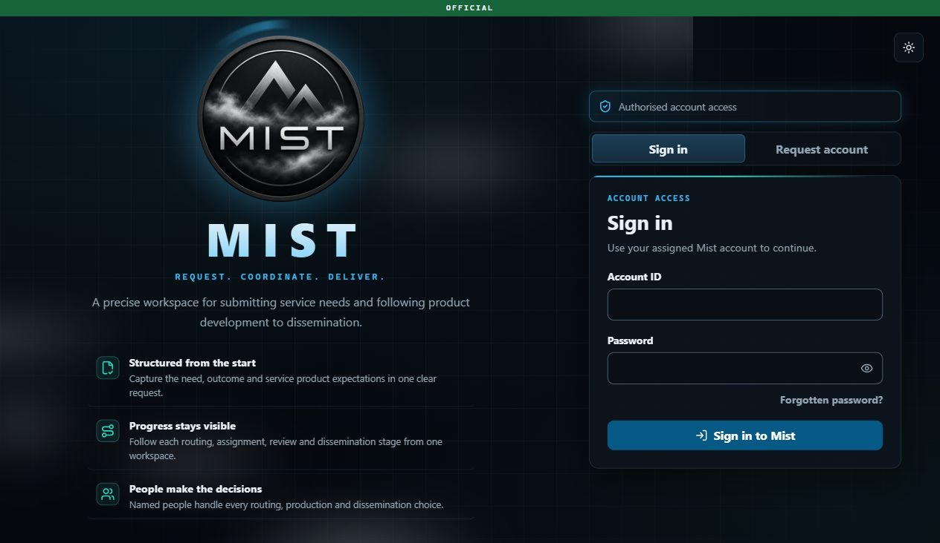
Secure access is the first step: structured requests, visible progress and named human decisions.
Request. Coordinate. Deliver: MIST keeps the Customer's need, the selected route, the accountable people, the exact product package and the final release connected in one governed service journey.
Prepared from latest main at commit 42533e2 | 17 August 2026 | Synthetic demonstration

THE JOURNEY AT A GLANCE

One request, one accountable chain
Every routing, assignment, review and dissemination choice is made by a named person. Camunda holds the workflow position, while MIST protects the request, assignment, product and audit record.
Step | Owner | Human decision or result
1 | Customer | Submit a complete service request and follow its progress.
2 | JIOC | Claim, clarify or choose DIGOC and set the priority.
3 | DIGOC | Choose NCGI-A Ops and record the routing note.
4 | NCGI-A Ops | Choose OSG Team and state the capabilities required.
5 | OSG Team Manager | Assign one Lead and any Contributing Analysts.
6 | OSG Team Analyst | Clarify if needed, build an immutable package and submit it.
7 | OSG Team Manager | Approve the exact package or require changes.
8 | QC Manager oversight | See the shared QC workload without assigning the review.
9 | QC User | Claim quality review, inspect the exact package and decide.
10 | Different QC Manager | Disseminate the approved package to the originating Customer.
11 | Customer | Download, accept and optionally submit service feedback.
Current product terminology: The configured command is DIGOC, not DGIOC. The review role is QC User, not QC Analyst. There is no QC Manager-to-QC User assignment task: the approved package enters a shared QC queue, a QC User or QC Manager may claim review, and a different QC Manager performs dissemination.

STAGE 01 | CUSTOMER

Describe the need once, with enough structure to act
The Customer uses a guided request form that makes the operational need, question, outcome, timing, product expectation and handling requirement explicit before routing begins.
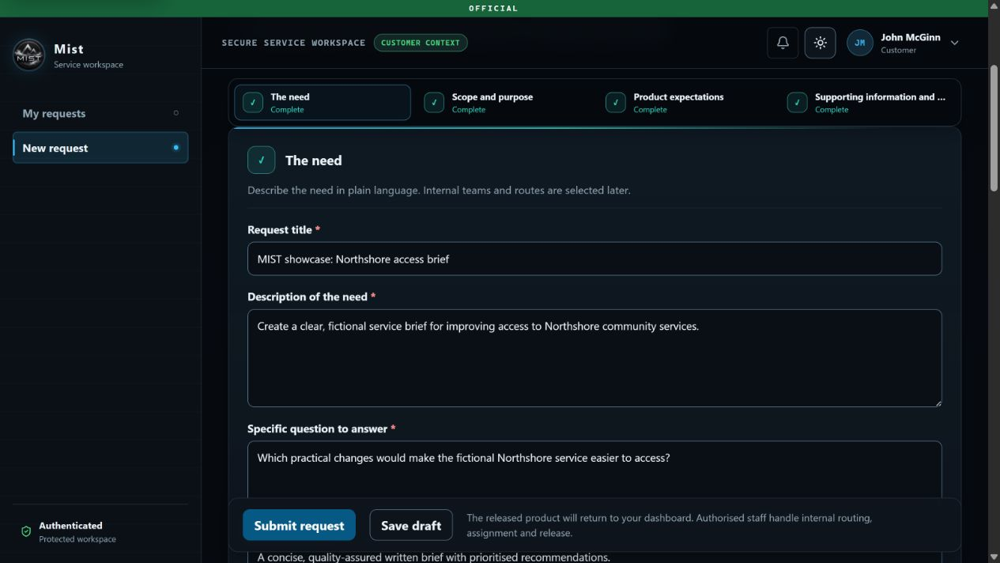
The Customer intake form is organised into The need, Scope and purpose, Product expectations, and Supporting information and handling.
Drafting: Incomplete work can be saved privately as a draft and resumed later.
Quality at entry: Required fields cover urgency, useful delivery date, preferred product type, success criteria, sensitivity and handling.
Clear boundary: The Customer describes the requirement; internal teams and routes are chosen later by authorised staff.

STAGE 02 | CUSTOMER

Track the request from submission onwards
After submission, the Customer sees one status journey from JIOC routing to dissemination, alongside the submitted details, current owner, conversations, immutable activity and eventual service product.
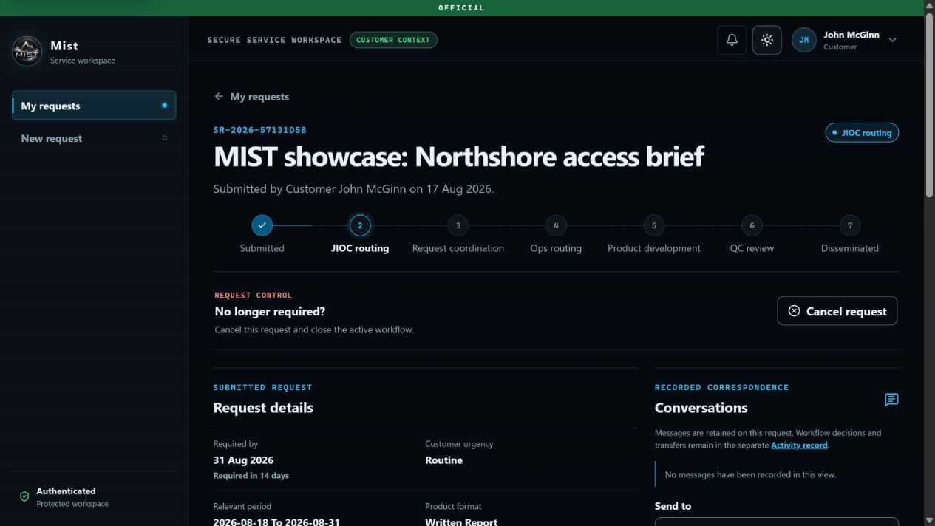
SR-2026-57131D5B is now visible to the Customer with a seven-stage progress indicator and JIOC as current owner.
Visibility: The dashboard distinguishes work in progress, requests needing Customer input and completed history.
Control: The Customer can cancel an active request when it is no longer required.
Correspondence: Customer-visible messages remain on the request, separate from the immutable workflow activity record.

STAGE 03 | JIOC ROUTING USER

JIOC chooses the command and priority
A JIOC Routing User claims the work item before protected context is revealed, then records the first named routing decision.
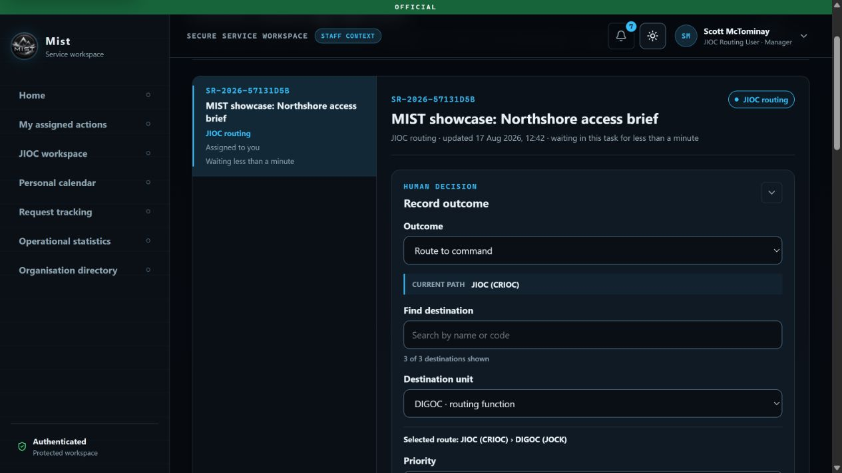
Scott McTominay routes the request from JIOC to DIGOC and records its priority.
Main outcome: Route to command exposes only configured direct-child commands, with a recorded priority.
Clarification: JIOC can select Request more information; the Customer response returns the task to JIOC.
Closure: JIOC can close without production when a named human decision supports that outcome.

STAGE 04 | DIGOC REQUEST COORDINATION

DIGOC coordinates the route to NCGI-A Ops
Request Coordination records the next organisational hand-off, including the destination and a routing note that explains the decision.
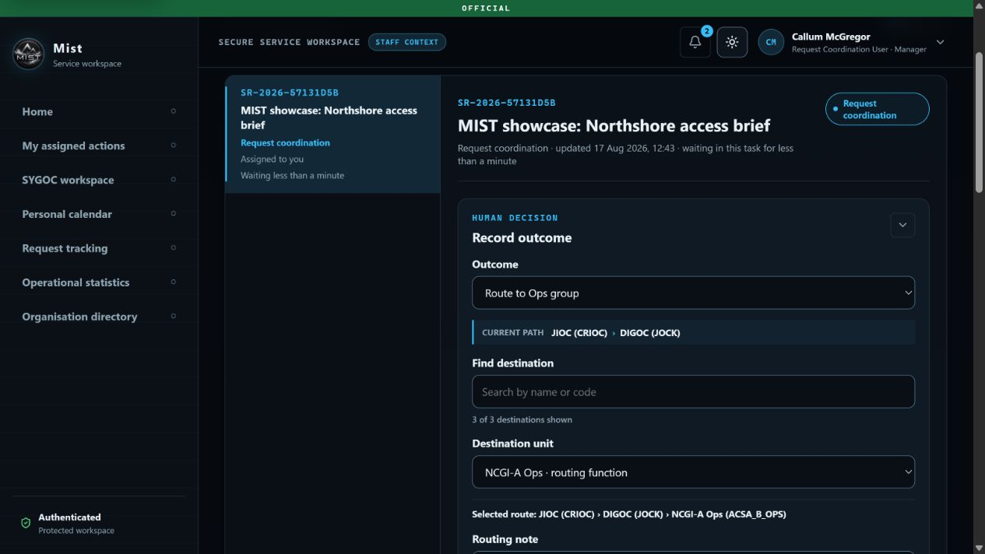
Callum McGregor selects NCGI-A Ops from DIGOC's valid child units and records the routing note.
Alternatives: The coordinator can return the request to JIOC, place it on hold, close it, or route it onward.
Human hold: A held request stays visible until a person resumes request coordination or closes it.
Tracking: DIGOC retains scoped, read-only lifecycle visibility after routing, but does not approve the product.

STAGE 05 | NCGI-A OPS ROUTING USER

NCGI-A Ops selects the delivery team
The Ops Routing User chooses the direct-child delivery team and states the capabilities the team will need for production.
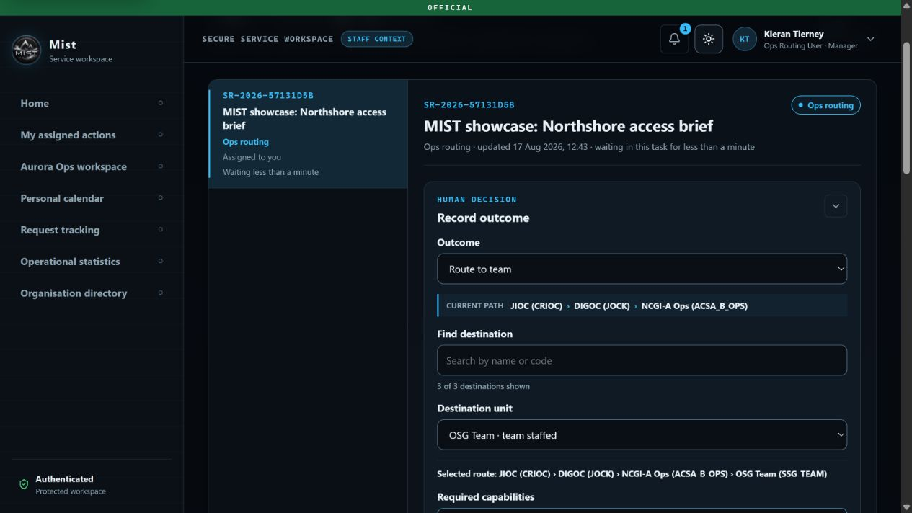
Kieran Tierney routes the work from NCGI-A Ops to the staffed OSG Team.
Valid routes: Only effective direct-child teams can be selected, preventing arbitrary or cross-branch routing.
Staffing guidance: An unstaffed destination produces factual warning and waiting state, not silent automatic fallback.
Return path: Ops can return the request for coordination with a recorded reason.

STAGE 06 | OSG TEAM MANAGER

The Manager assigns accountable Analysts
The Team Manager names one Lead Analyst, may add up to ten Contributing Analysts, and records why the assignment is appropriate.
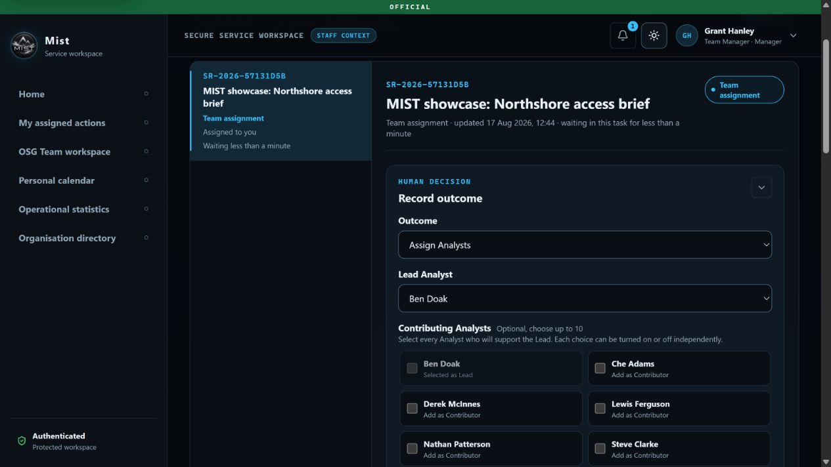
Grant Hanley assigns Ben Doak as Lead Analyst for the Northshore service product.
Accountability: The Lead label identifies accountability; every assigned Analyst has the same production controls.
No self-claim: Analysts cannot take an unassigned delivery task. A Team Manager must assign it.
Reallocation: The Manager may return the request to Ops routing instead of assigning the team.

STAGE 07 | OSG TEAM ANALYST

Clarify formally without losing the assignment
At any point in production, an assigned Analyst can ask the Customer a formal question, explain why it matters and set a response deadline.
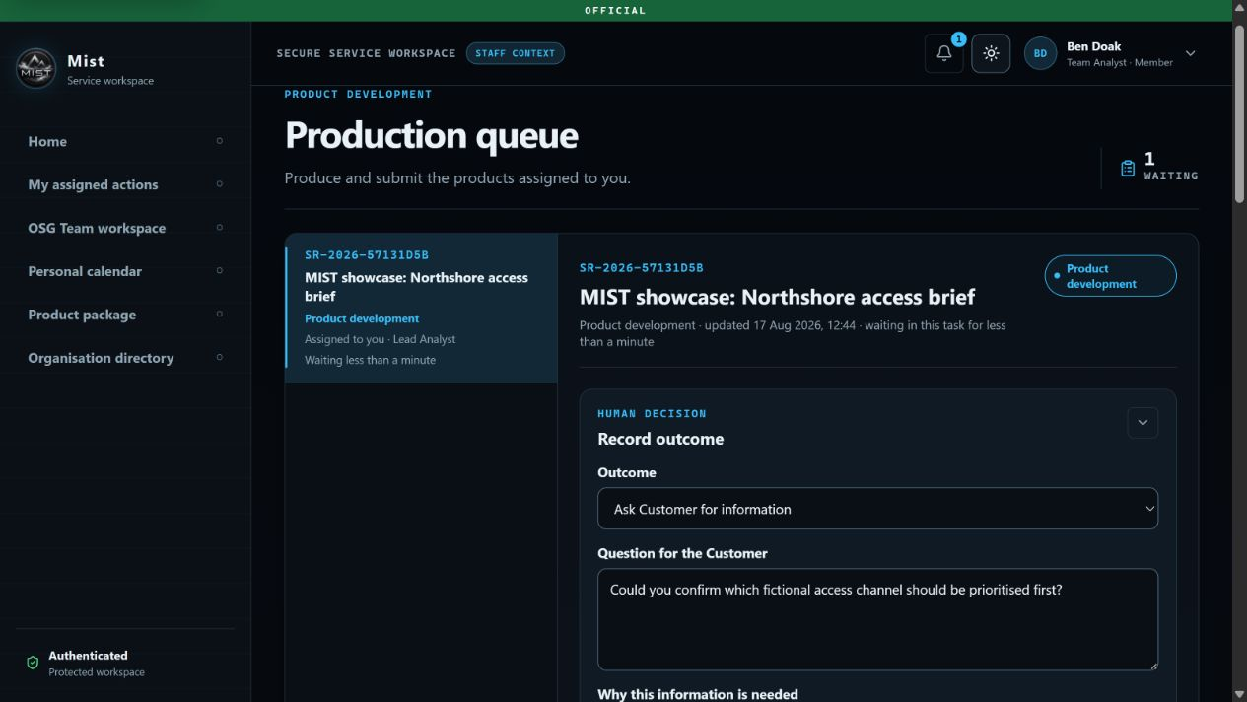
The clarification task pauses production and returns the Customer's answer to the same Analyst assignment.
Workflow action: The formal clarification moves the request to a named Customer response task.
Continuity: The Lead and Contributing Analyst assignments are preserved when the Customer answers.
Conversations: Ordinary Customer and internal messages are also available, but messages do not transfer or advance the workflow.

STAGE 08 | OSG TEAM ANALYST

Build an exact, quality-assured product package
The Analyst assembles a versioned package, adds managed artefacts or approved links, writes the Customer covering note and submits the exact version for review.
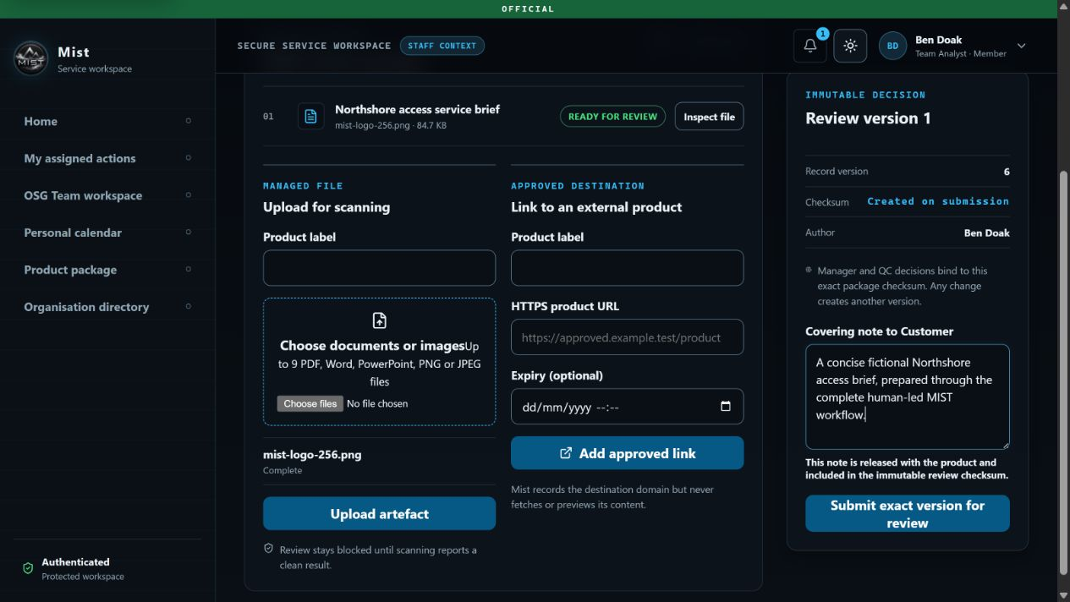
The package contains one scanned artefact and a Customer-facing note, ready to be bound to an immutable checksum.
Managed files: PDF, Word, PowerPoint, PNG and JPEG artefacts are supported, up to ten per package, and must pass validation and malware scanning.
External products: Approved HTTPS links can be recorded; MIST never fetches or previews their content.
Immutability: Manager and QC decisions bind to the exact submitted package. Any content change creates a new version.

STAGE 09 | OSG TEAM MANAGER

Review the Analyst's exact package
The Team Manager sees the author, artefacts, covering note, record version and checksum before approving the product for quality review.
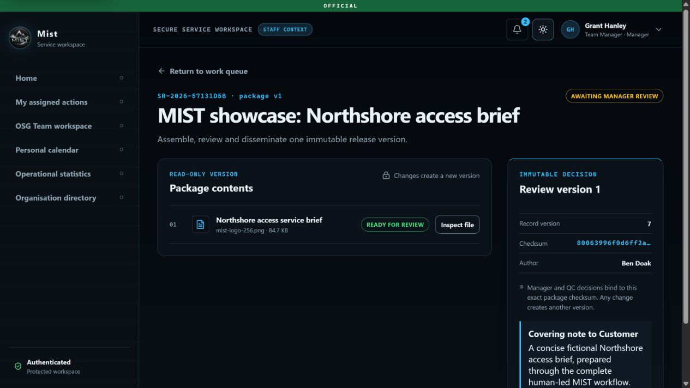
Grant Hanley reviews package v1, authored by Ben Doak, against the exact immutable package checksum.
Approve: The Manager first approves the exact package, then records the workflow outcome Approve.
Require changes: A mandatory reason returns work to the same Analyst assignment.
Re-review: After any Analyst resubmission, the new version must pass Manager review again before QC.

STAGE 10 | OSG TEAM WORKSPACE

See team attention, people, workload and service measures together
The Team Workspace gives Managers and Analysts one authorised place for operational work, staffing, calendars, planning and performance.
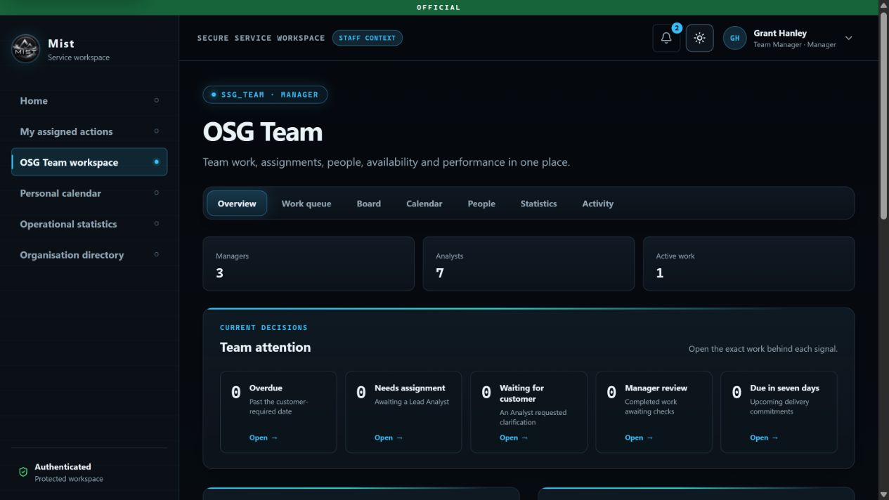
Overview, Work queue, Board, Calendar, People, Statistics and Activity are available from the same OSG Team Workspace.
Attention signals: Overdue, needs assignment, waiting for Customer, Manager review and due-in-seven-days tiles open the exact filtered work.
Team context: The overview combines staffing, current load, upcoming calendar, recent activity, notices, pinned links and 30-day service measures.
Bounded access: Workspace membership does not broaden queue authority; every request and action remains role-, route-, assignment- and object-authorised.

STAGE 11 | OSG TEAM WORKSPACE

Plan visibly without bypassing the workflow
The Board combines Camunda-derived service work with explicit internal planning, while preserving the rule that service requests move only through named workflow actions.
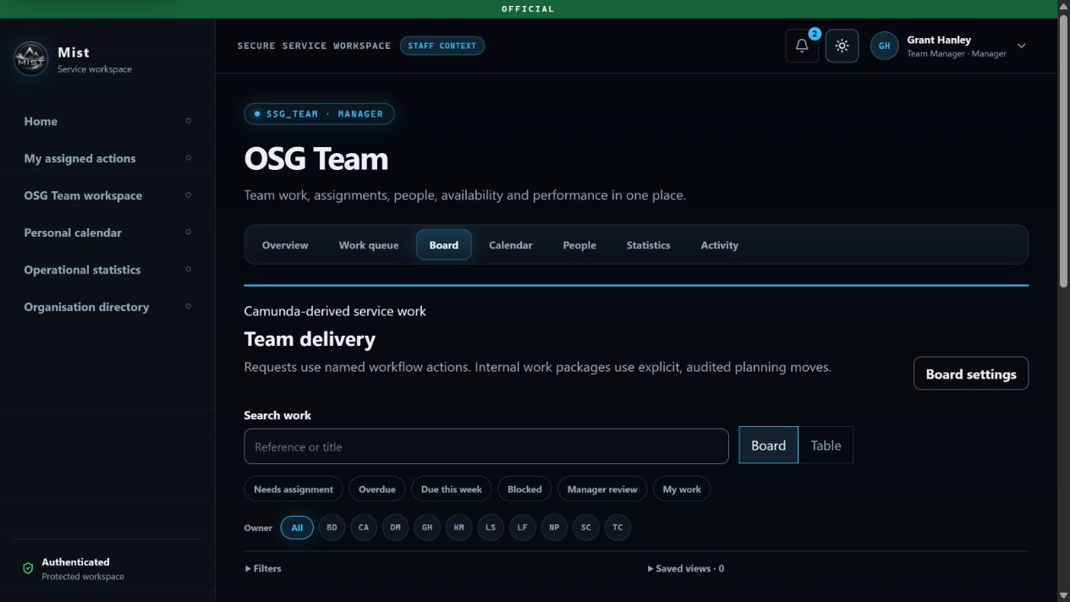
Managers can search, filter, save views, inspect owners and expose downstream or exception lanes without dragging a service request between stages.
Service board: Status, priority, owner, type and due-date filters support both Board and Table presentations.
Internal planning: Work packages can carry owners, contributors, estimates, effort, due dates, blockers, acceptance criteria, linked requests, iterations and dependencies.
Manager controls: WIP limits expose overload; recorded moves and task reminders never change workflow ownership automatically.

STAGE 12 | QC MANAGER OVERSIGHT

The shared QC queue separates review from dissemination
A QC Manager can see incoming quality work and ready-to-disseminate work in one Combined QC Team queue. Oversight is not an assignment or approval stage.
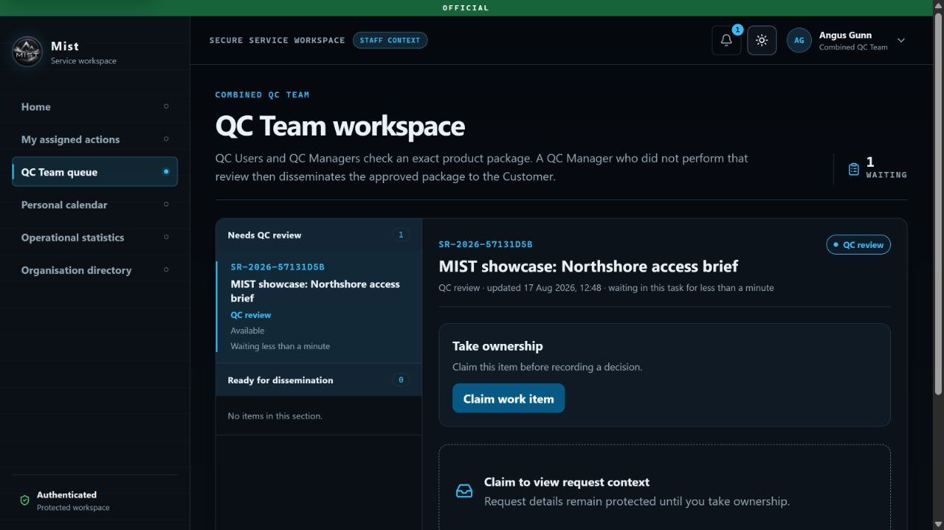
Angus Gunn sees the Northshore package waiting for QC review but leaves it unclaimed for a QC User.
Shared review: Any eligible QC User or QC Manager may claim the review item.
Protected context: Request and package detail remain hidden until an eligible reviewer establishes ownership.
No hand-off task: There is no QC Manager-to-QC User assignment in the executable workflow.

STAGE 13 | QC USER

QC independently checks the Manager-approved package
The QC User inspects the same package checksum, artefacts, author, covering note and Manager approval before recording Approve or Require changes.
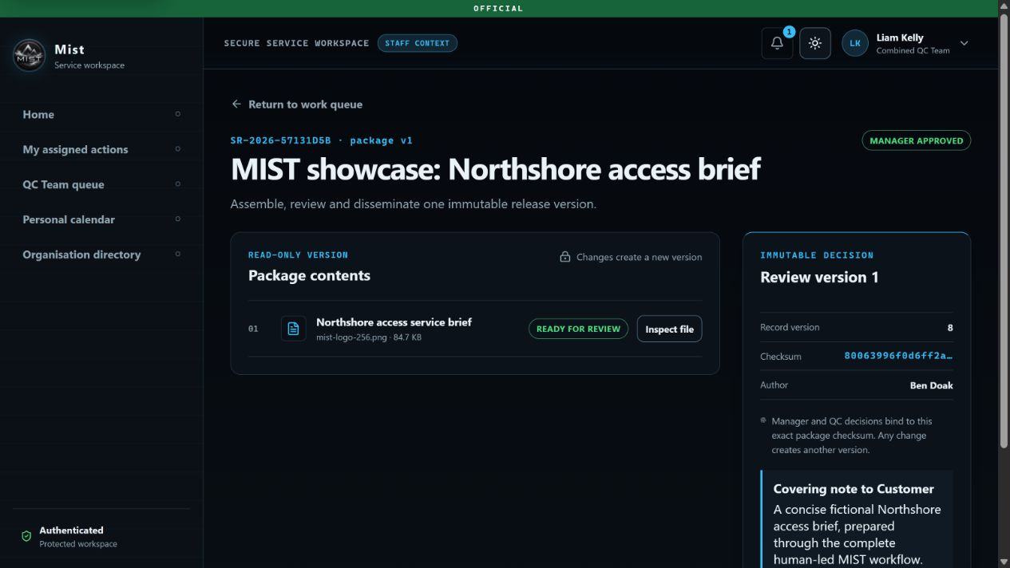
Liam Kelly performs QC review on the exact package approved by Grant Hanley.
Independence: The product author and Team Manager reviewer cannot approve the QC stage.
Rework: Require changes returns the work to the same Analysts; resubmission then repeats Manager review before returning to QC.
Role boundary: A QC User can review but never sees or performs dissemination work.

STAGE 14 | DIFFERENT QC MANAGER

Disseminate the approved package to its originating Customer
After QC approval, a different QC Manager releases the exact approved package. The recipient comes from the request and cannot be replaced by an arbitrary address.
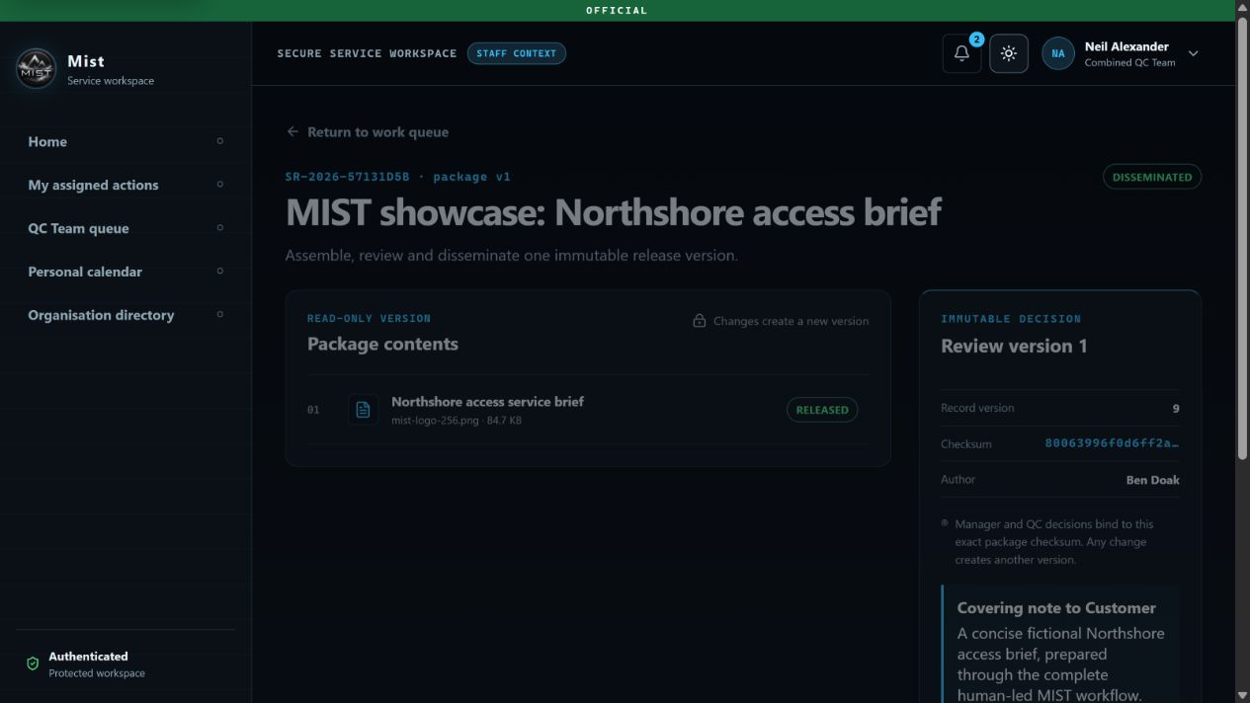
Neil Alexander disseminates package v1 after Liam Kelly's QC review; the release record names the disseminating Manager.
Separation of duties: The releaser cannot be the product author, Team Manager reviewer or QC reviewer.
External assurance: Where a package contains external links, the QC Manager must attest that Customer access is available.
Controlled release: Dissemination releases the exact immutable package and completes the Camunda process.

STAGE 15 | CUSTOMER

Receive the product, download it and decide whether to accept
The Customer sees the product team's covering note, each released artefact and the named releaser. Opening a product does not accept it automatically.
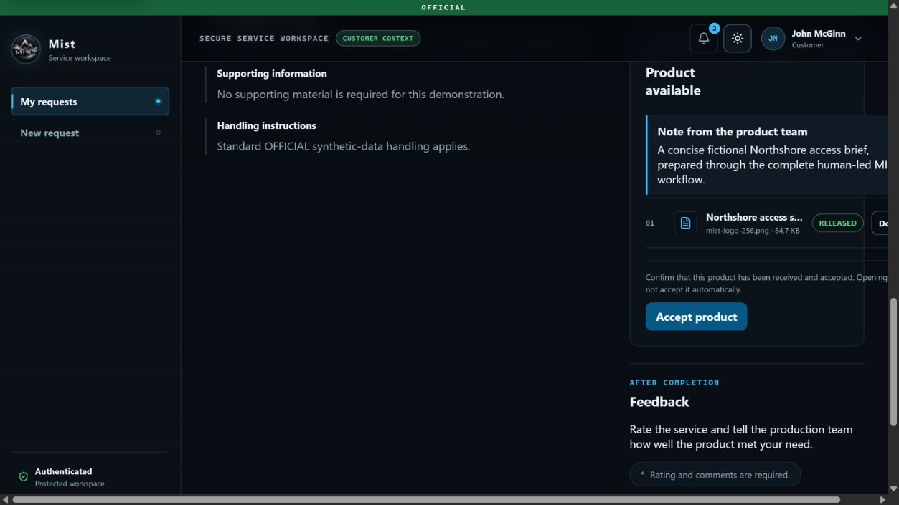
The disseminated result includes the released artefact, Customer note, explicit acceptance control and feedback form.
Access: Managed files use authenticated Download; approved external products use Open product.
Acceptance: Accept product records receipt separately after workflow completion.
Feedback: The Customer can rate the service from 1 to 5 and provide required comments when submitting feedback.

STAGE 16 | CUSTOMER

Close the loop with a recorded acceptance
Acceptance is visible on the released package without becoming another internal approval gateway. The Customer can still add feedback to improve future delivery.
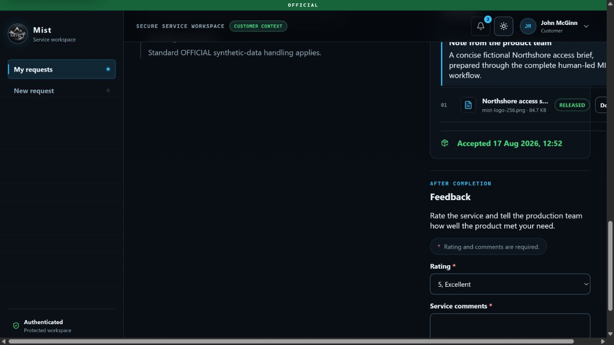
John McGinn accepts the released Northshore product; the feedback experience remains available below it.
Outcome: The request is completed, the product remains available, and acceptance is time-stamped.
Traceability: The request activity identifies the people who routed, assigned, submitted, reviewed and disseminated the work.
Learning: Feedback returns service insight without changing the completed workflow or product record.

DAY-TO-DAY WORKSPACE | USER PROFILE

Make identity, role and access scope visible
The profile gives each signed-in person a clear view of their managed identity, representative role, workspace access and optional personal information.
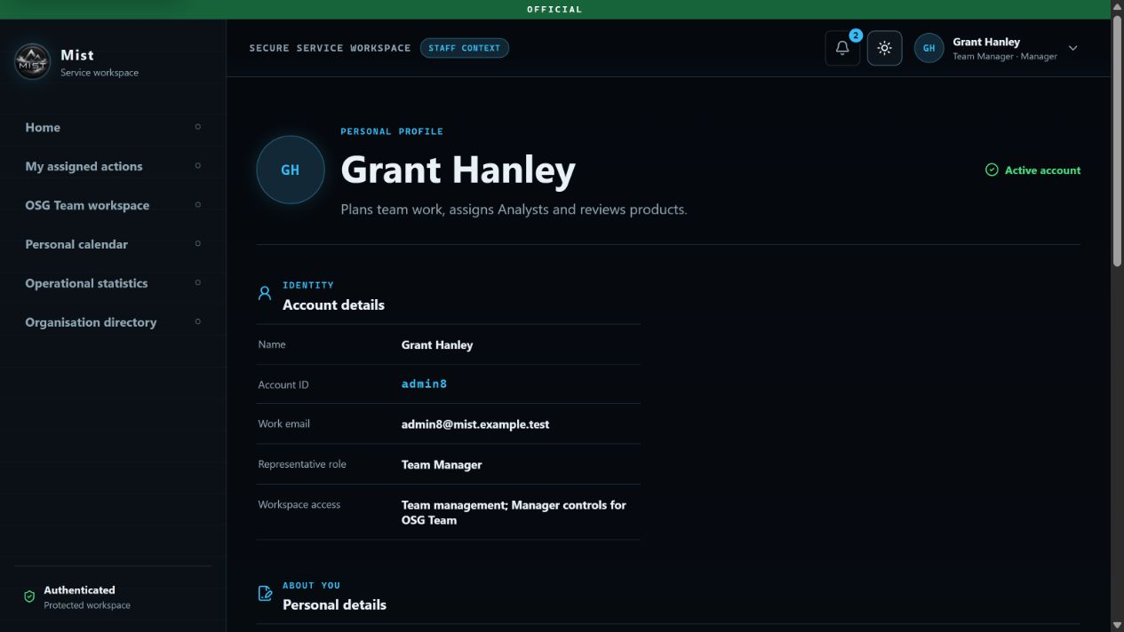
The profile makes the signed-in identity and access boundary explicit before a person begins operational work.
Identity: Name, Account ID, work email, representative role and account status are presented together.
Access boundary: Workspace access and organisation scope explain what the account may manage without implying access to every request.
Personal ownership: Users may maintain optional profile context; those details do not change permissions, routing or organisational assignment.

DAY-TO-DAY WORKSPACE | MY ASSIGNED ACTIONS

Keep personal responsibilities in one action register
My assigned actions is the personal work surface for actions needing attention, work waiting on others, due-soon items and recently completed activity.
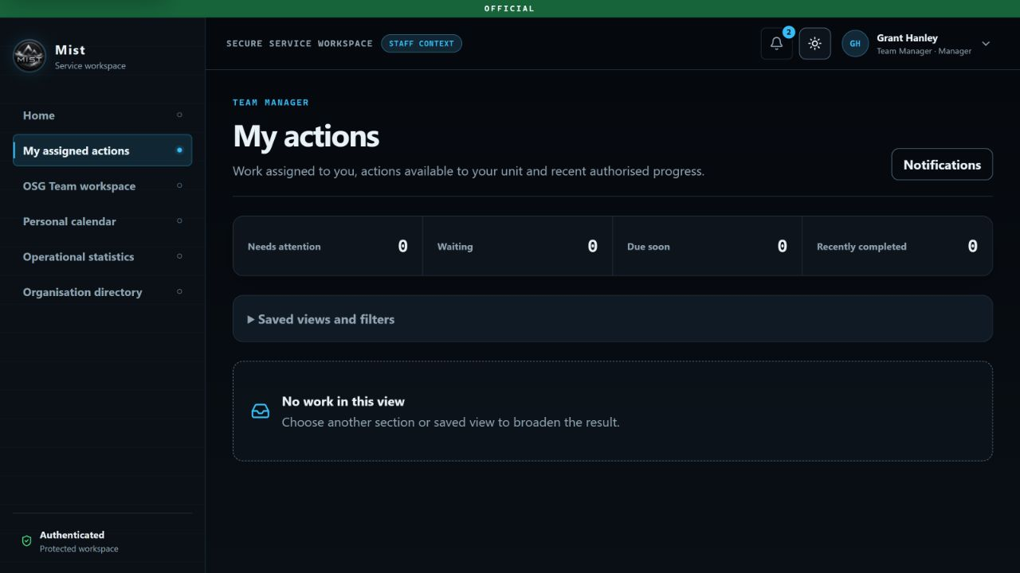
The personal register remains distinct from the wider OSG Team workload and makes an empty result explicit rather than ambiguous.
Prioritisation: Needs attention, Waiting, Due soon and Recently completed tiles provide a quick personal workload summary.
Findability: Saved views, action-type filters and notifications help a user return to the exact work they need.
Clear scope: A personal register never becomes a shortcut around role, route, assignment or object-level authorisation.

DAY-TO-DAY WORKSPACE | PERSONAL CALENDAR

Plan personal availability with privacy controls
The personal calendar supports month, week and agenda views, with quick period navigation and event creation from one schedule.
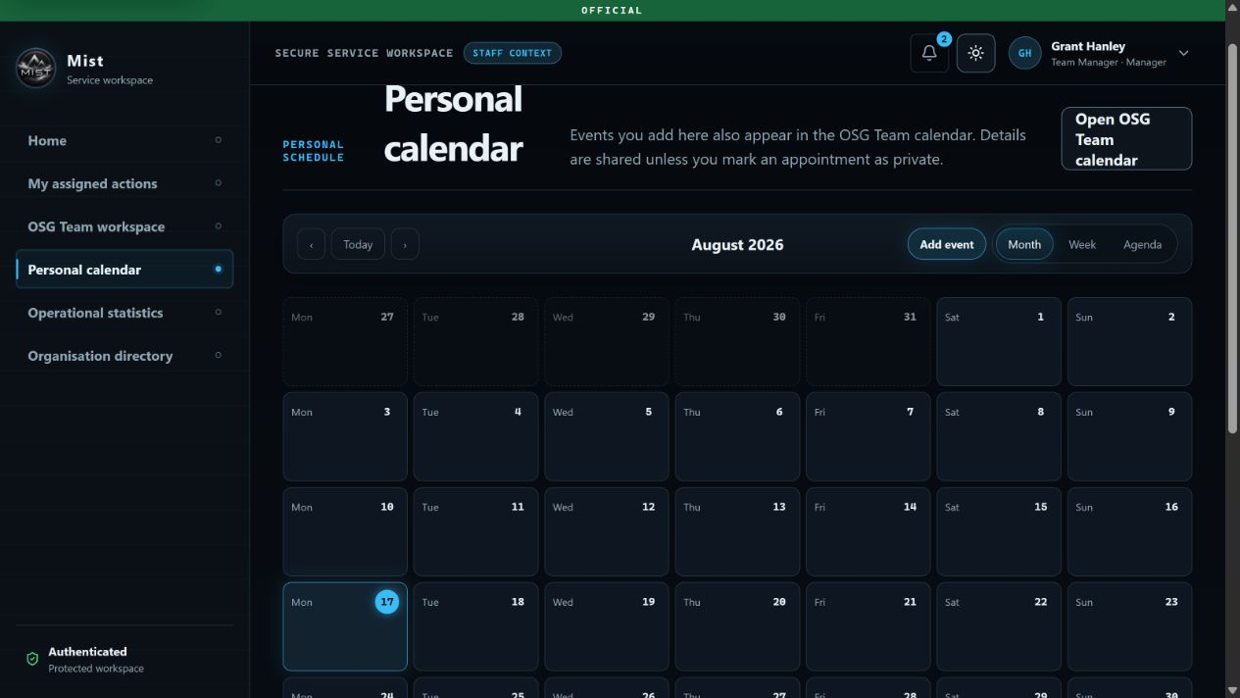
Personal events also appear in the current team calendar, while private appointments reveal only Busy and the time to colleagues.
Flexible views: Month, week and agenda presentations support both planning ahead and reviewing a focused period.
Privacy at source: Visible events can share useful team context; private appointments protect the detail while preserving availability.
Connected planning: A direct link moves from the personal schedule to the current Team Workspace calendar.

DAY-TO-DAY WORKSPACE | TEAM CALENDAR

Bring team availability into the shared workspace
The Team Workspace calendar puts shared planning beside the work queue, board, people, statistics and activity views used by the team.
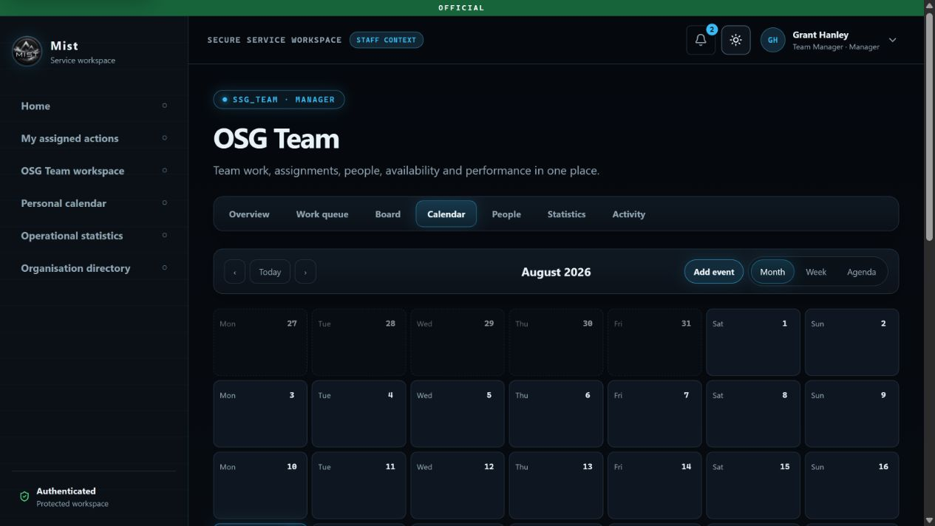
Managers and Members see one team calendar without losing the ownership and privacy rules of the underlying personal events.
One workspace: Overview, Work queue, Board, Calendar, People, Statistics and Activity remain one click apart.
Team planning: Authorised users can review shared availability and add appropriate team events in month, week or agenda views.
Capacity controls: Calendar-backed capacity can be previewed for a date range and committed only while its source versions remain unchanged.

DAY-TO-DAY WORKSPACE | TEAM WORKSPACE PEOPLE

Manage effective membership and team history
The People view gives Managers an effective-dated roster with positions, skills, membership state, active work and controlled roster changes.
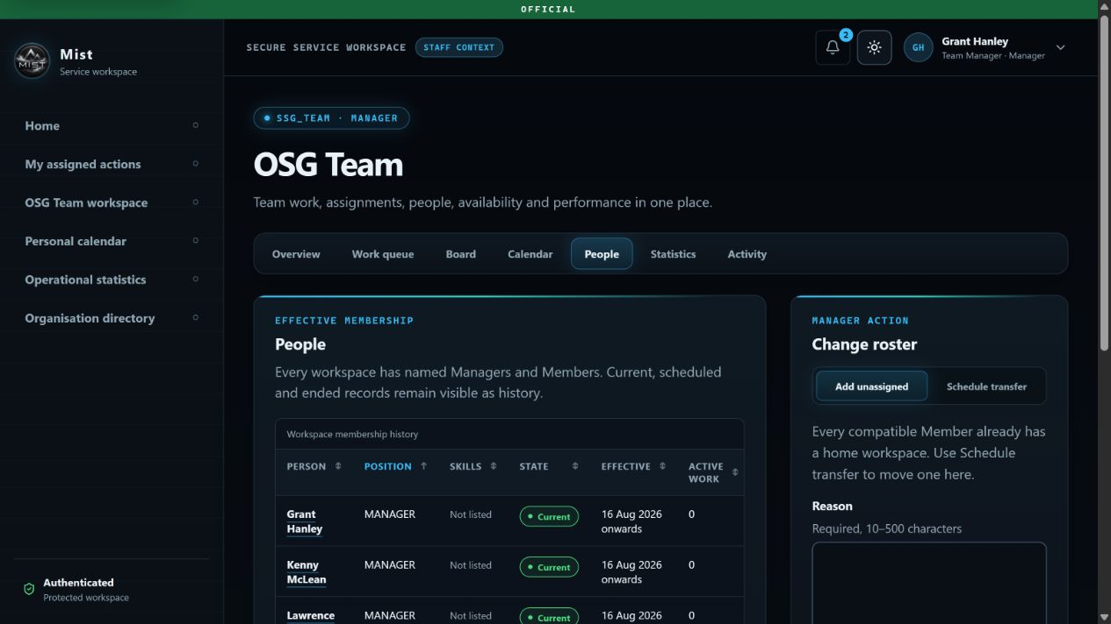
Current, scheduled and ended membership records remain visible as history, while roster changes require a named Manager action and reason.
Effective membership: Manager and Member positions are tied to dates, so current and future team composition is explicit.
Work-aware decisions: Skills and active-work counts support human allocation without allowing the system to choose an Analyst.
Controlled change: Managers may add an unassigned Member or schedule a transfer; changes remain bounded to compatible people and are recorded.

DESIGNED FOR REAL SERVICE WORK

Clarification and rework are first-class paths
MIST treats questions, holds, returns and corrections as normal governed outcomes. Each loop preserves the responsible people, reason and workflow position.
JIOC clarification: JIOC -> Customer information -> JIOC. The Customer may answer or withdraw.
Coordination hold: DIGOC -> On hold -> DIGOC. A person resumes or closes; no timer makes the decision.
Route correction: NCGI-A Ops may return to DIGOC; the OSG Team Manager may return to Ops routing.
Production clarification: Analyst -> Customer information -> same Analysts. Question, reason, deadline, answer and timestamps remain recorded.
Manager rework: OSG Manager -> Require changes -> same Analysts -> resubmit -> OSG Manager review.
QC rework: QC -> Require changes -> same Analysts -> OSG Manager review -> QC review again.
Customer withdrawal: A Customer response task can end in withdrawal, while an active request can also be cancelled from the Customer view.
Why this matters: The system never hides a return or correction behind informal chat. Formal workflow actions move the task; conversations add context but do not silently change ownership or stage.

THE WIDER PRODUCT

What MIST offers beyond the happy path
The same governed data model supports secure access, daily team operations, scoped tracking, product assurance, service insight and safe configuration.
Secure access and support: Account ID sign-in, global classification marking, light and dark themes, account requests, forgotten-password assistance, notifications and Staff/Customer context switching where authorised.
Customer service register: Drafts, structured submission, progress, current owner, information responses, cancellation, released products, acceptance and feedback.
My actions and tracking: Personal action registers, exact-route request tracking, read-only lifecycle views for routing units and immutable activity with actor and time.
Conversations: Customer and Internal correspondence, authorised targets, replies, unread counts and sender roles, clearly separated from formal workflow transfers.
Team Workspace: Overview, Work queue, Board, Calendar, People, Statistics and Activity, plus staffing totals, team attention, noticeboard, pinned links and service measures.
People and availability: Effective membership history, Manager and Member positions, bounded profiles, skill and workload visibility, transfers, membership endings, private appointments shown to colleagues only as Busy, recurring events and capacity snapshots.
Planning and reminders: Internal Kanban packages, dependencies, estimates, acceptance criteria, WIP limits, audited move reasons and recorded hasteners to all or named assigned Analysts.
Product assurance: Managed-file quarantine, structural validation, malware scanning, external-link allow-listing, immutable checksums, exact-version review and independent QC dissemination.
Statistics and administration: Hierarchy-scoped service measures, accessible charts and tables, organisation directory, identity and role administration, and guided current-configuration versus proposed-change controls.
Security by design: Role, route, assignment and object-level authorisation, protected context before claim, human-led decisions, separated duties and tamper-evident workflow-changing audit events.
The MIST proposition: A Customer can ask once, see progress throughout and receive one assured product. Staff can route, collaborate, plan, clarify, review and disseminate from connected workspaces, while every material decision stays human, attributable and auditable.

