About me

I started my career as a COBOL programmer for IBM mainframes. Later I moved to datawarehousing / Business Intelligence. For many years my life revolved around databases, data modelling and creating reports. I acquired skills in Informatica, OBIEE, SQL and was also hands on with various testing strategies.

After 5 years of being a stay-at-home mom, I decided to get back in the workforce and got an opportunity in the ‘Welcome Back Program’ at Shopify. Coming into Shopify, I had a basic knowledge of Object Oriented programming. So it was perfect for me to start with Ruby and logically move to Rails. During my time in Shopify, I refreshed my OOPs concepts by taking up a Shopify’s Ruby course. As part of the Ruby learning, I created a CLI Budgeter (Application for managing personal finance). My next step was to learn rails using online resources. Because of my background in databases, concepts like ActiveRecord came to me very easily. I replicated the Budgeter in Rails and implemented features like CSV upload and created charts using Google charts.

For the final presentation, I created a Shopify App to collect survey information from the buyers. I used many Rails features like form interface, SQL query, model relation and created charts using Chartkicks.

Week1

Trying to understand Shopify and what it involves

Kyle 1:1 - Decided to take up the Ruby course and also re-implement the Home card activity

6 November

Continued with the Git/Github course. Got stuck on branching as it was getting a bit complicated. Hence had to read often and slowly. Got digressed from Git into Home cards to try to understand the coding for an existing card. Could not figure out how.

7 November

* Although not in the sprint read thru a bit on “how the web works” with the few links that Gail shared. Also added part of the Git/Github tutorial into the sprint.
* Have implemented a very simple multi-location inventory project. Need to get the code reviewed by a mentor
* Have challenges to implement the Cli-kit app which I am resolving with external help. I have contacted **Jackson Hong** who i will meet today and will share my inventory code for review.
* Spoke with **Mehul Shah** 30 mins - Summary: Currently there is no DW environment even for vendors. There was a model that was earlier built for internal reporting which is now used for providing reports to external vendors. Currently the insight team is working towards creating a model that would address Merchant’s requirements. The platform team is creating the environment for the data model. The model is created using APIs and maybe eventually use Dataflow to create them. The need for the report/kpi etc and the usage statistics are analysed by the Insight team. Once they know what report needs to be built they work with the front end and backend engineering teams to produce the result. Technology used overall: Scala, spark, GraphQL, API and whatever the front end and backend team uses.
* Spoke with **Jackson Hong** 40 mins - Gave him my background, asked him his. He suggested I work on creating a blog using Rails. I asked him to review my inventory project. He would look for a project in his workspace that I can probably contribute or work on to get familiar. Also he suggested that I can pair program with him on his work.

8 November

* Pair programming with Ben for Home cards. In my previous attempt to create a home card by myself, I committed the changes to the master instead of creating a branch. So when I started with Ben, we cleaned this. With git reset HEAD --hard (which is like delete it) we eliminated all the additions we had recently added. We created a new branch and added the last code we had commited in the branch (by git add and git commit). Then we moved the head to one below by git reset HEAD~1 . Then we pulled the master from the github by giving command git pull origin master This pulled the master from the github with all the changes to it. Now, switch on the branch by git checkout <branchname> Then do a rebase. The rebase will move your changes to the top of the master head git rebase master. This will mostly give you a conflict. And the rebase would not be completed. If you do a git status here you will see the file with the conflict being in the “unmerged path” section. If you now go to the file that has the conflict, you will see it to be highlighted and marked between (<<<<<< ====== >>>>>>>). Fix the conflict and then on the terminal add the file to stage (git add <filename>). Then continue to rebase by git rebase --continue. This will get your new branch to be on top of your local master.

11 November

* Worked on Ruby Budgeter. Met with mentor Jackson Hong to give him an idea about the project and creating PRs for him to review.

12 November

* Issue with internet. Had to go to 620. Installed Rails and started reading about it. Had a chat with Caroline Rioux. She gave me an idea on what exists in “data” from shopify perspective. With the experience she said I would be right with the data team - maybe analyst. Got an idea about shopify apps - App review.

13 November

* Working/learning Rails used <https://guides.rubyonrails.org/getting_started.html> and Agile_Web_Development_with_Rails_5.pdf

14 November

* working/learning Rails. Worked bit on the budgeter - Ruby

15 November

* Working/learning Rails. Worked a bit on the budgeter - Ruby

18 November

* Started working on Rails. Going through “Ch 7: Validation and unit testing” in “Agile web development in rails”. Went half-way but finding it a bit tough so going restarting the chapter again! :(
* Had 1-1 with Kyle and he gave me ideas on the final project. He showed me an 3rd party app - Report Pundit - and suggested I can replicate it.
* Later met with Jackson and asked him to review the budgeter in Ruby. Jackson suggested I implement the budgeter first on Rails and then work on the app suggested by Kyle.
* I started working on creating the budgeter on Rails, although I did not finish the tutorial in Agile_Web_Development_with_Rails_5.pdf.
* I had to install rails a couple of times as I was getting errors.

19 November

* Did a scaffold for Transaction. All the views etc were created. I learnt how to use ChangeColumnName class to change the column names for Transaction. ‘Type’ was one of the fields for the transaction but it failed as it is a keyword. Created SpendingBudget with scaffold.

20 November

* Added a calculation to calculate daily amount for spendingbudget. Used “collection routing” in the routes.rb(took a long time figuring that addition).
* I tried putting the code in the model but values where the fields were involved were not saved in the database. I put it in the controller - created new method(search) and it worked! WHY not when using model??????????????

21 November

* Created new controller- Budgeter- to handle the flow. Set the root to have links for all the pages (actions).
* Implementing 2 actions today -

1) trying to pass date to the search action and retrieve the page.

2) upload csv file into database.

* Had a tough time trying to figure out 1) but was eventually able to. It took a long time to actually get it working!

>>>>>>>>>>>>>>>>>>>>>>>>>>>>>>>>>>>>>>>>>>>URL

* For CSV, getting errors

22 November

* Debugging CSV.
* Want to create some fancy graph report today !
* Learnt that if you have renamed the root routes in the routes.rb file, then a reference anywhere as root_url would fail.

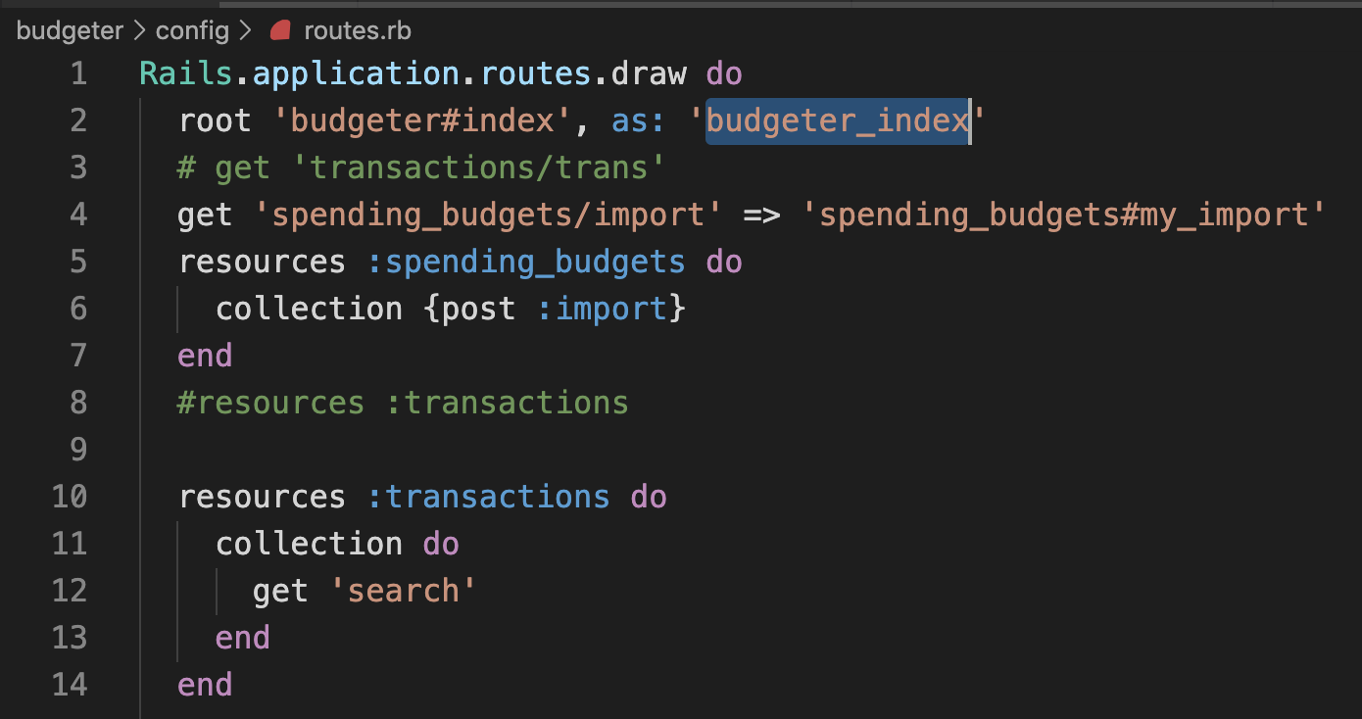

Instead of root_url need to put budgeter_index_url

* **ISSUE**: Used find_by_sql to retrieve data from the model/database table. But later figured out that find_by_sql is deprecated. The last existing version (v3.1.0). Had to re-create the logic.

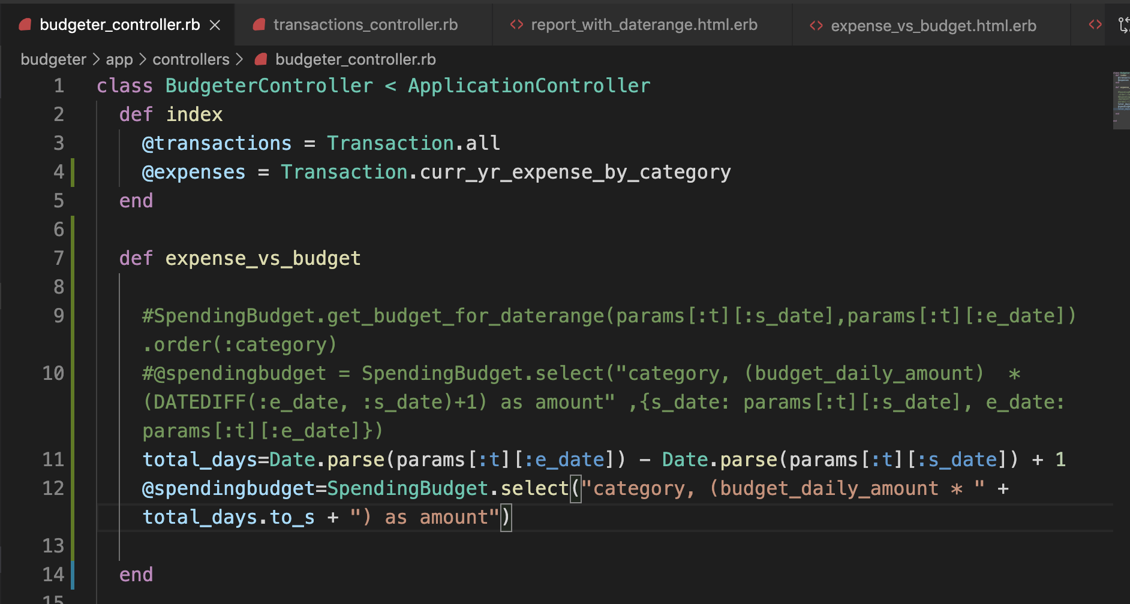

* **ISSUE**: wanted calculation in the select clause but the resultant was a Hash which the view did not like it. It wanted a string resultant. Had to use an indirect method to get the result by calculating the total_days outside the select method.
* **ISSUE**: Neither in Ruby nor Rails I could find any built-in module that would support rendering charts.

**Solution**: Javascript options were available to render the charts. Other options such as Chartkicks, Highcharts, charts.js required a gem to be installed on rails. So I just went with corechart library from google although that may not be the best solution.

* **ISSUE**: Charts cannot appear one below the other if simply copy+pasted the code for the page/view.

**Solution**: The complete code needs to be coded in a way that any number of charts can be rendered on the view/page as a single logical code. Instead of using 2 packages of bar chart one below the other (which does not work), a more exhaustive package “corecharts” that provides methods for all type of chart is included.

25 November

* Set up my own store. Added few products using the app - Oberlo (dropshipping app)
* Spoke with Kyle Acres sharing the budgeter I built on Rails. Got some feedback from him on what can possibly be the next steps to showcase for the final interview.

* Use Polaris style guide to add components to budgeter

* admin page add widget to analytics section

* For the widget, he asked me to speak with Kyle Kilbride.
* Slacking with Kyle Kilbride. He loves charts !! :) He suggested

“In that spirit it could be cool to make a visual data representation of something that might not have one yet.

* + Maybe on the customers page? Or recreating one of our Analytics we have made either on the dashboard or in Marketing.
  + You can 100% use Ruby and Rails to do this.
* [2:46 PM](https://shopify.slack.com/archives/DQM4V5WM9/p1574711179020700)
  + I know one of the other students I mentored is building an app that is standalone from Shopify but is inspired by one of our apps. That could be a good start,

”

* Spoke with Richard on Polaris. He said it would require React to be installed first, Rails server instead of Node and then add polaris to it by going thru the tutorial <https://developers.shopify.com/tutorials/build-a-shopify-app-with-node-and-react/build-your-user-interface-with-polaris>

26 November

* Meeting with Jackson. Showed him budgeter and asked him for next step.
* Followed document “Shopify App - CLI” to create app Pollapp.
* Set up shop, partner account. Added products to the shop. Was able to view Rails code for initial code.

27 November

* Installing Polaris for budgeter. Got in touch with Sergiy to get appropriate documentation. Started with the installation following the documentation: <https://github.com/Shopify/polaris-rails>
* Installed up till point 11. Then checked, page did not render. It said something is wrong, Check log files. Tested page by removing steps at a time. Figured out there is some problem with the polaris Gem file. If I remove the gem from the gemfile, application renders properly. Consulted with Sergiy for it. He tested the same by cloning my repo. He consulted Rails Dev and apparently both were confused!! He suggested I slack ‘Polaris-help’. The response I got was that Rails-Polaris is in maintenance mode and all usage is moved to React.
* Another thing I did to prove the package has a problem and not my application, I built a new Rails app using dev init. With a blank rails, I installed the gem, nothing broke. In my orig application when it broke, it gave an error at the point of retrieving data from the db. Hence I scaffolded a table in the new app. And it broke !!!!!! phew! My application is not a problem!!!!!!
* Steps to create your own app:
* Follow steps in <https://github.com/Shopify/shopify-app-cli/> till Start a development server
* On the terminal if you do CTRL+T it opens the development page and asks you to install the app.
* The view the API credentials, follow in ‘Generate API credentials from the Shopify admin’ in <https://help.shopify.com/en/api/getting-started/making-your-first-request> This would give you the URL where you can see all the metadata for the API
* For the Shopify-app-cli ⇒ If you get an error “Failed to complete tunnel connection”, it means the tunnel has expired and we need to re-connect to the tunnel. Copy the NGROK URL such as : <https://bcd3e6d6.ngrok.io/> .
* Go to partner dashboard->apps->Click the app you are working on -> App setup (just below the name of the app) -> Paste the ngrok url into App URL.
* On you terminal, cancel the shopify server (CNTRL+C), Then do a shopify tunnel down command, which will stop the tunnel. Then shopify tunnel start to establish the tunnel. Then SHOPIFY SERVe to start the server. After that a CTRL+T will get you to your application using the tunnel.

28 November

* Playing around with the Pollapp to figure out what can I do with the APIs
* Tried creating a new app to implement some test idea i.e. to display record details. Went through half the process and then changed mind and came back to Pollapp. Successful in simple display of product and order. Also was successful in rolling up the quantity sold in the order. (section Orders in pic below)

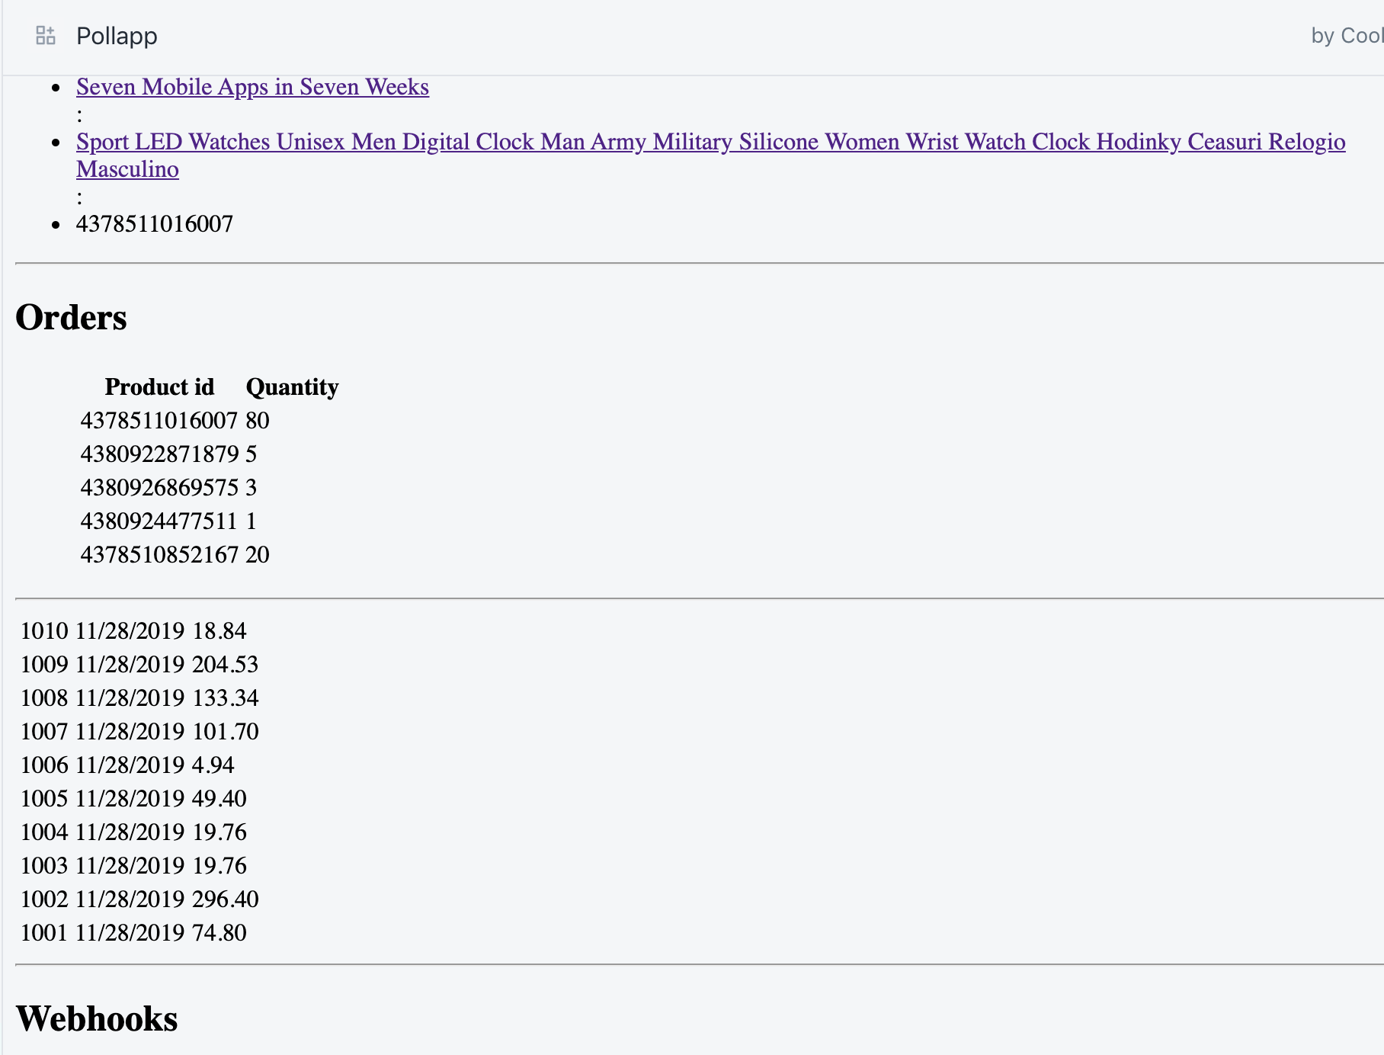

* Listening to conversation around I think I will have to use Bootstrap to make my work look good. And looks like GraphQL is better in retrieving exactly the objects we want using API. But this too maybe for another day. If I have time.
* My idea for the app is to get survey result. I want to give the user an option to fill the poll/survey once they have placed an order. “5% off on next shopping if you fill the survey”. Trying to figure out:

1. How to get to the point of creating an order from main website (customer facing)
2. Where to put code for the user to click after the payment
3. When the buyer clicks - ready to take survey - How to show him the survey page. Is this another view in the rails app I am building. What is the URL how do I direct the buyer there

* For 1. I was not able to buy anything from the storefront. Checked few help links from admin page. There was an option to set the payment to “Bogus gateway” for test purpose (Settings->Payment Provider -> Third-party payment providers). Tried setting but it says not available for the country

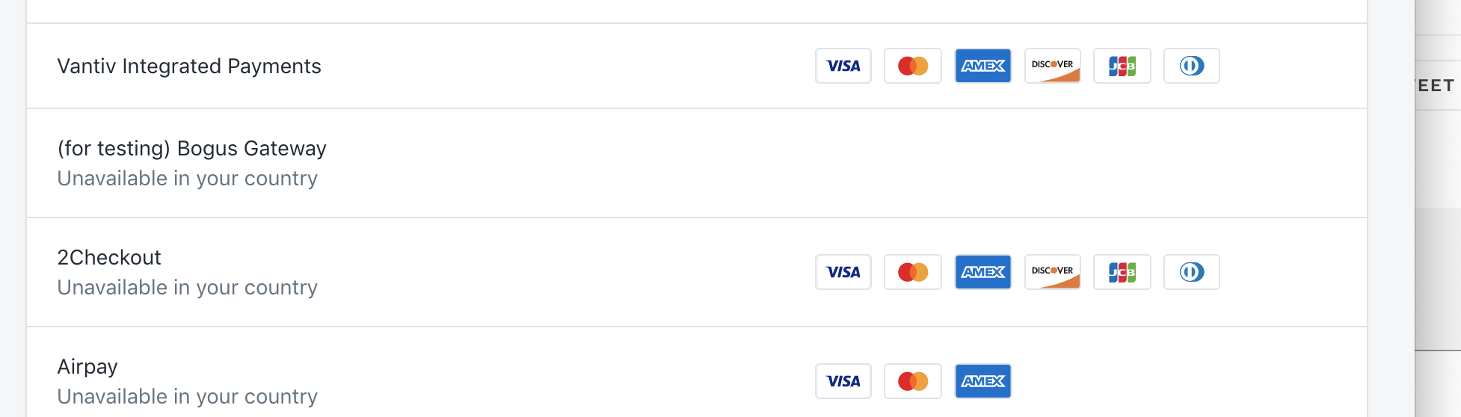

* 1. I was still able to select it but it was asking me to give credit card details. And it was not taking fake cards :(
  2. There is option of Manual payment method. Set it for COD. Now it works. Got a phone message too for the product I bought !!!

29 November

* My task for today is to figure out how to provide a page to the buyer to give his survey/poll. I can create a page/view in rails. But how to make only that page accessible to the buyer??????
* I created a view in Rails and tried accessing it from the index page. It opened up in the same location. I then gave target=blank so that it opened in a new tab. It did but still could see the merchant’s admin page. Not good!
* Installed App Review in my store (Caroline Rioux mentioned this shopify created app). Going through installation settings. Trying to understand how the shopify app works.
* With the installation guide for the shopify app, got an idea that there might be ways to insert/inject additional code.
* In the Merchant’s admin page, in settings -> checkout -> Order processing -> Additional script, wrote html to be able to open google.com. It did! Tried to replace it to open the new rails page, it did not understand the rails tag. :(
* Contacted Jonathan Dupuis. He made the last changes to the Product Review shopify app. He provided me with a lot of links to code that renders the form for the buyer to add reviews. I have to go through it. But all this is in javascript and liquid (no idea about all these!)

2 December

* Over the weekend, went thru the scripts that Jonathan sent. Skimmed thru it. Did not understand much.
* Went thru the documentation for liquid by Shopify. Got a bit idea on how it is coded. Looked at the code that Product Review asks to paste in the liquid. There is metafield mentioned in there. That is what I want to use!!
* Did a little research on metafield and found that they are “extension” columns to the tables that can be used to populate on the merchants webpage and then used in the Rails application. Now maybe pass the “answers” of the poll thru the metafield. Trying to add script to populate metafield for the order thru “additional scripts” in Settings -> checkout. Tried many versions of code such as: but they did not work.

<hr>

<script src="https://ajax.googleapis.com/ajax/libs/jquery/3.3.1/jquery.min.js"></script>

<script>

var url = "/admin/orders/{{order.id}}/metafields.json" ;

var data = {

"metafield": {

"namespace": "test",

"key": "testkey",

"value": "lorem ipsum",

"value_type": "string"

}

}

const otherPram= {

headers: {

"content-type":"application/json; charset=UTF-8"

},

body : JSON.stringify(data),

method:"POST"

};

console.log("Trying to post to...") ;

console.log(url) ;

fetch(url, otherPram)

.then(data=>{return data.json()})

.then(res=>{console.log(res)})

.catch(error=>console.log(error))

</script>

----------------------------------------------------------------

<hr>

<script>

var data = {

"metafield": {

"namespace": "test",

"key": "testkey",

"value": "lorem ipsum",

"value_type": "string"

}

}

var xhr = new XMLHttpRequest();

var myuser = '8e633e8ce6f89fc58cad75e8a0f15421'

var mypass = 'd021f84f0082a5e3ecee79677380ec84'

xhr.open("POST", "/admin/orders/1919410667591/metafields.json", true);

xhr.withCredentials = true;

xhr.setRequestHeader("Authorization", 'Basic ' + btoa('myuser:mypass'));

xhr.setRequestHeader("Content-Type", "application/json");

xhr.onload = function ()

{ console.log(xhr.responseText);

};

xhr.send(JSON.stringify(data));

</script>

* While googling on this issue came across a community.shopify webpage where people ask questions. From there got in touch with Zameer Masjedee, he mentioned about authorization. Said it was needed.
* Went through the documentation of oauth and tried passing the id/pwd in the code. It did not work. Metafields were not being updated yet. Then got in touch with Justin Brown (  
  Developer support). He said this task cannot be done in additional script.

[**Justin Brown**](https://app.slack.com/team/U07HHKSUS) [3:05 PM](https://shopify.slack.com/archives/DR6KYPJ1E/p1575317116015000)

If you had the app hosted somewhere else, you should be able to post the response to your app from additional_scripts, and then send an API call from your app to update the order

He also suggested I set up the app to recieve post first,and then you’ll need your app to take that data and send an API call to shopify to update the order.

[**Justin Brown**](https://app.slack.com/team/U07HHKSUS) [3:35 PM](https://shopify.slack.com/archives/DR6KYPJ1E/p1575318910035700)

From what I see here, a POST should route to the create action on a controller. So if you have a pollResponse controller, a post to this endpoint will create a new pollResponse resource, and then you can have that controller send the API call to shopify to update the order

* Mulling over Justin and Zameer’s responses to my questions, I tried accessing the Pollapp thru ngrok url (the app url mentioned in my app). Its asking to provide authentication. I tried giving authentication as per the oauth documentation but it was still redirecting to login page, asking me to login.
* https://**samdab**.[myshopify.com/admin/oauth/authorize?client_id=](http://myshopify.com/admin/oauth/authorize?client_id=)**2a1dc48a2e7810793e1b5e61ce98873b**&scope=**read_order,write_order**&redirect_uri=<http://localhost/generate_token.php>
* https://**samdab**.[myshopify.com/admin/oauth/authorize?client_id=](http://myshopify.com/admin/oauth/authorize?client_id=)**2a1dc48a2e7810793e1b5e61ce98873b&grant_options[]=per-user**

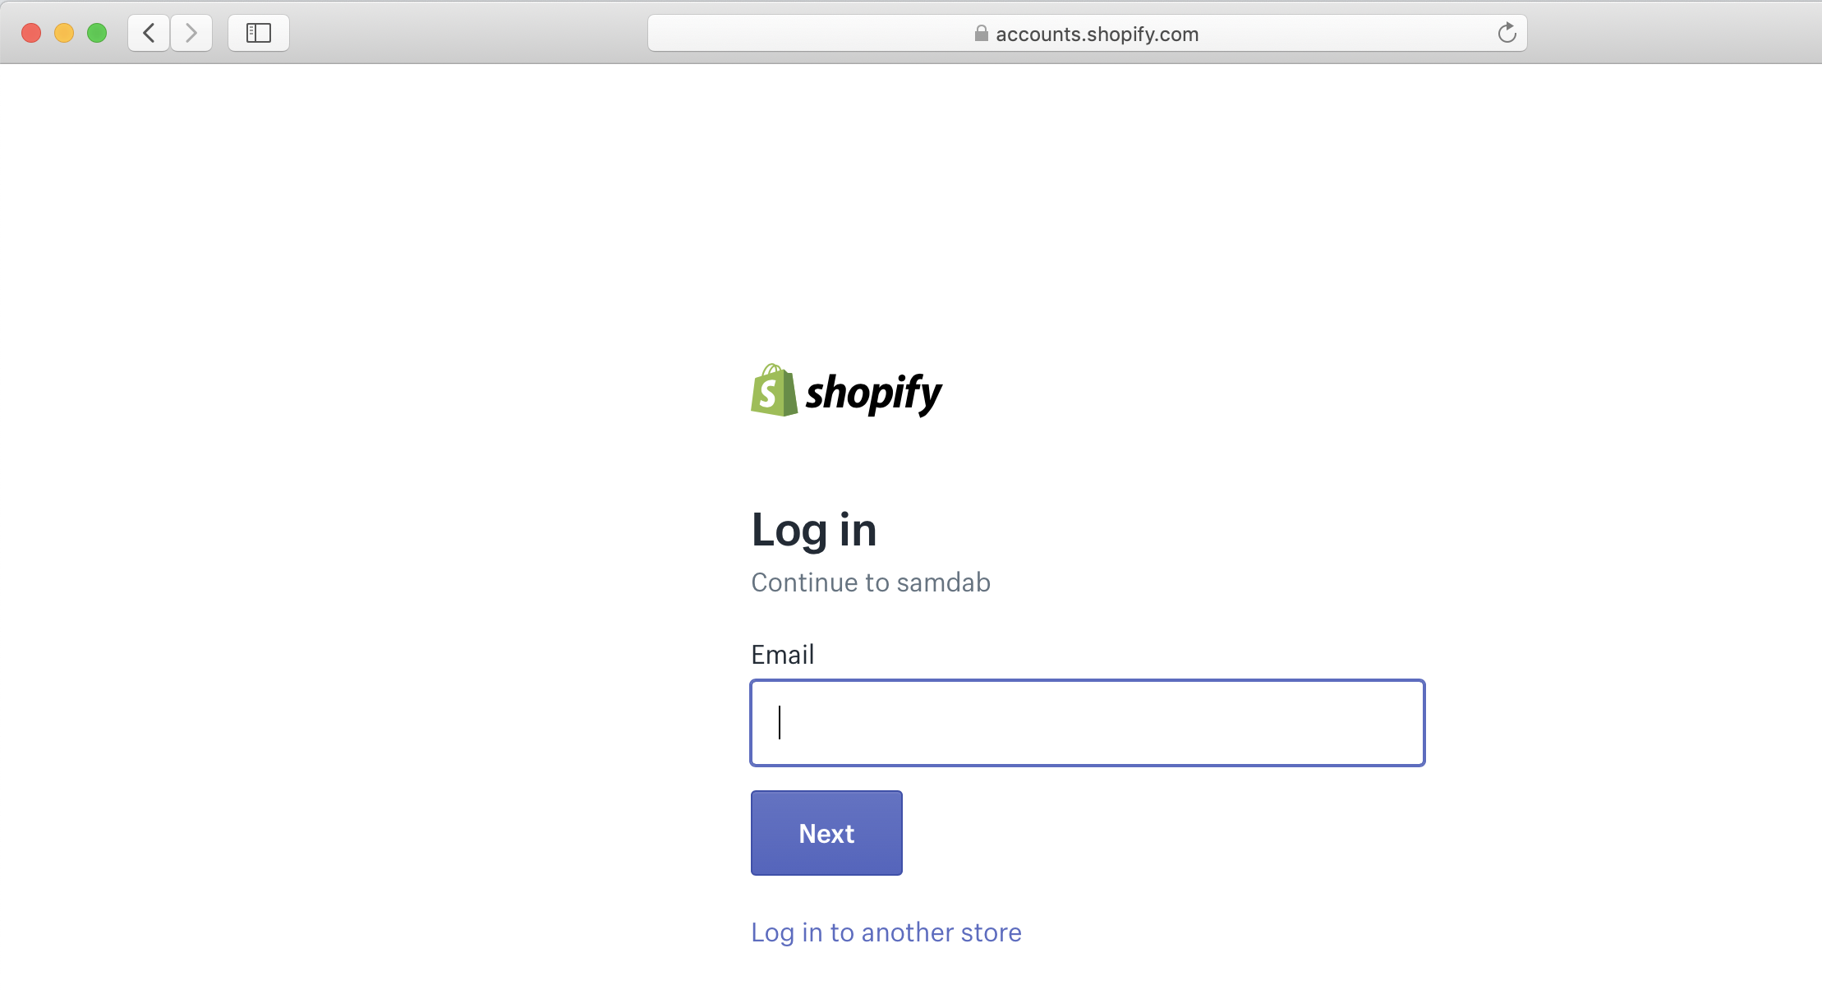

**The idea is, if this link works, then I will create a poll form at the additional script section. A submit on the button there would redirect it to the GET route defined in the rails.**

3 December

* Contacted Justin Brown again to figure out how to post from additional scripts to rails app. Changed the additional script to one that Justin shared

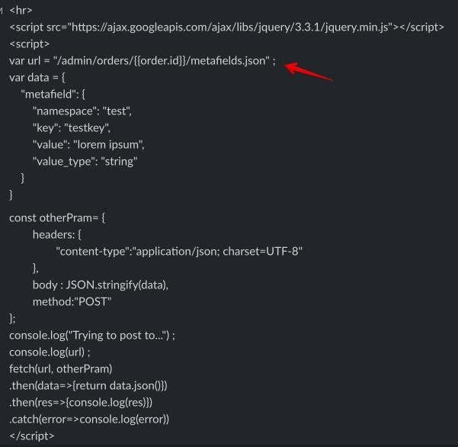

But i got ngrok error.

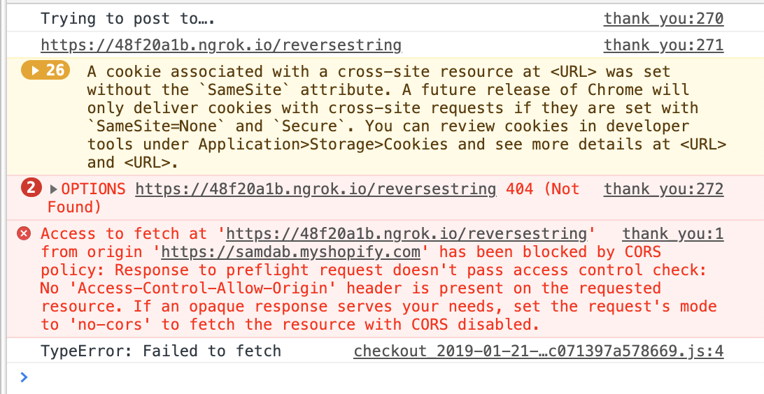

* Justin was not able to debug the issue for me. I think this is because of authentication problem.
* <https://thoughtbot.com/blog/back-to-basics-http-requests> followed this to understand how to recieve GET or POST. Tried using the CURL as per the blog. It gives redirection. Authentication required

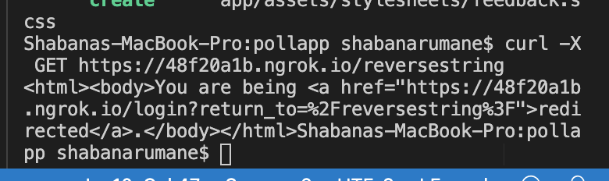

* Messaged Sanjana Desai. She suggested using App Proxy. Changed settings as per documentation. Created another controller and 2 dummy views. It worked perfectly as expected. It opens in a new tab without getting integrated into the merchant’s admin. BUT even when I remove the App Proxy, the dummy views still work as expected ! Will just continue working with the assumption that it works.

4 December

Starting my project today.

My data model design. Multiple re-visits to design it.

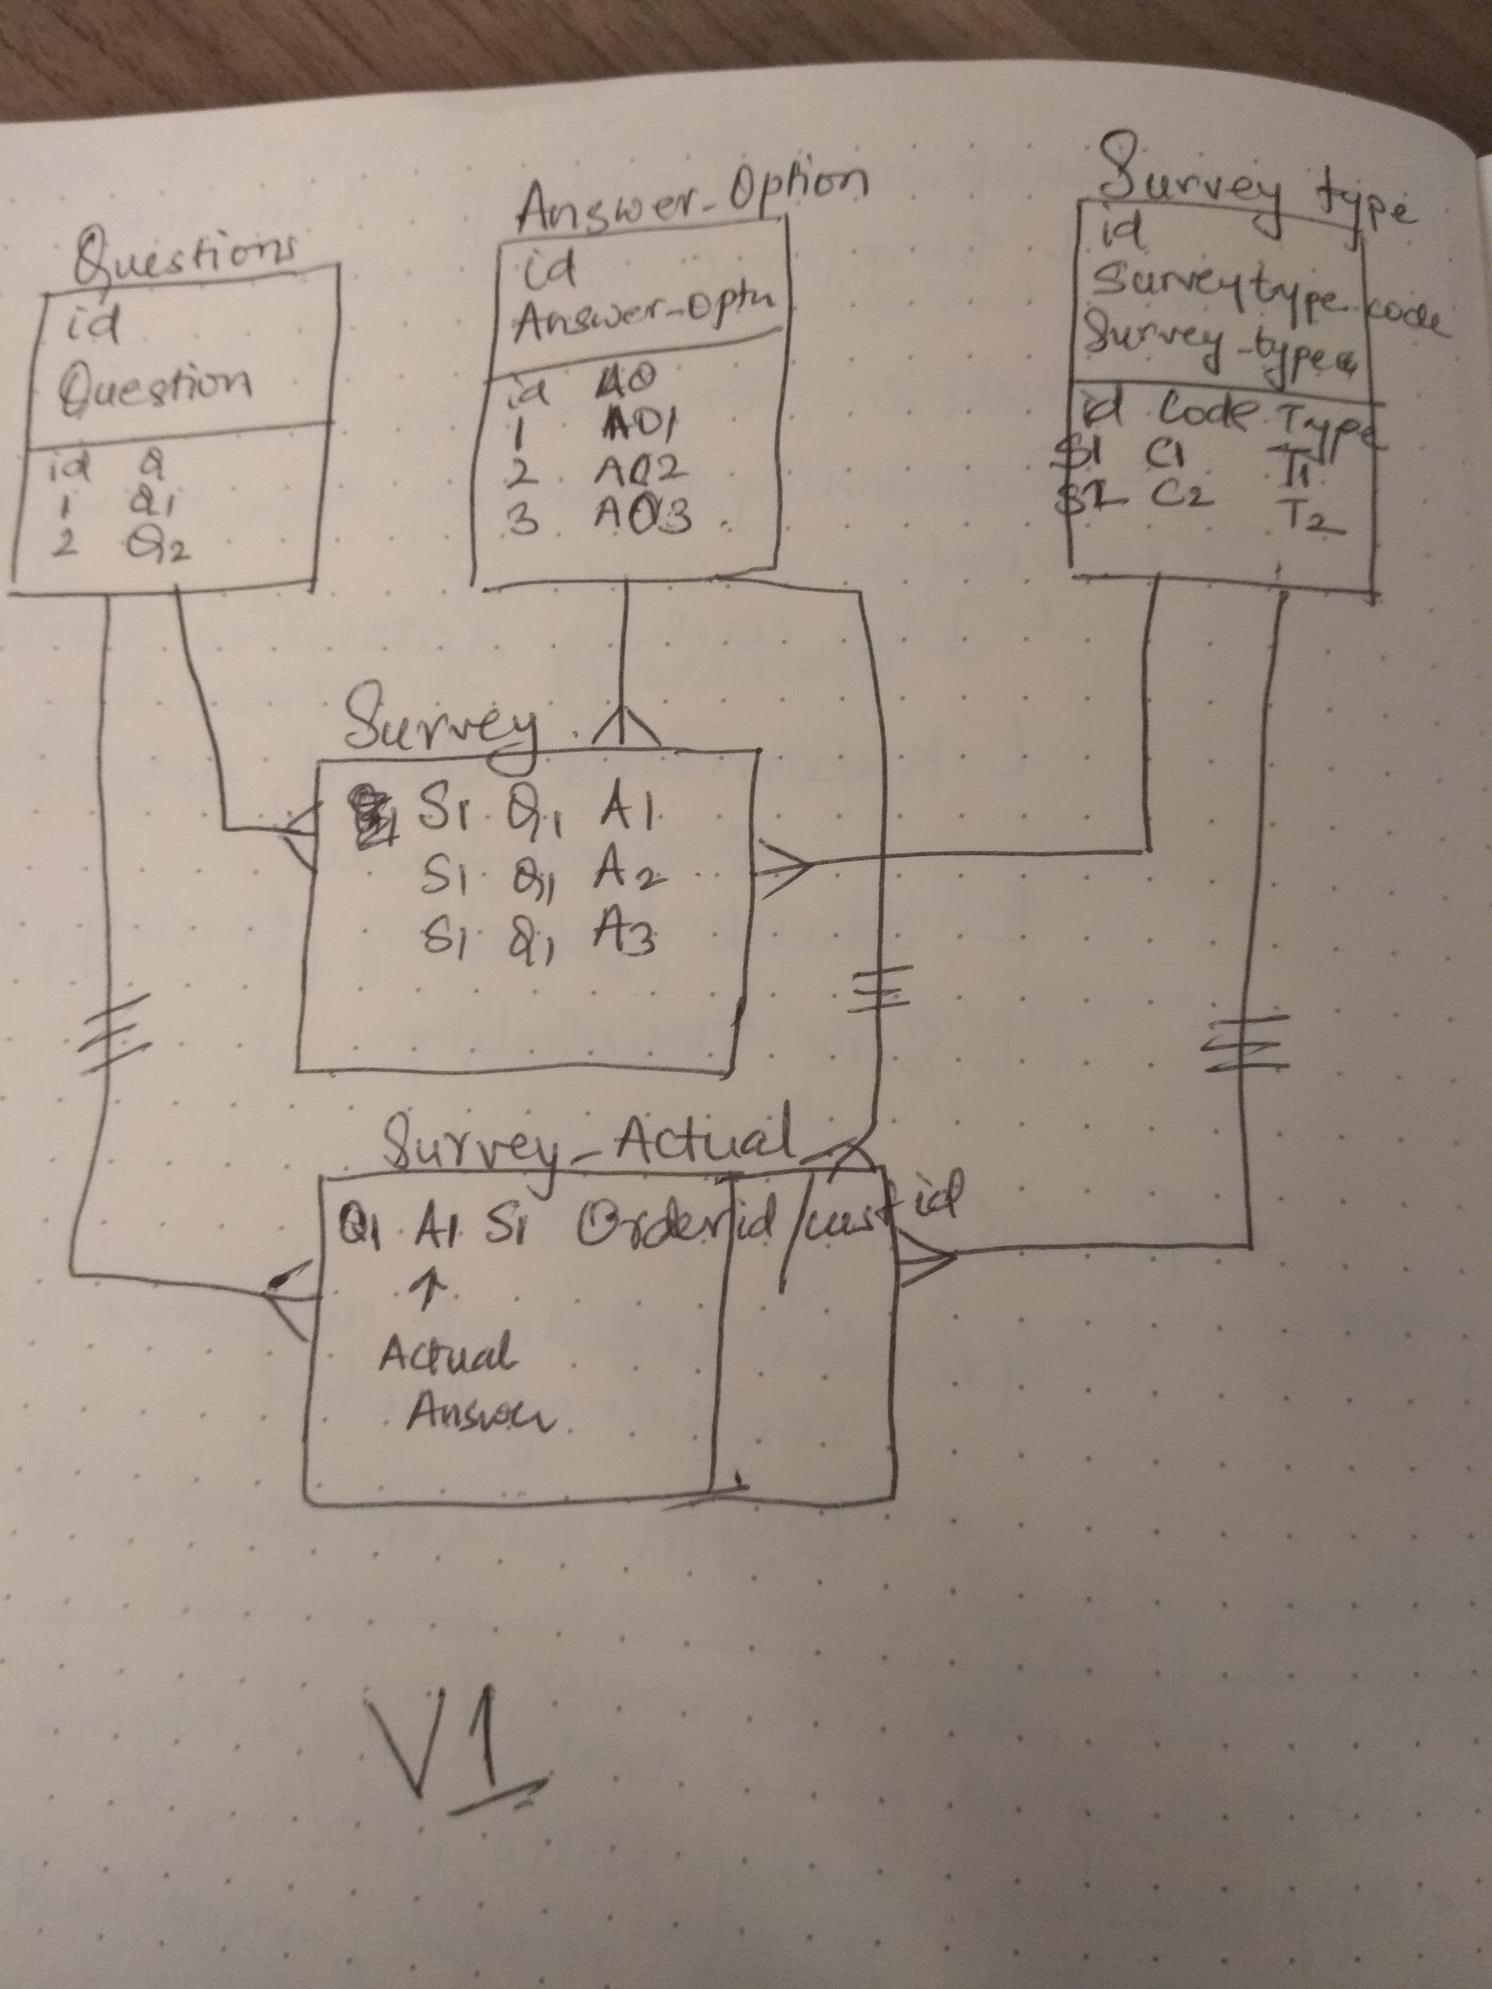

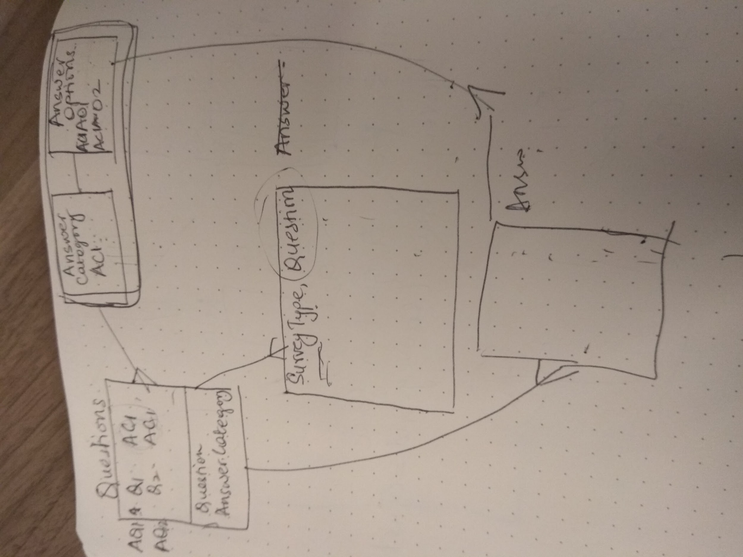

* Generated model for Answer_Category, Question, Answer_Option, Survey
* rails generate controller Surveys
* Working on a form for the merchant to create a survey and select the questions for the survey.

IMPORTANT:

Problem: Since few days worked on the following issues:

1. Why views integrate with the merchant’s admin page
2. How to pass metafields value from the pages exposed to the buyer to the rails app

Solution:

For 1.

As per Sanjana Desai’s suggestion tried using App PRoxy. In the process created a new view. This new view worked independently from the merchant’s admin(just like how i wanted). Removed the App Proxy that i had applied and the result was what I wanted , view opening in a separate window without exposing merchant’s admin. Surprisingly few views still integrated with the admin and few did not. REASON: The ones that were integrating had Parent class as Authenticated Controller which was controlling the authentication. The new views I created belong to Parent Class ApplicationController, which did not require any authentication. Hence it worked on a new page! - Thanks Luke Reeves

5 December

* Populated Questions and answer_options though seed. Created form for creating Survey. First implemented functionality to select one question for the survey. Changed the feature to enable multiple questions selection for creating the survey using collection_select helper method.
* ISSUE1: Was not able to process the array of the questions in the create method. It saved only the last value of the array. Not all
* Solution: looped the save syntax to occur the number of times array count. Passed the parameter as a hash of hash and then looped thru it to save every entry
* ISSUE2: gave error for Survey_params
* Solution: Could not find how to fix this. So created a new hash for survey parameter and used that to create a new survey. Did not use Survey parameters.

<https://api.rubyonrails.org/classes/ActionController/Parameters.html>

* Created model for feedback from buyer. Brainstormed on the process of tables relation to create the feedback form. Maybe need to split the Answer_options table into 2 and create a PK-FK relation with questions and the new split table.
* Rails generate model Feedback survey:references answer_option:references customer_id:integer

6 December

Rails generate model Answer_Category category:string

Rails generate model Feedback survey:references answer_option:references customer_id:integer

Rails generate controller Feedbacks

* Created feedback form using form_with and looping q and answer -

ISSUE: An hash of hash should be passed to the create method so that all the individual questions and answers could be saved. No such hash was created

* To solve issue above, when researched, lot of solutions involved radio button. Hence changed form to pick answers using radio buttons

ISSUE: With radio button - could select only one options for ANY questions.

* The id of the answer is captured in an hash of hash using the radio_button_tag : Feedbacks[a][b] - Here ‘a’ should be the id for the question and ‘b’ should be hash for answer. I was not changing the question id when the question id actually changed. So instead of leaving ‘a’ blank, replaced it by survey_id (which is key for question) and used that instead.So now for every question the survey_id changed, hence was now able to select one option for each question.
* Clicked save, to enable saving it.

ISSUE: it was not moving anywhere. Nothing was being saved and page redirected.

Solution: Somehow form_with does not work! Do not know why!!! Changed the form_with to be html Form action. It went to the next page

* ISSUE:But it always opened up the index page (the feedback form for the buyer is in feedbacks/new) and nothing was saved. The create method was not being accessed

Solution: Added method=”post” to the form action. This would take the post method for the controller as defined in the route.

* ISSUE: Now save - gave authenticity token error

Solution: added <input type="hidden" name="authenticity_token" value="dummy" />

**WHAT IS label for=q**

[**https://stackoverflow.com/questions/18432376/what-does-for-attribute-do-in-html-label-tag**](https://stackoverflow.com/questions/18432376/what-does-for-attribute-do-in-html-label-tag)

* Applied the same logic to save the record as I did for saving survey, looping through the params[feedbacks]
* ISSUE: the customer_id from the checkout is not passing to the create method from the new method.

Solution: in the views page, passed the customer id from the URL params to the params for the create method.

* <https://stackoverflow.com/questions/3089849/ruby-on-rails-submitting-an-array-in-a-form/3090026>
* [issue with multiple radio button tags in same form](https://stackoverflow.com/questions/33555328/issue-with-multiple-radio-button-tags-in-same-form)

Created style sheet for all the pages of the budgeter. Beautified it and checked all the functionality.

8 December

Started working on the creation of charts for Feedback for the merchant to review. Used chartkicks instead Google charts that I had used in Budgeter. According to the design of the database/model, there were many tables that required a join to give and extract of exactly what is required for building the chart i.e. survey questions, survey answers and the count. To achieve this

1) I tried using Rails join and select command <https://guides.rubyonrails.org/association_basics.html>

<https://guides.rubyonrails.org/active_record_querying.html>

2) applied all the possible relation “has_many”, “belongs_to”, “has_many…..through” in the model. But nothing worked. It gave error “Association named not found, perhaps you misspelled it?”

3) After several hours of trying to resolve this issue with no outcome, resorted to using native SQL. Which was much simpler.

<https://blog.lunarcollective.co/writing-sql-in-rails-speed-vs-convenience-e5d8c0ec25d9>

4) converted the array of rows into hash of hash which was then easily passed to the chartkick method.

5) Created Column chart and pie chart for the feedback.

6) For better visualization, tried restricting the height and the width of the graphs so that there would be only 2 in a row. The definition of width and height provided for the chart was not being applied. Restriction on stylesheet too was not being taken. So had to put them in a table to restrict the available space for the charts.

9 December

1. Moved the layout of the feedback form (new) into partials _form.html.erb
2. Wanted to remove the call to the active record embedded in the view (the logic is, for every question, the corresponding answers need to be retrieved.) Created a method called get_answer_options to which question was passed and corresponding answer was retrieved. Declared this method as helper_method

<https://stackoverflow.com/questions/8906527/can-we-call-a-controllers-method-from-a-view-as-we-call-from-helper-ideally>

1. Wanted to create form for entering questions. I wanted a logic that after the merchant enters the questions, he should pick the answer category that is applied to the question. Even before he saves (and at the time he picks the answer category), all the corresponding answer options need to be seen so that merchant can evaluate if what he picked is what he wants to pick! Cannot get the functionality working. Googled - says need to use AJAX or coffeescript to implement this. So abondoned the option
2. Created a view that would upload question, answer category and answer options. ASSUMPTION: Merchant validates the data before he imports it.

10 December

Client server Architecture - wishlist app

1. Cloned app from github : <https://github/shopify.wishlist>
2. Create a new app in partner.myshopify.com
3. Clone wishlist
4. Dev up
5. Dev s
6. Open shopify_app.rb file in wishlist/config/initializer
7. Add the api key and secret from the app setup
8. Install ngrok - brew cask install ngrok
9. ngrok http (ip address) (port) - ip address and port is retrieved from dev s screen 192.168.64.1:58761
10. Copy the ngrok and add it to the whitelist URL in app setup of your app

Rest API -

GET - gets info from the database

POST - posts info into db

PUT - updates the product info

DESTROY - deletes

Install app graphQL thru [**shopify-graphiql-app.shopifycloud.com**](http://shopify-graphiql-app.shopifycloud.com/)

In the app- right side - Docs query: QueryRoot

mutation: Mutation

Click query and do a search on products

Storefront communication

Put in a logic to check if there are any parameters passed (condition when buyer submits an empty form)

<https://stackoverflow.com/questions/5629402/how-to-test-if-parameters-exist-in-rails>

Created ppt for interview

11 December

Issue: Tried to change the database to add null/not null to the tables. With migration, tried to use the available methods - change_column_null, change_column_default. It failed to do it for table answer_options and many such tables. **rails db:migrate**

Solution: For SQLite, ALTER COLUMN is minimally supported. To make any changes to the table, SQLite, copies the data/information of the table, drops the table, creates a new one, makes changes and then “pastes” the old info into the new table. When there is a FK existing in the table, SQLite does not know how to implement it. As a user, I should drop the FK, implement the changes I need and then re-create the FK

<https://stackoverflow.com/questions/53582444/rails-5-2-error-changing-or-removing-table-column-sqlite3constraintexception>

Figured out that this can be done by issuing **bin/rails db:migrate RAILS_ENV=test** in the terminal. This command says that the changes should be done only in the test env!

12 December

* Dry run with Kyle and Jackson. Meeting takeaway -
  + Talk about more technical - stuff in the deck
  + More on the decisions that were made.
  + Time myself for the talk.
  + Talk about tech challenges
  + Timer on screen
  + Talk through code. Trade offs
  + Architecture picture with shopify.
  + Decision making and problem solving to be brought it.
  + Resources to be added at the end
  + Talk about byebug
  + STAR(situation, task, action, result): talk about the effort.
  + It is ok if you do not know. Talk about the effort made.
  + Edge cases, assumptions
  + No need to talk about everything in the slides
  + Talk about challenges faced. About different ways you went about it.
  + Less text on slide. And talk about problem

Important and useful links

<https://github.com/Shopify/app_reviews> -- git for in-house app - product review

<https://github.com/Shopify/shopify_app> - how to be a shopify app developer

<https://apidock.com/rails/v5.2.3/ActiveRecord/QueryMethods/includes> - Methods in ActiveRecord that can be used.

<https://guides.rubyonrails.org/routing.html> - for routes

<https://rubyinrails.com/2019/07/11/rails-routes-member-vs-collection/> - members vs collection

file:///Users/shabanarumane/LearningGit/2charts.html

Links for charts/pdfs in Rails

<https://www.sitepoint.com/make-easy-graphs-and-charts-on-rails-with-chartkick/> - making charts and graphs using chartkick

<https://www.pdftron.com/blog/rails/how-to-generate-pdf-with-ruby-on-rails/> - PDF in rails

<https://www.sitepoint.com/graphs-on-rails-chartkick-in-practice/>

<https://developers.google.com/chart/interactive/docs/reference>

<https://developers.google.com/chart/interactive/docs/reference>

<https://stackoverflow.com/questions/45582287/how-to-draw-a-pie-chart-and-a-column-chart-in-a-single-page>

<https://developers.google.com/chart/interactive/docs/gallery/barchart>

<https://medium.com/@tdaniel/adding-charts-to-rails-with-chartkick-highcharts-and-groupdate-68f3e718369e>

<https://blog.arkency.com/2017/07/how-to-quickly-add-graphs-and-charts-to-rails-app/>

<https://stackoverflow.com/questions/3089849/ruby-on-rails-submitting-an-array-in-a-form/3090026>

[issue with multiple radio button tags in same form](https://stackoverflow.com/questions/33555328/issue-with-multiple-radio-button-tags-in-same-form)

Upload csv

<https://medium.com/@amanahluwalia/uploading-massive-csvs-into-rails-using-active-record-import-8f382d06cea1>

<https://shopify.github.io/liquid-code-examples/example/product-metafields>

<https://dzone.com/articles/fighting-custom-actions-in-rails-controllers>

CSS

<https://stackoverflow.com/questions/21093902/how-to-style-a-form-action>