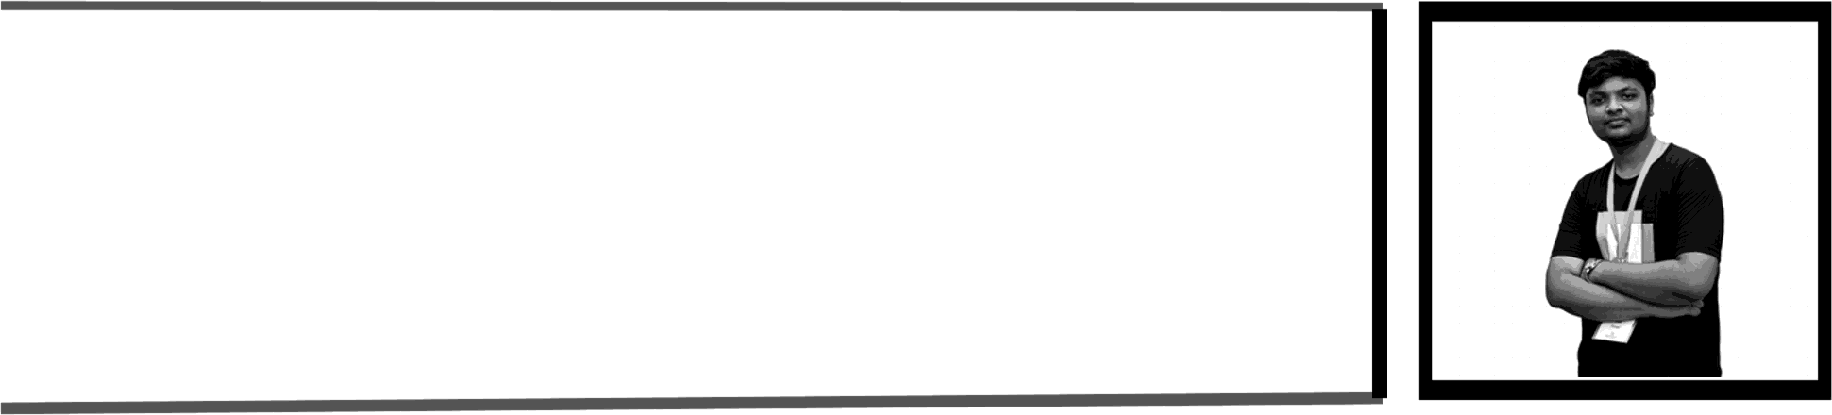

SHABARI E S

## CAREER OBJECTIVE :

To work in an institution where I can use my skills and knowledge to deliver best teaching as well as to enhance my learning and dynamically develop my career in the field of computer science

## ACADEMIC PROFILE :

QUALIFICATION Bachelor Of Engineering-

Computer Science Engineering INSTITUTION

Muthayammal Engineering

College ,Rasipuram

YEAR OF PASSING £0£J—

*2027*

PERCENTAGE/CGPA

SECURED 8.15

# MINI PROJECT:

Title:

E-Commerce web,ToDo,Weather checker. AREA OF INTEREST:

Web Designer. Fullstack Developer.

CONTACT:

Address:58/91 Sangamedu (st),Seerappalli (po),Rasipuram (tk),Namakkal (dt).

Phone no:ó3ó9035ó 33

G- [mail:shabaries28óó@gmail.com](mailto:shabaries28óó@gmail.com)

## SKILLS:

* Web Technologies: html,css,js .
* Design: Minimal webpage design,poster design.
* Known Language:C,3AVA.

# PROFESSIONAL PROFICIENCY:

Workshop:

. Participated in presentation of "SOFTWARE DEVELOPEMENT CYCLE" at MUTHAYAM MAL ENGINEERING COLLEGE.

Participated in workshop of

. "DIGITAL TWINS" at

Knowledge Institute of Technology(KIOT) and Won Third Price.

# DECLARATION:

### » I here by declare that all the above information are true and correct to the best of my knowledge.

your's faithfully

(SHABARI E S)