#### Grasshopper - Check for factor

## About factors

Factors are numbers you can multiply together to get another number.

2 and 3 are factors of 6 because: 2 * 3 = 6

* You can find a factor by dividing numbers. If the remainder is 0 then the number is a factor.
* You can use the mod operator (%) in most languages to check for a remainder

For example 2 is not a factor of 7 because: 7 % 2 = 1

Note: base is a non-negative number, factor is a positive number.

#### My solution:

#### function checkForFactor (base, factor) {

#### if(base%factor===0){

#### return true

#### }return false;

#### }

#### For Twins: 2. Math operations

### Task:

A magician in the subway showed you a trick, he put an ice brick in a bottle to impress you. The brick's length and width are equal, forming a square; its height may be different. Just for fun and also to impress the magician and people around, you decided to calculate the brick's volume. Write a function iceBrickVolume that will accept these parameters:

* radius - bottle's radius (always > 0);
* bottleLength - total bottle length (always > 0);
* rimLength - length from bottle top to brick (always < bottleLength);

And return volume of ice brick that magician managed to put into a bottle.

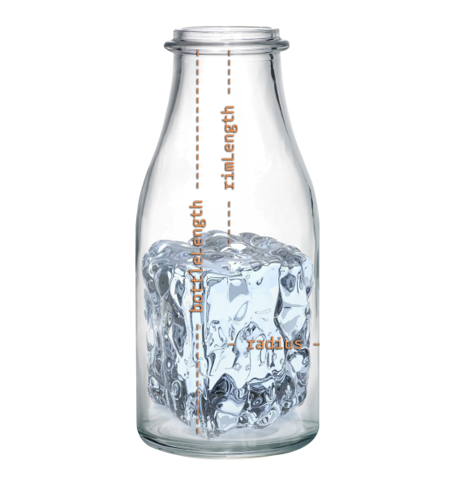

### Note:

All inputs are integers. Assume no irregularities to the cuboid brick. You may assume the bottle is shaped like a cylinder. The brick cannot fit inside the rim.

All inputs are integers.

#### My solution:

**function** iceBrickVolume(radius, bottleLength, rimLength) {

// Your code should be here ;)

return v=2*(radius*radius)*(bottleLength-rimLength);

}