Name: Shabbar Adamjee  
Roll No.: PB57  
PRN: 1032221508

*BDT ASSIGNMENT 6*

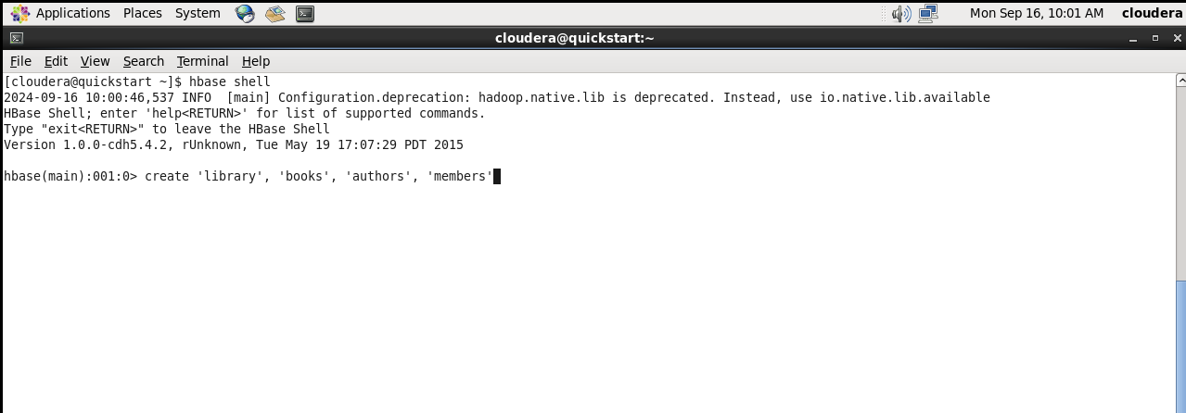

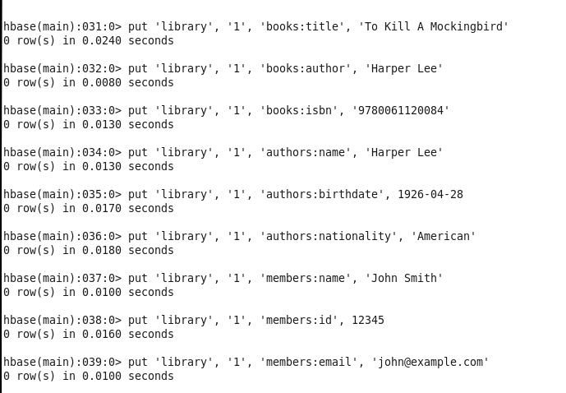

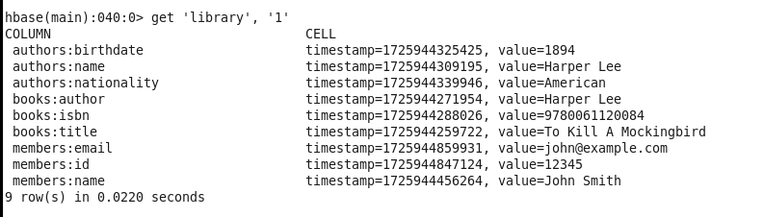

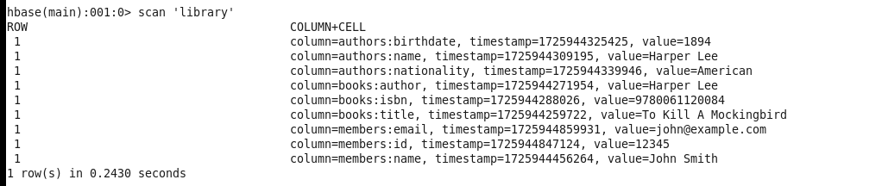

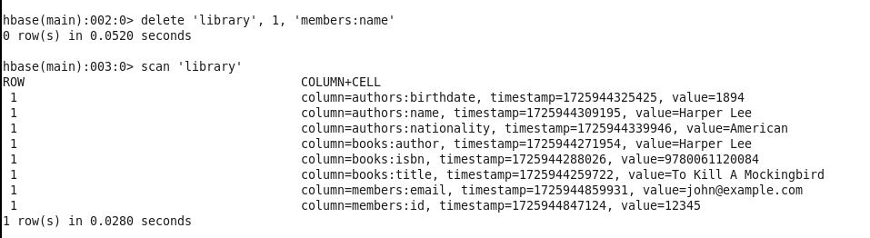

*PRACTICE ASSIGNMENT*



