Name: Shabbar Adamjee
Roll No.: PB57
PRN: 1032221508

BDT LAB ASSIGNMENT 2
- Create database ‘Restaurant’.

use Restaurant

- Create collection hotel.

db.createCollection(“hotel”)

- Insert 10 documents with above mentioned structure.

db.hotel.insertMany([
{ },
{ },
{ }.
...
])

- Display all Hotel information.

db.hotel.find()

- Display no of rooms in each hotel

db.hotel.aggregate(
{$unwind: "$rooms"},
{$group: {_id: "$name", noOfRooms: {$sum: 1}}}
)
- Compute the top five hotels.

db.hotel.aggregate([
{$group: {_id: '$name', totalLikes: {$sum: likes}}},
{$sort: {totallikes: -1}},
{$limit: 5},
{$project: {name: 1, totalLikes:1}}
])

- Return hotels having likes above 1000.

db.hotel.aggregate([
{$group: {_id: '$name', totalLikes: {$sum: likes}}},
{$match: {totalLikes: {$gt: 1000}}},
{$project: {name: 1, totalLikes:1}}
])

- Return the Five Most Common Cuisines.

db.hotel.aggregate([
{$unwind: "$cuisines"},
{$group: {_id: "$cuisines", count: {$sum: 1}}},
{$sort: {count: -1}},
{$limit: 5}
])

- Return all prices of room in different hotel of type ‘Deluxe' .

db.hotel.aggregate([
{$unwind: '$rooms'},
{$match: {'rooms.type': 'Deluxe'}},
{$project: {'name': 1, 'rooms.price': 1, _id: 0}}
])

- Get the total count of hotels having ratings ‘5 star’

db.hotel.aggregate([
{$match: {'rating': 5}},
{$group: {_id: 'rating', count: {$sum: 1}}}
])

- Display the count of hotels from ‘Pune’ city.

db.hotel.aggregate([
{$match: {'address.city': 'Pune'}},
{$count: 'name'}
])

- Get Indexes method : db.resto.getIndexes()
[ { v: 2, key: { _id: 1 }, name: '_id_' } ] – default index generated by system

- db.resto.find({borough : "Brooklyn"}).explain()
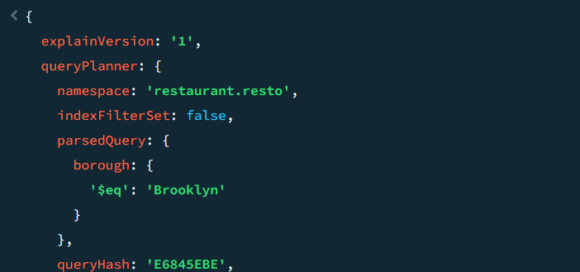
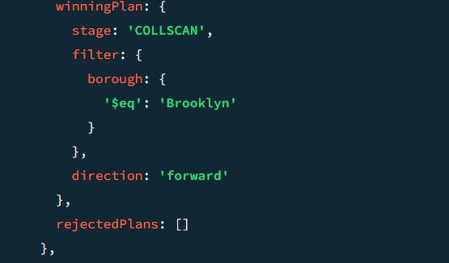

db.resto.find({borough : "Brooklyn"}).explain("executionStats")

- db.resto.createIndex({borough : 1}) -> Creating index on a field
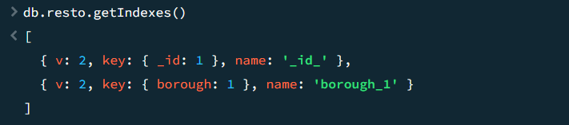

- db.resto.find({$and : [{"cuisine": {$eq : "Italian"}}, {"grades.score" : {$gt : 50}}]}).explain("executionStats")
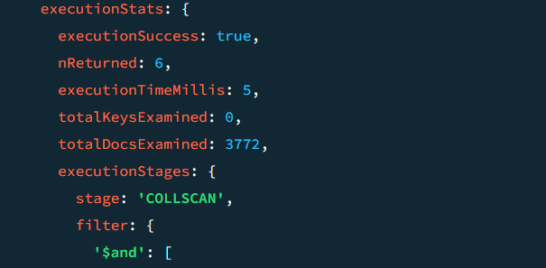
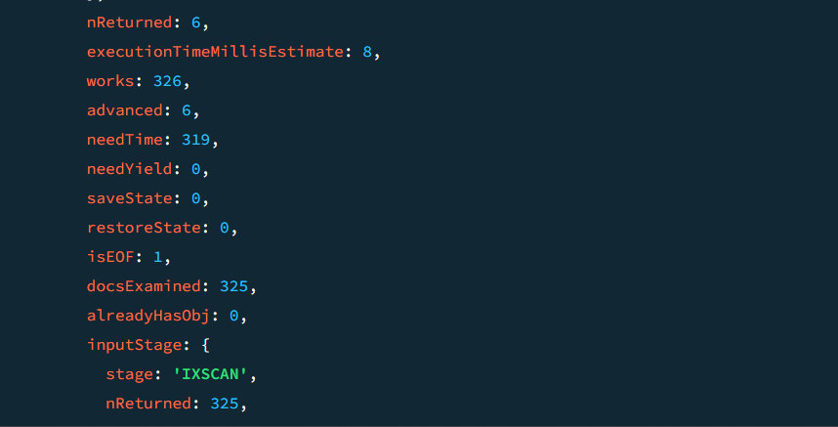
- db.resto.createIndex({cuisine : 1, "grades.score" : 1})
