FSD Laboratory 02
Name: Shabbar Adamjee
Roll No: PB57
PRN: 1032221508

Aim: Design and develop a responsive web page using Bootstrap front end framework.
Objectives:
1. To understand HTML tags
2. To learn the styling of web pages using CSS
3. To learn Bootstrap Front End Framework.

Theory:
- Bootstrap Grid System.
The Bootstrap grid system is a flexible and responsive layout system based on a 12-column structure. It allows you to create complex layouts by combining rows and columns. Key points include:
- Rows and Columns: Use .row to create horizontal groups of columns and .col to specify the number of columns spanning.
- Breakpoint Tiers: Control the layout across different screen sizes using classes like .col-sm-, .col-md-, .col-lg-, and .col-xl-.
- Responsive Design: Columns re-arrange themselves automatically to fit the screen size.
- Nestable: Columns can be nested within other columns.

- Bootstrap .container and .container-fluid class.
In Bootstrap, the .container and .container-fluid classes are used to create layout containers with different behaviors:
- .container:
  - Provides a fixed-width container.
  - Centers the content on the page with responsive padding.
  - Width adapts to different screen sizes (e.g., 100% on small screens, fixed width on larger screens).
- .container-fluid:
  - Provides a full-width container.
  - Spans the entire width of the viewport.
  - Useful for layouts that need to stretch across the entire screen width.

FAQ:
- What is a responsive website?
A responsive website is designed to provide an optimal viewing experience across a wide range of devices and screen sizes, from desktop monitors to mobile phones. Key characteristics include:
- Flexible Layouts: The layout adjusts based on the screen size, orientation, and resolution.
- Fluid Grids: Elements are sized in relative units (%) rather than absolute units (px).
- Media Queries: CSS techniques to apply different styles based on the device characteristics.
- Adaptive Images: Images scale with the layout or swap out at different resolutions.

- How Bootstrap helps to design a responsive website?
- Bootstrap is a widely-used open-source front-end framework that facilitates the development of responsive and mobile-first websites. It provides an extensive collection of CSS and JavaScript tools that enable developers to create visually appealing and functionally robust web pages efficiently.
  - A key feature of Bootstrap is its 12-column grid system, which allows for the creation of flexible and adaptive layouts that adjust seamlessly to various screen sizes. This grid system is complemented by a wide range of predefined CSS classes for common web elements, ensuring consistent styling without the need for extensive custom CSS.
  - Additionally, Bootstrap includes responsive utility classes that make it easy to show, hide, and modify elements based on screen size, enhancing the adaptability of web pages. The framework also offers numerous reusable UI components, such as navigation bars, buttons, forms, modals, and carousels, all designed to be responsive by default. This ensures that the website maintains a cohesive and functional design across different devices. Bootstrap’s use of media queries further refines the responsiveness by applying different styles based on device characteristics.
Output: Screenshots of the output to be attached.

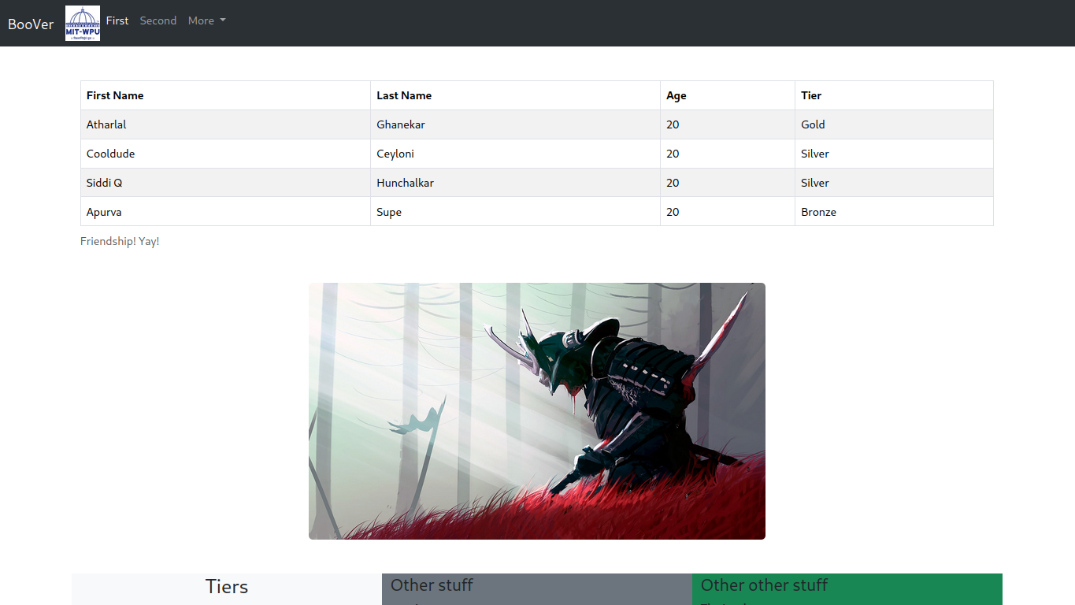

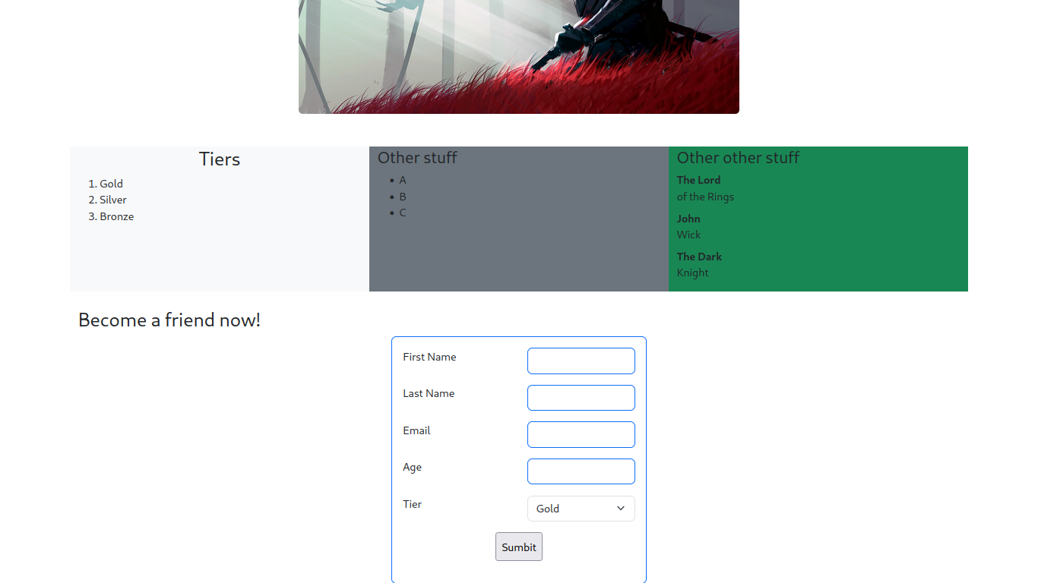

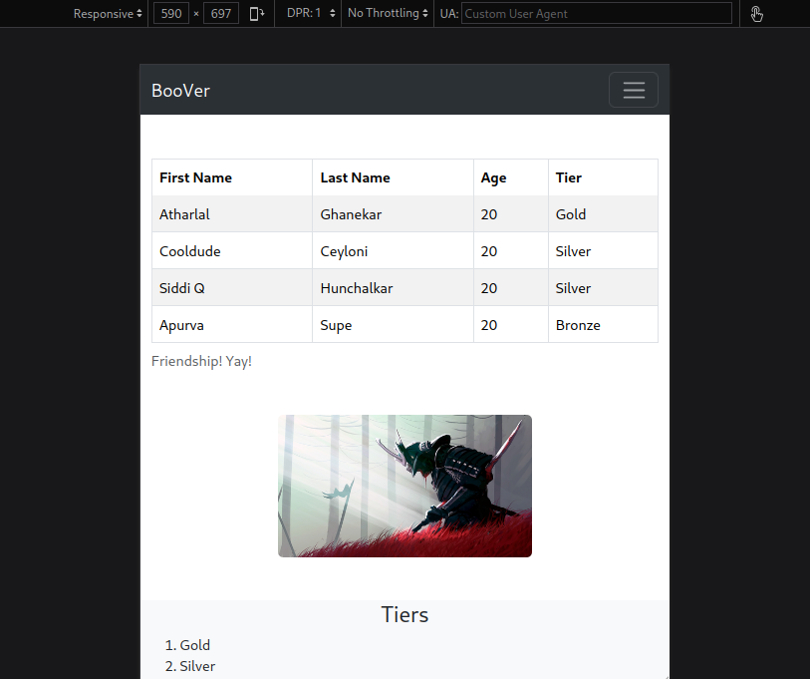

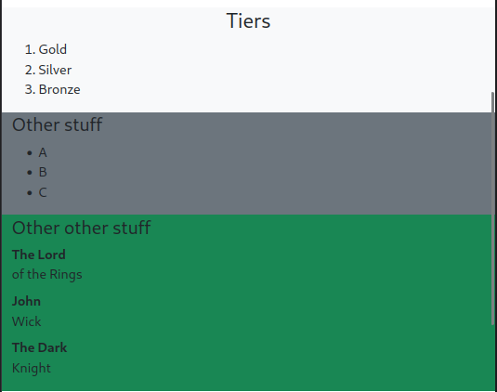

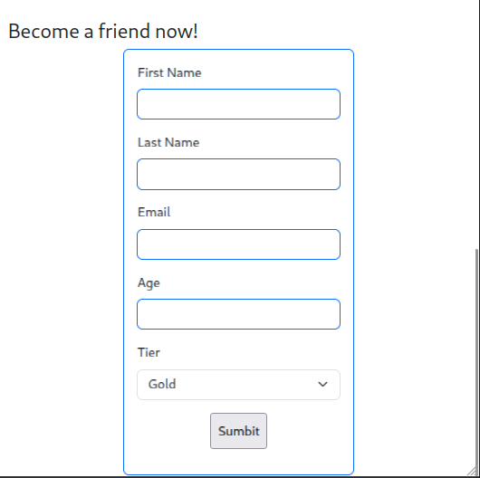

Problem Statement:
Design and develop a responsive web page (For example student registration, course enrollment, library management system, online shopping system etc.) using Bootstrap front end framework. Web pages should contain HTML5 elements (Use all possible formatting for example font, colour etc.).
Web page should include various
- images,
- links within the page,
- tables
- lists
- form elements
- paragraphs
- links to other pages for navigation,
- new tabs.
Use Cascaded Style Sheets (CSS) to style the web pages designed. Make use of
- Three types of styles (Inline, Internal and External)
- border,
- margins,
- padding,
- navigation,
- dropdown list
- tag selector
- class selector
- id selector
- exploring background image and position property etc.

