CREATE DATABASE IF NOT EXISTS hive_assignment_db COMMENT 'Holds hive assignment information' WITH DBPROPERTIES('edi

ted-by'='shabbir')



SHOW DATABASES like '*hive_assignment_db*';

USE hive_assignment_db;

CREATE TABLE facebook (

userid INT,

age INT,

dob_day INT,

dob_year INT,

dob_month INT,

gender STRING,

tenure INT,

friend_count INT,

friendships_initiated INT,

likes INT,

likes_received INT,

mobile_likes INT,

mobile_likes_received INT,

www_likes INT,

www_likes_received INT

)

ROW FORMAT DELIMITED

FIELDS TERMINATED BY ','

STORED AS TEXTFILE;

LOAD DATA local INPATH 'pseudo_facebook.csv' OVERWRITE INTO TABLE facebook;

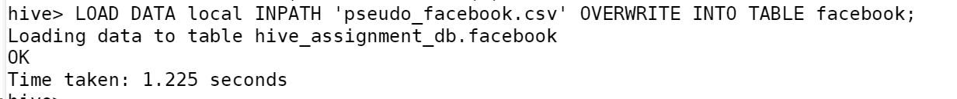

SET hive.cli.print.header=true;

select * from facebook limit 5;

Q1: Find out the total no of users in the dataset

SELECT COUNT(*) AS total_users FROM facebook;

Q2: Find out the no of users above the age of 25

SELECT COUNT(*) AS users_above_25 FROM facebook WHERE age > 25;

Q3: Do male face book users tend to have more friends or female users

SELECT gender,AVG(friend_count) AS average_friend_count FROM facebook GROUP BY gender;



Q4: How many likes do young people receive on facebook as opposed to old people

SELECT age_group,SUM(likes_received) AS total_likes_received FROM (SELECT CASE WHEN age < 30 THEN 'Young' ELSE 'Old' END AS age_group, likes_received FROM facebook) subquery GROUP BY age_group;



Q5: Find out the count of facebook users for each birthday month

SELECT dob_month, COUNT(*) AS user_count FROM facebook GROUP BY dob_month ORDER BY dob_month;

Q6: Do young members use mobile phones or computers for facebook browsing

WITH age_device AS (

    SELECT

        CASE

            WHEN age < 30 THEN 'Young'

            ELSE 'Old'

        END AS age_group,

        CASE

            WHEN mobile_likes > 0 THEN 'Mobile'

            ELSE 'Computer'

        END AS device_type

    FROM facebook

)

SELECT

    age_group,

    device_type,

    COUNT(*) AS user_count

FROM age_device

GROUP BY age_group, device_type;

Q7: Do adult members use mobile phones or computers for facebook browsing

SELECT

    age_group,

    device_type,

    COUNT(*) AS user_count

FROM (

    SELECT

        CASE WHEN age >= 18 THEN 'Adult' ELSE 'Not Adult' END AS age_group,

        CASE WHEN mobile_likes > 0 THEN 'Mobile' ELSE 'Computer' END AS device_type

    FROM facebook

) subquery

GROUP BY age_group, device_type;

