hdfs dfs -mkdir -p /user/mavricbdhnov0110/rawdata/airline/flights

hdfs dfs -mkdir -p /user/mavricbdhnov0110/rawdata/airline/planeinfo

hdfs dfs -mkdir -p /user/mavricbdhnov0110/rawdata/airline/airport

hdfs dfs -mkdir -p /user/mavricbdhnov0110/rawdata/airline/carriers

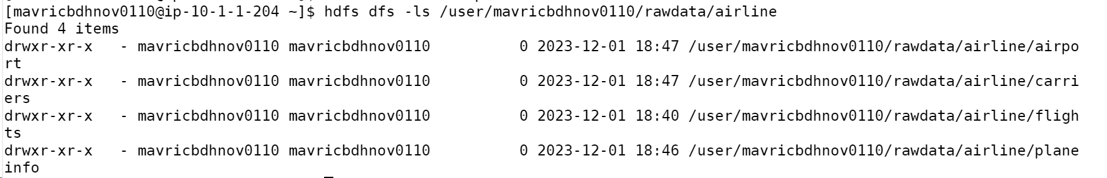

CREATE DATABASE airline_db_shabbir;

USE airline_db_shabbir;

CREATE EXTERNAL TABLE Airports_stg (

    IATA STRING,

    Name STRING,

    City STRING,

    State STRING,

    Country STRING,

    Lat DECIMAL(9, 6),

    Long DECIMAL(9, 6)

)

ROW FORMAT DELIMITED

FIELDS TERMINATED BY ','

STORED AS TEXTFILE

LOCATION '/user/mavricbdhnov0110/rawdata/airline/airports'

tblproperties(

"skip.header.line.count"="1"

);

CREATE EXTERNAL TABLE Carrier_stg (

    Code STRING,

    Description STRING

)

ROW FORMAT DELIMITED

FIELDS TERMINATED BY ','

STORED AS TEXTFILE

LOCATION '/user/mavricbdhnov0110/rawdata/airline/carriers'

tblproperties(

"skip.header.line.count"="1"

);

CREATE EXTERNAL TABLE PlaneInfo_stg (

    tailNum STRING,

    type STRING,

    manufacturer STRING,

    issue_date STRING,

    model STRING,

    status STRING,

    aircraft_type STRING

)

ROW FORMAT DELIMITED

FIELDS TERMINATED BY ','

STORED AS TEXTFILE

LOCATION '/user/mavricbdhnov0110/rawdata/airline/planeinfo'

tblproperties(

"skip.header.line.count"="1"

);

CREATE EXTERNAL TABLE Flights_stg (

    Year INT,

    Month INT,

    DayofMonth INT,

    DayOfWeek INT,

    DepTime INT,

    CRSDepTime INT,

    ArrTime INT,

    CRSArrTime INT,

    UniqueCarrier STRING,

    FlightNum STRING,

    TailNum STRING,

    ActualElapsedTime INT,

    CRSElapsedTime INT,

    AirTime INT,

    ArrDelay INT,

    DepDelay INT,

    Origin STRING,

    Dest STRING,

    Distance INT,

    TaxiIn STRING,

    TaxiOut STRING,

    Cancelled STRING,

    CancellationCode STRING,

    Diverted STRING,

    CarrierDelay INT,

    WeatherDelay INT,

    NASDelay INT,

    SecurityDelay INT,

    LateAircraftDelay INT

)

ROW FORMAT DELIMITED

FIELDS TERMINATED BY ','

STORED AS TEXTFILE

LOCATION '/user/mavricbdhnov0110/rawdata/airline/flights'

tblproperties(

"skip.header.line.count"="1"

);

LOAD DATA INPATH 'AirlinesOntimeAnalysis/airports.csv' OVERWRITE INTO TABLE Airports_stg;

LOAD DATA INPATH 'AirlinesOntimeAnalysis/carriers.csv' OVERWRITE INTO TABLE Carrier_stg;

LOAD DATA INPATH 'AirlinesOntimeAnalysis/plane-data.csv' OVERWRITE INTO TABLE PlaneInfo_stg;

LOAD DATA INPATH 'AirlinesOntimeAnalysis/2003.csv' OVERWRITE INTO TABLE Flights_stg;

LOAD DATA INPATH 'AirlinesOntimeAnalysis/2004.csv' OVERWRITE INTO TABLE Flights_stg;

LOAD DATA INPATH 'AirlinesOntimeAnalysis/2005.csv' OVERWRITE INTO TABLE Flights_stg;

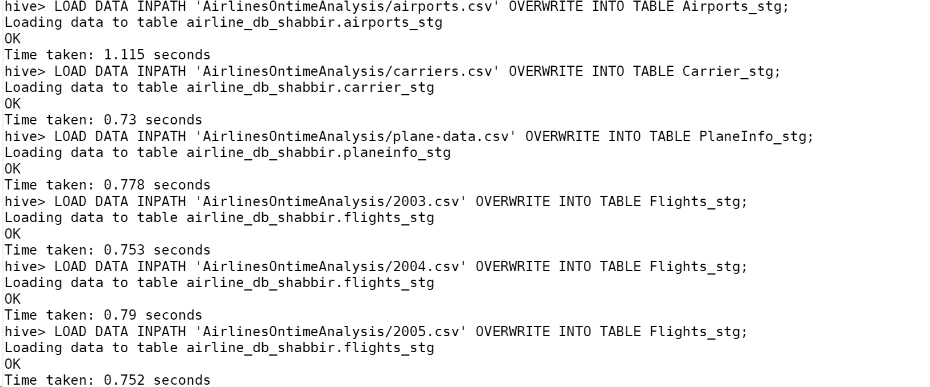

Q1.What is the average arrival delay and average departure delay in each

month of the year 2004?

INSERT OVERWRITE DIRECTORY 'workspace_shabbir/Flight_delay_analysis.csv'

SELECT

    Month,

    AVG(ArrDelay) AS avg_arrival_delay,

    AVG(DepDelay) AS avg_departure_delay

FROM Flights_stg

WHERE Year = 2004

GROUP BY Month

ORDER BY Month;

hdfs dfs -cat workspace_shabbir/Flight_delay_analysis.csv





CREATE EXTERNAL TABLE flights_pq (

    Year INT,

    Month INT,

    DayofMonth INT,

    DayOfWeek INT,

    DepTime INT,

    CRSDepTime INT,

    ArrTime INT,

    CRSArrTime INT,

    UniqueCarrier STRING,

    FlightNum STRING,

    TailNum STRING,

    ActualElapsedTime INT,

    CRSElapsedTime INT,

    AirTime INT,

    ArrDelay INT,

    DepDelay INT,

    Origin STRING,

    Dest STRING,

    Distance INT,

    TaxiIn STRING,

    TaxiOut STRING,

    Cancelled STRING,

    CancellationCode STRING,

    Diverted STRING,

    CarrierDelay INT,

    WeatherDelay INT,

    NASDelay INT,

    SecurityDelay INT,

    LateAircraftDelay INT

)

STORED AS PARQUET

LOCATION '/user/mavricbdhnov0110/output/airline/pq_flights';

What is the average arrival delay and average departure delay in each

month of the year 2004?

SELECT

    Month,

    AVG(ArrDelay) AS avg_arrival_delay,

    AVG(DepDelay) AS avg_departure_delay

FROM flights_pq

WHERE Year = 2004

GROUP BY Month

ORDER BY Month;

