**BIOMASS: CASE STUDY**

**Introduction:**

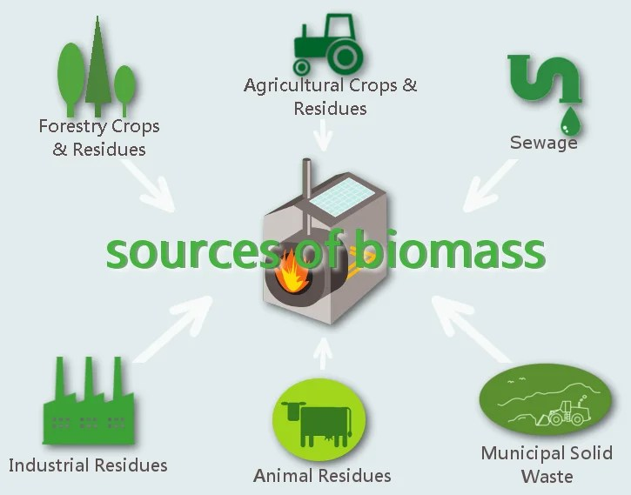Biomass is a renewable energy source that derives from organic materials such as plants, crops, agricultural residues, wood, and organic waste. It can be used to produce heat, electricity, and biofuels through various conversion processes. Biomass energy is considered carbon-neutral since the carbon dioxide released during its combustion is roughly equivalent to the carbon dioxide absorbed by plants during their growth.

**Sources of Biomass:**

* Agricultural Biomass: Crop residues, energy crops (such as switch grass and miscanthus), and by-products from agricultural activities are examples of agricultural biomass.
* Forestry Biomass: Wood chips, bark, sawdust, and tree trimmings are obtained from forestry operations and can be used as biomass fuel.
* Organic Waste: Biomass can be derived from organic waste materials like food waste, animal manure, and sewage sludge.

**Conversion Processes:**

* Combustion: Biomass can be burned directly to produce heat or generate steam, which can power turbines for electricity generation.
* Anaerobic Digestion: Organic waste materials can undergo anaerobic digestion, a process that produces biogas (a mixture of methane and carbon dioxide) for electricity or heat production.
* Biochemical Conversion: Biomass can be converted into biofuels such as ethanol or biodiesel through processes like fermentation or transesterification.

**Advantages of Biomass Energy:**

* Renewable and Sustainable: Biomass is derived from organic materials that can be replenished through proper management and cultivation practices.
* Carbon Neutral: The carbon dioxide released during biomass combustion is offset by the carbon dioxide absorbed during the growth of plants, making it a carbon-neutral energy source.
* Waste Reduction: Biomass energy can utilize organic waste materials, reducing the volume of waste going to landfills and providing an environmentally friendly waste management solution.

**Disadvantages of Biomass Energy:**

* High emissions: The combustion of biomass releases carbon dioxide, nitrogen oxides, and particulate matter, contributing to air pollution.
* Land use competition: Biomass production for energy purposes may compete with food production and natural land use, leading to deforestation and habitat destruction.
* Limited efficiency: Biomass energy conversion processes have lower efficiency compared to fossil fuel-based power plants, requiring larger quantities of biomass to generate the same amount of energy.
* Fuel supply challenges: Biomass availability can be variable, depending on seasonal and regional factors, and storing and handling bulky biomass feedstock can pose logistical challenges.

**Case Study: Drax Power Station, United Kingdom**

Drax power station is a large biomass power station in Drax, North Yorkshire, England, capable of co-firing petroleum coke. It has a 2.6 GW capacity for biomass and 1.29 GW capacity for coal. Its name comes from the nearby village of Drax. It is situated on the River Ouse between Selby and Goole. Its generating capacity of 3,906 megawatts (MW) is the highest of any power station in the United Kingdom, providing about 6% of the United Kingdom's electricity supply.

**Benefits and Sustainability:**

* Carbon Reduction: The conversion to biomass has resulted in significant carbon emission reductions, as biomass combustion releases fewer greenhouse gases compared to coal.
* Renewable Energy: The Drax Power Station's biomass operations play a vital role in the UK's renewable energy mix, supporting the country's renewable energy goals.
* Job Creation: The conversion project has created job opportunities in the biomass supply chain, supporting the local economy and the renewable energy sector.

**Challenges and Considerations:**

* Sustainable Biomass Sourcing: Ensuring the sustainability of biomass feedstock is crucial to prevent deforestation and protect biodiversity.
* 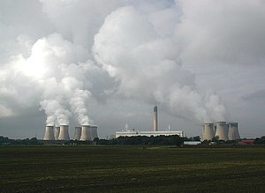Logistics and Supply Chain: Managing the logistics of procuring, storing, and transporting biomass feedstock requires robust supply chain infrastructure.

The Drax Power Station serves as a successful case study for the large-scale conversion of a coal-fired power station to biomass energy generation. The project showcases the potential of biomass as a renewable energy source, contributing to carbon reduction, renewable energy targets, and job creation. Continued advancements in sustainable biomass sourcing, logistics, and technology will further enhance the role of biomass in the global energy transition.

**Conclusion:**

In conclusion, biomass energy offers a renewable and potentially carbon-neutral solution to meet energy demands. It utilizes organic materials such as plants, crops, agricultural residues, wood, and organic waste to produce heat, electricity, and biofuels. While biomass energy has its advantages, including its renewable nature and waste reduction potential, there are also important considerations and disadvantages.

**References:**

* <https://en.wikipedia.org/wiki/Drax_Power_Station>
* https://education.nationalgeographic.org/resource/biomass-energy/