**BankNifty Long Strategy Analysis:**

Here are the list of Optimizations performed on the BankNifty Long Strategy in the month of Jan-2022:

|  |  |  |
| --- | --- | --- |
| Optimization File | Updated By | Date |
| Dropbox\Swan Documentation\Documentation\Systems\banknifty_long\ Long OVN with BN as Indicator Jan 2022.xlsx | Rishabh |  |

1. 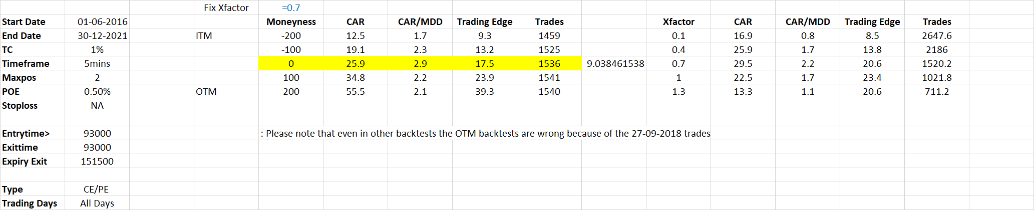Optimization 1: This optimization is for CEPE all days:
2. Optimization 2: CE Only All Days:

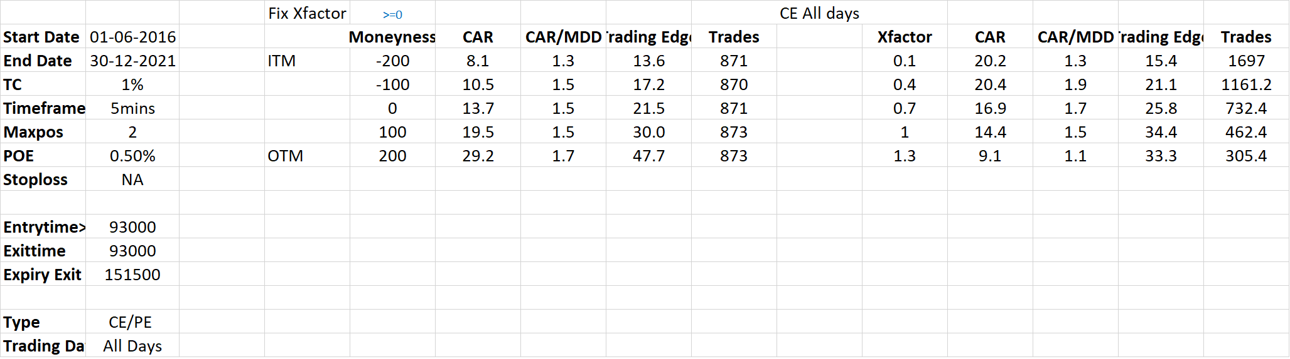

1. Optimization 3: PE Only All Days:

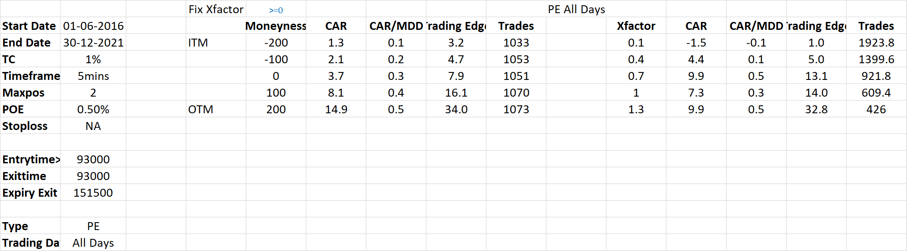

Based on the Analysis, here are the conclusions:

* Trade both CE and PE on all days
* Run one unit with Same Expiry Last day[Higher CAR on big moves]