|  |  |  |  |
| --- | --- | --- | --- |
| Optimization File | Updated By | Date | Sr no |
| Dropbox\Swan Documentation \Systems\QGF\qgf_strategy_optimisation_2021.10.04.xlsx  Dropbox\Swan Documentation \Systems\QGF\qgf_strategy_optimisation_2021.10.04.xlsx | Vidhi | 04/10/2021 (optimization date)  27/7/2022 (doc creation date) |  |

**PMS Strategy Optimizations:**

Here is the list of Optimizations performed on the QGF Strategy in the month of 04/10/2021:

1. Optimization: This optimization is for Ranking Indicator Selection **using** **Fundamental indicators**:

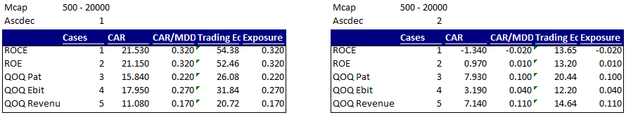

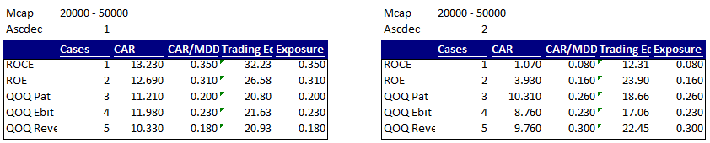

1. Fundamental Analysis: Yearly Average, Min, Max of all fundamental indicators

From 1/7/2011 – 1/7/2021

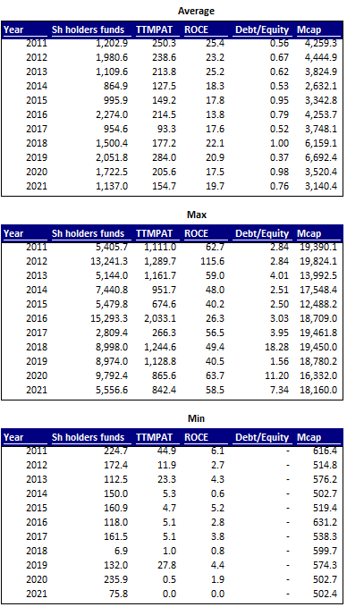

1. ROCE maxpos selection for different mcap:

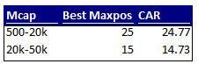

1. Optimization 1: This optimization is for Ranking Indicator Selection **using** **Technical indicators**:

Transaction Costs = 0.2; Close > 50; vp = 10; maxpos = 30;

Buy in July, **holding period 1 year**

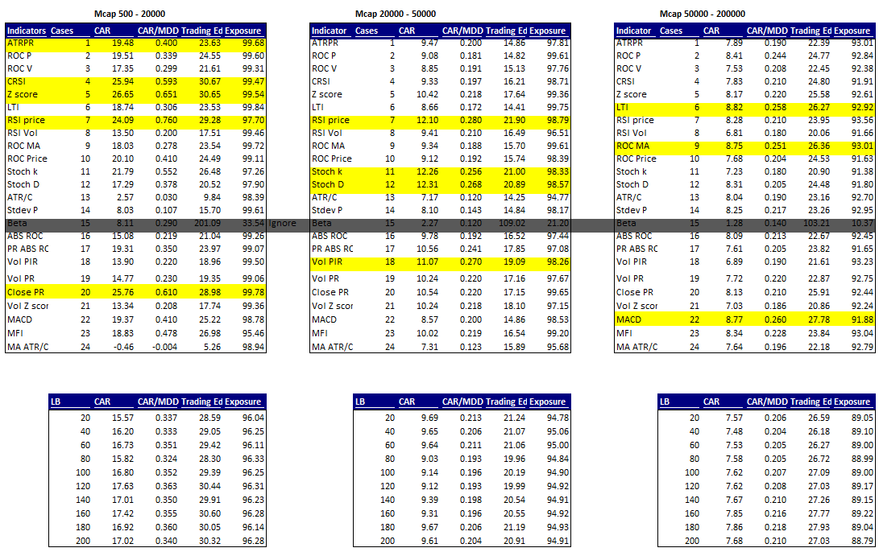

1. Optimization 2: Average price ranking optimization:

CRSI + RSIPrice + ClosePR

Buy in July, **holding period 1 year**

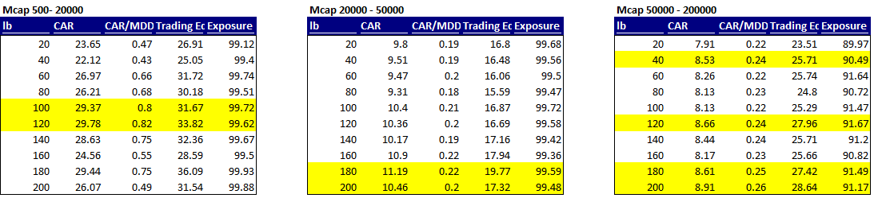

1. Optimization 3: Average Volatility Ranking:

ATRPR + Zscore

Vp = 10

Buy in July, **holding period 1 year**

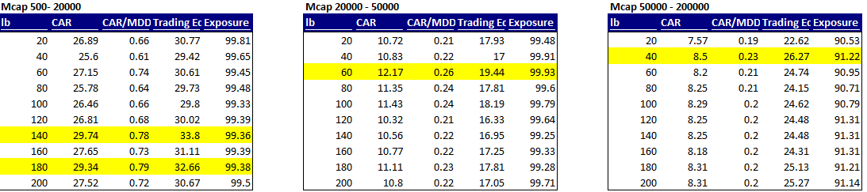

1. Optimization 4: Average Price and Volatility Indicators:

CRSI + RSI Price + Close PR + ATRPR + Z Score

Buy in July, **holding period 1 year**

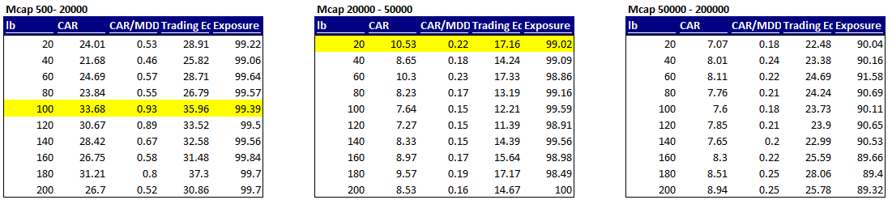

1. Optimization 5: Technical indicator ranking trend check:

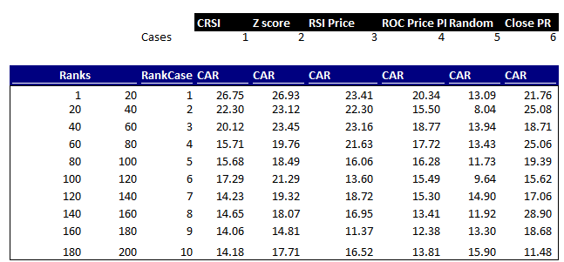

These optimizations were for the holding period of 1 year using the technical indicators.

Following 2 optimizations are for holding period for a quarter and a month. The variables are same as mentioned in the start.

1. Optimization 5: Ranking indicator using technical indicator: **Holding period 1 quarter**

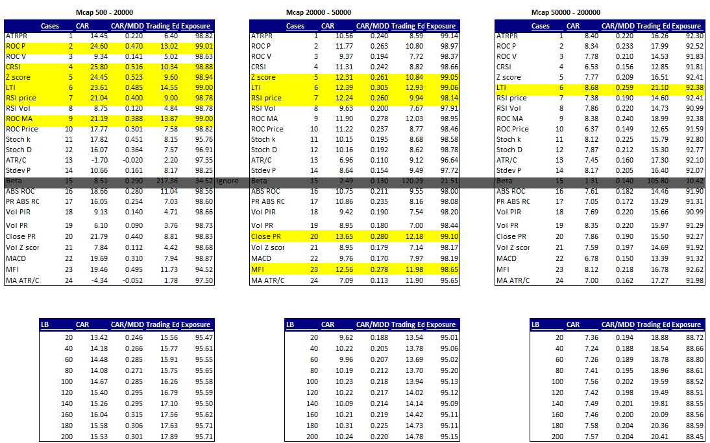

1. Optimization 6: Ranking indicator using technical Indicator: **Holding period 1 month:**

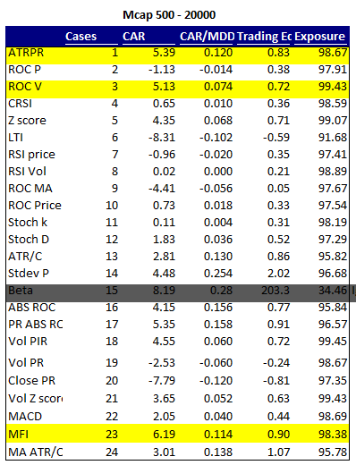

1. Universe count: We did a check to count the number of stocks each year that fall under the certain market cap category so that we know our backtest universe is not concentrated

From 1/7/2011 – 1/7/2021

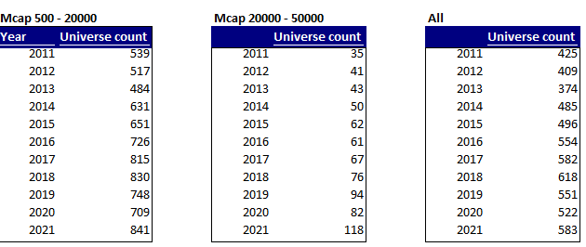

1. Optimization: Sector analysis:

We did an additional analysis of buy and hold each sector to understand which sector has performed on an average.

**Indicator = ROCPrice**

Lb = 100; vp = 10; maxpos = 10; mcap >= 500 and mcap <= 2000000

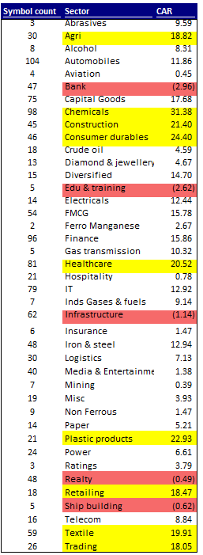

**Conclusion:**

Based on the Analysis, here are the conclusions:

* **Current inputs:** vp **=** 4; ef = 0.1; stop = 6/10; min stop = 2%; max stop = 8%; endtime = 094000; covertime = 151000
* **Ranking selection:**
  + In the start, we ran the system with 1 ranking indicator, CRSI. Then we saw that other indicators are even better so we optimized with ROC Price and ROC Volume and ran the system with 2 indicators. Later we decided to add more and have an average result for more stability and effectiveness of the indicator selection process
  + Ranking indicator selection: 9 indicators selected (3 each in price, volatility and volume) so that the system is not dependent on a single indicator and we can achieve average returns
* **Maxpos:**
  + There is a clear trend in the maxpos 0-10 is the best, 10-20 next best and so on. We started with 10 positions and ranking out of 30. The backtest had a random component in it because of this.
  + SID slippage increased by placing orders at 9:15 as REL orders. So we fixed the maxpos to 10 and placed orders in evening using bulk file
  + Current Maxpos = 15 ( to have lesser exposure in a single position )