|  |  |  |  |
| --- | --- | --- | --- |
| Optimization File | Updated By | Date | Number reference |
| Dropbox\Swan Documentation \Systems\Short_flat \shortflat_optimisations_2021.08.27.xlsx | Vidhi | 27/08/2021 | Sr no 1 to 9 |
| Same file as above (refer last optimization picture No. 10) | Vidhi | 21/07/2022 | Sr no 10 |

**Short flat Strategy Analysis:**

The following optimizations were done with the transaction cost of 0.1%.

Here is the list of Optimizations performed on the Short flat Strategy in the month of 27/8/2021:

1. Optimization 1: This optimization is for EMALLB:

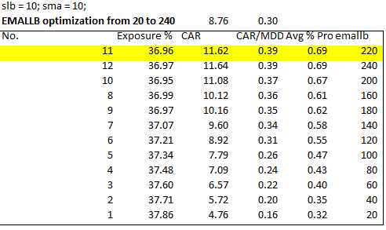

1. Optimization 2: EMALLB from 240 to 340:

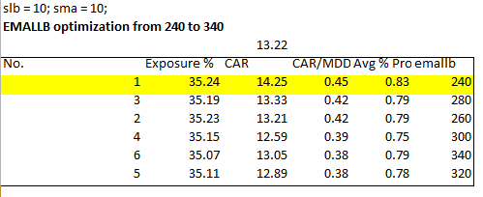

1. Optimization 3: Ranking Indicator selection:

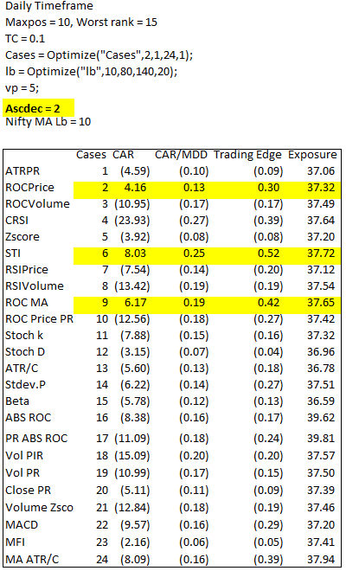

1. Optimization 4: maxpos:

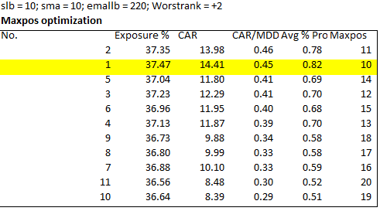

1. Optimization 5: Maxpos and worstrank:

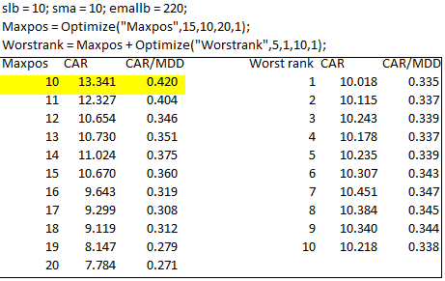

1. Walkforward 1: SLB, SMA, EMALLB:

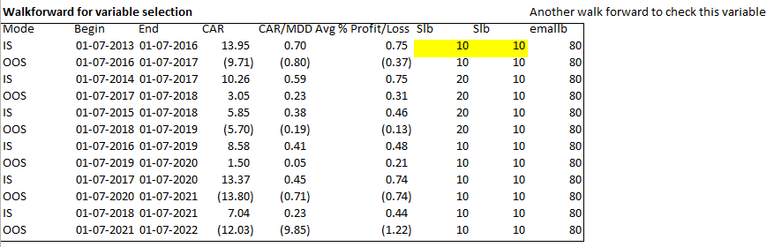

1. Walkforward 2: EMALLB:

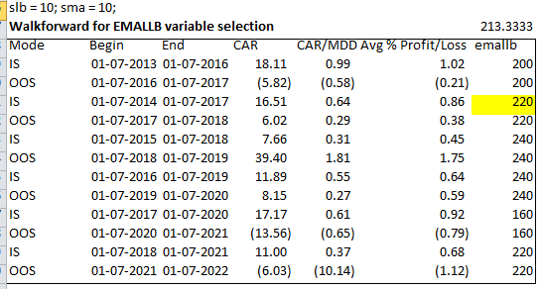

1. Walkforward 3: worstrank:

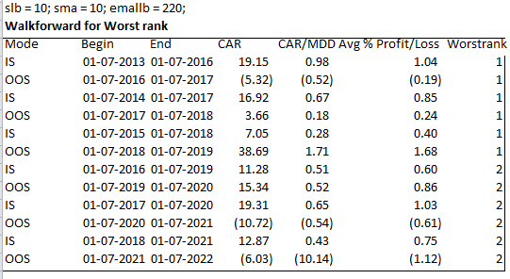

1. Walkforward 4: maxpos:

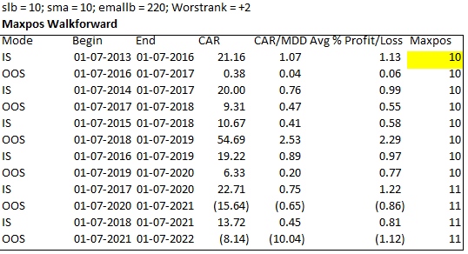

1. Optimization: sma, slb, emallb:

To check the results from 1/1/2011-1/4/2022 with 0.2% transaction cost. Check the average result for a longer time frame with a higher transaction cost to check the robustness of the system.

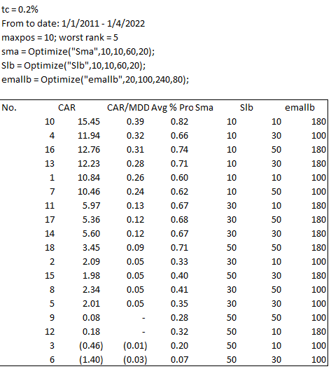

**Conclusion:**

Based on the Analysis, here are the conclusions:

* Maxpos = 15 ( to have lesser exposure in a single position )
* Worstrank = maxpos + 5
* Sma = slb = 10
* Emallb = 220