|  |  |  |
| --- | --- | --- |
| Optimization File | Updated By | Date |
| Dropbox\Swan Documentation \Systems\Short_Intraday \short_intraday_optimisation_2021.06.25.xlsx  Dropbox\Strategy Testing\ Short intraday\ Monday Check.xlsx  Dropbox\Strategy Testing\ Short intraday\2021\Mar 2021 Optimizations.xlsx | Vidhi | 27/05/2021 (optimization date)  22/7/2022 (doc creation date) |

**BankNifty Long Strategy Analysis:**

Here is the list of Optimizations performed on the Short Intraday Strategy in the month of 27/5/2021:

1. Optimization 1: This optimization is for Ranking Indicator Selection:

All Transaction Costs were 0 and stop loss is fixed at Atr: 6, ef: 0.1, vp: 1 and lb:1.

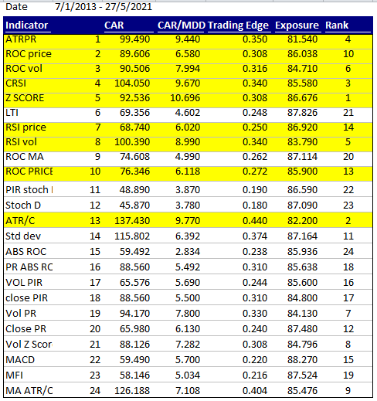

1. Optimization 2: Average ranking optimization:

All Transaction Costs were 0 and stop loss is fixed at Atr 6, ef: 0.1, vp: 1 and lb:1

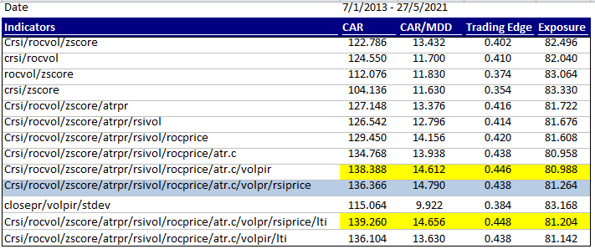

The detailed optimization of all combinations is in the excel sheet (Worksheet: All comb Optimizations)

After selecting the average of 9 indicators, we optimize the variables:

1. Optimization 3: **maxpos and lookback**: From to date: 1/5/2013 – 7/5/2021; tc: 0, ef: 0.1

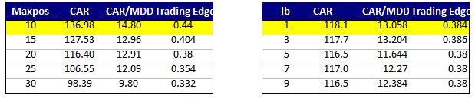

1. Optimization 4: **ef**: maxpos: 15; tc: 0.1%

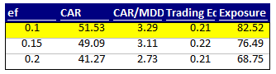

1. Walkforward 5:

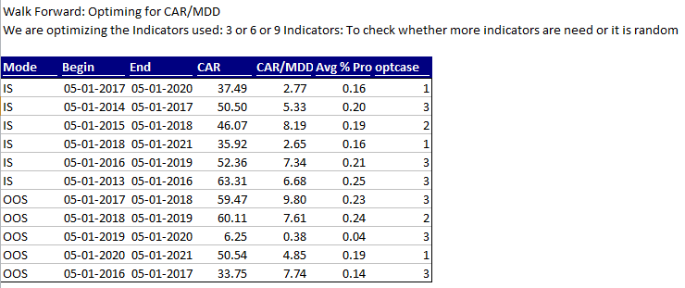

1. Walkforward 6:

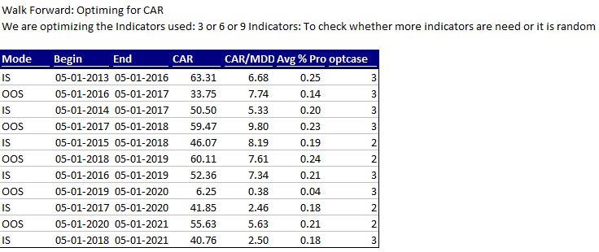

1. Walkforward 7:

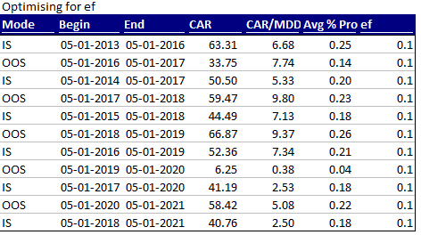

1. Optimization 8: Stoploss % using apply stop: From to date: 1/7/2014 – 30/6/2019; tc: 0.15; vp:3

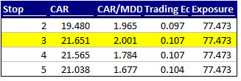

1. Optimization 9: To check average optimization if we trade only close>10, tried this since we incurred lot of slippage in Idea its price was less than 10: From to date: 1/7/2014 – 30/6/2019; tc: 0.15; checked on 11/3/2020

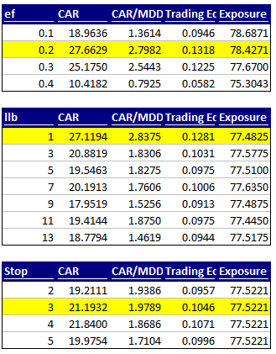

1. Optimization 10: Monday check:

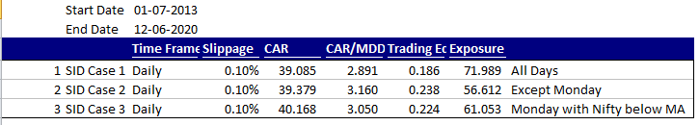

1. System health check: Can be checked by seeing the average CAR/MDD of the optimizations for every 3 years

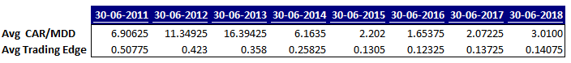

1. Optimization to select 10/10 maxpos or 10/30:

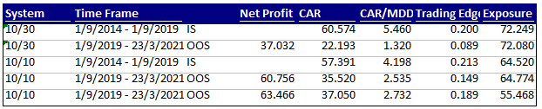

1. Optimization for endtime selection: maxpos 10/10:

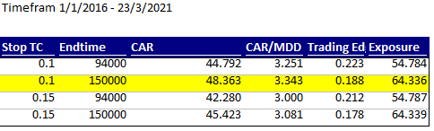

1. Stoploss and ef optimization for final selection:

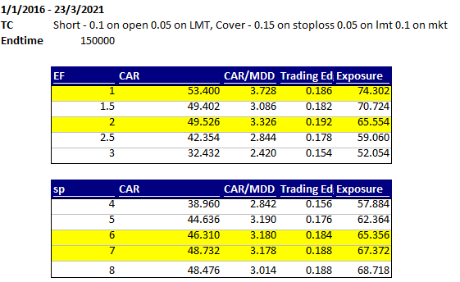

1. Slippage check:

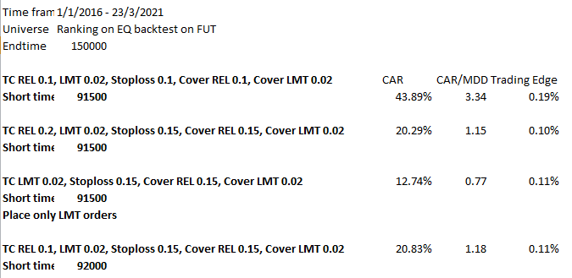

**Conclusion:**

Based on the Analysis, here are the conclusions:

* **Current inputs:** vp **=** 4; ef = 0.1; stop = 6/10; min stop = 2%; max stop = 8%; endtime = 094000; covertime = 151000
* **Ranking selection:**
  + In the start, we ran the system with 1 ranking indicator, CRSI. Then we saw that other indicators are even better so we optimized with ROC Price and ROC Volume and ran the system with 2 indicators. Later we decided to add more and have an average result for more stability and effectiveness of the indicator selection process
  + Ranking indicator selection: 9 indicators selected (3 each in price, volatility and volume) so that the system is not dependent on a single indicator and we can achieve average returns
* **Monday check:**
  + The results previously were better if you don’t trade on Monday but while trading live we missed out on a lot of opportunities on Monday so we backtested again with/without Monday and it does not make much difference. So we decided to go through with it and trade all days
* **Maxpos:**
  + There is a clear trend in the maxpos 0-10 is the best, 10-20 next best and so on. We started with 10 positions and ranking out of 30. The backtest had a random component in it because of this.
  + SID slippage increased by placing orders at 9:15 as REL orders. So we fixed the maxpos to 10 and placed orders in evening using bulk file
  + Current Maxpos = 15 ( to have lesser exposure in a single position )
* **Stoploss:**
  + We first placed stoploss based on % of short price. Then we changed the stoploss based on ATR which is the true stoploss based on volatility of each stock We fixed it to 6 ATR
  + Because of this we once lost a lot of money, more than 8% in one stock. We even faced a situation where the stoploss hit immediately since it was the low volatility stock. So we added a min and a max % stoploss as a limit. **Min 2% and max 8%.**
* **Trade close > 10:** 
  + It makes no difference if we exclude the stocks < 10. So we decided to exclude it for a while since slippage was high. Currently we removed that filter since slippage is under control
* **Futures volume filter:** 
  + We have not backtested this due to limitations on amibroker, but we follow this live. We don’t select stocks that have the average traded value in futures lower than 5*10^8 the previous day. We made this decision post march 2020 when we saw the traded volumes dropped in order to avoid slippage