**Eurecare Digital Report by ARCINFOSOFT**

**Integration with Google Tools:**

**Google Search Console and Google Analytics:**

**Setup Completion:** Integrated successfully with the EURECARE website to monitor performance and user behavior.

**Data Collection:** Commenced the collection of initial data, providing insights into traffic sources, user engagement, and website usability.

**SEO Optimization:**

**Meta-Tags, Meta Descriptions, and Title Tags:**

**Implementation:**

**Meta-Tags:** Added optimized meta-tags to the homepage and various service pages.

**Title Tags:** Applied descriptive title tags to each page to improve click-through rates from search results.

**Meta Descriptions:** Crafted engaging meta descriptions for each page to enhance visibility in search results.

***Impact:*** *These enhancements aim to significantly improve the site's SEO, increasing targeted traffic from search engines and boosting user engagement.*

**Content Development:**

**Service Pages:**

**Current Status:** Unique content developed for the homepage highlighting EURECARE's distinctive services.

**Ongoing Efforts:** Specialized content creation for individual service pages to optimize SEO and user engagement.

**FAQ Section:**

**Implementation:** Added an FAQ section to address common queries related to services, booking process, and safety protocols.

**Content Strategy:** The FAQ content is SEO optimized, incorporating relevant keywords that potential customers might use.

***User Experience:*** *Enhances the user experience by providing instant answers to common questions, improving customer satisfaction and potentially increasing conversion rates.*

**Location-Specific Pages:**

**Implementation:** Dedicated landing pages created for Bengaluru, Mumbai, Pune, Hyderabad, and Bhubaneswar.

**SEO and Usability Impact:** This structured approach to linking enhances SEO and improves the user experience by directing visitors to relevant local services.

**Monthly Overview:**

**Week 1-2:**

Initial Setup and Content Development: Focus on integrating tools and developing foundational content for the website.

**SEO Foundations:** Establishing SEO basics with meta-tags, descriptions, and title tags.

**Week 3-4:**

**Content Expansion:** Continued development of service-specific content and enhancements based on initial feedback.

**Optimization and Monitoring:** Refined SEO strategies and began detailed monitoring of website analytics to adjust tactics as needed.

**User Engagement Strategies:** Implementation of FAQ sections and optimization of landing pages for different locales to target specific regional markets.

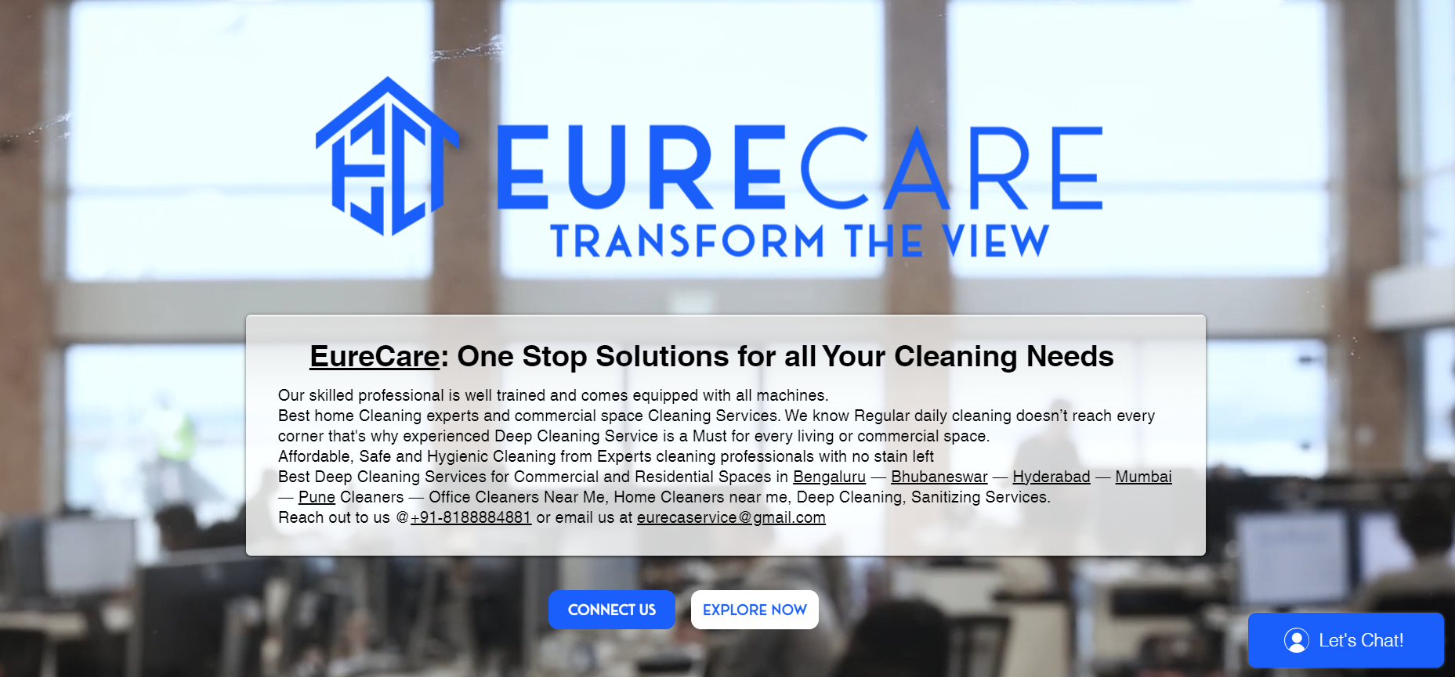

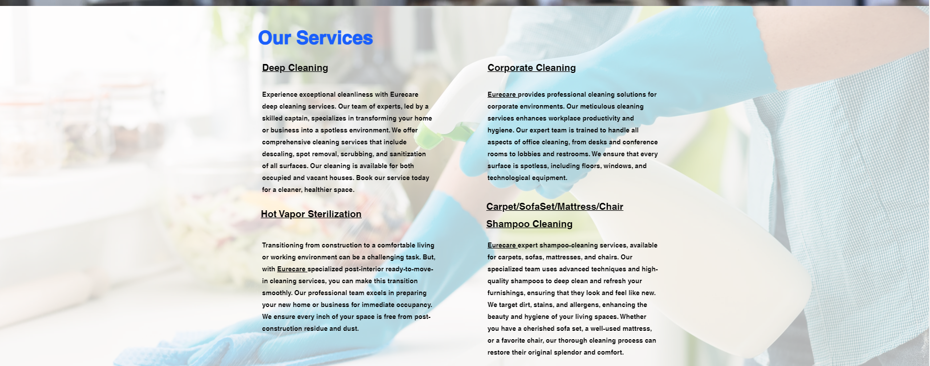  
  
[Best Home Cleaning Services in Mumbai | Eurecare](https://www.eurecare.in/mumbai)  
  
[Best Home Cleaning Services in Pune | Eurecare](https://www.eurecare.in/pune-professional-home-cleaning-services)  
  
[Best home cleaning services in Bhubhneshwar | Eurecare](https://www.eurecare.in/bhubhneshwar)  
  
[Best Home Cleaning Services in Hyderabad | Eurecare](https://www.eurecare.in/hyderabad)  
   
<https://www.eurecare.in/professional-home-cleaning-services-bengaluru>

**Performance Overview**

Total Clicks: 15  
Total Impressions: 336  
Average CTR (%): 4.46%  
Average Position: 17.42

Top Queries

|  |  |  |  |  |
| --- | --- | --- | --- | --- |
| **Query** | **Clicks** | **Impressions** | **CTR** | **Position** |
| eurecare | 5 | 52 | 0.0962 | 3.1 |
| mattress shampoo | 0 | 34 | 0.0 | 16.62 |
| eurecare (soinscom solution pvt.ltd) | 0 | 18 | 0.0 | 2.67 |
| express cleaning supplies | 0 | 9 | 0.0 | 45.33 |
| chair cleaning | 0 | 7 | 0.0 | 91.71 |
| shampoo wash sofa | 0 | 6 | 0.0 | 63.17 |
| post construction cleaning | 0 | 4 | 0.0 | 25.75 |
| deep cleaning services in hyderabad | 0 | 4 | 0.0 | 60.0 |
| best home cleaning service in pune | 0 | 4 | 0.0 | 61.25 |
| cleaning services in hyderabad | 0 | 3 | 0.0 | 56.0 |

Top Pages

|  |  |  |  |  |
| --- | --- | --- | --- | --- |
| **Page URL** | **Clicks** | **Impressions** | **CTR** | **Position** |
| https://www.eurecare.in/ | 8 | 208 | 0.0385 | 8.56 |
| https://www.eurecare.in/house-keeping-staff | 2 | 13 | 0.15380000000000002 | 23.92 |
| https://www.eurecare.in/mumbai | 2 | 10 | 0.2 | 4.3 |
| https://www.eurecare.in/pune | 1 | 25 | 0.04 | 15.24 |
| https://www.eurecare.in/services | 1 | 20 | 0.05 | 6.0 |
| https://www.eurecare.in/professional-home-cleaning-services-bengaluru | 1 | 8 | 0.125 | 15.38 |
| https://www.eurecare.in/home | 0 | 103 | 0.0 | 5.53 |
| https://www.eurecare.in/copy-of-carpet-shampoo-cleaning | 0 | 79 | 0.0 | 30.91 |
| https://www.eurecare.in/about | 0 | 48 | 0.0 | 5.35 |
| https://www.eurecare.in/express-cleaning | 0 | 22 | 0.0 | 29.23 |

Top Countries

|  |  |  |  |  |
| --- | --- | --- | --- | --- |
| **Country** | **Clicks** | **Impressions** | **CTR** | **Position** |
| India | 13 | 225 | 0.057800000000000004 | 9.08 |
| New Zealand | 1 | 1 | 1.0 | 4.0 |
| Kazakhstan | 1 | 1 | 1.0 | 1.0 |
| Paraguay | 0 | 1 | 0.0 | 74.0 |
| Azerbaijan | 0 | 1 | 0.0 | 74.0 |

Device Summary

|  |  |  |  |  |
| --- | --- | --- | --- | --- |
| **Device** | **Clicks** | **Impressions** | **CTR** | **Position** |
| Mobile | 8 | 172 | 0.04650000000000001 | 14.4 |
| Desktop | 7 | 164 | 0.042699999999999995 | 21.03 |

Search Appearance Summary

|  |  |  |  |  |
| --- | --- | --- | --- | --- |
| **Search Appearance** | **Clicks** | **Impressions** | **CTR** | **Position** |
| Product snippets | 0 | 1 | 0 | 2 |

