Assignment 1
Name: SHAIK SHABRIN

Bar Chart:
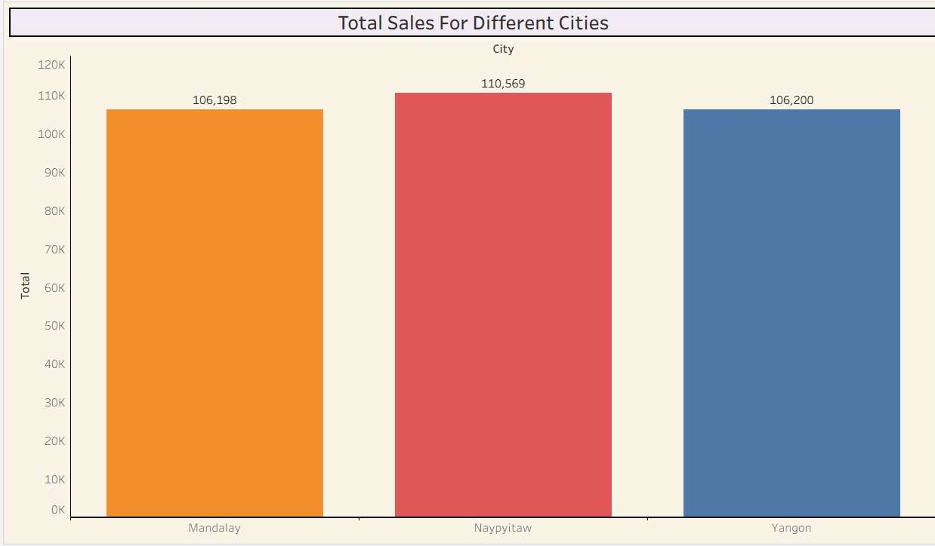
Sales across different cities

Pie Chart: Sales across different cities
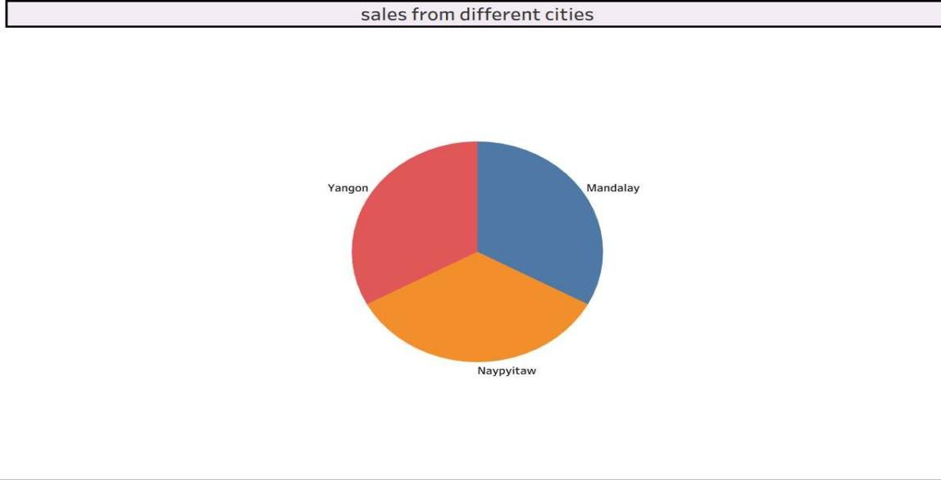

Stacked Bar Chart:
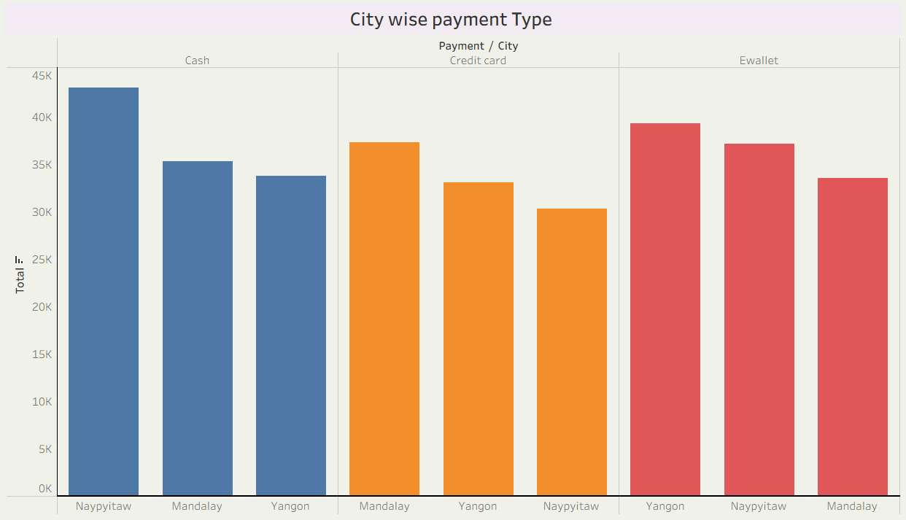
Payment method according to different cities

Line Chart:
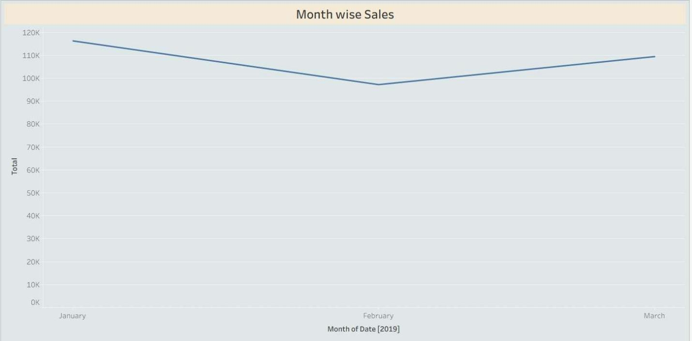
Sales from different months

Bubble chart:
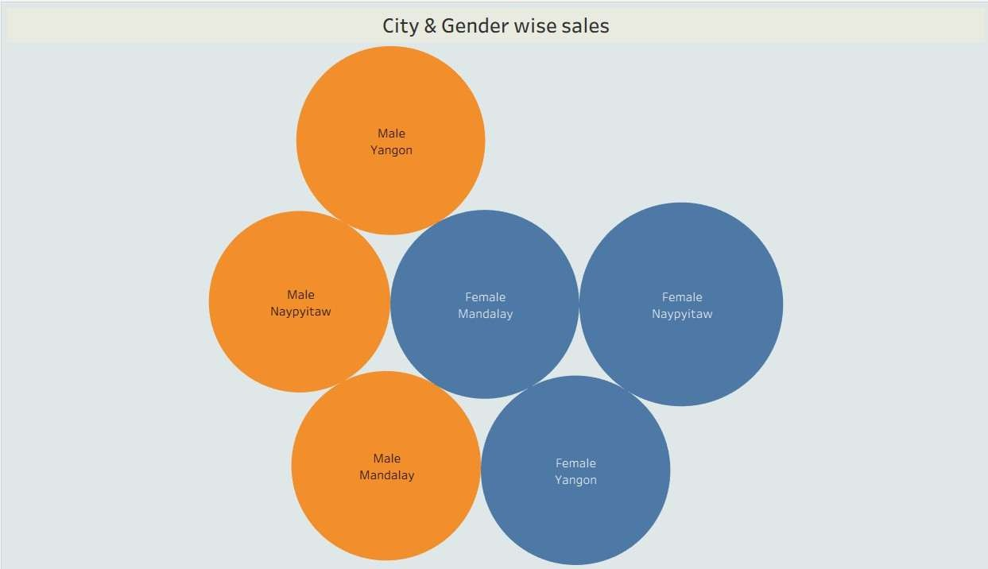
Gender wise sales in different cities

