Instructions for Hebergement Webserver

How to setup the database, the user and the tables for Assignment 3 in CPanel
You have been provided with the necessary SQL script in zipped format (bookCRM-vers2.sql.zip) that you will need to unzip and update the file. Then you need to import the updated SQL script into MySQL (easiest to use phpMyAdmin). After importing the SQL script, ‘books’ database will be created that will contain all tables required for this assignment.
The detailed instructions are as follows:
1. Log into your CPanel.
2. Under "Databases", click on "MySQL Data Base Wizard".
3. Create the Database: Name the database as ‘books’ and click "Next Step". Note: The full name of the database will be: [user_principal_ name] _ [database name]. For example, if the user name you use to log into your CPanel is ‘rejaulco’ and the name you chose for your database is ‘books’, the name of your new database will be: rejaulco_books.
4. Create Database Users: Select a username (e.g. bookrep) and a secure password (e.g. book@rep19) and click "Create User". Note: The full user name that you just created will be: [user_principal_ name] _ [database_user_name]. For example, if the user name you use to log into your CPanel is ‘rejaulco’ and the username that you chose for your database is ‘bookrep’, the user name of your new database will be: rejaulco_bookrep.
5. On this page, entitled "Add User to Database" you can give privileges to the user you just have created. Unless you have a good reason to do otherwise, we advise you to check the "ALL PRIVILEGES" which will grant all rights necessary to your user. Then click "Next Step".
6. Now you need to unzip the SQL script (bookCRM-vers2.sql.zip) provided with the template folder and modify the name of the database that is written inside the script (bookcrm-vers2.sql) according to your new database. Assuming that the name of your database is rejaulco_books, you will need to modify the SQL script as below:
DROP DATABASE IF EXISTS `rejaulco_books`;
CREATE DATABASE IF NOT EXISTS `rejaulco_books`;
USE `rejaulco_books`;

7. In the CPanel, under "Databases", click on “phpMyAdmin". Then click ‘Import’ on the following screen:
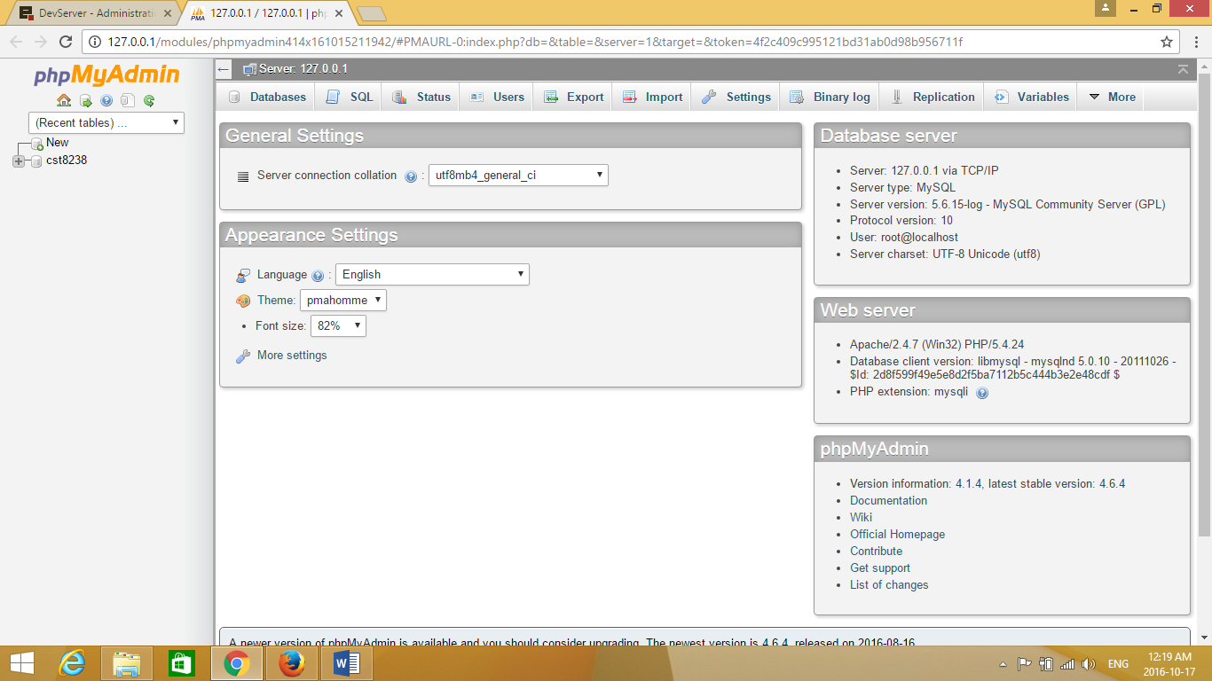

- Then choose the unzipped and updated SQL script file (bookcrm-vers2.sql) from your laptop and click ‘GO’ on the following screen to import the SQL script.
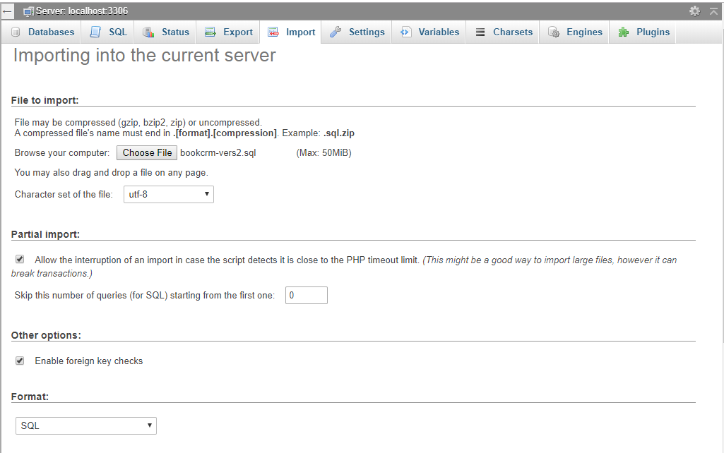

- It takes few minutes to import the SQL script. After ‘Import’ has been finished successfully, ‘books’ database will be created which consists of the following tables:
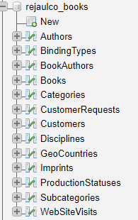

Access to MySQL database
Each database application must have a configuration file to connect your application with MySQL database.
Before we can get started using MySQL on the webserver we need a few pieces of information.
- Host
  - The host variable should contain the value “localhost”.
  - Example: $host = “localhost”;
  - NOTE: Localhost is a networking term meaning ‘this computer’
- Username
  - The Username to access YOUR database is: rejaulco_bookrep
  - Example: $user = “rejaulco_bookrep”;
- Password
  - The password is any legitimate password you choose
  - Example: $password = “book@rep19”;
- Database Name
  - The name of your database is: rejaulco_books
  - Example: $dbname = “rejaulco_books”

You have been provided with a configuration file (i.e. database.inc.php) that is required to connect your application with MySQL database. Finally, you need to update the configuration file according to the Username, Password and Database that you have created using the CPanel of Hebergement Web Server.

N.B. rejaulco represents the user name that someone uses to log into his CPanel. You MUST use your own username that you use to log into your CPanel.

