

Assignment3

Shabrina Sharmin | SEG3101 | 2024-07-25

Answer to Q1:
Positive and negative test situations for each functional requirement are provided below:
F1. Book catalogue management:
- Positive situation: Add a book with all mandatory and optional fields filled correctly and in a correct format
- Negative situation: Try to add a book with a book id which is 4 character long (invalid length)
F1.1
- Positive situation: Add a book with all mandatory and optional fields filled correctly and in a correct format
- Negative situation: Try to add a book without book title (mandatory field missing)
F2. Users browsing and searching for books:
- Positive situation: Search for a book using book category “Science”
- Negative situation: Try to find a book using nonexistent category such as “xxx”
F2.1 Search by category:
- Positive Test: search a book with the category "Science" and retrieve all books exist in the catalogue.
- Negative Test: search a book with a nonexistent category and system error message shown
F2.2: Search by empty category:
- Positive Test: search a book with the category empty and retrieve all books in that category.
- Negative Test: search a book with a nonexistent category and system error message shown
F3: Customer orders book
- Positive Test: Customer orders a book and it is added to the cart
- Negative Test: Customer tries to add a book to the cart when the book is not available in catalogue
F4: Customer allowed to view cart
- Positive Test: Customer is able to see the cart and the list of books and it’s details added to cart already.
- Negative Test: Customer tries to view cart while cart has no book that has been added yet
F4.1 Book details shown in the cart
- Positive Test: Customer is able to see the cart and verify books details added to cart already.
- Negative Test: Customer tries to view cart and the added books description is not showing all field (at least one of book id, description, unit cost, number of ordered copies, total cost including shipping and handling is missing).

F5: Updating number of books added to cart:
- Positive Test: Update the number of copies for an already added book from 1 to 3
- Negative Test: Update the number of copies for an already added book from 1 to -1
F5.1: Remove book from cart
- Positive Test: set the number of copies for an already added book from 1 to 0 and the book is removed from the cart
- Negative Test: Update the number of copies for an already added book from 1 to -1 and the book is not removed from the cart
F6: Checkout and order description
- Positive Test: Proceed to checkout while cart is not empty and verify the order date, amount of books ordered, amount of tax added, handling and shipping fees.
- Negative Test: Proceed to checkout when cart is empty and an appropriate error message is shown.
F6.1: Tax apply:
- Positive Test: Verify that a tax rate of 13% is correctly applied to the total order amount.
- Negative Test: Verify that tax rate of 10% (incorrect) is applied on the order
F6.2: Apply handling and shipping fees:
- Positive Test: Verify that fixed 10$ plus 5% of order total amount has been applied as handling and shipping cost
- Negative Test: Verify that fixed 5$(incorrect) plus 5% of order total amount has been applied as handling and shipping cost and an appropriate error message has been shown

F7: Book remove from catalogue:
- Positive Test: remove a book from the catalogue and verify it is no longer searchable or viewable.
- Negative Test: remove a book that does not exist in the catalogue and verify an appropriate error message is shown.
F8: administrator authentication:
- Positive Test: Successfully authenticate as an administrator and add a book to the catalogue.
- Negative Test: Attempt to add a book to the catalogue without administrator authentication and verify access is denied.

Answer to Q2:
UC1: Administrator Sign in
- scenario graph
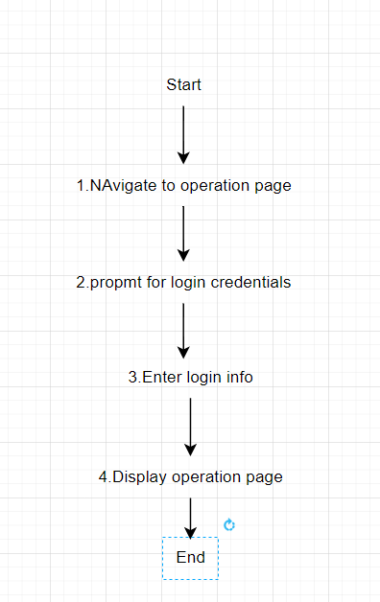

- Alternate scenario for total branch coverage:
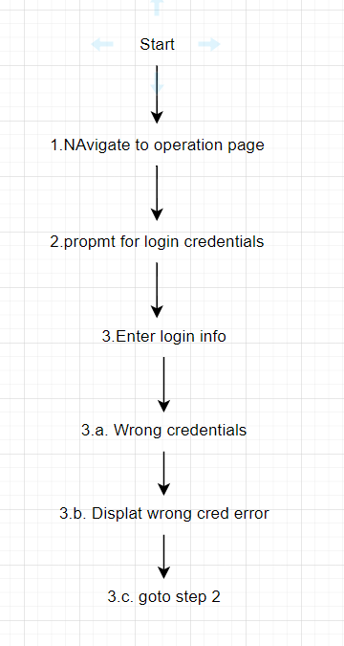

- Abstract test case for UC1:
TC1: Successful sign in
Precondition | Steps | Output
Admin is on the operation page | - Navigate to operations page.  - Enter correct login credentials.  - Verify the provided info | Admin is logged in and can perform administrative tasks

UC2: Administrators sign out
- Scenario graph
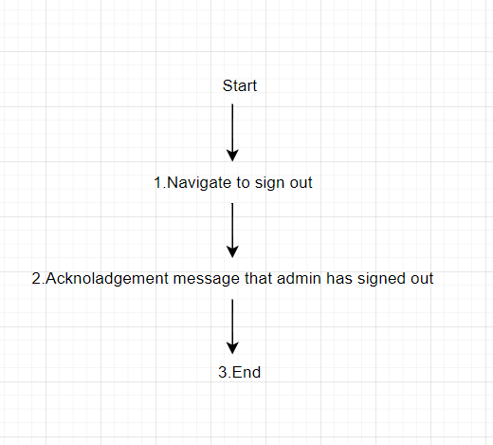
- Alternate scenario for total branch coverage:
No alternate branch is available for this UC. Thus, only the main scenario graph will be sufficient to get branch coverage

- Abstract test case for UC2:
Precondition | Steps | Output
Admin is logged in | - Select sign out.  - Verify the confirmation message of sign out | Admin is logged out

UC3: Add book
- Scenario graph
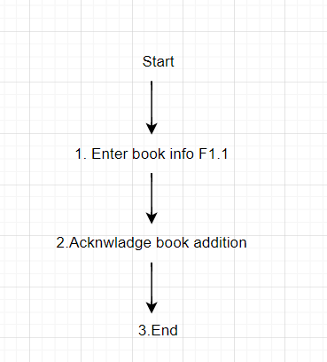
- Alternate scenario graph to get complete Branch coverage :
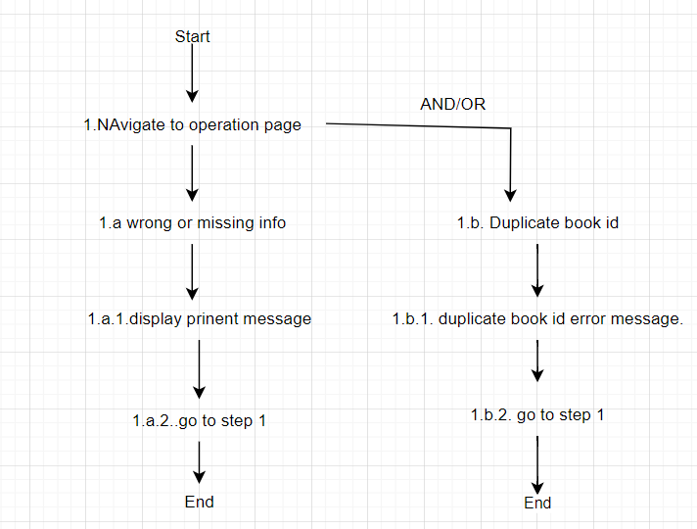

- Abstract test cases:
Precondition | Steps | Output
Admin is logged in and on the add book page | - Enter the book info  - Verify the provided info for validity | Book is added to the catalogue
UC4: Browse catalogue:
- Scenario graph:
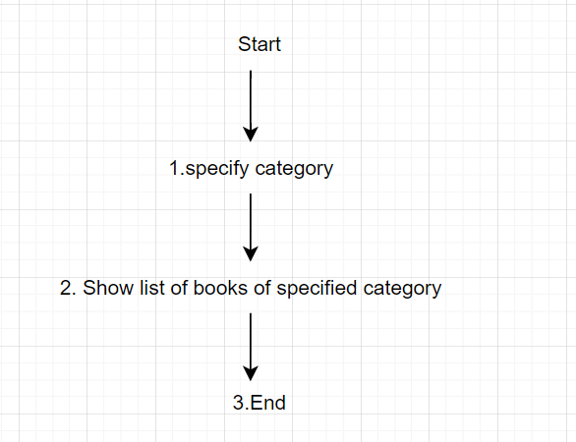
- Alternate scenario graph to get complete branch coverage:
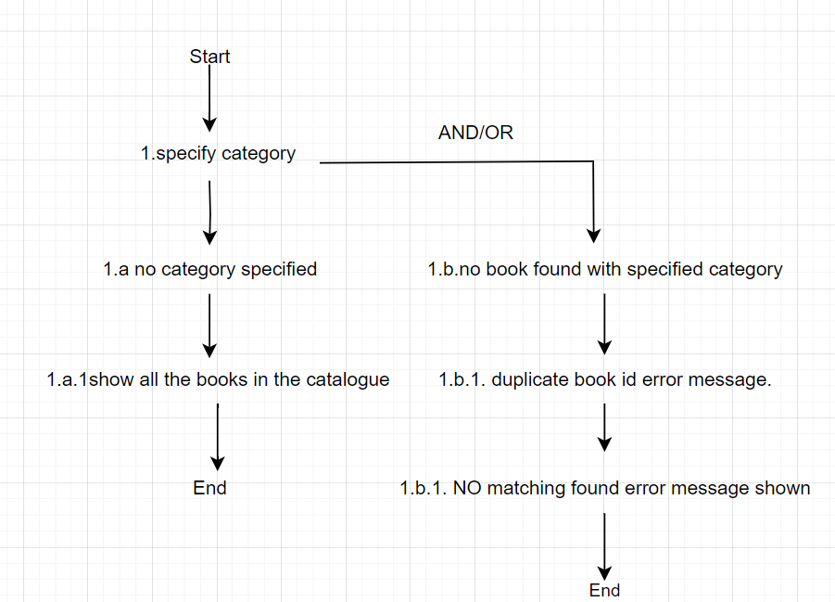
- Abstract test case: Browse by specific category
Precondition | Steps | Output
User is on the browse catalogue page | - Provide a category  - Verify the catalogue with the specified book and shown on the screen if found | Books of the specified category is shown in the screen

UC5: Remove book
- Scenario graph:
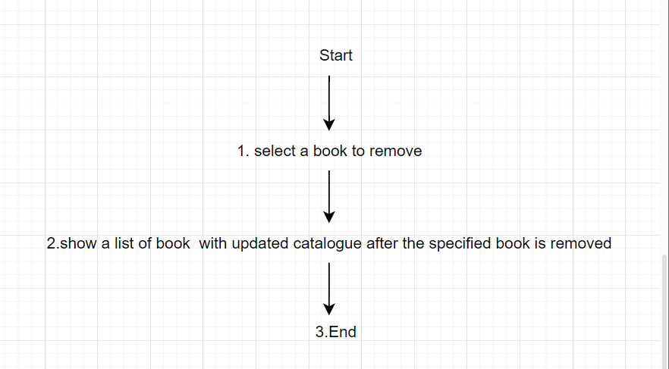

- Alternate scenario graph to get complete branch coverage: No alternate path
- Abstract test case: Browse by specific category
Precondition | Steps | Output
- Admin is logged in  - A list of catalogue books is being displayed | - Select a book to remove  - Verify the selected book is removed from the catalogue | Selected books has been removed from the catalogue

UC6: Order book
- Scenario graph:
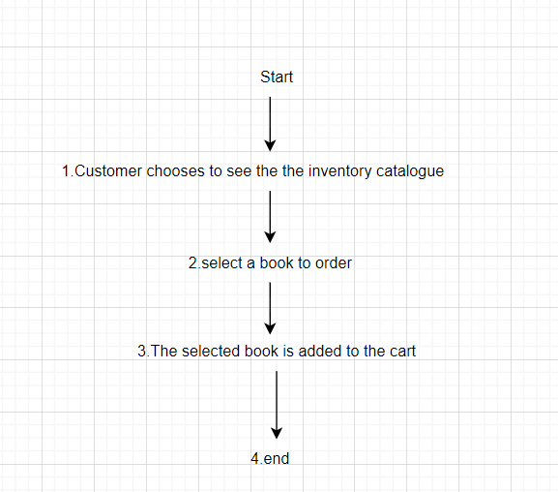
- Alternate scenario graph to get complete branch coverage:
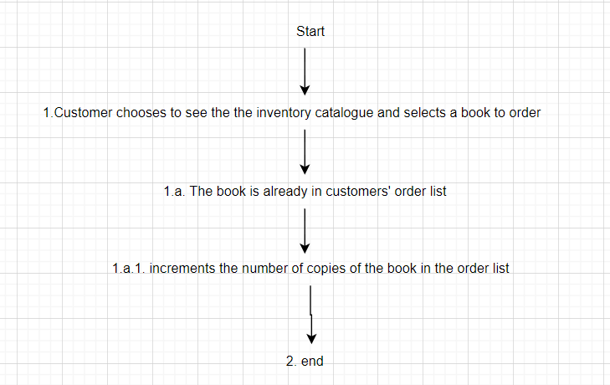
- Abstract test case: (a) Add a new book to the list
Precondition | Steps | Output
- A list of catalogue books is being displayed | - Select a book to order  - add that book to the order list | The selected book has been added to the customer’s books order

(b)Add an existing book to the list:
Precondition | Steps | Output
- A list of catalogue books is being displayed | - Select a book to order  - The book is already in the order list and increment the copies of the book in the order list | The selected book has been added to the customer’s books order

UC7: View books order
- Scenario graph:
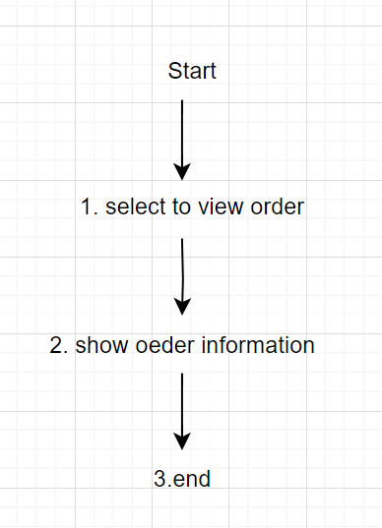

- Alternate scenario for total branch coverage:
No alternate branch is available for this UC. Thus, only the main scenario graph will be sufficient to get branch coverage
- Abstract test case: View book order list successfully
Precondition | Steps | Output
- A list of catalogue books is being displayed | - Select to view order | Order information containing the following fields is shown:  - book id  • book description  • book unit cost  • number of ordered copies  • total cost of the ordered copies (before taxes, shipping and handling)

UC8: Update book order
- Scenario graph:
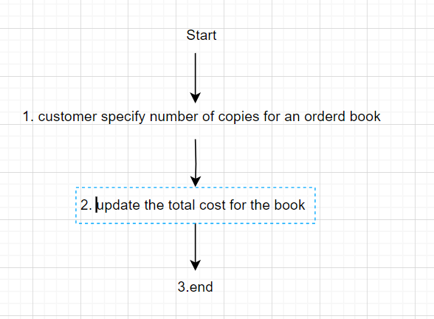
- Alternate scenario for total branch coverage: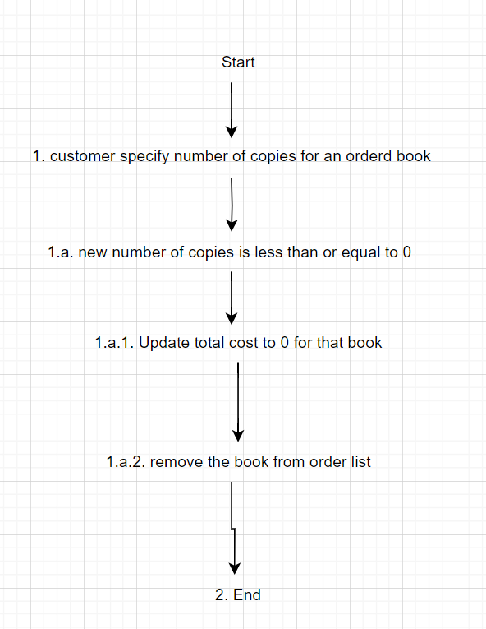

- Abstract case: (a) Update number of copies to 0
Precondition | Steps | Output
- The customer’s books order is being shown | - Specify a book copy with 0 in order list  - The book is removed from the order list | - The customer’s books order is being shown with the updated number of copies

(b) update number of copies to -1
Precondition | Steps | Output
- The customer’s books order is being shown | - Specify a book copy with -1 in order list  - The book is removed from the order list | - The customer’s books order is being shown with the updated number of copies

UC9: Checkout
- Scenario graph:
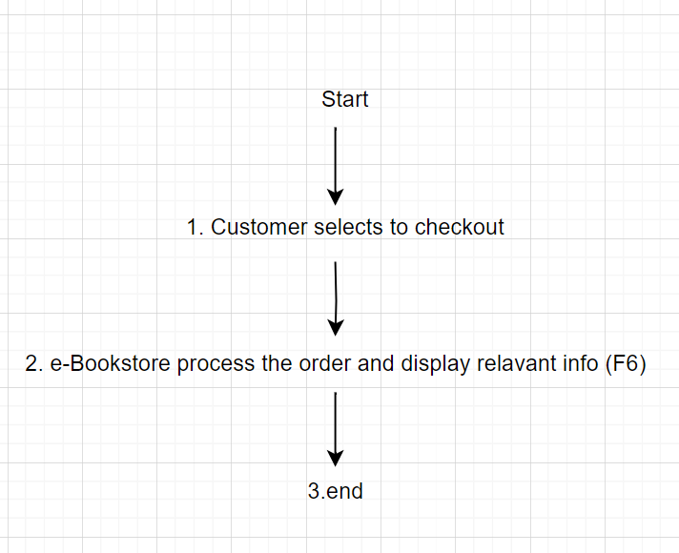

- Alternate scenario for total branch coverage:
No alternate branch is available for this UC. Thus, only the main scenario graph will be sufficient to get branch coverage

- Abstract case: Customer checks out successfully
Precondition | Steps | Output
- The customer’s books order is being shown | - Selects to check out  - The e-Bookstore process the order and shows following fields:  - the date of books order  - the total amount of books order  - the amount of taxes  - the amount of handling and shipping fee of book order | - The books order is processed, and payment information are being shown

UC10: Select Language
- Scenario graph:
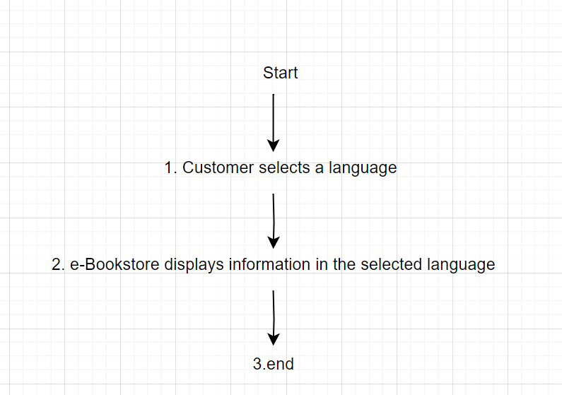

- Alternate scenario for total branch coverage:
No alternate branch is available for this UC. Thus, only the main scenario graph will be sufficient to get branch coverage

- Abstract test case: (a) Users (Admin, customer) selects language successfully
Precondition | Steps | Output
- The e-BookStore is ON | - Select a preferred language  - The bookstore shows the information in the selected language | - The selected language is used by the e-BookStore

Answer to Q3
Please find the attached implementation of the test situation with the attached file
Screenshot of the implementation:
Test run of AdminUCTest:
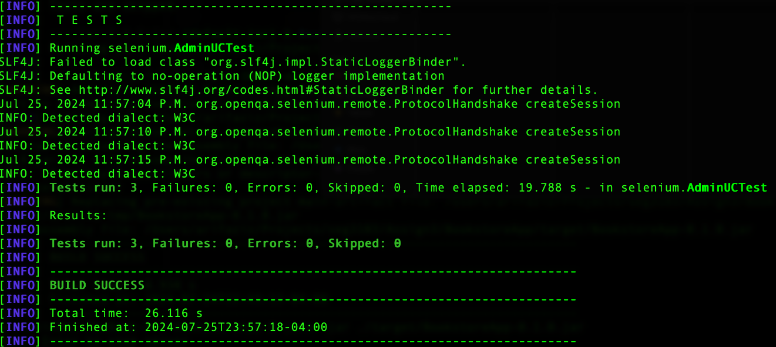
Test run of UserUCTest: