Name: Shabrya Lott

NSHE ID# 2000152049

Project Title: Light Monitoring

Problem Statement:

How to measure light with a TSL2591 sensor.

Objectives:

▪ To learn how to capture data from LUX sensor (TSL2591)

▪ To learn how to filter and display collected data in a visual manner

▪ To learn how to make device wireless by using a Wifi module (ESP8266).

Design Steps:

1. Learn to use I2C to interface Lux Sensor - TSL2591 with TM4C123GXL

2. Collect raw data and calculate the Lux.

3. Make device wireless by adding ESP8266 Wifi Module and using UART interface

4. Graph data by pushing data to the web server (ThingSpeak.com)

Timeline:

10/13 - Debugging project (if needed)

10/20 - Submit Completed Code and Video Demo

Hardware Components:

TM4C123GXL

High Dynamic Range Digital Light Sensor (Lux Sensor)- TSL2591

Wifi Module - ESP8266

Initial Schematics: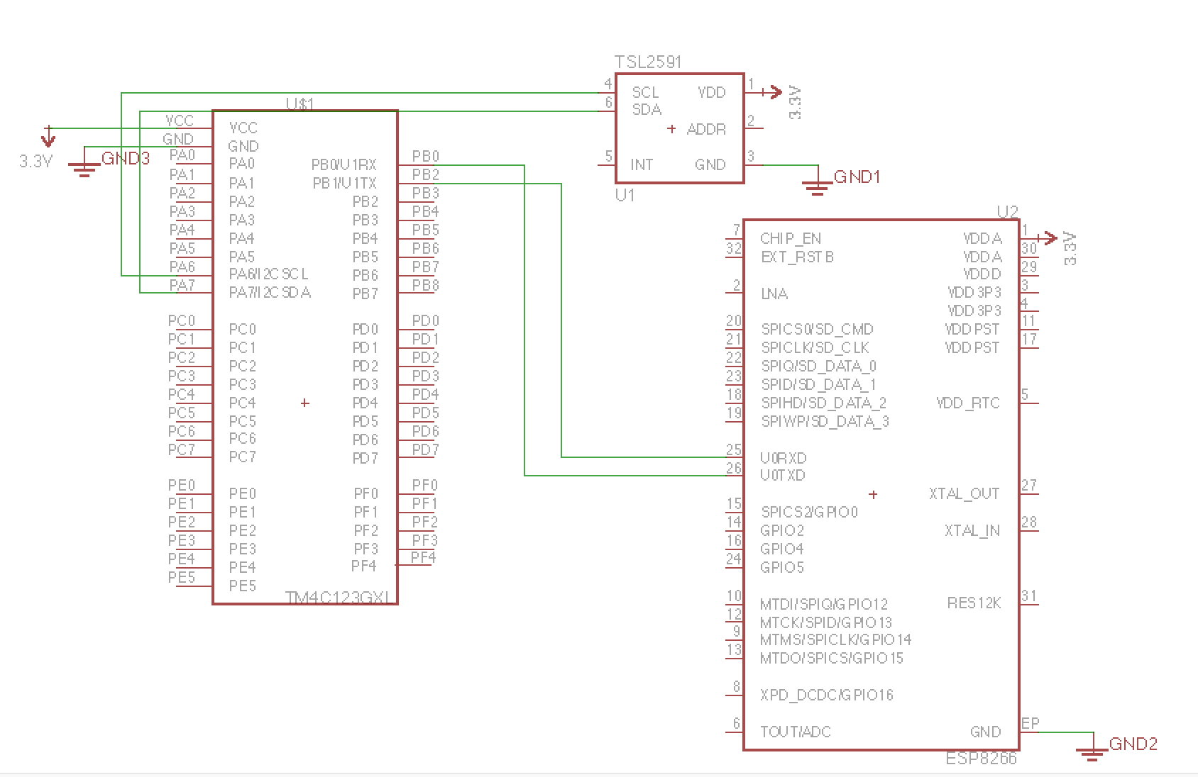

Reference:

Class website : https://tinyurl.com/unlvcpe301s16

Adafruit: https://learn.adafruit.com/adafruit-tsl2591