ספר הפרויקט
יוגש באתר הקורס ב MOODLE (לאחר אישור המנחה) עד לתאריך שפורסם.
הגשת ספר הפרויקט בזמן – סטודנטים שלא יגישו בזמן ולפי ההנחיות, לא יוכלו להציג את הפרויקט במועד שנקבע ויצטרכו לתאם מועד חדש.
ספר הפרויקט מסכם את עבודת הסטודנטים בפרויקט.
ספר הפרויקט יכלול את הפרקים הבאים:
  - תקציר (עמוד אחד)
  - הקדמה ורקע תיאורטי
  - תכנון ו\או סימולציה
  - מימוש
  - תוצאות ובדיקות (עם דגש לדרישות הכמותיות)
  - סיכום, מסקנות והצעות להמשך
  - תיעוד הפרויקט
  - רשימת מקורות (כמקובל בספרות מדעית)
יש להיוועץ עם המנחה בפרויקט, על מנת להבין, איזה פרקים יש לכלול בספר הפרויקט בהתאם לאופיו של הפרויקט שלכם.
יש להגיש את הספר, לפי התבנית המצורפת.
ניתן להגיש את הספר באנגלית, תוך הקפדה על התבנית. גודל הקובץ הוא לכל היותר 10 מגה.
סדר הגודל המומלץ לספר הפרויקט הוא 20 עמודים.
ספר הפרויקט לא יכלול את קטעי הקוד ,דפי נתונים וכו'. במידה ויש התייחסות ספציפית בספר הפרויקט לחלק מהקוד או דפי הנתונים וכו', ניתן לצרף את החומר הרלוונטי בלבד וכנספח לספר הפרויקט.



Insert the Project Title here

3335 | Project Number:

Project Report

Student: | Shachar Weinberg | ID: | 313132284
Student: | Amit Sharvit | ID: | 3146619107

Supervisor: | Hezi Nistani

Project Carried Out at: | Tel Aviv University

Contents
Abstract……….. 2
1 Introduction 3
2 Theoretical background 4
3 Simulation.. 5
4 Implementation 6
4.1 Hardware Description 6
4.2 Software Description 7
5 Analysis of results 8
6 Conclusions and further work 9
7 Project Documentation 10
8 References.. 11
Appendix A. Subject 1 12
Appendix B Subject 2 13

List of figures
Figure 1: Block diagram 2
Figure 2: The System 6
Figure 3: Amplifier Input Circuit 6

List of tables
Table 1: Results 8

List of equations

Abstract
The abstract summarizes the essence of the work (project topic, project purpose, and project deliverable). Further to the description, a block diagram of the project should be presented .
This project presents the design and implementation of a stand alone, low power object detection system for open field environments. The system is intended for areas without fixed electrical infrastructure or wired communication, where long term autonomous operation is required. The main objective is to detect relevant objects in the field, activate a camera only when an event is detected, and transfer the captured information to a local computer or operator interface.

The system is based on the integration of off the shelf hardware components, including an ESP32 S3 CAM controller, an OV2640 camera, motion and presence sensors, a battery based power unit, a charging module, and a local WiFi communication interface. The sensors act as the first detection layer and monitor the environment with low power consumption. When a trigger is detected, the controller wakes up, checks the sensor inputs, activates the camera, captures an image, and sends the relevant data through the WiFi interface.

A central design consideration in this project is reducing the average power consumption. Instead of operating the camera and communication continuously, the system follows an event driven duty cycle. High power components are activated only during suspected detection events, while the system remains in a low power mode during idle periods. This approach is intended to extend battery life and support prolonged outdoor operation.
The final prototype demonstrates the complete system flow: sensor based trigger, ESP32 S3 wake up, image capture, communication with a computer, and return to low power operation. The project is evaluated according to the main requirements: detection range, false alarm rate, power consumption, and practical outdoor operation.
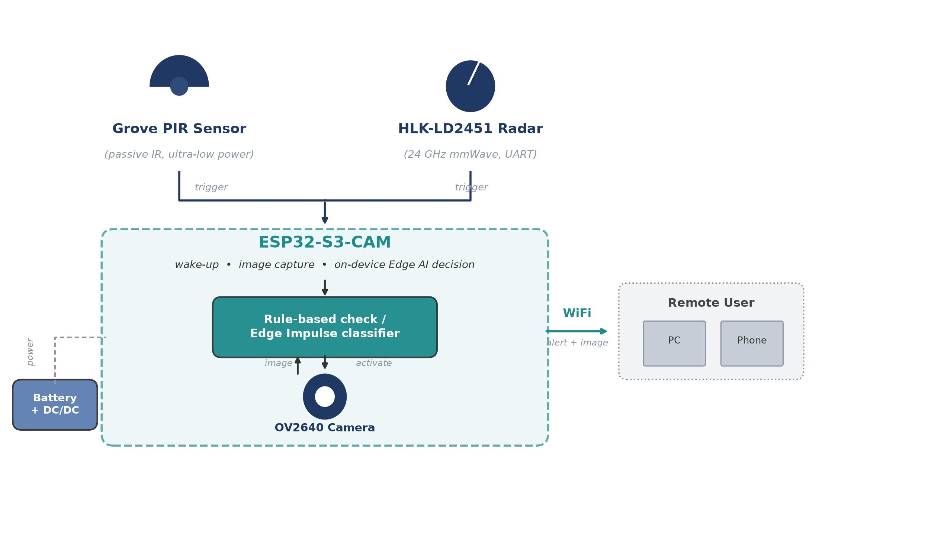
Figure 1: Block diagram

The chapters, illustrations and tables should be numbered automatically, as done here. The Table of Contents should also be generated.
Figures and illustrations can be generated either from a POWERPOINT slide (as done here) or added (JPG, TIFF, BMP) as done in Chapter 4, or from a PDF document as done in Subsection 4.1.
An example of the table can be seen in subchapter 5.1.

Introduction
Open field object detection - for perimeter security, remote area monitoring, and smart agriculture - is often needed where there is no fixed power or wired communication. The project Work Plan therefore defines a stand alone, low power human detection system bound by three quantitative requirements: detection range up to 30 m, false detection rate below 10%, and reliable operation under reasonable (non extreme) weather, plus a target of about three months of battery life.

Continuous camera operation or a cloud connected system would consume too much energy and require infrastructure that is not available in the field. Instead, low power sensors (PIR and mmWave radar) continuously monitor the environment; only a valid trigger wakes the ESP32-S3-CAM controller, which captures an image, evaluates the event, and reports it over local WiFi. This sensor gated approach trades a small increase in response time and complexity for a large reduction in average power compared to always on cameras or cloud based systems.

The intended use case is a compact, battery powered field unit with no external power or network infrastructure. The final deliverable is a working prototype demonstrating the full flow - sensor trigger, wake up, image capture, decision, and WiFi report - documented with schematics, firmware, and test results.

Theoretical background
This chapter summarizes the alternatives considered for each subsystem and the trade-offs behind the final selection, aiming for the best balance of power, reliability, response time, and complexity.
2.1 Low Power Embedded Systems
Low power embedded design minimizes average energy by keeping the system idle most of the time and active only during detection events; duty cycle, not peak current, is the dominant factor in battery life.
2.2 Microcontroller Alternatives and Selection
Four controllers were compared. Arduino Uno offers low standby current but lacks WiFi, camera support, and sufficient memory. Raspberry Pi offers high performance with built in WiFi and camera support, but has no microcontroller style deep sleep and high active current. STM32L4 offers efficient sleep modes, but requires external WiFi and camera modules, adding complexity. The ESP32-S3-CAM was selected as the only option combining camera support, WiFi, adequate processing, and deep sleep modes in a single compact module.
2.3 Sensor Technologies
PIR sensors detect infrared changes from warm bodies at very low power, but are sensitive to temperature and sunlight and cannot detect stationary targets. The HLK-LD2451 24GHz mmWave radar detects presence and motion independent of lighting or temperature, at a higher power cost, and was added to improve reliability. LiDAR (YDLIDAR SDM18) provides accurate distance but at higher power and complexity, and was evaluated but not included in the final sensing configuration.
2.4 Camera as an Event Verification Unit
The camera is activated only after a valid sensor trigger, avoiding the power cost of continuous imaging; it serves purely as an event verification unit rather than a continuously running sensor.
2.5 Local WiFi Communication
WiFi, built into the ESP32-S3, reports status and images to a local operator. Its relatively high current draw means it is activated only briefly, on a valid detection.
2.6 Decision Algorithms and Alternatives
A trigger can be validated using a threshold rule, a multi-sensor logic rule, or weighted sensor fusion.
Two trigger architectures were considered: sequential, where the lowest power sensor wakes the system first (minimizing baseline current at the cost of response time), and parallel fusion, where all sensors are active simultaneously (improving response time and accuracy at the cost of higher average power). The final design is a practical trade-off between these two.
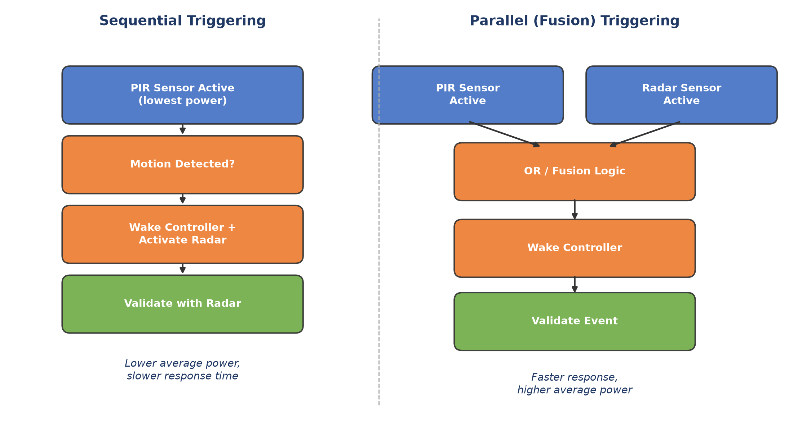
Figure X: Sequential vs. parallel sensor trigger architectures

Simulation
Validation combined electrical simulation with practical hardware testing, since the project spans embedded hardware, sensors, power management, camera operation, and firmware.

3.1 Simulation Environment

OrCAD Capture / PSpice were used for circuit level simulation of the MCU, power management, and sensor blocks, evaluating voltage stability and current behavior before physical build. EasyEDA supported schematic organization and PCB layout for the ESP32-S3-CAM related connections and power routing. Firmware was developed in the Arduino IDE, with Python scripts on the host side for image reception and logging; lab validation used a power supply, multimeter, oscilloscope, and serial monitor.

3.2 Power Supply Simulation

The power supply simulation confirms that the battery, charging circuit, and DC/DC stages deliver stable 5V and 3.3V rails under the expected load of the controller, sensors, camera, and WiFi modules (Figure X).

Figure X presents the simulated 5V and 3.3V voltage levels under load.

3.3 Sensor Trigger Logic Simulation
The sensor trigger logic was simulated to confirm a valid, ESP32-S3 compatible logic transition suitable for use as an interrupt / wake up source (Figure X), later verified on hardware via serial monitor output.
Figure X presents the simulated sensor trigger signal.

3.4 Power Consumption Model
A theoretical power model estimates battery lifetime by dividing system operation into distinct current states: sleep, sensor monitoring, active, camera capture, and WiFi communication.
The average current is calculated according to:

$$I_{avg} = \frac{∑I_{i}t_{i}}{T}$$

where Ii is the current consumption in state i, ti is the time spent in that state, and T is the total observation time.

Table 1 lists the current and power consumption of each component used in this model, based on the relevant manufacturer datasheets.
Component | State | Current | Power | Source
PIR sensor (Grove PIR) | Always on (monitoring) | 0.15 mA @ 5V | 0.75 mW | Seeed Studio, Grove PIR Motion Sensor User Manual
HLK-LD2451 radar | Always on (monitoring) | 107 mA @ 5V | 535 mW | Hi-Link Electronic, HLK-LD2451 User Manual, Section 6
ESP32-S3 | Deep-sleep | 0.008 mA @ 3.3V | 0.026 mW | Espressif Systems, ESP32-S3 Series Datasheet, Table 5-10
ESP32-S3 | Active (CPU, AI inference, radio off) | 85 mA @ 3.3V | 280.5 mW | Espressif Systems, ESP32-S3 Series Datasheet, Table 5-9
ESP32-S3 | Active (WiFi transmit) | 283 - 340 mA @ 3.3V | ~934 - 1122 mW | Espressif Systems, ESP32-S3 Series Datasheet, Table 5-7
OV2640 camera | Active (capture, JPEG mode) | - | 140 mW | OmniVision, OV2640 Preliminary Datasheet
Table 1: Component current and power consumption (datasheet values)
Since the system is expected to spend most of its time in low power states, this model is central to estimating achievable battery life (Chapter 5).

3.5 Simulation and Evaluation Summary

Table X summarizes the required simulation and evaluation results:

Parameter | Method | Expected result | Final result
Power supply voltage levels | PSpice | Stable 5V and 3.3V rails | To be completed
Sensor trigger logic | PSpice or hardware test | Valid ESP32-S3 logic transition | To be completed
Sleep mode current | Measurement | Low current state | To be completed
Image capture | ESP32-S3-CAM test | Successful image capture | To be completed
WiFi communication | Web server or Python client | Status or image transfer | To be completed
Detection behavior | Sensor tests | Trigger on relevant event | To be completed
Table X: Simulation and evaluation summary

Implementation
This chapter describes the practical hardware and software implementation of the prototype.
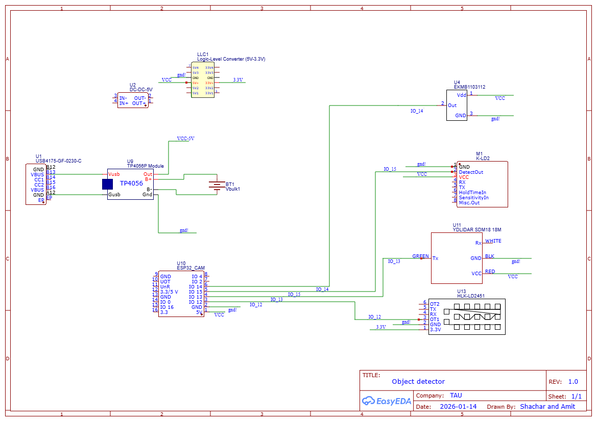
Figure 2: The System

Hardware Description
The hardware is based on an ESP32-S3-CAM controller, low power detection sensors, and an independent battery power unit, selected together for the best balance of processing, camera support, WiFi, and deep sleep capability (Table X).

As in section 2.4, the camera activates only after a valid sensor trigger, minimizing average power consumption.

Power is supplied from a lithium battery through a TP4056 charging module and DC/DC converters producing the 5V and 3.3V rails; a logic level converter safely interfaces the 5V sensor outputs with the 3.3V ESP32-S3 GPIO pins.

The final sensing layer uses a Grove PIR sensor and the HLK-LD2451 mmWave radar (UART), as detailed in section 2.3; RFbeam K-LD2 radar and YDLIDAR SDM18 were evaluated but not included in the final configuration.

Table X summarizes the main hardware components.

Component | Role | Interface | Voltage | Final status
ESP32-S3-CAM | Main controller, camera and WiFi | GPIO, UART, camera interface | 3.3V / 5V module input | Final
OV2640 camera | Image capture | Camera interface | Module dependent | Final
Grove PIR sensor | Low power motion trigger | GPIO | 3.3V / 5V according to module | Final
HLK-LD2451 | mmWave presence detection | UART | 5V | Final / tested
TP4056 | Battery charging | Power path | Battery / 5V input | Final
DC/DC converters | Voltage regulation | Power | 5V and 3.3V | Final
Logic level converter | 5V to 3.3V interface protection | GPIO / UART | 5V and 3.3V | As required
Table X: Main hardware components

Figure X presents the final hardware schematic.
Figure X presents the physical prototype.

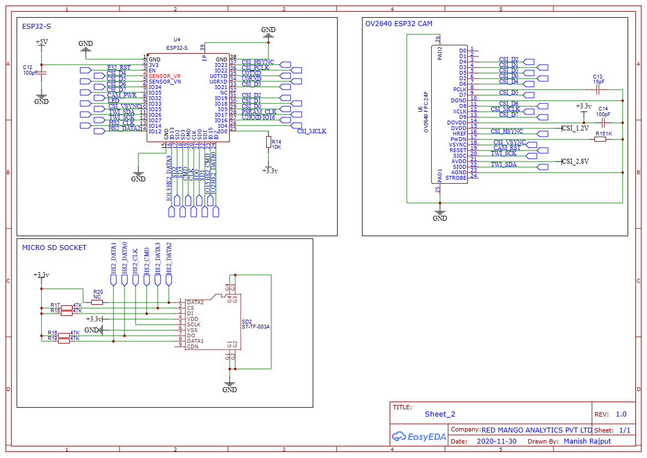
Figure 3: ESP32-S3-CAM Module Reference Schematic

Software Description
The firmware is C++ in the Arduino IDE for the ESP32-S3; Python scripts on the host handle image reception and logging. Code is managed in the project GitHub repository, with main.ino as the integration entry point.

The firmware is modular (sensor tests, sleep mode, camera capture, WiFi server, image transfer), each tested separately before integration. The system flow is:

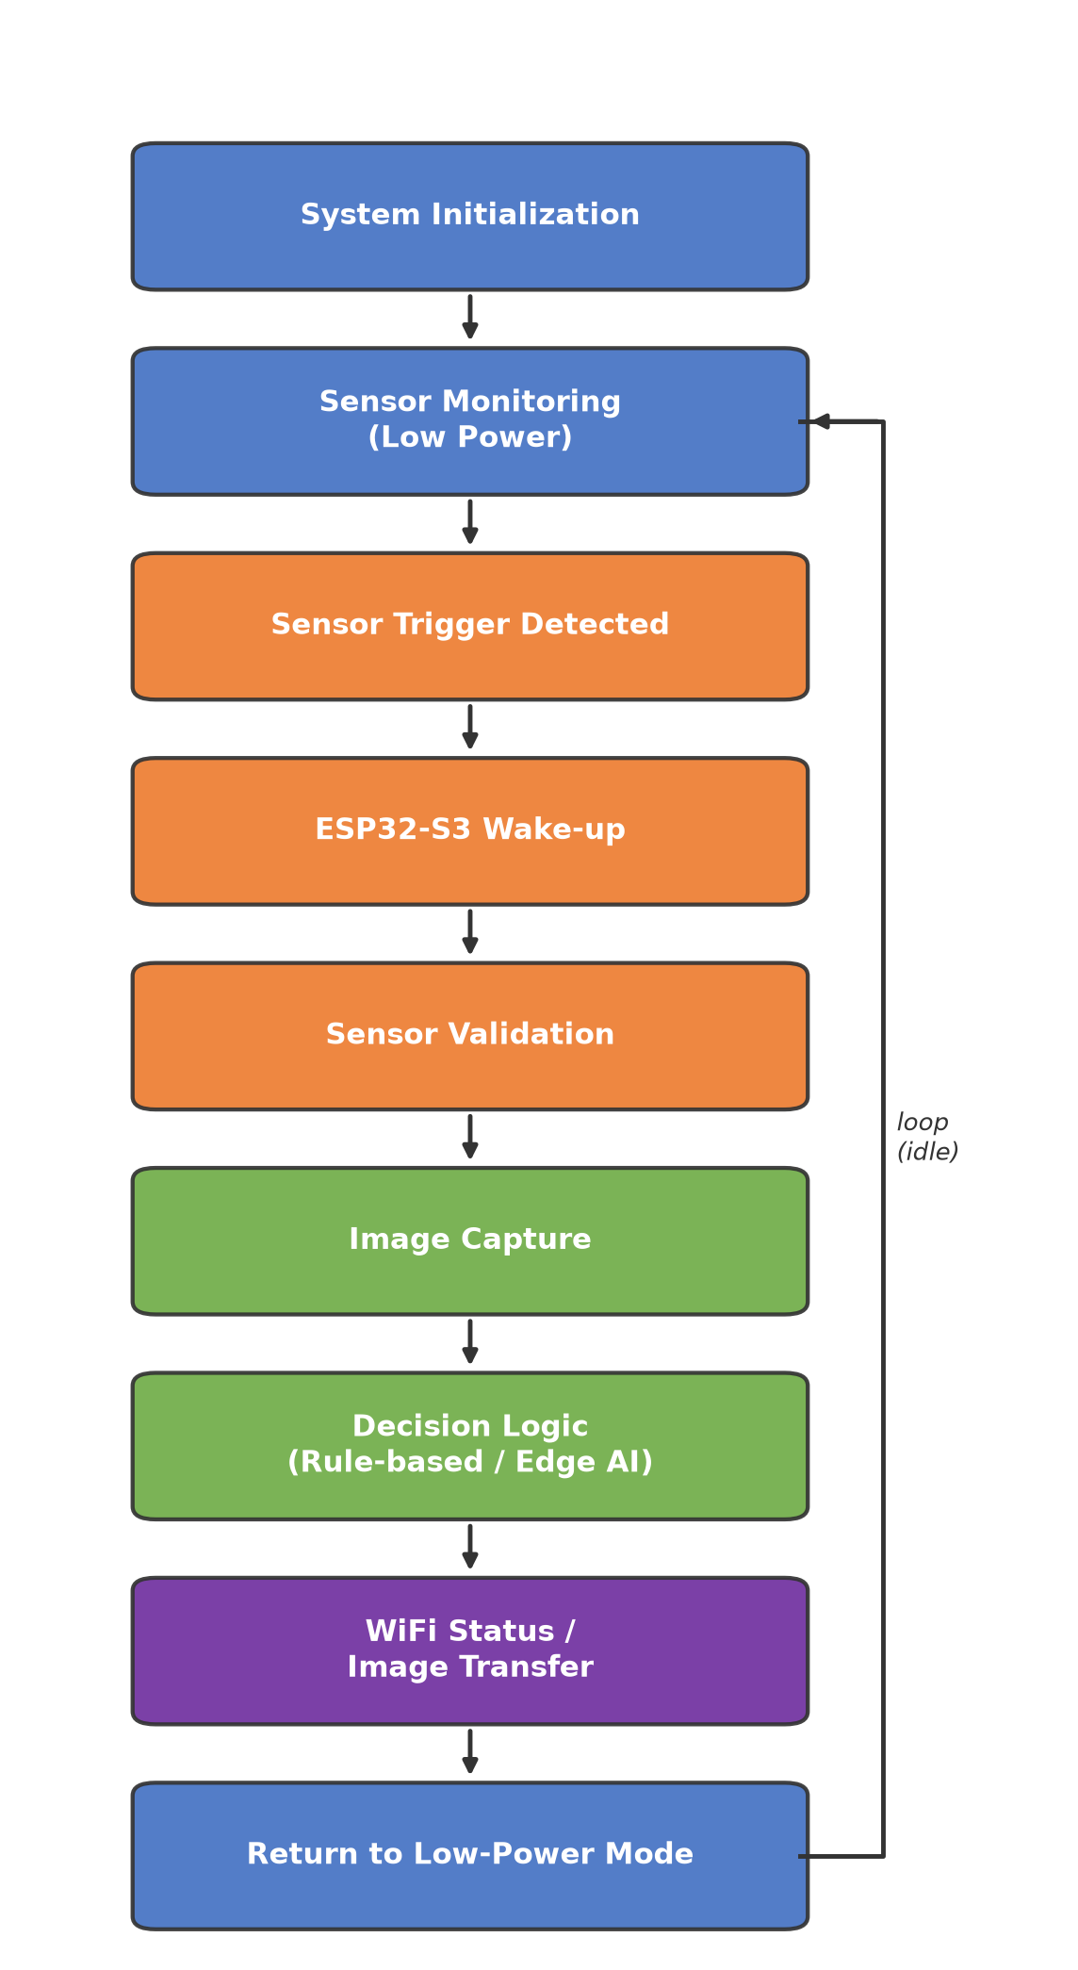
Figure X: System operation flow

The decision logic can run as a simple rule based check or the Edge AI model below, without changing the hardware architecture.
The event verification classifier (person / no_person) was trained with Edge Impulse and deployed as an ESP32 Arduino library, using 176 images (99 person, 77 no_person) captured on-device. The camera captures QVGA (320x240), but the model runs on a reduced 96x96 RGB input, since the ESP32-S3's limited internal RAM cannot hold a full resolution inference buffer; the inference arena is allocated in external PSRAM instead. This resolution reduction is a direct accuracy vs. feasibility trade-off required to run the classifier on-device.

4.3 Integration Process

Integration was gradual: the camera, sensors, WiFi, and sleep mode were tested separately, then combined. The integrated prototype demonstrates the full required sequence: sensor trigger, wake up, image capture, communication, and return to low power operation.

Analysis of results
This chapter presents the analysis of the system results with respect to the three quantitative requirements defined in the project Work Plan: detection range up to 30 m, false detection rate below 10%, and reliable operation under reasonable (non extreme) outdoor weather conditions, in addition to the project target of approximately three months of battery powered operation. The analysis is based on the manufacturer datasheets of the final components (Table 1, section 3.4) and the average current model presented in section 3.4.

Power Consumption Analysis
The system activates the PIR sensor and the HLK-LD2451 radar sensor in parallel: either sensor may independently trigger the ESP32-S3 to wake up, capture an image, run the on-device AI model, and transmit an alert over WiFi. Table 2 compares the required and calculated values of the main power related parameters. Measured values will be added after the field measurement stage.
Parameter | Requirement / Target | Calculated result | Measured result
Average current, Iavg (baseline duty cycle) | - | 112.9 mA | To be completed
Average system power, Pavg (baseline duty cycle) | - | ~555 mW | To be completed
Battery life (3350 mAh cell, baseline duty cycle) | ~3 months (90 days) | ~22.3 hours | To be completed
Table 2: Power consumption results compared to the project requirements
Each component in Table 1 draws a relatively small amount of power on its own; for example, the camera draws only 140 mW and the PIR sensor draws under 1 mW. However, the overall battery life is determined by the total power drawn by the module as a whole, not by any single component. Because the sensors operate on a 5V supply rail while the ESP32-S3 operates on a 3.3V rail, the total system power (in mW) is a more physically meaningful aggregate metric than a single current value blended across different voltage domains. The total system power is calculated as the sum of the individual component powers, as defined below.
$$P_{total} = ∑V_{i}I_{i}$$
Table 3 applies this definition to the Sleep / Monitoring state (PIR and radar sensors active, ESP32-S3 in deep-sleep) and the Active state (sensors remain active while the ESP32-S3 wakes up, the camera captures an image, and the result is transmitted over WiFi).
State | Components contributing | Total power
Sleep / Monitoring | PIR (0.75 mW) + Radar (535 mW) + ESP32-S3 deep-sleep (0.026 mW) | ~535.8 mW
Active (wake, capture, AI, WiFi send) | Sleep-state power (~535.8 mW) + Camera (140 mW) + ESP32-S3 WiFi TX (~1023 mW) | ~1698.8 mW
Table 3: Total system power per operating state
A key finding is that the Sleep / Monitoring state is not a low power state: the HLK-LD2451 radar alone draws 535 mW continuously, which dominates the system power budget regardless of how often the camera, AI inference, and WiFi transmission are triggered. Using the duty cycle definition below, where t_active is the time spent in the Active state and T_cycle is the total monitoring cycle period, the average system power is calculated for a baseline scenario of 3 minutes Active time per 3 hours of total cycle time. Both t_active and T_cycle are configurable system parameters.
$$d = \frac{t_{active}}{T_{cycle}}$$
$$P_{avg} = P_{sleep}(1 - d) + P_{active} d$$
$$P_{avg} = 535.8 mW × 0.9833 + 1698.8 mW × 0.0167 = 555.2 mW$$
Table 4 repeats this calculation over a range of duty cycles, to show how the average power depends on the chosen Active state frequency and duration.
Active time / Cycle period | Duty cycle d | Pavg
3 min / 1 hour | 5.00% | ~611 mW
3 min / 3 hours (baseline) | 1.67% | ~555 mW
3 min / 6 hours | 0.83% | ~545 mW
3 min / 12 hours | 0.42% | ~540 mW
3 min / 24 hours | 0.21% | ~538 mW
1 min / 3 hours | 0.56% | ~536 mW
5 min / 3 hours | 2.78% | ~568 mW
10 min / 3 hours | 5.56% | ~600 mW
Table 4: Average system power sensitivity to Active state duty cycle
As in the current based estimate, Pavg is bounded below by the Sleep / Monitoring power of about 535.8 mW: even a single check-in per day does not bring Pavg meaningfully below this floor, because it is set by the continuously powered radar rather than by the camera, AI, or WiFi processing.
Battery life is estimated from the available battery energy (capacity in mAh at the nominal lithium-ion cell voltage of 3.7V) divided by the average system power:
$$Life = \frac{Capacity × 3.7V}{P_{avg}}$$
Table 5 compares the resulting battery life, using the baseline scenario (Pavg = 555.2 mW), against the project target of approximately three months (90 days). The exact battery capacity to be used in the final prototype has not yet been finalized, so the calculation is presented parametrically for typical single-cell lithium-ion (18650) capacities.
Battery capacity | Estimated battery life (Pavg = 555.2 mW) | vs. 90-day target
2600 mAh (typical 18650) | ~17.3 hours (~0.7 day) | ~125x short
3350 mAh (high-capacity 18650) | ~22.3 hours (~0.9 day) | ~97x short
5000 mAh | ~33.3 hours (~1.4 days) | ~65x short
Table 5: Estimated battery life vs. the three-month operation target
To reach the 90-day target with a 3350 mAh cell, the average system power would need to be reduced to approximately 5.7 mW. Since the HLK-LD2451 radar alone draws 535 mW when continuously powered, this target cannot be met while both sensors remain active in parallel at all times, regardless of the camera, AI, or WiFi duty cycle. The root cause is the sensing architecture rather than the processing or communication stages: meeting the battery life target requires duty-cycling the radar itself (for example, gating it with the PIR sensor so that the radar is only powered for a small fraction of the monitoring time), which is identified here as a necessary direction for further optimization of the system.

Detection Range Analysis
The 30 m detection range requirement is evaluated against the datasheet range of each sensor used in the final prototype. Table 6 summarizes the maximum detection range of the PIR sensor and the HLK-LD2451 radar, as specified by the manufacturer.
Sensor | Datasheet detection range | Meets 30 m requirement alone?
PIR sensor (Grove PIR) | 3 m default, up to 6 m adjustable | No
HLK-LD2451 radar | 10 - 100 m, configurable | Yes, when configured to >= 30 m
Table 6: Detection range comparison against the 30 m requirement
Since the PIR sensor and the radar operate in parallel (either sensor may independently trigger the camera), the effective detection range of the system as a whole is determined by whichever sensor has the longer range. The PIR sensor alone would not satisfy the 30 m requirement, and its short range is an inherent property of passive infrared sensing rather than a design flaw: it is intended to provide a low power, close range presence indication. The HLK-LD2451 radar, configured to a detection distance of 30 m or more, is the sensor that allows the system to satisfy the range requirement. This is consistent with the power analysis in section 5.1: the radar is the dominant power consumer precisely because it is also the component responsible for meeting the range requirement, while the PIR sensor contributes negligible power in exchange for a short range, redundant detection at close proximity.
This range analysis, however, applies to sensor triggering rather than to the AI based classification stage. Once triggered, the OV2640 camera image is downscaled to the 96x96 RGB input required by the Edge Impulse classifier (section 4.2). For a typical camera module field of view of about 65 degrees, a person standing 30 m away occupies only on the order of one to two pixels in width in this 96x96 input, which is too small for reliable classification. The effective range at which the system can reliably classify a detected event is therefore considerably shorter than the 30 m sensor trigger range; at longer distances the system can detect that an event occurred, but the image based decision stage cannot be relied on to confirm what caused it. Increasing the effective classification range would require a higher resolution classifier input, camera zoom, or an ROI crop around the triggering sensor's detected direction, and is identified as a limitation of the current implementation.

Weather Resilience
The Work Plan requires reliable operation under reasonable outdoor weather conditions. No outdoor field trials under adverse weather have been performed yet (section 6.1), so this section evaluates weather resilience qualitatively, based on the sensing physics and manufacturer datasheets of the sensors considered in section 2.3.
The sensors evaluated for this project rely on two different physical principles: optical sensing (the Grove PIR, the OV2640 camera, and the YDLIDAR SDM18 evaluated in section 2.3) and radio frequency sensing (the HLK-LD2451 mmWave radar). Optical and infrared sensors are attenuated and scattered by fog, rain, and airborne dust, and their effective range is reduced under these conditions; the PIR sensor is additionally sensitive to ambient temperature and direct sunlight, which affect the thermal contrast it relies on. In contrast, radio frequency signals in the 24 GHz band used by the HLK-LD2451 pass through fog, light rain, and dust with little attenuation, since their wavelength is much larger than these particles.
This has a direct implication for the LiDAR alternative considered in section 2.3: although the YDLIDAR SDM18 provides accurate distance measurement, it is an optical time-of-flight sensor and would therefore be similarly degraded by adverse weather as the camera, in addition to its higher power and complexity cost. The HLK-LD2451 radar was therefore the more weather resilient choice for the long range trigger role, not only the more power efficient one for range, since it is largely unaffected by the same conditions that would degrade an optical ranging sensor. Table 7 summarizes this comparison.
Sensor | Sensing principle | Expected weather behavior | Role in final design
Grove PIR | Passive infrared (thermal contrast) | Sensitive to ambient temperature and direct sunlight | Low power, short range trigger
HLK-LD2451 radar | 24 GHz mmWave RF | Largely unaffected by fog, rain, or dust | Primary long range, weather resilient trigger
YDLIDAR SDM18 (evaluated, not used) | Optical time-of-flight (laser) | Degraded by fog, rain, and dust, similar to a camera | Rejected: higher power/complexity and weather sensitivity
OV2640 camera | Optical (visible light imaging) | Degraded by fog, rain, and low light | Short, triggered event verification only
Table X: Qualitative weather resilience comparison of the sensors evaluated in section 2.3
This analysis indicates that the final sensing configuration (PIR and radar) is expected to be at least as weather resilient as the LiDAR based alternative, while also drawing less power; quantitative validation under real outdoor weather conditions remains future work (section 6.3).

Classification Accuracy Limitations
In addition to the trigger-range limitation described in section 5.2, the practical accuracy of the Edge AI classification stage itself is limited by two compounding factors: the size and diversity of the training dataset, and the resolution of the image the classifier receives.
The classifier was trained on only 176 labeled images (99 person, 77 no_person, section 4.2), captured in a single session with the project's own ESP32-S3-CAM hardware. Since all training images were captured under similar lighting, background, and distance conditions, the model was not exposed to the range of real-world variation (different times of day, distances, poses, and backgrounds) needed to generalize reliably; this is a typical risk of a small, low-diversity training set, where the model can fit the specific training conditions rather than learning a general person / no_person distinction.
This is compounded by image quality: the classifier receives the image only after it is cropped and downscaled from the already modest QVGA (320x240) capture to the 96x96 RGB input required by the Edge Impulse runtime (section 4.2), discarding most spatial detail and any context outside the cropped region, in addition to JPEG compression artifacts from the capture stage. The combination of a small, low-diversity training set and a low-resolution model input is the most likely explanation for the inconsistent classification results observed during bench testing, and is a probable contributor to the false detection rate requirement (below 10%) not yet being met.
Testing to date has been limited to a small number of manual trigger tests rather than a systematic accuracy evaluation: initial bench testing yielded a correct, high-confidence result on a single sample (98.4% person), but subsequent ad hoc tests showed inconsistent results, including occasional misclassification. This is too small a sample to establish a reliable false detection rate in either direction. Quantifying the actual false detection rate requires a structured evaluation set captured under varied field conditions and, most likely, retraining on a larger and more diverse dataset; this is identified as required future work (section 6.3).

Conclusions and further work
This chapter evaluates the prototype against the Work Plan requirements and outlines directions for improving and extending the system.

Results vs. Project Goals
Of the four Work Plan targets, the detection range requirement is partially met: the HLK-LD2451 radar, configured to 30 m or more, satisfies the range requirement for sensor triggering, while the Grove PIR sensor covers only 3-6 m by design, since it is intended as a low power, close range indication rather than the primary range sensor (Table 6). However, as shown in section 5.2, the 96x96 resolution required by the on-device Edge AI classifier limits reliable person classification to a much shorter effective range than 30 m, so the requirement is met for detecting that an event occurred but not yet for classifying it at the full sensor range. The false detection rate requirement (below 10%) is not met and, as shown in section 5.4, this is most likely rooted in the small, low-diversity training dataset (176 images from a single capture session) combined with the same 96x96 resolution limitation, rather than in the sensing or trigger logic. The weather resilience requirement was not quantitatively validated within the project timeline: section 5.3 gives a datasheet based argument that the radar-based sensing layer should be reasonably weather resilient, but outdoor field trials and a weatherproof enclosure remain outstanding. The battery life target of about 90 days is not met by the current architecture: the baseline scenario yields only about 22.3 hours on a 3350 mAh cell, roughly 97 times short of the target (Table 5). The root cause, identified in section 5.1, is that the HLK-LD2451 radar draws about 535 mW continuously as the always-on trigger sensor, dominating the power budget regardless of camera, AI, or WiFi duty cycle.

Suggestions for Improvement
Since the radar, not the camera, AI inference, or WiFi, is the dominant power consumer, the most direct improvement is to duty-cycle the radar itself rather than keep both sensors active in parallel at all times: for example, using the PIR sensor as the always-on low power trigger and powering the radar only briefly to confirm range once the PIR detects motion. This trades a small increase in response time for a large reduction in average power, following the same sensor-gated philosophy already applied to the camera and WiFi. A complementary option is selecting a radar module with a native low power sleep mode and fast wake time, instead of continuous UART polling.

Future Work
Further work should include outdoor field trials to measure the actual false detection rate and weather resilience, and a weatherproof enclosure suited to outdoor deployment. Improving classification accuracy requires expanding the training dataset with a larger and more diverse set of real-world captures (varied lighting, distance, pose, and background) and evaluating whether a higher resolution classifier input is feasible within the ESP32-S3's memory constraints (section 5.4). On the power side, implementing the radar duty-cycling suggested above and validating the resulting battery life against the 90-day target is the priority. Additional directions include adaptive duty cycling based on time-of-day or historical trigger patterns, and evaluating solar charging to offset the remaining power budget.

Project Documentation
All project deliverables are to be documented (e.g. GitHub), this final project report should only include their description:
- Description of the project documentation (Hardware, software, additional simulations, user guide, etc.)
- The Documentation location (e.g. the GitHub link)
- Description of the project files

References
Here are some examples of references, and how they should be included.
Books:
- A. M. Bronstein, M. M. Bronstein, and R. Kimmel. "Numerical geometry of non-rigid shapes”, Springer-Verlag New York Inc, 2008.
Papers:
- G. B. Giannakis , "Highlights of Signal Processing for Communications", IEEE Signal Processing Magazine, Vol. 16, no 2, pp. 14-49, March 1999
Datasheet
- “Spartan-3A DSP FPGA Family Data Sheet”, XILINX Product Specification DS610, October 4, 2010. http://www.xilinx.com/support/documentation/data_sheets/ds610.pdf
Application Note :
- X. Zhang, "Developing a CCStudio 2.0 DSP/BIOS Application for FLASH Booting on the TMS320C5402 DSK", TI Application Report SPRA661A, November 2000. http://www.ti.com/lit/an/spra661a/spra661a.pdf
User's Guide:
- "TMS320C6201/6701 Evaluation Module User's Guide", SPRU269F, August 2002
- Code Composer Studio IDE 2.0 online help.
Links:
- "Dolby E Multichannel Coding for DTV Audio Production and Distribution", http://www.dolby.com/tech/m.br.9903.epaper.pdf
- G. Welch and G. Bishop – "An Introduction to the Kalman Filter", http://www.cs.unc.edu/~welch/kalman/kalman_filter/kalman.html#pgfId-11854
- C. Mercer, "Smoothing Spectral Data", The PROSIG Digital Signal Processing Tutorials, http://www.prosig.com/signal-processing/smoothingspectra.html

- Subject 1
If you need to go into details of a specific subject, you should do it here.
A dedicated appendix should be included for each subject.

- Subject 2

A single page length at most.
The abstract should allow a person who does not read all chapters of the project book to have a complete picture of the nature of the work.
Notice the insertion of the FOOTNOTE, and the links from this page to the chapters in which the examples appear.
If applicable
If relevant

