

Hezi the Prophet

3335 | Project Number:

Project Report

Student: | Shachar Weinberg | ID: | 313132284
Student: | Amit Sharvit | ID: | 314619107

Supervisor: | Hezi Nistani

Project Carried Out at: | Tel Aviv University

Contents
Abstract……….. 2
1 Introduction 3
2 Theoretical background 4
3 Simulation.. 5
4 Implementation 6
4.1 Hardware Description 6
4.2 Software Description 7
5 Analysis of results 8
6 Conclusions and further work 9
7 Project Documentation 10
8 References.. 11
Appendix A. Subject 1 12
Appendix B Subject 2 13

List of figures
Figure 1: Block diagram 2
Figure 2: The System 6
Figure 3: Amplifier Input Circuit 6

List of tables
Table 1: Results 8

List of equations

Abstract
This project presents the design and implementation of a stand alone, low power object detection system for open field environments, intended for areas without fixed electrical infrastructure or wired communication. The system integrates an ESP32-S3-CAM controller, an OV2640 camera, a Grove PIR motion sensor, an HLK-LD2451 24GHz mmWave radar, a battery based power unit, and a local WiFi interface: the sensors act as an always-on, low power first detection layer, and the camera and WiFi are activated only after a valid trigger, following an event driven duty cycle intended to extend battery life.

An Edge Impulse image classification model, running on-device, is used to confirm whether a captured image actually contains a person before the result is reported, reducing false alarms compared to triggering on sensor input alone.

The completed prototype demonstrates the full system flow: sensor based trigger, controller wake up, image capture, on-device classification, and reporting to a local computer over WiFi, followed by a return to low power operation. The system was evaluated against four Work Plan targets: detection range, false detection rate, power consumption, and weather resilience.
The radar meets the 30 m detection range requirement for sensor triggering, although the 96x96 pixel resolution required by the on-device classifier limits reliable person classification to a considerably shorter effective range. The false detection rate target was not met, most likely due to the small and low-diversity training dataset used. Power consumption is dominated by the radar, which is continuously active as the trigger sensor; as a result, the estimated battery life of about 22 hours falls well short of the 90-day target, and duty-cycling the radar itself is identified as the most direct path to closing this gap. Weather resilience was assessed only through datasheet based reasoning and was not validated in outdoor field trials. Overall, the project demonstrates that a fully integrated, low power, lightweight detection module built from off the shelf components is a feasible approach, while also identifying the specific power, dataset, and resolution limitations that must be addressed before the full set of project targets can be met.
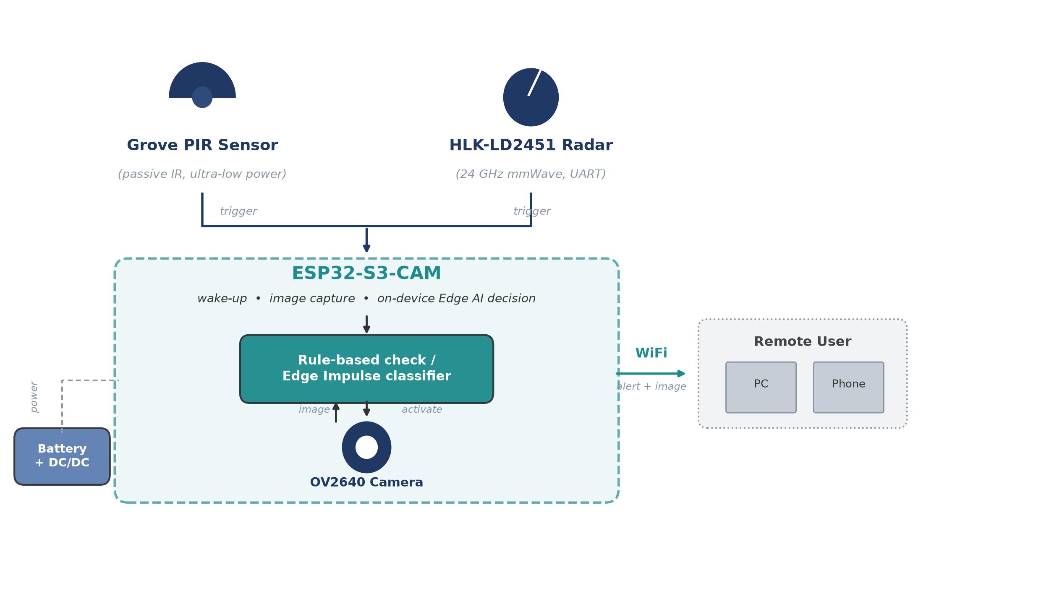
Figure 1: Block diagram

Introduction
Open field object detection - for perimeter security, remote area monitoring, and smart agriculture - is often needed where there is no fixed power or wired communication. The project Work Plan therefore defines a stand alone, low power human detection system bound by three quantitative requirements: detection range up to 30 m, false detection rate below 10%, and reliable operation under reasonable (non extreme) weather, plus a target of about three months of battery life.
Continuous camera operation or a cloud connected system would consume too much energy and require infrastructure that is not available in the field. Instead, low power sensors (PIR and mmWave radar) continuously monitor the environment; only a valid trigger wakes the ESP32-S3-CAM controller, which captures an image, evaluates the event, and reports it over local WiFi. This sensor gated approach trades a small increase in response time and complexity for a large reduction in average power compared to always on cameras or cloud based systems.
The intended use case is a compact, battery powered field unit with no external power or network infrastructure. The final deliverable is a working prototype demonstrating the full flow - sensor trigger, wake up, image capture, decision, and WiFi report - documented with schematics, firmware, and test results.

Theoretical background
This chapter summarizes the alternatives considered for each subsystem and the trade-offs behind the final selection, aiming for the best balance of power, reliability, response time, and complexity.
2.1 Low Power Embedded Systems
Low power embedded design minimizes average energy by keeping the system idle most of the time and active only during detection events; duty cycle, not peak current, is the dominant factor in battery life.
2.2 Microcontroller Alternatives and Selection
Four controllers were compared. Arduino Uno offers low standby current but lacks WiFi, camera support, and sufficient memory. Raspberry Pi offers high performance with built in WiFi and camera support, but has no microcontroller style deep sleep and high active current. STM32L4 offers efficient sleep modes, but requires external WiFi and camera modules, adding complexity. The ESP32-S3-CAM was selected as the only option combining camera support, WiFi, adequate processing, and deep sleep modes in a single compact module.
2.3 Sensor Technologies
PIR sensors detect infrared changes from warm bodies at very low power, but are sensitive to temperature and sunlight and cannot detect stationary targets. The HLK-LD2451 24GHz mmWave radar detects presence and motion independent of lighting or temperature, at a higher power cost, and was added to improve reliability. LiDAR (YDLIDAR SDM18) provides accurate distance but at higher power and complexity, and was evaluated but not included in the final sensing configuration.
2.4 Camera as an Event Verification Unit
The camera is activated only after a valid sensor trigger, avoiding the power cost of continuous imaging; it serves purely as an event verification unit rather than a continuously running sensor.
2.5 Local WiFi Communication
WiFi, built into the ESP32-S3, reports status and images to a local operator. Its relatively high current draw means it is activated only briefly, on a valid detection.

Simulation
System validation combined circuit level simulation (OrCAD Capture / PSpice, for the MCU, power management, and sensor blocks) with hardware testing (power supply, multimeter, oscilloscope, and serial monitor), confirming stable 5V/3.3V supply rails and a valid ESP32-S3 compatible sensor trigger logic transition before physical build.
3.4 Power Consumption Model
A theoretical power model estimates battery lifetime by dividing system operation into distinct current states: sleep, sensor monitoring, active, camera capture, and WiFi communication.
The average current is calculated according to:
$$I_{avg} = \frac{∑I_{i}t_{i}}{T}$$
where Ii is the current consumption in state i, ti is the time spent in that state, and T is the total observation time.
Table 1 lists the current and power consumption of each component used in this model, based on the relevant manufacturer datasheets.
Component | State | Current | Power | Source
PIR sensor (Grove PIR) | Always on (monitoring) | 0.15 mA @ 5V | 0.75 mW | Seeed Studio, Grove PIR Motion Sensor User Manual
HLK-LD2451 radar | Always on (monitoring) | 107 mA @ 5V | 535 mW | Hi-Link Electronic, HLK-LD2451 User Manual, Section 6
ESP32-S3 | Deep-sleep | 0.008 mA @ 3.3V | 0.026 mW | Espressif Systems, ESP32-S3 Series Datasheet, Table 5-10
ESP32-S3 | Active (CPU, AI inference, radio off) | 85 mA @ 3.3V | 280.5 mW | Espressif Systems, ESP32-S3 Series Datasheet, Table 5-9
ESP32-S3 | Active (WiFi transmit) | 283 - 340 mA @ 3.3V | ~934 - 1122 mW | Espressif Systems, ESP32-S3 Series Datasheet, Table 5-7
OV2640 camera | Active (capture, JPEG mode) | - | 140 mW | OmniVision, OV2640 Preliminary Datasheet
Table 1: Component current and power consumption (datasheet values)
Since the system is expected to spend most of its time in low power states, this model is central to estimating achievable battery life (Chapter 5).
3.5 Simulation and Evaluation Summary
Table 2 summarizes the required simulation and evaluation results:
Parameter | Method | Expected result | Final result
Power supply voltage levels | PSpice | Stable 5V and 3.3V rails | Confirmed in simulation (PSpice); not physically re-measured
Sensor trigger logic | PSpice or hardware test | Valid ESP32-S3 logic transition | Confirmed in simulation and on hardware via serial monitor output
Sleep mode current | Measurement | Low current state | Not measured (theoretical estimate only, section 6.1)
Image capture | ESP32-S3-CAM test | Successful image capture | Successful image capture confirmed on hardware
WiFi communication | Web server or Python client | Status or image transfer | Status and image transfer confirmed on hardware
Detection behavior | Sensor tests | Trigger on relevant event | Trigger on relevant event confirmed on hardware
Table 2: Simulation and evaluation summary

Implementation
This chapter describes the practical hardware and software implementation of the prototype.
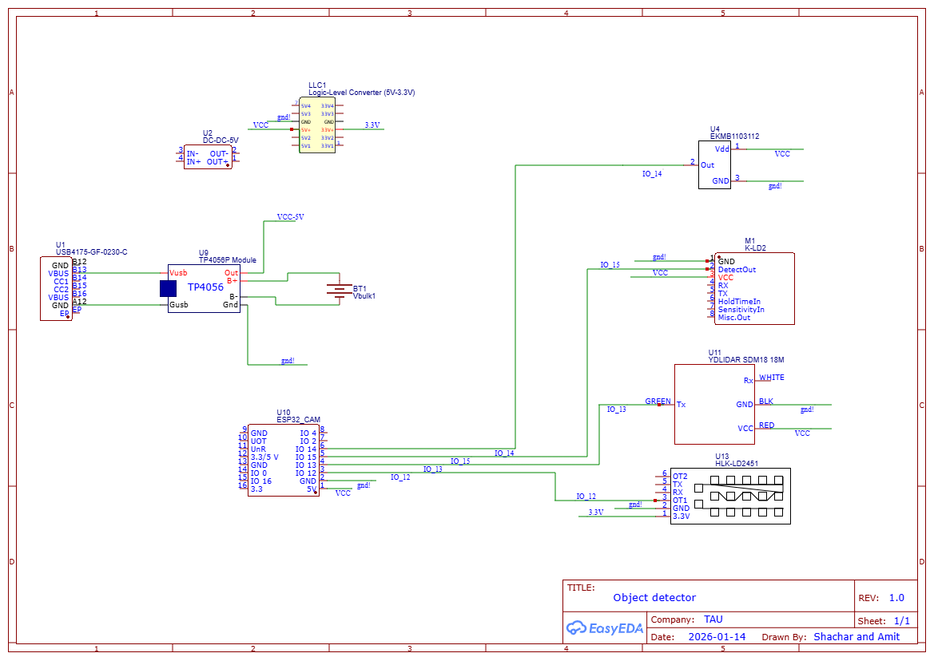
Figure 3: The System

Hardware Description
The hardware is based on an ESP32-S3-CAM controller, low power detection sensors, and an independent battery power unit, selected together for the best balance of processing, camera support, WiFi, and deep sleep capability (Table 3).
As in section 2.4, the camera activates only after a valid sensor trigger, minimizing average power consumption.
Power is supplied from a lithium battery through a TP4056 charging module and DC/DC converters producing the 5V and 3.3V rails; a logic level converter safely interfaces the 5V sensor outputs with the 3.3V ESP32-S3 GPIO pins.
The final sensing layer uses a Grove PIR sensor and the HLK-LD2451 mmWave radar (UART), as detailed in section 2.3; RFbeam K-LD2 radar and YDLIDAR SDM18 were evaluated but not included in the final configuration.
Table 3 summarizes the main hardware components.
Component | Role | Interface | Voltage | Final status
ESP32-S3-CAM | Main controller, camera and WiFi | GPIO, UART, camera interface | 3.3V / 5V module input | Final
OV2640 camera | Image capture | Camera interface | Module dependent | Final
Grove PIR sensor | Low power motion trigger | GPIO | 3.3V / 5V according to module | Final
HLK-LD2451 | mmWave presence detection | UART | 5V | Final / tested
TP4056 | Battery charging | Power path | Battery / 5V input | Final
DC/DC converters | Voltage regulation | Power | 5V and 3.3V | Final
Logic level converter | 5V to 3.3V interface protection | GPIO / UART | 5V and 3.3V | As required
Table 3: Main hardware components
Figure 3 presents the final hardware schematic.
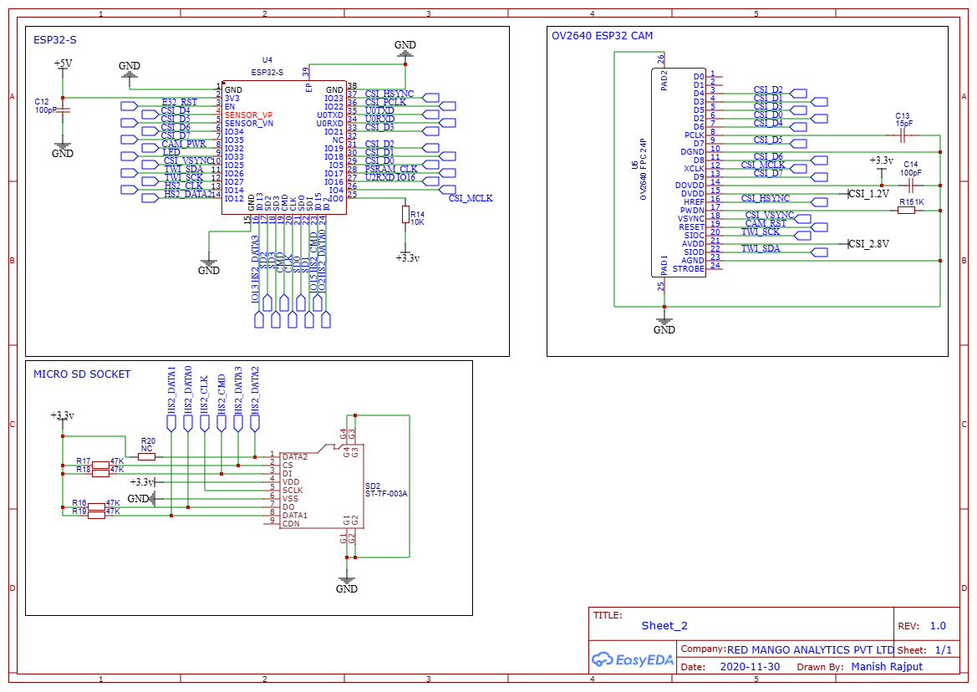
Figure 3: ESP32-S3-CAM Module Reference Schematic

Software Description
The firmware is C++ in the Arduino IDE for the ESP32-S3; Python scripts on the host handle image reception and logging. Code is managed in the project GitHub repository, with main.ino as the integration entry point.
The firmware is modular (sensor tests, sleep mode, camera capture, WiFi server, image transfer), each tested separately before integration. The system flow is:
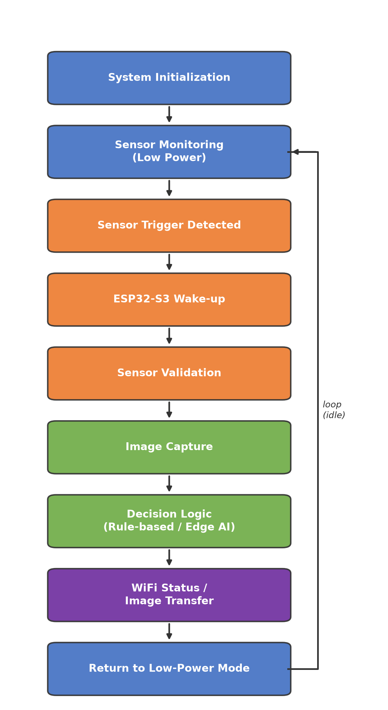
Figure 4: System operation flow
The decision logic can run as a simple rule based check or the Edge AI model below, without changing the hardware architecture.
The event verification classifier (person / no_person) was trained with Edge Impulse and deployed as an ESP32 Arduino library, using 176 images (99 person, 77 no_person) captured on-device. The camera captures QVGA (320x240), but the model runs on a reduced 96x96 RGB input, since the ESP32-S3's limited internal RAM cannot hold a full resolution inference buffer; the inference arena is allocated in external PSRAM instead. This resolution reduction is a direct accuracy vs. feasibility trade-off required to run the classifier on-device.
4.3 Integration Process
Integration was gradual: the camera, sensors, WiFi, and sleep mode were tested separately, then combined. The integrated prototype demonstrates the full required sequence: sensor trigger, wake up, image capture, communication, and return to low power operation.

Analysis of results
This chapter presents the analysis of the system results with respect to the three quantitative requirements defined in the project Work Plan: detection range up to 30 m, false detection rate below 10%, and reliable operation under reasonable (non extreme) outdoor weather conditions, in addition to the project target of approximately three months of battery powered operation. The analysis is based on the manufacturer datasheets of the final components (Table 1, section 3.4) and the average current model presented in section 3.4.

Power Consumption Analysis
The system activates the PIR sensor and the HLK-LD2451 radar sensor in parallel: either sensor may independently trigger the ESP32-S3 to wake up, capture an image, run the on-device AI model, and transmit an alert over WiFi. Table 4 compares the required and calculated values of the main power related parameters. Measured values will be added after the field measurement stage. No further physical power measurements were performed beyond an informal bench continuity check of the ESP32 and PIR supply lines; that check recorded a PIR current on the order of 50 mA, roughly 330 times higher than the 150 uA datasheet rating, most likely due to the informal test setup rather than the sensor itself, so the datasheet-derived values in Table 1 are used throughout this analysis instead of that reading.
Parameter | Requirement / Target | Calculated result | Measured result
Average current, Iavg (baseline duty cycle) | - | 112.9 mA | Not measured (theoretical estimate only)
Average system power, Pavg (baseline duty cycle) | - | ~555 mW | Not measured (theoretical estimate only)
Battery life (3350 mAh cell, baseline duty cycle) | ~3 months (90 days) | ~22.3 hours | Not measured (theoretical estimate only)
Table 4: Power consumption results compared to the project requirements
Each component in Table 1 draws a relatively small amount of power on its own; for example, the camera draws only 140 mW and the PIR sensor draws under 1 mW. However, the overall battery life is determined by the total power drawn by the module as a whole, not by any single component. Because the sensors operate on a 5V supply rail while the ESP32-S3 operates on a 3.3V rail, the total system power (in mW) is a more physically meaningful aggregate metric than a single current value blended across different voltage domains. The total system power is calculated as the sum of the individual component powers, as defined below.
$$P_{total} = ∑V_{i}I_{i}$$
Table 5 applies this definition to the Sleep / Monitoring state (PIR and radar sensors active, ESP32-S3 in deep-sleep) and the Active state (sensors remain active while the ESP32-S3 wakes up, the camera captures an image, and the result is transmitted over WiFi).
State | Components contributing | Total power
Sleep / Monitoring | PIR (0.75 mW) + Radar (535 mW) + ESP32-S3 deep-sleep (0.026 mW) | ~535.8 mW
Active (wake, capture, AI, WiFi send) | Sleep-state power (~535.8 mW) + Camera (140 mW) + ESP32-S3 WiFi TX (~1023 mW) | ~1698.8 mW
Table 5: Total system power per operating state
A key finding is that the Sleep / Monitoring state is not a low power state: the HLK-LD2451 radar alone draws 535 mW continuously, which dominates the system power budget regardless of how often the camera, AI inference, and WiFi transmission are triggered. Using the duty cycle definition below, where t_active is the time spent in the Active state and T_cycle is the total monitoring cycle period, the average system power is calculated for a baseline scenario of 3 minutes Active time per 3 hours of total cycle time. Both t_active and T_cycle are configurable system parameters.
$$d = \frac{t_{active}}{T_{cycle}}$$
$$P_{avg} = P_{sleep}(1 - d) + P_{active} d$$
$$P_{avg} = 535.8 mW × 0.9833 + 1698.8 mW × 0.0167 = 555.2 mW$$
Table 6 repeats this calculation over a range of duty cycles, to show how the average power depends on the chosen Active state frequency and duration.
Active time / Cycle period | Duty cycle d | Pavg
3 min / 1 hour | 5.00% | ~611 mW
3 min / 3 hours (baseline) | 1.67% | ~555 mW
3 min / 6 hours | 0.83% | ~545 mW
3 min / 12 hours | 0.42% | ~540 mW
3 min / 24 hours | 0.21% | ~538 mW
1 min / 3 hours | 0.56% | ~536 mW
5 min / 3 hours | 2.78% | ~568 mW
10 min / 3 hours | 5.56% | ~600 mW
Table 6: Average system power sensitivity to Active state duty cycle
As in the current based estimate, Pavg is bounded below by the Sleep / Monitoring power of about 535.8 mW: even a single check-in per day does not bring Pavg meaningfully below this floor, because it is set by the continuously powered radar rather than by the camera, AI, or WiFi processing.
Battery life is estimated from the available battery energy (capacity in mAh at the nominal lithium-ion cell voltage of 3.7V) divided by the average system power:
$$Life = \frac{Capacity × 3.7V}{P_{avg}}$$
Table 7 compares the resulting battery life, using the baseline scenario (Pavg = 555.2 mW), against the project target of approximately three months (90 days). The exact battery capacity to be used in the final prototype has not yet been finalized, so the calculation is presented parametrically for typical single-cell lithium-ion (18650) capacities.
Battery capacity | Estimated battery life (Pavg = 555.2 mW) | vs. 90-day target
2600 mAh (typical 18650) | ~17.3 hours (~0.7 day) | ~125x short
3350 mAh (high-capacity 18650) | ~22.3 hours (~0.9 day) | ~97x short
5000 mAh | ~33.3 hours (~1.4 days) | ~65x short
Table 7: Estimated battery life vs. the three-month operation target
To reach the 90-day target with a 3350 mAh cell, the average system power would need to be reduced to approximately 5.7 mW. Since the HLK-LD2451 radar alone draws 535 mW when continuously powered, this target cannot be met while both sensors remain active in parallel at all times, regardless of the camera, AI, or WiFi duty cycle. The root cause is the sensing architecture rather than the processing or communication stages: meeting the battery life target requires duty-cycling the radar itself (for example, gating it with the PIR sensor so that the radar is only powered for a small fraction of the monitoring time), which is identified here as a necessary direction for further optimization of the system.

Detection Range Analysis
The 30 m detection range requirement is evaluated against the datasheet range of each sensor used in the final prototype. Table 8 summarizes the maximum detection range of the PIR sensor and the HLK-LD2451 radar, as specified by the manufacturer.
Sensor | Datasheet detection range | Meets 30 m requirement alone?
PIR sensor (Grove PIR) | 3 m default, up to 6 m adjustable | No
HLK-LD2451 radar | 10 - 100 m, configurable | Yes, when configured to >= 30 m
Table 8: Detection range comparison against the 30 m requirement
Since the PIR sensor and the radar operate in parallel (either sensor may independently trigger the camera), the effective detection range of the system as a whole is determined by whichever sensor has the longer range. The PIR sensor alone would not satisfy the 30 m requirement, and its short range is an inherent property of passive infrared sensing rather than a design flaw: it is intended to provide a low power, close range presence indication. The HLK-LD2451 radar, configured to a detection distance of 30 m or more, is the sensor that allows the system to satisfy the range requirement. This is consistent with the power analysis in section 5.1: the radar is the dominant power consumer precisely because it is also the component responsible for meeting the range requirement, while the PIR sensor contributes negligible power in exchange for a short range, redundant detection at close proximity.
This range analysis applies to sensor triggering rather than to the AI based classification stage: as discussed in section 5.4, the 96x96 pixel resolution required by the on-device classifier limits reliable person classification to a considerably shorter effective range than the 30 m sensor trigger range.

Weather Resilience
The Work Plan requires reliable operation under reasonable outdoor weather conditions; this was not a primary project priority and has not yet been validated through outdoor field trials. Qualitatively, the HLK-LD2451 mmWave radar (24 GHz RF) is expected to remain effective in fog, rain, and dust, unlike the optical PIR and camera sensors or the LiDAR alternative considered in section 2.3, since RF signals at this wavelength are largely unaffected by such particles. Quantitative validation under real outdoor conditions remains future work (section 6.3).

Classification Accuracy Limitations
In addition to the trigger-range limitation described in section 5.2, the practical accuracy of the Edge AI classification stage itself is limited by two compounding factors: the size and diversity of the training dataset, and the resolution of the image the classifier receives.
The classifier was trained on only 176 labeled images (99 person, 77 no_person, section 4.2), captured in a single session with the project's own ESP32-S3-CAM hardware. Since all training images were captured under similar lighting, background, and distance conditions, the model was not exposed to the range of real-world variation (different times of day, distances, poses, and backgrounds) needed to generalize reliably; this is a typical risk of a small, low-diversity training set, where the model can fit the specific training conditions rather than learning a general person / no_person distinction.
This is compounded by image quality: the classifier receives the image only after it is cropped and downscaled from the already modest QVGA (320x240) capture to the 96x96 RGB input required by the Edge Impulse runtime (section 4.2), discarding most spatial detail and any context outside the cropped region, in addition to JPEG compression artifacts from the capture stage. The combination of a small, low-diversity training set and a low-resolution model input is the most likely explanation for the inconsistent classification results observed during bench testing, and is a probable contributor to the false detection rate requirement (below 10%) not yet being met.
Testing to date has been limited to a small number of manual trigger tests rather than a systematic accuracy evaluation: initial bench testing yielded a correct, high-confidence result on a single sample (98.4% person), but subsequent ad hoc tests showed inconsistent results, including occasional misclassification. This is too small a sample to establish a reliable false detection rate in either direction. Quantifying the actual false detection rate requires a structured evaluation set captured under varied field conditions and, most likely, retraining on a larger and more diverse dataset; this is identified as required future work (section 6.3).

Component Integration Analysis
Beyond the accuracy of any single sensor or the classifier in isolation, several integration level issues affect overall system behavior. The trigger logic implemented in firmware (shouldRunInference() in main.ino) treats the Grove PIR and the HLK-LD2451 radar as an unconditional logical OR: either sensor alone is sufficient to wake the ESP32-S3 and start a capture cycle, and the system does not currently record which sensor caused the wake-up or deduplicate near-simultaneous triggers from both sensors. This is adequate for the current goal of not missing a real event, but means every wake-up costs a full capture-inference-transmission cycle even when both sensors report the same physical event, which is a secondary contributor to the average power figures in section 5.1.
A second integration constraint is memory: the Edge Impulse inference arena requires approximately 256 KB, while the ESP32-S3's internal RAM leaves only about 29 KB free after the WiFi and camera drivers are initialized, so both the camera frame buffer and the inference arena are allocated in external PSRAM (men_ai_model.ino). Because this is a shared, limited resource, the firmware must free the camera frame buffer (esp_camera_fb_return) immediately after the RGB565-to-RGB888 crop step and before running the classifier, rather than holding both buffers at once; this ordering is a direct consequence of integrating the camera and AI subsystems on the same PSRAM budget as the WiFi stack, and leaves little headroom for the higher resolution classifier input suggested in section 5.4 without a corresponding reduction elsewhere.
These findings indicate that the individual subsystems (sensors, camera, classifier, WiFi) each function correctly on their own, as demonstrated by the modular testing approach of section 4.3, but their combination introduces resource-sharing and event-arbitration behavior that does not appear when each subsystem is evaluated in isolation. Adding sensor-source tagging and trigger deduplication, together with the radar duty-cycling suggested in section 6.2, would address both the redundant wake-up and the power-budget issues identified here.
During the integration process, it was found that the ESP32-S3 was capable of operating the camera, the AI model, and the web server separately. However, running all components within the same system flow created a significant load on the controller's memory and processing resources. This limitation required the use of relatively low resolution and low quality images in order to reduce image buffer sizes and memory consumption during inference; although further software optimization may have been possible, the current controller did not provide sufficient resource margin for stable, reliable, and scalable operation of the complete system. The reduced image quality lowered the memory requirements, but it also decreased the amount of visual information available to the AI model and may therefore have limited the classification performance (section 5.4). A recommended future solution is to use a controller with larger Flash and PSRAM capacity, allowing higher quality images and a more advanced AI model to be processed with greater stability. Another possible solution is to divide the system between two controllers, with one controller managing the sensors and the main system flow, while the second controller handles the camera and AI inference.

Conclusions and further work
This chapter evaluates the prototype against the Work Plan requirements and outlines directions for improving and extending the system.

Results vs. Project Goals
Beyond the four quantitative Work Plan targets, the project demonstrates that a fully integrated, low power module built from lightweight, off the shelf components (an ESP32-S3-CAM, low power PIR and mmWave radar sensors, and a compact battery power unit) is a feasible approach for a stand alone open field detection system, even though the current controller's memory and processing constraints limit image quality and full duty-cycle efficiency, as discussed in section 5.5. Of the four Work Plan targets, the detection range requirement is partially met: the HLK-LD2451 radar, configured to 30 m or more, satisfies the range requirement for sensor triggering, while the Grove PIR sensor covers only 3-6 m by design, since it is intended as a low power, close range indication rather than the primary range sensor (Table 8). However, as shown in section 5.2, the 96x96 resolution required by the on-device Edge AI classifier limits reliable person classification to a much shorter effective range than 30 m, so the requirement is met for detecting that an event occurred but not yet for classifying it at the full sensor range. The false detection rate requirement (below 10%) is not met and, as shown in section 5.4, this is most likely rooted in the small, low-diversity training dataset (176 images from a single capture session) combined with the same 96x96 resolution limitation, rather than in the sensing or trigger logic. The weather resilience requirement was not quantitatively validated within the project timeline: section 5.3 gives a datasheet based argument that the radar-based sensing layer should be reasonably weather resilient, but outdoor field trials and a weatherproof enclosure remain outstanding. The battery life target of about 90 days is not met by the current architecture: the baseline scenario yields only about 22.3 hours on a 3350 mAh cell, roughly 97 times short of the target (Table 7). The root cause, identified in section 5.1, is that the HLK-LD2451 radar draws about 535 mW continuously as the always-on trigger sensor, dominating the power budget regardless of camera, AI, or WiFi duty cycle.

Suggestions for Improvement
Since the radar, not the camera, AI inference, or WiFi, is the dominant power consumer, the most direct improvement is to duty-cycle the radar itself rather than keep both sensors active in parallel at all times: for example, using the PIR sensor as the always-on low power trigger and powering the radar only briefly to confirm range once the PIR detects motion. This trades a small increase in response time for a large reduction in average power, following the same sensor-gated philosophy already applied to the camera and WiFi. A complementary option is selecting a radar module with a native low power sleep mode and fast wake time, instead of continuous UART polling. In addition, tagging each wake-up with the sensor that triggered it and suppressing duplicate wake-ups from near-simultaneous PIR and radar triggers (section 5.5) would avoid redundant capture-inference-transmission cycles.

Future Work
Further work should include outdoor field trials to measure the actual false detection rate and weather resilience, and a weatherproof enclosure suited to outdoor deployment. Improving classification accuracy requires expanding the training dataset with a larger and more diverse set of real-world captures (varied lighting, distance, pose, and background) and evaluating whether a higher resolution classifier input is feasible within the ESP32-S3's memory constraints (section 5.4). On the power side, implementing the radar duty-cycling suggested above and validating the resulting battery life against the 90-day target is the priority. Additional directions include adaptive duty cycling based on time-of-day or historical trigger patterns, and evaluating solar charging to offset the remaining power budget.

Project Documentation
All project deliverables, including firmware, Python client/server code, training data, and documentation, are hosted in the project's GitHub repository.
- Repository location: https://github.com/Shacharito/Final-Project
- Repository structure:
- firmware/main/ - the main ESP32-S3 firmware (sensors, camera, AI inference, deep sleep, web server).
- firmware/diagnostic/, firmware/factory_test/, and firmware/test_*/ - standalone hardware and integration test sketches used during development.
- python/main_client.py - the Python client used to communicate with the ESP32-S3 web server and retrieve captured images.
- training/capturing/ and training/dataset/ - the image capture script and the labeled person / no_person dataset used to train the Edge Impulse model.
- docs/ - project documentation, including this report, the firmware design notes, and the architecture diagram.
- archive/ - earlier standalone firmware and Python modules developed and tested individually before integration into the final system.

References
- Espressif Systems, "ESP32-S3 Series Datasheet", version 1.9, 2024. https://www.espressif.com/sites/default/files/documentation/esp32-s3_datasheet_en.pdf
- OmniVision Technologies, "OV2640 Color CMOS UXGA (2.0 MegaPixel) CameraChip Datasheet", OV2640DS Rev. 2.5.
- Hi-Link Electronic, "HLK-LD2451 24GHz Human Motion Detection Radar Module User Manual", version 1.0.
- Seeed Studio, "Grove - PIR Motion Sensor User Manual", https://wiki.seeedstudio.com/Grove-PIR_Motion_Sensor/
- Edge Impulse Inc., "Edge Impulse Documentation", https://docs.edgeimpulse.com/
- Espressif Systems, "ESP-IDF Programming Guide", https://docs.espressif.com/projects/esp-idf/

If applicable
If relevant

