ASSIGNMENT – 1

- Steps(with command and screenshots) for installing apache.
Ans: sudo apt-get install apache2
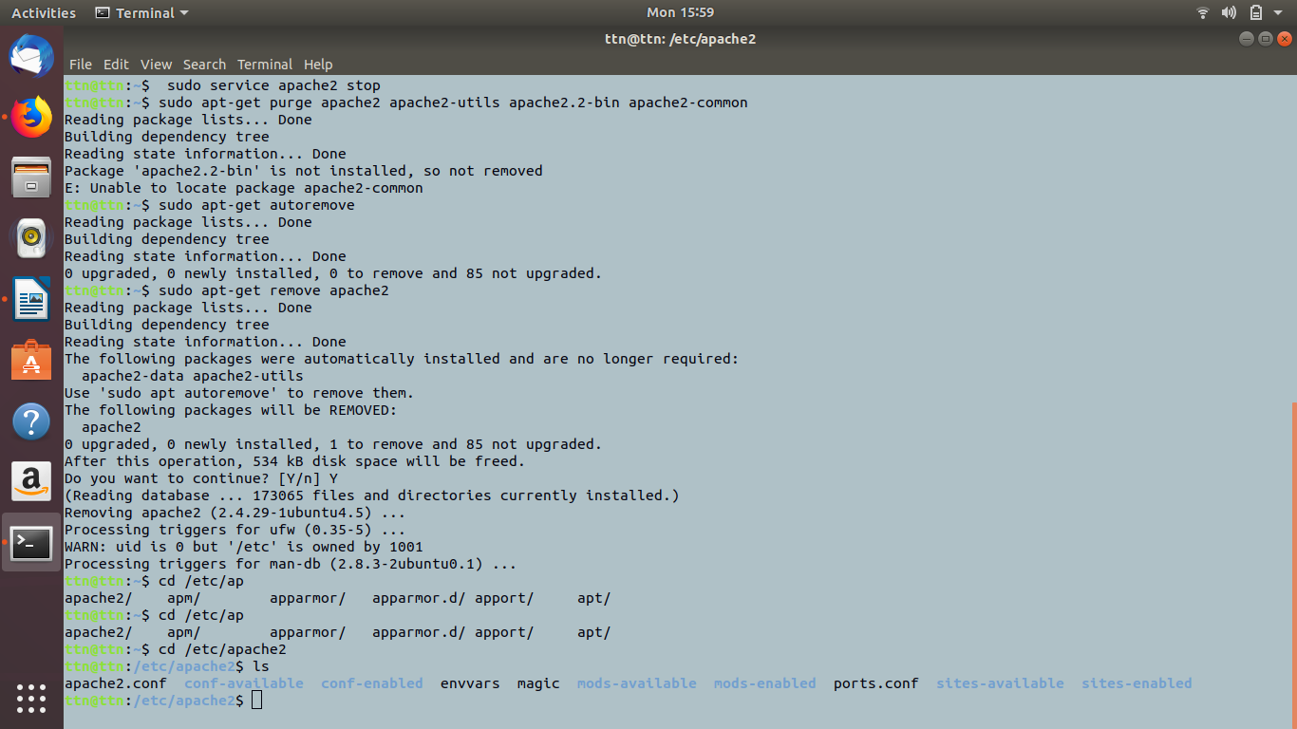
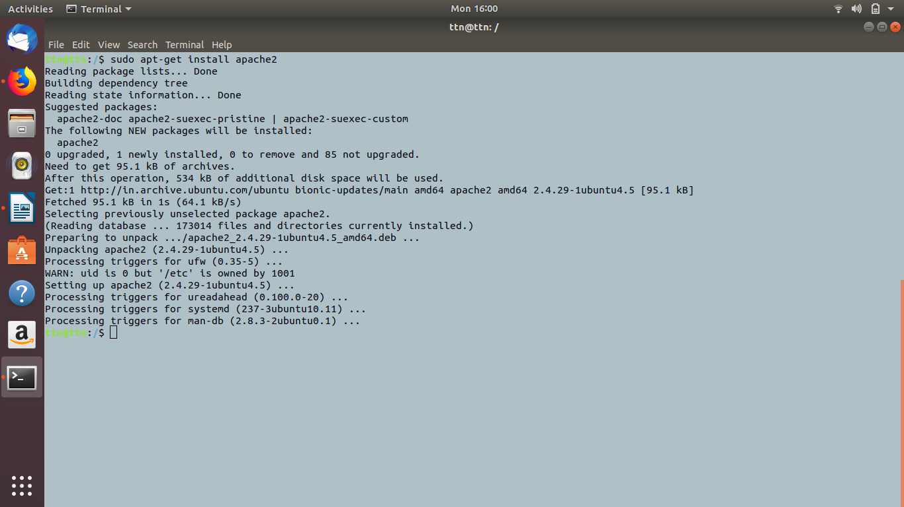

- Installation steps(with command and screenshots) Php and print current version

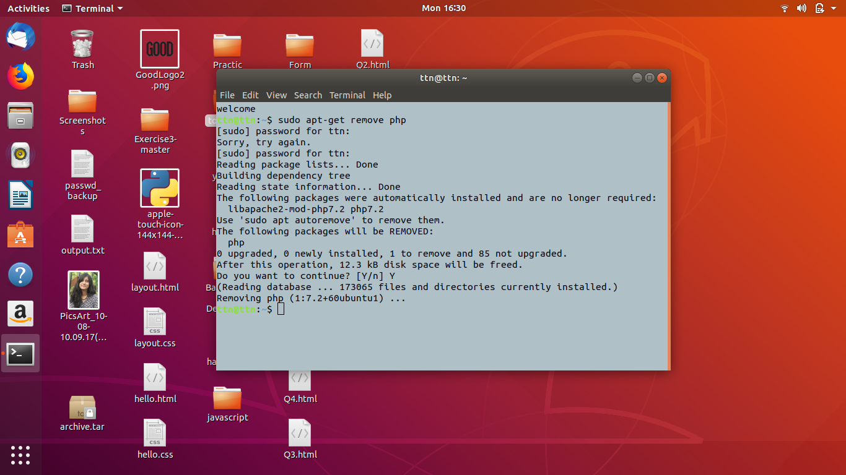
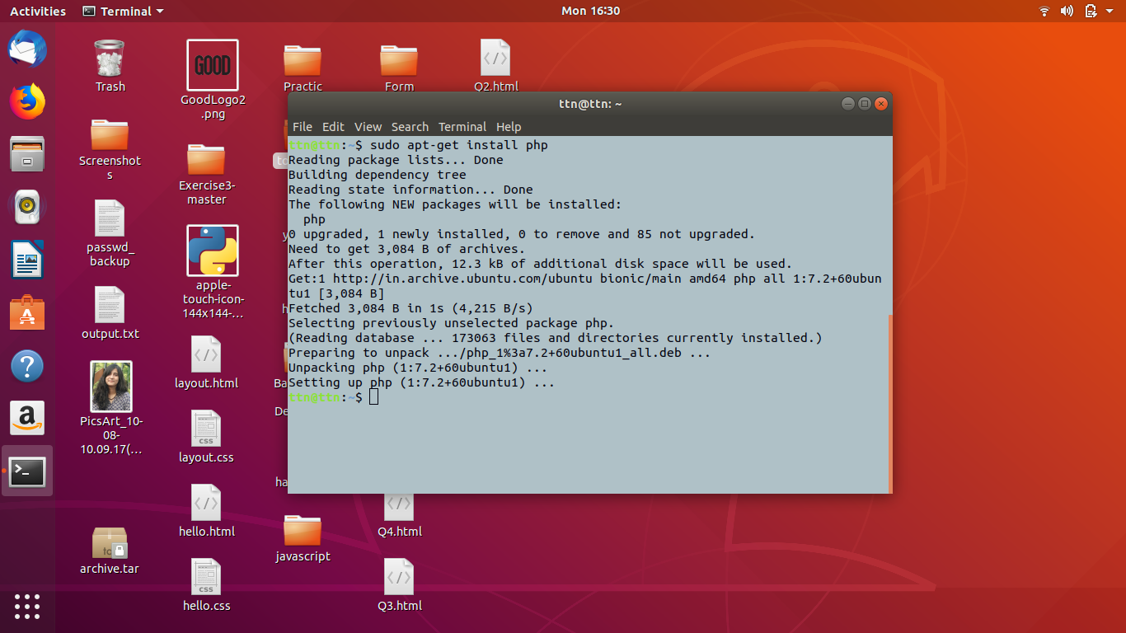
sudo apt-get install php

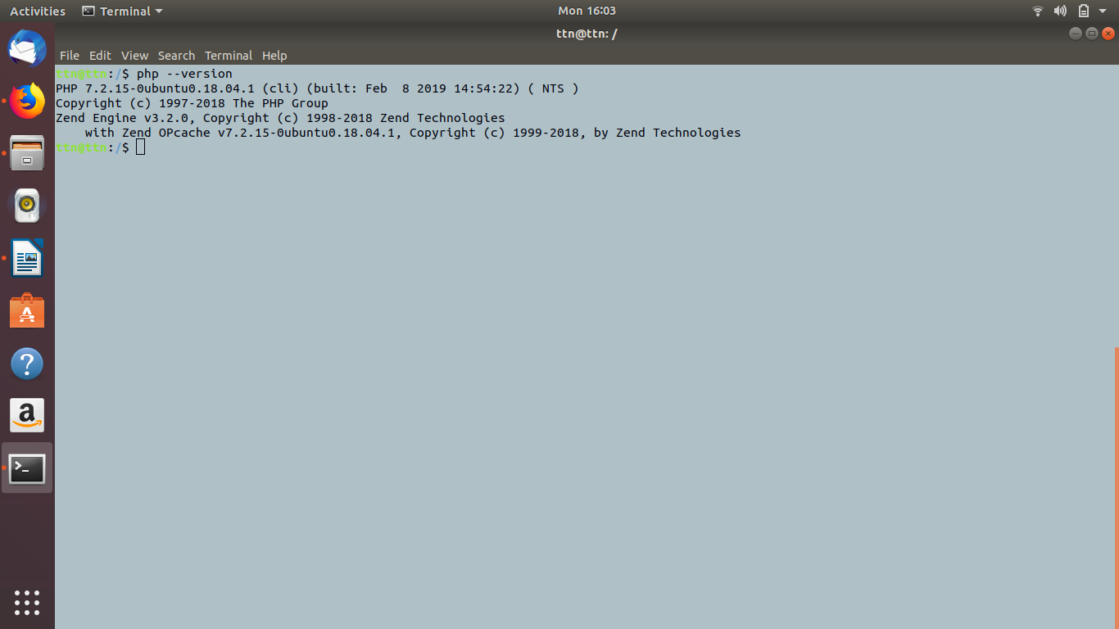
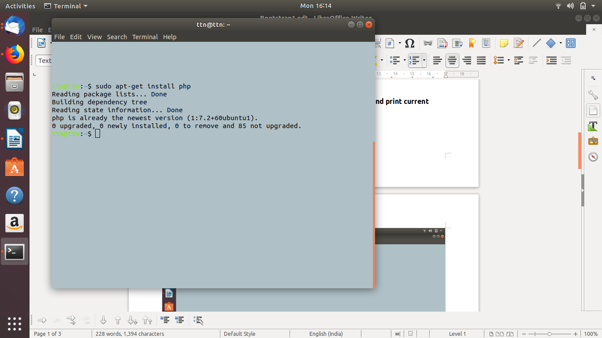
php –version
- Installation steps(with command and screenshots) mysql and print current version
sudo apt-get update
sudo apt-get install mysql-server
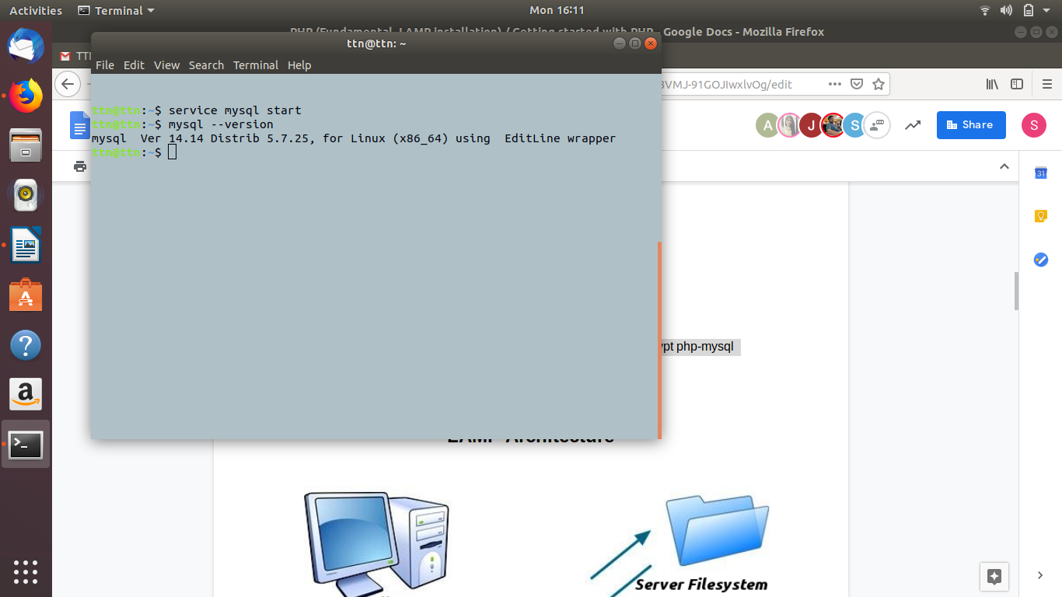

- What is HTTP?
Ans: HTTP (Hypertext Transfer Protocol) is the set of rules for transferring files (text, graphic images, sound, video, and other multimedia files) on the World Wide Web. As soon as a Web user opens their Web browser, the user is indirectly making use of HTTP. HTTP is an application protocol that runs on top of the TCP/IP suite of protocols (the foundation protocols for the Internet).
- What is the name of a superuser in Linux
Ans: ROOT is the name of a superuser in Linux.
- What domain name will have the following address – 127.0.0.1
Ans: 127.0.0.1 is the loopback Internet protocol (IP) address also referred to as the “localhost.” The address is used to establish an IP connection to the same machine or computer being used by the end-user.
- What language should you use for writing a queries for database?
Ans: SQL (structural query language) is used for writing queries for databases.
- Which command is used for restart apache
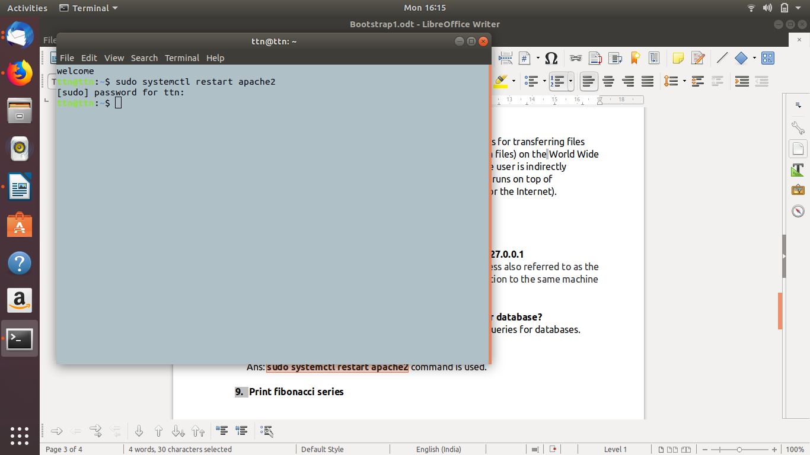
Ans: sudo systemctl restart apache2 command is used.
- Print fibonacci series

