SHACK  ENTERTAINMENT |   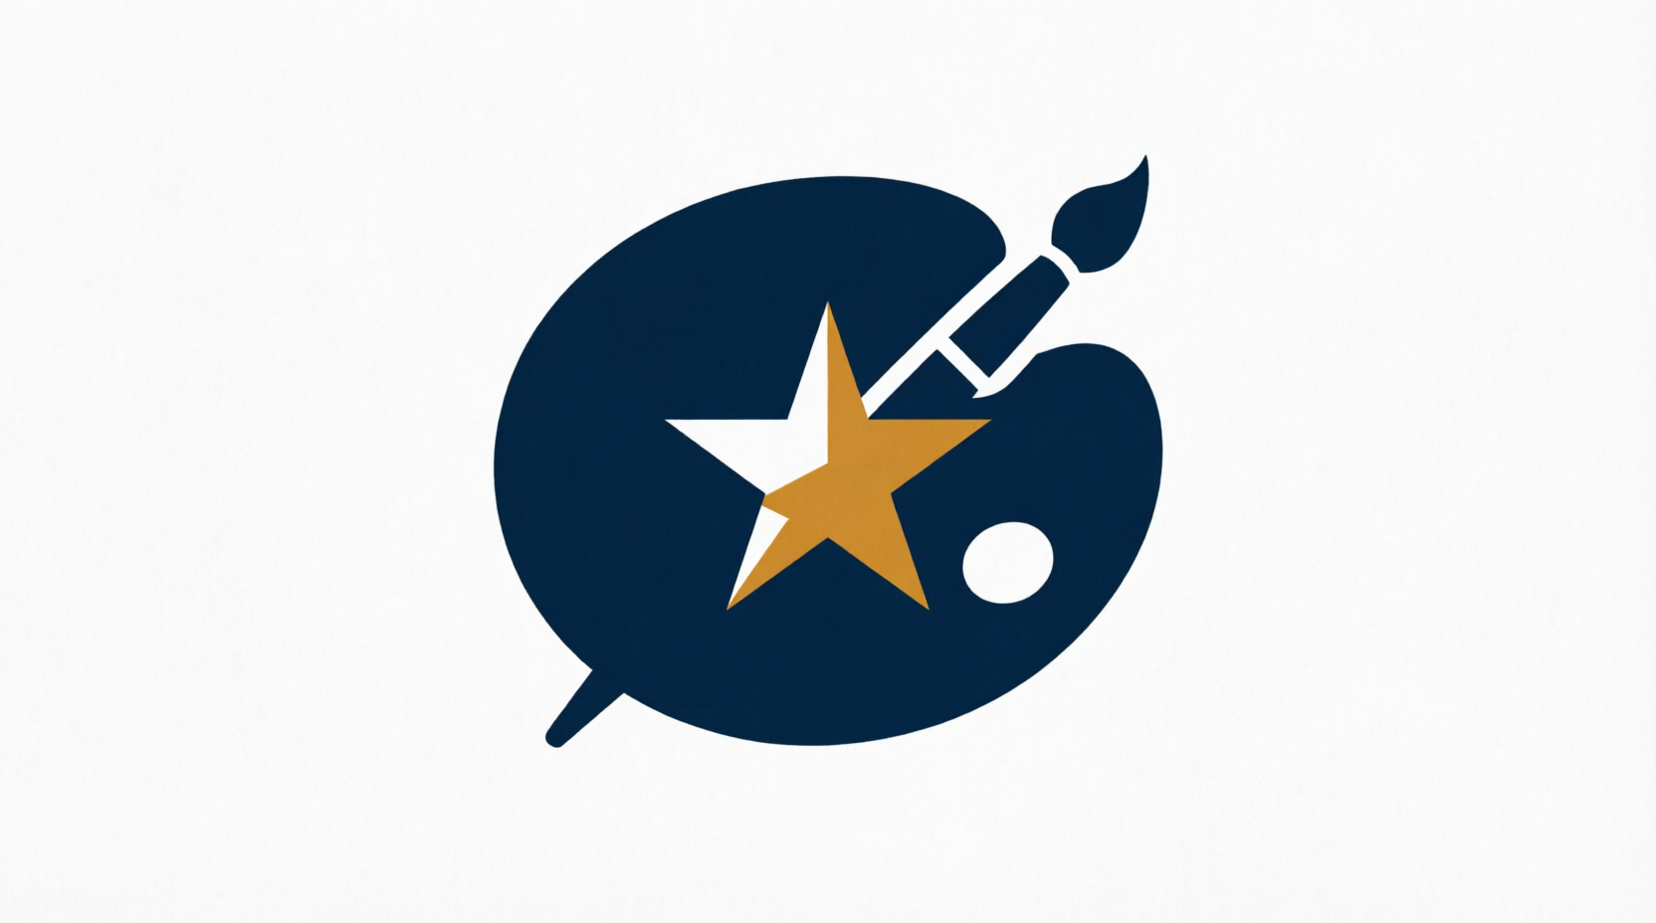  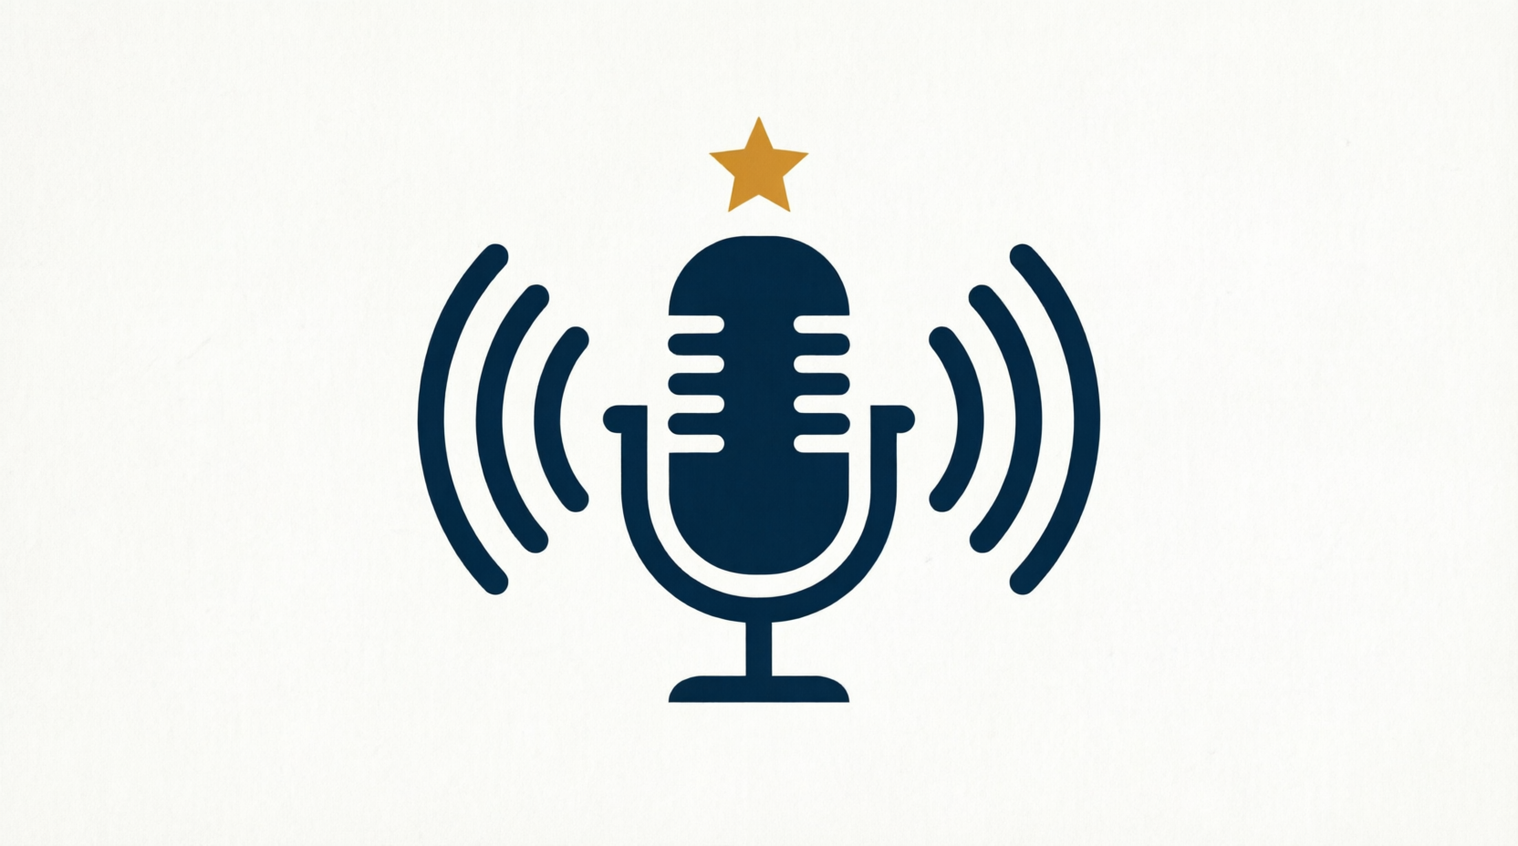  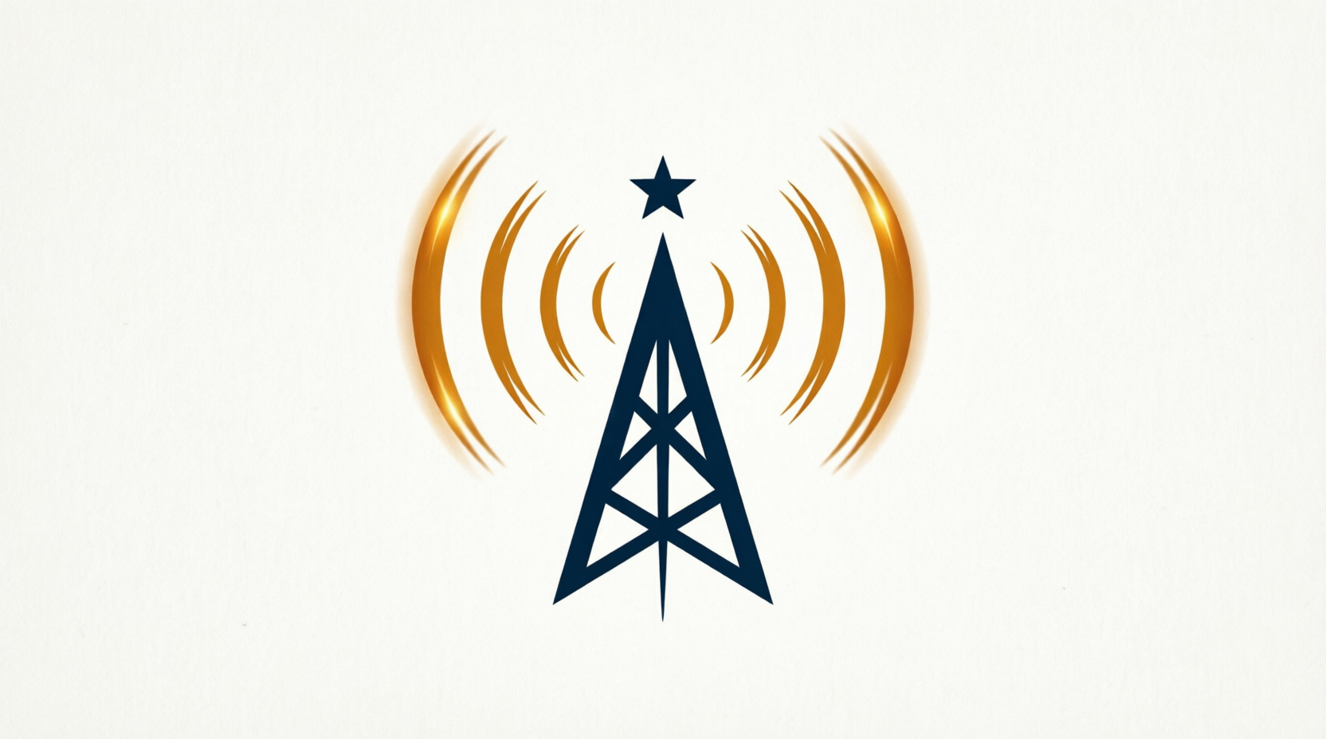

ARTISTS UNLIMITED · THE LIVE EXCHANGE · SHACK NEWS NETWORK

