SHACK  ENTERTAINMENT |   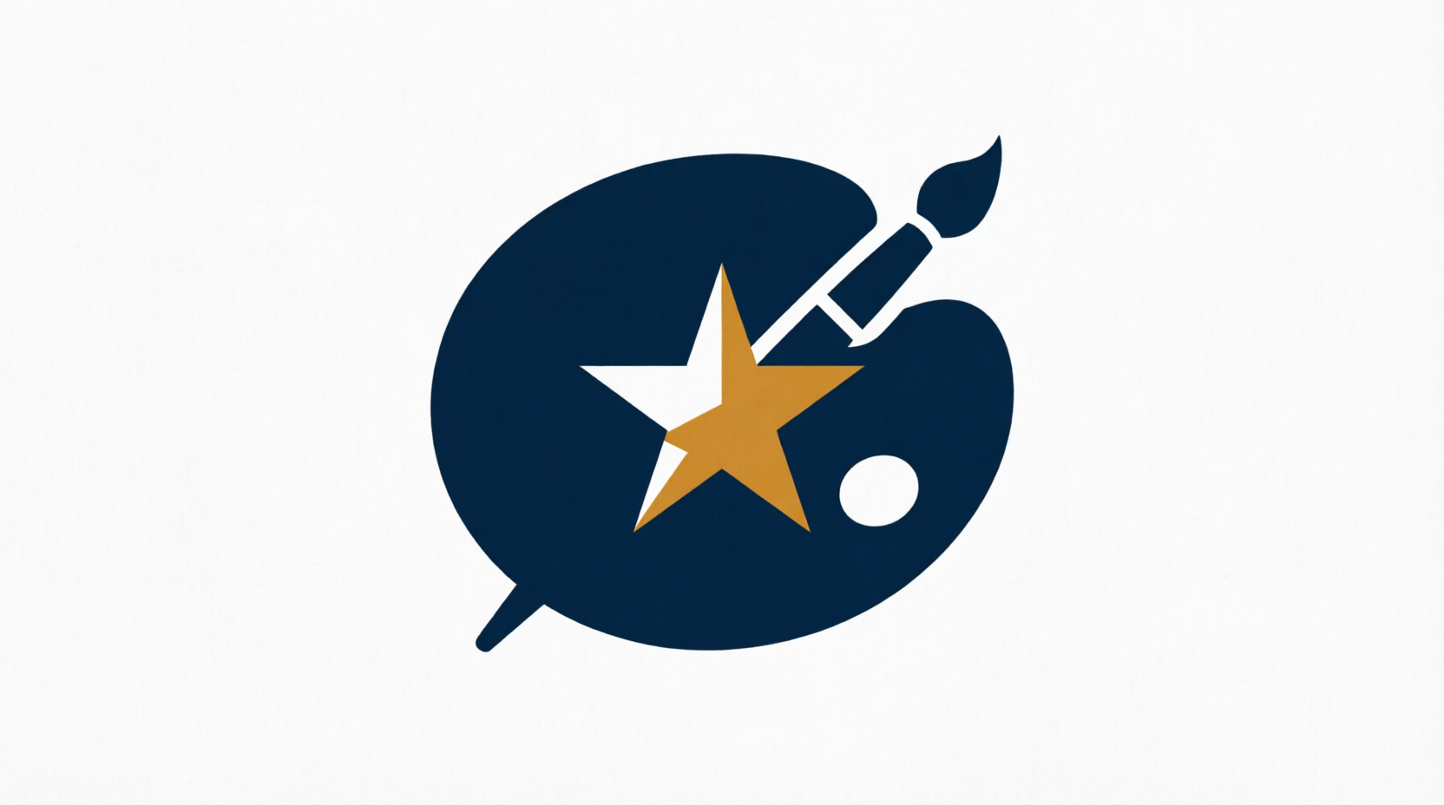    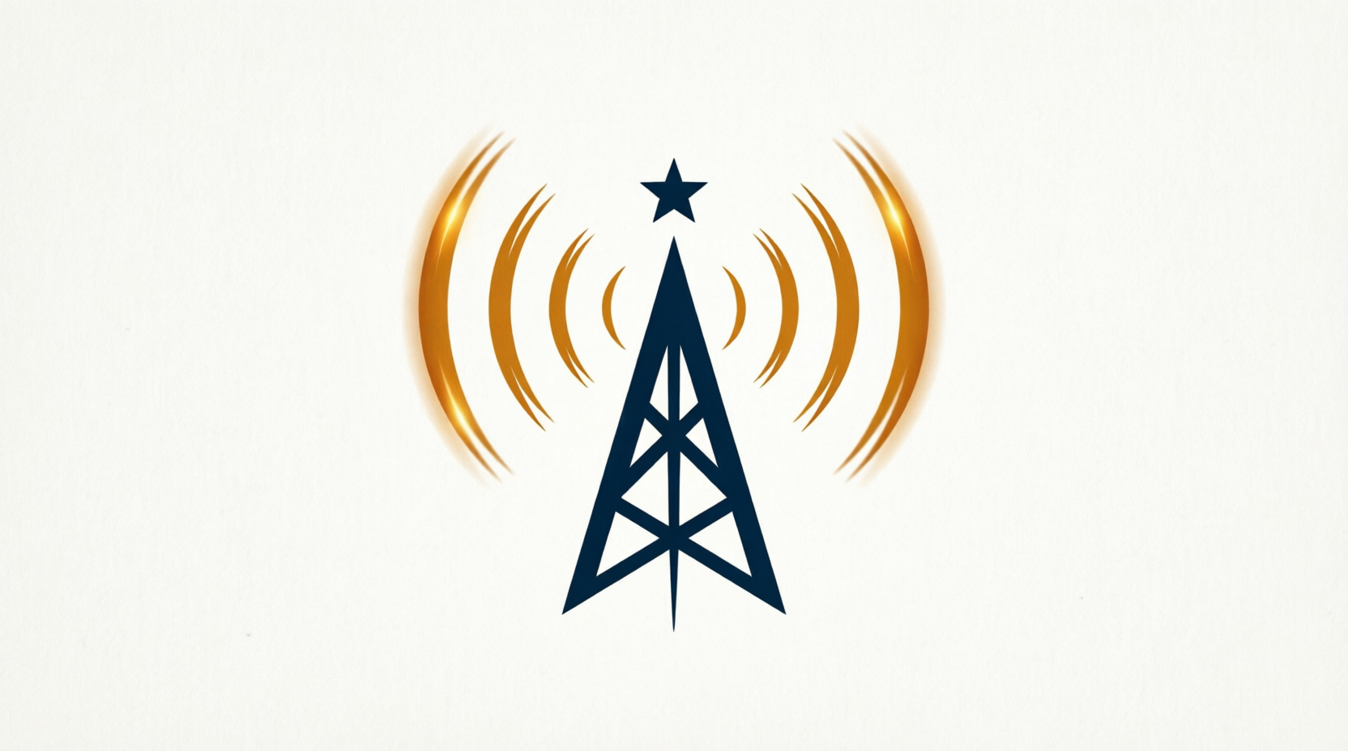

ARTISTS UNLIMITED · THE LIVE EXCHANGE · SHACK NEWS NETWORK
ARTIST STATEMENT — AUGUST 2026
Canary Artist — ART-0000
Item | Outlet | Gross | Commission | Net
Canary Print | OUT-000 | 100.00 | 30.00 | 70.00

Artist Net Payable: £70.00
Paid within 7 days of month-end from the Santander Client Account.

