**LUNA: A Low Cost Near-UV Laser Communication System for high-speed secure data transfer to remote areas.**

Ayush Nayak

Westview High School

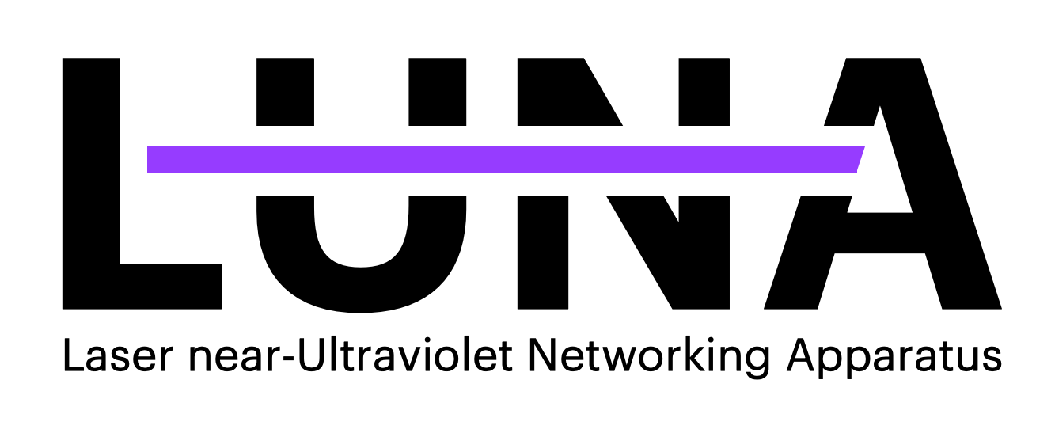

**Abstract:**

The Internet is easily the hallmark invention of the late 20th century, connecting people and powering our world to new levels of prosperity. Amid this, however, just under half of the world doesn’t use the Internet, with this figure is almost three quarters in rural areas. As prosperity and improving conditions are directly tied to it, broadcasting internet, and the ideas, information, education, and even entertainment that come with it to *everyone* should be humanities forefront goal. Unfortunately, in a world driven by money, small unprofitable remote areas – the areas that need the internet the most – are, outside of publicity stunts, left out of the conversation. This project aims to change that, creating a low cost Near-UV Laser based data transfer device that when daisy-chained over long distances can transfer data at extremely low costs across vast areas. It targets 100mbps data transfer over 20km, while staying under a per module cost of $250. I plan on beginning by starting with very manageable goals of just 20m and 20kbps, and fine tuning the laser pointing until it can reach expected speeds of 100mbps. Following this, I plan on moving farther out, and testing the maximum range of this laser. The structure of the project will be 3D printed with a hope that these modules can be produced anywhere cheaply, with the right laser components. With the equipment chosen theoretically able to go to gigabytes per second, I hope to get close to this even accounting for atmospheric events and error correction.

***Idea***

**Problem:**

Global internet uptake is around 59%. This relatively low number is primarily driven by off-the-grid rural communities, such as those deep in Africa, in remote areas of Asia, or north of the arctic circle, with adoption levels lower than 25% (S, 2021). Without a clear return on investment, telecoms often neglect in building expensive infrastructure in these places (Dada, 2021). Telecoms often face costs of upwards of $150,000 per cellular tower (Donkoh & Amponsah, 2017), and would obviously not want to supply to areas with extremely small populations and not much money.

**Current Approaches:**

Various approaches to this problem exist. Google’s Project Loon used high altitude balloons to provide cellular access over areas, but was extremely unreliable, slow (1MBits/s), and required high continued costs from Google (Burr, 2015). The project was shut down in 2021 due to a lack of commercial viability (Teller, 2021). Google spun off part of Loon to create a solution to connect hard to reach cities together with laser tech, however this project per module costs over $10,000, and was more geared towards commercialization in large areas, across shorter distances, than low-cost long-range transmission (Burr, 2015). SpaceX’s StarLink seems like a viable solution, but has many shortcomings. StarLink itself, at full capacity can only support 25 million users, however, as many of the satellites are over oceans most of the time, it can reasonably only provide half of this (Kan, 2021). At the same time, StarLink is dangerous, projected to be responsible for 90% of near misses between spacecraft (Marqardt, 2021). For highly remote communities, a $99 fee a month, is an exorbitant expenditure, with the $499 startup cost high as well (Order Starlink, 2021). The problems with StarLink are only multiplied for other satellite systems, which are more limited, less commercialized at scale and thus costlier, and just as dangerous.

**Solution:**

I will create a high data rate laser-based system using a pair of Near-UV Lasers. These utilize an electromagnetic frequency which isn’t harmful and isn’t overly disturbed by the sun (Garner, 2017). The beam diameter of these lasers is magnified, so they won’t be as perturbed by dust or other atmospheric aerosols while traveling through the air. These beams are shot into high-polling-rate photoresistors, which can detect data being sent. With a switching speed of around 10ns for both the lasers and the heads, speeds of up to 100-200mbps can be achieved. The range of such a system is around 10-20 km between each “repeater”. The cost of each system is around $200 for a transmitter/receiver. For settlements around 100km from a connected town or city, only $2000 would be needed as a one-time expense to link faraway areas to cities - orders of magnitude in cost less than systems by Google, and over time easily beating overpriced Satellite offerings like SpaceX. The system would also have higher range and over 100x less cost than standard 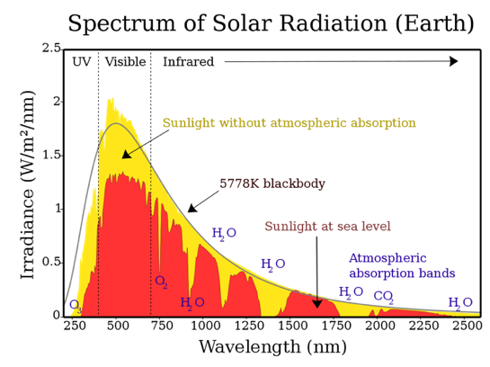implementations of long-range wireless technology such as Cellular towers.

**Approach:**

1. **Laser Selection**

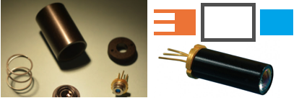The 488nm wavelength was chosen for its relative safety (hence near-UV), the low cost of laser heads at that frequency, as well as photodetectors and filters (Reichow, 2006). Looking at Sunlight at sea level, (the red in the top image), close to 450nm, there is a sharp drop-off in irradiance. The Sharp GH04850B2G 488nm laser was chosen for meeting the specifications required by this project (Sharp, 2020), which are a high output wattage per area, through having an extremely low divergence (angle of beam spread over distance) of 0.07mrad (LaserPointer, 2019). The laser is collimated by a DTR-G-3 (reducing divergence right outside of a lens with an initial lens), reaching this 0.07 mrad number. (Photonlexicon, 2018). The DTR-G-3 is attached to a printed housing via compatible threading, and the laser diode itself is inserted into the other edge. In the diagram, one which shows models for housing parts, the second which is a simplified image of how the parts (the blue being the collimator and the orange being the lens) and the bottom right image showing a similar final assembly with the collimator and lens.

1. **Building beam expander**

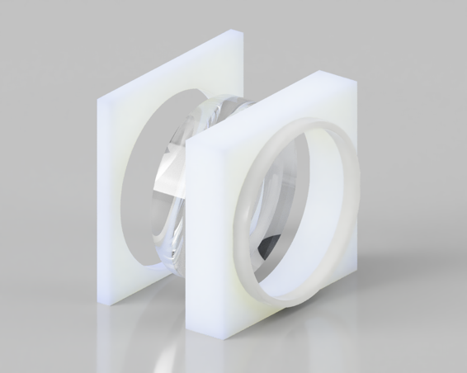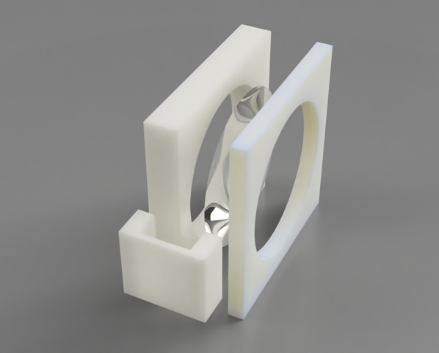After almost 10km, divergence plays a huge role in how large the spot will be. Thus, a beam expander is used, to reduce this (Duerr, 2016). The equation for beam expansion is: (Smith, 2000), (Greivenkamp, 2004). The beam expansion itself is done with a pair of lenses, a 50mm Thorlabs N-BK7 Uncoated Plano-Convex lens with a 500mm focal length and a TechSpec 6mm diameter lens with a -12mm focal length for a 35.7x reduction in divergence through expansion (Thorlabs, n.d.). The calculated beam divergence was around 0.002mrad, meaning that the final diameter of the beam, assuming a maximum beam diameter out of the expander of 50mm, after 20,000km is 90mm with the final area of the beam at the receiver being 6,361 mm2. Considering the 55mW inputted, the 8.645 Watts per square meter calculated figure is significantly higher than the sun’s energy at 488nm. This makes it extremely clear when the laser is either on or off, as long as a transmitter can pick up the information. Both lenses are fit into 3D printed housings, which contain two halves in order to fully and securely contain the lenses. For testing these can then be moved to adjust focal distance and alignment. The diagrams are shown below of the larger lens and the smaller lens, with their 3D enclosures. Glue or printed holders keep the two sides together. The laser head itself with the collimator is housed inside of its own 3D printed housing raising it up so that the output beam can be at the right level for the larger final lens.

1. **Controlling Laser at high frequencies with Diode Driver**

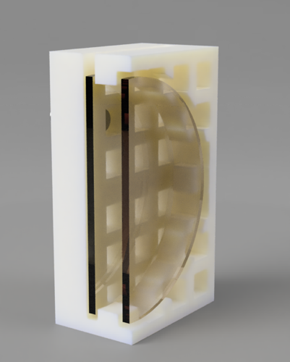Arduinos can’t independently switch high currents at around 10-20ns (Arduino, n.d.), and instead need another piece of hardware called a Diode Driver to switch the laser. For initial testing, the 100 kHz LPLDD-1.5A-12V driver is used (Opt Lasers, n.d.). This is a cheaper easier to drive product that’s useful for initial assembly and testing. The module for use in the final build is a Renesas ISL78365ARZ-T7A which can go up too 130MHz (Renesas, 2016). While being inexpensive as well, it requires more complicated wiring, and will be utilized after the other hardware has been initially validated. The laser head is wired directly to the driver, which powers and modulates it. The laser driver can receive data from the Arduino, and power from the solar array. The LPLDD is housed inside of the 3D printed enclosure, with the Renesas on a breadboard with the Arduino. The Arduino DUE is used as a controller board, for its high power and ability to handle the data transmission, decoding and encoding, as well as error correction. It is wired directly to the power array. A wiring diagram is provided later in the text.

1. **Receiving laser power**

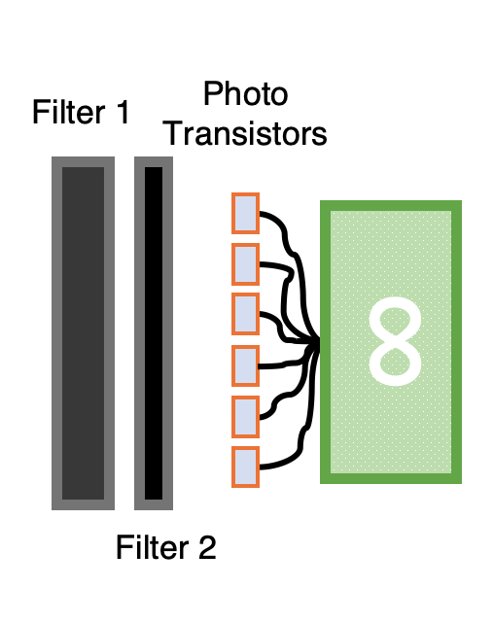In order to receive a signal from a faraway distance, extremely sensitive phototransistors are utilized, as they have high sensitivity to light, and can switch more quickly than photoresistors or other sensors (Lynch, Marchuk, & Elwin, 2015). The Osram SFH3410 was chosen, as it has high sensitivity around 480nm, and also has high enough switching rate to easily be able to detect 20 ns changes in the laser (Osram Opto Semiconductors, 2021). An astronomical filter, one which limits the frequency of incoming light around 488nm allows only the light frequencies at or around 488nm to pass through exactly where the laser should literally outshine all other sources. Another filter if needed, clear but for durability reasons could also be installed, but most likely this won’t be needed. The filter(s) are mounted in a 3D printed bracket, similar to those used with the lenses. A 3D printed backplate with many cutouts for phototransistors is used to house the array of them, as seen in the cross section. The phototransistors are connected to the Arduino, as seen in the diagram. Both the phototransistors and the laser are connected to the same Arduino DUE, which is connected to a supplied MacBook Pro for programming.

1. **Solar Assembly**

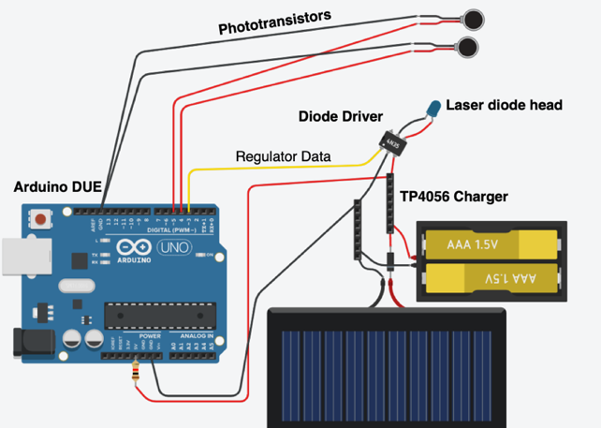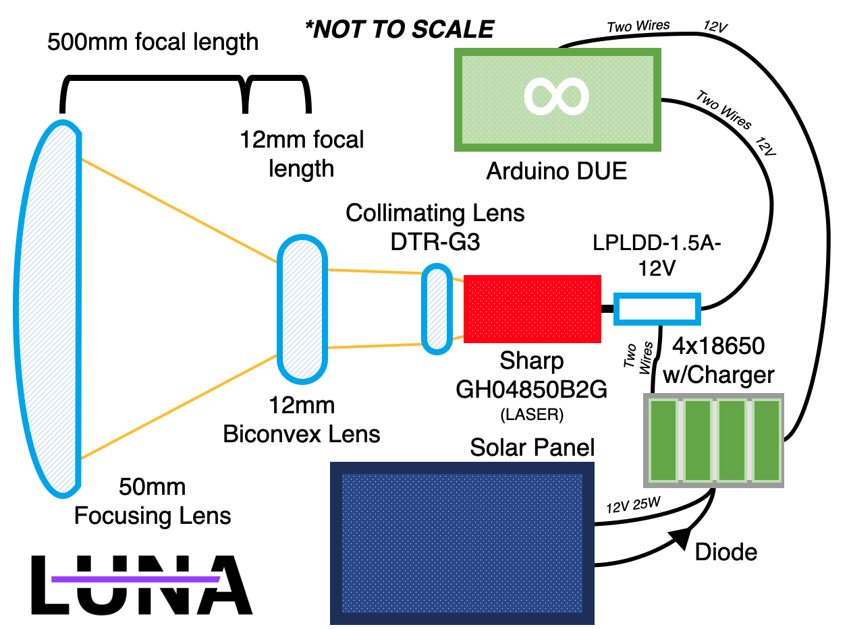This entire system is powered by solar energy. As a reliable, efficient, and powerful yet cost effective solar solution, the ECO-WORTHY 25W 12V (Eco-Worthy, n.d.) board is chosen, for being relatively inexpensive and high powered. This are connected to a diode and TP4056 battery charge, which has an array of four 18650 cells, and should provide enough battery power for three cloudy days and nights to this system in case of failure. The parts themselves are only used once the setup moves outside, in which case they are mounted on a metal bracket, and connected to the 3D printed part.

A 3d printed enclosure houses the Diode modulator, the laser head, and the collimating lens. The other parts are placed in their own 3D enclosures. A wiring diagram is shown below:

1. **Mounting**

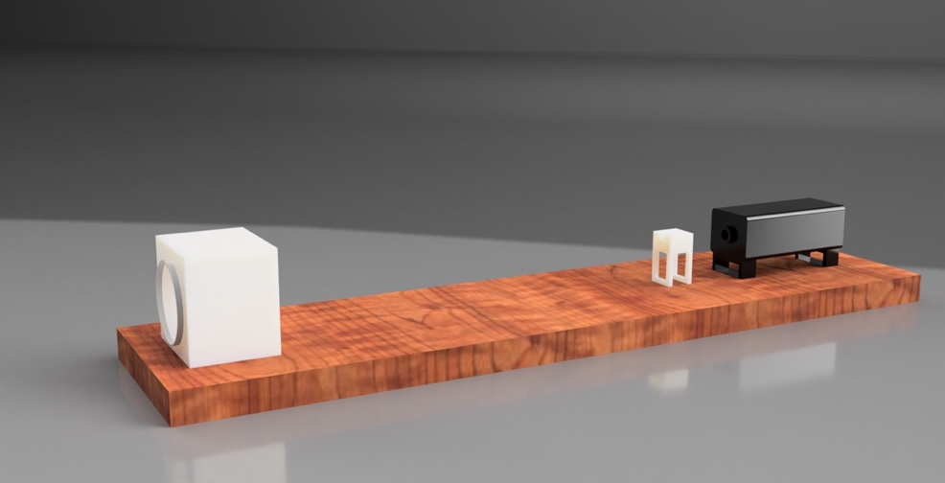After around 10km, the optimal height for both towers to project is 10m (Stern, 2014). It would allow transmitters to transmit over obstacles, even accounting for the earth’s curvature. For the purposes of this proposal, a simple Celesteron telescope mount will be used. Telescopes have the same needs as this system, extremely small movement causing huge inaccuracy, and since the curvature of the Earth isn’t a factor over just 5-6 km, the initial testing distance of this project, the curvature of the Earth isn’t a huge consideration. For the 10km test, the telescope mounts can be on top of platforms or hills without obstruction. A platform is shown to the right, this is mounted via screws onto the Telescope mount.

**Goals/ Timeline:**

My project is evaluated on three metrics, Distance, Data Transmission Rate, and Accuracy. Distance is easily measured, data transmission rate is in hertz, switches seen by the receiver per second. Accuracy is measured in the percent of dropped bits. Error correction will be heavily applied, but having decent initial figures and a high transmission rate, always translates to better outcomes later. I plan on testing my project by recording data through the receiver, to the Arduino, and comparing this data to the initial bit string inputted to the laser.

*Goal 1: Super short distance (2 weeks):* This is quite simple, getting the receiver above 90% accuracy, at just 10kHz from a distance of 1 meter. This is more for testing that the technology works, and making sure that the parts themselves are functioning properly.

*Goal 2: Still short, but hypersonic (5 weeks):* 100 m, with 90% accuracy, but now at 100 kHz.

*Goal 3: Not-so-short, but not hypersonic (6 weeks):* As moving out might pose some problems for maintaining ultrafast speed, so at the 250 m test, only 100 kHz is desired. Aiming and solar panels will be added into the package. Tested down an unfinished road very close to my house.

*Goal 4: Even-not-so-shorter (8 weeks):* 500m, 100 kHz, 90% accuracy, here the package will be basically finished. Tested in a 2km wide natural preserve less than a 1-minute drive away.

*Goal 5: Almost done… (9 weeks):* 1km, 15 mHz, 90% accuracy. This uses the Renesas module.

*Goal 6: Stage 1 - COMPLETE (10 weeks):* 5km, 50 mHz, 95% accuracy. This will be completion of the project, but to verify the claims of 200mbps at 10km, I’m projecting another 5 weeks, crossing the one semester mark. This isn’t due to building the tech being hard, but just separating more than 5 km being hard, and taking up lots of time to find locations and transport. I’m planning on testing 2 km – 5 km at the top of a park, and transmitting between hills, however going to 10km or more requires multiple parks and lots of weekend driving.

*Goal 9: And beyond… (15 weeks):* 10km, 100 mHz, 95% accuracy

Before Goal 1, I plan on recording daily photos of what’s working and what’s not been built. After Goal 1, I plan on recording which parts are functioning as intended as well as the accuracy, max transfer rate, and distance I was able to get that day. I plan on photographing the machine often, and hourly Git commits for documenting code progress.

**Risks:**

To me there are three clear risks. Light fog or clouds of dust won’t hinder the machine, but heavy rain would require the final model to have a waterproof exterior to not be damaged, and even so, the downpour would block out the laser beam rendering it mostly inoperable. There is no real solution to water droplets, as they don’t just block parts of the light, but actively refract it. Across many areas where deployment of these makes sense, such as Sub-Saharan Africa, this should not be a problem, as there are few heavily rainy days. The second issue, is interference not by weather, but blunt force damage by flying objects, or animals. These transmission layers are not particularly fragile and should resist most blunt force, but being around 20 km apart, this would mean any servicing is quite time consuming. The poles should be high enough and study enough that land-based animals should not be able to disturb them. Finally, the final beam diameter is only 10cm, which aimed from almost 5 km away would be somewhat hard to do. I plan to mitigate this by using a large already owned telescope also mounted to the same mount, to attempt to view the other stand, allowing for a visual way too align, which is also very sensitive to small movements.

**Current Progress:**

As of right now, I’ve designed the optics and created CAD models of many parts I would need to 3D print, as well as done wiring diagrams. I haven’t bought or assembled anything yet however. Funding from THINK would greatly improve my ability to actually fabricate this machine, as it’s hard to request over $700 for projects such as this. I’ve also not done too much optics and laser work before, and I believe THINK mentorship could greatly improve my ability to actually carry out this project, as I believe the idea is extremely viable, and wish to have appropriate mentorship to complete it. The intended costs for creation are around $500, as both a relatively expensive telescope mount, and (as I learned from Lego days) many spare parts are required. Once the design is fine-tuned, the $200 combo for transmitter and receiver can be achieved.

**Budget:**

|  |  |  |
| --- | --- | --- |
| *Part Name* | *Price* | *Description* |
| Module Construction | | |
| 10LF10-488 Astronomical Filter | *$51\** | Filter |
| Arduino DUE x2† | *$80* | Processing |
| Sharp 488nm GH04850B2G | *$35* | Laser |
| ECO-WORTHY 25W 12V | *$33* | Solar Panel |
| OSRAM SFH 3410-Z x30 | *$30* | Diode |
| Renesas ISL78365ARZ-T7A | *$21* | Diode Driver (Production) |
| 18650 Batteries x10 | *$20* | Batteries |
| Basic Electronics Components Set | *$14* | Wires, Resistors, Capacitors and Diodes |
| 6mm, 14mm focal Concave Lens | *$24* | Initial lens |
| 50mm, 500mm focal Thorlabs | *$21* | Final lens |
| TP4056 | *$8* | Charging set |
| Testing and Initial Parts | | |
| Creality Ender 3 Pro | *$250* | 3D Printer |
| Celesteron Alt-Azimuth Mount x2 | *$200* | Telescope Mount |
| LPLDD-1.5A-12V Diode | *$43* | Diode Driver (Test) |
| Creality Ender 3 Filament | *$26* | 3D Printer “Ink” |
| Laser Safety Goggles | *$12* | Safety First! |
| Plywood Assorted | *$10* | For screwing things into and initial testing |

***\*This product is quoted around $15 for most customers as a clearance product (70% off), however the “regular price” is $51 so that is used.***

***†There are two Arduinos, one is connected to the solar array to test it and the laser diode, the other is connected to a computer and on the receiver end (for the phototransistors)***

***Total: $878***

**Interest and Qualifications:**

I have

# **Bibliography**

Arduino. (n.d.). *Arduino Due*. Retrieved from Arduino: https://www.arduino.cc/en/pmwiki.php?n=Main/arduinoBoardDue

Burr, J. (2015). *The Feasibility of Google's Project Loon.* Retrieved from http://users.cecs.anu.edu.au/~Chris.Browne/student_work/example_work/15_2226_lp_jamesb.pdf

Dada, B. (2021, May 14). *Elon Musk’s Starlink presence in Africa and how that affects Telcos*. Retrieved from Benjamin Dada: https://www.benjamindada.com/elon-musks-starlink-presence-in-africa-and-the-telco-dilemma/

Donkoh, E. K., & Amponsah, S. K. (2017). Hexagonal Tessellation Model for Masting GSM Antenna; A Case Study of MTN Kumasi- East, Ghana October 2017International Journal of Applied Mathematics 30(1) Project: Generalized frequency re-use for uniform and non uniform cell range in telecommunication . *International Journal of Applied Mathematics*.

Duerr, T. (2016, October 31). *SPIE.* Retrieved from Direct design of laser-beam shapers, zoom-beam expanders, and combinations thereof: https://www.spiedigitallibrary.org/conference-proceedings-of-spie/10021/100210K/Direct-design-of-laser-beam-shapers-zoom-beam-expanders-and/10.1117/12.2245400.short?SSO=1

Eco-Worthy. (n.d.). *25W 12V Polycrystalline Solar Panel*. Retrieved from ECO-WORTHY: https://www.eco-worthy.com/products/25w-12v-polycrystalline-solar-panel

Garner, R. (2017, November 27). *NASA*. Retrieved from Solar Irradiance: https://www.nasa.gov/mission_pages/sdo/science/solar-irradiance.html

Greivenkamp, J. (2004). *Field Guide to Geometrical Optics.* SPIE Press.

Kan, M. (2021, March 15). *What Is Starlink? SpaceX's Much-Hyped Satellite Internet Service Explained*. Retrieved from PCMag: https://www.pcmag.com/how-to/what-is-starlink-spacex-satellite-internet-service-explained

LaserPointer. (2019, November 21). *What's the divergence on the Sharp 488nm GH04850B2G 55mW Laser Diode*. Retrieved from LaserPointer: https://laserpointerforums.com/threads/hows-the-divergence-on-the-sharp-488nm-gh04850b2g-55mw-laser-diodes.105912/

Lynch, Marchuk, & Elwin. (2015). *Embedded Computing and Mechatronics with the PIC32 Microcontroller.* Science Direct.

Marqardt, A. (2021, December 28). *A SpaceX sattelite controversy is ading to Elon Musk's bad year in China*. Retrieved from Fortune: https://fortune.com/2021/12/28/spacex-satellite-near-miss-elon-musk-china-tesla/

Opt Lasers. (n.d.). *LPLDD-1.5A -12V Laser Diode Driver*. Retrieved from Opt Lasers: https://optlasers.com/medium-power-drivers/lpldd-15a-12v

*Order Starlink*. (2021). Retrieved from Starlink: https://www.starlink.com/

Osram Opto Semiconductors. (2021, June 29). *Smart DIL SFH 3410.* Retrieved from OSRAM Opto Semiconductors: https://www.osram.com/ecat/Smart%20DIL%20SFH%203410/com/en/class_pim_web_catalog_103489/prd_pim_device_2219680/

Photonlexicon. (2018, February 01). *Photonlexicon*. Retrieved from Photolexicon Forums: https://laserpointerforums.com/threads/hows-the-divergence-on-the-sharp-488nm-gh04850b2g-55mw-laser-diodes.105912/

Reichow, C. E. (2006). ULTRAVIOLET AND SHORT WAVELENGTH VISIBLE LIGHT EXPOSURE: WHY ULTRAVIOLET PROTECTION ALONE IS NOT ADEQUATE. *JOURNAL OF LONG TERM EFFECTS OF MEDICAL IMPLANTS*. Retrieved from Ultraviolet and short wavelength visible light exposure: why ultraviolet protection alone is not adequate: https://pubmed.ncbi.nlm.nih.gov/17073573/

Renesas. (2016, October 20). *ISL78365 Data Short.* Retrieved from Mouser Electronics: https://www.mouser.com/datasheet/2/698/REN_isl78365_SDS_20160308-1713544.pdf

S, O. (2021, December 9). *Estimated share of individuals using the internet worldwide and in rural and urban areas in 2020, by regional type*. Retrieved from Statista

Sharp. (2020, June 22). *Specifications GH04850B2G Laser Diode.* Retrieved from Socle-Tech: http://www.socle-tech.com/doc/IC%20Channel%20Product/SHARP_LASER/GH04850B2G.pdf

Smith, W. (2000). *Modern Optical Engineering, Third Edition.* SPIE Press.

Stern, D. (2014, April 1). *Distance to the Horizon*. Retrieved from NASA: https://pwg.gsfc.nasa.gov/stargaze/Shorizon.htm

Teller, A. (2021, January 1). *Loon's Final Flight.* Retrieved from X Company Blog: https://blog.x.company/loons-final-flight-e9d699123a96?gi=b6d6e2096325

Thorlabs. (n.d.). *N-BK7 Plano-Convex Lenses (Uncoated)*. Retrieved from Thorlabs: https://www.thorlabs.com/newgrouppage9.cfm?objectgroup_id=112

IMAGES:

<https://www.amstechnologies-webshop.com/media/image/e1/2b/bc/HULDO-Laser-Diode-Collimators-OZ-Optics_600x600.jpg>

<http://www.optima-optics.com/ld_kit3.htm>