**LUNA: A Low Cost 480nm Laser Communication System for high-speed secure data transfer to remote areas.**

Ayush Nayak

Westview High School

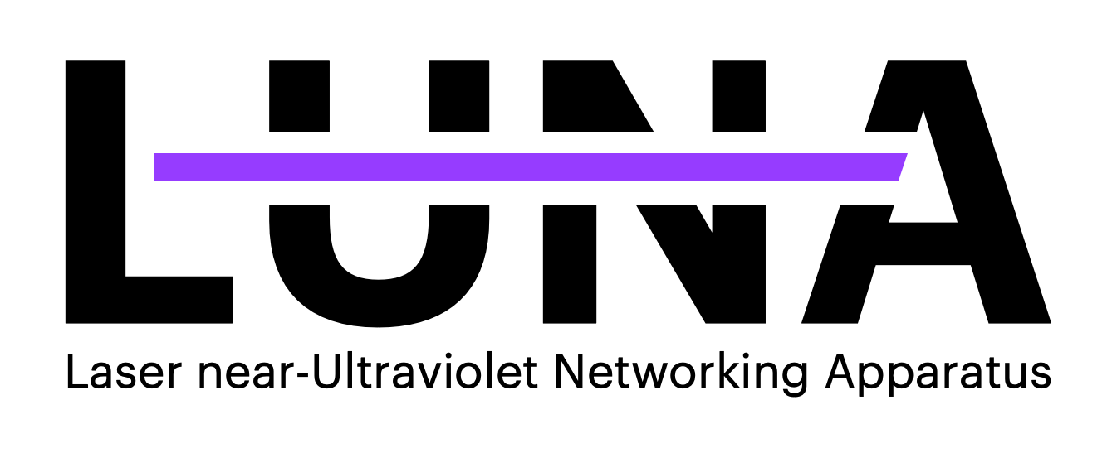

**Abstract:**

The Internet is easily the hallmark invention of the late 20th century, connecting people and powering our world to new levels of prosperity. However, just under half of the world doesn’t use it, sometimes reaching three quarters of the population in especially rural areas. As internet access means prosperity, information, ideas and education, humanities forefront goal should be projecting the internet to *everyone*. Unfortunately, in a world driven by money, small remote areas – the areas that need the Internet the most – are unprofitable and left out of the conversation. This project aims to change that, creating an extremely low-cost Laser based data transfer device that when chained together over long distances can transfer data across vast areas. I plan on starting with very manageable goals of just 20 meters of separation distance and 20kbps of data speed, and testing and refining the device until it can reach expected speeds of 100mbps. Following this, I plan on moving farther out, testing the maximum range of this laser. Most of the project will be 3D printed with a hope that it can be replicated anywhere rapidly and cheaply. One of my major goals is also to create a system capable of telling operators how to move lasers into optimal positions, as well as figuring out how to best mitigate atmospheric effects. With the parts chosen theoretically capable of handling data in the range of gigabytes per second, even accounting for atmospheric events and error correction I hope to get close to these speeds. A 100mpbs goal should be feasible given budget, and time constraints.

**Problem:**

Telecommunications companies (telecoms) often neglect in building expensive infrastructure in off-grid rural areas (Dada, 2021). Consequently, many of these places have internet adoption levels lower than 25% (S, 2021). Telecoms often spend upwards of $150,000 per cellular tower (Donkoh & Amponsah, 2017), and such costs could not be economically justified to supply relatively poor small populations. No solution currently exists to transfer data to these areas cheaply.

**Current Approaches:**

Various approaches to this problem exist. Google’s Project Loon used high altitude balloons to provide cellular access over areas, but was extremely unreliable, slow (1MBits/s), and required high continued costs from Google (Burr, 2015). The project was shut down in 2021 due to a lack of commercial viability (Teller, 2021). Google spun off part of Loon to create a solution to connect hard to reach cities together with laser tech, however this project costs over $10,000 per module, and was more geared towards commercialization in large areas, across shorter distances, than low-cost long-range transmission. SpaceX’s Starlink seems like a viable solution, but has many shortcomings. Starlink itself, at full capacity can only support 25 million users, however, as many of the satellites are over oceans most of the time, it can reasonably only provide half of this at any given time (Kan, 2021). At the same time, Starlink satellites pose a dangerous risk in orbit as they are projected to be responsible for 90% of near misses between spacecraft (Marqardt, 2021). For highly remote communities, Starlink’s $99 monthly fee, is an exorbitant expenditure, coupled with the $499 startup cost. (Order Starlink, 2021). Other similar-purpose satellite systems face the same problems as Starlink, only they are more expensive due to a smaller scale and customer base.

**Solution:**

I will create a high-data-rate laser-based system using a pair of lasers which utilize an electromagnetic frequency that is harmless and is mostly undisturbed by the Sun (Garner, 2017). The beam diameter of these lasers is magnified, so dust or other atmospheric aerosols are less can block less of the beam itself while the light is traveling through the air. These beams are aimed into high-polling-rate phototransistors, which can detect data being sent. With “reaction times” of around 10ns for both the lasers and the receivers, data transfer speeds of up to 100-200mbps can be achieved. The range of such a system is around 10-20 km between each “repeater”. The cost is around $200 for a transmitter/receiver. With low powered lasers, power consumption can entirely be handled by Solar Power. Upkeep should be minimal, but with the low cost of parts, expecting around $30-$40 in maintenance per year isn’t unreasonable. For settlements around 100km from a connected town or city, around $2000 would be needed as a one-time expense to link faraway areas to cities. Even factoring in upkeep, this cost is orders of magnitude in cheaper than systems by Google, and over time surpassing satellite offerings like SpaceX’s Starlink. The system would also have higher range and cost two orders of magnitude lower less than more traditional implementations of long-range wireless technology such as cellular towers. One of my major goals with 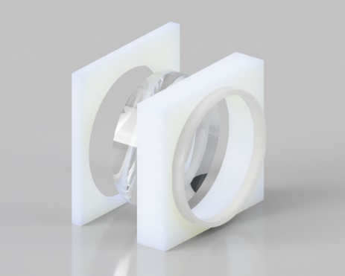this project, is also to create a system capable of telling operators how to 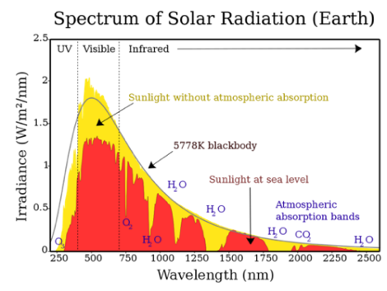move lasers into optimal positions, and figuring 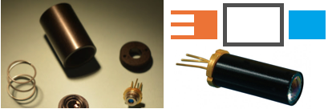out how to best mitigate atmospheric effects.

**Approach:**

***Laser Selection:***

The 488nm wavelength was chosen for its relative safety and low cost of laser diodes phototransistors and filters at that frequency, as well as phototransistors and filters (Reichow, 2006). At sea level, there is a sharp drop-off in irradiance of sunlight close to 450nm (The red in the top image). The Sharp GH04850B2G 488nm laser was chosen for meeting the specifications required by this project (Sharp, 2020), which are a high output wattage per area, through having and an extremely low divergence (angle of beam spread over distance) of 0.07mrad after collimation (reducing divergence right outside of a lens with an initial lens) (LaserPointer, 2019) (Photonlexicon, 2018). More power could be useful, but this low powered low divergence lens should better deliver power than a higher power higher divergent lens (as higher-powered lenses are more divergent) The DTR-G-3 is attached to a printed housing via compatible threading, and the laser diode itself is inserted into the other edge. In the diagram, one which shows models for housing parts, the second shows a simplified image of how 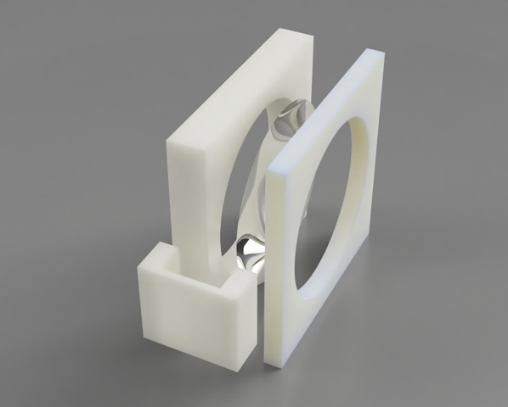the parts (the blue being the collimator and the orange being the lens) fit together, and the bottom right image showing a final assembly similar to the one proposed.

***Building beam expander:***

After almost 10km, divergence plays a huge role in how large the laser spot will be. Thus, a beam expander is used, to reduce divergence, and increase beam size (Duerr, 2016). Beam expansion is given by $\frac{Input Beam Divergence (θ_{I})}{Output Beam Divergence(θ_{I})}=\frac{Output Beam Diameter (D_{O}) (Focal Length Can be Used)}{Input Beam Diameter (D_{I}) (Focal Length Can be Used)}$ (Smith, 2000), (Greivenkamp, 2004). The beam expansion itself is done with a pair of lenses, a 50mm Thorlabs N-BK7 Uncoated Plano-Convex lens with a 500mm focal length and a TechSpec 6mm diameter lens with a -12mm focal length. Using the above equation this gives a total 35.7x reduction in divergence through expansion (Thorlabs, n.d.). The calculated beam divergence after expansion was around 0.002mrad, meaning that the final diameter of the beam after 20,000km, assuming a maximum beam diameter out of the expander of 50mm, is 90mm. The final area of the beam at the receiver is 6,361 mm2, and considering the 55mW inputted, 8.645 Watts per square meter at the receiver is significantly higher than the sun’s energy at 488nm. This makes it extremely clear when the laser is either on or off, as long as a transmitter can pick up the information. Both lenses are mounted in 3D printed housings, which contain two halves in order to fully and securely contain the lenses. For testing these can then be moved to adjust focal distance and alignment, and later a fixed housing can be developed. The diagrams shown are of the larger lens and the smaller lens, with their 3D enclosures. Glue or the printed holders as seen in the Fusion360 render keep the two sides together. The laser head itself with the collimator is housed inside of its own 3D printed 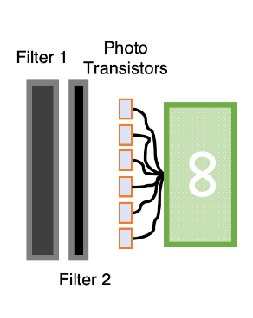housing raising it up so that the output beam can be at the right level for the larger final lens.

***Controlling Laser at high frequencies with Diode Driver:***

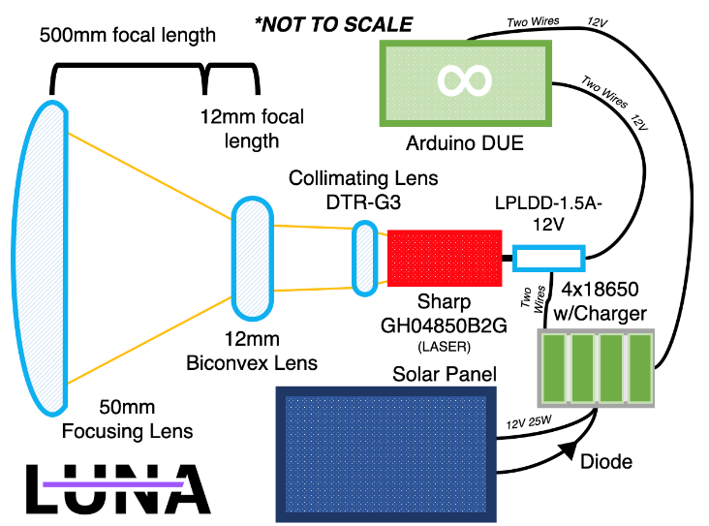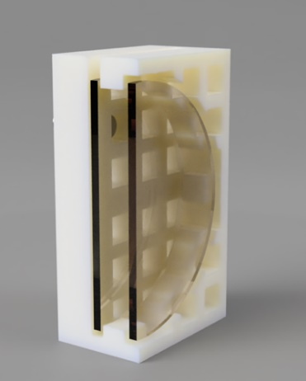Arduinos can’t independently switch high currents at around 10-20ns (Arduino, n.d.), and instead use another piece of hardware called a Diode Driver to switch the laser. For initial testing, the 100 kHz LPLDD-1.5A-12V driver is used (Opt Lasers, n.d.). This is a cheaper easier to drive product that’s useful for initial assembly and testing. The module for use in the final build is a Renesas ISL78365ARZ-T7A which can reach up to 130MHz (Renesas, 2016). While also being inexpensive, it requires more complicated wiring, and will be utilized after the other hardware has been initially validated. The laser head is wired directly to the driver, which powers and modulates it. The laser driver can receive data from the Arduino, and power from the solar array. The LPLDD is housed inside of the 3D printed enclosure with the Arduino. The Arduino DUE is used as a controller board, for its high computing power and ability to handle the data transmission, decoding and encoding, as well as error correction. The Arduino is wired directly to the battery array. 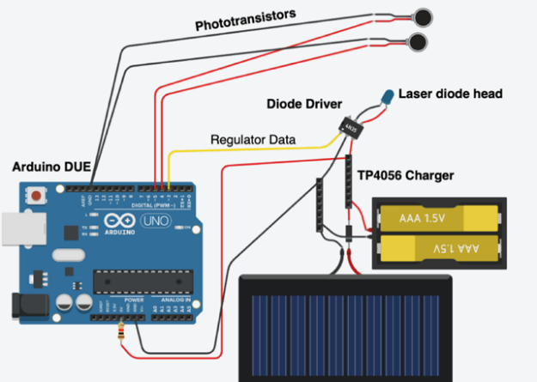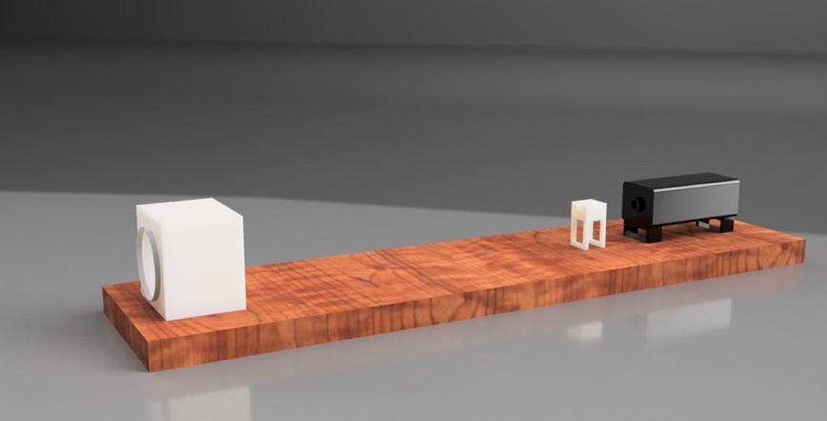In order to receive a signal from a faraway distance, extremely sensitive phototransistors are utilized, as they have high sensitivity to light, and can switch more quickly than photoresistors or other photosensors (Lynch, Marchuk, & Elwin, 2015). These sensors signals can be connected to the Arduino modules and used to decode the initial message. The Osram SFH3410 was chosen, as it has high sensitivity around 480nm, and also has high enough switching rate to easily be able to detect 20 ns changes in the laser (Osram Opto Semiconductors, 2021). An astronomical filter, one which limits the frequency of incoming light around 488nm allows only the light frequencies at or around 488nm to pass through exactly where the laser will outshine all other sources. The filter(s) are mounted in a 3D printed bracket, similar to those used with the lenses. A 3D printed backplate with many cutouts for phototransistors is used to house the array of them, as seen in the cross section. The phototransistors are connected to the Arduino, as seen in the diagram. Both the phototransistors and the laser are connected to the same Arduino DUE, which is connected to a supplied laptop for programming. LoRA modules are connected directly to the Arduino(s). (To keep the diagram clean, these are not shown in the wiring diagram, although LoRA projects are common, and a standard setup is used) Also note the diagram uses an UNO instead of a Due as the software used only had UNO’s.

***Solar Assembly:***

For almost no maintenance and external energy needs, solar is used. The Arduino Due draws around 3W and the lasers themselves pull 55 mW, the diode driver pulling a maximum of 5W (but for such a low powered laser, much less than this is expected). Thus, as a reliable, efficient, and powerful yet cost effective solar solution, the ECO-WORTHY 25W 12V (Eco-Worthy, n.d.) board is chosen, for being relatively inexpensive and working well with the parts required. This is connected to a diode and TP4056 battery charger, which has an array of four 3.7v 3000mah 18650 Samsung cells in the 1s4p configuration, and should provide enough battery power for three cloudy days and nights to this system in case of failure. A 3D printed enclosure houses the Diode modulator, the laser head, and the collimating lens. The other parts are placed in their own 3D printed enclosures. Radio modules for guiding aim can be attached on the outside of enclosures. These radios communicate information such as intensity of the phototransistors, and can be used to test whether a strong signal has been created. Radios at such a distance are very slow, and only used to help pinpoint aim properly, and optimize data rates during weather events.

***Mounting:***

After around 10km, the optimal height for both towers to project is 10m (Stern, 2014). It would allow transmitters to transmit over obstacles, even accounting for the earth’s curvature which was calculated. Early on in testing, clamps will be used to keep individual housings to a table for testing. For more advanced testing, a two simple Celesteron telescope mounts will be used, one for the receiver and one for the transmitter (in the final design, each module will house two transmitters and receivers for two-way data transfer, but for testing only one is needed of each). Telescopes have the same needs as this system, extremely fine pointing, and so one is used to finely tune aiming for the testing portion. Since the curvature of the Earth isn’t a huge factor over just 5-6 km, it isn’t a huge consideration for the testing phases of this project. . **Goals & Timeline:**    
 My project is evaluated on three metrics, Distance, Data Transmission Rate, and Accuracy. Distance is easily measured, data transmission rate is in hertz, switches seen by the receiver per second. Accuracy is measured in the percent of dropped bits. Error correction will be heavily applied, but having decent initial figures and a high transmission rate, always translates to better outcomes later. I plan on testing my project by recording data through the receiver, to the Arduino, and comparing this data to the initial bit string inputted to the laser. As once I’ve initially built the device, outside of aiming and testing laser specifications, it would be boring to just make higher and higher goals, I’ve decided many of my goals will be attacking bad weather situations, and figuring out how to create an aiming system, through LoRa. While I don’t have servos for durability reasons, communicating intensity information between transmitters can help operators change settings to aim properly.

*Goal 1: Super short distance (2 weeks):* This is quite simple, getting the receiver above 90% accuracy (no error correction), at just 10kHz from a distance of 1 meter. This is more for testing that the technology works, and making sure that the parts themselves are functioning properly.

*Goal 2: Still short, but high-speed (5 weeks):* 100 m, with 90% accuracy, but now at 100 kHz.

*Goal 3: Dust and rain (6 weeks):* 250m 90% variable speed. This is a test where the speed and intensity of the laser is modulated to attempt to see what data speeds and lens and intensity setups will allow transmission during dusty and rainy situations.

*Goal 4: Fully packaged (8 weeks):* 500m, 100 kHz, 90% accuracy, here the package will use all production parts. Tested in a 2km wide natural preserve less than a 1-minute drive away.

*Goal 5: Auto-Aiming (9 weeks):* 1km, 15 mHz, 90% accuracy. Here I attempt to use radio between transmitters and receivers in order to tell operators when the laser is pointed properly. *Goal 6: Stage 1 – COMPLETE (10 weeks):* 5km, 50 mHz, 99% accuracy (with error correction).  
This will be completion of the project, but to verify the claims of 200mbps at 10km, I’m projecting another 5 weeks, crossing the one semester mark. This isn’t due to building the tech being hard, but just separating more than 5 km being hard (finding locations and transport). Before Goal 1, I plan on recording daily photos of what’s working and what’s not been built. After Goal 1, I plan on recording which parts are functioning as intended as well as the accuracy, max transfer rate, and distance I was able to get that day. I plan on photographing the machine often, and regular Git commits for documenting code progress.

**Risks:**

To me there are three clear risks. Light fog or clouds of dust won’t hinder the machine, but heavy rain would block out the laser beam rendering it mostly inoperable, as they don’t just block parts of the light, but actively refract it. Across many areas where deployment of these makes sense, such as Sub-Saharan Africa, this should not be a problem, as there are few heavily rainy days. The second issue, is interference not by weather, but blunt force damage by flying objects, or animals. These transmission layers are not particularly fragile and should resist most blunt force, but being around 20 km apart, this would mean any servicing is quite time consuming. Finally, the final beam diameter is only 10cm, which aimed from almost 5 km away would be somewhat hard to do. LoRA aiming should help with this, but it’s still a consideration, and a risk when setting these up in a production environment.

**Current Progress & Think Funding/Mentorship Benefits:**

As of right now, I’ve designed the optics and created CAD models of many parts I would need to 3D print (the above are renders from Fusion360 projects, however I have many files already of other auxiliary parts), as well as checked tolerances and done wiring blueprints. I haven’t bought or assembled anything yet however. Funding from THINK would greatly improve my ability to actually fabricate this machine, as it’s hard to request over $700 for projects such as this. While final module costs are somewhat low, testing and building the module itself could get very expensive, and I’d like to talk to people in the field to understand how to best achieve what I need to do. I’ve also not done too much optics and laser work before, and I believe THINK mentorship could greatly improve my ability to actually carry out this project, as I believe the idea is extremely viable, the problem important and need appropriate mentorship to help solve it.

|  |  |  |
| --- | --- | --- |
| *Part Name* | *Price ($852)* | *Description* |
| Creality Ender 3 Pro | *$250* | 3D Printer |
| Celesteron Alt-Azimuth Mount x2 | *$200* | Telescope Mount(s) |
| Arduino DUE x2*\** | *$80* | Processing |
| 10LF10-488 Astronomical Filter | *$51*† | Filter |
| LPLDD-1.5A-12V Diode | *$43* | Diode Driver (Test) |
| 18650 Batteries (Samsung) | *$41* | Batteries |
| Sharp 488nm GH04850B2G | *$35* | Laser |
| ECO-WORTHY 25W 12V | *$33* | Solar Panel |
| OSRAM SFH 3410-Z x30 | *$30* | Diode |
| Creality Ender 3 Filament | *$26* | 3D Printer “Ink” |
| LoRa SX1278 SX1276 433MHz | *$25* | Radio |
| 6mm, 14mm focal Concave Lens | *$24* | Initial lens |
| 50mm, 500mm focal Thorlabs | *$21* | Final lens |
| Basic Electronics Components Set | *$14* | Wires, Resistors, Capacitors and Diodes |
| Laser Safety Goggles | *$12* | Safety First! |
| Clamps | *$10* | To hold to table. |
| TP4056 (Pack of 10) | *$8* | Charging set |

*\*There are two Arduinos, one is connected to the solar array to test it and the laser diode, the other is connected to a computer and on the receiver end (for the phototransistors)*

*†This product is quoted around $15 for most customers as a clearance product (70% off), however the “regular price” is $51 so that is used.*

**Interest:**

After uncountable defeats at the hands of mother nature, I became what I guess you could call a late-stage dreamer, someone who’s finally accepted that pretty much all cool ideas are inevitably going to be ended in some way or another by the insurmountable laws of the universe. However, probably the result of too much Star Wars and my inability to let go of the notion that one day the lightsaber *will* exist, lasers have been a fascination of mine for a long time. Throwing myself into the research, optics, laser focusing and electronics work, my prior experiences with telescopes and magnification led me to really enjoy tinkering with laser parameters and lens types to find that perfect match. As a self-diagnosed computer addict the ideas and principles of the internet, engaged me quickly, and spreading it to others especially those who could benefit immensely from it is incredibly important to me. Finally, there’s probably something that incites the inner sci-fi nerd in me about shooting concentrated energy across huge distances to transmit the fabric of modern communication and connect the rest of the world to the future of humanity. But that’s probably just me.

# **References**

Arduino. (n.d.). *Arduino Due*. Retrieved from Arduino: https://www.arduino.cc/en/pmwiki.php?n=Main/arduinoBoardDue

Burr, J. (2015). *The Feasibility of Google's Project Loon.* Retrieved from http://users.cecs.anu.edu.au/~Chris.Browne/student_work/example_work/15_2226_lp_jamesb.pdf

Dada, B. (2021, May 14). *Elon Musk’s Starlink presence in Africa and how that affects Telcos*. Retrieved from Benjamin Dada: https://www.benjamindada.com/elon-musks-starlink-presence-in-africa-and-the-telco-dilemma/

Donkoh, E. K., & Amponsah, S. K. (2017). Hexagonal Tessellation Model for Masting GSM Antenna; A Case Study of MTN Kumasi- East, Ghana October 2017International Journal of Applied Mathematics 30(1) Project: Generalized frequency re-use for uniform and non uniform cell range in telecommunication . *International Journal of Applied Mathematics*.

Duerr, T. (2016, October 31). *SPIE.* Retrieved from Direct design of laser-beam shapers, zoom-beam expanders, and combinations thereof: https://www.spiedigitallibrary.org/conference-proceedings-of-spie/10021/100210K/Direct-design-of-laser-beam-shapers-zoom-beam-expanders-and/10.1117/12.2245400.short?SSO=1

Eco-Worthy. (n.d.). *25W 12V Polycrystalline Solar Panel*. Retrieved from ECO-WORTHY: https://www.eco-worthy.com/products/25w-12v-polycrystalline-solar-panel

Garner, R. (2017, November 27). *NASA*. Retrieved from Solar Irradiance: https://www.nasa.gov/mission_pages/sdo/science/solar-irradiance.html

Greivenkamp, J. (2004). *Field Guide to Geometrical Optics.* SPIE Press.

Kan, M. (2021, March 15). *What Is Starlink? SpaceX's Much-Hyped Satellite Internet Service Explained*. Retrieved from PCMag: https://www.pcmag.com/how-to/what-is-starlink-spacex-satellite-internet-service-explained

LaserPointer. (2019, November 21). *What's the divergence on the Sharp 488nm GH04850B2G 55mW Laser Diode*. Retrieved from LaserPointer: https://laserpointerforums.com/threads/hows-the-divergence-on-the-sharp-488nm-gh04850b2g-55mw-laser-diodes.105912/

Lynch, Marchuk, & Elwin. (2015). *Embedded Computing and Mechatronics with the PIC32 Microcontroller.* Science Direct.

Marqardt, A. (2021, December 28). *A SpaceX sattelite controversy is ading to Elon Musk's bad year in China*. Retrieved from Fortune: https://fortune.com/2021/12/28/spacex-satellite-near-miss-elon-musk-china-tesla/

Opt Lasers. (n.d.). *LPLDD-1.5A -12V Laser Diode Driver*. Retrieved from Opt Lasers: https://optlasers.com/medium-power-drivers/lpldd-15a-12v

*Order Starlink*. (2021). Retrieved from Starlink: https://www.starlink.com/

Osram Opto Semiconductors. (2021, June 29). *Smart DIL SFH 3410.* Retrieved from OSRAM Opto Semiconductors: https://www.osram.com/ecat/Smart%20DIL%20SFH%203410/com/en/class_pim_web_catalog_103489/prd_pim_device_2219680/

Photonlexicon. (2018, February 01). *Photonlexicon*. Retrieved from Photolexicon Forums: https://laserpointerforums.com/threads/hows-the-divergence-on-the-sharp-488nm-gh04850b2g-55mw-laser-diodes.105912/

Reichow, C. E. (2006). ULTRAVIOLET AND SHORT WAVELENGTH VISIBLE LIGHT EXPOSURE: WHY ULTRAVIOLET PROTECTION ALONE IS NOT ADEQUATE. *JOURNAL OF LONG TERM EFFECTS OF MEDICAL IMPLANTS*. Retrieved from Ultraviolet and short wavelength visible light exposure: why ultraviolet protection alone is not adequate: https://pubmed.ncbi.nlm.nih.gov/17073573/

Renesas. (2016, October 20). *ISL78365 Data Short.* Retrieved from Mouser Electronics: https://www.mouser.com/datasheet/2/698/REN_isl78365_SDS_20160308-1713544.pdf

S, O. (2021, December 9). *Estimated share of individuals using the internet worldwide and in rural and urban areas in 2020, by regional type*. Retrieved from Statista:

Sharp. (2020, June 22). *Specifications GH04850B2G Laser Diode.* Retrieved from Socle-Tech: http://www.socle-tech.com/doc/IC%20Channel%20Product/SHARP_LASER/GH04850B2G.pdf

Smith, W. (2000). *Modern Optical Engineering, Third Edition.* SPIE Press.

Stern, D. (2014, April 1). *Distance to the Horizon*. Retrieved from NASA: https://pwg.gsfc.nasa.gov/stargaze/Shorizon.htm

Teller, A. (2021, January 1). *Loon's Final Flight.* Retrieved from X Company Blog: https://blog.x.company/loons-final-flight-e9d699123a96?gi=b6d6e2096325

Thorlabs. (n.d.). *N-BK7 Plano-Convex Lenses (Uncoated)*. Retrieved from Thorlabs: https://www.thorlabs.com/newgrouppage9.cfm?objectgroup_id=112

**Image Credits:**

Image on Page 4, showing parts for a lens collimator:  
Optima Electronics, URL: <http://www.optima-optics.com/ld_kit3.htm>

Image on Page 4 showing laser with collimator:

AMS Technologies, URL:

Image on Page 4 with sunlight wavelengths:  
Wikimedia, URL: <https://upload.wikimedia.org/wikipedia/commons/thumb/e/e7/Solar_spectrum_en.svg/1024px-Solar_spectrum_en.svg.png>

“What if we tried more power” Page 4:  
XKCD, General url: <https://xkcd.com/>

Thank you for reading!.   
 Have a great day **:D.**