**PROJECT NAME: - AMAZON CLONE**

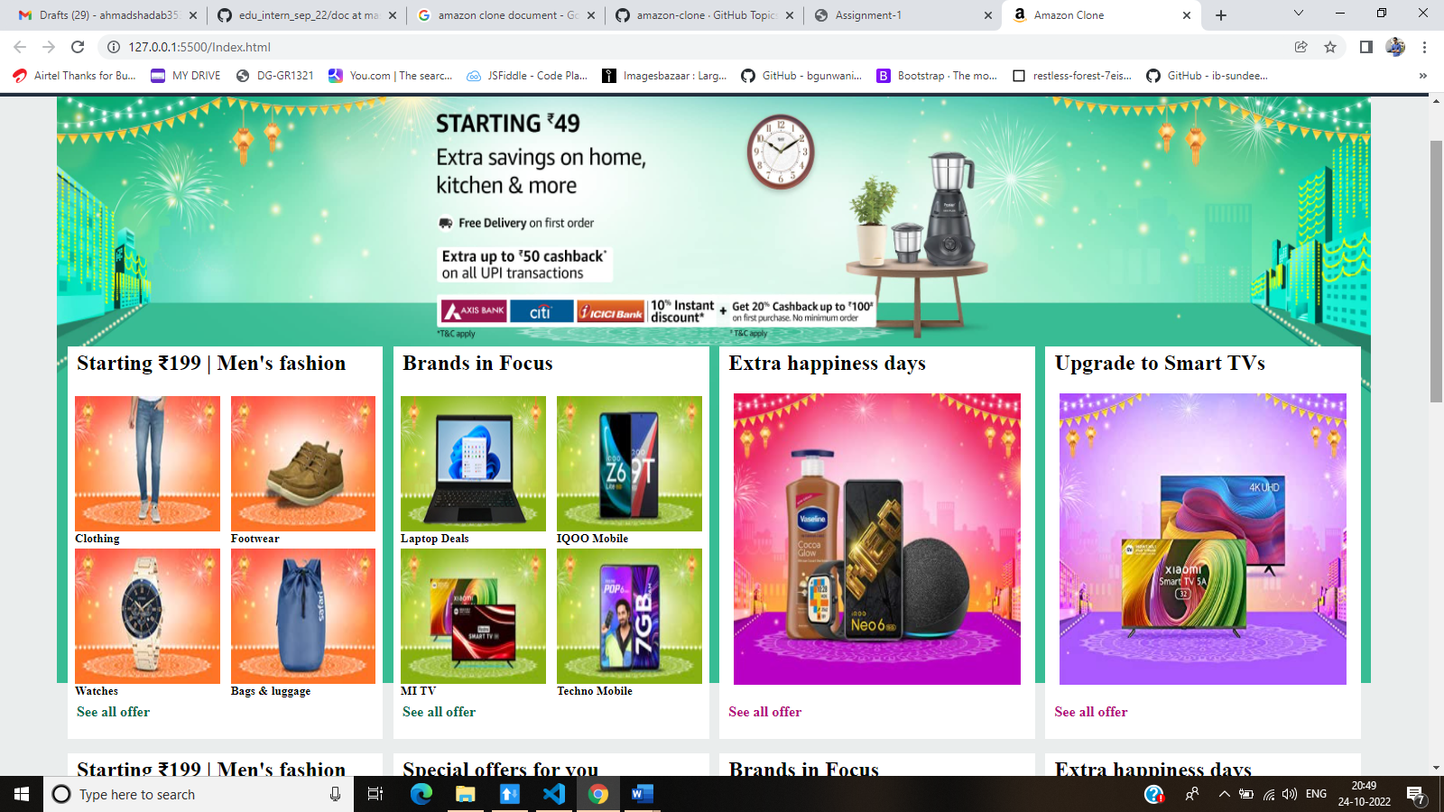

**Overview-** This is a clone of popular e-commerce website Amazon. I have started working in my final project. I will complete later with React in frontend, Node and Express for backend and MongoDB for storing data. screenshot I have added above created using HTML and CSS. Bootstrap will use for extra features.

This will be a functional shopping web application intended to be a clone of Amazon and some of its features. This clone is mixed with my design style and features that I thought would make it look better.

**Technologies will be used in Amazon Clone**

**Front-End:**

1. Html

2. CSS

3. Bootstrap

4. React

**Dynamic:**

1. JavaScript

3. Login and Logout

**Database:**

1. Mongo dB

2. Json Data

**Code compilers:**

1. Visual studio code

2. Git bash

3. Git hub

4. Node js.

**Primary goals: -**

* Create header/navigation bar to navigate between pages.
* Create a home page to display products.
* Create a login page for user login or registration.
* Add functionalities like basket, payment and authentication.

**DESCRIPTION OF MODULES OF WEBSITE: -**

1. **Homepage**

The website is a user-friendly website. When the user opens the website, they will be directed to the home page. Home Page can be divided into three parts the header, auto scrolling ads section and the products part. The header contains the search function, cart function, login/register of user/seller function along with categories side bar.

1. **Products**

When the user clicks on any product, they will be re-directed to the product page where the product image and details are visible. User can choose to add the product to the cart, and it requires user to already logged in to add products to the cart.

1. **Login / Register Page**

Users and Sellers can register into the website and login with their e-mail or phone number and password.

1. **Cart Page**

Products can be added to the cart and can be viewed in cart page. The cart page can be accessed from the cart icon on the header of homepage. User can proceed to checkout in this page.

1. **Checkout page**

In this page user can see all the products that were added to the cart and, they need to enter their address and basic details of the recipient. Order will be successfully placed after the confirming the order.

1. **Orders Page**

Orders page can be accessed by the user from the header from the homepage by clicking the account name choosing ‘My Orders’. In this page the user can view all his orders including delivered and cancelled orders. The user also can cancel the orders from here if needed.

1. **Account Settings**

Users and sellers can update theirs accounts info and credentials from here, including password change. Seller Specific Modules Seller has their own dashboard and landing page in which they can view they’re currently processing and delivered products, add new products to sell, view list of products they sell and also view products that are on sale/discount from other sellers.

1. **Admin Dashboard**

Administrator login and logout page with admin rights to the website.