ENTERPRISE SYSTEM ARCHITECTURE & USER MANUAL
MERN Stack Blog Application & Full Admin Panel Documentation
Comprehensive Operational Manual, Feature Specification, Role-Based Access Control, and Step-by-Step Administrative Walkthrough with High-Resolution Visuals.
Project Property | Specification Details
System Application | MERN Stack Full-Featured Blog & Content Management Engine
Frontend Technology | React 19, Material-UI (MUI), React Router v7, Uppy Uploader, Axios
Backend Technology | Node.js (v24), Express.js RESTful API, JSON Web Tokens (JWT), Nodemailer
Database Layer | MongoDB Atlas (Cloud Cluster) with Mongoose ODM
External Integrations | Stripe API Payments, SMTP Mailer, Google Analytics, Google OAuth, reCAPTCHA
Document Version | v1.0 (Enterprise Comprehensive Release)
Prepared For | System Administrators, Content Editors, Developers, and Support Staff
Date of Publication | September 2026

1. System Overview & Technical Architecture
The MERN Stack Blog Platform is a modern, modular, enterprise-grade content publishing, subscription, and user engagement platform. Engineered for scale, speed, and responsiveness, the application decouples frontend user experience from backend business logic while enforcing robust security mechanisms at every level.

1.1 Architecture & Component Interaction
The platform is structured into three primary architectural tiers:
Tier Layer | Core Technologies | Responsibilities
Frontend Client | React 19, MUI v7, React Router 7, Emotion, Axios, i18next | User Interface, Responsive Layout, State Context (Auth, Language, Settings), RTL rendering, client-side validation
API Server | Node.js, Express.js, JWT, Bcrypt, Multer/AizUpload, Nodemailer | RESTful Endpoints, Token Authentication, RBAC middleware, File management, Mail dispatch, Payment processing
Persistence Tier | MongoDB Atlas Cluster, Mongoose ODM | Document data storage: Users, Roles, Blogs, Categories, Comments, UploadedFiles, Settings, Logs, Transactions

1.2 Security & Role-Based Access Control (RBAC)
Authentication and authorization are managed through a dual-token JWT mechanism (short-lived access tokens and refresh tokens) paired with granular database-driven permission trees. Users are categorized into four primary roles:
• Super Administrator (admin): Unrestricted global authority across all content, settings, users, payment gateways, and system logs (* wildcard permission).
• Staff / Content Manager (staff): Configurable access dictated by specific role permissions (e.g., blogs_view, blogs_create, uploads_view, users_view).
• Registered User (user): Standard authenticated reader and contributor who can author their own articles, save drafts, purchase premium categories via Stripe, and participate in discussions.
• Public Visitor: Unauthenticated guest capable of exploring published posts, reading articles, browsing custom pages, searching topics, and submitting contact inquiries.
[SECURITY PROTOCOL] Two-Factor Authentication (2FA) is natively supported via 6-digit one-time password (OTP) email dispatch during login, providing defense-in-depth against credential theft.

2. Public Website Features & Operational Guide
The public interface delivers an immersive, accessible experience optimized across desktops, tablets, and mobile devices. It incorporates full internationalization (i18n) and Right-to-Left (RTL) layout switching.

2.1 Homepage & Content Discovery
The homepage functions as the dynamic front door of the publication. It features a customizable hero banner, live keyword search, horizontal category selector, featured trending blogs, and a paginated chronological post feed.
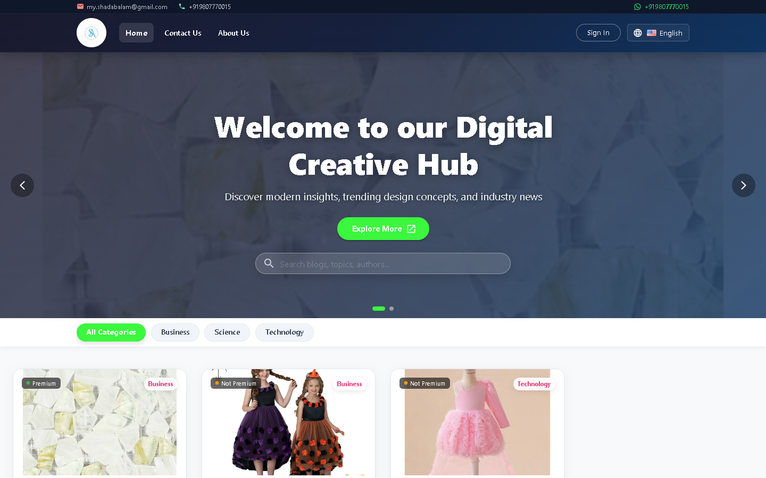
Figure 1: Public Website Homepage with Hero Header, Search Bar, Categories, and Post Grid
Key Homepage Capabilities:
1. Dynamic Category Filter: Clicking any category filter instantly queries the backend API for posts tagged with that category without full page reloads.
2. Real-time Search: Live debounce querying allows readers to locate blogs by title, keywords, tags, or author.
3. Responsive Layout: Mobile drawer navigation and responsive card grids ensure optimal readability on any viewport.

2.2 Article Detail View & Reader Engagement
Clicking any blog card transitions the visitor to the full article reader. The page renders high-resolution cover graphics, author profile metadata, publication timestamps, category pills, structured body content, and social sharing hooks.
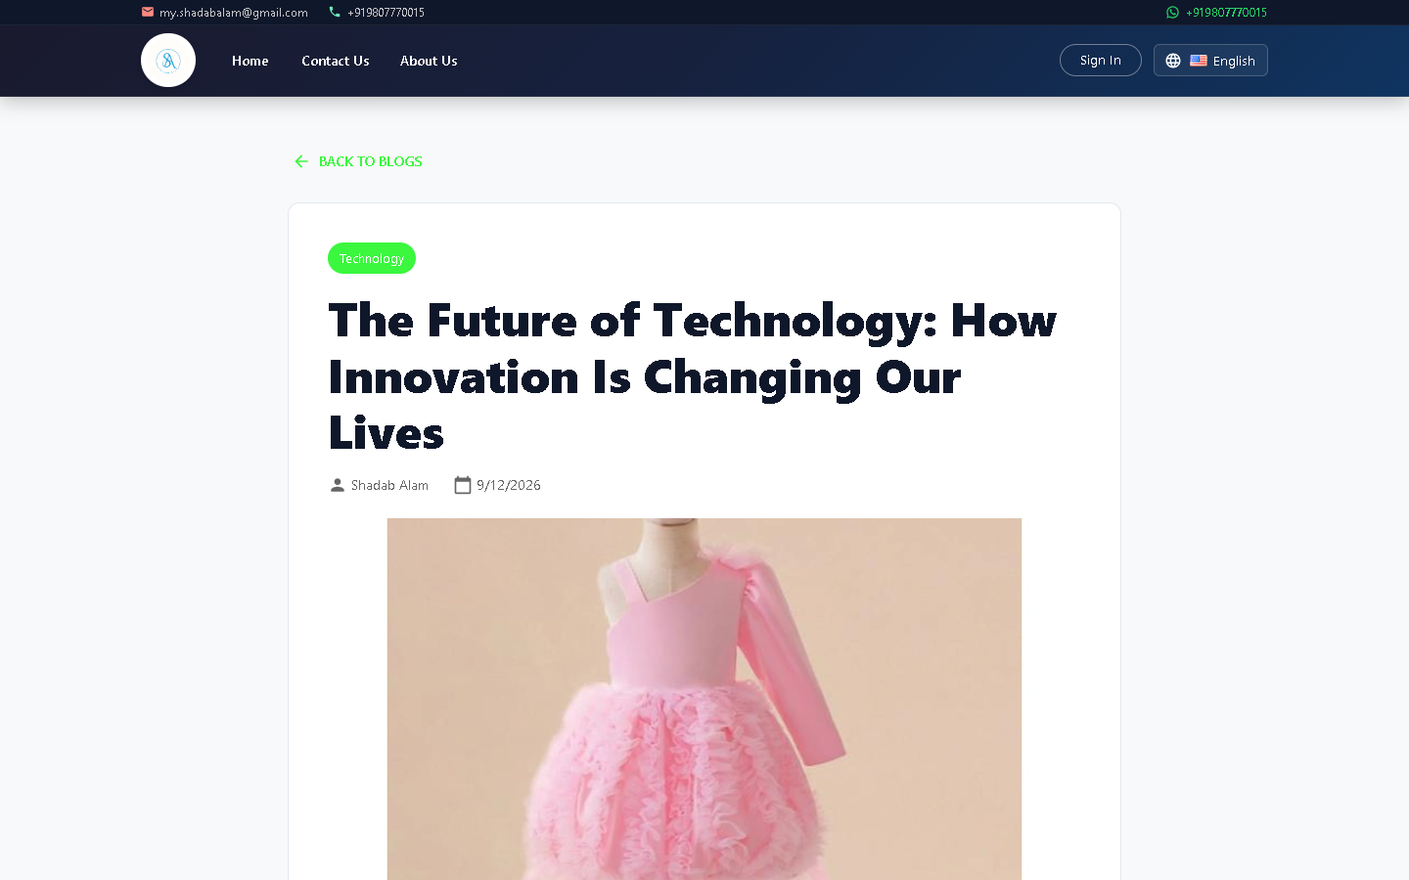
Figure 2: Detailed Article View with Cover Art, Metadata, and Author Details
Article Page Features:
• Interactive Discussion Section: Authenticated users can write comments, reply to existing threads, and moderate their own contributions.
• Social Sharing Suite: Direct single-click sharing to Twitter/X, LinkedIn, Facebook, and WhatsApp.
• Dynamic Breadcrumb Navigation: Simple hierarchical return path back to the parent category and homepage.

2.3 About Us & Company Information
The About Us page provides readers with background on the publication, mission statements, team profiles, and milestones.
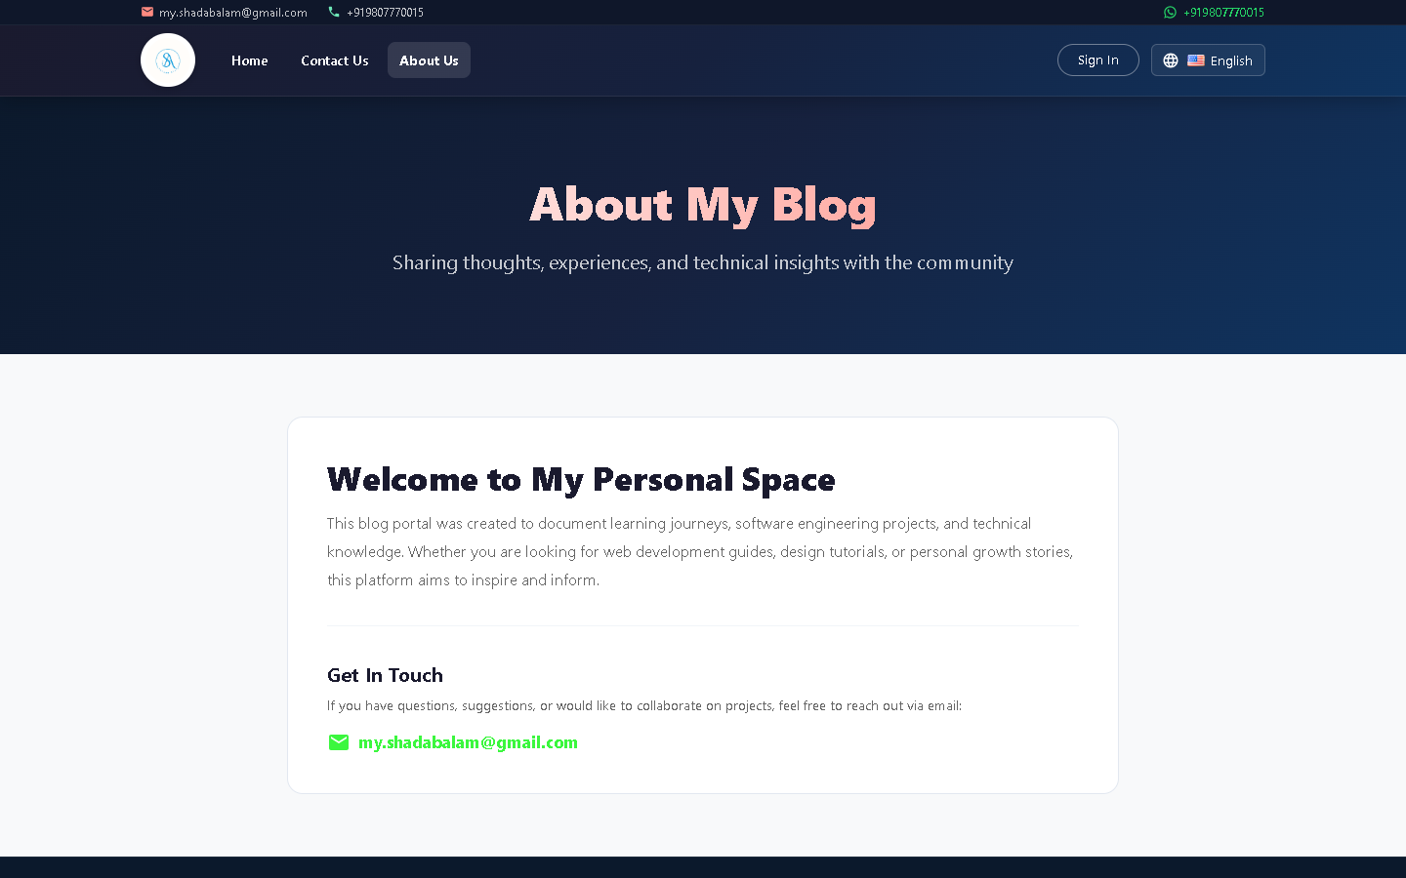
Figure 3: Public About Us Page showcasing Publication Overview and Mission

2.4 Contact Us & Public Inquiries
The Contact Us module enables visitors, readers, and business partners to submit direct communications to the administrative team.
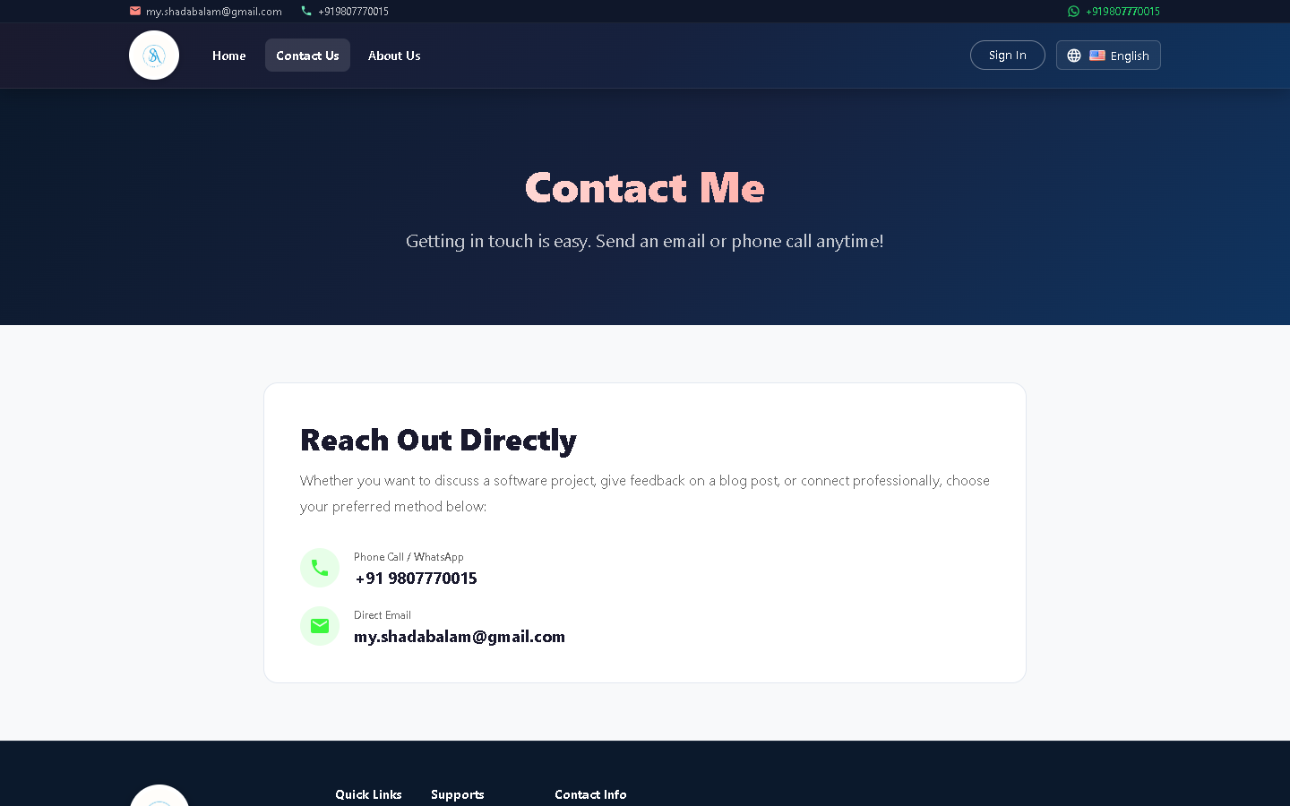
Figure 4: Contact Us Page with Inquiry Submission Form and Office Information
Step-by-Step Inquiry Submission:
1. Navigate to the /contact route via the navigation menu.
2. Input Full Name, Valid Email Address, Subject line, and Message content.
3. Click 'Submit Message'. The form executes client-side schema validation and transmits the payload to /api/contact.
4. The inquiry is logged in the database and immediately appears in the Admin Panel's Contact Inquiries table.

3. Authentication Suite & User Dashboard
User authentication is built on secure cryptographic hashing (Bcrypt with salt rounds) and stateless JWT tokens. Sensitive password credentials are never stored in plain text.

3.1 Login, Registration & Password Recovery
The authentication portal includes streamlined forms for account creation, credential verification, and automated password recovery.
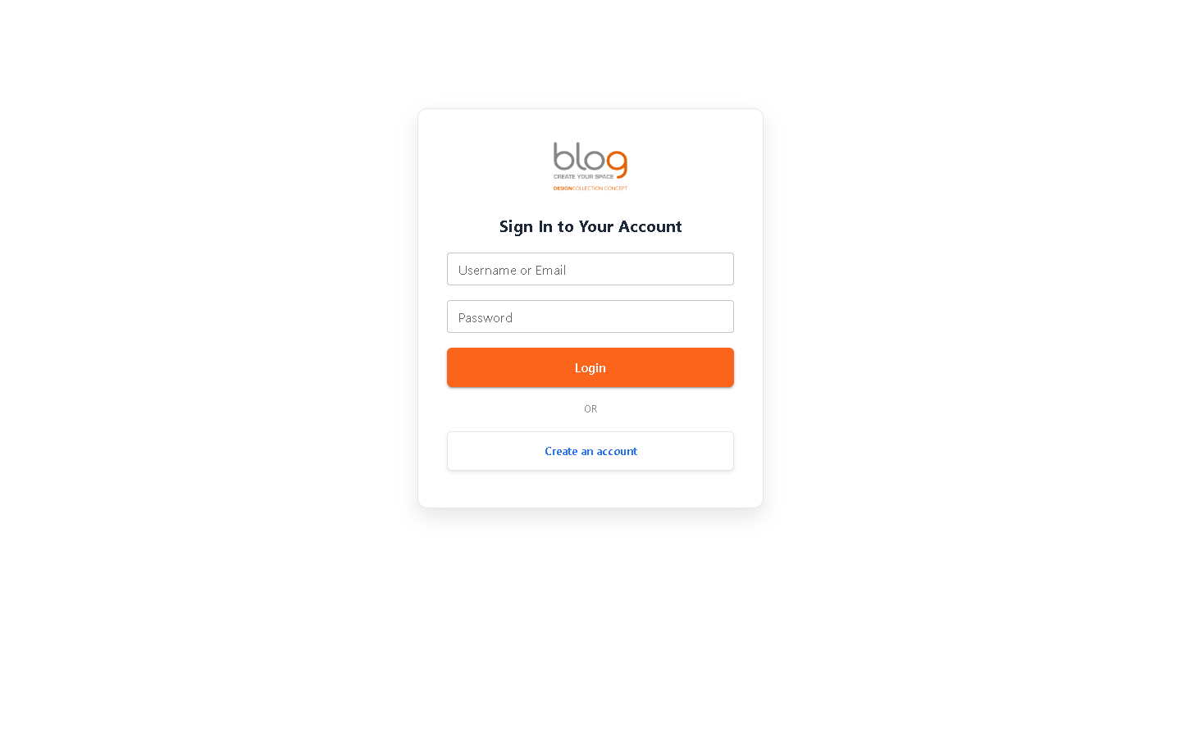
Figure 5: Secure User & Administrator Login Portal
Authentication Screens Overview:
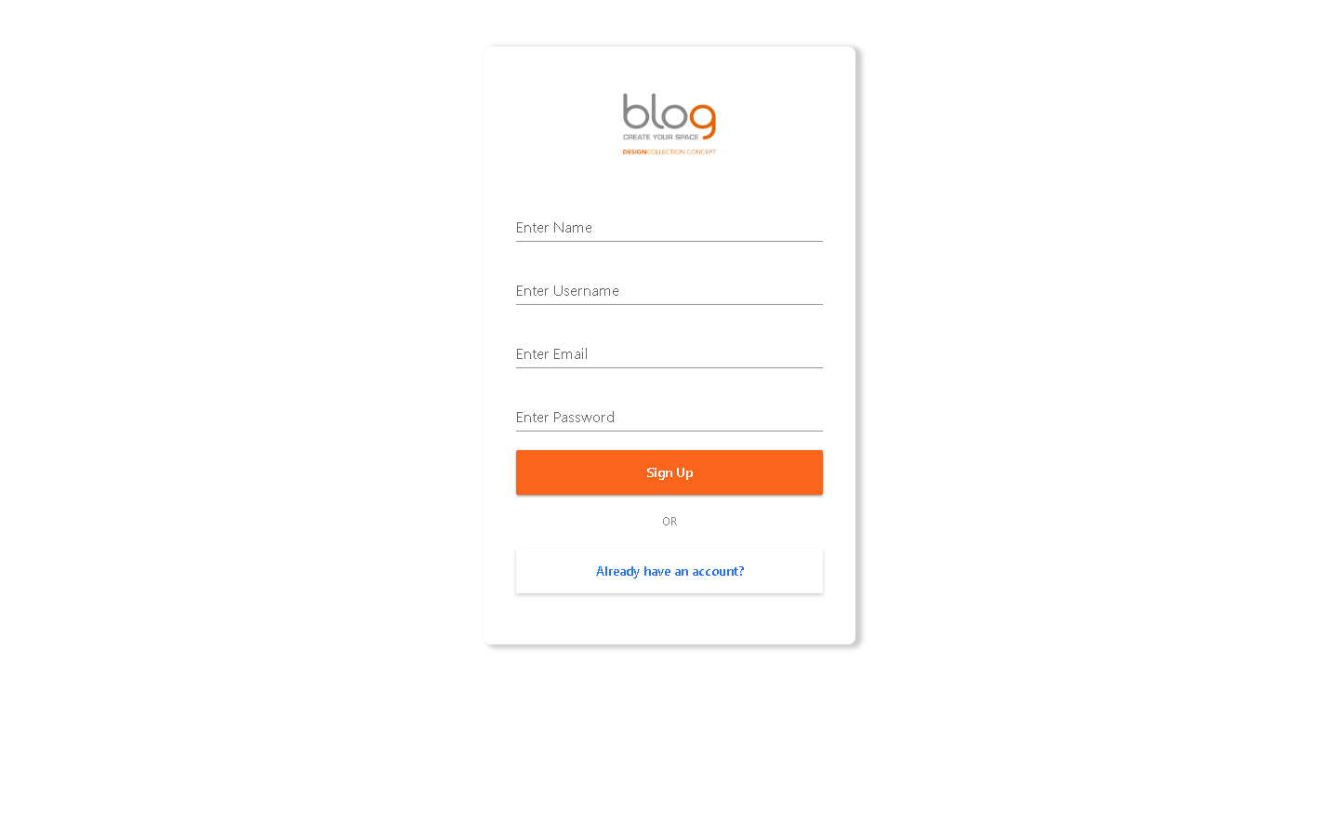
Figure 6: New User Account Registration Screen
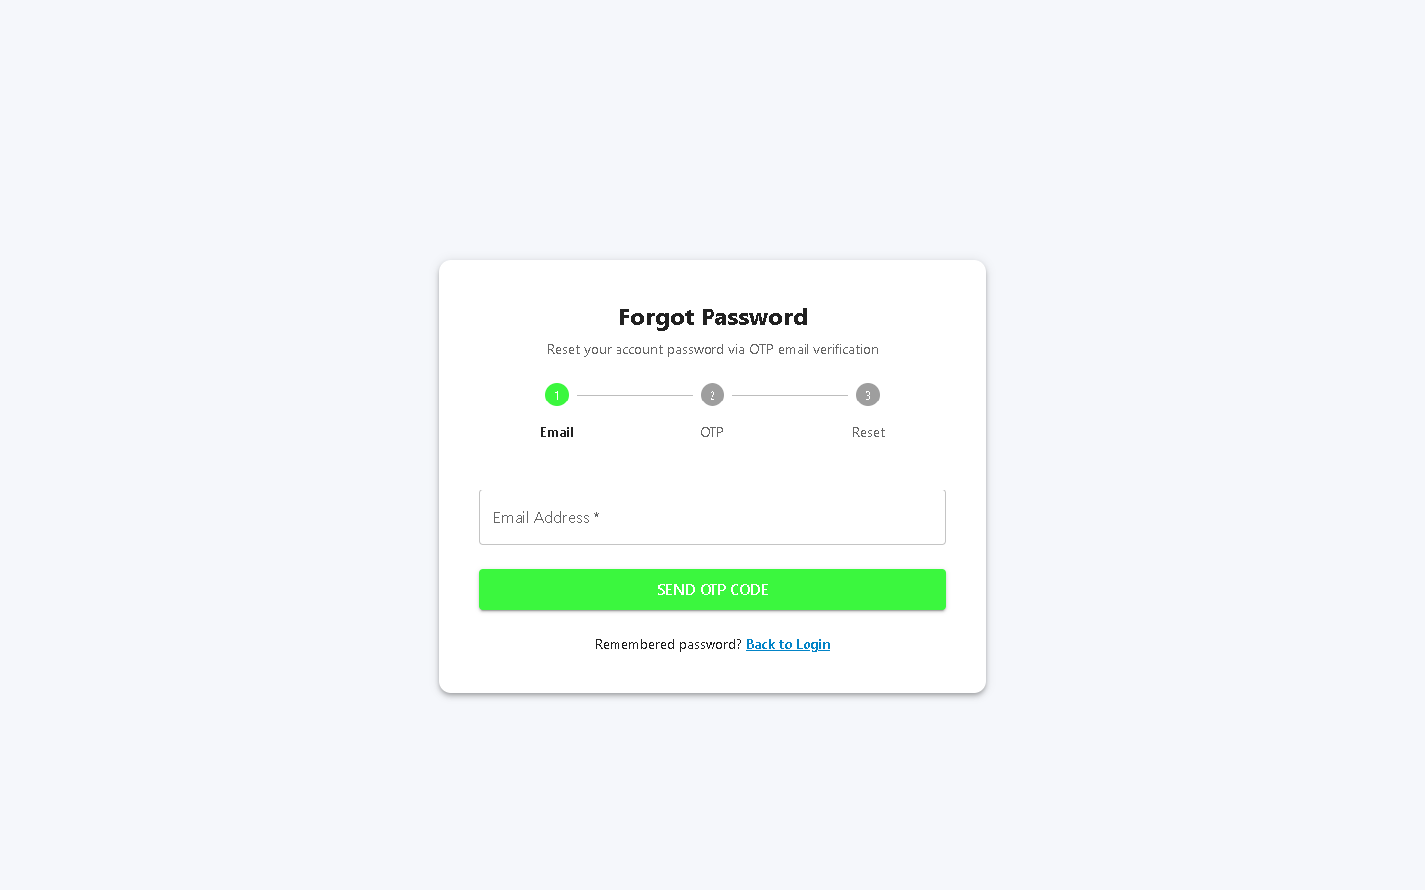
Figure 7: Automated Password Recovery & Reset Request Screen
Form Screen | Required Fields | Validation & Handling
User Login | Email or Username, Password | Bcrypt comparison; detects 2FA requirements; issues JWT access & refresh tokens.
User Registration | Full Name, Username (optional), Email, Password | Checks for email/username uniqueness; hashes password; auto-assigns 'user' role.
Forgot Password | Registered Email Address | Generates crypto-secure reset token; sends HTML recovery link via SMTP mailer.

3.2 User Dashboard
Upon successful authentication, standard users are routed to their personal Author Dashboard (/dashboard). Here, contributors can manage their articles, inspect view metrics, and draft new content.
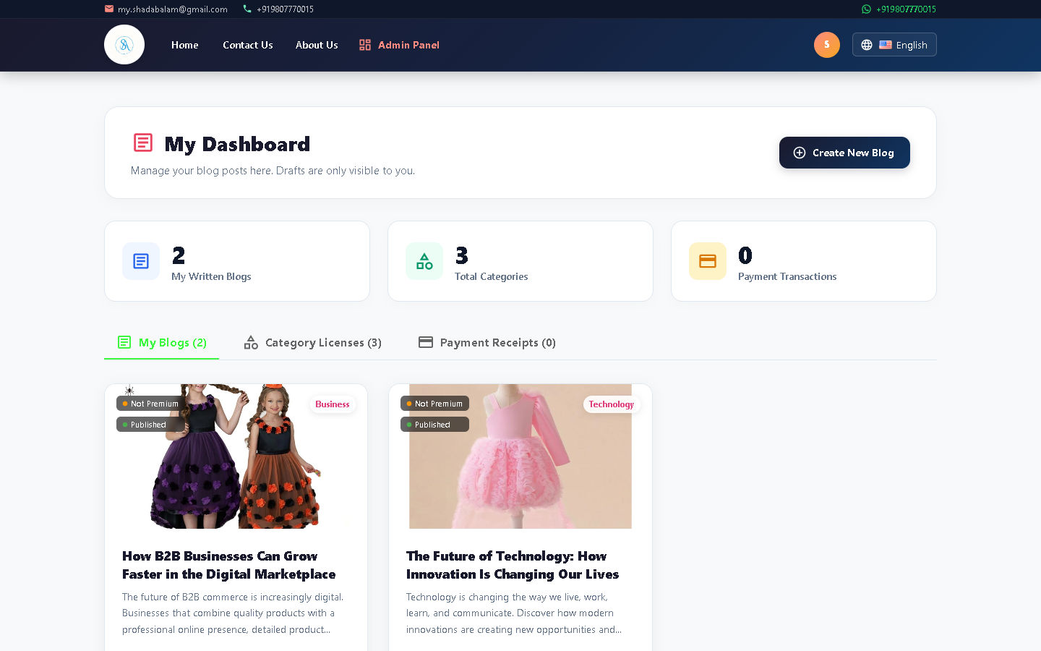
Figure 8: Authenticated User Dashboard with Authored Articles and Status Tags

3.3 Authoring & Editing Articles (User View)
Users can draft, edit, and publish their articles using an intuitive, distraction-free editor.
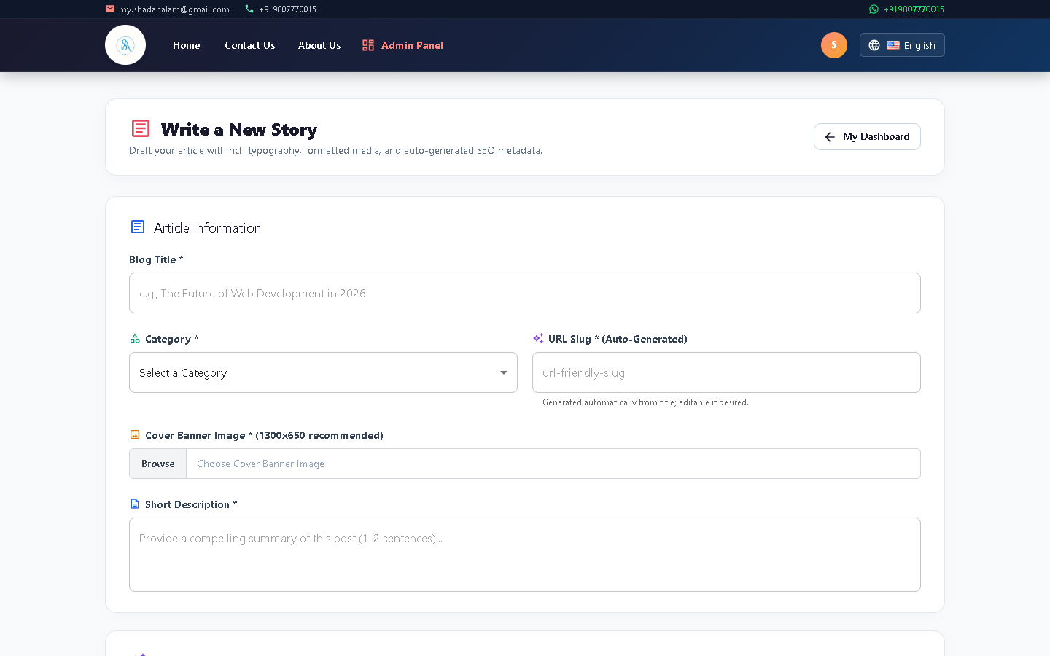
Figure 9: User Post Creation Interface with Image Upload and Content Editor
Step-by-Step: How a User Creates a Blog Post:
1. Click the '+ Create Post' or 'Start Writing' button on the dashboard.
2. Upload a high-resolution cover image using the image selector.
3. Enter an engaging Title and select the appropriate Category from the dropdown.
4. Compose the article body in the content editor with formatting tools.
5. Choose to save as 'Draft' (private to the author) or click 'Publish' to make it live.

3.4 Stripe Payments & Transaction History
The platform integrates Stripe Checkout for monetization, premium category subscriptions, and tipping. Users can review all past financial transactions at any time.
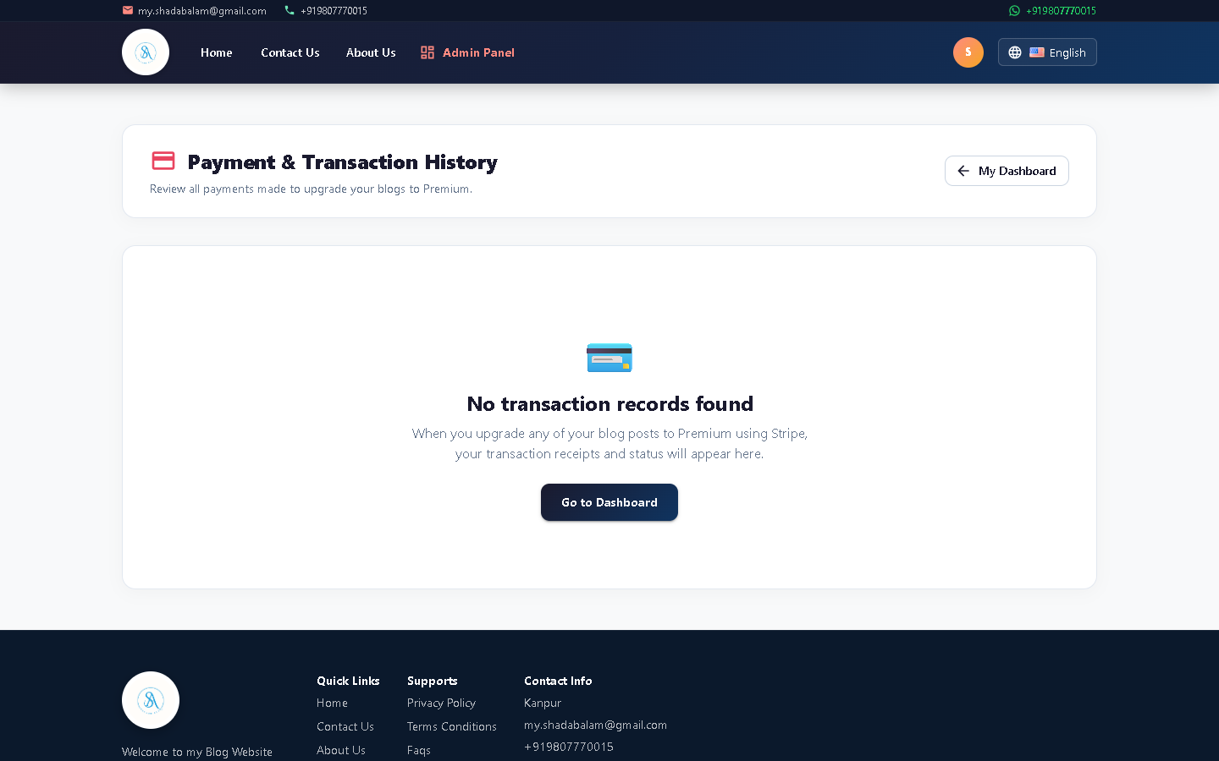
Figure 10: User Stripe Payment History Table with Transaction Details and Status
[FINANCIAL INTEGRATION] Stripe transactions are validated via cryptographically signed webhooks to guarantee idempotency and eliminate duplicate charge processing.

4. Comprehensive Admin Panel & Operations Manual
The Admin Panel (/admin/dashboard) is a powerful, centralized control center for managing every aspect of the platform. Accessible only to users holding the 'admin' or 'staff' role, it enforces strict RBAC permissions across all CRUD operations.

4.1 Administrative Dashboard Overview
The dashboard provides a real-time operational pulse of the application. It highlights key system metrics, aggregate counters, quick shortcuts, and latest system alerts.
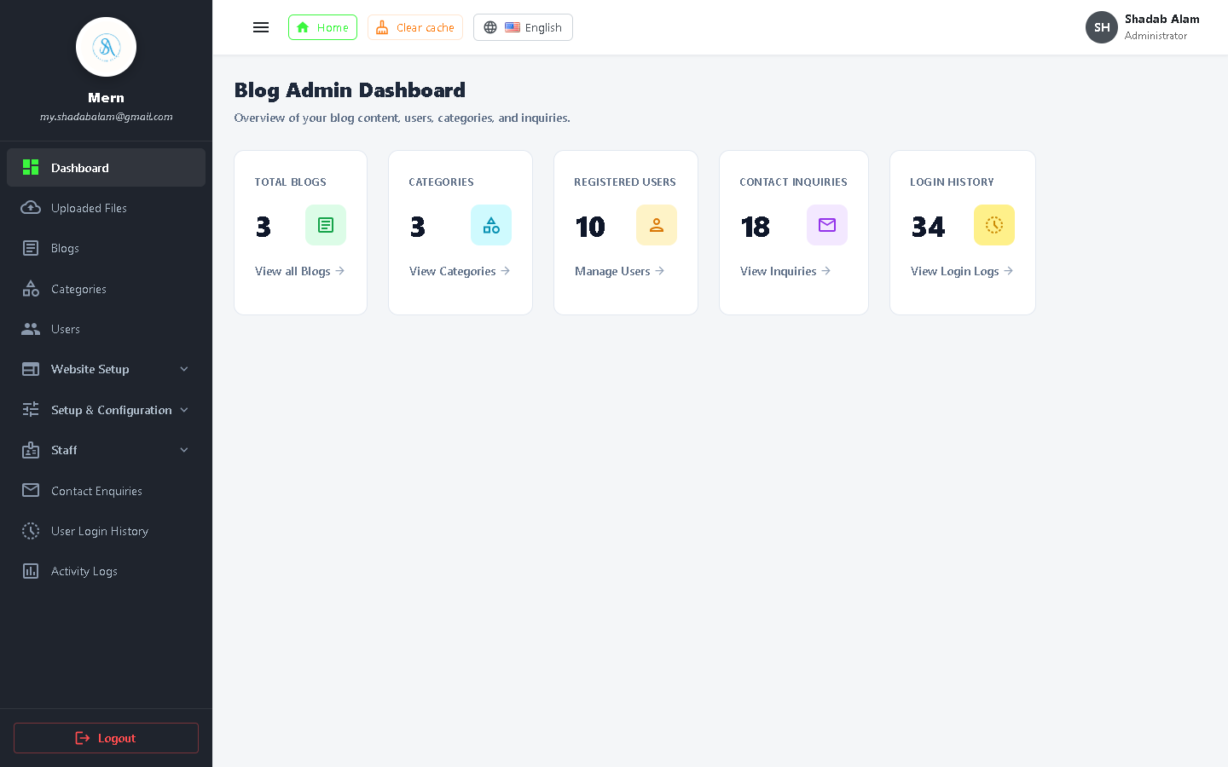
Figure 11: Master Admin Dashboard with Aggregate Metric Counters and Activity Overview
Dashboard Widget | Indicator Metric | Operational Purpose
Total Blog Posts | Active count of published & draft posts | Monitor publication volume and content growth
Registered Users | Total customer & staff account count | Track user acquisition and active community size
Categories | Count of active content taxonomies | Maintain organized content segmentation
Pending Inquiries | Unresolved visitor messages | Prompt administrative response to reader inquiries

4.2 Blog Management (CRUD Operations)
The Blog Management suite gives administrators full lifecycle control over every article published on the network.
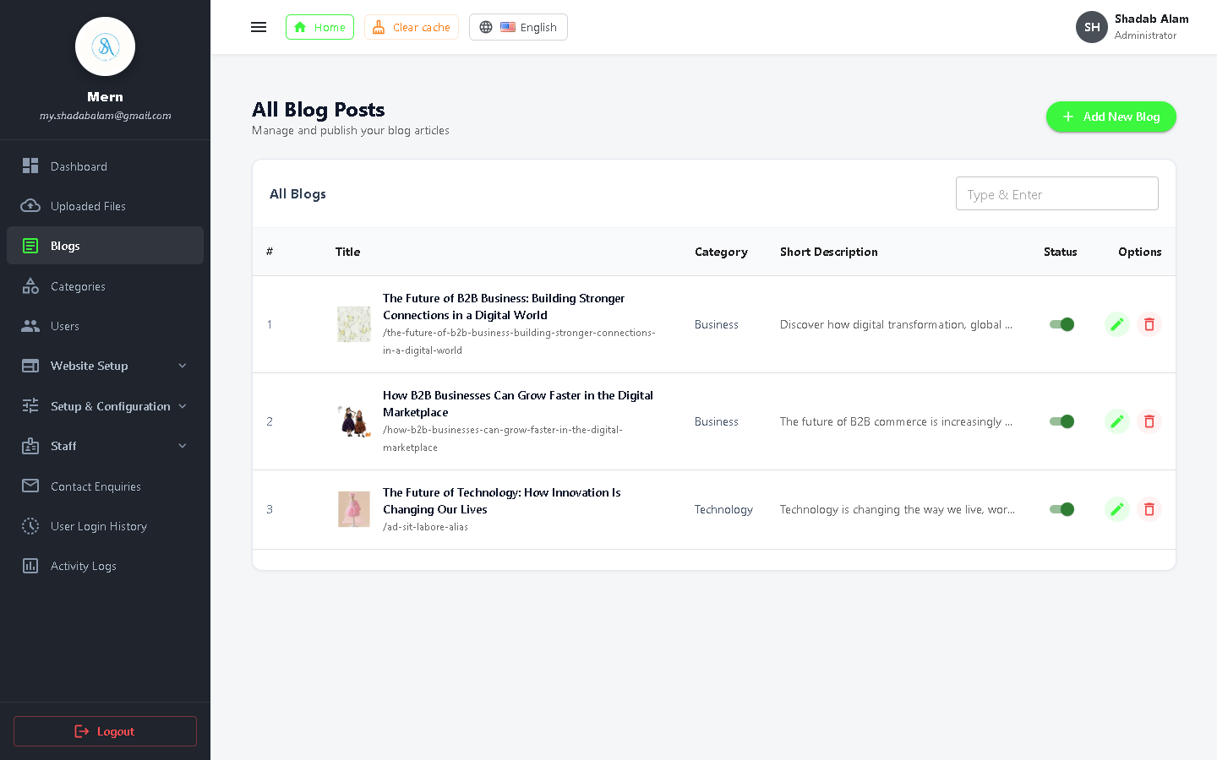
Figure 12: Admin Blog List Table with Search, Filters, Status Toggles, and Action Buttons
Step-by-Step: Creating a New Blog Article (Admin):
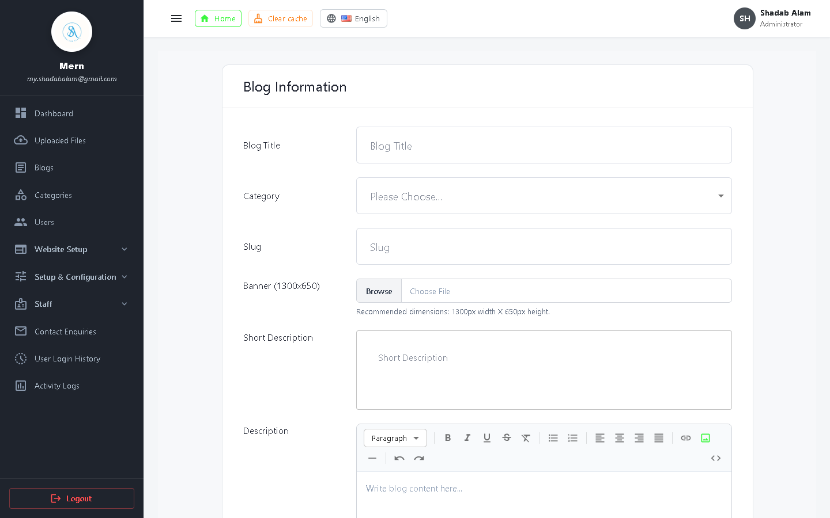
Figure 13: Create Blog Form with Title, Category, Banner Upload, Tags, and Rich Text Body
1. Navigate to 'Blogs' > 'Add New Blog' in the admin sidebar.
2. Fill in the required fields: Title, URL Slug (auto-generated or custom), Category, and Summary Description.
3. Select or upload a Banner Image from the Media Manager.
4. Author the main article body using the rich text / markdown editor.
5. Specify SEO Meta Title, Meta Description, and comma-separated Meta Keywords.
6. Toggle Status to 'Published' or 'Draft' and click 'Save Blog Post'.
Step-by-Step: Editing an Existing Blog Article:
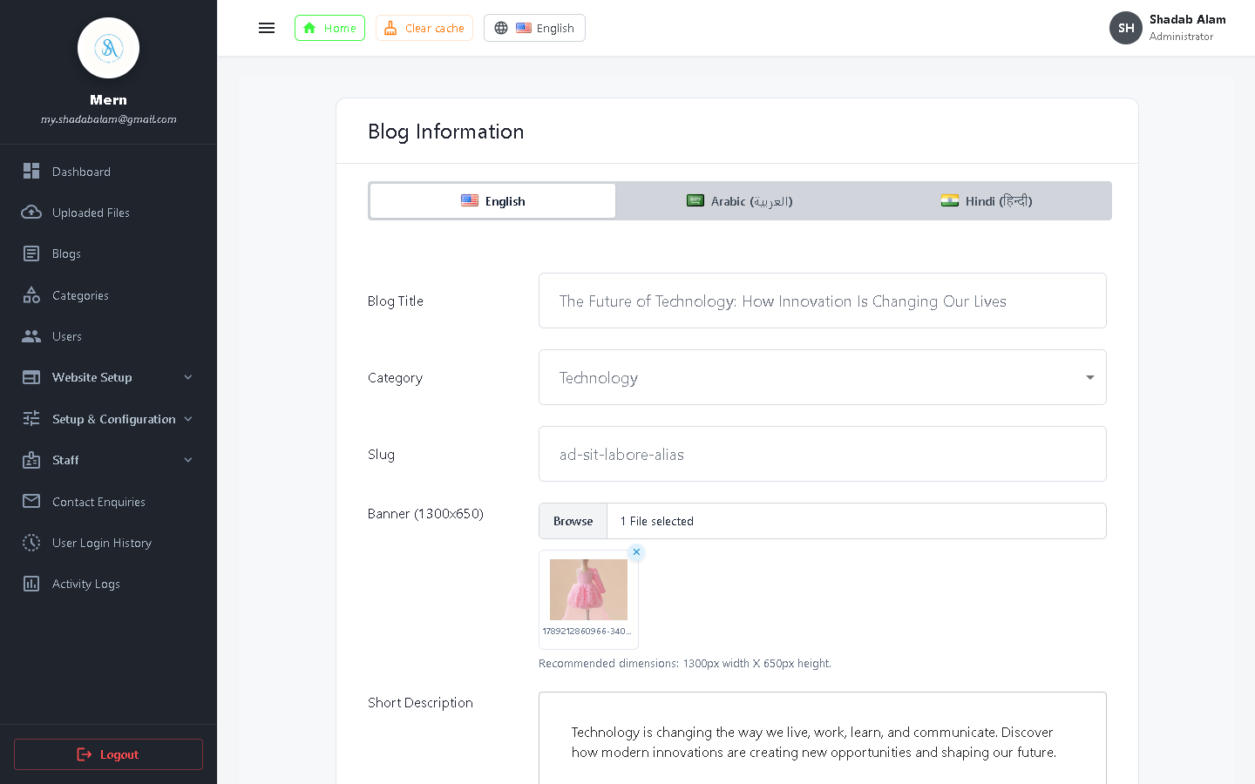
Figure 14: Admin Edit Blog Screen with Pre-populated Data and Image Replacement
1. In the Blog List table, locate the target article using the search bar.
2. Click the 'Edit' icon in the Actions column.
3. Modify any attributes (title, text, image, category, status).
4. Click 'Update Blog'. The system invalidates cached responses and immediately updates public pages.
Step-by-Step: Deleting a Blog Article:
1. In the Blog List table, locate the article to remove.
2. Click the 'Delete' (Trash) icon.
3. A confirmation modal appears asking: 'Are you sure you want to delete this blog?'.
4. Confirm the prompt. The server executes blogRemove(), cascading deletion to associated comments and media references.

4.3 Category Management (CRUD Operations)
Categories provide structured organization for all published content, allowing targeted browsing and premium monetization.
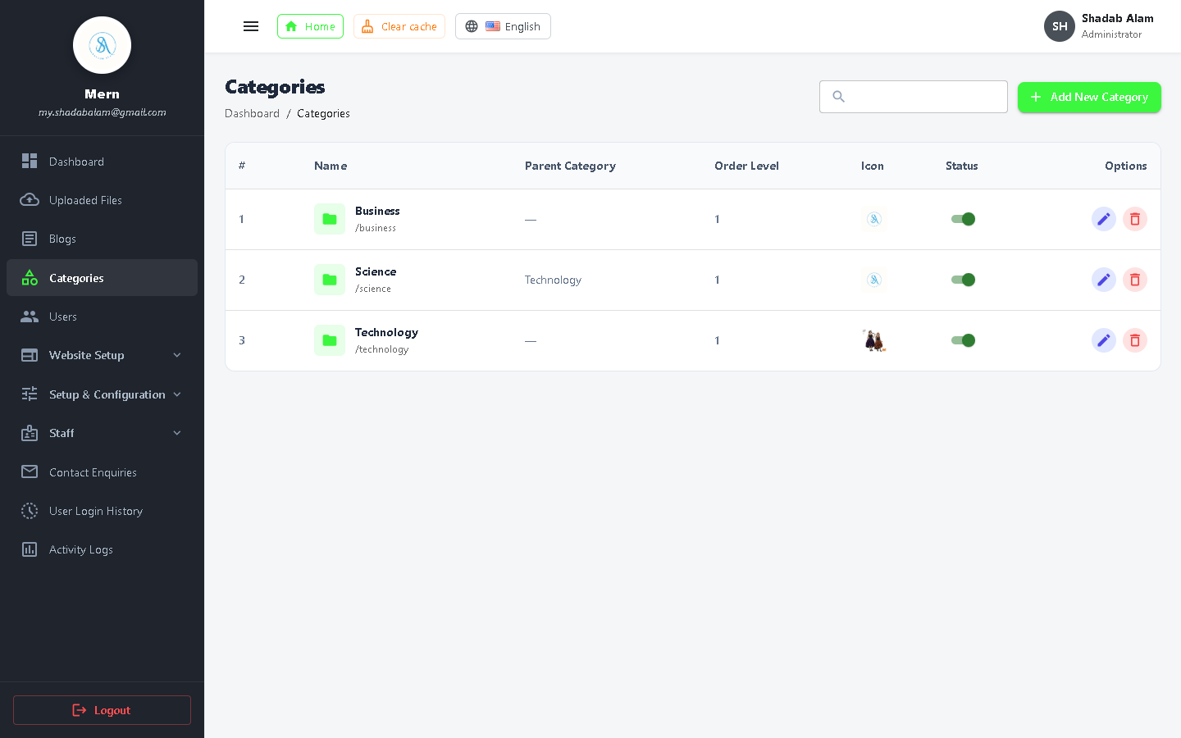
Figure 15: Category Management Table with Post Counts, Slugs, and Actions
Step-by-Step: Adding a New Category:
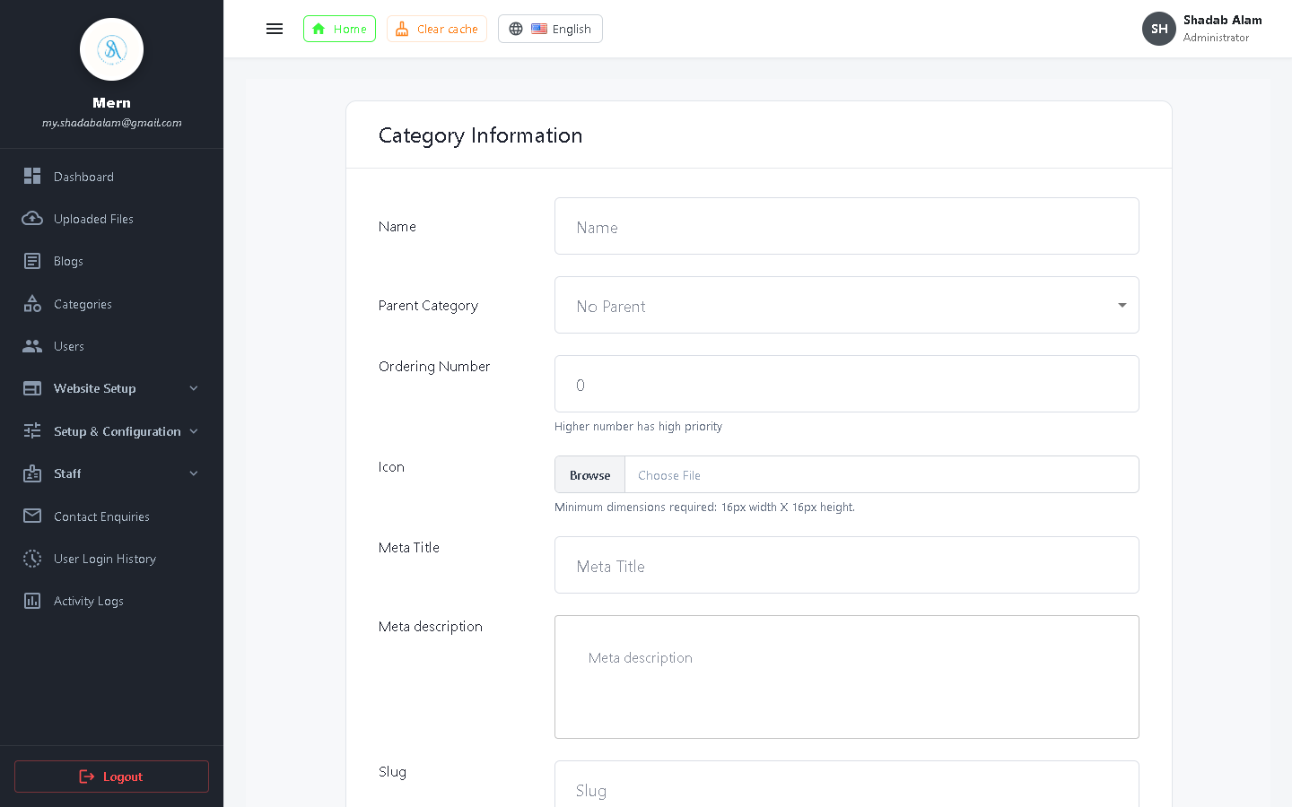
Figure 16: Add New Category Form with Name, Slug, Description, and Icon Upload
1. In the sidebar, select 'Categories' > 'Add Category'.
2. Enter the Category Name (e.g., 'Artificial Intelligence', 'Cloud Computing').
3. Enter or verify the auto-generated Slug.
4. Upload an icon or representative graphic.
5. (Optional) Set a premium purchase price for paid access via Stripe.
6. Click 'Create Category' to save.

4.4 User & Customer Management
Administrators can oversee all registered customer accounts, review activity, toggle account statuses, and impersonate users for customer support.
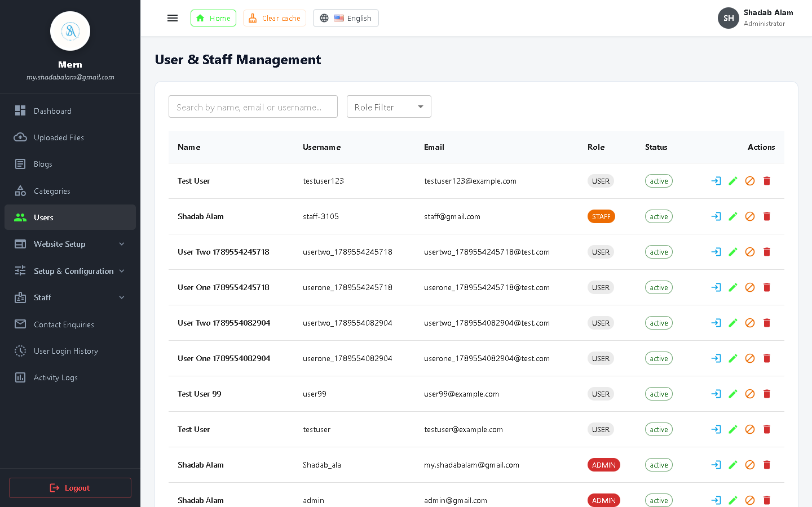
Figure 17: User Management Table with Roles, Status Flags, and Impersonation Trigger
Action Trigger | Functionality | Security Impact
Edit Role / Status | Change role between user, staff, and admin; toggle active/blocked | Instantly updates session privileges on next token refresh
Login as User | Generates temporary impersonation token to view UI from customer perspective | Audit-logged in ActivityLogs to prevent administrative abuse
Delete Account | Permanently deletes user profile, comments, and private drafts | Requires high-privilege admin authentication

4.5 Staff & Role-Based Access Control (RBAC)
Staff management allows delegating administrative responsibilities without compromising security. Fine-grained roles can be tailored to match organizational hierarchies.
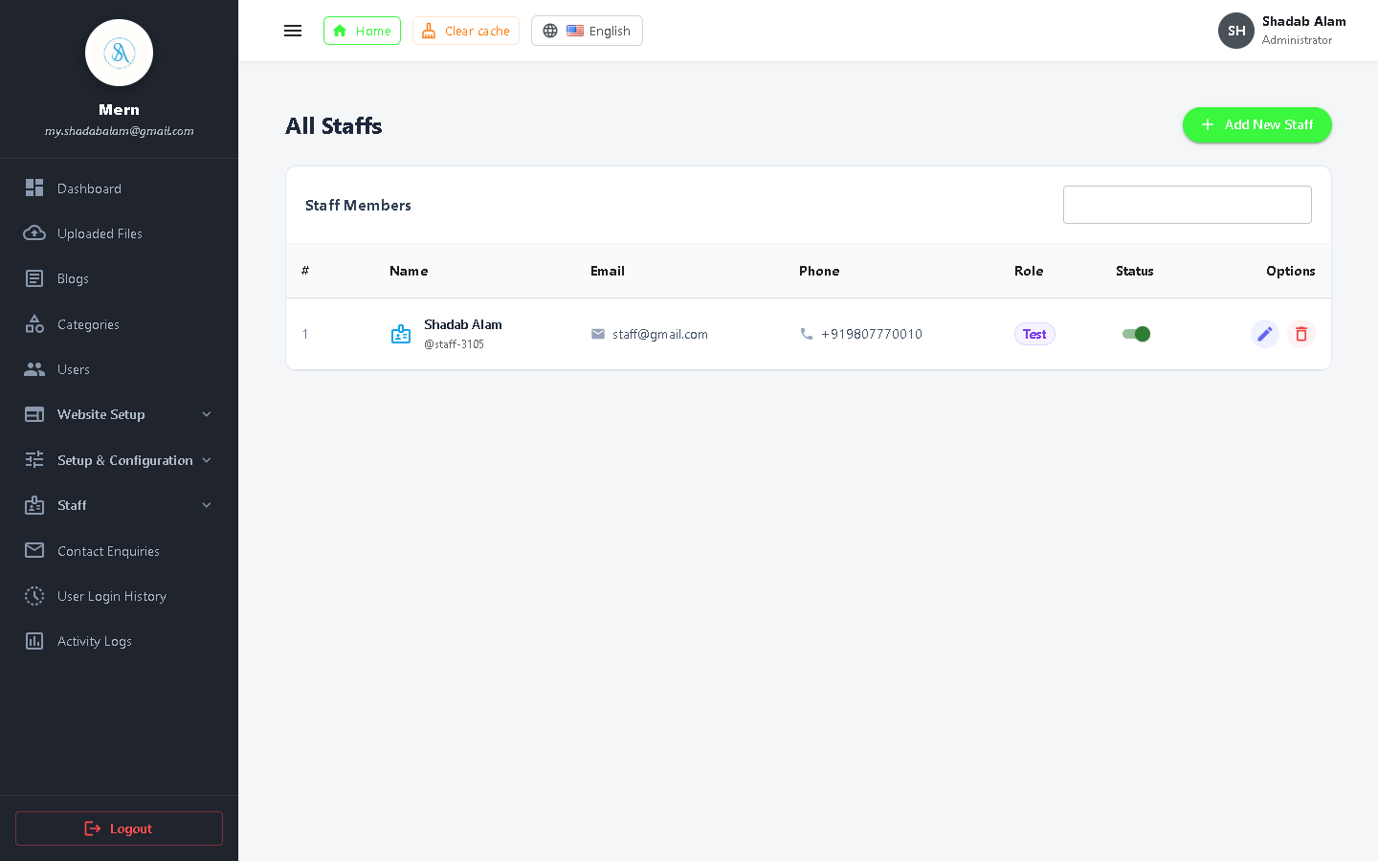
Figure 18: Staff Members Table with Assigned Roles, Contact Info, and Status
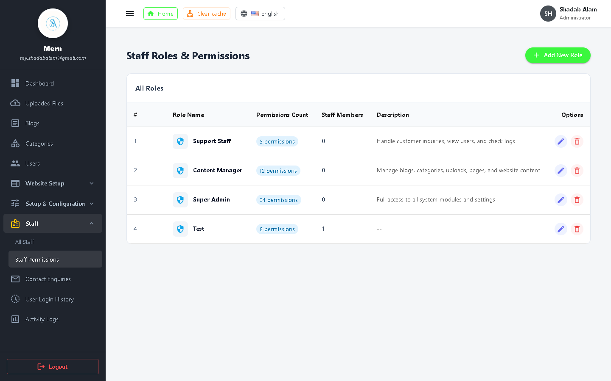
Figure 19: Staff Roles & Permissions Configuration Matrix
Step-by-Step: Creating and Assigning a Custom Staff Role:
1. Navigate to 'Staff' > 'Staff Roles & Permissions'.
2. Click 'Add New Role'.
3. Specify Role Name (e.g., 'Junior Content Editor', 'Support Specialist') and Description.
4. Select permissions across functional groups: Blog System, Uploaded Files, Users, Staff, Settings, and Setup.
5. Save the Role.
6. Under 'Staff List', create a new staff member and assign this newly created Role.

4.6 Uploaded Files & Media Asset Manager
The platform features an enterprise media library powered by Uppy and Multer. Assets can be uploaded once and reused across multiple articles, banners, and categories.
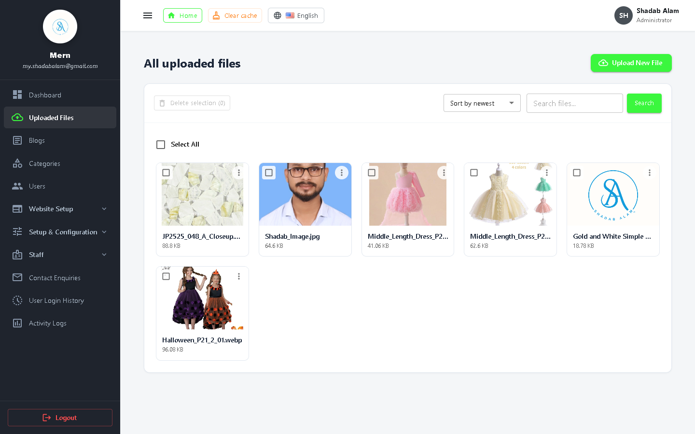
Figure 20: Uploaded Files Media Gallery with Grid View, Search, and URL Copy Utility
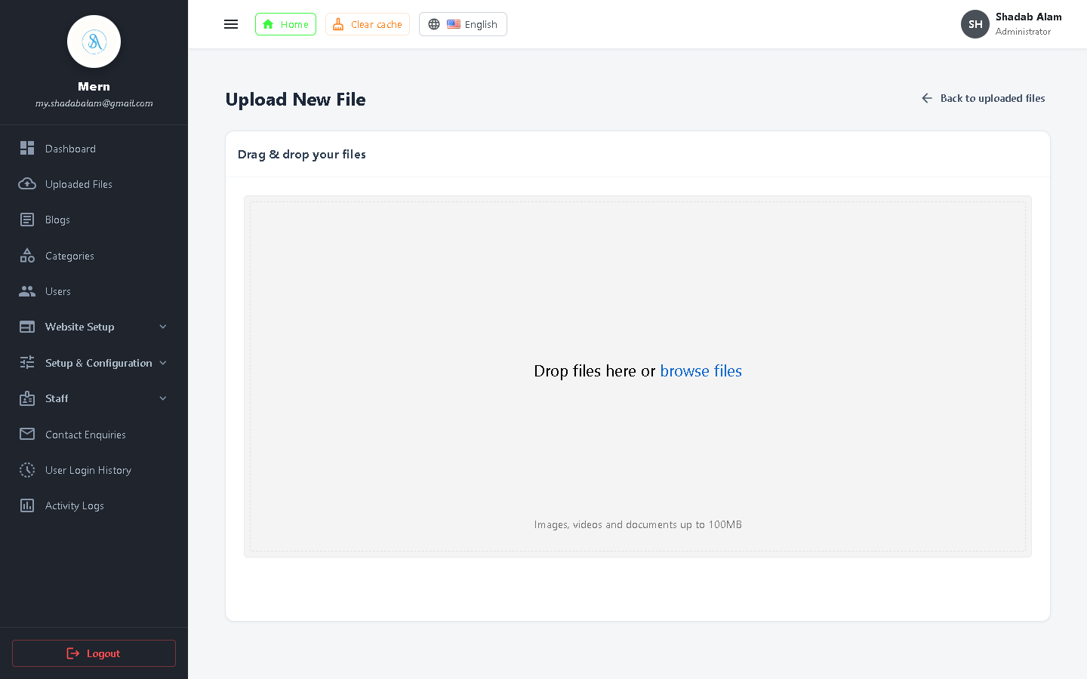
Figure 21: Upload New File Interface featuring Drag & Drop Uppy Uploader
Step-by-Step: Uploading and Managing Media Files:
1. Click 'Uploaded Files' > 'Upload New File'.
2. Drag and drop single or multiple image files (JPG, PNG, WebP, SVG) into the dropzone.
3. The system validates MIME types, resizes if necessary, and writes the file to the storage directory.
4. Back in the Media Gallery, click on any image to copy its permanent URL or delete it from disk.

4.7 Website Setup & Customization Suite
Administrators can customize the website's branding, layout, headers, footers, and color themes without modifying a single line of source code.
Website Setup Modules Breakdown:
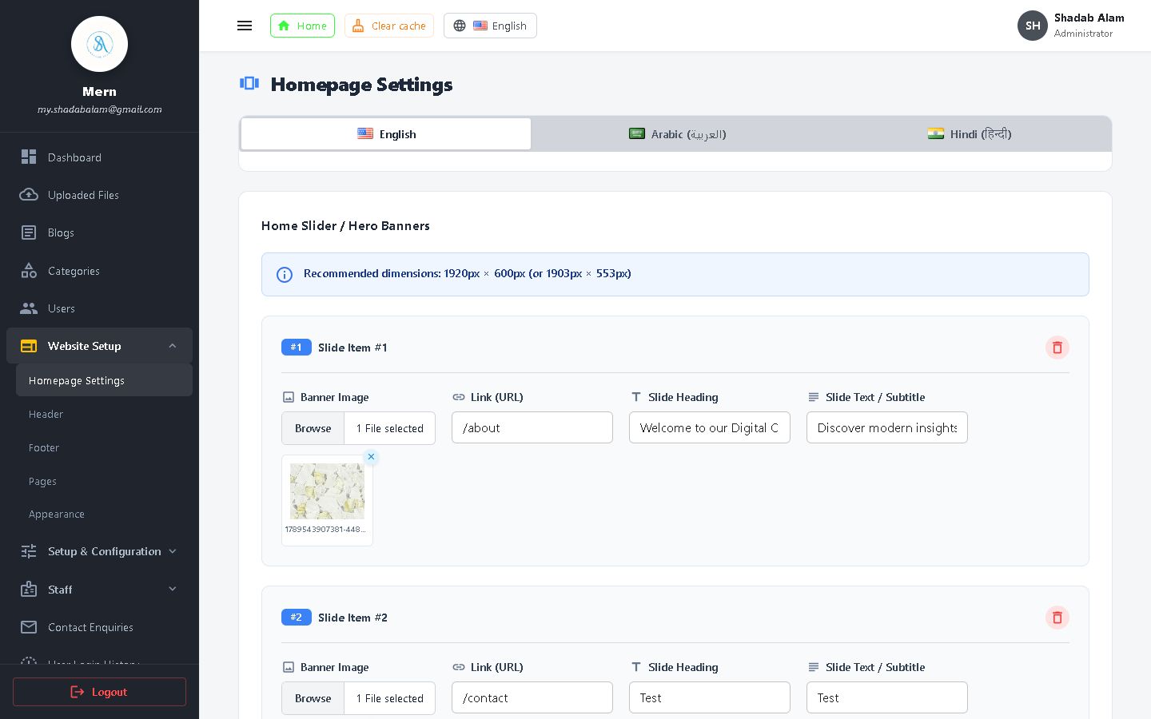
Figure 22: Homepage Setup: Hero Banner, Headings, Subtitles, and Section Toggles
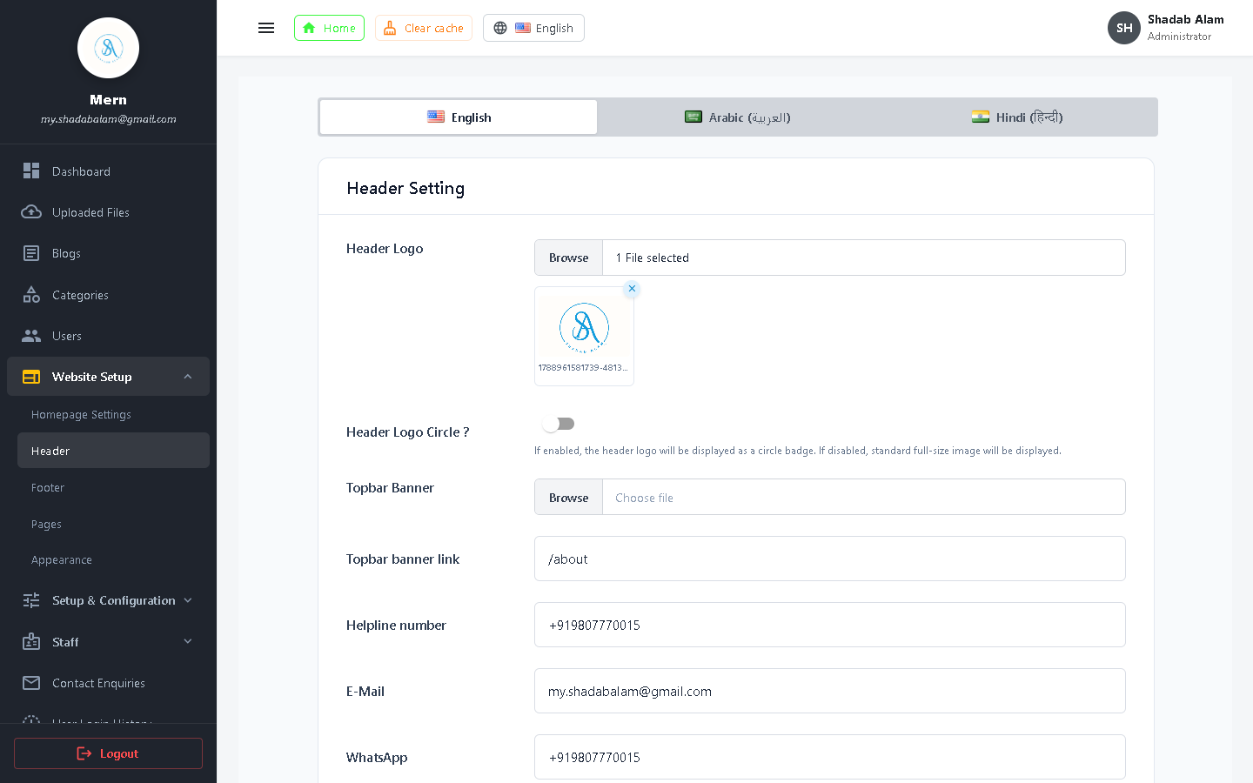
Figure 23: Header Setup: Site Logo, Navigation Menu, Category Dropdown Toggle
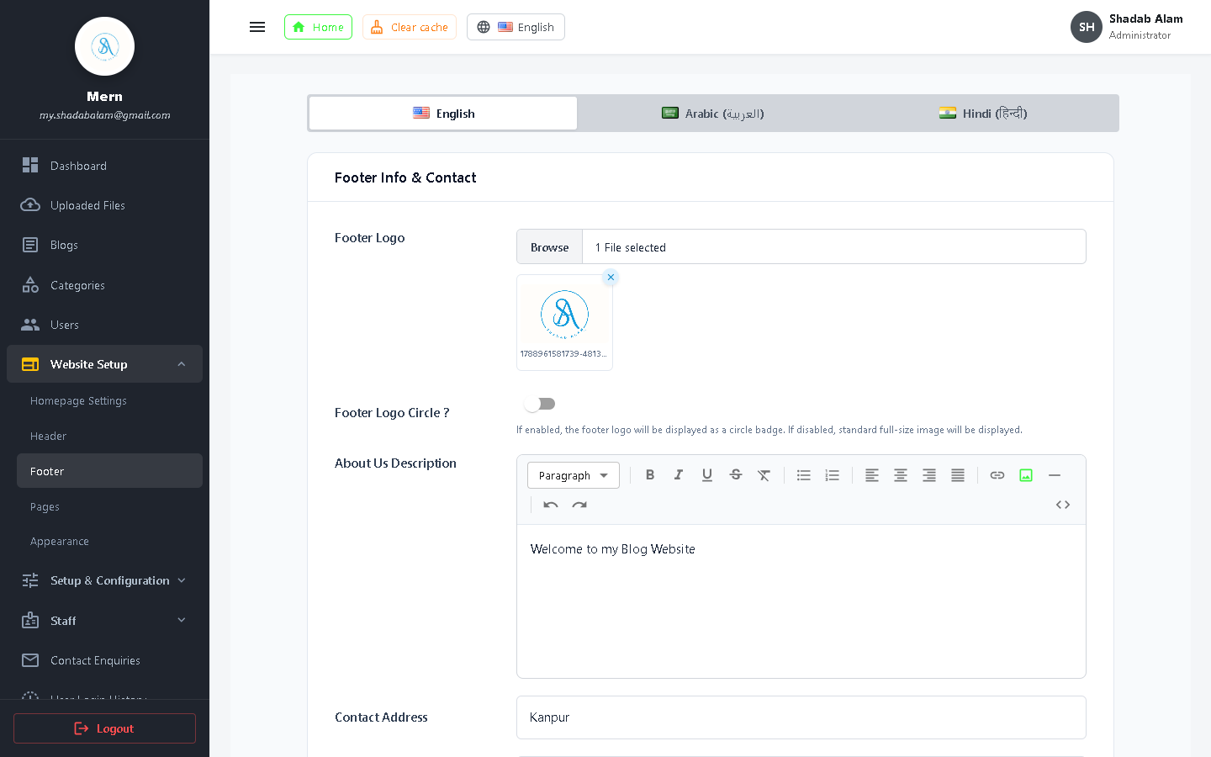
Figure 24: Footer Setup: About Widget, Quick Links, Newsletter, and Copyright Notice
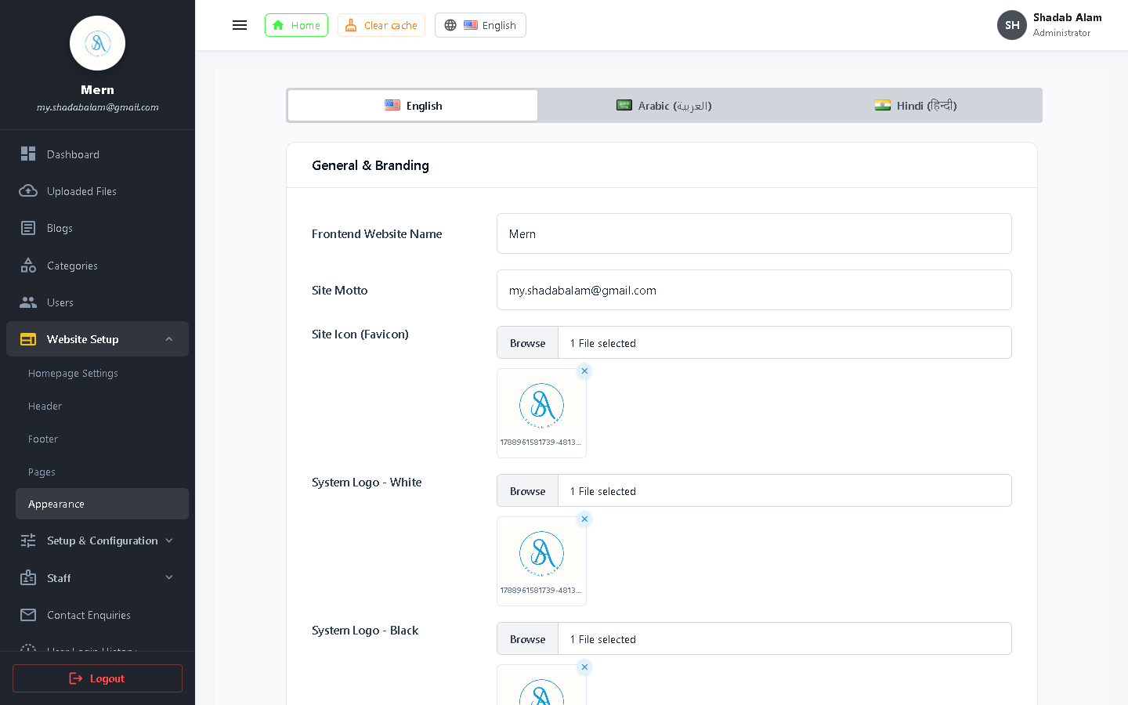
Figure 25: Appearance Settings: Color Schemes, Dark/Light Mode, Typography, RTL Mode
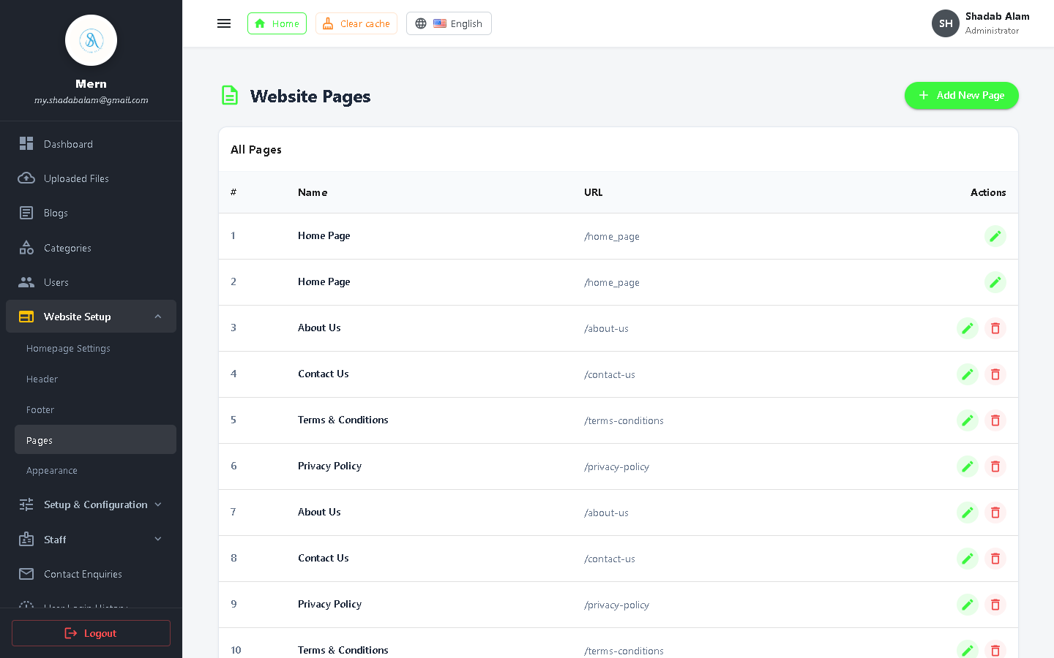
Figure 26: Custom Pages Directory with Slugs, Status, and Action Buttons
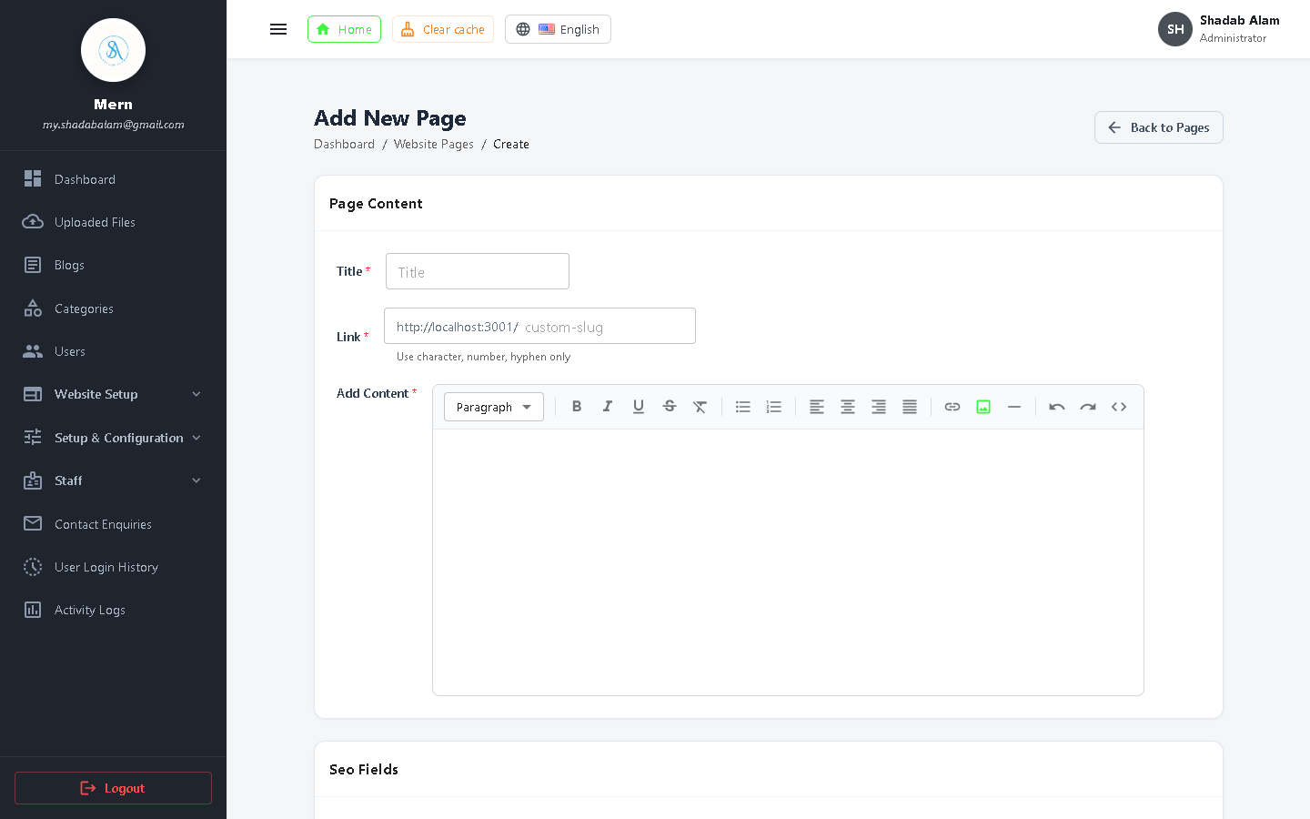
Figure 27: Create Custom Page Form with Slug, Content Editor, and SEO Meta Tags
Setup Screen | Customizable Elements | Effect on Website
Homepage Settings | Hero Title, Subtitle, Banner Image, Featured Section Toggles | Alters the public landing page appearance immediately
Header Settings | Logo upload, sticky nav switch, category dropdown switch | Updates primary top navigation bar across all pages
Footer Settings | About text, social media links, copyright notice, columns | Controls bottom information widgets across all pages
Appearance Settings | Primary/Secondary theme colors, dark mode default, fonts, RTL | Adjusts CSS variables and Material UI theme globally
Custom Pages | WYSIWYG content editor, custom URL slug, SEO titles | Allows creating static pages like Terms of Service, Privacy Policy

4.8 Setup & System Configurations
The Setup menu hosts mission-critical system configurations including feature flags, email delivery, payment keys, and external API credentials.
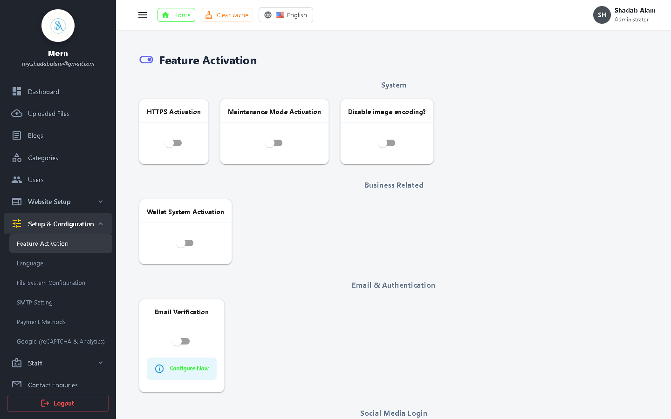
Figure 28: Feature Activation Switches: User Registrations, Comments, Payments
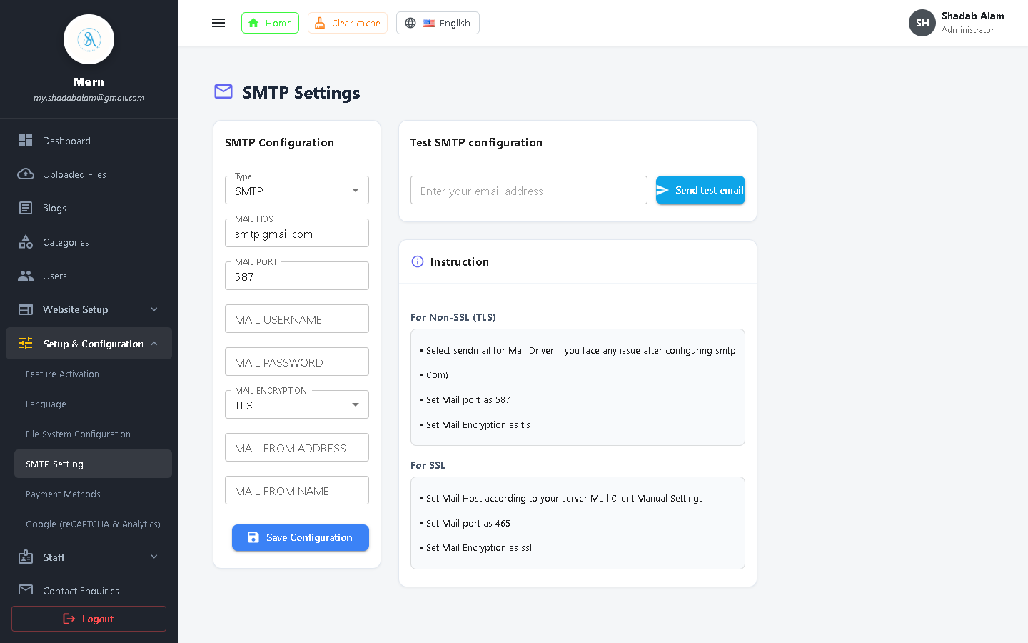
Figure 29: SMTP Mailer Configuration: Host, Port, TLS/SSL, and Test Email Delivery
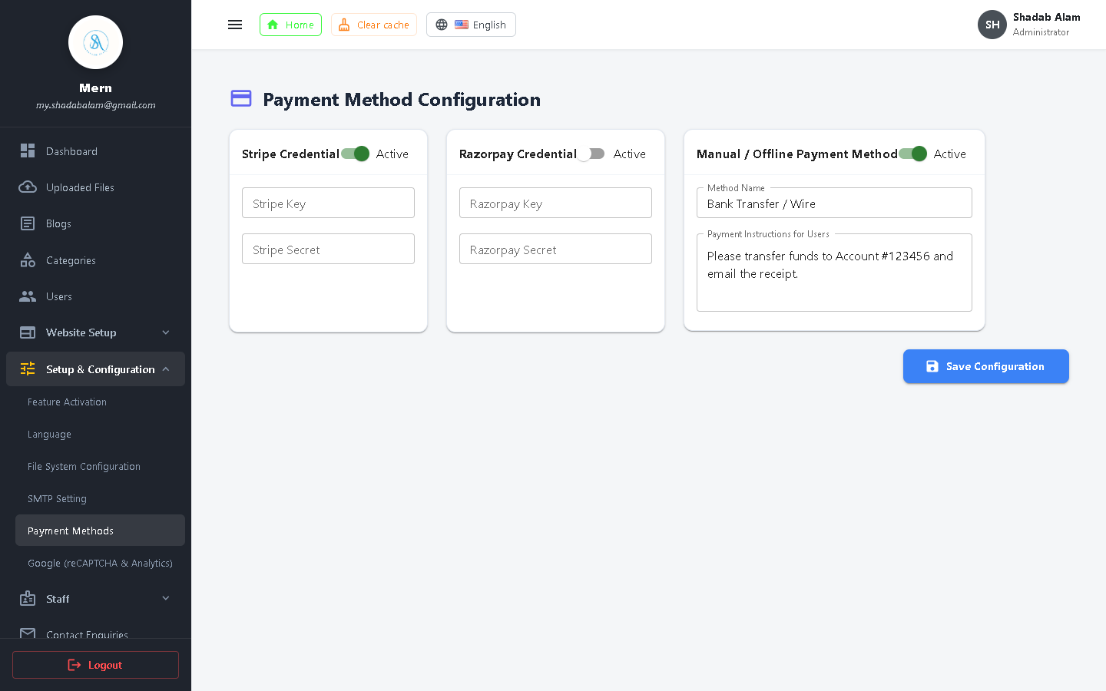
Figure 30: Payment Methods Setup: Stripe Secret Key, Publishable Key, Currency Selector
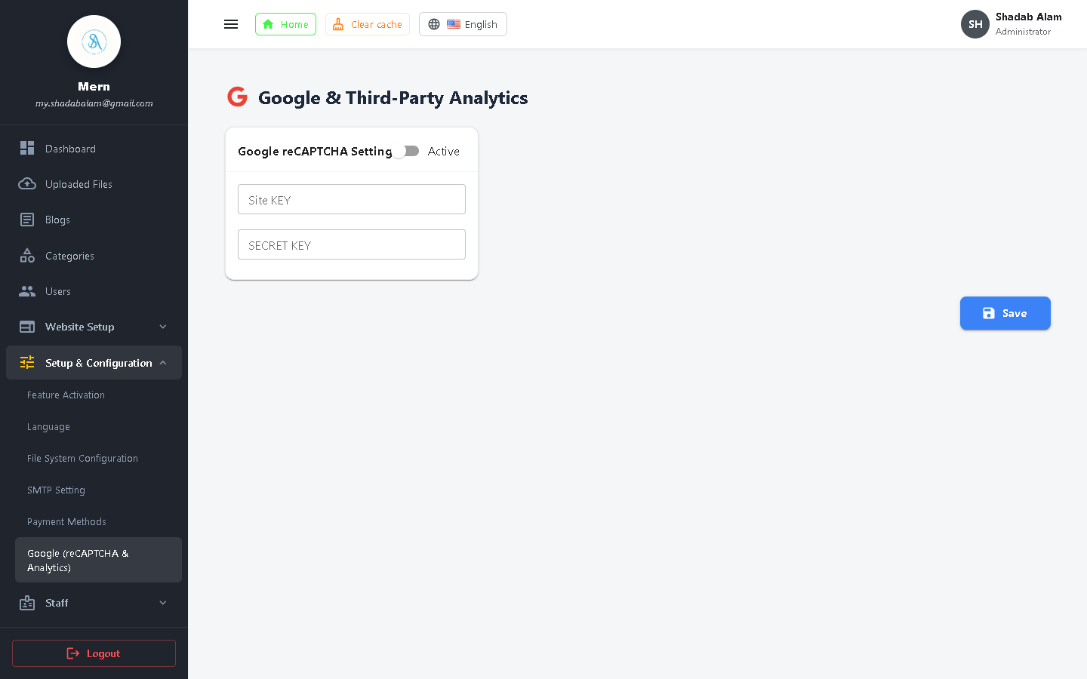
Figure 31: Google Integration: Analytics Tracking ID, OAuth 2.0, reCAPTCHA v2/v3
Configuration Checklist for Production Deployment:
1. Feature Activation: Ensure user registrations and comments are toggled ON; enable email verification.
2. SMTP Configuration: Input valid mail server credentials and click 'Send Test Email' to verify delivery.
3. Stripe Payments: Toggle between 'Sandbox / Test Mode' and 'Live Mode'; verify Stripe webhook secrets.
4. Google Settings: Enter valid Google Client ID for one-click social authentication and reCAPTCHA keys.

4.9 Multi-Language System (i18n & Localization)
The platform incorporates an integrated internationalization framework supporting multiple languages and bi-directional text (LTR / RTL).
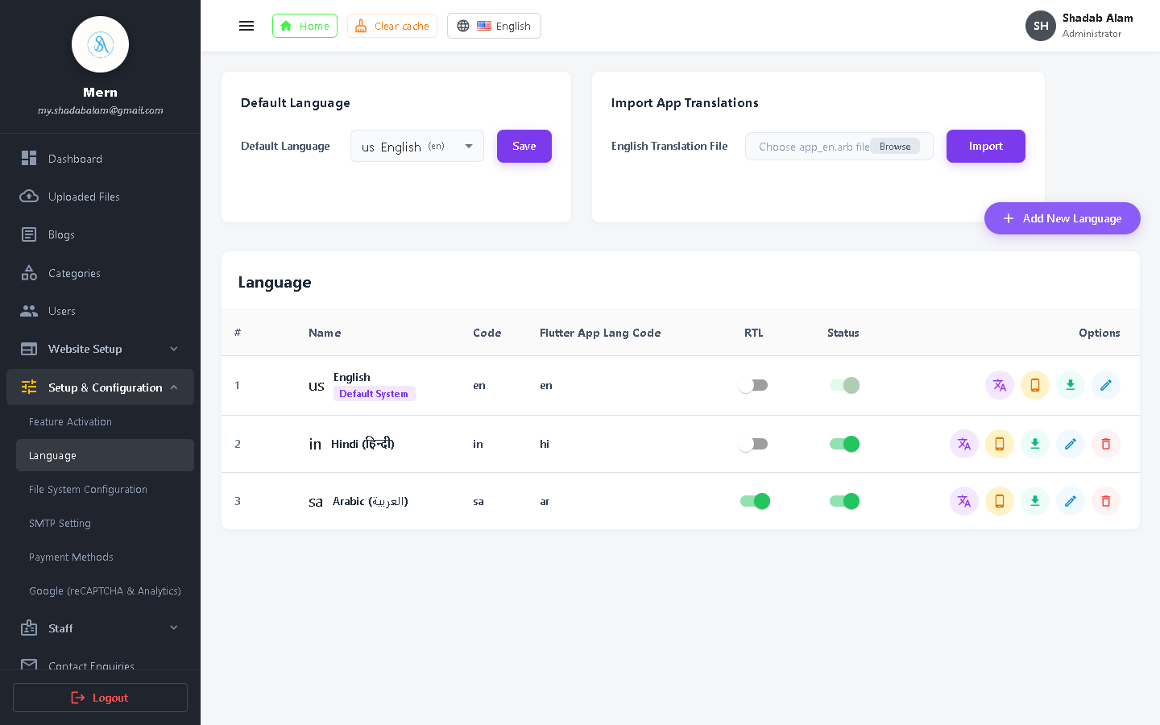
Figure 32: Language Management Table with Active Languages and Default Selector
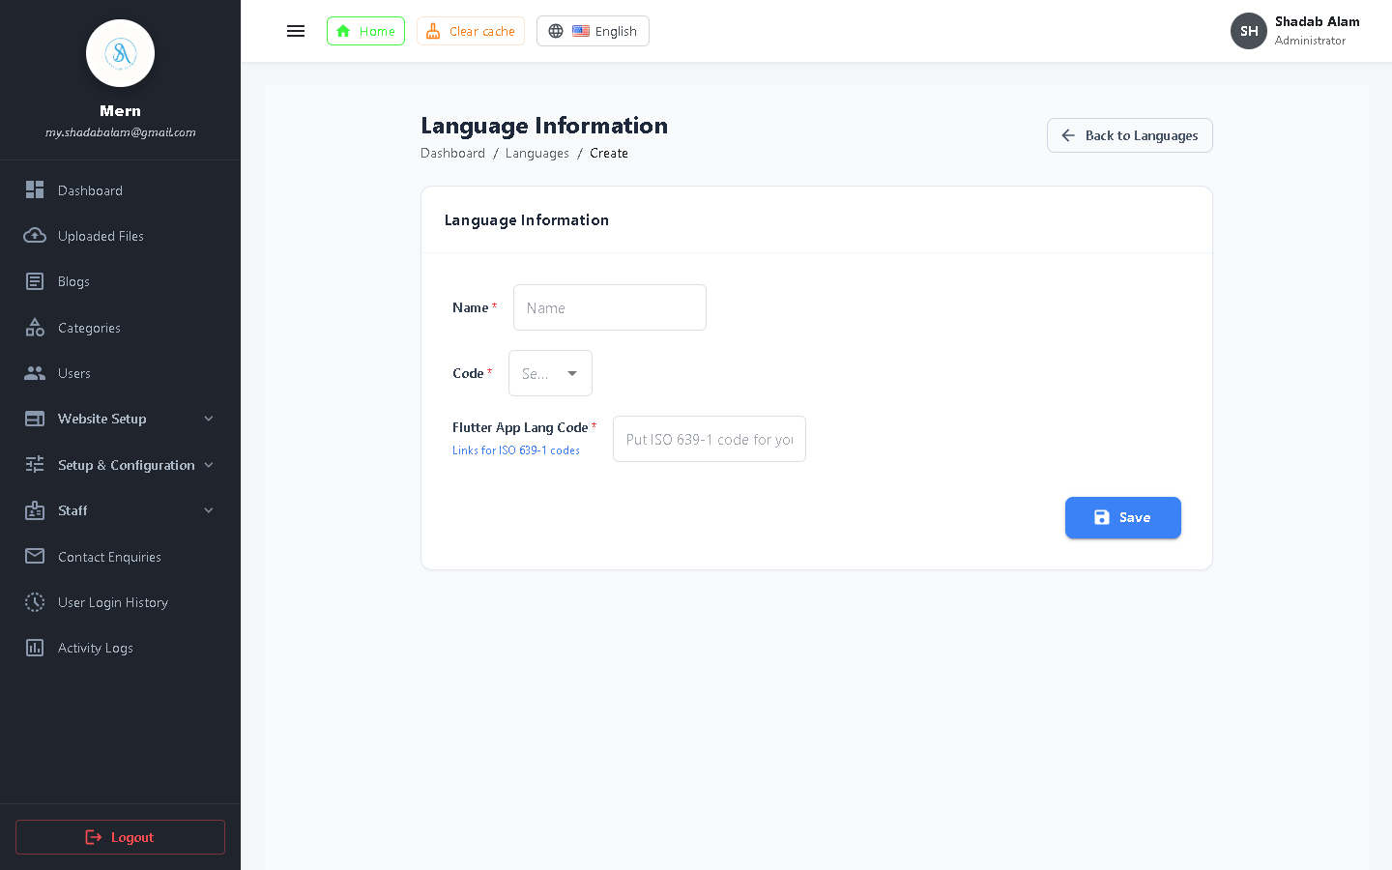
Figure 33: Add New Language Form with Name, ISO Code, and RTL Toggle
Step-by-Step: Adding and Translating a New Language:
1. Go to 'Setup' > 'Languages' > 'Add New Language'.
2. Input Language Name (e.g., 'Arabic', 'Spanish', 'French') and Code (e.g., 'ar', 'es', 'fr').
3. For Arabic or Hebrew, check the 'RTL (Right to Left)' toggle switch.
4. Click Save. In the language table, click the 'Translations' icon to open the key-value dictionary editor.
5. Input translated terms for standard system strings ('Home', 'Login', 'Dashboard', etc.) and click 'Update Translations'.

4.10 Security, Audit Logs & Inquiries
Comprehensive auditing tools ensure that all administrative activity, user logins, and customer messages are permanently recorded.
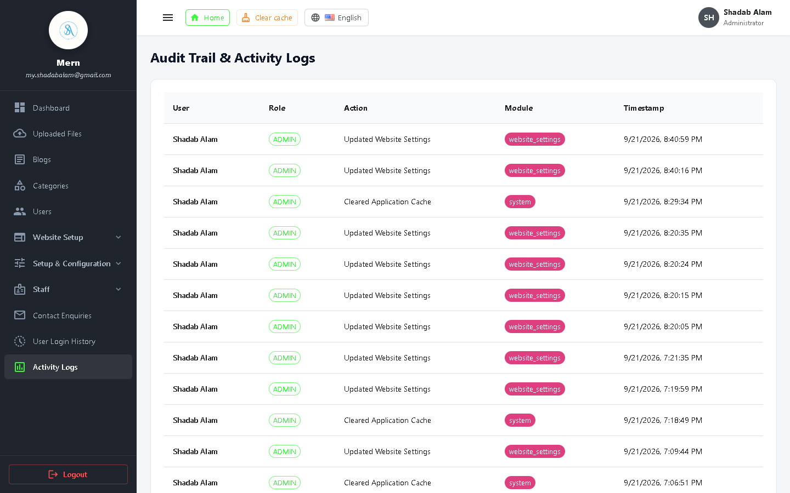
Figure 34: System Activity Logs with Administrator Actions, Timestamps, and IP Addresses
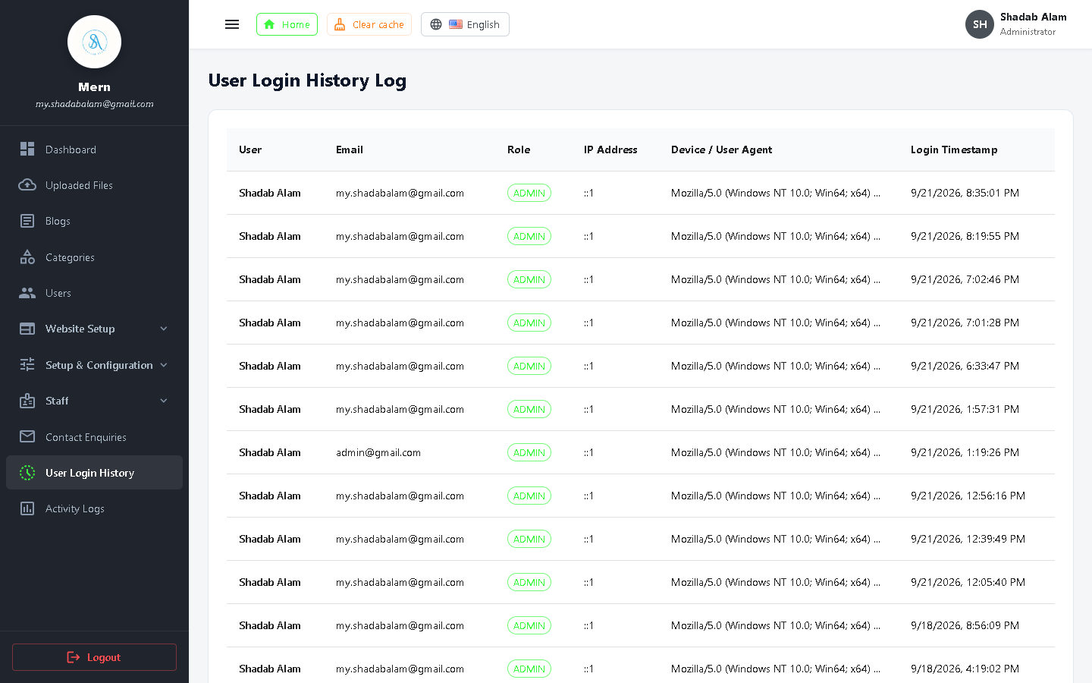
Figure 35: Login History Audit Trail with Devices, Operating Systems, and IP Tracking
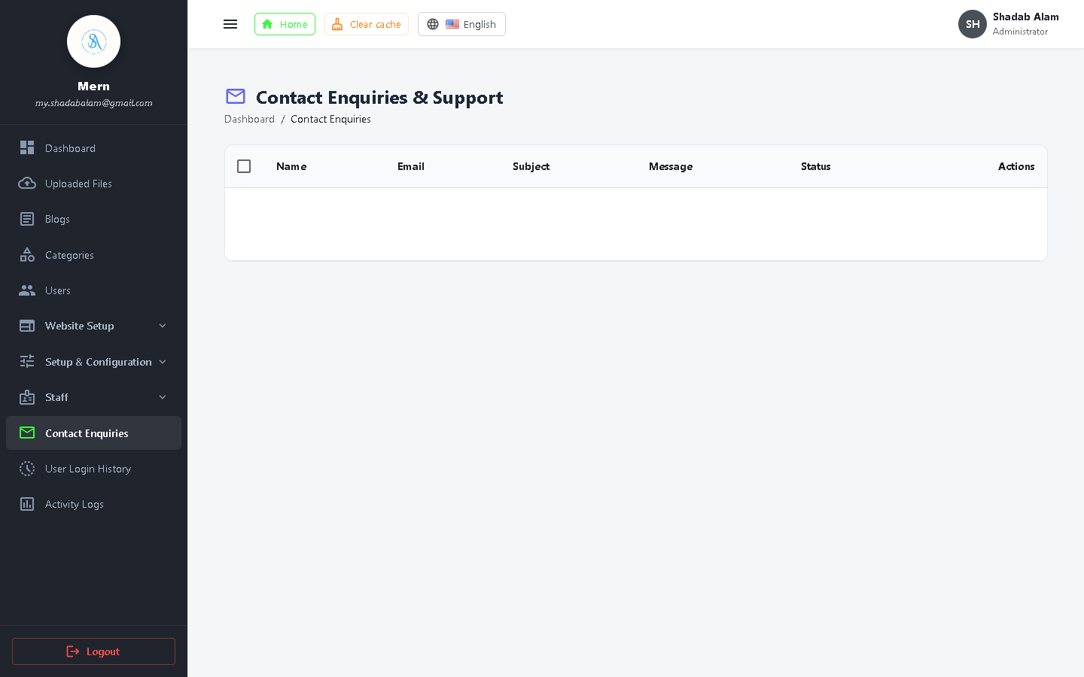
Figure 36: Customer Contact Inquiries Management with Resolution Status and Reply
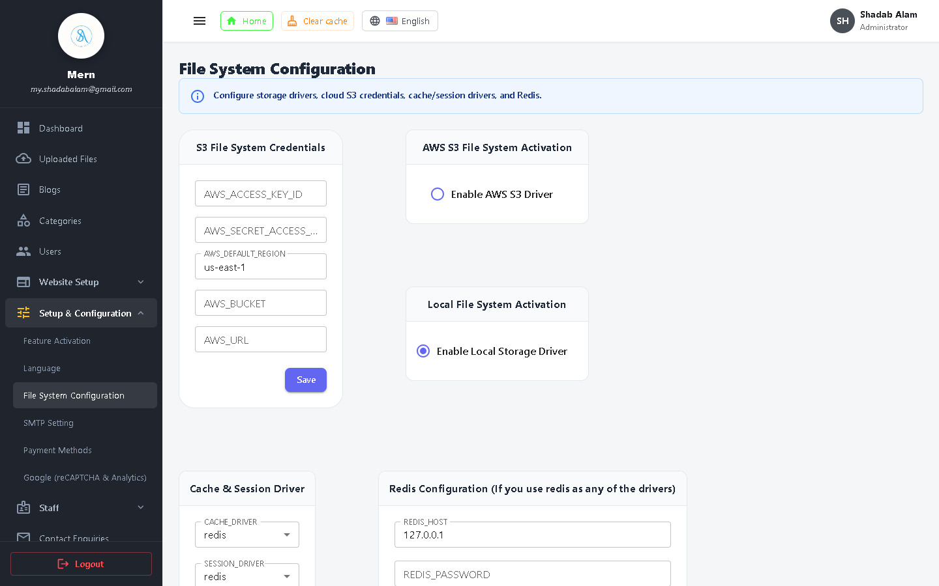
Figure 37: File System & Server Storage Settings with Driver Configurations

5. Operational Troubleshooting & Best Practices
This section provides guidelines for troubleshooting common operational issues and maintaining system health.
Scenario / Issue | Root Cause | Recommended Resolution
Email notifications not delivering | Incorrect SMTP credentials or port block (587/465) | Verify SMTP host in Admin Setup > SMTP; confirm App Passwords if using Gmail; test using 'Send Test Email'.
Payment status remaining 'Pending' | Stripe webhook endpoint not reachable from public internet | Verify Stripe Webhook Secret; ensure local dev tunnels (ngrok) or public domains are registered in Stripe Dashboard.
Uploaded image failing to render | File permissions or static asset route misconfiguration | Check file uploads directory permissions; verify public asset URL prefix in File System settings.
User blocked from admin panel | Missing required permission in assigned staff role | Log in as Super Admin; navigate to Staff Roles; inspect and enable required permission checkboxes.

[AUDIT BEST PRACTICE] Regularly review Activity Logs and Login History to identify anomalous login spikes or unauthorized configuration updates.

