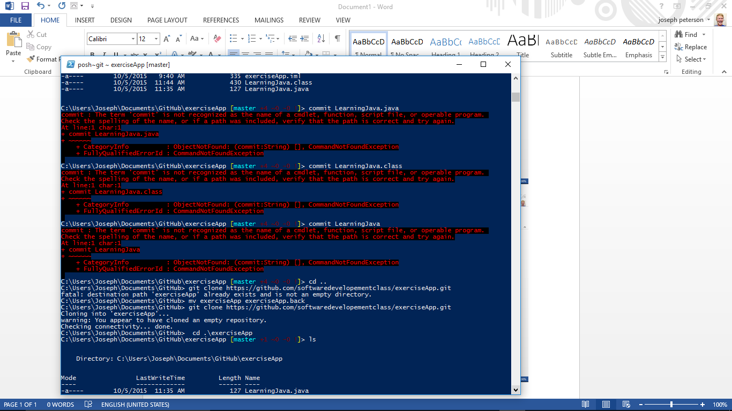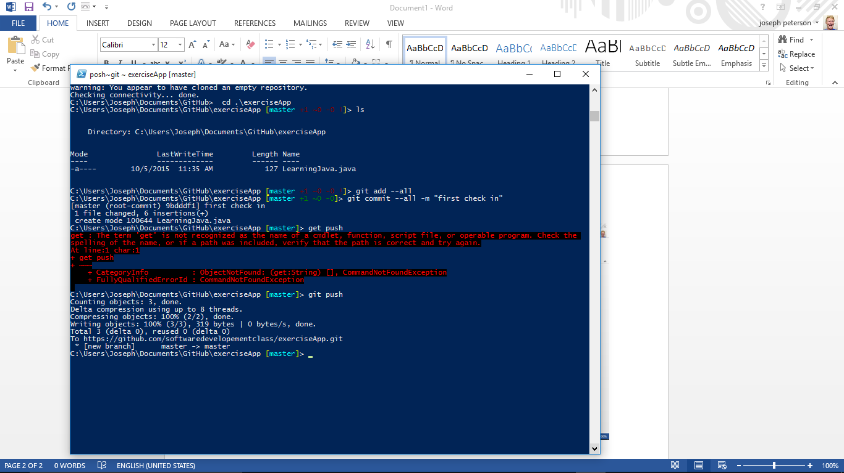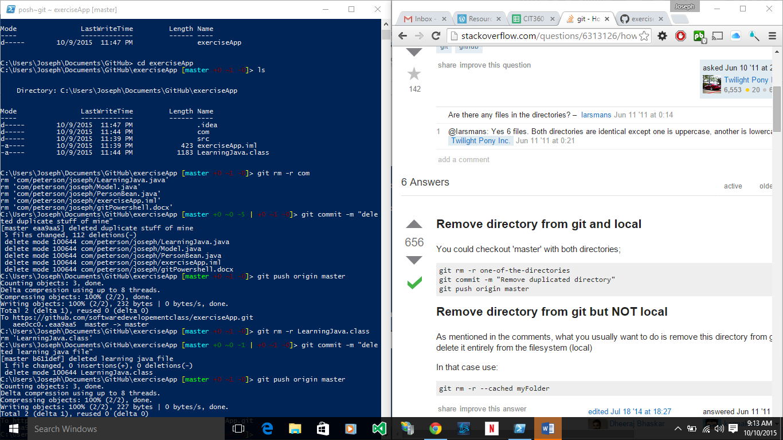

Fork your main project, add .gitgnore file and in that type .idea/ to ignore the idea folder(which is your local files) connect to it then in that forked project of yours after you make changes, push them, then merge to master. And to get others’ changes, do this

1. Open a Terminal
2. cd to your forked project directory
3. git remote add upstream <url-of-original-repository>
4. git branch and verify you are on master branch
5. git pull --rebase upstream master

This allows you to pull anyones elses changes to your FORKED project that they have pushed to master.