DESIGN AND IMPLEMENTATION OF A DATA-DRIVEN DECISION SUPPORT SYSTEM FOR SMALL BUSINESS OPERATIONS USING INTERACTIVE DASHBOARDS AND ANALYTICAL MODELS
BY
ABIDOYE ENIOLA FAVOUR
COS/8933/2021
DEPARTMENT OF COMPUTER SCIENCE
COLLEGE OF SCIENCE
FEDERAL UNIVERSITY OF PETROLEUM RESOURCES, EFFURUN, DELTA STATE, NIGERIA
2026

DESIGN AND IMPLEMENTATION OF A DATA-DRIVEN DECISION SUPPORT SYSTEM FOR SMALL BUSINESS OPERATIONS USING INTERACTIVE DASHBOARDS AND ANALYTICAL MODELS
BY
ABIDOYE ENIOLA FAVOUR
COS/8933/2021
A PROJECT SUBMITTED TO THE DEPARTMENT OF COMPUTER SCIENCE, COLLEGE OF SCIENCE, FEDERAL UNIVERSITY OF PETROLEUM RESOURCES, EFFURUN, IN PARTIAL FULFILMENT OF THE REQUIREMENTS FOR THE AWARD OF THE DEGREE OF BACHELOR OF SCIENCE (B.Sc.) IN COMPUTER SCIENCE
PROJECT SUPERVISOR
MR AGHOGHO ONOKPASA
2026

DECLARATION
I hereby declare that this project titled “Design and Implementation of a Data-Driven Decision Support System for Small Business Operations Using Interactive Dashboards and Analytical Models” was carried out by Abidoye Eniola Favour (COS/8933/2021). The work presented in this report is my own except where sources have been acknowledged.

CERTIFICATION
This is to certify that this project titled “Design and Implementation of a Data-Driven Decision Support System for Small Business Operations Using Interactive Dashboards and Analytical Models” was carried out by Abidoye Eniola Favour (COS/8933/2021), and has been approved by the undersigned as having fulfilled the requirements for the award of the Bachelor of Science degree in Computer Science.

DEDICATION
This project is dedicated to Almighty God for the strength, guidance and understanding throughout the study.

ACKNOWLEDGEMENTS
I express my gratitude to Almighty God for the strength and perseverance to complete this work. I sincerely appreciate my project supervisor, Mr Aghogho Onokpasa, for his guidance and constructive feedback during the study. I also appreciate the lecturers and staff of the Department of Computer Science, Federal University of Petroleum Resources, Effurun, and my family and friends for their support.

ABSTRACT
Small businesses often generate sales, expense and inventory records without having a convenient way to consolidate and interpret those records. This project presents the design and implementation of BizInsight, a web-based data-driven Decision Support System intended for small business operations. The system provides a central workspace for business setup, categories, products, sales and expenses, then converts the stored records into descriptive dashboard measures, trend summaries, stock indicators and rule-based decision-support findings. Structured CSV import and export are included so that existing records can be moved into and out of the system without repeated manual entry.
The implementation uses React and TypeScript for the presentation layer, Python with FastAPI for application logic, and Supabase PostgreSQL for persistent storage. Supabase Auth is used for authentication. An optional DeepSeek service provides natural-language interpretation of deterministic analytics. The AI layer is deliberately separated from the calculation layer: business metrics and rule-based findings are calculated by the application, while DeepSeek receives a controlled context and is not treated as the source of truth.
Development follows an iterative Agile approach. The system is designed for descriptive and diagnostic analysis rather than predictive forecasting. Evaluation focuses on functional correctness, calculation accuracy, business-data isolation, responsive interface behaviour and AI fallback reliability. Formal user-evaluation results are to be added after deployment and user testing rather than estimated in advance.

TABLE OF CONTENTS
CHAPTER ONE: INTRODUCTION
1.1 Background of the Study
1.2 Statement of the Problem
1.3 Aim and Objectives of the Study
1.4 Significance of the Study
1.5 Scope of the Study
1.6 Definition of Terms
CHAPTER TWO: LITERATURE REVIEW
2.1 Conceptual Review
2.2 Previous Approaches and Techniques
2.3 Review of Related Works
2.4 Gaps in Related Works
CHAPTER THREE: SYSTEM ANALYSIS AND DESIGN
3.1 Analysis of the Existing System
3.2 Analysis of the Proposed System
3.3 Methodology
3.4 Methods of Data Collection
3.5 Design Specification
CHAPTER FOUR: SYSTEM IMPLEMENTATION
4.1 Implementation Tools
4.2 System Requirements
4.3 Choice of Programming Language and Implementation Platform
4.4 Implemented Components
4.5 System Evaluation and Comparison with the Existing System
4.6 Implementation Method and Iterations
4.7 Current Implementation Limitations
CHAPTER FIVE: SUMMARY, CONCLUSION AND RECOMMENDATIONS
5.0 Summary
5.1 Conclusion
5.2 Recommendations
5.3 Final Observation
REFERENCES

LIST OF FIGURES
Figure 3.1: Existing record-to-decision workflow
Figure 3.2: Proposed three-tier BizInsight architecture
Figure 3.3: Operational request flow

LIST OF TABLES
Table 2.1: Summary of Related Literature
Table 3.1: Major Data Entities
Table 3.2: Functional Requirements
Table 3.3: Non-Functional Requirements
Table 4.1: Implementation Tools
Table 4.2: Software Requirements
Table 4.3: Verification Areas
Table 4.4: Existing and Proposed System

CHAPTER ONE
INTRODUCTION
1.1 Background of the Study
Small businesses generate a large amount of operational information even when they do not describe what they do as data management. Sales are recorded, expenses are paid, products move in and out of stock, and customers arrive through different channels. The difficulty is that these records are often kept in separate notebooks, spreadsheets, messaging applications, or memory. The result is not necessarily a lack of information. It is a lack of a usable view of the information.
Recent work on Nigerian small and medium enterprises continues to connect record keeping with financial stability and resource management. Oluwo et al. (2024) report that systematic record keeping and financial literacy are associated with stronger financial management and operational sustainability among Nigerian SMEs. Fabian et al. (2024) similarly argue that business intelligence can improve the speed and quality of decision making in African MSMEs, while noting the practical need to adapt such tools to the environment in which small firms operate.
The problem becomes clearer when the cost of existing business intelligence products is considered. BI platforms are capable of sophisticated reporting, but adoption by SMEs is constrained by cost, skills, organisational readiness and implementation risk. Poba-Nzaou et al. (2022) show that BI adoption in an African SME is shaped by implementation risk and the need to fit the system to the organisation. Perdana et al. (2022) also identify resource constraints and management support as important factors in data analytics adoption among SMEs.
Decision Support Systems provide a useful way to frame the problem. The purpose is not to remove the business owner from the decision process. Instead, the system gathers relevant information, applies defined analytical procedures, and presents the result in a form that can be considered before action is taken. Ibrahim and Alkhazmi (2024) describe DSS as systems whose data, model and interaction components work together to support decision makers.
This study applies that idea to small business operations. The proposed BizInsight system stores sales, expenses, products and categories in a central relational database. It calculates descriptive measures such as revenue, expenses, estimated profit, stock status, product performance, channel performance and recent trends. It also produces rule-based findings that point to conditions requiring attention.
The dashboard is intentionally restrained. Research on dashboards shows that more information is not automatically better. Frazão et al. (2021) reviewed business and management dashboards and identified recurring questions around information visualisation and decision support, while Toreini et al. (2022) show that dashboards can place substantial demands on users' limited attention. Hjelle et al. (2024) further found that the format, currency and completeness of information presented in dashboards can affect information satisfaction and decision quality. These findings support a design in which the main screen prioritises the measures a small business owner is most likely to need rather than attempting to display every available metric.
BizInsight also includes an optional DeepSeek interpretation layer. The AI component does not calculate the underlying business figures and does not receive unrestricted access to the database. The application first computes deterministic analytics and rule-based findings, then passes that controlled context to the language model for interpretation. This boundary is important because recent research on AI-supported decision making warns that users can over-rely on incorrect advice, even when explanations are provided (Cecil et al., 2024; Fok et al., 2024).
The project therefore sits at the intersection of small-business record keeping, data-driven decision support, dashboard design and controlled AI assistance. Its scope remains descriptive and diagnostic. It does not claim to forecast sales or automatically decide what a business owner should do.
1.2 Statement of the Problem
Many small businesses have records but cannot easily turn those records into a current picture of performance. Sales may be stored separately from expenses, stock information may be updated manually, and information from different sales channels may never be consolidated. This makes simple questions difficult to answer: How much was earned during a period? Which products moved most? Which expenses increased? Which items need restocking? Which sales channel is contributing most?
The problem is not solved simply by adding another spreadsheet. A useful system must reduce repeated calculation, preserve the relationship between operational records, and present the resulting information without requiring specialist analytical training. Agwuna et al. (2022) emphasise that dashboard value depends on data integration, stable definitions, suitable visual encoding and a clear link between signals and action.
Existing BI and analytics research demonstrates value, but much of the literature concerns organisations with stronger technical capacity or larger information environments. Ragazou et al. (2023) note that SMEs have historically viewed BI as complicated or costly, even though cloud-based approaches have lowered the barriers. Anjaningrum et al. (2024) further show that BI does not automatically translate into better SME performance; organisational learning and related capabilities influence how BI produces value.
The specific problem addressed by this study is therefore the absence of a lightweight decision-support environment designed around the everyday records of a small business, with a simple interface, centralised data, descriptive analytics, CSV ingestion and a controlled optional AI interpretation layer.
1.3 Aim and Objectives of the Study
Aim
The aim of this study is to design and implement a data-driven decision support system for small business operations using interactive dashboards and analytical models.
Objectives
1. To review recent literature and comparable systems concerning small-business record keeping, business intelligence, dashboards and decision support.
2. To design a three-tier system architecture containing a web interface, application logic and a central relational database.
3. To implement a web platform through which a business owner can create a business profile and manage categories, products, sales and expenses.
4. To develop descriptive dashboard analytics covering revenue, expenses, estimated profit, stock status, product performance, sales channels and trends.
5. To implement rule-based decision-support findings that identify conditions such as low stock, inactive products, changing sales performance and rising expenses.
6. To support structured CSV import and CSV export so that existing records can enter or leave the system without manual re-entry.
7. To integrate an optional DeepSeek interpretation service whose output is constrained by deterministic analytics generated by the application.
8. To evaluate the implementation for functional correctness, calculation accuracy, data isolation, interface responsiveness and the reliability of the AI fallback behaviour.
1.4 Significance of the Study
The practical significance of the system lies in bringing routine records closer to the point at which business decisions are made. A business owner does not have to understand database queries or build charts manually to answer common operational questions. The system handles the repetitive calculations and presents the result in a single workspace.
The academic significance is narrower. The project provides a concrete example of how a data-driven DSS can be scaled down for small-business use without turning the system into a miniature enterprise BI platform. Okfalisa et al. (2022) demonstrate the use of an intelligent dashboard DSS for SME digital readiness, while the present study focuses on everyday operating records and the connection between those records, descriptive analytics and decision-support findings.
The project also demonstrates a controlled use of generative AI in a DSS context. Onwujekwe and Weistroffer (2025) describe the growing body of intelligent DSS research and the incorporation of machine-learning techniques into decision-support artefacts. BizInsight takes a more limited position: the deterministic DSS remains the source of truth, while DeepSeek is used to explain the information already calculated by the system.
1.5 Scope of the Study
The study covers a browser-based system for a small business owner. The implementation includes account authentication through Supabase Auth, business profile management, product categories, product and inventory management, sales recording, expense recording, dashboard analytics, rule-based recommendations, report exports, structured CSV imports and optional AI business insights.
The analytical scope is descriptive and diagnostic. It includes totals, comparisons, trend patterns, stock thresholds, product rankings, channel summaries and rule-based signals. It does not include machine-learning forecasting, automated pricing, external accounting integrations, real-time transaction streaming or automated business decisions.
The system uses a three-tier structure consisting of a React and TypeScript presentation layer, a Python and FastAPI application layer, and Supabase PostgreSQL as the persistent data layer. Supabase Auth provides identity management. DeepSeek is accessed only from the backend so that the provider credential is not exposed in the browser.
1.6 Definition of Terms
Decision Support System: An interactive information system that combines data, analytical procedures and a user interface to support human decision making.
Business Intelligence: The organised use of business data, analytical methods and reporting interfaces to produce information that can be used in management.
Dashboard: A visual interface that presents selected measures and trends in one place for rapid interpretation.
Key Performance Indicator: A measurable business value used to monitor a defined aspect of performance.
Data Ingestion: The process by which records enter the application for validation, storage and processing.
Trend Analysis: A descriptive analysis of how a metric changes across time.
Rule-Based Recommendation: A decision-support finding produced when defined business conditions are met.
AI Interpretation: Natural-language explanation generated from a controlled set of deterministic analytics.
Three-Tier Architecture: Separation of the presentation, application logic and data layers.
Small Business: For this project, a business operating at a scale where routine records and decisions can be managed by an owner or small operational team without dedicated enterprise analytics staff.

CHAPTER TWO
LITERATURE REVIEW
2.1 Conceptual Review
2.1.1 Decision Support and the Human Decision Maker
The central idea behind a DSS is that information and analytical procedures can improve the conditions under which a person makes a decision. The system does not have to make the final decision itself. This distinction is important for BizInsight because a recommendation such as “review stock levels” is materially different from an automated instruction to purchase stock.
Giarlotta and Petralia (2024) revisit Simon's bounded-rationality perspective and reinforce the relevance of decision processes that operate under limits of time and information. For a small-business owner, those limits are practical rather than theoretical. A dashboard that requires prolonged interpretation can fail even when the underlying calculations are correct.
Oral et al. (2024) examine the relationship between visualisation and the stages of decision making. Their analysis highlights that visual systems are particularly useful for the intelligence stage, where a decision maker explores and understands the relevant information. This aligns with the role assigned to the BizInsight dashboard.
2.1.2 Business Intelligence in SMEs
Business intelligence has expanded beyond large corporate data warehouses. Ragazou et al. (2023) describe the continuing development of BI for SMEs and note that cloud technologies have reduced some of the cost and infrastructure barriers. Tafuro et al. (2026) similarly identify fragmented adoption, resource constraints and the need for adaptable governance as continuing issues in SME BI research.
The implication for BizInsight is not that a small business needs every feature offered by a commercial BI suite. The system instead selects a smaller set of functions that correspond directly to its operating records. Sales, expenses, products and stock are connected first; analytics are then calculated from those records.
2.1.3 Dashboards and Visual Information
Dashboards are useful because they reduce the distance between a stored record and a visible business condition. They can also create new problems if too many metrics are placed on one screen. Burnay et al. (2024) discuss cognitive load and dashboard adoption in BI systems, showing why content selection matters as much as the underlying data.
Toreini et al. (2022) focus on attention management in dashboards. Their work supports the decision to keep BizInsight's dashboard selective rather than dense. Hjelle et al. (2024) provide additional evidence that information format, currency and completeness influence information satisfaction and decision quality.
2.1.4 Data Quality and Traceability
A decision-support screen is only useful if its measures can be traced back to records. Agwuna et al. (2022) distinguish information delivery from actual decision improvement and emphasise traceable data and stable definitions. This is reflected in the system design by calculating revenue from recorded sales, calculating expenses from recorded expense entries, and calculating stock from product records and server-side stock movements.
2.1.5 AI-Assisted Decision Support
AI can add a natural-language layer to a DSS, but the addition creates a new reliability problem. Alufaisan et al. (2021) found that AI advice can improve decision accuracy in some settings, but explainability alone did not guarantee better human performance. Cecil et al. (2024) similarly found that incorrect AI advice can produce over-reliance, and Fok et al. (2024) argue that explanations are most useful when they help a decision maker verify an AI recommendation.
BizInsight therefore does not allow the language model to calculate the business KPIs. It receives a compact context containing the already-calculated dashboard values and rule-based findings. If DeepSeek is unavailable, the deterministic findings remain available.
2.2 Previous Approaches and Techniques
2.2.1 Manual and Spreadsheet-Based Reporting
Manual records remain attractive because they are inexpensive and familiar. Their weakness is the amount of repeated work required to consolidate them. Subagio (2026), working with an MSME dashboard scenario, reports improvements when spreadsheet-style reporting is replaced with Python-based preparation and an interactive BI dashboard. The study is not treated as proof that the same gains will occur in BizInsight because the datasets, participants and evaluation setting differ. It is useful as evidence of the problem addressed by this class of system.
2.2.2 SME BI and Dashboard DSS
Okfalisa et al. (2022) implemented a dashboard-based DSS for SME digital readiness using multiple assessment criteria. The work demonstrates how dashboard interfaces can expose analytical results to SME users, although its decision domain differs from the operational sales and expense focus of BizInsight.
Agwuna et al. (2022) review dashboard use for SME decision support and stress that dashboards must connect information to action. This study is closer to the present project because it treats the dashboard as part of a decision process rather than as a reporting screen alone.
2.2.3 BI Adoption and Implementation Constraints
Poba-Nzaou et al. (2022) studied BI adoption in an African SME and found implementation risk to be an important part of the adoption process. Perdana et al. (2022) similarly identify management support and resource conditions as important to data analytics adoption in SMEs.
These findings influence the proposed system in two ways. First, the application is web-based so that the business does not need a dedicated desktop analytics installation. Second, the initial feature set is intentionally limited to functions directly connected to the identified problem.
2.2.4 Data-Driven SME Performance
Anjaningrum et al. (2024) found that BI did not directly guarantee SME performance in their sample. Organisational learning and innovation affected the relationship. This is a useful warning against describing BizInsight as a system that automatically improves business performance. The project can improve access to information, but the value of that information still depends on what the business owner does with it.
2.2.5 Intelligent DSS
Onwujekwe and Weistroffer (2025) reviewed more than two thousand journal papers concerning intelligent DSS and proposed a framework for the development of systems that incorporate machine learning. Reis et al. (2025) demonstrate a context-aware DSS for selecting explainable AI methods in a business setting. These studies show that the integration of AI into DSS is an active research area, but they also support the need to define what the AI layer is responsible for.
BizInsight does not attempt to reproduce a full intelligent DSS framework. Its AI function is deliberately narrower. It explains existing analytics and produces suggestions that remain subject to the user's judgement.
2.3 Review of Related Works
Table 2.1 summarises selected recent studies relevant to the project.

Table 2.1: Summary of Related Literature
Study | Focus | Main contribution | Relevance to BizInsight
Frazão et al. (2021) | Business dashboards | Review of visualisation techniques used for management decisions | Supports purposeful dashboard selection
Alufaisan et al. (2021) | Explainable AI | Examines human decision accuracy with AI advice and explanations | Supports caution around AI advice
Agwuna et al. (2022) | SME BI dashboards | Integrates BI, governance and decision support perspectives | Supports dashboard-to-decision design
Okfalisa et al. (2022) | SME DSS dashboard | Uses a dashboard to assess digital readiness | Demonstrates SME-oriented DSS
Poba-Nzaou et al. (2022) | BI adoption in African SME | Examines implementation risk | Supports lightweight implementation
Perdana et al. (2022) | SME analytics adoption | Identifies organisational and support factors | Supports accessible deployment
Toreini et al. (2022) | Dashboard attention | Studies management of users' attention | Supports restrained interface design
Ragazou et al. (2023) | BI and SMEs | Reviews BI's role in SME decisions and competitiveness | Supports SME-specific BI
Giarlotta and Petralia (2024) | Bounded rationality | Revisits Simon's decision-making model | Supports human-centred DSS framing
Burnay et al. (2024) | BI and cognitive load | Examines dashboard content and adoption | Supports metric selection
Hjelle et al. (2024) | Dashboard visualisation | Tests effects of information quality dimensions | Supports clear and current measures
Oral et al. (2024) | Visualisation and decision stages | Reviews how visual tools support decision stages | Supports intelligence-stage dashboard
Anjaningrum et al. (2024) | BI and SME performance | Tests mediating organisational factors | Prevents overclaiming business impact
Fabian et al. (2024) | BI in African MSMEs | Examines BI and decision making in African firms | Provides regional relevance
Oluwo et al. (2024) | SME records | Links record keeping with financial stability | Establishes local problem context
Cecil et al. (2024) | AI advice | Studies over-reliance on incorrect AI advice | Supports AI safeguards
Fok et al. (2024) | AI explanations | Examines verification in AI-advised decisions | Supports bounded AI role
Ibrahim and Alkhazmi (2024) | DSS types | Reviews DSS classifications | Supports system positioning
Mudau et al. (2024) | BI use | Examines routine and advanced BI use | Supports staged user adoption
Qatawneh (2024) | BI adoption | Examines BI adoption and decision performance | Supports adoption rationale
Onwujekwe and Weistroffer (2025) | Intelligent DSS | Reviews intelligent DSS literature | Positions AI layer
Ossai (2025) | Nigerian SME BI | Reviews e-business intelligence in Nigerian SMEs | Regional gap
Reis et al. (2025) | XAI DSS | Develops context-aware DSS for XAI method selection | Supports human-in-the-loop approach
Ariati et al. (2026) | Web sales system | Demonstrates web-based sales information handling | Supports practical web architecture
Subagio (2026) | MSME BI dashboard | Uses Python and Power BI for retail decision support | Supports feasibility of lightweight analytics
Tafuro et al. (2026) | SME BI review | Reviews models, barriers and future directions | Supports current research gap
2.4 Gaps in Related Works
The reviewed studies leave several practical gaps. First, many systems address a specialised decision problem, such as digital readiness or XAI method selection, rather than the routine operational records of a small business. Second, dashboard research often examines visualisation quality without integrating the full record-to-decision workflow.
A second gap concerns the African and Nigerian context. Fabian et al. (2024), Ossai (2025) and the Nigerian record-keeping literature point toward a need for systems that match local operational constraints. The project therefore treats low infrastructure requirements and simple data entry as design requirements rather than secondary conveniences.
A third gap concerns AI boundaries. Current intelligent DSS literature is increasingly concerned with AI and machine learning, but a small business DSS does not necessarily need predictive modelling to benefit from language-based assistance. BizInsight contributes a narrower architecture in which deterministic analytics remain authoritative and generative AI is used only for interpretation.

CHAPTER THREE
SYSTEM ANALYSIS AND DESIGN
3.1 Analysis of the Existing System
The existing situation addressed by the project is a fragmented record-keeping workflow. A business owner may record sales in a notebook or spreadsheet, keep expense receipts separately, track stock by manual count, and calculate performance when a decision is already required.
3.1.1 Architecture of the Existing System
The existing workflow can be represented as four informal components: manual data capture, separate storage, manual calculation and human interpretation. There is no guaranteed relationship between the records, and the same value may be entered more than once.
3.1.2 Advantages of the Existing System
Manual methods have low entry cost and require little training. They also remain flexible because an owner can record unusual transactions without waiting for a software change.
3.1.3 Limitations of the Existing System
The main weaknesses are fragmentation, repeated calculation, inconsistent updates, limited trend visibility, weak auditability and difficulty comparing records across sales channels. Manual methods also make it difficult to generate a current view without first collecting records from several places.
3.2 Analysis of the Proposed System
BizInsight replaces the fragmented workflow with a single browser-based workspace. Authentication establishes the user identity, a business profile establishes the tenant boundary, operational modules write to a central relational database, and the dashboard reads the same records to calculate descriptive measures.
3.2.1 Architecture of the Proposed System
The proposed architecture has three application tiers. The presentation tier is a React and TypeScript application deployed on Vercel. The application tier is a Python FastAPI service deployed on pxxl.app. The data tier is Supabase PostgreSQL, while Supabase Auth manages identity.
The backend applies a second separation inside the application tier. Domain operations handle products, sales and expenses. The DSS layer calculates metrics and rules. The AI service receives only the resulting analytics context. This prevents the language model from becoming the system of record.
The database contains businesses, business settings, categories, products, sales, expenses, recommendation history and AI insight runs. Every operational entity is connected to a business identifier. Protected backend queries first resolve the authenticated user's business and then apply the business identifier to data access.
3.2.2 Data Flow
A typical sale begins at the browser. The user selects a product, enters a quantity and confirms the channel and payment method. The request is authenticated by the Supabase session token. The FastAPI endpoint verifies the token, resolves the business, checks product ownership and stock, calculates the sale total on the server and reduces the product stock in the same database transaction.
The dashboard follows the opposite direction. It reads stored sales, expenses and products, applies the selected period, computes totals and trends, and returns a compact response to the browser. When the user requests AI insight, the dashboard payload and deterministic recommendations are assembled into a controlled context. Only then is DeepSeek called.
3.2.3 Security Design
Authentication is delegated to Supabase Auth. The frontend stores the user session through the Supabase client, while the backend verifies the access token before protected requests are processed. The DeepSeek key remains server-side.
Tenant isolation is enforced in the backend by resolving the business from the authenticated user and applying that business identifier to every protected query. Supabase Row Level Security policies are also defined for the business-owned tables. The system rejects attempts to use a product, category, sale or expense belonging to another business.
Input validation is handled by Pydantic schemas. Server-side calculations prevent the browser from choosing an arbitrary total amount. Database constraints protect relationships and positive quantities or amounts.
3.3 Methodology
Development follows an iterative Agile approach. The project is not presented as a sequence of fixed ceremonial Scrum events. Instead, requirements, interface design, implementation and verification are treated as repeated cycles.
The first cycle establishes the domain model and core authentication. The second covers business setup, categories and products. The third covers sales and expenses with stock movement. The fourth builds dashboard analytics and reports. The fifth adds the controlled AI layer and the CSV import/export workflow. Each cycle can be verified independently before the next layer is added.
3.4 Methods of Data Collection
The project does not depend on a proprietary customer dataset. The system accepts two forms of operational input defined by the study: manual records and structured CSV files. Manual records are entered through forms. CSV files are parsed and validated before they are committed.
3.4.1 Data Entities

Table 3.1: Major Data Entities
Entity | Purpose | Key fields
Business | Identifies the business workspace | id, owner_id, name, type
Business Settings | Stores preferences | currency, period, alert settings, theme
Category | Groups products | id, business_id, name
Product | Stores inventory items | category, cost, selling price, stock, reorder level
Sale | Records completed sales | product, quantity, unit price, channel, payment, date
Expense | Records operating costs | name, category, amount, date
Recommendation History | Stores rule findings | message, type, generated time
AI Insight Run | Stores AI output status | status, response, time
3.4.2 CSV Validation
Products require a name and valid numeric price and stock fields. Expenses require a date, name, category and positive amount. Sales require a valid product identifier, positive quantity and a quantity that does not exceed the current stock. Imports are transactional: if validation fails, the complete batch is rolled back.
3.5 Design Specification
3.5.1 Functional Requirements

Table 3.2: Functional Requirements
Requirement | Description
Authentication | Register and sign in through Supabase Auth
Business setup | Create and edit one business workspace
Categories | Create, view and delete categories subject to product relationships
Products | Create, edit and deactivate inventory products
Sales | Record and delete sales with server-side totals and stock movement
Expenses | Record and delete expenses
Dashboard | Display KPIs, trends, channels, top products and stock warnings
Recommendations | Produce deterministic rule-based findings
AI insight | Interpret controlled dashboard context through DeepSeek
Reports | Export sales, expenses and inventory CSV files
Import | Validate and import products, sales and expenses CSV files
Settings | Control currency, period, alerts, AI and theme preferences
3.5.2 Non-Functional Requirements

Table 3.3: Non-Functional Requirements
Area | Requirement
Security | Protected endpoints, backend secrets, input validation and tenant isolation
Usability | Clear labels, restrained dashboard density and responsive layout
Performance | Avoid unnecessary database work and keep analytics calculations server-side
Reliability | Transactional stock movement and deterministic AI fallback
Maintainability | Separated frontend, API, DSS and data concerns
Portability | Frontend and backend can be deployed independently
Scalability | Relational design and indexed business identifiers support growth beyond the initial deployment
3.5.3 Input and Output Specification
Inputs include account credentials, business details, category data, product data, sales, expenses and CSV files. Outputs include dashboard measures, tables, charts, rule-based findings, AI interpretation and downloadable CSV reports.
3.5.4 Database Design
The relational design keeps sales and expenses separate because they represent different financial events. Products reference categories, while sales reference products. Every operational table references a business so that the same schema can support isolated business workspaces.

CHAPTER FOUR
SYSTEM IMPLEMENTATION
4.0 Introduction
The implementation translates the architecture in Chapter Three into a working web application. The backend and frontend were rebuilt around the project scope rather than carrying forward the original .NET authentication and database model.
4.1 Implementation Tools

Table 4.1: Implementation Tools
Tool | Role
React | User interface components
TypeScript | Frontend type checking
Vite | Frontend build and development tooling
FastAPI | Python REST API
Pydantic | Request validation
SQLAlchemy | Relational database access
PostgreSQL | Persistent data storage
Supabase Auth | Authentication and identity
DeepSeek | Optional natural-language interpretation
Recharts | Dashboard visualisation
Vercel | Frontend deployment target
pxxl.app | Backend deployment target
Git | Source control
4.2 System Requirements
4.2.1 Hardware Requirements
The application does not require specialised hardware. Development and testing can be carried out on a modern personal computer with at least 8 GB RAM, a multi-core processor, sufficient local storage for source code and browser testing, and a stable internet connection.
4.2.2 Software Requirements

Table 4.2: Software Requirements
Software | Requirement
Operating system | Windows, Linux or macOS
Python | 3.12 or compatible supported version
Node.js | Current LTS
Database | Supabase PostgreSQL
Browser | Current Chrome, Edge, Firefox or Safari
Editor | VS Code or equivalent
Version control | Git
4.3 Choice of Programming Language and Implementation Platform
Python was selected for the backend because the project contains data processing and analytical logic in addition to ordinary API operations. FastAPI provides a direct way to expose those functions through HTTP endpoints without introducing a separate analytics language.
React and TypeScript were retained for the frontend because the system contains repeated forms, tables, charts, filters and stateful application screens. TypeScript reduces accidental mismatches between API responses and interface code.
Supabase was selected for the new database and authentication layer because it provides managed PostgreSQL and a ready authentication service without requiring the project to maintain a separate password store. The backend still treats the database as a protected server-side resource.
4.3.1 Justification for the Technology Choices
The choice of technology is driven by the actual project requirements rather than by a claim that one language is universally better than another. The previous implementation used .NET and PostgreSQL successfully as an application foundation. The remake uses Python because the project now places more emphasis on a compact analytics and AI service layer.
4.4 Implemented Components
4.4.1 Authentication and Account Entry
Registration and sign-in are handled through Supabase Auth. The application does not store user passwords in its own business tables. After authentication, protected API requests carry the Supabase access token.
[INSERT FINAL AUTHENTICATION SCREENSHOT AFTER FIRST LIVE RUN]
4.4.2 Business Setup
A newly authenticated user is taken through a business setup step before operational screens are exposed. The form records the business name, type, description, phone, email and address.
[INSERT FINAL BUSINESS SETUP SCREENSHOT AFTER FIRST LIVE RUN]
4.4.3 Product and Category Management
Categories provide the first level of product organisation. Products store cost price, selling price, stock, reorder level and optional SKU. Low-stock status is derived from current stock and reorder level rather than stored as a separate flag.
[INSERT FINAL PRODUCTS SCREENSHOT AFTER FIRST LIVE RUN]
4.4.4 Sales Recording
The sales workflow requires a product and quantity and allows the user to specify the channel and payment method. The server selects the product's selling price when a unit price is not supplied and calculates the total itself. Stock is reduced only after the business and product relationship has been verified.
[INSERT FINAL SALES SCREENSHOT AFTER FIRST LIVE RUN]
4.4.5 Expense Recording
Expenses capture a name, category, amount, date and optional notes. The dashboard uses these records to calculate operating expenditure and estimated profit.
[INSERT FINAL EXPENSES SCREENSHOT AFTER FIRST LIVE RUN]
4.4.6 Dashboard Analytics
The dashboard presents revenue, expenses, estimated profit, sales count and low-stock count as primary measures. It also includes a revenue and expense trend, channel performance, top products and rule-based findings.
[INSERT FINAL DASHBOARD SCREENSHOT AFTER FIRST LIVE RUN]
4.4.7 Rule-Based Decision Support
The rule engine identifies defined conditions. Examples include low stock, products with no recent sales, month-over-month sales movement, increased expenses and the busiest recorded sales day. These rules are deterministic and can be traced back to the underlying records.
4.4.8 DeepSeek Interpretation Layer
The AI endpoint receives a controlled JSON context containing business name, currency, dashboard measures, trends, channels, top products, stock findings and rule-based recommendations. The prompt instructs the model not to invent values or facts. The response is parsed into a fixed structure containing a summary, findings, positive signals, attention items and recommendations.
If the API key is absent or the provider fails, the system returns the deterministic findings instead. This is preferable to presenting an empty dashboard or treating an AI outage as a loss of the underlying decision-support capability.
[INSERT FINAL AI INSIGHT SCREENSHOT AFTER FIRST LIVE RUN]
4.4.9 Reports and CSV Import
Reports expose the underlying sales, expense and inventory records as CSV. The import service accepts structured CSV files for products, sales and expenses. Validation occurs before commit, and an import containing invalid rows is rolled back.
4.4.10 Settings
Settings allow the owner to choose currency, dashboard period, recommendation alerts, low-stock alerts, expense alerts, sales alerts, AI insights and theme preference.
4.5 System Evaluation and Comparison with the Existing System
The evaluation plan is aligned with the project objectives and does not invent user-test results. Functional testing checks each major workflow. Calculation testing compares expected totals against system results. Security checks focus on cross-business access attempts. Interface testing covers desktop and mobile viewport behaviour. AI testing checks that provider failure returns the deterministic fallback and that the model response is restricted to the expected structure.

Table 4.3: Verification Areas
Area | Verification
Authentication | Valid and invalid sign-in behaviour
Business isolation | User A cannot read User B's business records
Sales totals | Server calculation equals quantity multiplied by unit price
Stock movement | Sale reduces stock and deletion restores it
Low-stock logic | Items at or below reorder level appear in findings
Dashboard totals | Revenue and expense totals match source records
CSV import | Invalid batches do not partially commit
AI fallback | Provider failure leaves deterministic DSS available
Responsive UI | Main workflows remain usable at narrow viewport widths
4.5.1 Comparison with the Existing Workflow

Table 4.4: Existing and Proposed System
Area | Existing workflow | BizInsight
Record storage | Separate notebooks or spreadsheets | Central relational database
Sales calculation | Manual | Server-side
Stock visibility | Manual count | Current stock and reorder threshold
Trend analysis | Manual spreadsheet work | Dashboard calculation
Recommendations | Owner interpretation only | Rule-based findings plus optional AI interpretation
Reports | Manual compilation | CSV exports
Data entry | Manual | Forms and structured CSV
Authentication | Informal or separate accounts | Supabase Auth
Data isolation | Dependent on file discipline | Business-scoped API and RLS
4.6 Implementation Method and Iterations
The build was carried out in increments. The first implementation pass established the FastAPI service and Supabase schema. The second connected the core operational entities. The third connected dashboard calculations. The fourth added CSV handling and the DeepSeek boundary. The frontend pass then applied the same data model to the dashboard and operational screens.
This order matters because the interface was not treated as an isolated visual exercise. Each screen is tied to an actual endpoint and data entity. The result is a system in which the dashboard can be tested against the same records used by the sales, expense and inventory screens.
4.7 Current Implementation Limitations
The current build does not include predictive sales forecasting, external accounting integration, payment integration, real-time streaming or a native mobile application. The AI layer also depends on an external provider and therefore cannot be treated as a guaranteed service.
The final report should also distinguish between implementation verification performed during development and formal user evaluation. If user testing is carried out after deployment, the measured results should be added to this section rather than estimated in advance.

CHAPTER FIVE
SUMMARY, CONCLUSION AND RECOMMENDATIONS
5.0 Summary
This study designed and implemented a data-driven decision support system for small business operations. The system responds to a practical problem: routine business records are often available but are difficult to consolidate and interpret quickly.
The implementation combines a React and TypeScript frontend, a Python FastAPI backend, Supabase PostgreSQL, Supabase Auth and an optional DeepSeek interpretation service. The system records sales, expenses, products and categories, calculates descriptive business measures and exposes the results through a dashboard.
The deterministic DSS component is the foundation of the system. It calculates revenue, expenses, estimated profit, stock status, top products, channel performance and trend information. Rule-based findings then identify conditions requiring attention. DeepSeek is positioned above this layer and is constrained to interpreting the information supplied by the deterministic system.
The implementation also supports structured CSV import and export. This keeps the project aligned with the requirement that businesses should not have to re-enter existing records simply to begin using the system.
5.1 Conclusion
The project demonstrates that a small-business DSS can be implemented without reproducing the complexity of an enterprise BI platform. The useful unit of design is the workflow from record to interpretation: capture the record, validate it, store it, calculate the relevant measure and present the result in a form the business owner can act upon.
The project also shows why the AI layer should remain subordinate to the data layer. A language model can explain a trend in accessible language, but it should not be allowed to invent the underlying numbers. Keeping the deterministic analytics separate makes the system easier to test and provides a useful fallback when the external AI provider is unavailable.
The system does not remove the business owner's responsibility for decisions. It reduces the effort needed to assemble the information on which those decisions are based.
5.2 Recommendations
Future development should prioritise formal user evaluation with small-business owners after deployment. The evaluation should measure task completion time, calculation accuracy, perceived usability and the usefulness of the decision-support findings.
A second recommendation is to add role-based collaboration when the target businesses require more than one operator. This should be introduced with explicit permission boundaries rather than by sharing one account.
A third recommendation is to add additional data ingestion options only when there is a demonstrated need. External accounting or payment integrations should be introduced carefully because they create new data-consistency, security and operational requirements.
The AI component should remain bounded. Future work may add richer explanation, source references to the exact dashboard measures used, or an evaluation framework for AI suggestions. Predictive analytics should be treated as a separate research and validation problem rather than being added simply because the system already contains an AI endpoint.
5.3 Final Observation
The strongest feature of the system is not any single chart or AI response. It is the connection between ordinary business records and a clear view of what those records currently show. For a small business, that connection is often more useful than a larger collection of advanced analytics that require specialist interpretation.

REFERENCES
Agwuna, L. U., Oyesiji, S. O., Ezeako, C. R., Kinyanjui, A., Ngonadi, U., Onche, V. O., Elebe, O., & Fadero, S. (2022). Business intelligence dashboards for timely decision support in small and medium-sized enterprises. DME Journal of Management, 3(1), 71–91.
Alufaisan, Y., Marusich, L. R., Bakdash, J. Z., Zhou, Y., & Kantarcioglu, M. (2021). Does explainable artificial intelligence improve human decision-making? Proceedings of the AAAI Conference on Artificial Intelligence, 35(8), 6618–6626.
Anjaningrum, W. D., Azizah, N., & Suryadi, N. (2024). Spurring SMEs’ performance through business intelligence, organizational and network learning, customer value anticipation, and innovation. Heliyon, 10(7), e27998.
Ariati, M., Rusnedy, H., & Musridho, R. J. (2026). Design and construction of a web-based sales information system: Case study of a simple coffee shop business. Journal of Engineering Science and Technology Management, 6(1), 101–112.
Burnay, C., Lega, M., & Bouraga, S. (2024). Business intelligence and cognitive loads: Proposition of a dashboard adoption model. Data & Knowledge Engineering, 152, 102310.
Cecil, J., Lermer, E., Hudecek, M. F. C., Sauer, J., et al. (2024). Explainability does not mitigate the negative impact of incorrect AI advice in a personnel selection task. Scientific Reports, 14, 9736.
Fabian, A. A., Uchechukwu, E. S., & Blessing, E. O. (2024). Business intelligence and decision-making in micro small and medium enterprises in Africa. Scholars Journal of Economics, Business and Management, 11(4), 124–133.
Fok, R., et al. (2024). In search of verifiability: Explanations rarely enable complementary performance in AI-advised decision making. AI Magazine.
Frazão, D. A. G., da Costa, T. S. A., de Araújo, T. D. O., Meiguins, B. S., & dos Santos, C. G. R. (2021). A brief review of dashboard visualizations employed to support management or business decisions. Proceedings of the 25th International Conference Information Visualisation, 100–107.
Giarlotta, A., & Petralia, A. (2024). Simon’s bounded rationality. Decisions in Economics and Finance, 47, 327–346.
Hjelle, S., Mikalef, P., Altwaijry, N., & Parida, V. (2024). Organizational decision making and analytics: An experimental study on dashboard visualizations. Information & Management, 61(6), 104011.
Ibrahim, A. S., & Alkhazmi, R. A. (2024). Types of decision support systems: Review. Sebha University Conference Proceedings, 3(3), 81–87.
Mudau, T. N., Cohen, J., & Papageorgiou, E. (2024). Determinants and consequences of routine and advanced use of business intelligence systems by management accountants. Information & Management, 61(1), 103888.
Okfalisa, Mahyarni, Anggraini, W., Saktioto, & Pranggono, B. (2022). Assessing digital readiness of small medium enterprises: Intelligent dashboard decision support system. International Journal of Advanced Computer Science and Applications, 13(4).
Oluwo, A. O., Ayoola, O. O., & Adegboye, I. O. (2024). Assessing record-keeping practices and financial literacy as predictors of financial stability in SMEs. COEASU Erudite Journal, 6(1), 151–160.
Onwujekwe, G., & Weistroffer, H. R. (2025). Intelligent decision support systems: An analysis of the literature and a framework for development. Information Systems Frontiers, 27(5), 2027–2058.
Ossai, I. O. (2025). E-business intelligence in Nigerian small and medium scale enterprises: A review of existing literature. Impact International Journal & Publications.
Poba-Nzaou, P., Galani, M., & Aloui, C. (2022). Business intelligence adoption and implementation risk in SMEs. International Journal of Business Intelligence Research.
Perdana, A., Lee, H. H., Arisandi, D., & Koh, S. K. (2022). Accelerating data analytics adoption in small and mid-size enterprises: A Singapore context. Technology in Society, 69, 101966.
Qatawneh, N. (2024). Empirical insights into business intelligence adoption and decision-making performance during the digital transformation era: Extending the TOE model in the Jordanian banking sector. Journal of Open Innovation: Technology, Market, and Complexity.
Ragazou, K., Passas, I., Garefalakis, A., et al. (2023). Business intelligence model empowering SMEs to make better decisions and enhance their competitive advantage. Discover Analytics, 1, 2.
Reis, M. I., Gonçalves, J. N. C., Cortez, P., Carvalho, M. S., & Fernandes, J. M. (2025). A context-aware decision support system for selecting explainable artificial intelligence methods in business organizations. Computers in Industry, 165, 104233.
Subagio, A. R. (2026). Optimizing decision making in MSMEs through business intelligence dashboards using Python and Power BI. TIN: Terapan Informatika Nusantara, 6(8), 1382–1397.
Tafuro, A., Colamartino, C., Dammacco, G., & Toma, P. (2026). Business intelligence for SMEs: A hybrid review of models, barriers, and future directions. Enterprise Information Systems, 20(1).
Toreini, P., Langner, M., Maedche, A., Morana, S., & Vogel, T. (2022). Designing attentive information dashboards. Journal of the Association for Information Systems, 23(2), 521–552.

FIGURES FOR SYSTEM ANALYSIS AND DESIGN
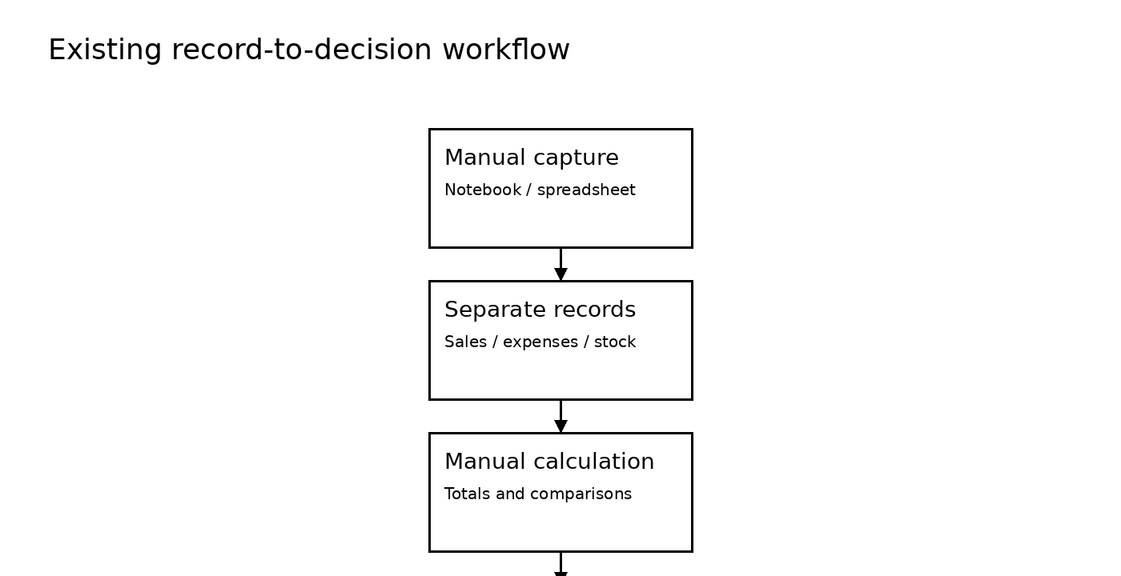
Figure 3.1: Existing record-to-decision workflow
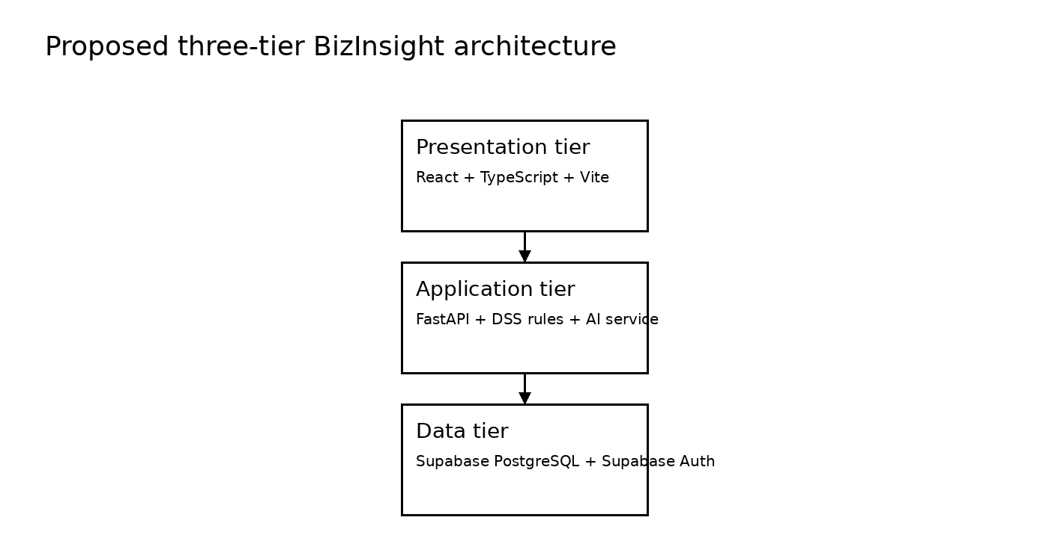
Figure 3.2: Proposed three-tier BizInsight architecture
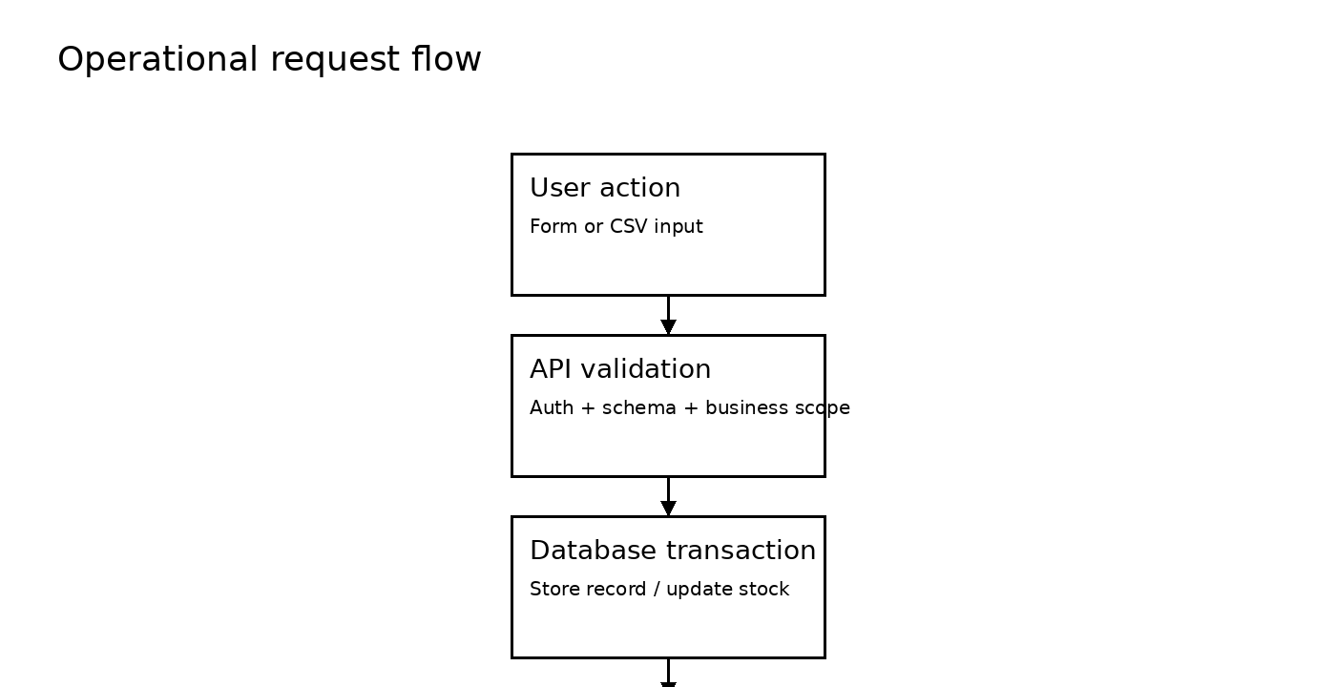
Figure 3.3: Operational request flow

