

Faculty of Arts, Humanities. Education and Social Sciences
Cambridge School of Art

MOD011410
Academic Skills for Games

Element 010
Portfolio

SID: 2505087

Academic Year 2026/27

Declarations

Course
I am a student on BA (Hons) Computer Games Art

External Sources
Except where a challenge told me otherwise, my external sources are cited properly and listed in the References section, using CTR Harvard Referencing.

AI Tools
I have used no AI tools in the creation of the report or the artefact.

Contents
Declarations 3
External Sources 3
External Assets and Code 3
Tutorials 3
Contents 1
Table of Figures 1
Introduction 2
Investigation Aims 2
The Artefact 2
Background and Context 3
Approach 5
Artefact Outcomes 6
Conclusion and Reflection 7
References 8
External Resources 9

[Wk1, LO4] Study Agreement
I understand and agree that to secure the best chances at good grades, skills, employability
and other academic benefits, I should do the following things, suggested by my class and
compiled/summarised by the lecturer:
• Sessions: Show up on time when scheduled; pay attention; use the time well
• Deadlines: Meet them; make sure I know when they are
• Study Time: Manage my time, including independent study time (40-50 hours if
possible)
• Catch up: …with things I miss (but keep up if possible)
• Respect: Be respectful & tolerant; cultivate an open environment & let everyone speak;
communicate and contribute; take care of the computers
• Self-Care: Look after myself; eat, drink responsibly; keep a good work/life balance
• Ask for help
• Get a cat, if you can; cats are great!
Signed: Chloe Holmes

[Wk1, LO1] Group Discussion: Games Likes/Dislikes
Chloe Upchurch: Games Art
Harold (Harry) Mortimer: Games Design à moving to Games Art
Harry:
Favourite game: Kameo: Elements of Power
Kameo is my favourite game of all time due to it being such a large part of my gaming experience when I was younger, with the world being so vivid and interconnected design wise. The link between the environment and the characters/elementals is also a very interesting and well thought out design choice that over the years as I've grown up, I’ve come to appreciate more. This has cemented my love for this Xbox 360 release title and has likely affected my taste in games growing up and moving on to other fantasy titles such as Skyrim and similar such games.
Least Favourite game: League of Legends
My distaste for League stems from my dislike of the gameplay loop, lack of visual interest and the overall community being a closed loop of toxicity, racism and overall negativity and bullying. This is purely my own opinion formed through content I’ve watched, members of the community I’ve interacted with and negative things I’ve heard about League from random people on the internet.
Chloe:
Favourite game: Minecraft
Minecraft is my favourite game since it’s one of the few games that I’ve played. I don’t play a lot of games overall, but I play Minecraft in it’s creative mode since it lets me express my creativity in different ways.
Least favourite game: n/a
As I already mentioned, I don’t play a lot of games, so I don’t really have a least favourite. I hope as the course goes on I can maybe play some more games, but it’s not my main goal.

[Wk1, LO4] Getting Organised
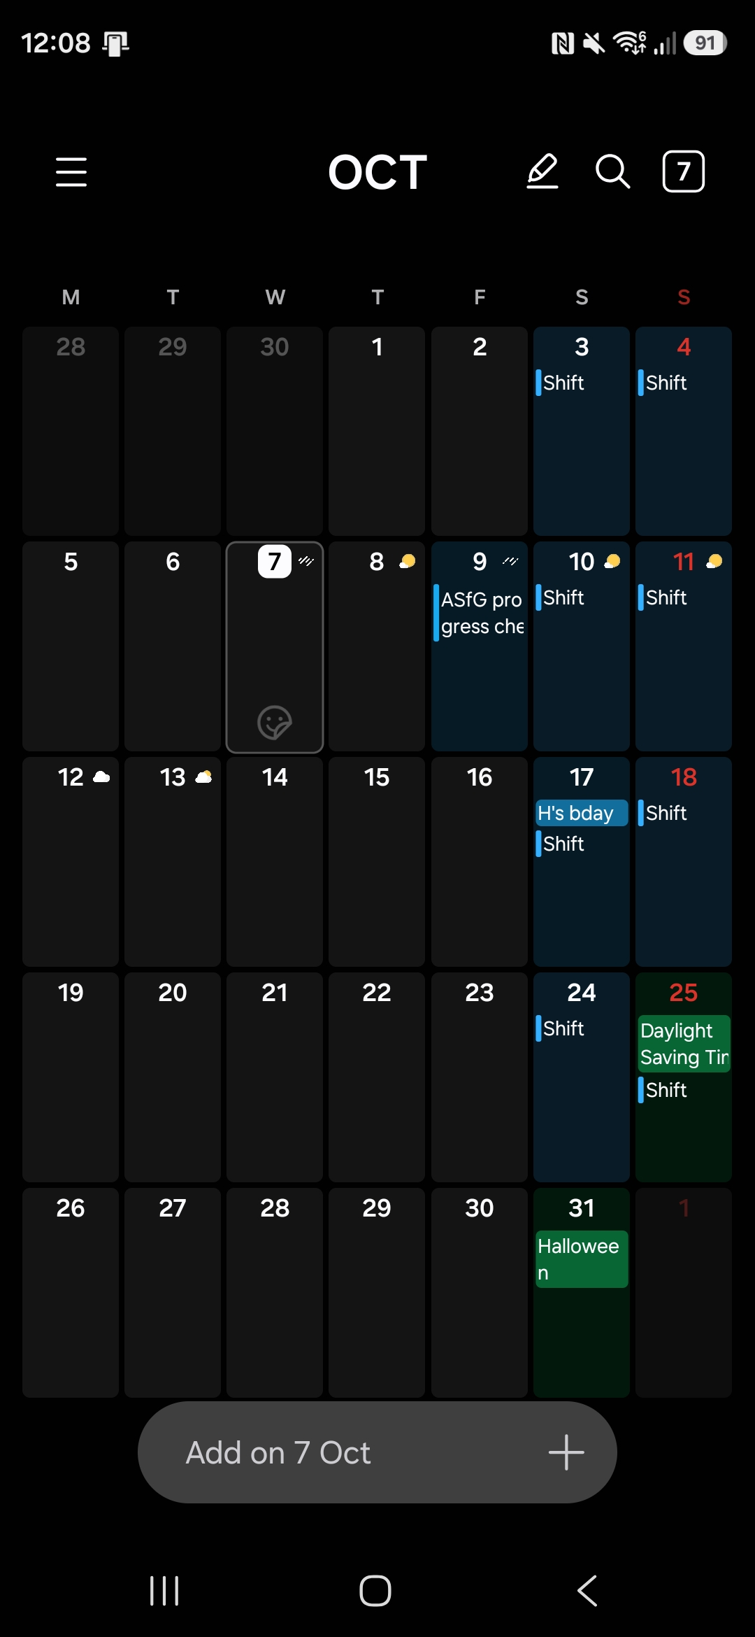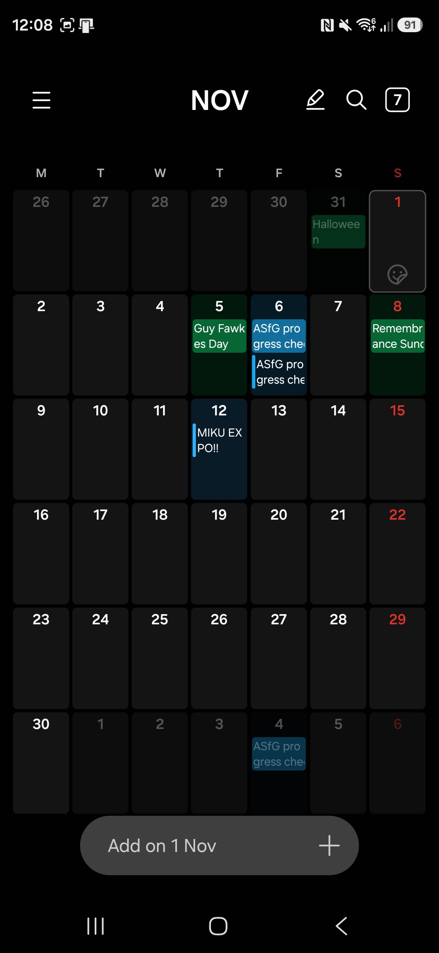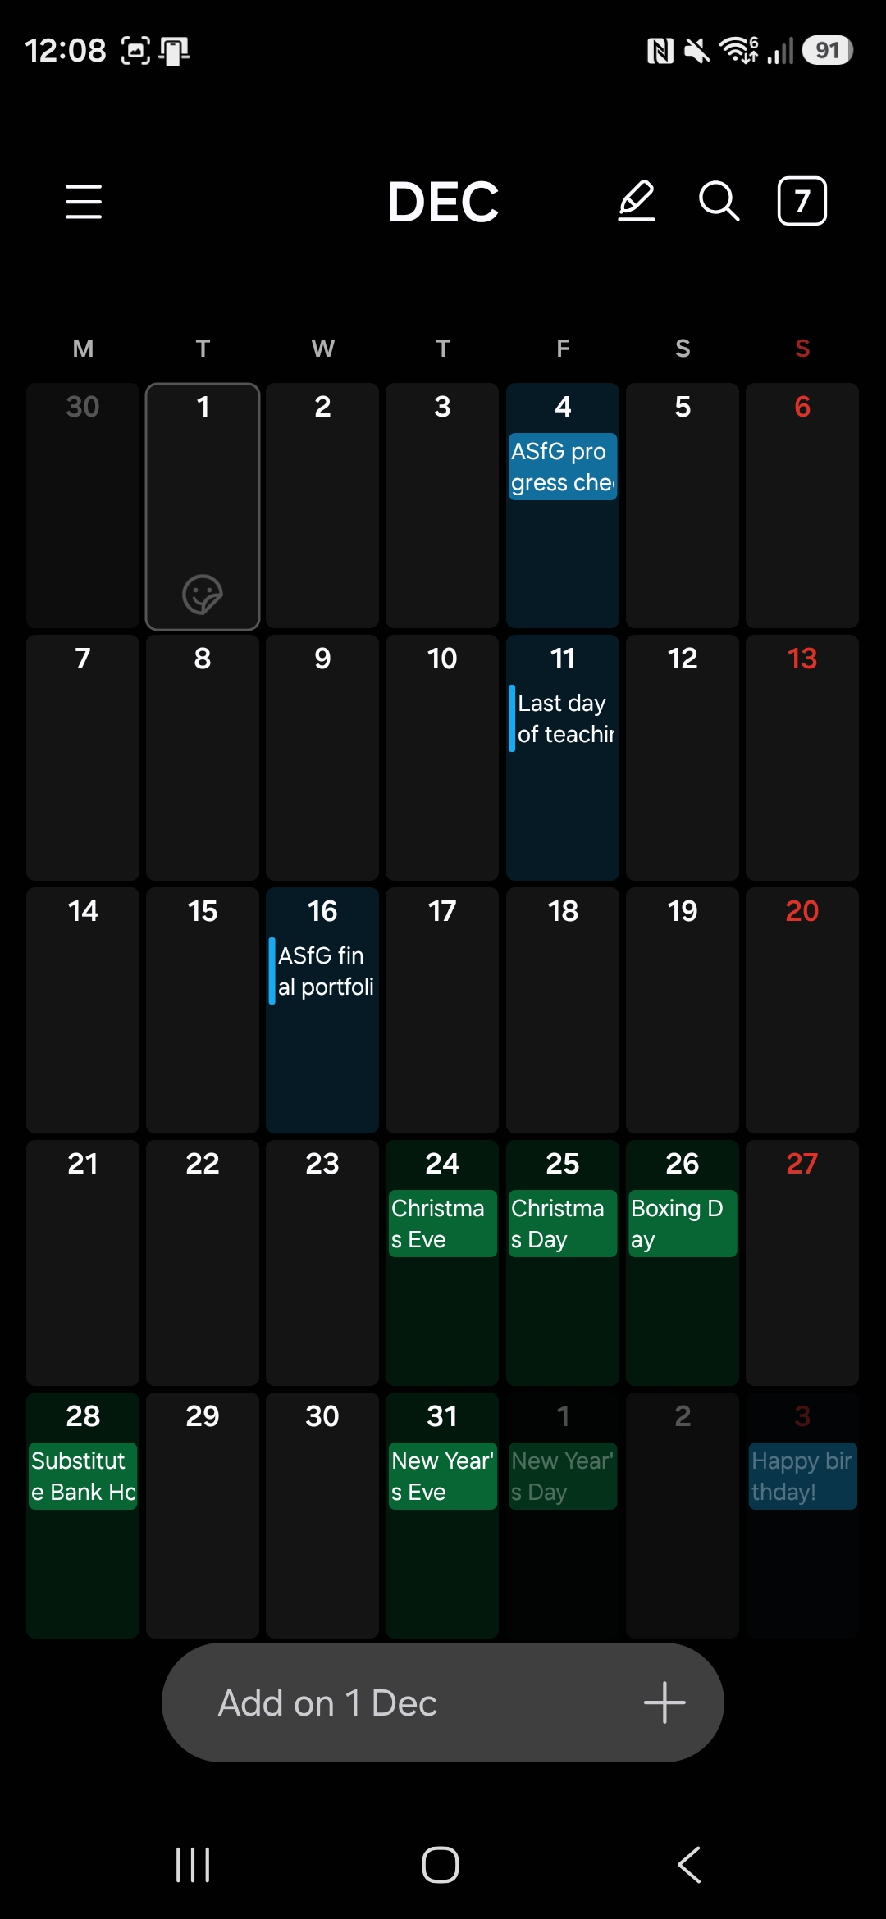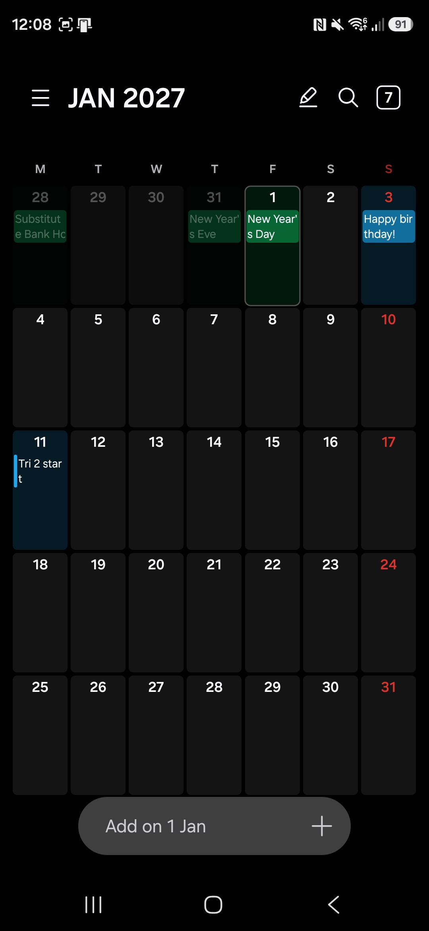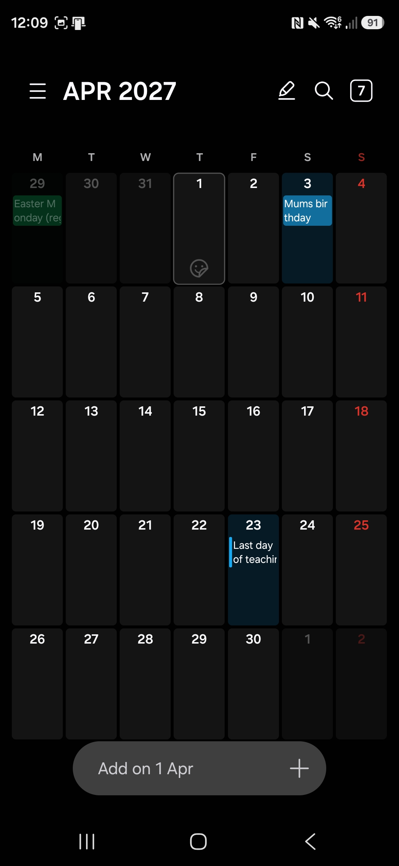

[Wk1, LO1,4] Preparation: Game Developer Roles
Junior Character Artist
https://entrylevel.games/database/junior-character-artist
The Junior Character Artist role is tailored for artists who have a deep-seated passion for crafting characters. Those in this position will significantly contribute to the development of engaging and high-quality characters, participating actively in their evolution from concept to completion.
An artist in this role will apply their specialised skills and artistic insight to enhance the impact of the project. The work done in this capacity is crucial for establishing a strong connection between audiences and the characters they encounter.
To excel in this role, an artist must have an extensive understanding of human anatomy, a strong foundation in artistic principles, including form, structure, colour theory and lighting; and the ability to adeptly use industry-standard software tools for character creation including ZBrush, Maya and the Substance Suite.
https://www.aweinteractive.com/career-junior-character-artist
- Collaborate closely with the Art Director, Game Designers, and Animators to conceptualise, create, and refine high-quality 3D character models and textures, ensuring the visual consistency and quality of our game assets.
- Develop a wide variety of characters, including humans, robots, and human-machine hybrids that align with the project's visual style, narrative, and gameplay requirements.
- Create high-quality, low-poly models with good topology and materials optimised for performance in Unreal Engine 5.
- Create character models with their skinning and rigging in mind.
- Work closely with the technical artists to ensure the proper implementation and functionality of character assets in the game engine.
- Deliver assets in accordance with project deadlines and maintain a high level of productivity while working independently.
- Participate in art reviews and provide constructive feedback to other artists on the team.
- Continuously improve artistic skills and stay up-to-date with the latest industry trends and techniques.
Requirements:
- Strong understanding of human anatomy, proportions, and mechanical design principles.
- Strong skills in 3D modelling, sculpting, and texturing using industry-standard software, such as ZBrush, Maya, and Substance Painter.
- Understanding of mesh preparation for riggers.
- Ability to create and optimise assets for use in a real-time game engine, adhering to performance and memory constraints.
- Excellent communication skills and the ability to work collaboratively.
- Self-motivated, detail-oriented, and capable of managing multiple tasks simultaneously in a fast-paced environment.

Junior Environment Artist
https://entrylevel.games/database/junior-environment-artist
A Junior Environment Artist’s primary responsibilities include interpreting design concepts, creating 3D models, textures, and landscapes in alignment with the game's thematic guidelines and technical specifications. They engage with software tools such as Maya, 3DS Max, or Unreal Engine to breathe life into design ideas, ensuring the visual elements are both compelling and technically sound for a seamless gameplay experience.
Their role extends beyond individual contribution, requiring active collaboration with a multidisciplinary team of art directors, designers, and engineers to achieve a collective vision for the game. Through regular interactions and feedback loops with the team, they refine their work, ensuring adherence to the established artistic style and technical guidelines. This collaborative essence of their role facilitates a harmonious workflow, contributing to the overall project goal while fostering a productive environment for personal and professional growth.
https://www.aweinteractive.com/career-junior-environment-artist
Responsibilities:
- Collaborate with the Art Director, Lead Artist, Designers, and other team members to create visually compelling and immersive environments that seamlessly blend beautiful rural vistas with advanced technology elements
- Have a strong design eye and be able to fill in the gaps for environmental design in a Cassette Futurism style where technology permeates the landscapes
- Maintain a consistent art style for environments throughout the game
- Create high-quality realistic environments in Unreal Engine 5, including 3D assets, textures, materials, and lighting setups
- Effectively use and adapt Megascans and other photogrammetry assets and textures
- Participate in art and level design reviews, offering constructive feedback and iterating on designs as necessary
- Stay up-to-date on industry trends, tools, and best practices to continually improve the quality and efficiency of your work
Requirements:
- Strong portfolio demonstrating expertise in creating organic exteriors and environments that feature technology
- Expertise in Unreal Engine 5 and understanding of the latest technologies such as Nanite and Lumen. Proficiency in 3D modelling tools such as Blender, 3ds Max or Maya
- Skilled in creating PBR materials using Substance Painter, Substance Designer or Quixel Mixer
- Knowledge of the optimization techniques for the best possible performance on PC and Console
- Strong understanding of composition, colour theory, and environmental storytelling
- Ability to work well in a team, communicate effectively, and adapt to constructive criticism
Nice to Have:
- Experience with world-building tools such as World Machine, Houdini, or SpeedTree
- Knowledge of procedural content generation techniques and tools
- Experience with ZBrush or other sculpting tools
- Prior experience working in a team

Junior Concept Artist
https://entrylevel.games/database/junior-concept-artist
A Junior Concept Artist plays a supportive role in the visual storytelling of a game, helping to shape the early visuals that aim to captivate players around the globe. This role revolves around crafting 2D assets from initial sketches to more refined digital paintings that assists the production team in realising the visualisation of the final in-game visuals.
Teamwork is at the core of their position. A Junior Concept Artist collaborates with more experienced members, different departments, and the broader development team. This involves regular discussions and sharing their concepts in structured formats, making sure their visual interpretations are clear and actionable for the team. They also need to be proficient in receiving and applying feedback effectively to their art pieces.
https://www.cgspectrum.com/career-pathways/concept-artist
What does a concept artist do?
Concept artists develop the initial visual concepts (characters, props, vehicles, environments) from a script or creative brief. They set the tone and style of the work, giving life to an abstract idea. Concept art is used as a reference point throughout a project's development.
Visual storytelling is the key task of the Concept Artist, they imagine characters and worlds from off the page and bring the story to life. If you have a talent for visualizing abstract ideas a career as a Concept Artist could be for you!
Concept artist job description
The role of the Concept Artist is crucial as their work will be the stylistic building blocks upon which the animation, video game, cartoon, etc are built. They interpret a design brief from a client or expand their own original idea by illustrating the key characters and environments of a project. This preliminary artwork will be simple but expressive as it will be developed and expanded further during the development process.

Role and responsibilities of a concept artist in film and games:
- Liaising with the producer, art director, game developer, etc regarding the brief for the project
- Researching concept subjects, styles & genres
- Creating detailed key designs from a written brief
- Presenting a series of drafts of the concepts for approval
- Responding positively & proactively to feedback
- Drawing up specification sheets, establishing dimensions & details for others to follow
- Working to a schedule
- Using traditional & technological approaches to creating designs in either a 2D or 3D environment
- Assisting in creation of marketing materials and assets
- Continuing to develop concepts & designs for the duration of the production process

My choice statement:
I joined games art because of passion for art and games, along with a small game I made and created the art for as a final project in my foundation year. As my specialism, I’d like to work in character design, since that has always been my area of interest.

[Wk2, Priority, LO1,2,4] Dream Job report
(Climax Studios, 2026)
My Dream Job when I finish the course is Junior Character Artist, the listing I found on StudySmarter was for a studio in Portsmouth called Climax Studios. This studio is AAA, which hands itself to how I would like to start my career by playing to my (current) specialties, before progressing up the ladder to more senior character roles. As a dream start, this job seems ideal as my focus in art has always primarily been character design, and while I’m trying to broaden my options while on this course, it has always been my intention to go into character design. The job description for this role is rather vague in terms of how far in the character pipeline is required, but based on what I can see, it’s modelling only. This job’s duties appeal to me because it fits the parts of the pipeline that I enjoy, creating the characters and adding every detail with intent, and if the role is more generalist in terms of character art as a whole I’m super excited to learn the pipeline as a whole and expand my preexisting knowledge of highpoly sculpting and some lowpoly sculpting that I learned in Blender over the last year further on the course and apply that in a professional setting as well. Climax studios itself appeals to me since they advertise remote work, which aligns a lot with my schedule in my home life. A larger part of why the studio appeals to me in addition to the great location arrangements is the studio’s culture, the dynamics of the studio that encourage further training would be an amazing way to keep growing once I leave university, both in my art-related skills and my professional and career development ones. This role fits into my future plans as the previously mentioned dynamics in the studio makes it easy to gain experience and potentially climb the ladder to gain even more experience from different people. This is the most important thing to me, as my ultimate goal is to potentially gather together with some friends in different disciplines in games and create an indie studio, and with large studio experience under my belt, I hope it will also teach me the skills and give the experience necessary to manage and run a team to help make the games that I have been designing concept art for and meticulously planning for years.

[Wk3, LO2] Good Academic Practice assignment



[Wk3, Priority, LO2,3] Referencing Practice
Hollow Knight (Team Cherry, 2017) is a metroidvania platformer game that takes place in the abandoned kingdom of Hallownest that has been taken over by a mysterious infection, which the player needs to clear to beat the game. A fan made resource was made about the game to help struggling players or people wanting to learn more about the mechanics or story of the game called the Hollow Knight Wiki (2026). It is an open-source website that can be used to find out different facts about enemies, areas or strategies used to find certain important items and defeat bosses that might be giving newer players trouble. However, since the wiki is open-source and anyone can edit the information provided, it is not the most reliable source academically. The video that Gamer's Little Playground (2023) published online provides some more experience of how certain things are found within the game, and possible ways to approach its huge map and non-linear progression. While the source isn't that credible being from someone uploading on an online forum, the content of the video itself is very clear evidence of gameplay of Hollow Knight.

[Wk4, LO1,4] Mark Scheme Table Swap
This is for Hannah's "interim challenge", which is worth 20 of the 100 marks available, and asks her to make a working inventory system.
Criterion | Marks | Delivery
Functionality | 10 | Making the inventory system work as Hannah has been asked to
Use of Language | 10 | Using the correct choices of programming language features to make the inventory system run effectively and efficiently. This includes making sure that the code is well structured and laid out well.

This is for Hannah's text-based adventure game, which is worth 80 of the 100 marks available.
Criterion | Marks | Delivery
Presentation and Polish | 20 | Making the controls comfortable and easily identifiable by the player. Making sure they have all the tools and information they need to play the game and representing the environment in an easy to understand way so that the player always knows what is going on in the game.
Functionality | 20 | How well can the player interact with the game environment and world, including items inside of it, and how well can they work the input system to do these things.
Coding Standards | 20 | Making sure the code is clear and concise, with no unused sections, duplication or errors.
Coding structure | 20 | Using the correct choice of programming language features and keeping the structure clear and readable.

[Wk4, LO4] Self-Assessment Rubric Practice
[Insert the deliverable for this challenge here.]

[Wk5, LO4] Weekly Timetable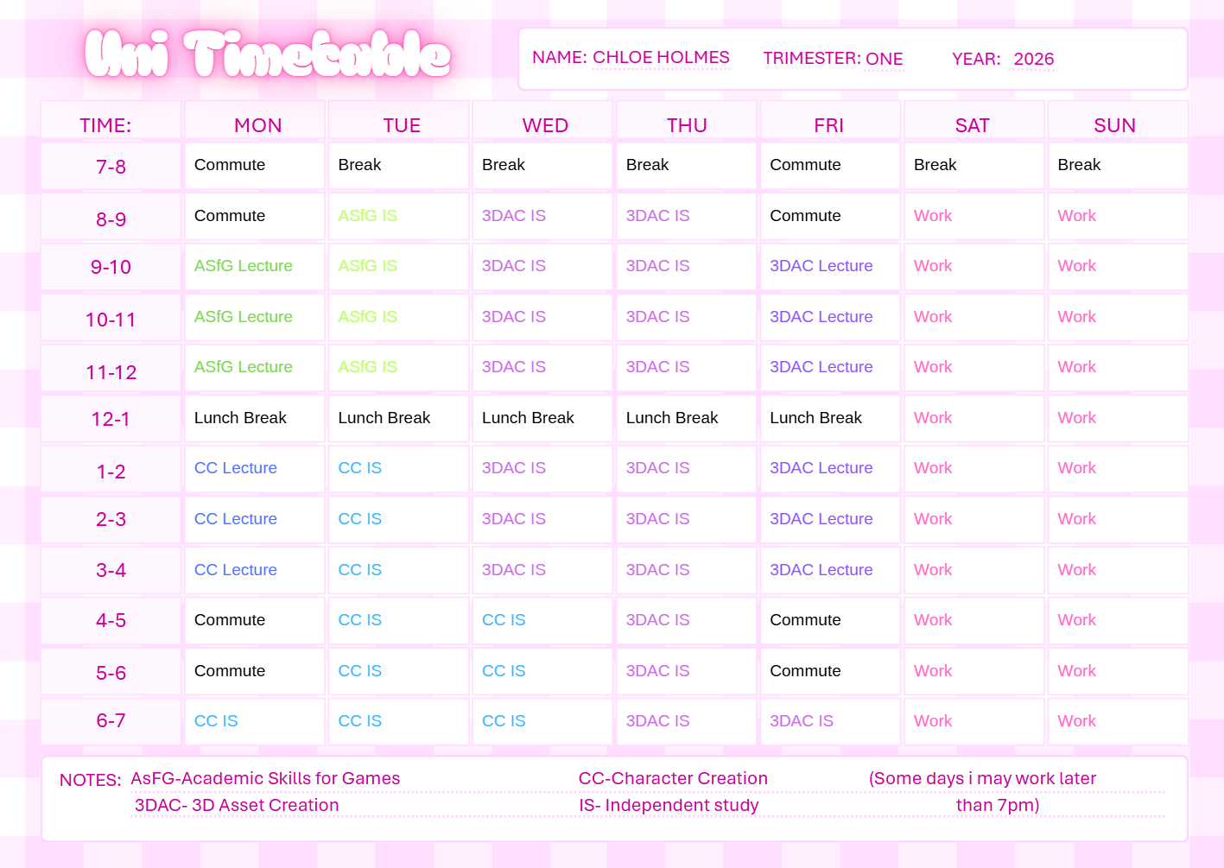

[Wk5, LO3,4] Module Timeline Diagram
Update the heading and insert the deliverable for this challenge. If you need subsections you can use Heading 2 or 3; don’t use Heading 1 again until the next challenge.
Remember the other guidance in the assignment page about formatting, inserting images, and other things.
Scope & word count limit (or equivalent): Varies by challenge: see the challenge page.
Get ready for the next challenge by taking a copy of the heading from here (and optionally the purple text, but remember to remove it before submission).
[Insert the deliverable for this challenge here.]

[Wk5, LO4] Mystery Photo!
Update the heading and insert the deliverable for this challenge. If you need subsections you can use Heading 2 or 3; don’t use Heading 1 again until the next challenge.
Remember the other guidance in the assignment page about formatting, inserting images, and other things.
Scope & word count limit (or equivalent): Varies by challenge: see the challenge page.
Get ready for the next challenge by taking a copy of the heading from here (and optionally the purple text, but remember to remove it before submission).
[Insert the deliverable for this challenge here.]

[Wk6, LO4] Version Control Playground
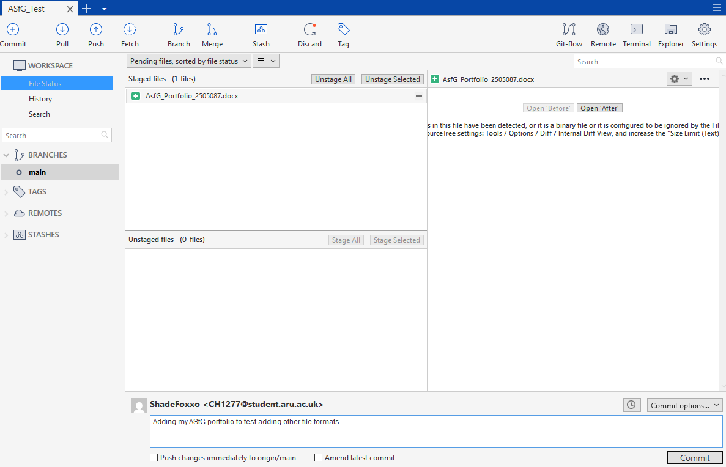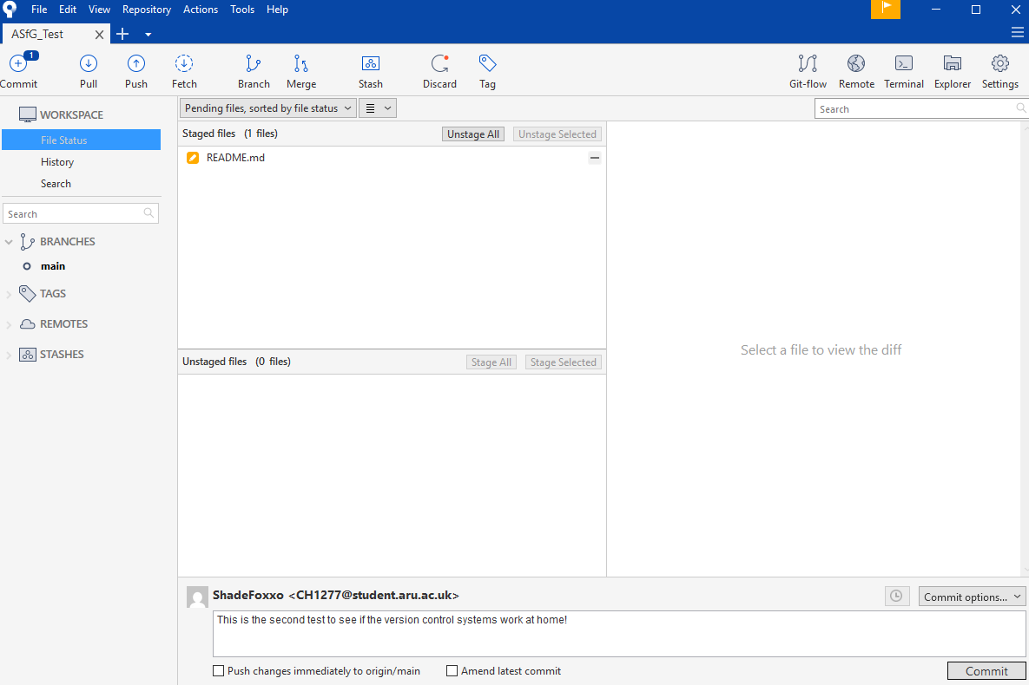
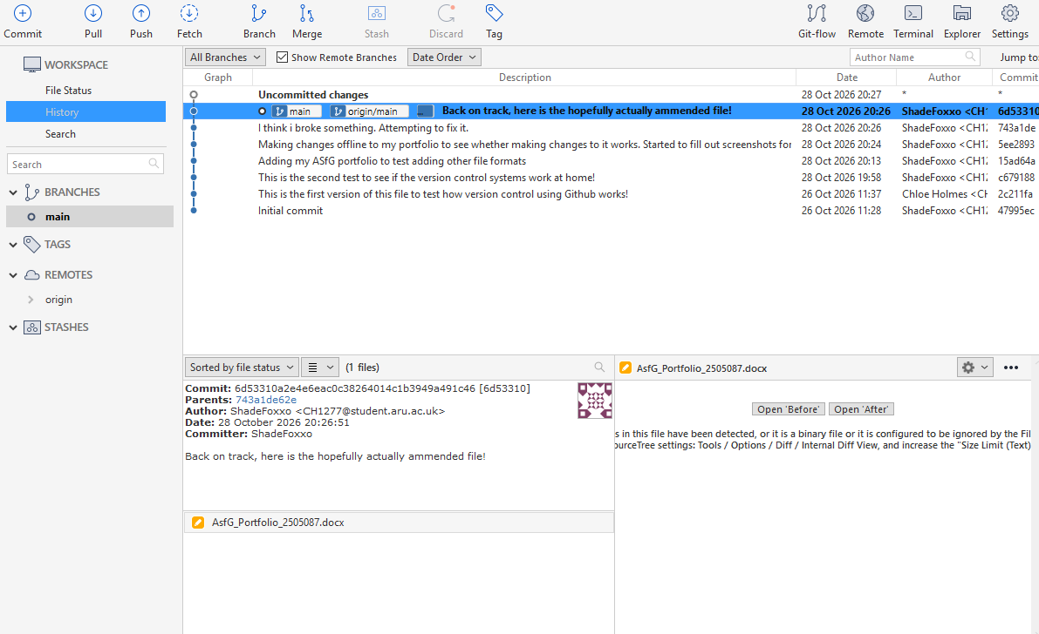

[WkX, XX] Challenge name here
Update the heading and insert the deliverable for this challenge. If you need subsections you can use Heading 2 or 3; don’t use Heading 1 again until the next challenge.
Remember the other guidance in the assignment page about formatting, inserting images, and other things.
Scope & word count limit (or equivalent): Varies by challenge: see the challenge page.
Get ready for the next challenge by taking a copy of the heading from here (and optionally the purple text, but remember to remove it before submission).
[Insert the deliverable for this challenge here.]

References
Climax Studios (2026) Available at: https://talents.studysmarter.co.uk/companies/climax-studios/portsmouth/onsite-junior-character-artist-game-studio-21668163/ (Accessed: 29th September 2026).
Team Cherry (2017) Hollow Knight [Video game]. Team Cherry
Hollow Knight Wiki (2026) Available at: https://hollowknight.wiki/w/Hollow_Knight_Wiki (Accessed: 5th October 2026)
Gamer's Little Playground (2023) HOLLOW KNIGHT Full Gameplay Walkthrough / No Commentary 【FULL GAME】4K 60FPS Ultra HD. 9th September. Available at: (3) HOLLOW KNIGHT Full Gameplay Walkthrough / No Commentary 【FULL GAME】4K 60FPS Ultra HD - YouTube

