# Practice Questions – Detailed Explanations with Visuals

## Case 0: Drought → Supply Reduced

A drought damages orange crops, raising the cost of production for orange juice. Producers can’t produce as much juice at the same cost, so the supply curve shifts left (S₀ → S₁).

Effect: Price increases (P₀ → P₁) and Quantity decreases (Q₀ → Q₁). The market moves from equilibrium E₀ to E₁.

Beginner Tip: Think — fewer oranges → less juice → higher prices.

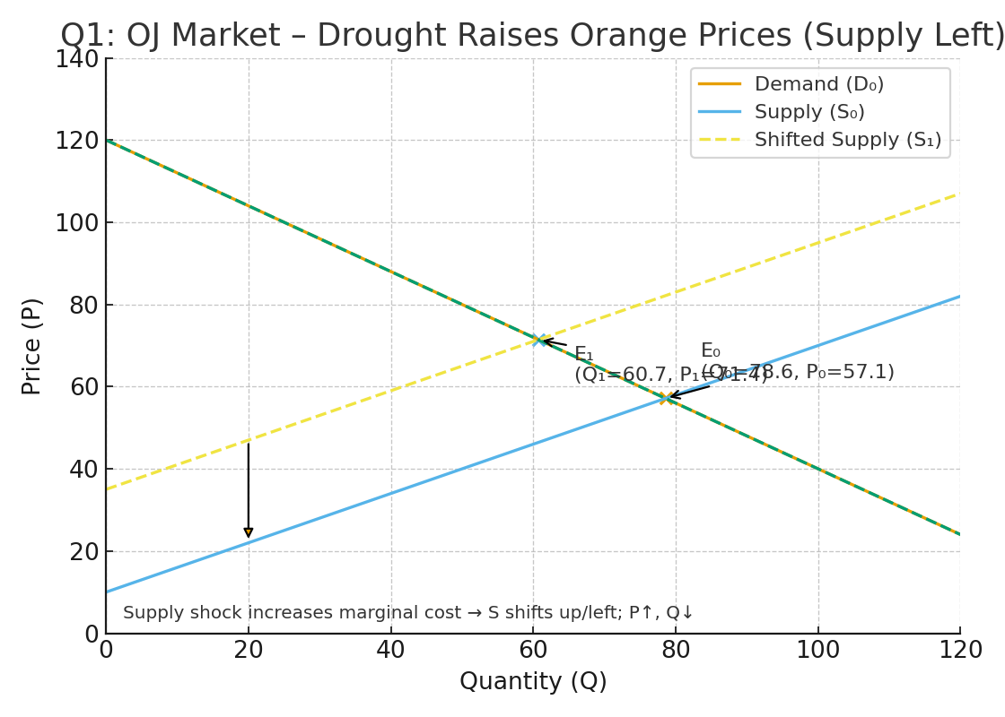

## Case 1: Price of Substitute (OJ) Rises → Demand for Apple Juice Increases

As orange juice becomes more expensive, consumers switch to apple juice. Demand for apple juice rises, shifting the demand curve right (D₀ → D₁).

Effect: Price increases (P₀ → P₁) and Quantity increases (Q₀ → Q₁).

Beginner Tip: Substitute effect — when one good’s price rises, the other’s demand goes up.

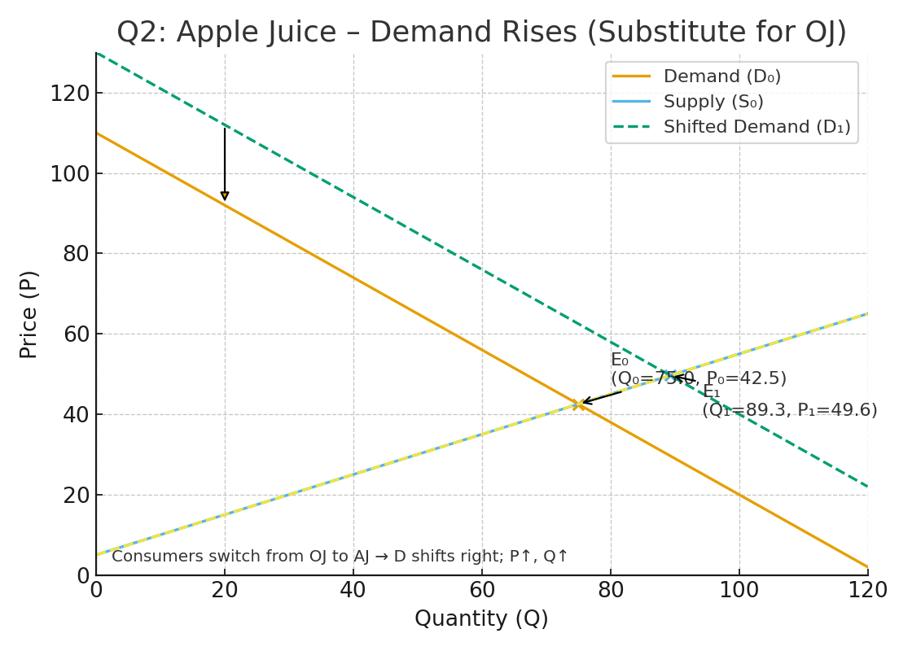

## Case 2: Soda Ban → Demand for Coffee Increases

A ban on caffeinated sodas drives more people to drink coffee. Demand shifts right (D₀ → D₁).

Effect: Price rises (P₀ → P₁) and Quantity rises (Q₀ → Q₁). Producer surplus also increases.

Beginner Tip: When one source of caffeine is banned, consumers turn to the next best option — coffee!

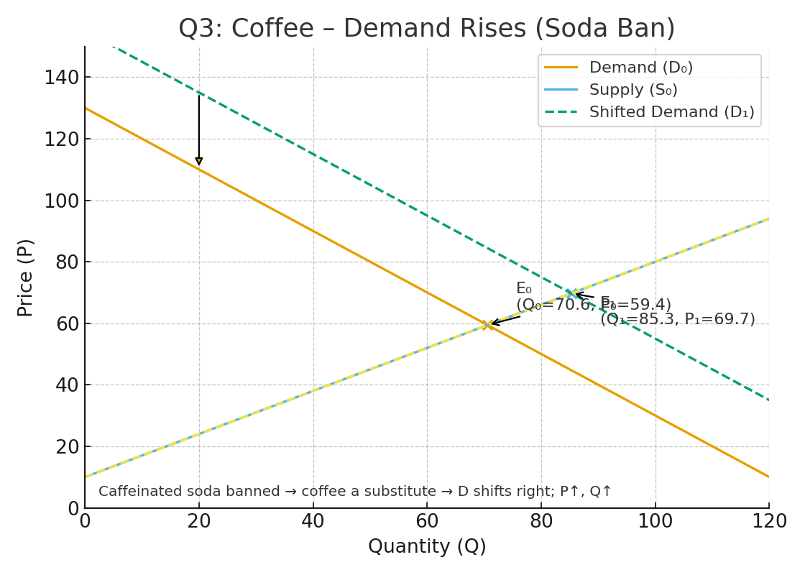

## Case 3–4: Coffee Price Rises → Movement Along Supply Curve

A rise in coffee prices encourages producers to supply more, but the supply curve itself doesn’t shift. It’s just a movement along the existing curve from E₀ to E₁.

Effect: Higher price leads to higher quantity supplied, no shift in the curve itself.

Beginner Tip: Remember — a price change causes a movement along the curve, not a shift.

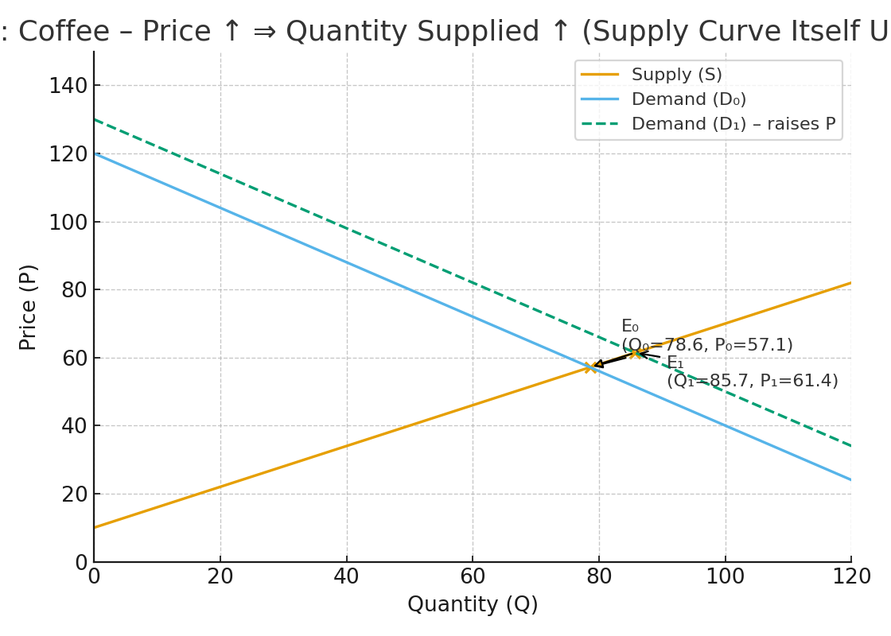

## Case 5: Gas Tax → Supply Shifts Up (Elastic Demand)

When the government adds a tax on gas producers, the supply curve shifts up by the tax amount. With elastic demand, consumers reduce consumption sharply, so prices rise by less than the full tax.

Effect: Buyers pay slightly more, sellers receive less, total quantity falls.

Beginner Tip: If buyers are flexible (elastic), they’ll cut back sharply when price rises.

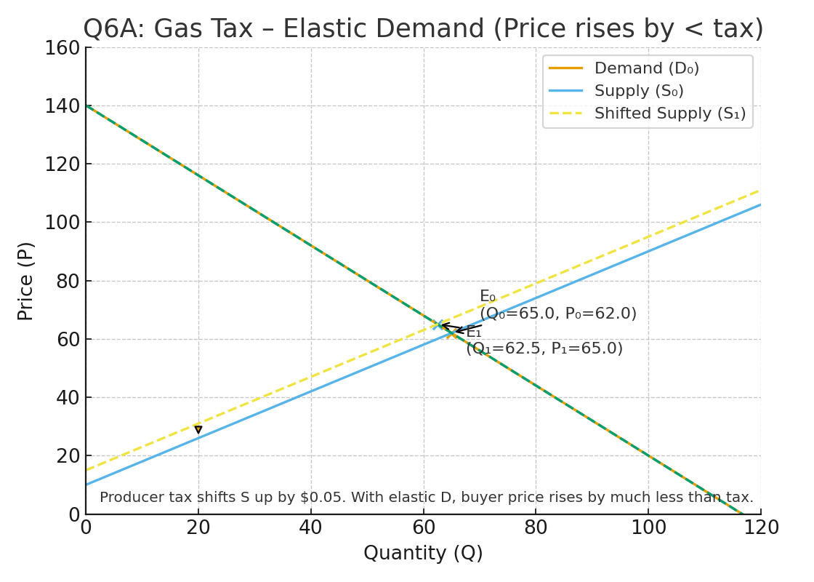

## Case 6: Gas Tax → Supply Shifts Up (Inelastic Demand)

If demand is inelastic, buyers don’t cut back much when prices rise. So, most of the tax burden falls on consumers.

Effect: Buyer price rises more, seller revenue drops slightly, quantity changes little.

Beginner Tip: Inelastic = ‘I’m not flexible.’ People still buy even if prices go up (like gas or medicine).

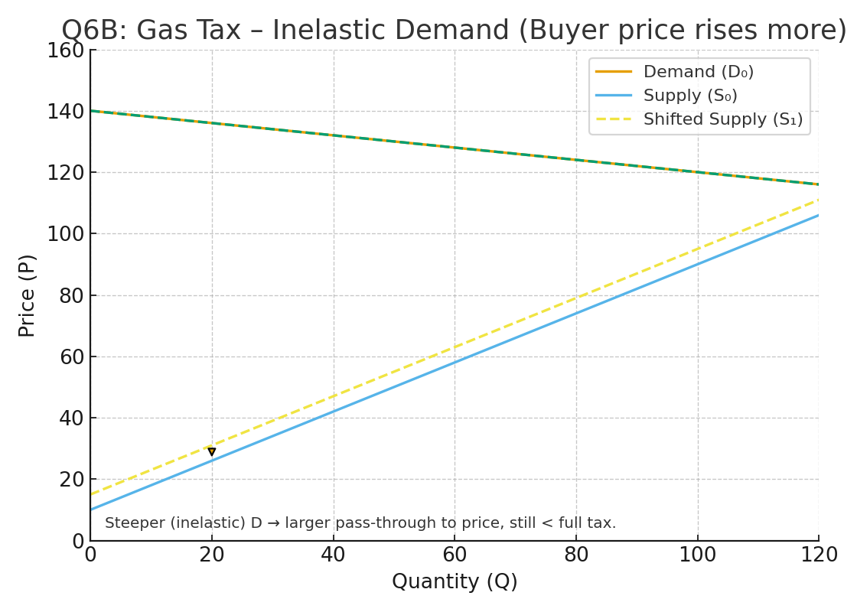

## Case 7: Cigarette Elasticity (E = -0.3)

If the price of cigarettes rises by 15%, quantity demanded falls by only 4.5%. This shows demand is inelastic.

Effect: Price +15%, Quantity −4.5%.

Beginner Tip: Addictive goods = low responsiveness to price changes (inelastic).

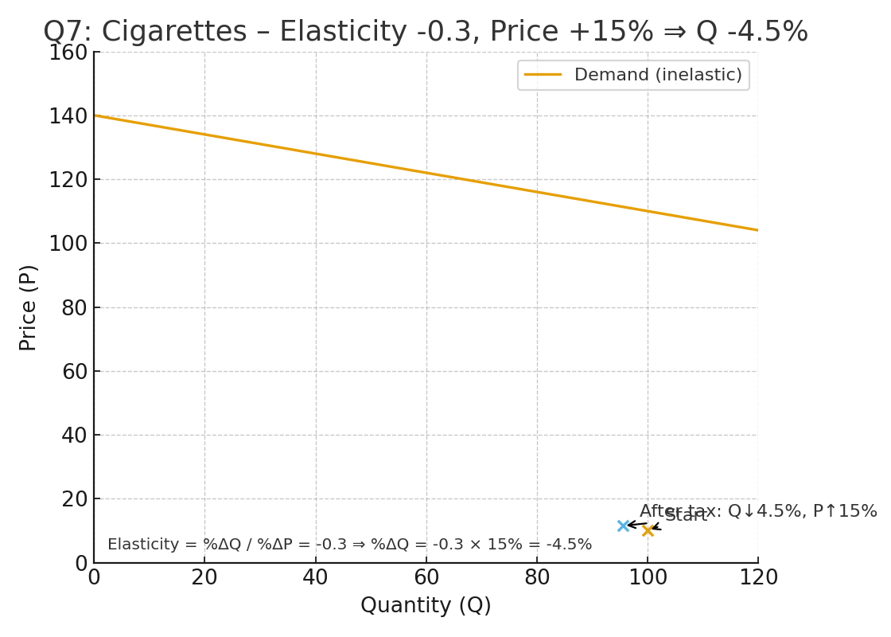

## Case 8–9: Linear Demand (Q = 100 − 20P) → Elastic Region

At higher prices and lower quantities, demand tends to be elastic. A small price cut leads to a large rise in quantity demanded.

Effect: A 1% price drop raises quantity by 1.5% → total revenue increases.

Beginner Tip: Elastic = sensitive buyers. Lower price can actually increase total sales revenue.

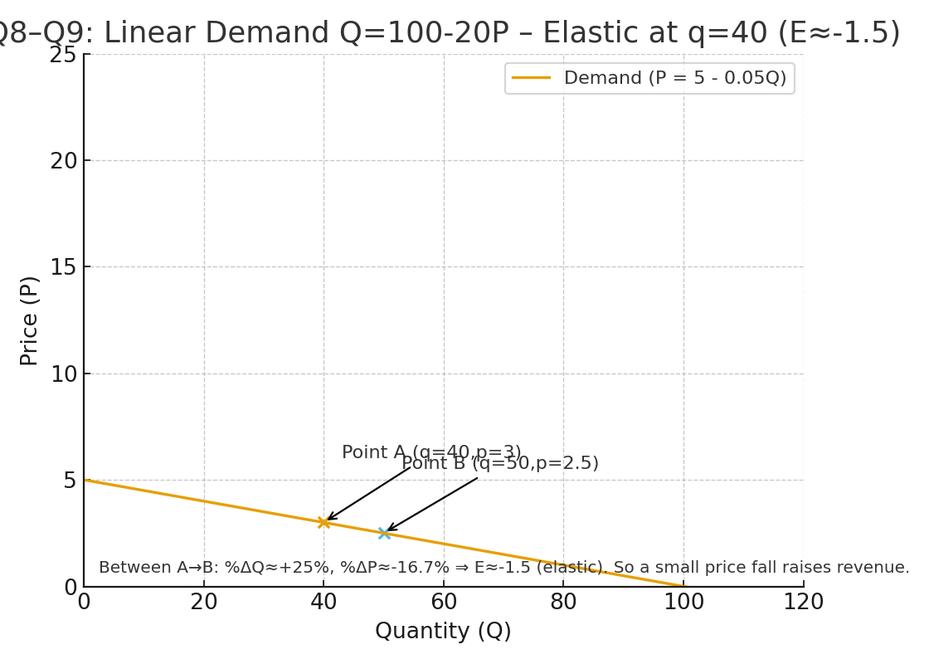

## Case 10–11: Linear Demand → Inelastic Region

At lower prices and higher quantities, demand becomes inelastic. A price increase reduces quantity only slightly.

Effect: A 1% price increase lowers quantity by less than 1%, so total revenue rises.

Beginner Tip: Inelastic = price-insensitive buyers. Raising prices increases total revenue.

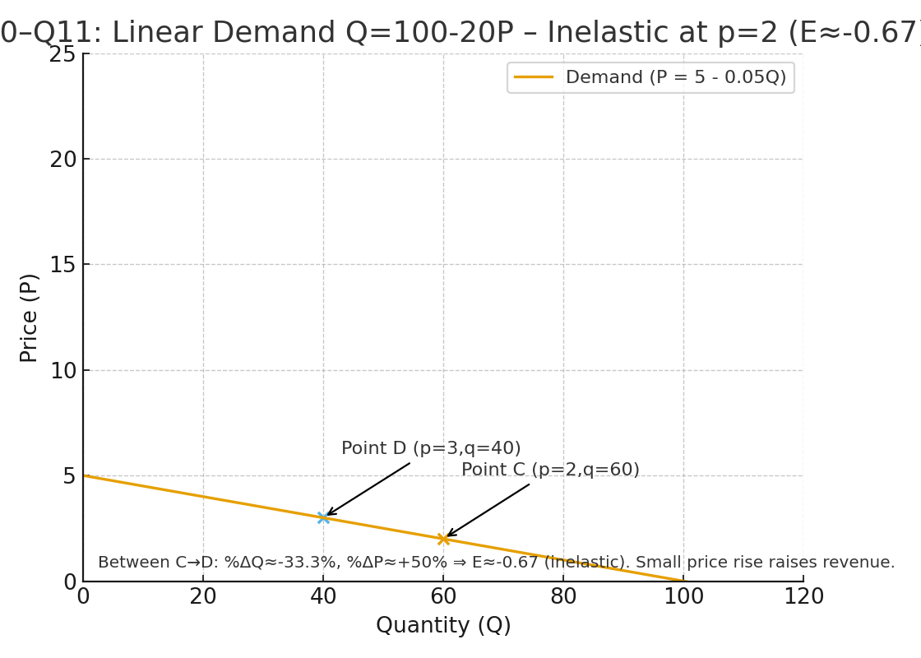

## Case 12: Target Quantity +10% with Elasticity −0.5

To increase sales by 10% when elasticity = −0.5, price must fall by 20%.

Effect: Price 10 → 8, Quantity 1000 → 1100.

Beginner Tip: When elasticity is small (−0.5), quantity doesn’t react much — so you need a big price cut to boost sales.

