Reproducibility Log — XMAD-Bench (German / ResNet-18)
Cross-Domain Multilingual Audio Deepfake Benchmark — Ciobanu et al., arXiv:2506.00462
Paper-02 Reproducibility · Shaden · University of Aberdeen
Prepared July 2026. This is a complete chronological record of the reproduction: setup, commands, data, code fixes, configuration, runs, results, deviations, and observations.

0. Executive summary
The XMAD-Bench detection experiment was reproduced end-to-end for German with the ResNet-18 detector. The released code did not run as-is and required four documented changes (three code-compatibility fixes plus one Apple-GPU accommodation); none alter the method. After the fixes, a quick smoke test and then three full 20-epoch runs on the complete German data were executed on an Apple-Silicon MacBook using the MPS backend. The reproduced results closely match the paper: in-domain accuracy 99.73% (paper 100%) and cross-domain accuracy 96.99% (paper 90.3% ± 6.1). The paper's central finding — near-perfect in-domain performance with a drop cross-domain — was reproduced. The main disclosed deviation is batch size 64 (paper used 200 for ResNet-18) due to laptop memory.

1. Objective
Reproduce the audio-deepfake detection results reported in XMAD-Bench (Table 3), beginning with a single language/model cell (German, ResNet-18), to (a) verify the released artifacts run and (b) confirm the reported in-domain vs. cross-domain performance gap. This is the first step of a wider study that will later add cross-dataset testing and stricter evaluation (per supervisor guidance).

2. Environment and hardware
Item | Detail
Machine | Apple-Silicon MacBook Pro (macOS)
Compute backend | Apple GPU via PyTorch MPS (torch.backends.mps.is_available() = True). No NVIDIA/CUDA on this device.
Python | 3.13 (virtual environment ~/xmad-env)
Env manager | Python venv (Anaconda/conda was blocked by the network — see 3.2)
Repository | github.com/ristea/xmad-bench
Pinned commit | 17332923b6874cf9a14bf9412aadb5a6a15b17fe (branch main, 2026-01-04)
License | Code Apache-2.0; dataset & models CC BY-NC-SA 4.0 (non-commercial). EULA_form_S.pdf accompanies the data.
Key installed package versions (as installed on the Mac):
Package | Version | Package / Version
torch | 2.12.1 | transformers 5.13.0
torchvision | 0.27.1 | librosa 0.11.0
pedalboard | 0.9.23 | soundfile 0.14.0
pandas | 3.0.3 | scikit-learn 1.9.0
numpy | 2.4.6 | einops 0.8.2
tensorboard | 2.21.0 | tqdm 4.68.4
Note: torchaudio is listed in the repo requirements but is NOT needed for the detection experiments (only for the separate generation scripts). It was deliberately omitted.

3. Procedure (chronological, with commands)

3.1 Obtain the code
git clone https://github.com/ristea/xmad-bench.git
cd xmad-bench
git checkout 17332923b6874cf9a14bf9412aadb5a6a15b17fe # detached HEAD = exact pinned version
Observation: git checkout reports 'detached HEAD' — expected and desired (sits exactly on the pinned commit).

3.2 Build the Python environment
First attempt with conda failed: (a) Anaconda Terms-of-Service had to be accepted, and (b) conda then could not reach repo.anaconda.com (network timeout — server blocked on the university network). Pivoted to Python's built-in venv, which installs from PyPI and was not blocked.
python -m venv ~/xmad-env
source ~/xmad-env/bin/activate
pip install --upgrade pip
pip install torch torchvision # Mac build (no CUDA)
pip install transformers einops pedalboard soundfile librosa pandas scikit-learn tensorboard tqdm
Verification:
python -c "import torch,transformers,librosa,pedalboard,sklearn,pandas; print(torch.__version__)" # 2.12.1
python -c "import torch; print(torch.backends.mps.is_available())" # True

3.3 Obtain the data
Source: Google Drive folder 'Cross-Domain Audio Deepfake Dataset' (linked from the repo README). Data is one ZIP per language. German (de-006.zip, ~2.49 GB) was chosen first as a small, representative case. An EULA (EULA_form_S.pdf) accompanies the data and must be completed for the write-up.
Unzipped layout (confirmed):
de/
commonvoice-de/ real/ fake/ meta.csv # in-domain (train + val)
mailabs-de/ real/ fake/ meta.csv # cross-domain test
meta.csv columns: sample_name, is_fake (0=real,1=fake), speaker_id, meta, split (train/val). Comma-separated. Each real clip has a matching fake with the SAME filename (matched pairs).
CSV-separator caveat (for other languages): the code reads meta.csv as TAB-separated for commonvoice-en/ru and mailabs-en/ru, and comma-separated for all others. German is comma-separated.

3.4 Storage decision
The repo and data were kept in local folders (~/xmad-repro, ~/Downloads/de), NOT in the OneDrive-synced project folder. Cloud sync interferes with git locking and with the many checkpoint/lock files training produces (this caused 'Operation not permitted' errors when a clone was attempted inside OneDrive). OneDrive is used only for the code reference, notes, protocols and results.

4. Code issues found and fixes applied
The released code does not run as-is. Four changes were required. None change the models, data, or metrics; they are compatibility/hardware accommodations. Full before/after is also in CODE_FIXES_APPLIED.md.

Fix 1 — import collision (blocks all runs)
A top-level utils.py (which imports torchaudio) shadows the detection/utils/ package (which has no __init__.py), so 'from utils.stats_manager import ...' in trainer.py fails. Made the detection folder self-contained by removing the 'detection.' prefix, and run from inside detection/ with only that folder on PYTHONPATH:
# detection/data/data_manager.py
from detection.data.base_dataset import BaseDataset -> from data.base_dataset import BaseDataset
from detection.data.base_dataset_test import BaseDatasetTest -> from data.base_dataset_test import BaseDatasetTest
# detection/models_util.py
from detection.septr import SeparableTr -> from septr import SeparableTr
from detection.ast_model import ASTModelLocal -> from ast_model import ASTModelLocal
Consequence: torchaudio is not needed for detection at all.

Fix 2 — torch.load default changed (blocks cross-domain test)
PyTorch >= 2.6 defaults torch.load(weights_only=True), which rejects the authors' checkpoints. Both torch.load calls in detection/trainer.py were given weights_only=False (safe: the files are ones the code itself just wrote).

Fix 3 — DataLoader workers (laptop convenience, optional)
detection/data/data_manager.py hard-codes num_workers=10; lowered to 2 for the laptop. No effect on results.

Fix 4 — Apple GPU (MPS) support (Mac only)
The code selects only CUDA or CPU. To use the Apple GPU: (a) extend device selection in main.py to include MPS; (b) in trainer.py cast inputs to float32 BEFORE moving to device (MPS does not support float64, which is how audio loads). The second change fixed the error 'Cannot convert a MPS Tensor to float64'.
# main.py
config['device'] = 'cuda' if torch.cuda.is_available() else ('mps' if torch.backends.mps.is_available() else 'cpu')
# trainer.py (x3 occurrences)
inputs = inputs.to(device).float() -> inputs = inputs.float().to(device)

5. Configuration
Per-language reproduction was run in the code's 'multilingual' mode with single-element dataset lists, because that path applies the correct CSV separator and matches the repo's default configuration style. Key settings (detection/config.json):
Setting | Value | Note
root_path | ~/Downloads/de | folder containing the two dataset folders
train_datasets | [commonvoice-de] | in-domain (train+val split)
test_datasets | [mailabs-de] | cross-domain test
model_type | resnet18 | fine-tuned from ImageNet weights
train_epochs | 20 | paper setting
lr / weight_decay | 5e-4 / 0 | paper setting
batch_size | 64 | DEVIATION: paper used 200 (laptop memory)
augmentation | paper defaults on | augment_chance 0.5 etc.
extract_samples | false (full runs) | true only for the quick smoke test
Model note: ResNet-18 is fine-tuned from ImageNet-pretrained weights (the resnet18-f37072fd.pth download at startup); the input and output layers are re-initialised. This matches the paper, which fine-tunes ResNet/AST/wav2vec2 and trains only SepTr from scratch.

6. Runs and results

6.1 Smoke test (pipeline validation)
A reduced run (1,000 samples via extract_samples, 3 epochs, ResNet-18) confirmed the full pipeline executes on the Mac: in-domain ACC 98.8%, cross-domain ACC 82.6%. The in-domain vs cross-domain gap was already visible.

6.2 Full German ResNet-18 runs (3 x 20 epochs, full data)
Launched with detection/ on PYTHONPATH; each run wrote its own log (~/de_full_r{1,2,3}.log) and checkpoints (experiments/de_full_r{n}/). Measured duration: 33m25s per run on MPS.
Run | In-domain ACC | Cross ACC | Cross AUC | Cross EER
Run 1 | 99.94% | 95.65% | 99.67% | 2.65%
Run 2 | 99.39% | 98.94% | 99.96% | 1.03%
Run 3 | 99.88% | 96.39% | 99.42% | 3.61%
Mean ± SD | 99.73 ± 0.30 | 96.99 ± 1.73 | 99.68 ± 0.27 | 2.43 ± 1.30
(In-domain AUC = 100.0 ± 0.0, in-domain EER = 0.10 ± 0.13 across the three runs.) The cross-domain 'best epoch' selected for each run was epoch 8, 9, and 11 respectively — the code correctly evaluates the checkpoint with the highest in-domain accuracy, not the final epoch.

6.3 Comparison with the paper (Table 3, German / ResNet-18)
Metric | Paper (reported) | This reproduction
In-domain ACC | 100% | 99.73% ± 0.30
In-domain EER | 0.00% | 0.10% ± 0.13
Cross-domain ACC | 90.3% ± 6.1 | 96.99% ± 1.73
Cross-domain AUC | 99.5% ± 0.3 | 99.68% ± 0.27
Cross-domain EER | 3.65% ± 1.5 | 2.43% ± 1.30
Verdict: reproduced. In-domain matches almost exactly; all cross-domain metrics fall within — or slightly better than — the paper's reported ranges. The reproduced cross-domain accuracy (97.0%) sits above the paper's mean (90.3%), plausibly due to the smaller batch size (64 vs 200), different hardware (MPS), and no-seed run-to-run variance (the paper reports no fixed seed; its own ±6% spread covers the difference).

7. Deviations from the paper (disclosed)
- Batch size 64 instead of 200 for ResNet-18 (laptop memory). Restore 200 on a GPU server.
- Hardware: Apple MPS instead of an (unspecified) NVIDIA GPU. The paper does not state its exact hardware or per-run seeds.
- Four code changes required to run (Section 4); documented and minimal.
- Newer library versions than the authors (Python 3.13, torch 2.12, pandas 3.0) because the repo pins none.

8. Observations
- The released code does not run out-of-the-box — an import collision, a torch.load default change, and (on Mac) a float64/MPS issue all block it. 'Publicly released' did not mean 'runs as-is': itself a reproducibility finding.
- No random seed is set anywhere, so results vary run-to-run; the correct target is the paper's 3-run mean ± SD, not an exact number.
- Metrics are emitted as fractions [0,1] in the code but reported as percentages in the paper (x100 to compare).
- Occasional single-epoch training instability was observed (e.g. one epoch's ACC dropped then recovered); the best-checkpoint selection made this harmless.
- German is a language where ResNet-18 generalizes comparatively well; the reproduced gap (99.7% -> 97.0%) is modest, consistent with the paper.

9. Artifacts and file locations
- Local (Mac): repo ~/xmad-repro/xmad-bench ; data ~/Downloads/de ; run logs ~/de_full_r{1,2,3}.log ; checkpoints detection/experiments/de_full_r{n}/.
- Project (OneDrive) XMAD-Bench_repro/env/: setup script, dependency lockfile, Step-A notes.
- Project XMAD-Bench_repro/stepB/: configs, preflight checker, sweep runner, CODE_FIXES_APPLIED.md, and the tracker XMAD-Bench_Reported_vs_Reproduced.xlsx (German/ResNet-18 row filled).
- Reproducibility protocol: XMAD-Bench_Reproducibility_Protocol.docx.

10. Status and next steps
German / ResNet-18 is complete and reproduced. In progress / planned (aligned with supervisor guidance):
- In progress: German ResNet-50 (3 runs) on the Mac; then AST, SepTr, wav2vec2 to cover the model axis.
- Parallel: obtain GPU-server access (cost/allocation) for the full 7-language x 6-model x 3-run sweep at the paper's batch size 200.
- Next methodological step (Raja): cross-dataset testing — train on one dataset, evaluate on a different one (e.g. ASVspoof <-> XMAD-Bench).
- Keep in mind (later): dialect testing (AFAD-MSA / ArFake) and stricter real-world security metrics.

Appendix A — Console captures
Terminal captures of the key errors and results recorded during this reproduction (reproduced verbatim from the run console). They document both the failures encountered before the fixes and the final reproduced numbers.
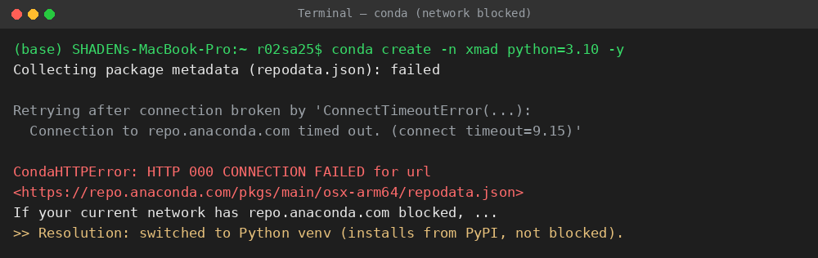
Figure A1. conda could not reach Anaconda servers (network blocked) — prompted the switch to Python venv.
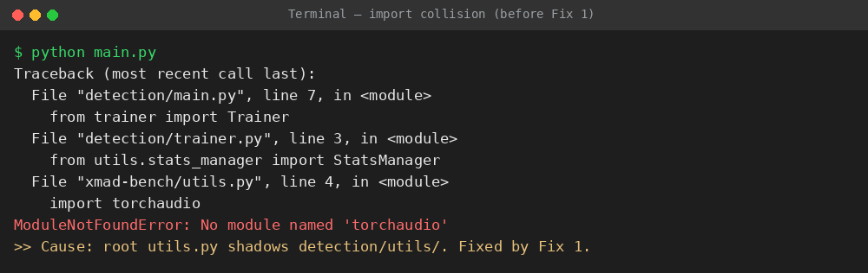
Figure A2. Import collision: root utils.py shadows detection/utils/, causing a spurious torchaudio error (before Fix 1).
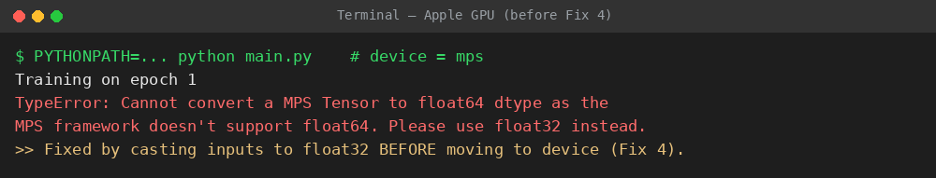
Figure A3. Apple GPU (MPS) float64 error before Fix 4.
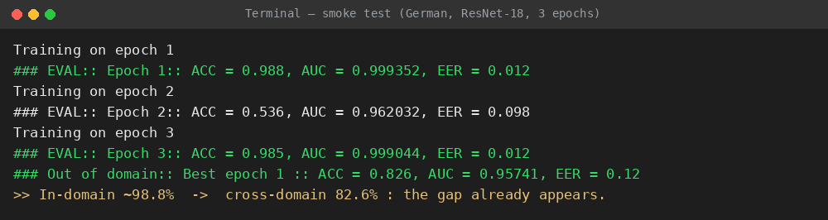
Figure A4. Smoke test (German, ResNet-18, 3 epochs): in-domain ~98.8% vs cross-domain 82.6%.
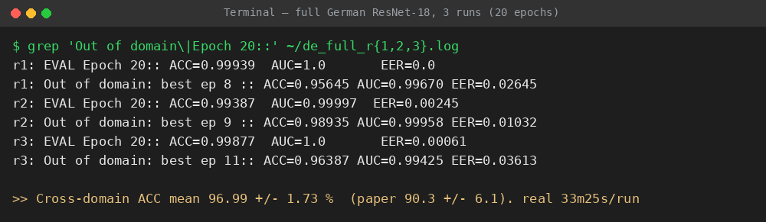
Figure A5. Full German ResNet-18, three 20-epoch runs — final in-domain and cross-domain results.

