

**Lab-7**

Course **Title:** **Object Oriented ProgrammingLab**

**Course Code:****CSE 215**

**Submitted To:**

**Anup Majumdar**

Lecturer

Dept. of Computer Science and Engineering

Daffodil International University

**Submitted By:**

NAME: Shadesh Ram Gour

ID: **171-15-8599**

Section: **E**

Department of **CSE**

**Date of Submission: 15-03-2018**

Code: Simple Calculator

#using switch case:-

package simple.calculator;

import java.util.Scanner;

public class Calculator {

public static void main(String[] args){

int num1=0;

int num2=0;

char operator;

double answer = 0.0;

Scanner input = new Scanner(System.in);

System.out.println("Enter your first number : ");

num1 = input.nextInt();

System.out.println("Enter your second number : ");

num2 = input.nextInt();

System.out.println("What operation? ");

operator = input.next().charAt(0);

switch(operator){

case '+' : answer = num1 + num2;

break;

case '-' : answer = num1 - num2;

break;

case '*' : answer = num1 * num2;

break;

case '/' : answer = num1 / num2;

break;

}

System.out.println(num1+" "+operator+" "+num2+" = "+answer);

}

}

Output:

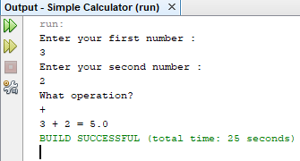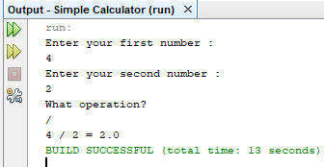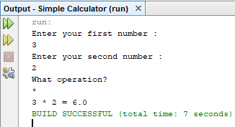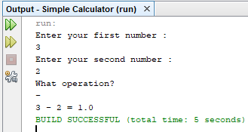

#using method:-

package simple.calculator;

import java.util.Scanner;

public class Calculator1 {

public static void main(String[] args){

int num1=0;

int num2=0;

char operator;

double answer = 0.0;

Scanner input = new Scanner(System.in);

System.out.println("Enter your first number : ");

num1 = input.nextInt();

System.out.println("Enter your second number : ");

num2 = input.nextInt();

System.out.println("What operation? ");

operator = input.next().charAt(0);

switch(operator){

case '+' : answer = addition(num1,num2);

break;

case '-' : answer = subtraction(num1,num2);

break;

case '*' : answer = multiplication(num1,num2);

break;

case '/' : answer = division(num1,num2);

break;

}

System.out.println(num1+" "+operator+" "+num2+" = "+answer);

}

public static int addition(int x,int y){

return x+y;

}

public static int subtraction(int x,int y){

return x-y;

}

public static int multiplication(int x,int y){

return x*y;

}

public static int division(int x,int y){

return x/y;

}

}

Output:

Same as while we using switch case.

***Thank You!!***