*Report*

Description:

The website I created is an informative web page on the saxophone, designed for long-time layers, amateurs, but also non-players. It is also interactive since different user can access different parts of the website and interact with the site. For instance, administrators can edit the main page, and other users can post comments, opinions, or views on the instrument, and saxophone players.

Functionalities:

1. Interactive and intuitive homepage: dynamic navigation menu (hovers), promotion banner that redirects the reader towards a saxophone online shop, sidebar with integrated links to the twitter page, the facebook account, and the YouTube channel of the player discovered this week.
2. An account of the number of words and line for each page.
3. A login page and a sign-in page are included. The latter stores username and passwords in a database. Users login have the access to further functionalities. For example :
4. A forum where users can post comments, and edit comments that they already posted. If the user happens to be an administrator, he is then also entitled to edit other people posts, or delete them.
5. An edit page where administrators can edit the content of the home page, or reset it to its original value.
6. An admin controls page where administrators can view all the users, give admin privileges to other users, or delete users.
7. An about page that provides information about the creator of the page.
8. The website also has a log file that is appended every time the wiki is modified.

How to install:

Start up the server by typing “ruby webpage.rb” in the terminal, or through a build in function in your favourite text editor (in ScITe, just press F5 after having opened the webpage.rb file).

Then simply chose a browser, and type in: <http://localhost:4567/>

You are now on the website.

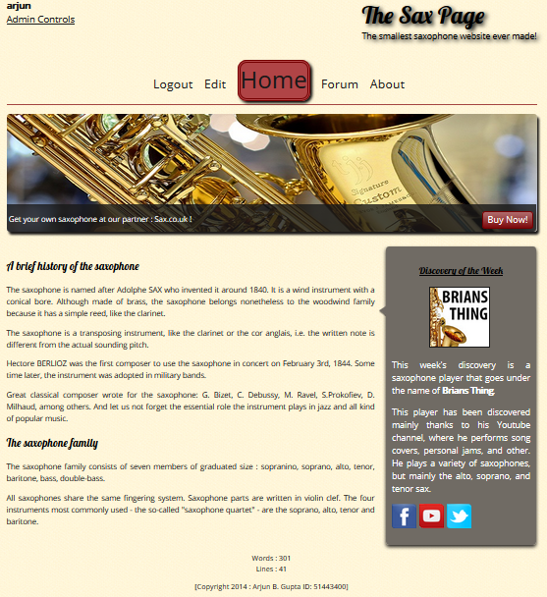Appendix:

