**Build Process:**

The code artefact is built and pushed to ECR by AWS CodeBuild service by integrating with GitHub repository.

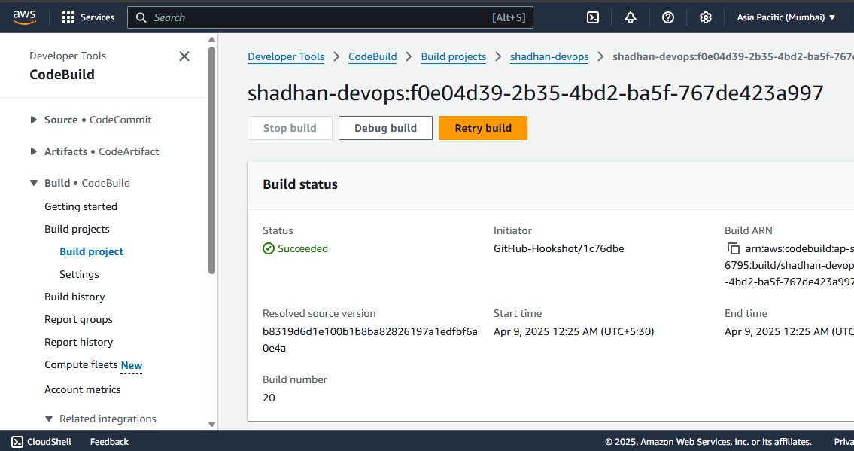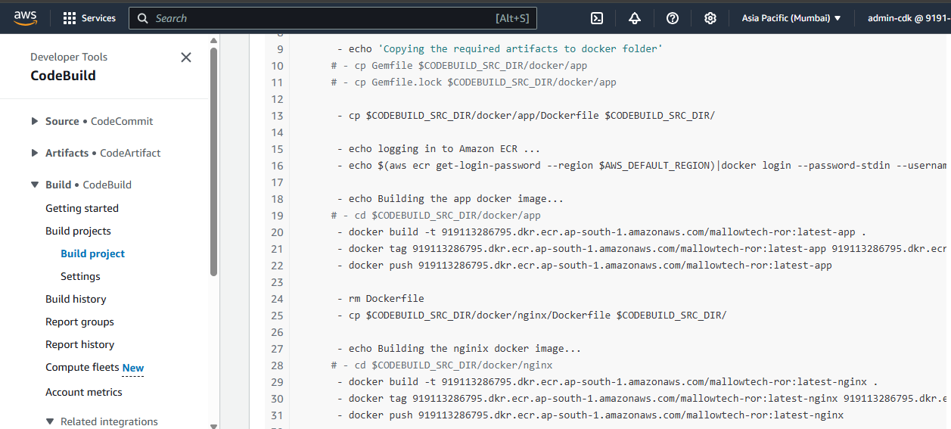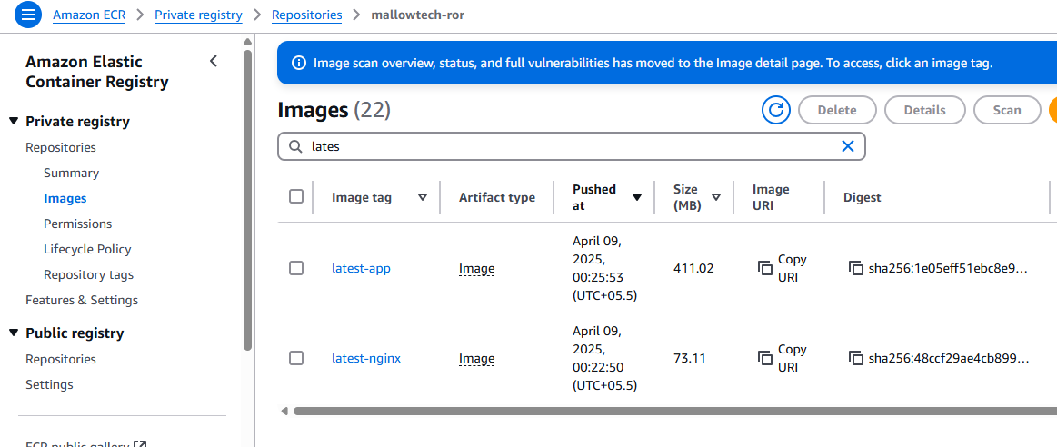

**Manual Infrastructure setup**

The following components were created manually for PoC.

1. VPC
2. 2 Public Subnets
3. 2 Private Subnets
4. Route Tables
5. NAT Gateway
6. Internet Gateway
7. ALB
8. RDS Postgres instance
9. S3 Bucket
10. ECS Cluster (EC2 type) and Service

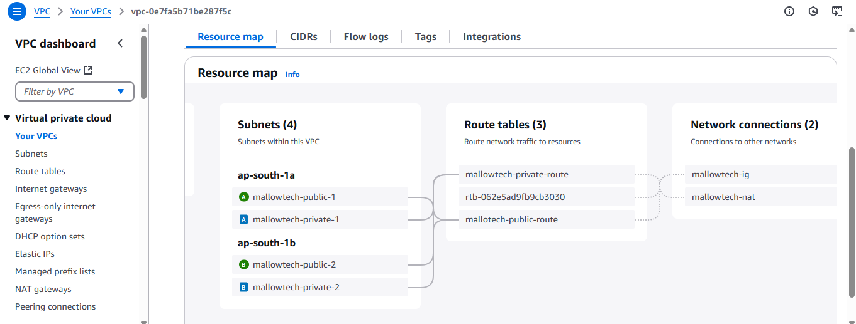

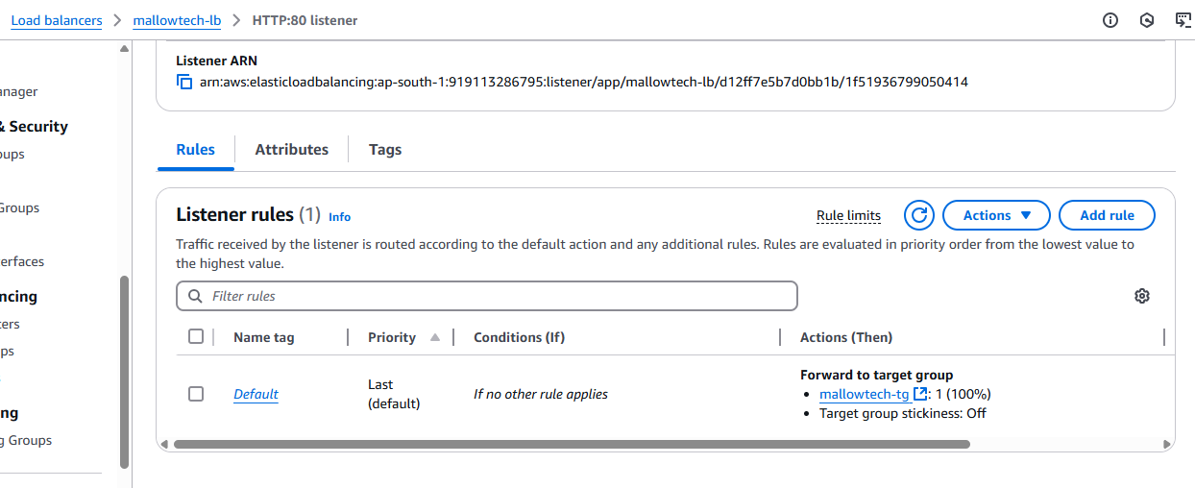

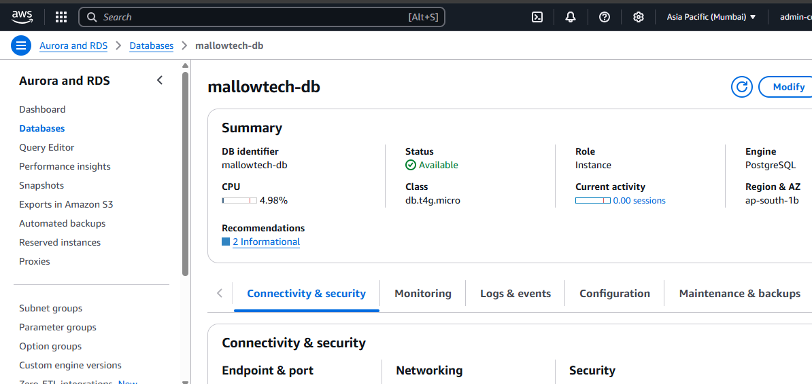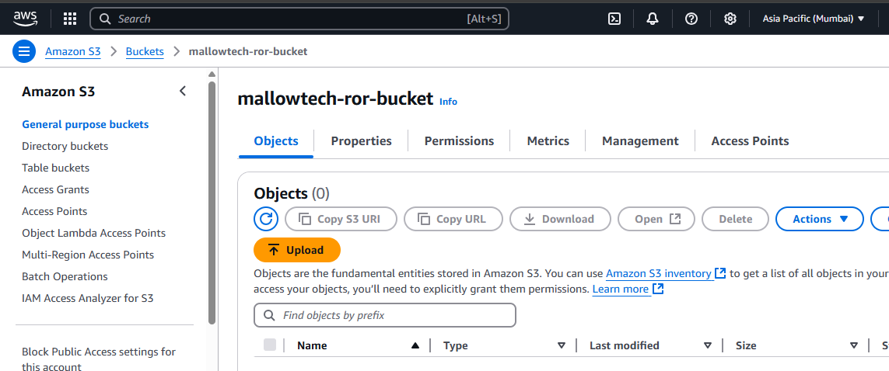

Cluster and Service

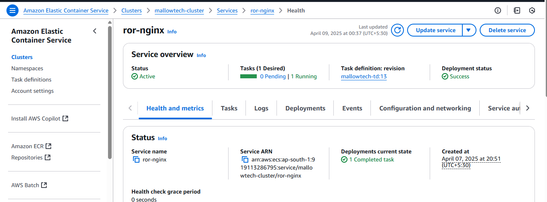

Task definition

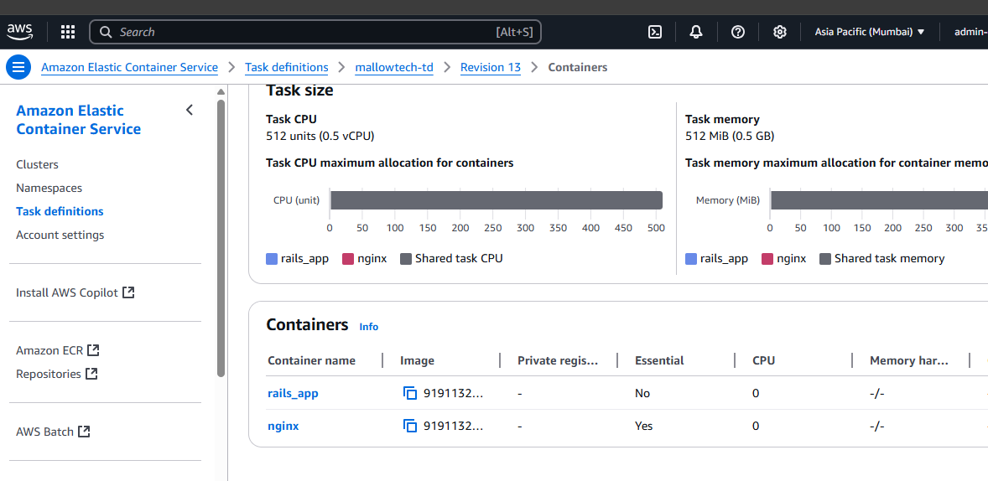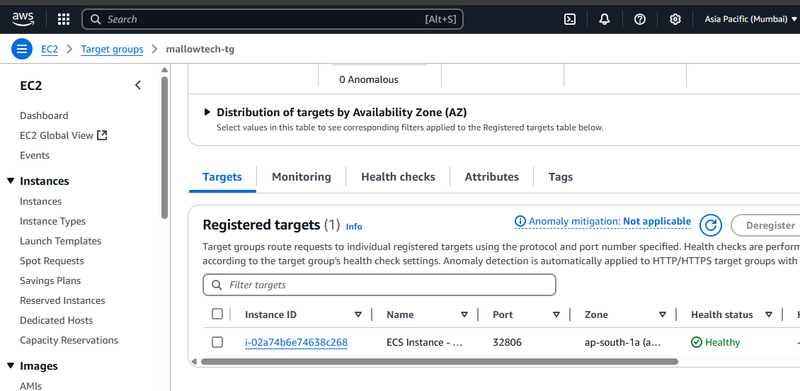

ALB DNS : <http://mallowtech-lb-516832665.ap-south-1.elb.amazonaws.com/>

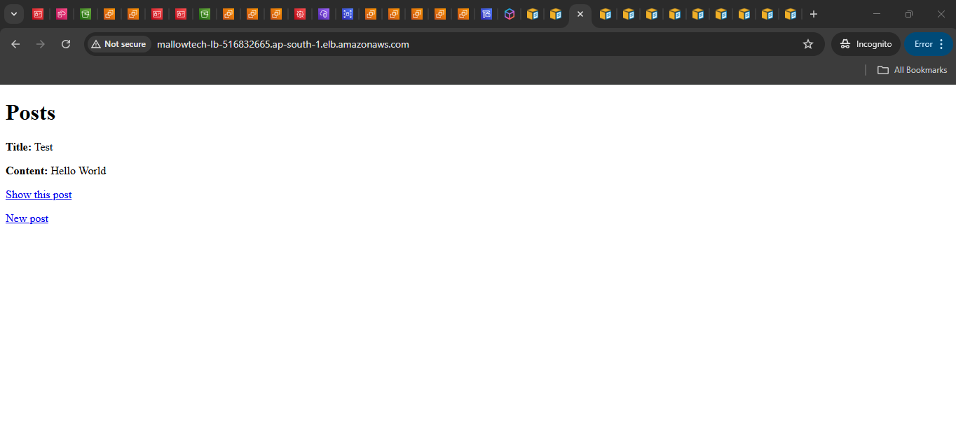

IaC