Predicting 30-Day Hospital Readmission of Diabetic Patients
Logistic Regression vs Random Forest
Module: Fundamentals of Machine Learning
Student: [Your full name]
Student ID: [Your student ID]
Dataset: https://archive.ics.uci.edu/dataset/296/diabetes+130-us+hospitals+for+years+1999-2008
GitHub: https://github.com/Shadhani-Rushanthi/FML-Assignment
Video: [YouTube link]
How to use: turn each yellow box into a short paragraph in your own words, then delete the box and the grey placeholder. Keep sentences simple. Save as PDF when done.

1. Problem Addressed
WRITING NOTES (delete this box before submitting)
- Some diabetic patients come back to hospital within 30 days of going home. This is costly for hospitals and bad for patients.
- Doctors cannot easily tell at discharge which patients will come back.
- Goal of this project: use machine learning to predict, at discharge, whether a patient will be readmitted within 30 days (yes / no). This is supervised binary classification.
- Two algorithms are compared: Logistic Regression and Random Forest.

[Write here: about 200 words]

2. Dataset
WRITING NOTES (delete this box before submitting)
- Name and source: Diabetes 130-US Hospitals (1999-2008), UCI Machine Learning Repository [1], [2].
- Each row is one hospital stay of a diabetic patient. Describe the main attribute groups listed in Table 2.
- Target: 11.16% readmitted within 30 days, so the classes are imbalanced.
- Problems in the data: missing values (weight 96.9%, medical specialty 49.1%, payer code 39.6%) and many patients appearing more than once.

Table 1: Dataset summary
Property | Value
Source | UCI Machine Learning Repository (dataset 296)
Records | 101,766 hospital stays from 130 US hospitals
Attributes | 50
Unique patients | 71,518 (16,773 have more than one stay)
Target (readmitted) | NO 53.91% | after 30 days 34.93% | within 30 days 11.16%

Table 2: Main attribute groups
Group | Attributes
Patient details | race, gender, age (10-year bands)
Hospital stay | admission type, admission source, discharge destination, days in hospital, medical specialty
Treatment | number of lab tests, procedures and medications; 23 diabetes medication columns; change of medication
Medical history | outpatient, emergency and inpatient visits in the previous year; number of diagnoses
Diagnoses | primary, secondary and additional diagnosis (ICD-9 codes)
Lab results | HbA1c result, glucose serum test result

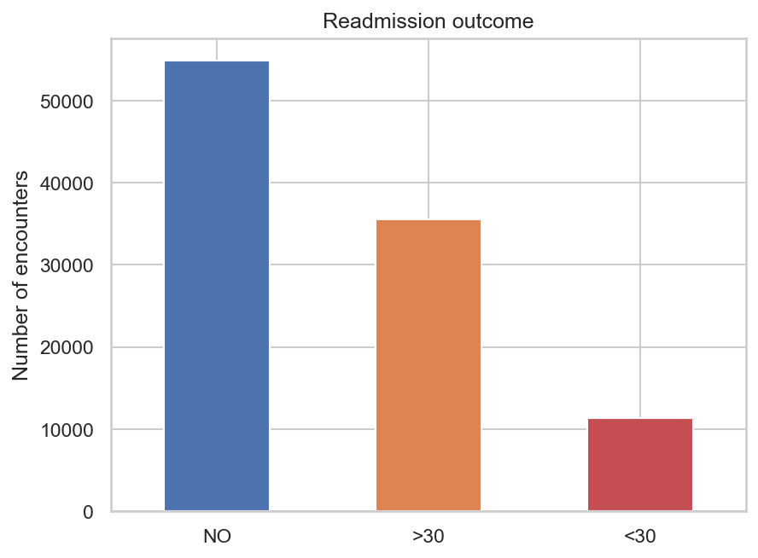
Figure 1: Distribution of the readmission outcome
[Write here: about 300 words]

3. Methodology

3.1 Data Preprocessing
WRITING NOTES (delete this box before submitting)
- Removed patients who died or went to hospice, because they cannot be readmitted. 99,340 rows remain.
- Dropped columns with too much missing data (weight, payer code) and the ID column.
- Filled missing values (e.g. "Unknown", "Not measured") and grouped 700+ diagnosis codes into 9 groups.
- Created new features: number of medication changes, number of medications used, total previous visits.
- Split 80/20 by patient (79,567 train / 19,773 test), so no patient is in both sets. This avoids data leakage.

[Write here: about 200 words]

3.2 Algorithm 1: Logistic Regression
WRITING NOTES (delete this box before submitting)
- A linear model that turns a weighted sum of the features into a probability (sigmoid function).
- Why chosen: simple, fast, easy to explain (each feature has a weight / odds ratio). Common baseline in medical studies.
- Settings: features scaled; class_weight = balanced to handle the imbalance; C tuned with 5-fold cross-validation (best C = 0.01).

[Write here: about 150 words]

3.3 Algorithm 2: Random Forest
WRITING NOTES (delete this box before submitting)
- Many decision trees, each trained on a random sample of patients and features; the final answer is the average vote [3].
- Why chosen: can learn non-linear patterns and combinations of features that Logistic Regression cannot.
- Settings: class_weight = balanced_subsample; tuned with randomized search (best: 300 trees, min_samples_leaf = 20, max_features = 0.3).

[Write here: about 150 words]

3.4 Evaluation Metrics
WRITING NOTES (delete this box before submitting)
- Accuracy is misleading here: predicting "no" for everyone gives about 89% accuracy.
- So the models are compared with ROC-AUC, PR-AUC, recall, precision and F1 [4].
- The decision threshold was chosen on training data to give the best F1 (LR 0.53, RF 0.43).

[Write here: about 100 words]

4. Results and Comparison
Table 3: Test-set results (19,773 hospital stays)
Metric | Logistic Regression | Random Forest
ROC-AUC | 0.665 | 0.671
PR-AUC | 0.213 | 0.228
Recall | 0.476 | 0.528
Precision | 0.189 | 0.190
F1 score | 0.271 | 0.280
Balanced accuracy | 0.607 | 0.620
Training time | 0.9 seconds | 28.2 seconds

WRITING NOTES (delete this box before submitting)
- Random Forest is better on every accuracy metric, but only by a small amount (ROC-AUC 0.671 vs 0.665).
- Random Forest finds about 53 of every 100 readmitted patients; Logistic Regression finds about 48.
- A bootstrap test (1,000 samples) shows the difference is real but small: the 95% interval for the AUC difference is 0.0002 to 0.0125.
- Logistic Regression trains about 30 times faster.
- Both models agree that the most important factors are previous inpatient visits and discharge destination (Figure 4).

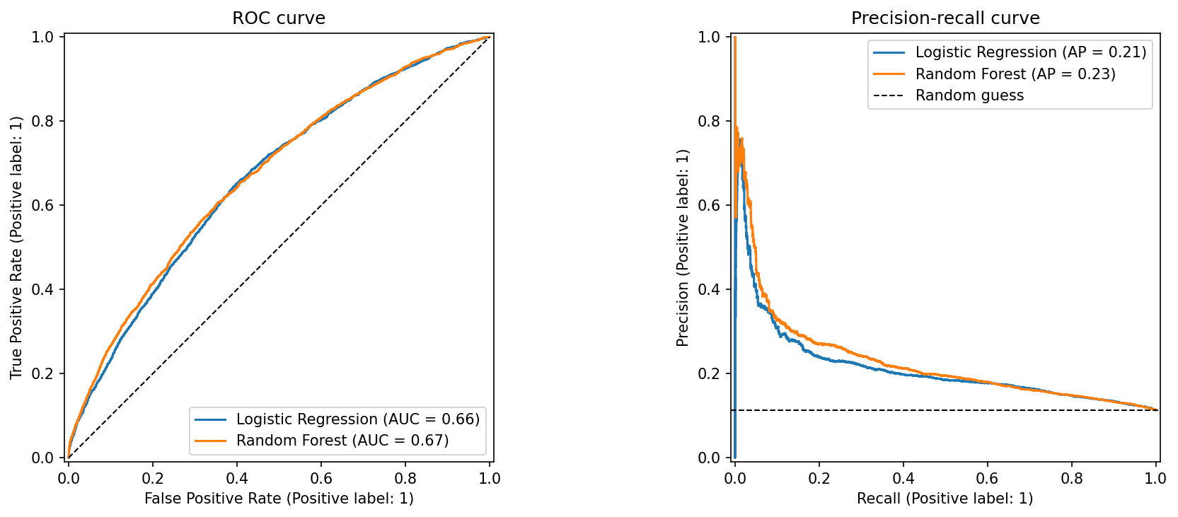
Figure 2: ROC and precision-recall curves for both models
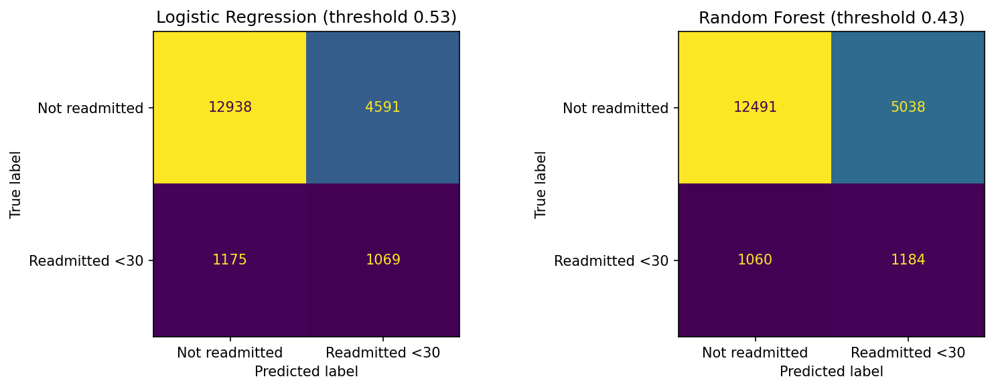
Figure 3: Confusion matrices for both models
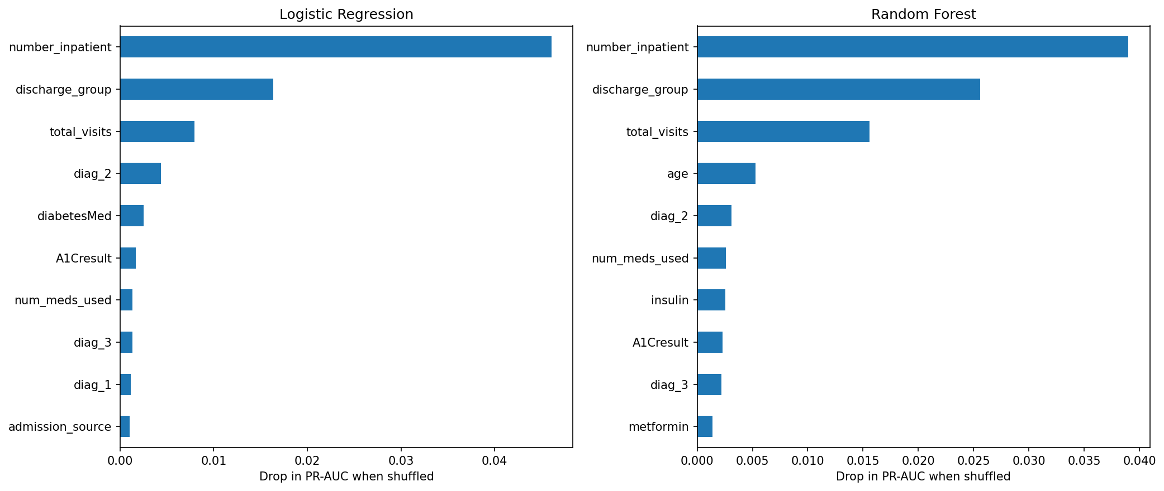
Figure 4: Most important features for each model
[Write here: about 400 words describing the table and the three figures]

5. Discussion, Limitations and Future Work

5.1 Comparing the Two Algorithms
WRITING NOTES (delete this box before submitting)
- Random Forest is slightly more accurate. Logistic Regression is much faster and easier to explain to doctors.
- The difference is small because most of the useful information is in a few strong features, which a simple linear model already captures.
- Your opinion: which one would you recommend for a hospital, and why?

[Write here: about 150 words]

5.2 Limitations
WRITING NOTES (delete this box before submitting)
- Both models only reach about 0.67 AUC: the data has no lab results over time, no social information and nothing about care after discharge.
- The data is old (1999-2008) and from the US only.
- Grouping diagnosis codes loses some detail.

[Write here: about 120 words]

5.3 Future Work
WRITING NOTES (delete this box before submitting)
- Try other algorithms such as gradient boosting (XGBoost / LightGBM).
- Add more useful features (e.g. patient history over several visits).
- Calibrate the probabilities so they can be used as real risk percentages.
- Test on newer data from other hospitals.

[Write here: about 120 words]

6. Conclusion
WRITING NOTES (delete this box before submitting)
- 3 to 4 sentences: what you did, which model did better, and the main limitation.

[Write here: about 80 words]

References
[1] B. Strack et al., "Impact of HbA1c measurement on hospital readmission rates: Analysis of 70,000 clinical database patient records," BioMed Research International, vol. 2014, Art. no. 781670, 2014.
[2] J. Clore, K. Cios, J. DeShazo and B. Strack, "Diabetes 130-US Hospitals for Years 1999-2008," UCI Machine Learning Repository, 2014. [Online]. Available: https://archive.ics.uci.edu/dataset/296/diabetes+130-us+hospitals+for+years+1999-2008
[3] L. Breiman, "Random forests," Machine Learning, vol. 45, no. 1, pp. 5-32, 2001.
[4] T. Saito and M. Rehmsmeier, "The precision-recall plot is more informative than the ROC plot when evaluating binary classifiers on imbalanced datasets," PLoS ONE, vol. 10, no. 3, Art. no. e0118432, 2015.
[5] F. Pedregosa et al., "Scikit-learn: Machine learning in Python," Journal of Machine Learning Research, vol. 12, pp. 2825-2830, 2011.

Appendix A: Source Code
The complete source code is reproduced below as text. It is also available in the GitHub repository: https://github.com/Shadhani-Rushanthi/FML-Assignment
WRITING NOTES (delete this box before submitting)
- Generated from your notebooks on the date this template was built. If you change any code, regenerate or update this appendix so it matches the repository.

A.1 src/preprocessing.py
import re
import numpy as np
import pandas as pd
from sklearn.metrics import (
average_precision_score, balanced_accuracy_score, brier_score_loss,
f1_score, precision_recall_curve, precision_score, recall_score,
roc_auc_score,
)

EXPIRED_OR_HOSPICE = [11, 13, 14, 19, 20, 21]

# The 23 diabetes medication columns in the dataset
MEDICATIONS = [
'metformin', 'repaglinide', 'nateglinide', 'chlorpropamide', 'glimepiride',
'acetohexamide', 'glipizide', 'glyburide', 'tolbutamide', 'pioglitazone',
'rosiglitazone', 'acarbose', 'miglitol', 'troglitazone', 'tolazamide',
'examide', 'citoglipton', 'insulin', 'glyburide-metformin',
'glipizide-metformin', 'glimepiride-pioglitazone',
'metformin-rosiglitazone', 'metformin-pioglitazone',
]

def load_raw(path):
"""Read the raw CSV. '?' is how this dataset marks missing values.
Diagnosis codes are read as text because some start with V or E."""
diag_types = {'diag_1': str, 'diag_2': str, 'diag_3': str}
return pd.read_csv(path, na_values='?', dtype=diag_types, low_memory=False)

def group_icd9(code):
if pd.isna(code):
return 'Missing'
code = str(code)
if code.startswith(('V', 'E')):
return 'Other'
c = float(code)
if 390 <= c <= 459 or c == 785:
return 'Circulatory'
if 460 <= c <= 519 or c == 786:
return 'Respiratory'
if 520 <= c <= 579 or c == 787:
return 'Digestive'
if int(c) == 250:
return 'Diabetes'
if 800 <= c <= 999:
return 'Injury'
if 710 <= c <= 739:
return 'Musculoskeletal'
if 580 <= c <= 629 or c == 788:
return 'Genitourinary'
if 140 <= c <= 239:
return 'Neoplasms'
return 'Other'

def age_to_midpoint(age_band):
low, high = re.findall(r'\d+', age_band)
return (int(low) + int(high)) / 2

# The ID columns are codes, not quantities. These groupings follow IDS_mapping.csv.
def map_admission_type(x):
if x in (1, 2, 7): # emergency, urgent, trauma centre
return 'Emergency/Urgent'
if x == 3:
return 'Elective'
return 'Other/Unknown'

def map_admission_source(x):
if x == 7:
return 'Emergency Room'
if x in (1, 2, 3): # physician, clinic, HMO referral
return 'Referral'
if x in (4, 5, 6, 10, 18, 19, 22, 25, 26):
return 'Transfer'
return 'Other/Unknown'

def map_discharge(x):
if x == 1:
return 'Home'
if x in (6, 8): # home with health service / home IV
return 'Home with care'
if x in (2, 3, 4, 5, 10, 15, 22, 23, 24, 27, 28, 29, 30):
return 'Transferred'
return 'Other/Unknown'

def clean_data(df, top_n_specialties=10):
"""Run every cleaning step and return (X, y, groups).
groups = patient_nbr, used only for splitting, never as a feature."""
df = df.copy()

df = df[~df['discharge_disposition_id'].isin(EXPIRED_OR_HOSPICE)]

df = df[df['gender'] != 'Unknown/Invalid']

# 3. Drop the ID column, columns with mostly missing data, and two
# medications that have the same value for every patient
df = df.drop(columns=['encounter_id', 'weight', 'payer_code',
'examide', 'citoglipton'])

# 4. Fill the remaining missing categories
df['race'] = df['race'].fillna('Unknown')
df['medical_specialty'] = df['medical_specialty'].fillna('Missing')
top = df['medical_specialty'].value_counts().nlargest(top_n_specialties).index
df['medical_specialty'] = df['medical_specialty'].where(
df['medical_specialty'].isin(top), 'Other')

# 5. Lab results: missing here means the test wasn't done
df['max_glu_serum'] = df['max_glu_serum'].fillna('Not measured')
df['A1Cresult'] = df['A1Cresult'].fillna('Not measured')

# 6. Collapse 700+ ICD-9 codes into 9 clinical groups
for col in ['diag_1', 'diag_2', 'diag_3']:
df[col] = df[col].apply(group_icd9)

# 7. Age bands -> numbers, ID codes -> readable groups
df['age'] = df['age'].apply(age_to_midpoint)
df['admission_type'] = df.pop('admission_type_id').apply(map_admission_type)
df['admission_source'] = df.pop('admission_source_id').apply(map_admission_source)
df['discharge_group'] = df.pop('discharge_disposition_id').apply(map_discharge)

# 8. Summarise the medication columns, keeping only the two most common ones
meds = [m for m in MEDICATIONS if m in df.columns]
df['num_med_changes'] = df[meds].isin(['Up', 'Down']).sum(axis=1)
df['num_meds_used'] = (df[meds] != 'No').sum(axis=1)
df = df.drop(columns=[m for m in meds if m not in ('insulin', 'metformin')])

# 9. Healthcare use in the year before this stay
df['total_visits'] = (df['number_outpatient'] + df['number_emergency']
+ df['number_inpatient'])

# 10. Yes/No columns -> 1/0
df['change'] = (df['change'] == 'Ch').astype(int)
df['diabetesMed'] = (df['diabetesMed'] == 'Yes').astype(int)

# 11. Target: readmitted within 30 days = 1, everything else = 0
y = (df.pop('readmitted') == '<30').astype(int)
groups = df.pop('patient_nbr')

return (df.reset_index(drop=True), y.reset_index(drop=True),
groups.reset_index(drop=True))

def split_columns(X):
num_cols = X.select_dtypes(include='number').columns.tolist()
cat_cols = [c for c in X.columns if c not in num_cols]
return num_cols, cat_cols

def best_f1_threshold(y_true, proba):
precision, recall, thresholds = precision_recall_curve(y_true, proba)
f1 = 2 * precision * recall / (precision + recall + 1e-12)
best = np.argmax(f1[:-1]) # the last point has no matching threshold
return thresholds[best], f1[best]

def evaluate(y_true, proba, threshold):
pred = (proba >= threshold).astype(int)
return {
'ROC-AUC': roc_auc_score(y_true, proba),
'PR-AUC': average_precision_score(y_true, proba),
'Recall': recall_score(y_true, pred),
'Precision': precision_score(y_true, pred, zero_division=0),
'F1': f1_score(y_true, pred),
'Balanced accuracy': balanced_accuracy_score(y_true, pred),
'Brier score': brier_score_loss(y_true, proba),
'Threshold': threshold,
}

A.2 notebooks/data_desc.ipynb (data understanding)
# ---------- Cell 1 ----------
# Problem:
# Predicting the readmission of diabetic patients within 30-day after discharged, and how does a simple, interpretable model (Logistic Regression) compare with a more complex ensemble model (Random Forest)?

# This file will read the diabetic patients dataset and preprocess the data to create the model.

# ---------- Cell 2 ----------
import sys
import pandas as pd
import numpy as np
import matplotlib.pyplot as plt
import seaborn as sns

from src.preprocessing import load_raw

sys.path.append('..')
pd.set_option('display.max_columns', None)
sns.set_theme(style='whitegrid')
FIG = '../reports/figures/'

# ---------- Cell 3 ----------
df = load_raw('../Data/diabetic_data.csv')
print(df.shape)
df.head()

# ---------- Cell 4 ----------
summary = pd.DataFrame({
'dtype': df.dtypes.astype(str),
'unique_values': df.nunique(),
'missing_%': (df.isna().mean() * 100).round(2),
'example': df.iloc[0]
})
summary.to_csv(FIG+'attribute_summary.csv')
summary

# ---------- Cell 5 ----------
counts = df['readmitted'].value_counts()
print((counts/len(df)*100).round(2))

ax = counts.plot(kind='bar', color=['#4c72b0', '#dd8452', '#c44e52'])
ax.set_title('Readmission outcome')
ax.set_xlabel('')
ax.set_ylabel('Number of encounters')
plt.xticks(rotation=0)
plt.savefig(FIG +'01_target.png', dpi=150, bbox_inches='tight')
plt.show()

# ---------- Cell 6 ----------
# As the classes are imbalanced, so accuracy would be misleading.
# Only about [11.2]% of encounters ended in a readmission within 30 days, while [53.9]% were never readmitted and [34.9]% came back
# after 30 days. Since I'm treating this as "readmitted within 30 days or not", the class is small. Accuracy alone would be misleading here, so I'll focus on
# PR-AUC, recall and F1 when evaluating the models.

# ---------- Cell 7 ----------
missing = df.isna().mean().mul(100).sort_values(ascending=False)
missing = missing[missing > 0]

missing.plot(kind='barh')
plt.title('Missing values (%)')
plt.savefig(FIG + '01_missing.png', dpi=150, bbox_inches='tight')
plt.show()
missing

# ---------- Cell 8 ----------
# Some columns values are mostly missing
# `weight` is missing for about [97]% of encounters, so it can't be used. `payer_code` ([40]%) and `medical_specialty` ([49]%)
# also have a lot of gaps. I'll drop the first two and keep `medical_specialty`, treating "missing" as its own category, because whether a specialty was recorded
# may itself carry some information.

# ---------- Cell 9 ----------
visits = df['patient_nbr'].value_counts()
print('Unique patients:', visits.size)
print('Patients with more than one encounter:', (visits > 1).sum())
print('Share of rows from repeat patients: {:.1%}'.format((df['patient_nbr'].map(visits) > 1).mean()))

# ---------- Cell 10 ----------
# Many patients appear more than once.
# There are [101,766] encounters but only
# [71,518] unique patients, and about [X]% of rows belong to patients with several
# stays. If I split the data randomly, the same person could end up in both training
# and testing, which would make the results look better than they really are. To avoid
# this, I'll split the data by patient.

# ---------- Cell 11 ----------
df['target'] = (df['readmitted'] == '<30').astype(int)

fig, axes = plt.subplots(1, 3, figsize=(17, 4))
df.groupby('age')['target'].mean().plot(kind='bar', ax=axes[0], title='By age group')
df.groupby(df['number_inpatient'].clip(upper=10))['target'].mean().plot(
marker='o', ax=axes[1], title='By previous inpatient visits (10 = 10+)')
df.groupby(df['A1Cresult'].fillna('Not measured'))['target'].mean().plot(
kind='bar', ax=axes[2], title='By HbA1c result')
for ax in axes:
ax.set_ylabel('30-day readmission rate')
plt.tight_layout()
plt.savefig(FIG + '01_rates.png', dpi=150, bbox_inches='tight')
plt.show()

# ---------- Cell 12 ----------
# Previous hospital stays are the clearest warning sign.
# The readmission rate rises steadily with the number of inpatient visits in the year before: from about [8]% for
# patients with none to over [X]% for those with [5] or more. Age has a much weaker effect, and the HbA1c result shows only small differences between groups.

# ---------- Cell 13 ----------
num_cols = ['time_in_hospital', 'num_lab_procedures', 'num_procedures', 'num_medications', 'number_outpatient', 'number_emergency', 'number_inpatient', 'number_diagnoses']
df[num_cols].hist(bins=30, figsize=(14,8))
plt.tight_layout()
plt.savefig(FIG + '01_hist.png', dpi=150, bbox_inches='tight')
plt.show()

plt.figure(figsize=(8,6))
sns.heatmap(df[num_cols + ['target']].corr(), annot=True, fmt='.2f', cmap='coolwarm')
plt.title('Correlation between numeric features')
plt.savefig(FIG + '01_corr.png', dpi=150, bbox_inches='tight')
plt.show()

# ---------- Cell 14 ----------
# No single numeric feature explains readmission.
# Every correlation with the target is weak (the highest is about [0.17], for `number_inpatient`). On its own, no variable
# is a strong predictor. Readmission seems to depend on several factors together, which is exactly why a machine learning model is needed rather than a simple rule.

# Several features are skewed and need preparing.
# Columns such as `number_outpatient`, `number_emergency` and `number_inpatient` are mostly zero with a long tail.
# The diagnosis columns contain hundreds of different ICD-9 codes, which is far too many to use directly. In the next notebook I'll group the diagnoses into
# broader categories and scale the numeric features for Logistic Regression.

A.3 notebooks/preprocessing.ipynb
# ---------- Cell 1 ----------
import sys
sys.path.append('..')

import pandas as pd
import joblib
from sklearn.model_selection import GroupShuffleSplit

from src.preprocessing import load_raw, clean_data, split_columns

# ---------- Cell 2 ----------
raw = load_raw('../Data/diabetic_data.csv')
X, y, groups = clean_data(raw)

print('Rows before: ', len(raw), ' | after: ', len(X))
print('Columns before:', raw.shape[1], ' | feature after: ', X.shape[1])
print('Positive class rate: {: .2%}'.format(y.mean()))

# ---------- Cell 3 ----------
X['diag_1'].value_counts()

# ---------- Cell 4 ----------
print('Missing values left:', X.isna().sum().sum())
num_cols, cat_cols = split_columns(X)
print('Numeric:', num_cols)
print('Categorical:', cat_cols)

# ---------- Cell 5 ----------
gss = GroupShuffleSplit(n_splits=1, test_size=0.2, random_state=42)
train_idx, test_idx = next(gss.split(X, y, groups=groups))

X_train, X_test = X.iloc[train_idx].reset_index(drop=True), X.iloc[test_idx].reset_index(drop=True)
y_train, y_test = y.iloc[train_idx].reset_index(drop=True), y.iloc[test_idx].reset_index(drop=True)
g_train, g_test = groups.iloc[train_idx].reset_index(drop=True), groups.iloc[test_idx].reset_index(drop=True)

overlap = set(g_train) & set(g_test)
print('Train:', X_train.shape, '| Test:', X_test.shape)
print('Patients in both sets:', len(overlap))
print('Positive rate train {:.2%} | test {:.2%}'.format(y_train.mean(), y_test.mean()))

# ---------- Cell 6 ----------
joblib.dump({
'X_train': X_train, 'X_test': X_test,
'y_train': y_train, 'y_test': y_test,
'g_train': g_train, 'g_test': g_test,
}, '../data/processed/split.joblib')
print('Saved.')

A.4 notebooks/logistic_regression.ipynb
# ---------- Cell 1 ----------
import sys
sys.path.append('..')

import numpy as np
import pandas as pd
import matplotlib.pyplot as plt
import joblib
from sklearn.base import clone
from sklearn.compose import ColumnTransformer
from sklearn.linear_model import LogisticRegression
from sklearn.model_selection import GridSearchCV, StratifiedGroupKFold, cross_val_predict
from sklearn.pipeline import Pipeline
from sklearn.preprocessing import OneHotEncoder, StandardScaler

from src.preprocessing import split_columns, best_f1_threshold

d = joblib.load('../data/processed/split.joblib')
X_train, y_train, g_train = d['X_train'], d['y_train'], d['g_train']
num_cols, cat_cols = split_columns(X_train)
FIG = '../reports/figures/'

# ---------- Cell 2 ----------
preprocess = ColumnTransformer([
('num', StandardScaler(), num_cols),
('cat', OneHotEncoder(handle_unknown='ignore'), cat_cols),
])

lr_pipe = Pipeline([
('pre', preprocess),
('clf', LogisticRegression(class_weight='balanced', max_iter=3000)),
])

# ---------- Cell 3 ----------
cv = StratifiedGroupKFold(n_splits=5, shuffle=True, random_state=42)
param_grid = {'clf__C': [0.001, 0.01, 0.1, 1, 10]}

lr_search = GridSearchCV(lr_pipe, param_grid, cv=cv, scoring='average_precision', n_jobs=-1)
lr_search.fit(X_train, y_train, groups=g_train)

print('Best C:', lr_search.best_params_)
print('Best CV PR-AUC: {:.4f}'.format(lr_search.best_score_))
print('Refit time: {:.1f}s'.format(lr_search.refit_time_))

# ---------- Cell 4 ----------
res = pd.DataFrame(lr_search.cv_results_)
plt.errorbar(res['param_clf__C'].astype(float), res['mean_test_score'],yerr=res['std_test_score'], marker='o', capsize=4)
plt.xscale('log')
plt.xlabel('C (inverse regularisation strength)')
plt.ylabel('CV PR-AUC')
plt.title('Logistic Regression: effect of C')
plt.savefig(FIG + '03_lr_C.png', dpi=150, bbox_inches='tight')
plt.show()

# ---------- Cell 5 ----------
best_lr = lr_search.best_estimator_
names = best_lr.named_steps['pre'].get_feature_names_out()
coefs = best_lr.named_steps['clf'].coef_[0]

odds = pd.DataFrame({'feature': names, 'odds_ratio': np.exp(coefs)})
odds['effect'] = np.abs(np.log(odds['odds_ratio']))
top = odds.sort_values('effect', ascending=False).head(15).sort_values('odds_ratio')

plt.figure(figsize=(8, 6))
plt.barh(top['feature'], top['odds_ratio'],
color=np.where(top['odds_ratio'] > 1, '#c44e52', '#4c72b0'))
plt.axvline(1, color='black', linewidth=1)
plt.xlabel('Odds ratio (>1 increases risk)')
plt.title('Top 15 Logistic Regression features')
plt.savefig(FIG + '03_lr_odds.png', dpi=150, bbox_inches='tight')
plt.show()
top[['feature', 'odds_ratio']]

# ---------- Cell 6 ----------
l1_model = clone(best_lr).set_params(clf__penalty='l1', clf__solver='saga', clf__max_iter=2000)
l1_model.fit(X_train, y_train)
zero = (l1_model.named_steps['clf'].coef_[0] == 0).sum()
print(f'L1 set {zero} of {len(names)} coefficients exactly to zero')

# ---------- Cell 7 ----------
oof_lr = cross_val_predict(best_lr, X_train, y_train, groups=g_train, cv=cv, method='predict_proba', n_jobs=-1)[:, 1]
lr_threshold, lr_f1 = best_f1_threshold(y_train, oof_lr)
print(f'Chosen threshold: {lr_threshold:.3f} (OOF F1 = {lr_f1:.3f})')

# ---------- Cell 8 ----------
joblib.dump({'model': best_lr, 'threshold': lr_threshold,
'refit_time': lr_search.refit_time_}, '../models/linearReg.joblib')

A.5 notebooks/random_forest.ipynb
# ---------- Cell 1 ----------
import sys
sys.path.append('..')

import numpy as np
import pandas as pd
import matplotlib.pyplot as plt
import joblib
from sklearn.compose import ColumnTransformer
from sklearn.ensemble import RandomForestClassifier
from sklearn.model_selection import RandomizedSearchCV, StratifiedGroupKFold, cross_val_predict
from sklearn.pipeline import Pipeline
from sklearn.preprocessing import OneHotEncoder
import warnings
warnings.filterwarnings('ignore', category=RuntimeWarning, module='numpy')
from src.preprocessing import split_columns, best_f1_threshold

d = joblib.load('../Data/processed/split.joblib')
X_train, y_train, g_train = d['X_train'], d['y_train'], d['g_train']
num_cols, cat_cols = split_columns(X_train)
FIG = '../reports/figures/'
print('done')

# ---------- Cell 2 ----------
preprocess_rf = ColumnTransformer([
('num', 'passthrough', num_cols),
('cat', OneHotEncoder(handle_unknown='ignore'), cat_cols),
])

rf_pipe = Pipeline([
('pre', preprocess_rf),
('clf', RandomForestClassifier(class_weight='balanced_subsample', random_state=42, n_jobs=-1)),
])

# ---------- Cell 3 ----------
cv = StratifiedGroupKFold(n_splits=5, shuffle=True, random_state=42)
param_dist = {
'clf__n_estimators': [200, 300, 500],
'clf__max_depth': [10, 15, 20, None],
'clf__min_samples_leaf': [1, 5, 10, 20],
'clf__max_features': ['sqrt', 0.3],
}

rf_search = RandomizedSearchCV(rf_pipe, param_dist, n_iter=15, cv=cv, scoring='average_precision', n_jobs=-1, random_state=42, return_train_score=True, verbose=2)
rf_search.fit(X_train, y_train, groups=g_train)

print('Best params:', rf_search.best_params_)
print('Best CV PR-AUC: {:.4f}'.format(rf_search.best_score_))
print('Refit time: {:.1f}s'.format(rf_search.refit_time_))

# ---------- Cell 4 ----------
res = pd.DataFrame(rf_search.cv_results_)
res = res[['params', 'mean_train_score', 'mean_test_score']].sort_values(
'mean_test_score', ascending=False)
res['gap'] = res['mean_train_score'] - res['mean_test_score']
res.head(10)

# ---------- Cell 5 ----------
best_rf = rf_search.best_estimator_
names = best_rf.named_steps['pre'].get_feature_names_out()
imp = pd.Series(best_rf.named_steps['clf'].feature_importances_, index=names)
imp.sort_values().tail(15).plot(kind='barh', figsize=(8, 6))
plt.title('Random Forest: top 15 features (impurity importance)')
plt.savefig(FIG + '04_rf_importance.png', dpi=150, bbox_inches='tight')
plt.show()

# ---------- Cell 6 ----------
import shap

pre = best_rf.named_steps['pre']
sample = X_train.sample(500, random_state=42)
Xs = pre.transform(sample)
if hasattr(Xs, 'toarray'):
Xs = Xs.toarray()

explainer = shap.TreeExplainer(best_rf.named_steps['clf'])
sv = explainer.shap_values(Xs)
# different shap versions return different shapes for binary models
if isinstance(sv, list):
sv = sv[1]
elif sv.ndim == 3:
sv = sv[:, :, 1]

shap.summary_plot(sv, Xs, feature_names=names, max_display=15, show=False)
plt.savefig(FIG + '04_rf_shap.png', dpi=150, bbox_inches='tight')
plt.show()

# ---------- Cell 7 ----------
oof_rf = cross_val_predict(best_rf, X_train, y_train, groups=g_train,
cv=cv, method='predict_proba')[:, 1]
rf_threshold, rf_f1 = best_f1_threshold(y_train, oof_rf)
print(f'Chosen threshold: {rf_threshold:.3f} (OOF F1 = {rf_f1:.3f})')

# ---------- Cell 8 ----------
joblib.dump({'model': best_rf, 'threshold': rf_threshold, 'refit_time': rf_search.refit_time_}, '../models/randomforest.joblib')

A.6 notebooks/comparison.ipynb
# ---------- Cell 1 ----------
import sys
sys.path.append('..')

import numpy as np
import pandas as pd
import matplotlib.pyplot as plt
import joblib
from sklearn.calibration import CalibrationDisplay
from sklearn.inspection import permutation_importance
from sklearn.metrics import (ConfusionMatrixDisplay, PrecisionRecallDisplay,
RocCurveDisplay, roc_auc_score)

from src.preprocessing import evaluate

d = joblib.load('../Data/processed/split.joblib')
X_test, y_test = d['X_test'], d['y_test']
lr = joblib.load('../models/linearReg.joblib')
rf = joblib.load('../models/randomforest.joblib')
FIG = '../reports/figures/'

p_lr = lr['model'].predict_proba(X_test)[:, 1]
p_rf = rf['model'].predict_proba(X_test)[:, 1]
print('done')

# ---------- Cell 2 ----------
results = pd.DataFrame({
'Logistic Regression': evaluate(y_test, p_lr, lr['threshold']),
'Random Forest': evaluate(y_test, p_rf, rf['threshold']),
}).T
results['Training time (s)'] = [lr['refit_time'], rf['refit_time']]
results.round(4)

# ---------- Cell 3 ----------
fig, axes = plt.subplots(1, 2, figsize=(13, 5))
RocCurveDisplay.from_predictions(y_test, p_lr, name='Logistic Regression', ax=axes[0])
RocCurveDisplay.from_predictions(y_test, p_rf, name='Random Forest', ax=axes[0])
axes[0].plot([0, 1], [0, 1], 'k--', linewidth=1)
axes[0].set_title('ROC curve')

PrecisionRecallDisplay.from_predictions(y_test, p_lr, name='Logistic Regression', ax=axes[1])
PrecisionRecallDisplay.from_predictions(y_test, p_rf, name='Random Forest', ax=axes[1])
axes[1].axhline(y_test.mean(), color='k', linestyle='--', linewidth=1, label='Random guess')
axes[1].legend()
axes[1].set_title('Precision-recall curve')
plt.tight_layout()
plt.savefig(FIG + '05_roc_pr.png', dpi=150, bbox_inches='tight')
plt.show()

# ---------- Cell 4 ----------
fig, axes = plt.subplots(1, 2, figsize=(11, 4))
for ax, (name, p, t) in zip(axes, [('Logistic Regression', p_lr, lr['threshold']),
('Random Forest', p_rf, rf['threshold'])]):
ConfusionMatrixDisplay.from_predictions(
y_test, (p >= t).astype(int), ax=ax, colorbar=False,
display_labels=['Not readmitted', 'Readmitted <30'])
ax.set_title(f'{name} (threshold {t:.2f})')
plt.tight_layout()
plt.savefig(FIG + '05_confusion.png', dpi=150, bbox_inches='tight')
plt.show()

# ---------- Cell 5 ----------
fig, ax = plt.subplots(figsize=(6, 5))
CalibrationDisplay.from_predictions(y_test, p_lr, n_bins=10, name='Logistic Regression', ax=ax)
CalibrationDisplay.from_predictions(y_test, p_rf, n_bins=10, name='Random Forest', ax=ax)
ax.set_title('Calibration curve')
plt.savefig(FIG + '05_calibration.png', dpi=150, bbox_inches='tight')
plt.show()

# ---------- Cell 6 ----------
rng = np.random.default_rng(42)
y_arr = y_test.to_numpy()
n = len(y_arr)
auc_lr, auc_rf, diff = [], [], []

for _ in range(1000):
idx = rng.integers(0, n, n)
if y_arr[idx].sum() == 0:
continue
a, b = roc_auc_score(y_arr[idx], p_lr[idx]), roc_auc_score(y_arr[idx], p_rf[idx])
auc_lr.append(a); auc_rf.append(b); diff.append(b - a)

def ci(values):
return np.percentile(values, [2.5, 97.5])

print('LR AUC 95% CI:', ci(auc_lr).round(4))
print('RF AUC 95% CI:', ci(auc_rf).round(4))
print('RF - LR difference 95% CI:', ci(diff).round(4))

# ---------- Cell 7 ----------
sample = X_test.sample(5000, random_state=42)
y_sample = y_test.loc[sample.index]

fig, axes = plt.subplots(1, 2, figsize=(14, 6))
for ax, (name, m) in zip(axes, [('Logistic Regression', lr['model']), ('Random Forest', rf['model'])]):
r = permutation_importance(m, sample, y_sample, scoring='average_precision',
n_repeats=5, random_state=42, n_jobs=-1)
imp = pd.Series(r.importances_mean, index=sample.columns).sort_values().tail(10)
imp.plot(kind='barh', ax=ax, title=name)
ax.set_xlabel('Drop in PR-AUC when shuffled')
plt.tight_layout()
plt.savefig(FIG + '05_permutation.png', dpi=150, bbox_inches='tight')
plt.show()

