Predicting 30-Day Hospital Readmission of Diabetic Patients
A Comparison of Logistic Regression and Random Forest
Module: Fundamentals of Machine Learning (FML)
Programme: MSc in [your programme name], SLIIT
Student: [Your full name]
Student ID: [Your student ID]
Email: [Your email]
Dataset: https://archive.ics.uci.edu/dataset/296/diabetes+130-us+hospitals+for+years+1999-2008
GitHub repository: https://github.com/Shadhani-Rushanthi/FML-Assignment
Video: [YouTube link]
Date: [Submission date]

How to use this template (delete this page)
WRITING NOTES (delete this box before submitting)
- Grey italic text in [brackets] marks where you write. Yellow boxes list what to cover. Delete both before submitting.
- All numbers in the tables come from your notebook outputs. If you re-run a notebook, update the numbers.
- Write every paragraph in your own words. Turnitin similarity must stay under 20%, and the viva will test what you wrote.
- Target length: about 5,000 to 6,500 words, excluding tables, figures and the appendix.
- Update the table of contents at the end: right-click it and choose Update Field, then Update entire table.
- Export to PDF: File > Save As > PDF. The appendix code must stay as text (no screenshots).
- Submission bundle (zip named ML-assignment): members.txt, submission.txt (dataset link, GitHub link, YouTube link), report PDF.
- Ask your lecturer whether a solo submission is acceptable and mention their approval in Section 9.

Table of Contents

Abstract
WRITING NOTES (delete this box before submitting)
- 150 to 200 words, written last.
- One sentence each: the problem, the dataset, the two algorithms, the evaluation approach (patient-level split, PR-AUC, bootstrap), the headline result, the conclusion.
- Headline numbers: test ROC-AUC 0.665 (LR) vs 0.671 (RF); PR-AUC 0.213 vs 0.228; RF better by a small but statistically significant margin; RF about 32x slower to train.

[Write here: abstract]

1. Introduction

1.1 Background
WRITING NOTES (delete this box before submitting)
- What a 30-day readmission is and why hospitals care: cost, quality of care, and financial penalties (e.g. the US Hospital Readmissions Reduction Program) [9].
- Why diabetic patients are a high-risk group.
- Why predicting risk at discharge helps: extra follow-up, medication review, earlier clinic appointment.
- Cite 2 to 3 sources, e.g. [1], [9], [10].

[Write here: about 250 words of background]

1.2 Problem Statement
WRITING NOTES (delete this box before submitting)
- At discharge, clinicians cannot easily tell which diabetic patients will be readmitted within 30 days.
- Framed as supervised binary classification: input = information recorded during the stay; output = readmitted within 30 days (1) or not (0), plus a risk probability.

[Write here: about 120 words]

1.3 Aim and Research Questions
WRITING NOTES (delete this box before submitting)
- Aim: build and compare two classical ML models that predict 30-day readmission.
- RQ1: How well can classical ML predict 30-day readmission on this data?
- RQ2: Does a non-linear ensemble (Random Forest) outperform an interpretable linear model (Logistic Regression), and is the difference significant?
- RQ3: Which patient factors drive readmission risk?

[Write here: aim and research questions]

1.4 Report Structure
[Write here: one short paragraph listing what each section covers]

2. Dataset

2.1 Source and Justification
WRITING NOTES (delete this box before submitting)
- Source: UCI Machine Learning Repository, Diabetes 130-US Hospitals for Years 1999-2008 [2]; original study by Strack et al. [1].
- Why it is appropriate (rubric criterion 1): real clinical records, large, messy (missing values, high-cardinality codes), imbalanced target, repeated patients that create a leakage risk. Not a tutorial toy dataset.

[Write here: about 150 words]

2.2 Context and Size
Table 1: Dataset summary
Property | Value
Source | UCI Machine Learning Repository (dataset 296)
Link | https://archive.ics.uci.edu/dataset/296/diabetes+130-us+hospitals+for+years+1999-2008
Origin | 130 US hospitals and integrated delivery networks, 1999-2008
Records | 101,766 hospital encounters
Attributes | 50 (47 features, 2 identifiers, 1 target)
Unique patients | 71,518
Patients with more than one encounter | 16,773
Rows belonging to repeat patients | 46.2%
Inclusion criteria | Inpatient diabetic encounters, stay of 1-14 days, lab tests performed, medication given
Target | readmitted: NO (53.91%), >30 days (34.93%), <30 days (11.16%)

WRITING NOTES (delete this box before submitting)
- Explain the inclusion criteria briefly and what one row represents (one hospital stay, not one patient).

[Write here: about 120 words on context]

2.3 Attribute Description
Table 2: Description of the attributes (* = test not performed rather than truly missing)
Attribute | Type | Description | Missing %
encounter_id | Identifier | Unique ID of the hospital stay | 0.00
patient_nbr | Identifier | Unique ID of the patient (used only for grouping) | 0.00
race | Nominal | Caucasian, AfricanAmerican, Hispanic, Asian, Other | 2.23
gender | Nominal | Male, Female, Unknown/Invalid | 0.00
age | Ordinal | Age in 10-year bands, [0-10) to [90-100) | 0.00
weight | Ordinal | Weight in pounds, banded | 96.86
admission_type_id | Nominal (code) | 8 values, e.g. emergency, urgent, elective | 0.00
discharge_disposition_id | Nominal (code) | 26 values, e.g. home, transferred, expired | 0.00
admission_source_id | Nominal (code) | 17 values, e.g. referral, emergency room | 0.00
time_in_hospital | Numeric | Length of stay in days (1-14) | 0.00
payer_code | Nominal | Insurance payer, e.g. Medicare, self-pay | 39.56
medical_specialty | Nominal | Specialty of the admitting physician (72 values) | 49.08
num_lab_procedures | Numeric | Number of lab tests during the stay | 0.00
num_procedures | Numeric | Number of non-lab procedures | 0.00
num_medications | Numeric | Number of distinct medications given | 0.00
number_outpatient | Numeric | Outpatient visits in the preceding year | 0.00
number_emergency | Numeric | Emergency visits in the preceding year | 0.00
number_inpatient | Numeric | Inpatient visits in the preceding year | 0.00
diag_1, diag_2, diag_3 | Nominal (ICD-9) | Primary, secondary and additional diagnosis (716 / 748 / 789 distinct codes) | 0.02 / 0.35 / 1.40
number_diagnoses | Numeric | Number of diagnoses entered | 0.00
max_glu_serum | Ordinal | Glucose serum test result: >300, >200, Norm, not measured | 94.75*
A1Cresult | Ordinal | HbA1c test result: >8, >7, Norm, not measured | 83.28*
23 medication columns | Ordinal | e.g. metformin, insulin: No, Steady, Up, Down | 0.00
change | Binary | Whether diabetes medication was changed | 0.00
diabetesMed | Binary | Whether any diabetes medication was prescribed | 0.00
readmitted | Target | NO, >30, <30 days | 0.00

2.4 Exploratory Data Analysis
WRITING NOTES (delete this box before submitting)
- Interpret every figure in 2 to 4 sentences. Use your Notebook 01 key findings as a starting point.
- Target imbalance: only 11.16% readmitted within 30 days, so accuracy is misleading.
- Missing data: weight, payer_code and medical_specialty; lab tests often not performed.
- Repeat patients: 16,773 patients, 46.2% of rows, which motivates a patient-level split.
- Readmission rate rises with prior inpatient visits; age and HbA1c show weaker effects.
- All numeric correlations with the target are weak, so no single feature is enough.

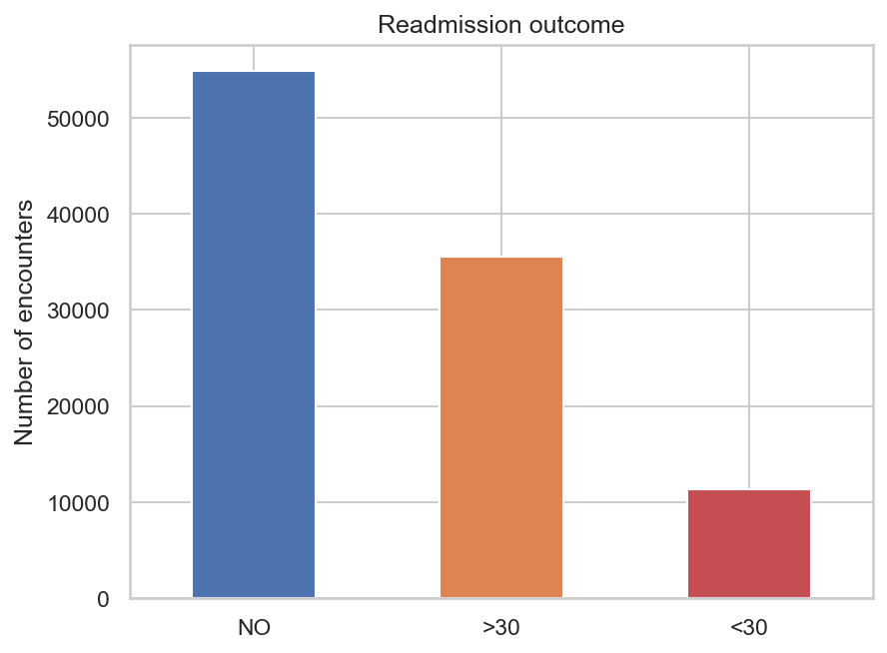
Figure 1: Distribution of the readmission outcome
[Write here: interpretation of Figure 1]
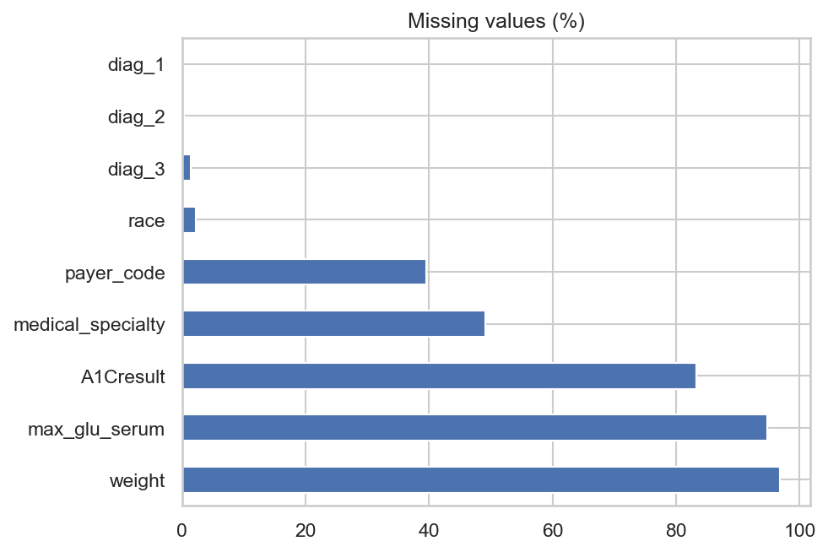
Figure 2: Percentage of missing values per attribute
[Write here: interpretation of Figure 2]
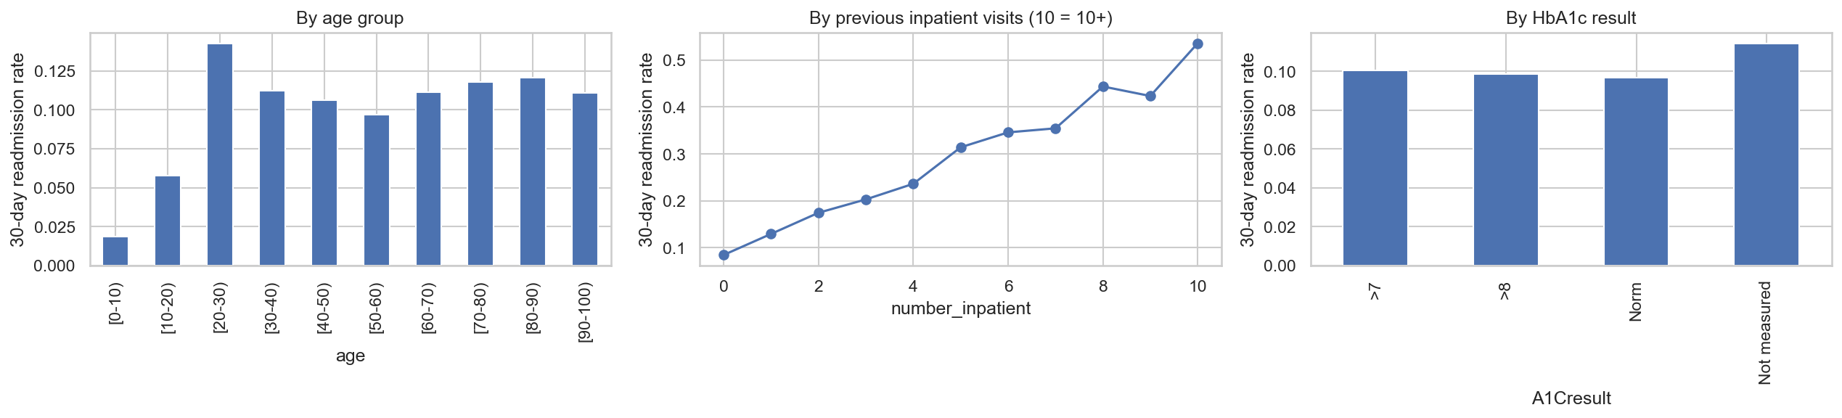
Figure 3: 30-day readmission rate by age group, prior inpatient visits and HbA1c result
[Write here: interpretation of Figure 3]
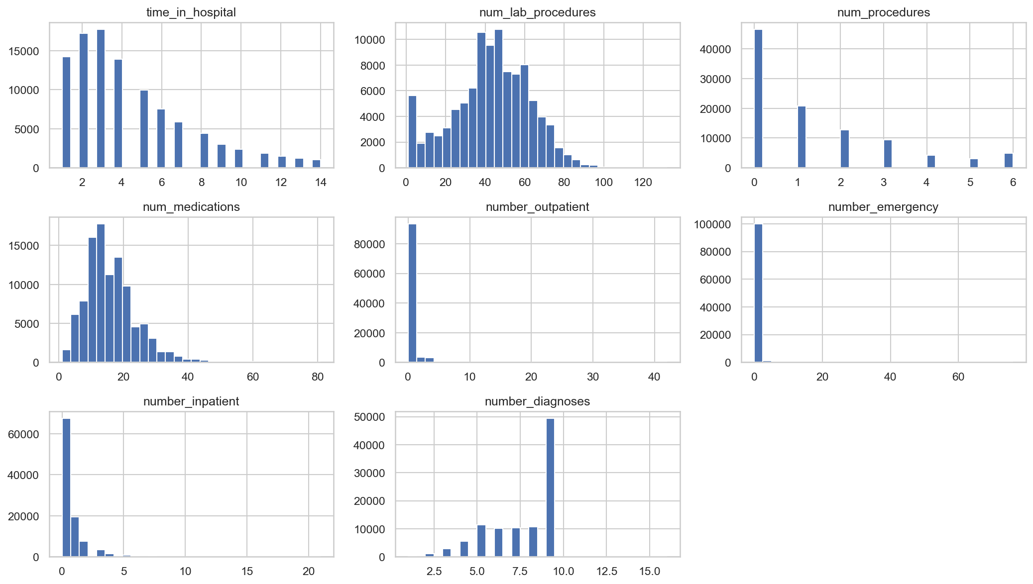
Figure 4: Distribution of the numeric attributes
[Write here: interpretation of Figure 4]
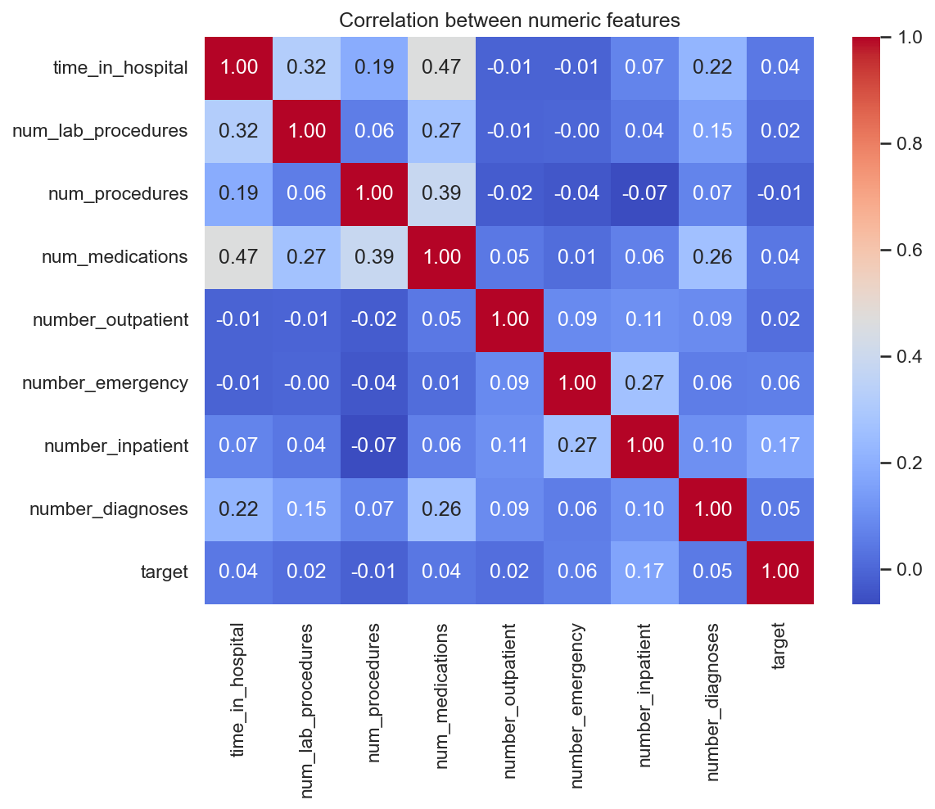
Figure 5: Correlation between numeric attributes and the target
[Write here: interpretation of Figure 5]

3. Data Preprocessing
WRITING NOTES (delete this box before submitting)
- Rubric criterion 3. For each step explain WHAT you did and WHY. The table gives the facts; expand on them in your own words.
- Mention the dimensionality reduction explicitly: ICD-9 grouping (700+ codes to 9 groups), medication summarisation (23 columns to 4), and the L1 experiment in Section 6.

Table 3: Preprocessing steps
# | Step | Reason
1 | Removed encounters with discharge codes 11, 13, 14, 19, 20, 21 (expired or hospice) | These patients cannot be readmitted
2 | Removed rows with gender = Unknown/Invalid | Invalid values
3 | Dropped encounter_id, weight, payer_code, examide, citoglipton | Identifier, >39% missing, or a single constant value
4 | race missing -> "Unknown"; medical_specialty missing -> "Missing", top 10 kept, rest -> "Other" | Keep rows; reduce 72 categories to 12
5 | max_glu_serum and A1Cresult missing -> "Not measured" | Missing means the test was not done, which is informative
6 | Grouped diag_1/2/3 ICD-9 codes into 9 clinical groups (Strack et al. [1]) | Dimensionality reduction from 700+ codes
7 | Age bands converted to midpoints (e.g. [70-80) -> 75) | Preserve order
8 | Admission type, source and discharge codes mapped to a few readable groups | Codes are categories, not quantities
9 | Medications summarised as num_med_changes and num_meds_used; insulin and metformin kept | Reduce 23 sparse columns
10 | New feature total_visits = outpatient + emergency + inpatient | Overall prior healthcare use
11 | change and diabetesMed encoded as 1/0; target = 1 if readmitted < 30 days | Binary problem
12 | Scaling and one-hot encoding inside scikit-learn pipelines (scaling for LR only) | Fitted on training folds only, avoids leakage

Table 4: Effect of preprocessing
Measure | Before | After
Rows | 101,766 | 99,340
Columns / features | 50 | 27 (14 numeric, 13 categorical)
Missing values | Present in 9 columns | 0
Positive class rate | 11.16% | 11.39%
Distinct primary diagnosis values | 716 | 10 (9 groups + Missing)

3.1 Patient-Level Train/Test Split
WRITING NOTES (delete this box before submitting)
- This is the most important methodological point. Explain the leakage problem and how GroupShuffleSplit (80/20, grouped by patient_nbr) and StratifiedGroupKFold (5 folds) solve it.
- Point out that most public notebooks on this dataset split randomly.

Table 5: Train/test split
Set | Encounters | Positive rate
Training | 79,567 | 11.40%
Test | 19,773 | 11.35%
Patients appearing in both | 0 | -

[Write here: about 200 words on leakage and the split]

4. Methodology

4.1 Logistic Regression
WRITING NOTES (delete this box before submitting)
- Background: linear combination of features passed through the sigmoid; trained by minimising log-loss; L2 (ridge) and L1 (lasso) regularisation; C = inverse regularisation strength.
- Interpretation: exp(coefficient) = odds ratio; numeric features are standardised, so odds ratios are per one standard deviation.
- class_weight="balanced" re-weights errors by inverse class frequency.
- Justification: standard baseline in clinical risk prediction, interpretable, fast. Cite [5].

[Write here: about 350 words]

4.2 Random Forest
WRITING NOTES (delete this box before submitting)
- Background: ensemble of decision trees (Breiman [3]); bootstrap sampling (bagging); random subset of features at each split; majority vote / averaged probabilities; reduces variance.
- Key hyperparameters: n_estimators, max_depth, min_samples_leaf, max_features. class_weight="balanced_subsample".
- Justification: captures non-linear effects and interactions, robust to mixed data and outliers, gives feature importance.
- Contrast with boosting in one or two sentences (viva question).

[Write here: about 350 words]

4.3 Hyperparameter Tuning
Table 6: Search spaces and selected hyperparameters
Model | Search method | Search space | Selected
Logistic Regression | GridSearchCV, 5-fold StratifiedGroupKFold, scoring = PR-AUC | C in {0.001, 0.01, 0.1, 1, 10} | C = 0.01
Random Forest | RandomizedSearchCV (15 candidates, 75 fits), same CV and scoring | n_estimators {200, 300, 500}; max_depth {10, 15, 20, None}; min_samples_leaf {1, 5, 10, 20}; max_features {sqrt, 0.3} | n_estimators = 300, min_samples_leaf = 20, max_features = 0.3, max_depth = None

[Write here: about 150 words on why PR-AUC was the tuning metric and why grouped CV was used]

4.4 Evaluation Strategy
WRITING NOTES (delete this box before submitting)
- Metrics and why: ROC-AUC (ranking), PR-AUC (focus on the rare positive class [6]), recall, precision, F1, balanced accuracy, Brier score (probability quality).
- Decision threshold chosen to maximise F1 on out-of-fold training predictions, never on the test set. LR threshold 0.528, RF threshold 0.433.
- Bootstrap (1,000 resamples) 95% confidence intervals for each AUC and for the difference [8].
- Permutation importance on 5,000 test rows for both models, so importances are comparable.

[Write here: about 250 words]

5. Implementation
WRITING NOTES (delete this box before submitting)
- Rubric criterion 5 (code quality). Describe the structure, not the code line by line; the code is in the appendix.
- Reusable functions in src/preprocessing.py; five notebooks in order; models saved with joblib; fixed random_state = 42 for reproducibility.
- scikit-learn Pipeline + ColumnTransformer so preprocessing is fitted inside each CV fold.
- Git commit history from project start (link to repository).

Table 7: Software environment
Component | Version
Python | 3.11.9
JupyterLab | 4.6.4
pandas | 2.2.3
NumPy | 2.0.2
scikit-learn | 1.5.2
matplotlib | 3.9.2
seaborn | 0.13.2
SHAP | 0.51.0
joblib | 1.4.2

Table 8: Project structure
Path | Purpose
src/preprocessing.py | Cleaning, ICD-9 grouping, threshold selection and evaluation functions
notebooks/data_desc.ipynb | Data understanding and EDA
notebooks/preprocessing.ipynb | Cleaning and patient-level split
notebooks/logistic_regression.ipynb | LR tuning, odds ratios, L1 experiment, threshold
notebooks/random_forest.ipynb | RF tuning, overfitting check, importance, SHAP, threshold
notebooks/comparison.ipynb | Test-set evaluation, curves, calibration, bootstrap, permutation importance
reports/figures/ | All figures used in this report

[Write here: about 250 words]

6. Results

6.1 Cross-Validation Results
Table 9: Cross-validation results on the training set (5-fold, grouped by patient)
Model | CV PR-AUC | Refit time (s) | OOF threshold | OOF F1
Logistic Regression | 0.2029 | 0.9 | 0.528 | 0.269
Random Forest | 0.2118 | 28.2 | 0.433 | 0.276

WRITING NOTES (delete this box before submitting)
- Compare with the random baseline PR-AUC of about 0.114 (the positive rate): both models roughly double it.

[Write here: about 120 words]

6.2 Logistic Regression
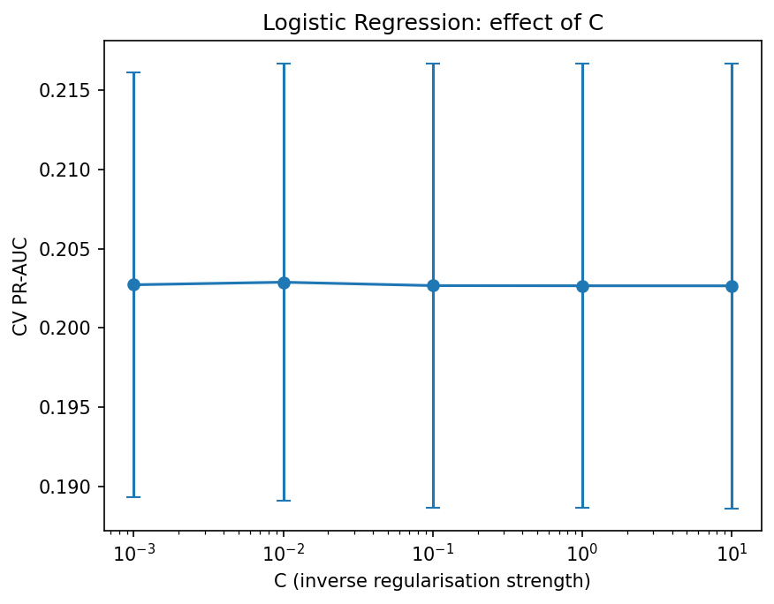
Figure 6: Effect of the regularisation parameter C on cross-validated PR-AUC
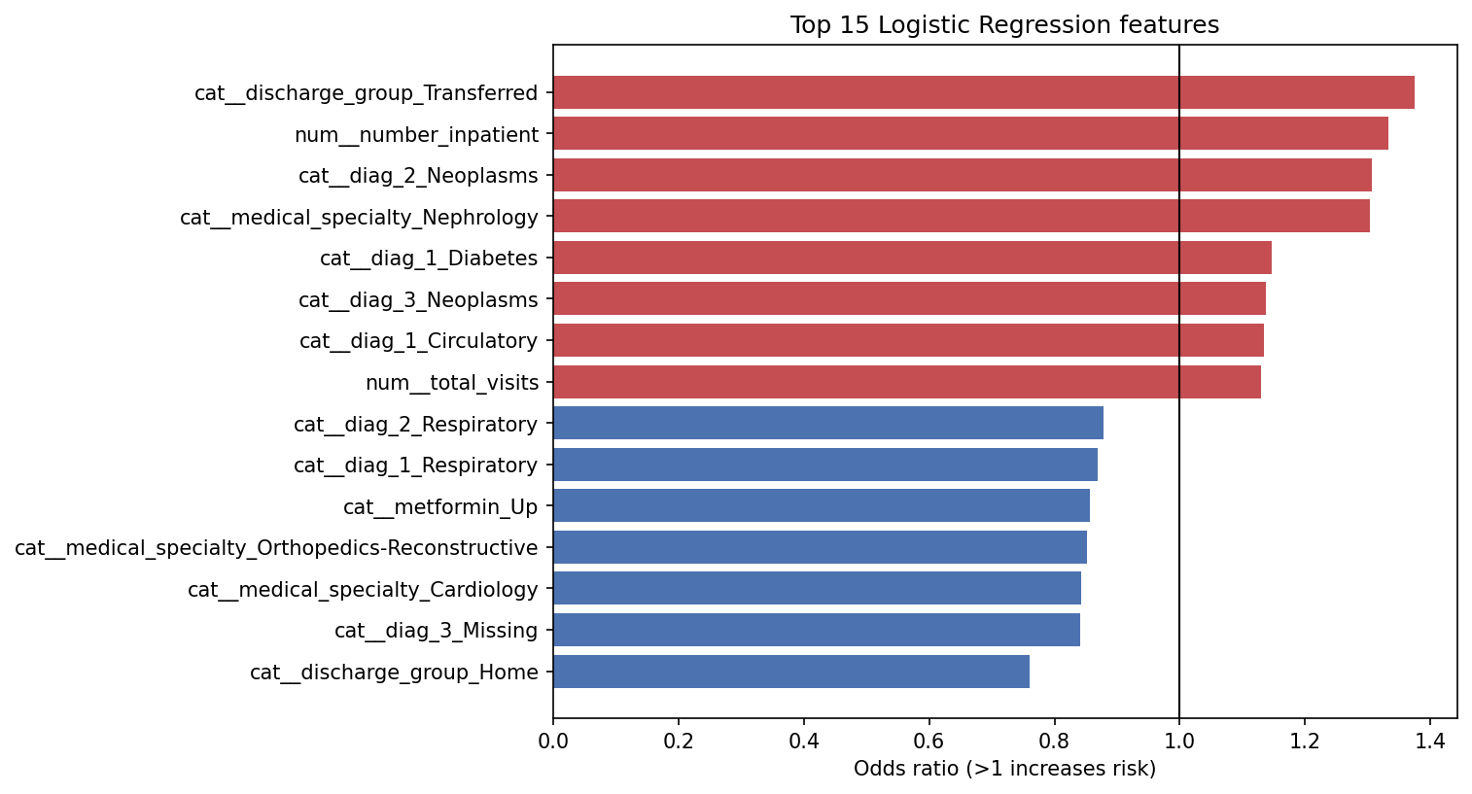
Figure 7: Fifteen largest Logistic Regression effects expressed as odds ratios
WRITING NOTES (delete this box before submitting)
- Strong regularisation (C = 0.01) was best: the model gains nothing from fitting the training data more closely.
- Odds ratios: discharge home (0.76) lowers risk; nephrology specialty (1.30), diabetes or circulatory primary diagnosis and more prior visits (total_visits 1.13 per SD) raise it. Check the full list in your notebook output.
- L1 experiment: 54 of 90 one-hot coefficients set exactly to zero, showing heavy redundancy.

[Write here: about 250 words]

6.3 Random Forest
Table 10: Top Random Forest configurations: training vs cross-validation PR-AUC
Rank | Mean train PR-AUC | Mean CV PR-AUC | Gap
1 (selected) | 0.531 | 0.212 | 0.319
3 | 0.697 | - | -
7 | 0.951 | - | -

WRITING NOTES (delete this box before submitting)
- Fill the "-" cells from the res.head(10) output in random_forest.ipynb (cell 4).
- Point: the most flexible configuration reaches 0.95 on training data with no gain in CV, which is clear overfitting; min_samples_leaf = 20 controls it.

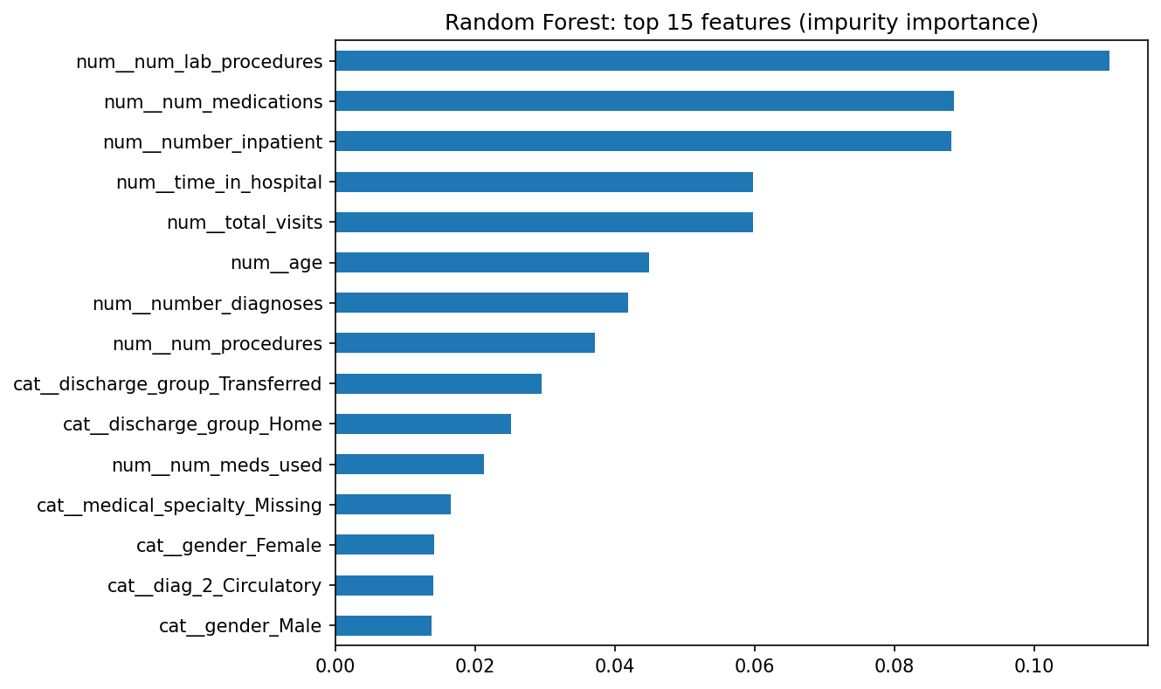
Figure 8: Random Forest impurity-based feature importance (top 15)
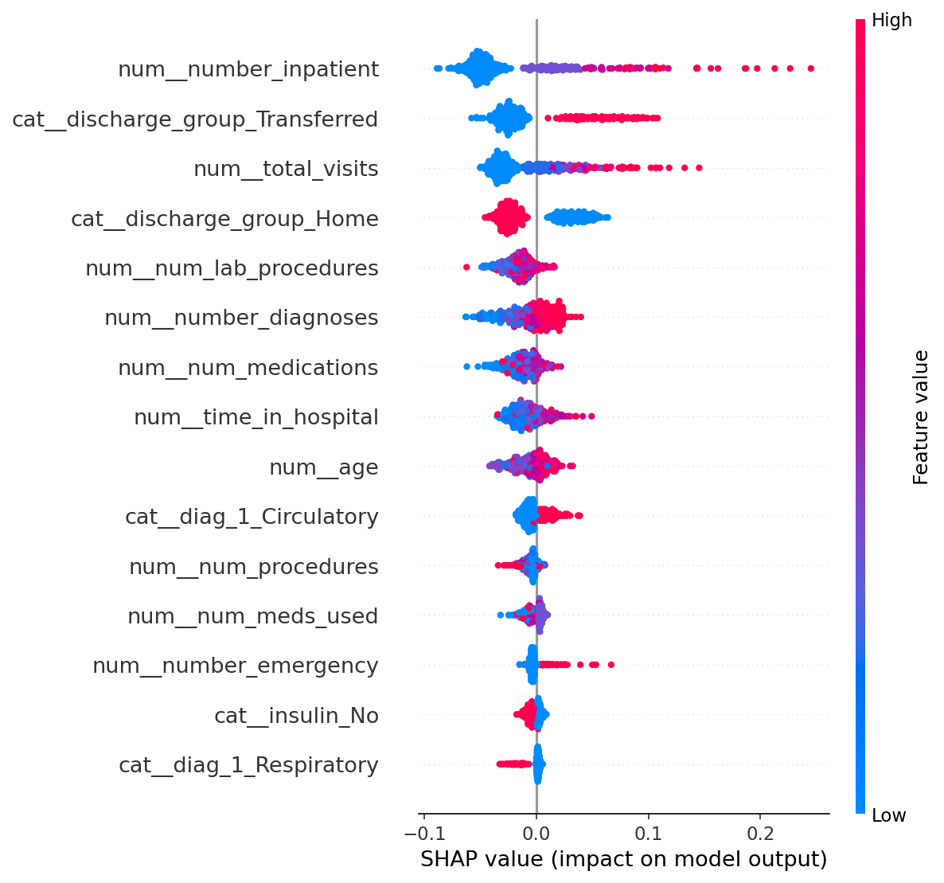
Figure 9: SHAP summary for the Random Forest (500 training samples)
[Write here: about 250 words interpreting importance and SHAP; note the bias of impurity importance toward high-cardinality numeric features]

6.4 Test-Set Comparison
Table 11: Test-set performance (19,773 encounters, thresholds chosen on training data)
Metric | Logistic Regression | Random Forest | Better
ROC-AUC | 0.6649 | 0.6710 | RF
PR-AUC | 0.2127 | 0.2278 | RF
Recall | 0.4764 | 0.5276 | RF
Precision | 0.1889 | 0.1903 | RF (marginal)
F1 | 0.2705 | 0.2797 | RF
Balanced accuracy | 0.6072 | 0.6201 | RF
Brier score (lower is better) | 0.2278 | 0.1659 | RF
Decision threshold | 0.5277 | 0.4333 | -
Training (refit) time (s) | 0.89 | 28.24 | LR

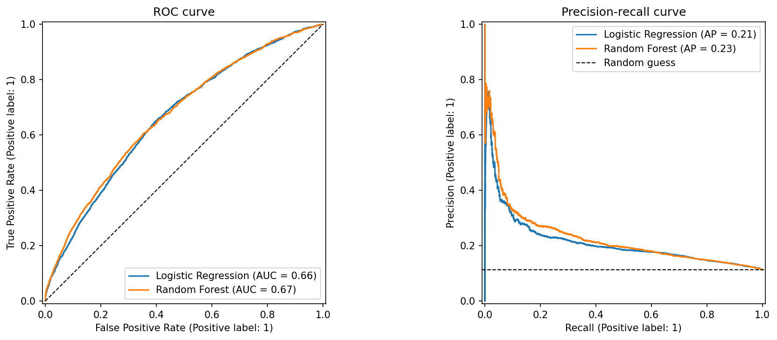
Figure 10: ROC and precision-recall curves on the test set
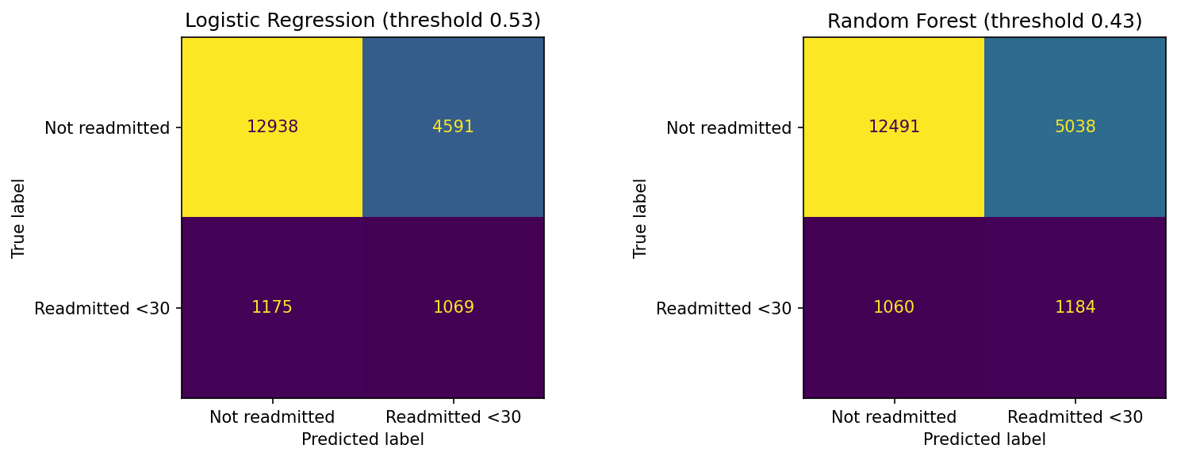
Figure 11: Confusion matrices on the test set
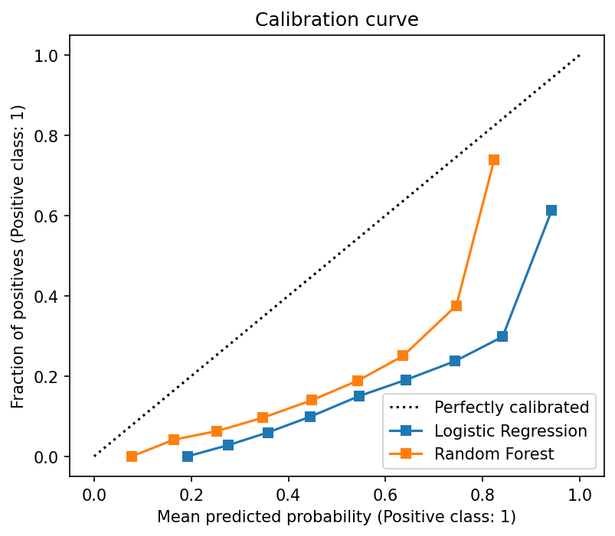
Figure 12: Calibration curves on the test set
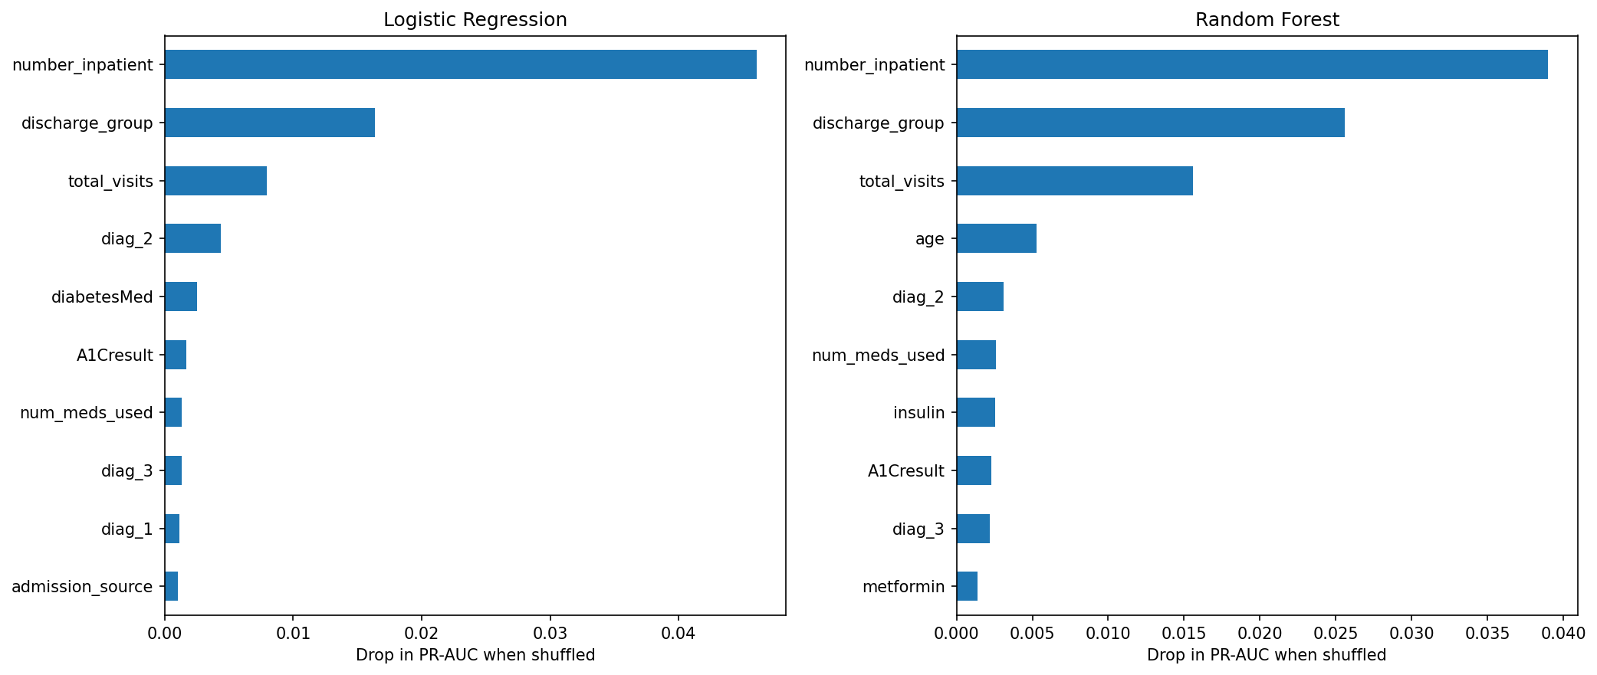
Figure 13: Permutation importance on the test set (drop in PR-AUC)
WRITING NOTES (delete this box before submitting)
- Describe each figure. Read the counts from the confusion matrices (true positives, false positives) and translate recall into patients: e.g. RF catches about 53 of every 100 readmissions.
- Calibration: both models over-estimate risk because of class weighting; LR more so (Brier 0.228 vs 0.166).
- Permutation importance: do both models rank the same features at the top? Agreement strengthens the finding.

[Write here: about 400 words]

6.5 Statistical Comparison
Table 12: Bootstrap 95% confidence intervals for ROC-AUC (1,000 resamples)
Quantity | 95% CI
Logistic Regression AUC | [0.6536, 0.6763]
Random Forest AUC | [0.6591, 0.6822]
Difference (RF - LR) | [0.0002, 0.0125]

WRITING NOTES (delete this box before submitting)
- The interval for the difference lies entirely above zero: RF is significantly better, but the effect is small (about 0.006 AUC).

[Write here: about 150 words]

7. Critical Analysis and Discussion

7.1 Comparison of the Algorithms
Table 13: Compare-and-contrast summary
Dimension | Logistic Regression | Random Forest
Discrimination (ROC-AUC / PR-AUC) | 0.665 / 0.213 | 0.671 / 0.228
Recall at chosen threshold | 47.6% | 52.8%
Probability quality (Brier) | 0.228 (poorly calibrated) | 0.166
Interpretability | High: odds ratios | Lower: needs SHAP / permutation importance
Training time | 0.9 s | 28.2 s (about 32x slower)
Tuning effort | 1 hyperparameter | 4 hyperparameters, 75 fits
Overfitting risk | Low (strong regularisation chosen) | High without leaf-size limits

WRITING NOTES (delete this box before submitting)
- Answer RQ2: RF is statistically better but by a small margin. Discuss whether that is worth the loss of interpretability and speed in a clinical setting.
- Explain why the gap is small: the useful signal is mostly in a few strong features (prior inpatient visits, discharge destination), which a linear model already captures.

[Write here: about 350 words]

7.2 Why Performance Plateaus
WRITING NOTES (delete this box before submitting)
- Both models stop around AUC 0.67, consistent with published work on this dataset [10].
- Missing information: no lab values over time, no social and economic factors, no post-discharge care data; readmission is partly random.

[Write here: about 200 words]

7.3 Limitations
WRITING NOTES (delete this box before submitting)
- Data from 1999-2008, US only: may not generalise to current or Sri Lankan settings.
- ICD-9 grouping loses detail; heavy missingness in weight and lab tests.
- Single hold-out test set; no external validation.
- Class weighting distorts probabilities; threshold optimised for F1, not for real clinical costs.

[Write here: about 200 words]

7.4 How Accuracy Could Be Improved and Future Work
WRITING NOTES (delete this box before submitting)
- Probability calibration (CalibratedClassifierCV, isotonic or Platt) [11].
- Cost-sensitive threshold based on the cost of a missed readmission vs a follow-up call.
- Richer features: patient history across encounters, finer diagnosis groups, interaction terms for LR.
- Other classical algorithms: gradient boosting (XGBoost, LightGBM), stacking ensembles.
- External validation on newer or local hospital data; fairness analysis across race, gender and age groups.

[Write here: about 300 words]

8. Conclusion
WRITING NOTES (delete this box before submitting)
- Answer RQ1 to RQ3 directly in about 200 words. No new information.

[Write here: conclusion]

9. Individual Contribution
WRITING NOTES (delete this box before submitting)
- State that you completed all parts (data analysis, preprocessing, both models, evaluation, report, video) and that the lecturer approved a solo submission (quote the date of approval).
- Refer to the Git commit history as evidence.

[Write here: contribution statement]

References
WRITING NOTES (delete this box before submitting)
- Check every reference yourself (authors, year, pages, URL) and add any further sources you cite. Keep the IEEE style consistent.

[1] B. Strack, J. P. DeShazo, C. Gennings, J. L. Olmo, S. Ventura, K. J. Cios and J. N. Clore, "Impact of HbA1c measurement on hospital readmission rates: Analysis of 70,000 clinical database patient records," BioMed Research International, vol. 2014, Art. no. 781670, 2014.
[2] J. Clore, K. Cios, J. DeShazo and B. Strack, "Diabetes 130-US Hospitals for Years 1999-2008," UCI Machine Learning Repository, 2014. [Online]. Available: https://archive.ics.uci.edu/dataset/296/diabetes+130-us+hospitals+for+years+1999-2008
[3] L. Breiman, "Random forests," Machine Learning, vol. 45, no. 1, pp. 5-32, 2001.
[4] F. Pedregosa et al., "Scikit-learn: Machine learning in Python," Journal of Machine Learning Research, vol. 12, pp. 2825-2830, 2011.
[5] D. W. Hosmer, S. Lemeshow and R. X. Sturdivant, Applied Logistic Regression, 3rd ed. Hoboken, NJ, USA: Wiley, 2013.
[6] T. Saito and M. Rehmsmeier, "The precision-recall plot is more informative than the ROC plot when evaluating binary classifiers on imbalanced datasets," PLoS ONE, vol. 10, no. 3, Art. no. e0118432, 2015.
[7] S. M. Lundberg and S.-I. Lee, "A unified approach to interpreting model predictions," in Advances in Neural Information Processing Systems 30, 2017.
[8] B. Efron and R. J. Tibshirani, An Introduction to the Bootstrap. New York, NY, USA: Chapman & Hall, 1993.
[9] Centers for Medicare & Medicaid Services, "Hospital Readmissions Reduction Program (HRRP)." [Online]. Available: https://www.cms.gov [add the exact page URL and access date]
[10] D. Kansagara et al., "Risk prediction models for hospital readmission: A systematic review," JAMA, vol. 306, no. 15, pp. 1688-1698, 2011.
[11] A. Niculescu-Mizil and R. Caruana, "Predicting good probabilities with supervised learning," in Proc. 22nd Int. Conf. Machine Learning (ICML), 2005, pp. 625-632.

Appendix A: Source Code
The complete source code is reproduced below as text. It is also available in the GitHub repository: https://github.com/Shadhani-Rushanthi/FML-Assignment
WRITING NOTES (delete this box before submitting)
- Generated from your notebooks on the date this template was built. If you change any code, regenerate or update this appendix so it matches the repository.

A.1 src/preprocessing.py
import re
import numpy as np
import pandas as pd
from sklearn.metrics import (
average_precision_score, balanced_accuracy_score, brier_score_loss,
f1_score, precision_recall_curve, precision_score, recall_score,
roc_auc_score,
)

EXPIRED_OR_HOSPICE = [11, 13, 14, 19, 20, 21]

# The 23 diabetes medication columns in the dataset
MEDICATIONS = [
'metformin', 'repaglinide', 'nateglinide', 'chlorpropamide', 'glimepiride',
'acetohexamide', 'glipizide', 'glyburide', 'tolbutamide', 'pioglitazone',
'rosiglitazone', 'acarbose', 'miglitol', 'troglitazone', 'tolazamide',
'examide', 'citoglipton', 'insulin', 'glyburide-metformin',
'glipizide-metformin', 'glimepiride-pioglitazone',
'metformin-rosiglitazone', 'metformin-pioglitazone',
]

def load_raw(path):
"""Read the raw CSV. '?' is how this dataset marks missing values.
Diagnosis codes are read as text because some start with V or E."""
diag_types = {'diag_1': str, 'diag_2': str, 'diag_3': str}
return pd.read_csv(path, na_values='?', dtype=diag_types, low_memory=False)

def group_icd9(code):
if pd.isna(code):
return 'Missing'
code = str(code)
if code.startswith(('V', 'E')):
return 'Other'
c = float(code)
if 390 <= c <= 459 or c == 785:
return 'Circulatory'
if 460 <= c <= 519 or c == 786:
return 'Respiratory'
if 520 <= c <= 579 or c == 787:
return 'Digestive'
if int(c) == 250:
return 'Diabetes'
if 800 <= c <= 999:
return 'Injury'
if 710 <= c <= 739:
return 'Musculoskeletal'
if 580 <= c <= 629 or c == 788:
return 'Genitourinary'
if 140 <= c <= 239:
return 'Neoplasms'
return 'Other'

def age_to_midpoint(age_band):
low, high = re.findall(r'\d+', age_band)
return (int(low) + int(high)) / 2

# The ID columns are codes, not quantities. These groupings follow IDS_mapping.csv.
def map_admission_type(x):
if x in (1, 2, 7): # emergency, urgent, trauma centre
return 'Emergency/Urgent'
if x == 3:
return 'Elective'
return 'Other/Unknown'

def map_admission_source(x):
if x == 7:
return 'Emergency Room'
if x in (1, 2, 3): # physician, clinic, HMO referral
return 'Referral'
if x in (4, 5, 6, 10, 18, 19, 22, 25, 26):
return 'Transfer'
return 'Other/Unknown'

def map_discharge(x):
if x == 1:
return 'Home'
if x in (6, 8): # home with health service / home IV
return 'Home with care'
if x in (2, 3, 4, 5, 10, 15, 22, 23, 24, 27, 28, 29, 30):
return 'Transferred'
return 'Other/Unknown'

def clean_data(df, top_n_specialties=10):
"""Run every cleaning step and return (X, y, groups).
groups = patient_nbr, used only for splitting, never as a feature."""
df = df.copy()

df = df[~df['discharge_disposition_id'].isin(EXPIRED_OR_HOSPICE)]

df = df[df['gender'] != 'Unknown/Invalid']

# 3. Drop the ID column, columns with mostly missing data, and two
# medications that have the same value for every patient
df = df.drop(columns=['encounter_id', 'weight', 'payer_code',
'examide', 'citoglipton'])

# 4. Fill the remaining missing categories
df['race'] = df['race'].fillna('Unknown')
df['medical_specialty'] = df['medical_specialty'].fillna('Missing')
top = df['medical_specialty'].value_counts().nlargest(top_n_specialties).index
df['medical_specialty'] = df['medical_specialty'].where(
df['medical_specialty'].isin(top), 'Other')

# 5. Lab results: missing here means the test wasn't done
df['max_glu_serum'] = df['max_glu_serum'].fillna('Not measured')
df['A1Cresult'] = df['A1Cresult'].fillna('Not measured')

# 6. Collapse 700+ ICD-9 codes into 9 clinical groups
for col in ['diag_1', 'diag_2', 'diag_3']:
df[col] = df[col].apply(group_icd9)

# 7. Age bands -> numbers, ID codes -> readable groups
df['age'] = df['age'].apply(age_to_midpoint)
df['admission_type'] = df.pop('admission_type_id').apply(map_admission_type)
df['admission_source'] = df.pop('admission_source_id').apply(map_admission_source)
df['discharge_group'] = df.pop('discharge_disposition_id').apply(map_discharge)

# 8. Summarise the medication columns, keeping only the two most common ones
meds = [m for m in MEDICATIONS if m in df.columns]
df['num_med_changes'] = df[meds].isin(['Up', 'Down']).sum(axis=1)
df['num_meds_used'] = (df[meds] != 'No').sum(axis=1)
df = df.drop(columns=[m for m in meds if m not in ('insulin', 'metformin')])

# 9. Healthcare use in the year before this stay
df['total_visits'] = (df['number_outpatient'] + df['number_emergency']
+ df['number_inpatient'])

# 10. Yes/No columns -> 1/0
df['change'] = (df['change'] == 'Ch').astype(int)
df['diabetesMed'] = (df['diabetesMed'] == 'Yes').astype(int)

# 11. Target: readmitted within 30 days = 1, everything else = 0
y = (df.pop('readmitted') == '<30').astype(int)
groups = df.pop('patient_nbr')

return (df.reset_index(drop=True), y.reset_index(drop=True),
groups.reset_index(drop=True))

def split_columns(X):
num_cols = X.select_dtypes(include='number').columns.tolist()
cat_cols = [c for c in X.columns if c not in num_cols]
return num_cols, cat_cols

def best_f1_threshold(y_true, proba):
precision, recall, thresholds = precision_recall_curve(y_true, proba)
f1 = 2 * precision * recall / (precision + recall + 1e-12)
best = np.argmax(f1[:-1]) # the last point has no matching threshold
return thresholds[best], f1[best]

def evaluate(y_true, proba, threshold):
pred = (proba >= threshold).astype(int)
return {
'ROC-AUC': roc_auc_score(y_true, proba),
'PR-AUC': average_precision_score(y_true, proba),
'Recall': recall_score(y_true, pred),
'Precision': precision_score(y_true, pred, zero_division=0),
'F1': f1_score(y_true, pred),
'Balanced accuracy': balanced_accuracy_score(y_true, pred),
'Brier score': brier_score_loss(y_true, proba),
'Threshold': threshold,
}

A.2 notebooks/data_desc.ipynb (data understanding)
# ---------- Cell 1 ----------
# Problem:
# Predicting the readmission of diabetic patients within 30-day after discharged, and how does a simple, interpretable model (Logistic Regression) compare with a more complex ensemble model (Random Forest)?

# This file will read the diabetic patients dataset and preprocess the data to create the model.

# ---------- Cell 2 ----------
import sys
import pandas as pd
import numpy as np
import matplotlib.pyplot as plt
import seaborn as sns

from src.preprocessing import load_raw

sys.path.append('..')
pd.set_option('display.max_columns', None)
sns.set_theme(style='whitegrid')
FIG = '../reports/figures/'

# ---------- Cell 3 ----------
df = load_raw('../Data/diabetic_data.csv')
print(df.shape)
df.head()

# ---------- Cell 4 ----------
summary = pd.DataFrame({
'dtype': df.dtypes.astype(str),
'unique_values': df.nunique(),
'missing_%': (df.isna().mean() * 100).round(2),
'example': df.iloc[0]
})
summary.to_csv(FIG+'attribute_summary.csv')
summary

# ---------- Cell 5 ----------
counts = df['readmitted'].value_counts()
print((counts/len(df)*100).round(2))

ax = counts.plot(kind='bar', color=['#4c72b0', '#dd8452', '#c44e52'])
ax.set_title('Readmission outcome')
ax.set_xlabel('')
ax.set_ylabel('Number of encounters')
plt.xticks(rotation=0)
plt.savefig(FIG +'01_target.png', dpi=150, bbox_inches='tight')
plt.show()

# ---------- Cell 6 ----------
# As the classes are imbalanced, so accuracy would be misleading.
# Only about [11.2]% of encounters ended in a readmission within 30 days, while [53.9]% were never readmitted and [34.9]% came back
# after 30 days. Since I'm treating this as "readmitted within 30 days or not", the class is small. Accuracy alone would be misleading here, so I'll focus on
# PR-AUC, recall and F1 when evaluating the models.

# ---------- Cell 7 ----------
missing = df.isna().mean().mul(100).sort_values(ascending=False)
missing = missing[missing > 0]

missing.plot(kind='barh')
plt.title('Missing values (%)')
plt.savefig(FIG + '01_missing.png', dpi=150, bbox_inches='tight')
plt.show()
missing

# ---------- Cell 8 ----------
# Some columns values are mostly missing
# `weight` is missing for about [97]% of encounters, so it can't be used. `payer_code` ([40]%) and `medical_specialty` ([49]%)
# also have a lot of gaps. I'll drop the first two and keep `medical_specialty`, treating "missing" as its own category, because whether a specialty was recorded
# may itself carry some information.

# ---------- Cell 9 ----------
visits = df['patient_nbr'].value_counts()
print('Unique patients:', visits.size)
print('Patients with more than one encounter:', (visits > 1).sum())
print('Share of rows from repeat patients: {:.1%}'.format((df['patient_nbr'].map(visits) > 1).mean()))

# ---------- Cell 10 ----------
# Many patients appear more than once.
# There are [101,766] encounters but only
# [71,518] unique patients, and about [X]% of rows belong to patients with several
# stays. If I split the data randomly, the same person could end up in both training
# and testing, which would make the results look better than they really are. To avoid
# this, I'll split the data by patient.

# ---------- Cell 11 ----------
df['target'] = (df['readmitted'] == '<30').astype(int)

fig, axes = plt.subplots(1, 3, figsize=(17, 4))
df.groupby('age')['target'].mean().plot(kind='bar', ax=axes[0], title='By age group')
df.groupby(df['number_inpatient'].clip(upper=10))['target'].mean().plot(
marker='o', ax=axes[1], title='By previous inpatient visits (10 = 10+)')
df.groupby(df['A1Cresult'].fillna('Not measured'))['target'].mean().plot(
kind='bar', ax=axes[2], title='By HbA1c result')
for ax in axes:
ax.set_ylabel('30-day readmission rate')
plt.tight_layout()
plt.savefig(FIG + '01_rates.png', dpi=150, bbox_inches='tight')
plt.show()

# ---------- Cell 12 ----------
# Previous hospital stays are the clearest warning sign.
# The readmission rate rises steadily with the number of inpatient visits in the year before: from about [8]% for
# patients with none to over [X]% for those with [5] or more. Age has a much weaker effect, and the HbA1c result shows only small differences between groups.

# ---------- Cell 13 ----------
num_cols = ['time_in_hospital', 'num_lab_procedures', 'num_procedures', 'num_medications', 'number_outpatient', 'number_emergency', 'number_inpatient', 'number_diagnoses']
df[num_cols].hist(bins=30, figsize=(14,8))
plt.tight_layout()
plt.savefig(FIG + '01_hist.png', dpi=150, bbox_inches='tight')
plt.show()

plt.figure(figsize=(8,6))
sns.heatmap(df[num_cols + ['target']].corr(), annot=True, fmt='.2f', cmap='coolwarm')
plt.title('Correlation between numeric features')
plt.savefig(FIG + '01_corr.png', dpi=150, bbox_inches='tight')
plt.show()

# ---------- Cell 14 ----------
# No single numeric feature explains readmission.
# Every correlation with the target is weak (the highest is about [0.17], for `number_inpatient`). On its own, no variable
# is a strong predictor. Readmission seems to depend on several factors together, which is exactly why a machine learning model is needed rather than a simple rule.

# Several features are skewed and need preparing.
# Columns such as `number_outpatient`, `number_emergency` and `number_inpatient` are mostly zero with a long tail.
# The diagnosis columns contain hundreds of different ICD-9 codes, which is far too many to use directly. In the next notebook I'll group the diagnoses into
# broader categories and scale the numeric features for Logistic Regression.

A.3 notebooks/preprocessing.ipynb
# ---------- Cell 1 ----------
import sys
sys.path.append('..')

import pandas as pd
import joblib
from sklearn.model_selection import GroupShuffleSplit

from src.preprocessing import load_raw, clean_data, split_columns

# ---------- Cell 2 ----------
raw = load_raw('../Data/diabetic_data.csv')
X, y, groups = clean_data(raw)

print('Rows before: ', len(raw), ' | after: ', len(X))
print('Columns before:', raw.shape[1], ' | feature after: ', X.shape[1])
print('Positive class rate: {: .2%}'.format(y.mean()))

# ---------- Cell 3 ----------
X['diag_1'].value_counts()

# ---------- Cell 4 ----------
print('Missing values left:', X.isna().sum().sum())
num_cols, cat_cols = split_columns(X)
print('Numeric:', num_cols)
print('Categorical:', cat_cols)

# ---------- Cell 5 ----------
gss = GroupShuffleSplit(n_splits=1, test_size=0.2, random_state=42)
train_idx, test_idx = next(gss.split(X, y, groups=groups))

X_train, X_test = X.iloc[train_idx].reset_index(drop=True), X.iloc[test_idx].reset_index(drop=True)
y_train, y_test = y.iloc[train_idx].reset_index(drop=True), y.iloc[test_idx].reset_index(drop=True)
g_train, g_test = groups.iloc[train_idx].reset_index(drop=True), groups.iloc[test_idx].reset_index(drop=True)

overlap = set(g_train) & set(g_test)
print('Train:', X_train.shape, '| Test:', X_test.shape)
print('Patients in both sets:', len(overlap))
print('Positive rate train {:.2%} | test {:.2%}'.format(y_train.mean(), y_test.mean()))

# ---------- Cell 6 ----------
joblib.dump({
'X_train': X_train, 'X_test': X_test,
'y_train': y_train, 'y_test': y_test,
'g_train': g_train, 'g_test': g_test,
}, '../data/processed/split.joblib')
print('Saved.')

A.4 notebooks/logistic_regression.ipynb
# ---------- Cell 1 ----------
import sys
sys.path.append('..')

import numpy as np
import pandas as pd
import matplotlib.pyplot as plt
import joblib
from sklearn.base import clone
from sklearn.compose import ColumnTransformer
from sklearn.linear_model import LogisticRegression
from sklearn.model_selection import GridSearchCV, StratifiedGroupKFold, cross_val_predict
from sklearn.pipeline import Pipeline
from sklearn.preprocessing import OneHotEncoder, StandardScaler

from src.preprocessing import split_columns, best_f1_threshold

d = joblib.load('../data/processed/split.joblib')
X_train, y_train, g_train = d['X_train'], d['y_train'], d['g_train']
num_cols, cat_cols = split_columns(X_train)
FIG = '../reports/figures/'

# ---------- Cell 2 ----------
preprocess = ColumnTransformer([
('num', StandardScaler(), num_cols),
('cat', OneHotEncoder(handle_unknown='ignore'), cat_cols),
])

lr_pipe = Pipeline([
('pre', preprocess),
('clf', LogisticRegression(class_weight='balanced', max_iter=3000)),
])

# ---------- Cell 3 ----------
cv = StratifiedGroupKFold(n_splits=5, shuffle=True, random_state=42)
param_grid = {'clf__C': [0.001, 0.01, 0.1, 1, 10]}

lr_search = GridSearchCV(lr_pipe, param_grid, cv=cv, scoring='average_precision', n_jobs=-1)
lr_search.fit(X_train, y_train, groups=g_train)

print('Best C:', lr_search.best_params_)
print('Best CV PR-AUC: {:.4f}'.format(lr_search.best_score_))
print('Refit time: {:.1f}s'.format(lr_search.refit_time_))

# ---------- Cell 4 ----------
res = pd.DataFrame(lr_search.cv_results_)
plt.errorbar(res['param_clf__C'].astype(float), res['mean_test_score'],yerr=res['std_test_score'], marker='o', capsize=4)
plt.xscale('log')
plt.xlabel('C (inverse regularisation strength)')
plt.ylabel('CV PR-AUC')
plt.title('Logistic Regression: effect of C')
plt.savefig(FIG + '03_lr_C.png', dpi=150, bbox_inches='tight')
plt.show()

# ---------- Cell 5 ----------
best_lr = lr_search.best_estimator_
names = best_lr.named_steps['pre'].get_feature_names_out()
coefs = best_lr.named_steps['clf'].coef_[0]

odds = pd.DataFrame({'feature': names, 'odds_ratio': np.exp(coefs)})
odds['effect'] = np.abs(np.log(odds['odds_ratio']))
top = odds.sort_values('effect', ascending=False).head(15).sort_values('odds_ratio')

plt.figure(figsize=(8, 6))
plt.barh(top['feature'], top['odds_ratio'],
color=np.where(top['odds_ratio'] > 1, '#c44e52', '#4c72b0'))
plt.axvline(1, color='black', linewidth=1)
plt.xlabel('Odds ratio (>1 increases risk)')
plt.title('Top 15 Logistic Regression features')
plt.savefig(FIG + '03_lr_odds.png', dpi=150, bbox_inches='tight')
plt.show()
top[['feature', 'odds_ratio']]

# ---------- Cell 6 ----------
l1_model = clone(best_lr).set_params(clf__penalty='l1', clf__solver='saga', clf__max_iter=2000)
l1_model.fit(X_train, y_train)
zero = (l1_model.named_steps['clf'].coef_[0] == 0).sum()
print(f'L1 set {zero} of {len(names)} coefficients exactly to zero')

# ---------- Cell 7 ----------
oof_lr = cross_val_predict(best_lr, X_train, y_train, groups=g_train, cv=cv, method='predict_proba', n_jobs=-1)[:, 1]
lr_threshold, lr_f1 = best_f1_threshold(y_train, oof_lr)
print(f'Chosen threshold: {lr_threshold:.3f} (OOF F1 = {lr_f1:.3f})')

# ---------- Cell 8 ----------
joblib.dump({'model': best_lr, 'threshold': lr_threshold,
'refit_time': lr_search.refit_time_}, '../models/linearReg.joblib')

A.5 notebooks/random_forest.ipynb
# ---------- Cell 1 ----------
import sys
sys.path.append('..')

import numpy as np
import pandas as pd
import matplotlib.pyplot as plt
import joblib
from sklearn.compose import ColumnTransformer
from sklearn.ensemble import RandomForestClassifier
from sklearn.model_selection import RandomizedSearchCV, StratifiedGroupKFold, cross_val_predict
from sklearn.pipeline import Pipeline
from sklearn.preprocessing import OneHotEncoder
import warnings
warnings.filterwarnings('ignore', category=RuntimeWarning, module='numpy')
from src.preprocessing import split_columns, best_f1_threshold

d = joblib.load('../Data/processed/split.joblib')
X_train, y_train, g_train = d['X_train'], d['y_train'], d['g_train']
num_cols, cat_cols = split_columns(X_train)
FIG = '../reports/figures/'
print('done')

# ---------- Cell 2 ----------
preprocess_rf = ColumnTransformer([
('num', 'passthrough', num_cols),
('cat', OneHotEncoder(handle_unknown='ignore'), cat_cols),
])

rf_pipe = Pipeline([
('pre', preprocess_rf),
('clf', RandomForestClassifier(class_weight='balanced_subsample', random_state=42, n_jobs=-1)),
])

# ---------- Cell 3 ----------
cv = StratifiedGroupKFold(n_splits=5, shuffle=True, random_state=42)
param_dist = {
'clf__n_estimators': [200, 300, 500],
'clf__max_depth': [10, 15, 20, None],
'clf__min_samples_leaf': [1, 5, 10, 20],
'clf__max_features': ['sqrt', 0.3],
}

rf_search = RandomizedSearchCV(rf_pipe, param_dist, n_iter=15, cv=cv, scoring='average_precision', n_jobs=-1, random_state=42, return_train_score=True, verbose=2)
rf_search.fit(X_train, y_train, groups=g_train)

print('Best params:', rf_search.best_params_)
print('Best CV PR-AUC: {:.4f}'.format(rf_search.best_score_))
print('Refit time: {:.1f}s'.format(rf_search.refit_time_))

# ---------- Cell 4 ----------
res = pd.DataFrame(rf_search.cv_results_)
res = res[['params', 'mean_train_score', 'mean_test_score']].sort_values(
'mean_test_score', ascending=False)
res['gap'] = res['mean_train_score'] - res['mean_test_score']
res.head(10)

# ---------- Cell 5 ----------
best_rf = rf_search.best_estimator_
names = best_rf.named_steps['pre'].get_feature_names_out()
imp = pd.Series(best_rf.named_steps['clf'].feature_importances_, index=names)
imp.sort_values().tail(15).plot(kind='barh', figsize=(8, 6))
plt.title('Random Forest: top 15 features (impurity importance)')
plt.savefig(FIG + '04_rf_importance.png', dpi=150, bbox_inches='tight')
plt.show()

# ---------- Cell 6 ----------
import shap

pre = best_rf.named_steps['pre']
sample = X_train.sample(500, random_state=42)
Xs = pre.transform(sample)
if hasattr(Xs, 'toarray'):
Xs = Xs.toarray()

explainer = shap.TreeExplainer(best_rf.named_steps['clf'])
sv = explainer.shap_values(Xs)
# different shap versions return different shapes for binary models
if isinstance(sv, list):
sv = sv[1]
elif sv.ndim == 3:
sv = sv[:, :, 1]

shap.summary_plot(sv, Xs, feature_names=names, max_display=15, show=False)
plt.savefig(FIG + '04_rf_shap.png', dpi=150, bbox_inches='tight')
plt.show()

# ---------- Cell 7 ----------
oof_rf = cross_val_predict(best_rf, X_train, y_train, groups=g_train,
cv=cv, method='predict_proba')[:, 1]
rf_threshold, rf_f1 = best_f1_threshold(y_train, oof_rf)
print(f'Chosen threshold: {rf_threshold:.3f} (OOF F1 = {rf_f1:.3f})')

# ---------- Cell 8 ----------
joblib.dump({'model': best_rf, 'threshold': rf_threshold, 'refit_time': rf_search.refit_time_}, '../models/randomforest.joblib')

A.6 notebooks/comparison.ipynb
# ---------- Cell 1 ----------
import sys
sys.path.append('..')

import numpy as np
import pandas as pd
import matplotlib.pyplot as plt
import joblib
from sklearn.calibration import CalibrationDisplay
from sklearn.inspection import permutation_importance
from sklearn.metrics import (ConfusionMatrixDisplay, PrecisionRecallDisplay,
RocCurveDisplay, roc_auc_score)

from src.preprocessing import evaluate

d = joblib.load('../Data/processed/split.joblib')
X_test, y_test = d['X_test'], d['y_test']
lr = joblib.load('../models/linearReg.joblib')
rf = joblib.load('../models/randomforest.joblib')
FIG = '../reports/figures/'

p_lr = lr['model'].predict_proba(X_test)[:, 1]
p_rf = rf['model'].predict_proba(X_test)[:, 1]
print('done')

# ---------- Cell 2 ----------
results = pd.DataFrame({
'Logistic Regression': evaluate(y_test, p_lr, lr['threshold']),
'Random Forest': evaluate(y_test, p_rf, rf['threshold']),
}).T
results['Training time (s)'] = [lr['refit_time'], rf['refit_time']]
results.round(4)

# ---------- Cell 3 ----------
fig, axes = plt.subplots(1, 2, figsize=(13, 5))
RocCurveDisplay.from_predictions(y_test, p_lr, name='Logistic Regression', ax=axes[0])
RocCurveDisplay.from_predictions(y_test, p_rf, name='Random Forest', ax=axes[0])
axes[0].plot([0, 1], [0, 1], 'k--', linewidth=1)
axes[0].set_title('ROC curve')

PrecisionRecallDisplay.from_predictions(y_test, p_lr, name='Logistic Regression', ax=axes[1])
PrecisionRecallDisplay.from_predictions(y_test, p_rf, name='Random Forest', ax=axes[1])
axes[1].axhline(y_test.mean(), color='k', linestyle='--', linewidth=1, label='Random guess')
axes[1].legend()
axes[1].set_title('Precision-recall curve')
plt.tight_layout()
plt.savefig(FIG + '05_roc_pr.png', dpi=150, bbox_inches='tight')
plt.show()

# ---------- Cell 4 ----------
fig, axes = plt.subplots(1, 2, figsize=(11, 4))
for ax, (name, p, t) in zip(axes, [('Logistic Regression', p_lr, lr['threshold']),
('Random Forest', p_rf, rf['threshold'])]):
ConfusionMatrixDisplay.from_predictions(
y_test, (p >= t).astype(int), ax=ax, colorbar=False,
display_labels=['Not readmitted', 'Readmitted <30'])
ax.set_title(f'{name} (threshold {t:.2f})')
plt.tight_layout()
plt.savefig(FIG + '05_confusion.png', dpi=150, bbox_inches='tight')
plt.show()

# ---------- Cell 5 ----------
fig, ax = plt.subplots(figsize=(6, 5))
CalibrationDisplay.from_predictions(y_test, p_lr, n_bins=10, name='Logistic Regression', ax=ax)
CalibrationDisplay.from_predictions(y_test, p_rf, n_bins=10, name='Random Forest', ax=ax)
ax.set_title('Calibration curve')
plt.savefig(FIG + '05_calibration.png', dpi=150, bbox_inches='tight')
plt.show()

# ---------- Cell 6 ----------
rng = np.random.default_rng(42)
y_arr = y_test.to_numpy()
n = len(y_arr)
auc_lr, auc_rf, diff = [], [], []

for _ in range(1000):
idx = rng.integers(0, n, n)
if y_arr[idx].sum() == 0:
continue
a, b = roc_auc_score(y_arr[idx], p_lr[idx]), roc_auc_score(y_arr[idx], p_rf[idx])
auc_lr.append(a); auc_rf.append(b); diff.append(b - a)

def ci(values):
return np.percentile(values, [2.5, 97.5])

print('LR AUC 95% CI:', ci(auc_lr).round(4))
print('RF AUC 95% CI:', ci(auc_rf).round(4))
print('RF - LR difference 95% CI:', ci(diff).round(4))

# ---------- Cell 7 ----------
sample = X_test.sample(5000, random_state=42)
y_sample = y_test.loc[sample.index]

fig, axes = plt.subplots(1, 2, figsize=(14, 6))
for ax, (name, m) in zip(axes, [('Logistic Regression', lr['model']), ('Random Forest', rf['model'])]):
r = permutation_importance(m, sample, y_sample, scoring='average_precision',
n_repeats=5, random_state=42, n_jobs=-1)
imp = pd.Series(r.importances_mean, index=sample.columns).sort_values().tail(10)
imp.plot(kind='barh', ax=ax, title=name)
ax.set_xlabel('Drop in PR-AUC when shuffled')
plt.tight_layout()
plt.savefig(FIG + '05_permutation.png', dpi=150, bbox_inches='tight')
plt.show()

