***Task #1: The Rationale***

The task I am going to write instructions for installing fonts onto Microsoft Word or any other MS Office software. Microsoft Word already has plenty of fonts available to the user but, if design is important to you, selecting the perfect font can be crucial to the outcome of the project you envisioned. Not only is this helpful to designers, but anyone who wants to take their work to the next level. Fortunately for us, there many free fonts available online and installing them is extremely easy.

(NOTE: This is a Windows OS based tutorial!)

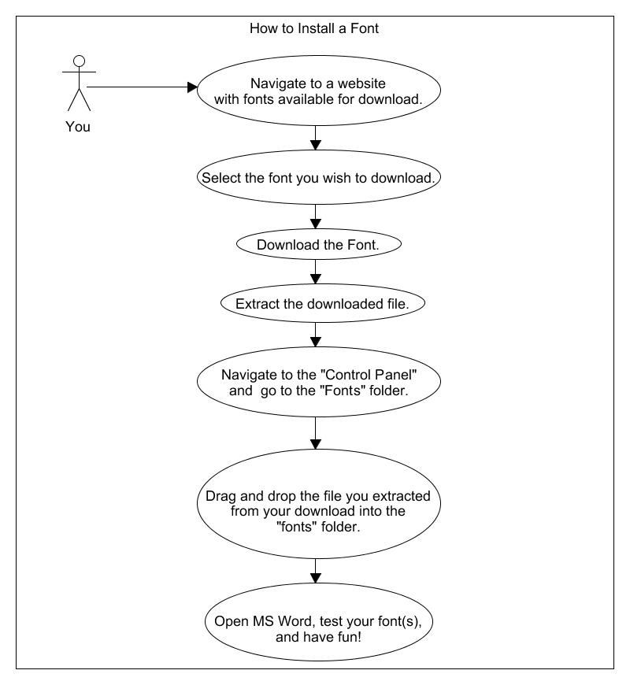***Task #2: The Flow Chart***

***Task #3: The Instructions***

**Step #1:**

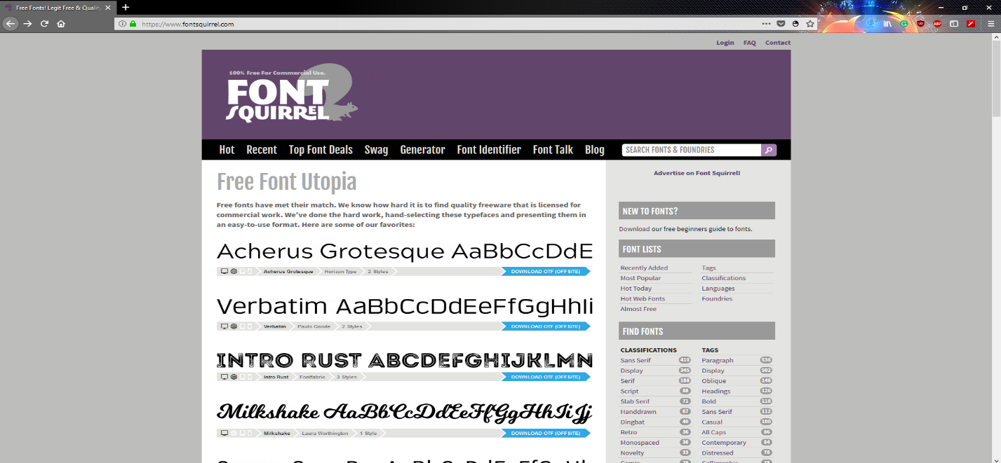Navigate to a website that has fonts available for download. Some websites you may wish to consider are [Dafont](https://www.dafont.com/), [FontSpace](http://www.fontspace.com/), [FontSquirrel](https://www.fontsquirrel.com/), and [GoogleFonts](https://fonts.google.com/). Though some fonts can only be downloaded for a small fee, there are many beautiful fonts for no charge at all. (I will be using FontSquirrel for this example.)

**Step #2:**

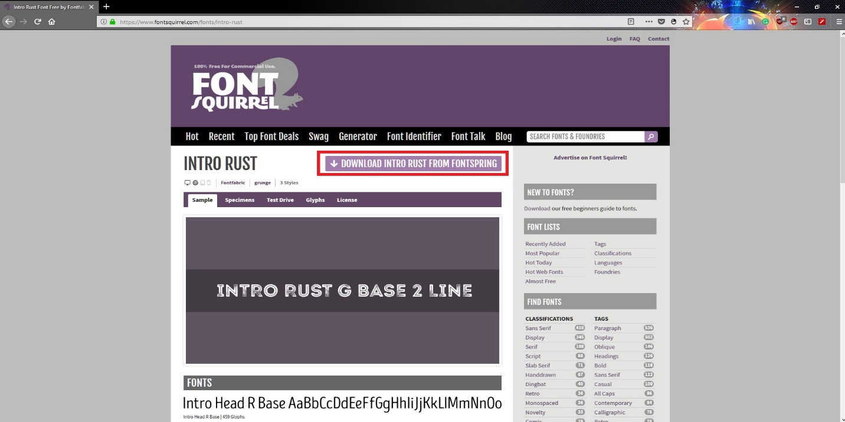Select the font you wish to download. In this example, I will download the font titled “Into Rust”. Once you have selected the font you want, download it by clicking the download button.

**Step #3:**

The file is downloads as a .ZIP folder, however your computer cannot read that type of file without your intervention. Extract the file by right clicking on it and selecting “Extract here”. This way, we can get to the more easily.

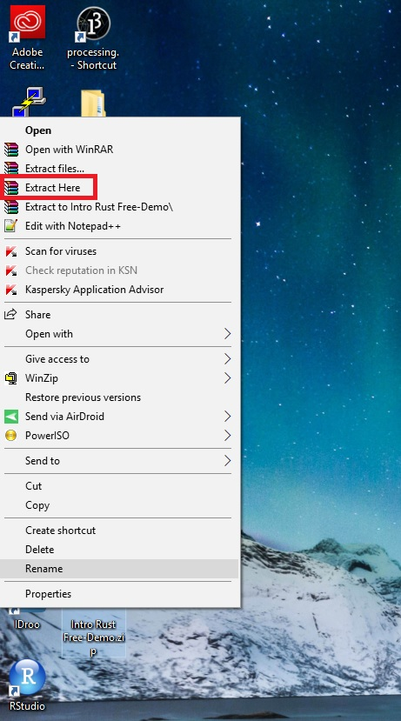

**Step #4:**

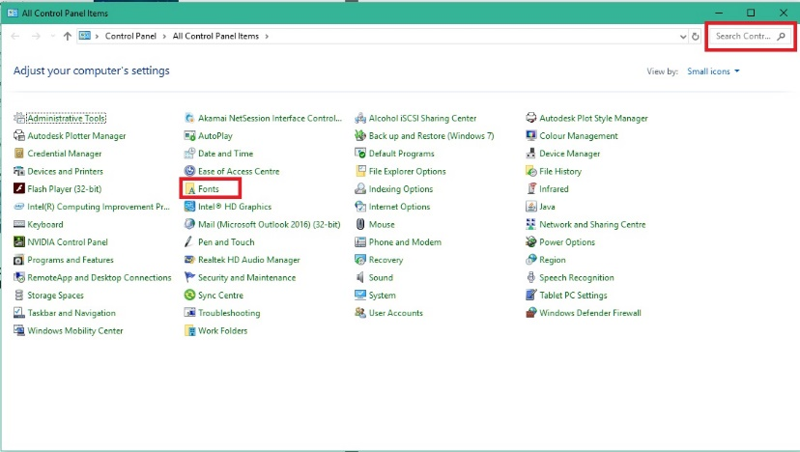In your Start menu, type in “Control Panel”. Once at the control panel, locate and navigate to the folder titled “Fonts”. If you cannot find it, try using the search bar in the top right.

**Step #5:**

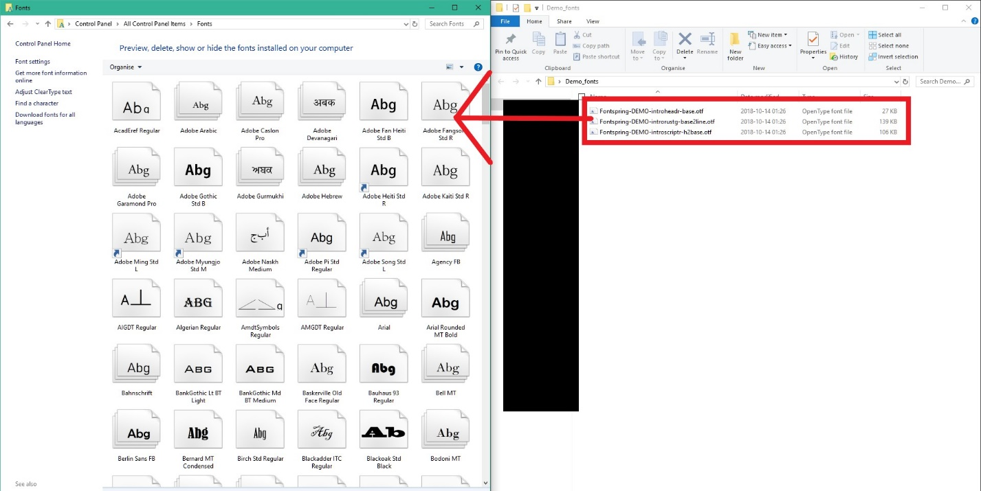Once the file has been extracted, search the folder to locate the .OTF files. These are your fonts! Select them all and drag them into the “Fonts” folder of your control panel.

**Step #6:**

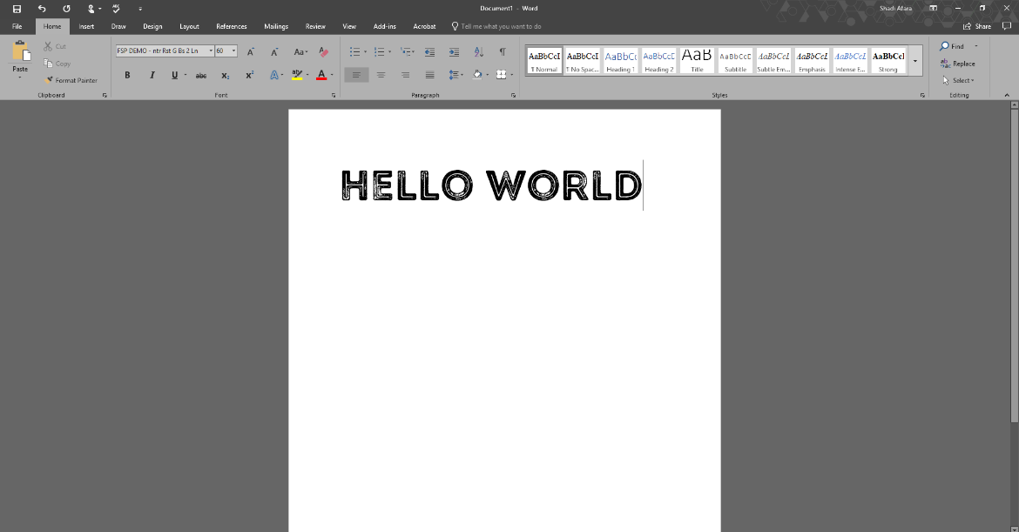Open Microsoft Word, test your font(s), and have fun!

***Task #4: Self-assessment and Reflection***

I think the most effective part of the draft is the flow chart. It provides the most information to the reader in the smallest amount of page space. Though I am happy with my draft, I believe the layout needs some work. Would readers prefer one step per page and having more information, or multiple steps per page with the sacrifice of smaller images and less information? Also, was the flow chart easy to understand and digest or would the readers prefer a more detailed and broken down visual representation?

Have you answered all the assignment tasks?

Did you respond to the instructions for each part accurately and thoughtfully?

Was your answer organized and presented effectively?

Was your answer organized and presented effectively?

Have you made sure that your instructions were explained in your own words and that any images or text from other sources were cited and referenced?