

rwda #5

WRIT 3988



October 22, 2018

sHADI AFARA

214 275 234

**Task #1: What I learned in class**

After just reading a few drafts from my colleagues, I discovered how what seem to be the smallest things (such as font) can have such a major impact on how your draft is perceived. By simply adding a touch of colour or sans-serif font can do wonders for the visual appeal and can take your work to the next level.

**Task #2: Feedback I received and what I can work on**

Having my work be reviewed in class gave me a greater outlook on what I need to do in my next iteration of instructions. Although, the content of my instructions was well received, the vast majority of criticism was directed at the esthetics of the draft. To my readers, it seemed as though things like font, spacing, colour, and small heading were just as (if not more than) important than the content itself. However, one colleague of mine mentioned that he would have liked to see references in my draft. Though I would usually agree with him, I did not use any outside resource in my work, and all photos provided, were taken by me. With that said, a couple of photos were screenshots of a website that I did not create and for the sake of keeping my reader happy (and a better grade ☺) I will reference it at the end of my revised edition.

**Task #3: Feedback I received and what I can work on**

Organization of the instructions is a topic that came up both from the link provided and from one of my readers. In order to meet the demands of my reader, the next iteration of instructions will have clear sub-headings for each step along with a table of contents. Furthermore, warnings will be placed where appropriate; however, esthetic measures will be taken to ensure they are recognized and read.

**Task #4: The revised version of my instructions**

The instructions will begin on the next page!

Have you answered all the assignment tasks, and done so thoughtfully?

Is your answer organized and presented effectively?

Is your answer expressed clearly for an intelligent, interested reader?

Did you check for and correct spelling / correct words, and make sure that your sentences made sense?

How to install:

Customized Fonts into MS Word

By: Shadi Afara

Student ID: 214 275 234

Email: [shadi3r@gmail.com](mailto:shadi3r@gmail.com)

**Table of Contents:**

Step #1: Finding a Font Resource

Step #2: Selecting a Font

Step #3: Extracting the Font

Step #4: Locating the Font Folder

Step #5: Installing the Font(s)

Step #6: Testing Your Font(s)

Note: This is a Windows 10 Tutorial!

**Step #1: Finding a Font Resource**

* 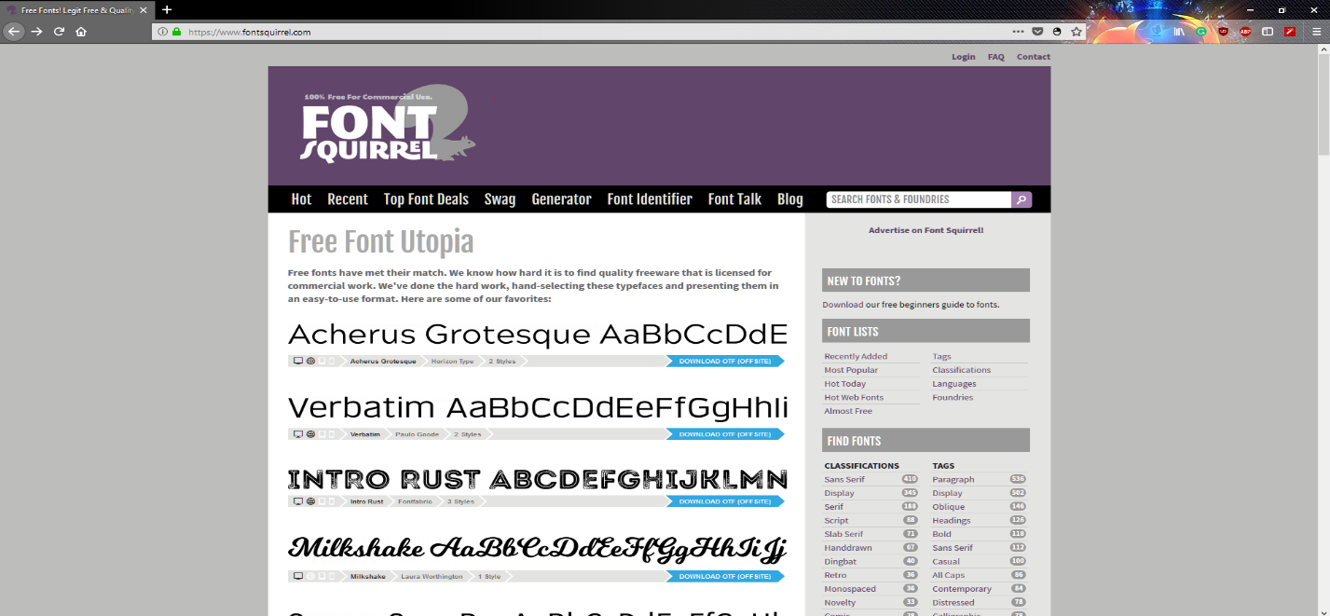Navigate to a website that has fonts available for download. Some websites you may wish to consider are: [Dafont](https://www.dafont.com/), [FontSpace](http://www.fontspace.com/), [FontSquirrel](https://www.fontsquirrel.com/), and [GoogleFonts](https://fonts.google.com/).

Note: Though some fonts can only be downloaded for a small fee, there are many beautiful fonts for no charge at all. (I will be using FontSquirrel for this example.)

**Step #2: Selecting a Font**

* 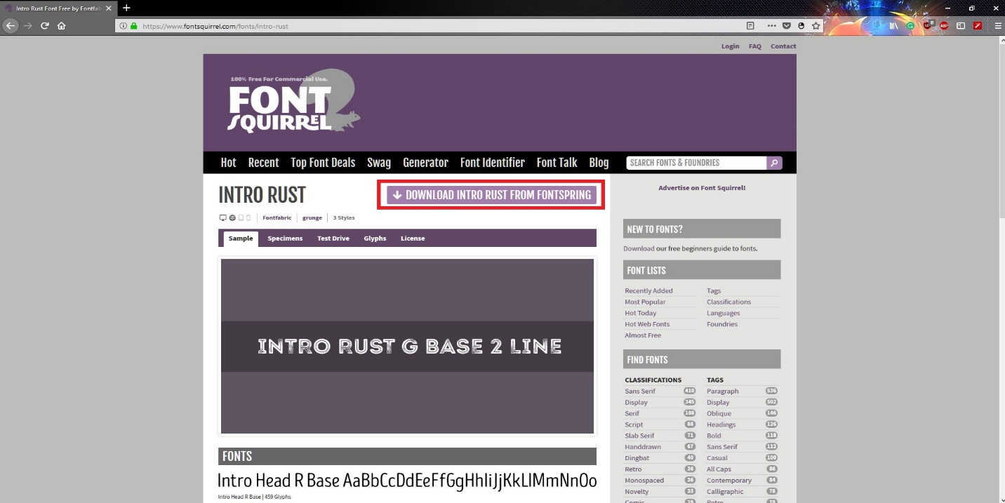Once you have selected a website to download from, select the font you wish to download. In this example, I will download the font titled “Into Rust”.
* Select the font you want, then download it by clicking the download button.
* Idealy, a good font is easy to read, and is still appropreate for the message you are trying to convey.

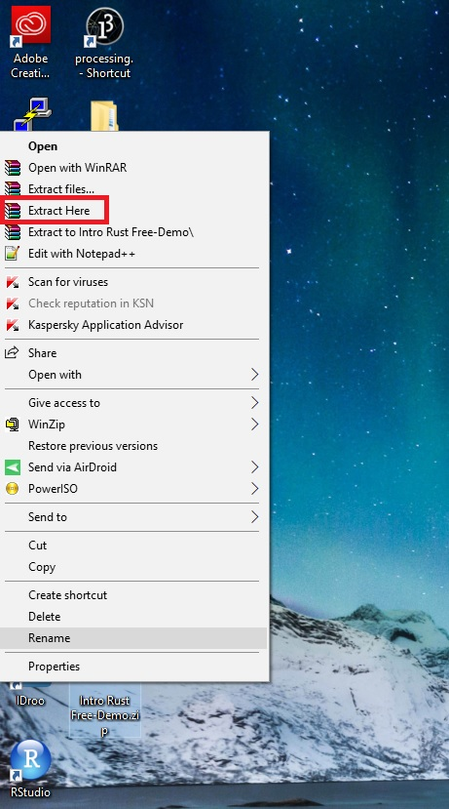**Step #3: Extracting the Font**

* The file is downloads to your computer as a .ZIP folder, however your computer cannot read that type of file without your intervention.
* Extract the file you downloaded by right clicking on it and selecting “Extract here”. This way, we can get to the more easily. Please note that an extraction tool such as WinZip or WinRAR is required.

**Step #4: Locating the Font Folder**

* 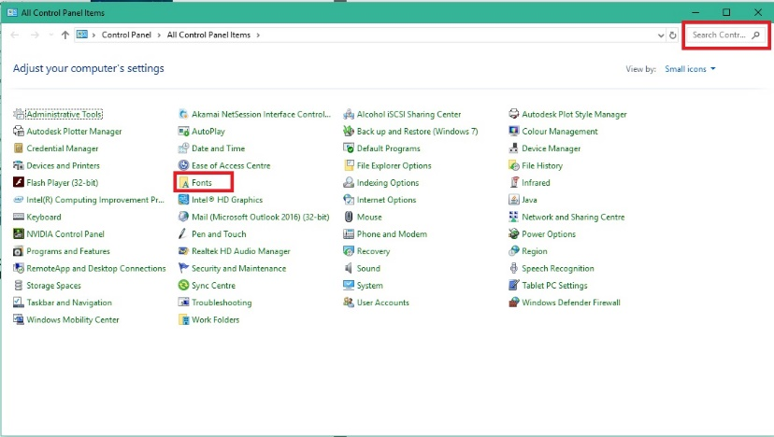In your Start menu, type in “Control Panel”.
* Once at the control panel, locate and navigate to the folder titled “Fonts”.

Note: If you cannot find it, try using the search bar in the top right.

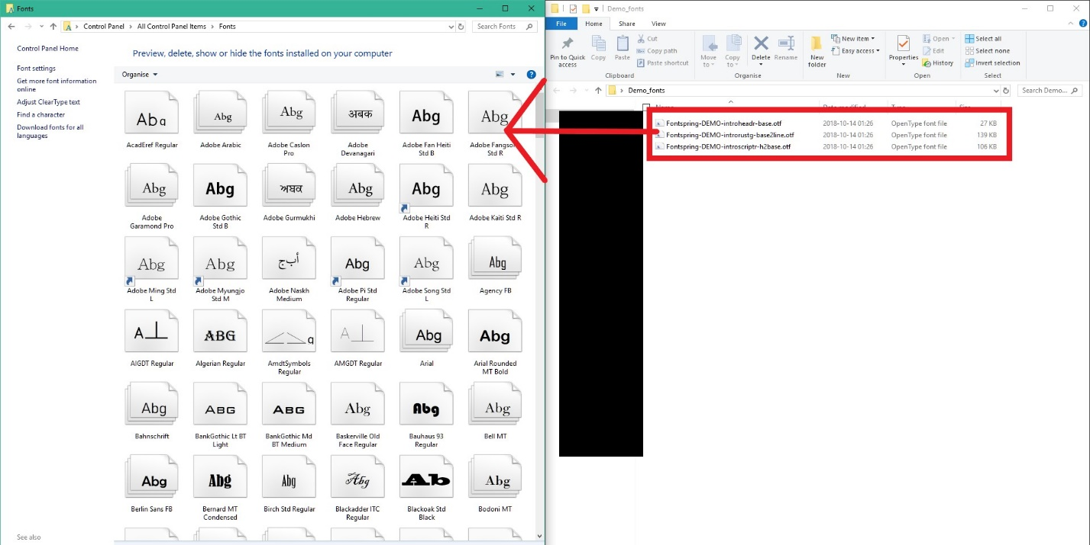**Step #5: Installing the Font(s)**

* Once the file has been extracted, search the folder to locate the .OTF files.
* These are your fonts! Select them all and drag them into the “Fonts” folder of your control panel.

**Step #6: Testing Your Font(s)**

* 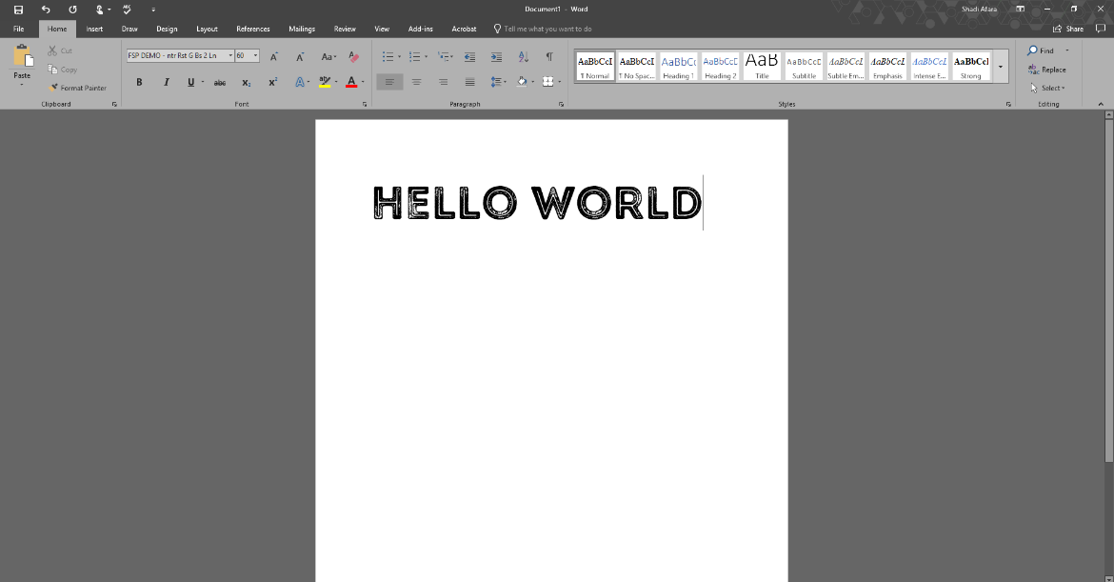Your fonts are now loaded into the font selection area of your tool bar in Microsoft Word.
* Open Microsoft Word, test your font(s), and have fun!

Note: Fonts installed will only display on computers they are installed on.