

**RWDA #6**

**WRIT 3988**



**October 30, 2018**

**214 275 234**

**Task # 1: Revising my instructions**

Looking back at the instructions I wrote for my previous RWDA, and at the resource provided in this assignment, I see a lot of small improvements that can make a big difference. Specifically, I am referring to the clarity of the instructions I wrote. The degree to which my readers can break down and digest the information is key to the success of instructive writing.

|  |  |  |
| --- | --- | --- |
| **Revisions** | **Previous Assignment**  **(RWDA #5)** | **New Edition**  **(RWDA #6)** |
| Breaking steps down into bullet points. |  | Checkmark |
| Adding background information to steps that require it.  (such as, “Your fonts are installed now…”) |  | Checkmark |

**Task # 2: Editing my instructions**

A.)

* Fixed minor spelling and grammar mistakes.
* Broke steps into easy-to-read bullet points.
* Added addition information to the steps that required it.

B.)

The resource provided many ways to make your documents look professional. However, I have already taken these into account in my last RWDA, but any constructive criticism would be highly appreciated.

C.)

Next to each step of instructions, I have taken the time screenshot illustrations to make the guide easier to follow. However in the last RWDA, a reader mentioned that the illustration on the font cover doesn’t fully match the guide. A new illustration along with reference to the source will be placed in the next edition of my guide.

**Task # 3: Making my instructions accessible**

After making a few changes to my guide, I was successfully able to make my document accessible. These changes mainly consisted of adding replacement text and formatting the positioning of my pictures.

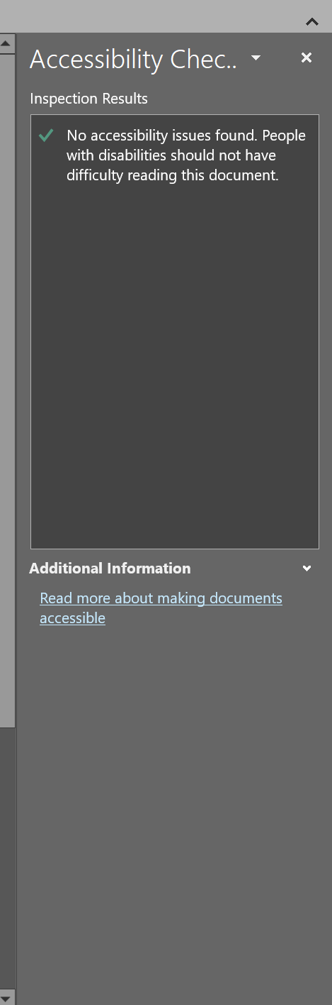

**Task #4: Reflecting on my development**

|  |  |
| --- | --- |
| ***facet of research*** | ***Example*** |
| Embark & Clarify | Researched various genres of writing in my WRIT 3988 course. The allows me to understand what style of writing is required to accomplish a specific task. |
| Find & Generate | In the course WRIT 3988, I looked into what styles of writing would fall under various writing genres; allowing me to piece together what writing genre would look like, and what it would need to include. |
| Evaluate & Reflect | In the 3rd assignment in WRIT 3988, we looked into various sources of information and what would make one more credible than another. |
| Organize & Manage | One of the tasks in WRIT 3988 was to create a set of instructions. The instructions didn’t have to be complicated but required the ability to communicate information in a simple and effective manner. |
| Analyse & Synthesise | Once our instructions were written, we were given the opportunity to have feedback on our work. From there, we had to analyse the feedback given to us and make adjustments wherever they were necessary. |
| Communicate & Apply | We did multiple drafts of our instructions, but one of the key aspects of the assignments were to teach us how to respond to feedback. I learned to fix my issues, log what had be changed, then explain how and why I did it in that way. |

**Self-assessment**

Have you answered all the assignment tasks?

Did you respond to the instructions for each part accurately and thoughtfully?

Were your answers organized and presented effectively?

Were your answers expressed clearly for an intelligent, interested reader?

Did you edit the writing in your answers?

How to install:

Customized Fonts into MS Word

By: Shadi Afara

Student ID: 214 275 234

Email: [shadi3r@gmail.com](mailto:shadi3r@gmail.com)

**Table of Contents:**

Step #1: Finding a Font Resource

Step #2: Selecting a Font

Step #3: Extracting the Font

Step #4: Locating the Font Folder

Step #5: Installing the Font(s)

Step #6: Testing Your Font(s)

Note: This is a Windows 10 Tutorial!

**Step #1: Finding a Font Resource**

* 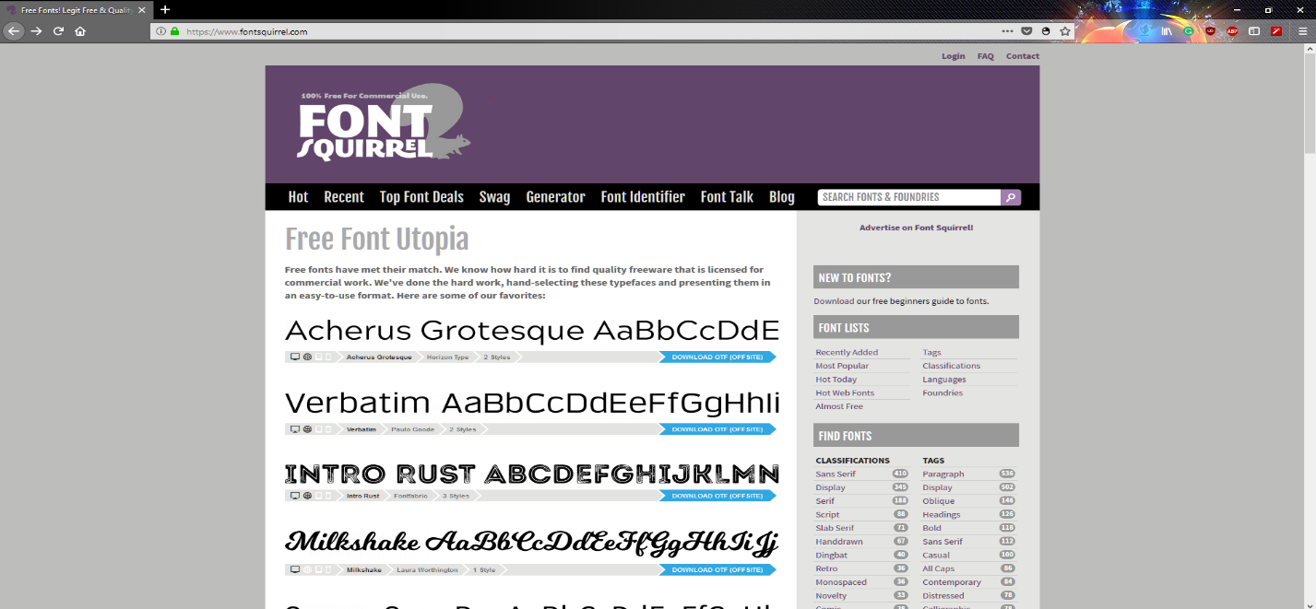Navigate to a website that has fonts available for download. Some websites you may wish to consider are: [Dafont](https://www.dafont.com/), [FontSpace](http://www.fontspace.com/), [FontSquirrel](https://www.fontsquirrel.com/), and [GoogleFonts](https://fonts.google.com/).

Note: Though some fonts can only be downloaded for a small fee, there are many beautiful fonts for no charge at all. (I will be using FontSquirrel for this example.)

**Step #2: Selecting a Font**

* 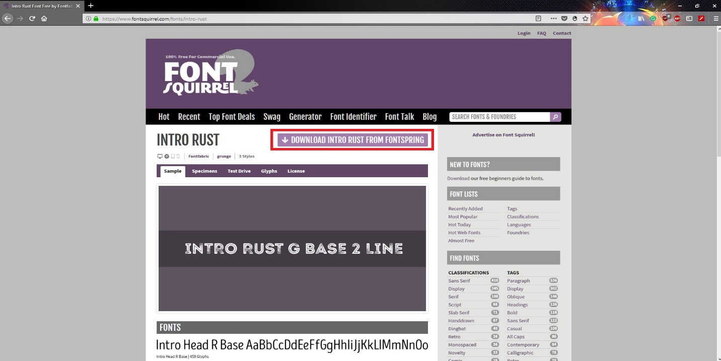Once you have selected a website to download from, select the font you wish to download. In this example, I will download the font titled “Into Rust”.
* Select the font you want, then download it by clicking the download button.
* Idealy, a good font is easy to read, and is still appropreate for the message you are trying to convey.

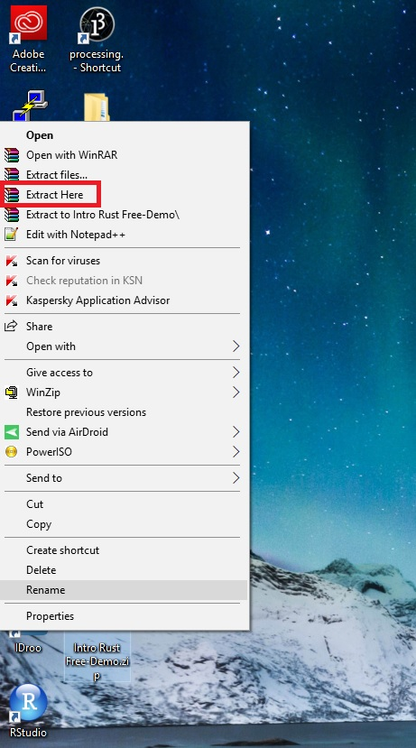**Step #3: Extracting the Font**

* The file is downloads to your computer as a .ZIP folder, however your computer cannot read that type of file without your intervention.
* Extract the file you downloaded by right clicking on it and selecting “Extract here”. This way, we can get to the more easily. Please note that an extraction tool such as WinZip or WinRAR is required.

**Step #4: Locating the Font Folder**

* In your Start menu, type in “Control Panel”.

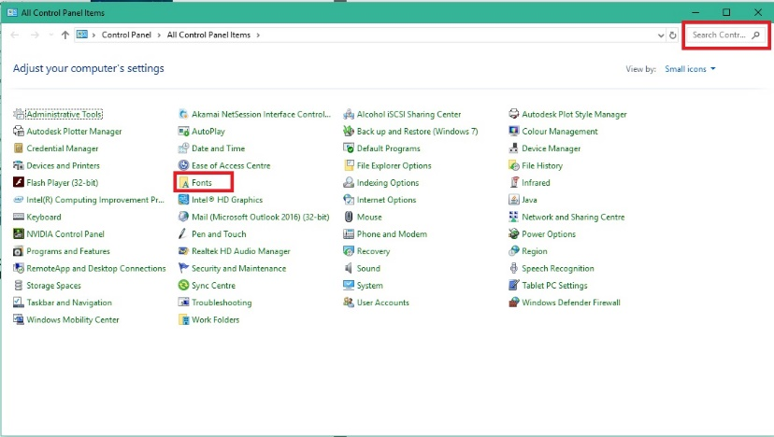

* Once at the control panel, locate and navigate to the folder titled “Fonts”.

Note: If you cannot find it, try using the search bar in the top right.

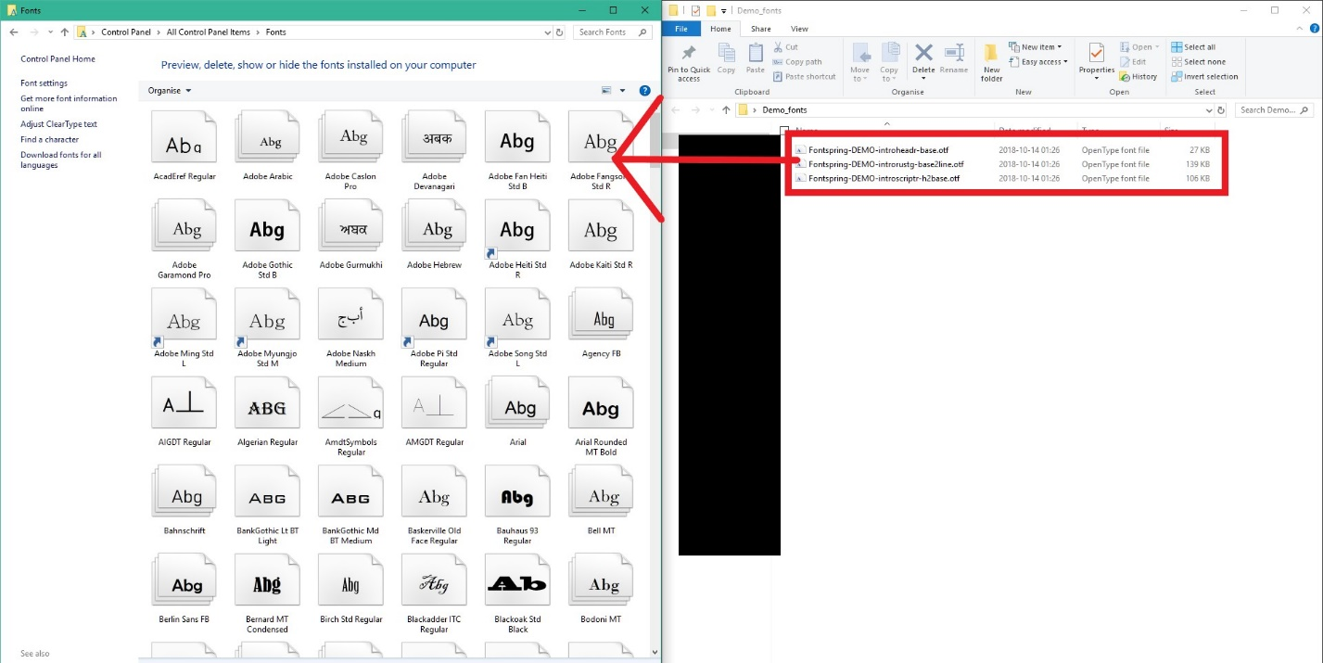**Step #5: Installing the Font(s)**

* Once the file has been extracted, search the folder to locate the .OTF files.
* These are your fonts! Select them all and drag them into the “Fonts” folder of your control panel.

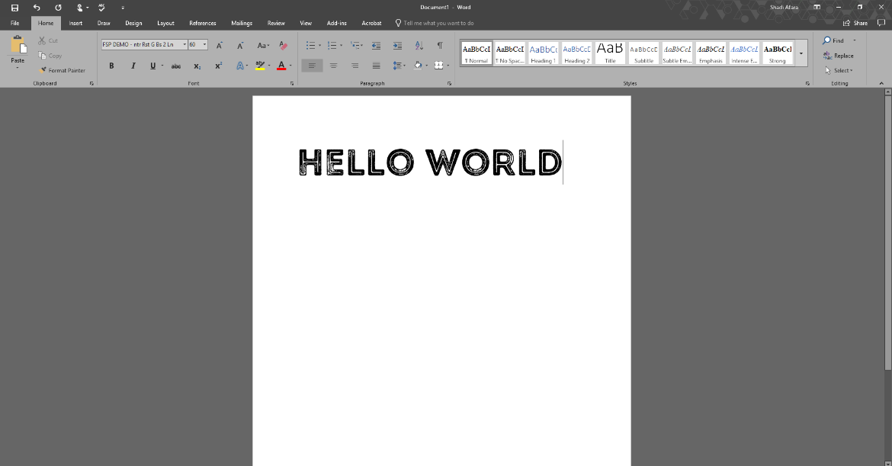**Step #6: Testing Your Font(s)**

* Your fonts are now loaded into the font selection area of your tool bar in Microsoft Word.
* Open Microsoft Word, test your font(s), and have fun!

Note: Fonts installed will only display on computers they are installed on.