Concordia Institute for Information System Engineering (CIISE)

Final Project Report
AI-Based Demand Forecasting and Inventory Optimization System
for Food Delivery Supply Chains
INSE 6290: Quality in Supply Chain Design
Winter 2026

Instructor: Chun Wang, Ph.D. PEO(Ont.)
Prepared by: Md Golam Raiyhan (40310101), Dylan Zuzarte (40301182),
Afsana Tasnim Nishat (40311862), Shadid Alam Al Huda (40334643)
Prototype context: Single restaurant / cloud kitchen, daily demand planning, synthetic dataset

Executive Summary
This report presents a complete system-development prototype for a single-echelon food-delivery supply chain. The system forecasts daily demand for ten menu items and converts those forecasts into replenishment decisions using a newsvendor-style inventory policy for perishable products. To stay aligned with the submitted proposal and system requirement specification, the prototype supports a single restaurant, daily planning, one baseline forecast, one AI forecast, daily inventory tracking, a 14-day simulation horizon, and evaluation through fill rate, stockout rate, inventory turnover, and food waste percentage.
Using a 90-day synthetic dataset (900 rows), the Random Forest model improved demand forecasting accuracy over the baseline moving-average method: MAE decreased from 5.07 to 3.80, and RMSE decreased from 6.35 to 4.92. In the 14-day test simulation, both approaches achieved a fill rate of 1.00, but the AI-based policy required fewer ordered units (5831 versus 5986), reduced food waste percentage from 0.74% to 0.36%, and increased inventory turnover from 78.98 to 95.00.

1. Introduction
Food delivery services and cloud kitchens operate in a high-variability service supply chain. Demand changes by day of week, weekend traffic, promotions, and random customer behavior. Because ingredients and prepared components are perishable, poor planning causes either stockouts and service failures or excess inventory and waste. The submitted project proposal framed this challenge as an AI-driven decision support problem, while the system requirement specification narrowed the scope to a single restaurant, daily demand forecasting, inventory replenishment planning, and supply-chain KPI evaluation.
The goal of this report is to document the full prototype, including the system architecture, dataset design, forecasting methods, inventory logic, simulation workflow, results, and the tools and code needed to reproduce the project.

2. Problem Statement and Project Objectives
- Forecast short-term daily demand for multiple menu items.
- Compare a traditional baseline forecast with an AI-based model.
- Convert forecast outputs into daily replenishment decisions.
- Track inventory aging for perishable products and simulate operations over time.
- Evaluate the resulting supply-chain performance using fill rate, stockout rate, food waste percentage, and inventory turnover.

3. Scope, Assumptions, and Requirements Mapping

3.1 Scope adopted for the prototype
- Single restaurant / cloud kitchen.
- Ten menu items.
- Daily demand forecasting.
- One-day lead time for replenishment.
- Shelf life of 3-4 days depending on item type.
- Single-echelon inventory system with no external platform integration.

3.2 Assumptions
- Historical demand is available and internally consistent.
- Demand for each menu item is independent for the purpose of this prototype.
- Shortage and holding costs are predefined for each item.
- Storage capacity is sufficient for recommended order quantities.
- Orders are received in one day and are added to the freshest inventory bucket.

3.3 Traceability to submitted documents
The implemented prototype directly satisfies the submitted proposal and SRS: (1) it is an executable AI-driven system, (2) it uses a baseline and an AI forecast, (3) it applies a single-period inventory policy, (4) it simulates daily operations over a planning horizon, and (5) it reports the requested performance metrics.

4. System Architecture
The system is a lightweight decision support pipeline with five main components:
- Input layer - historical daily demand data, item parameters, and inventory costs.
- Preprocessing layer - lag features, rolling averages, and day-of-week indicators.
- Forecasting layer - baseline moving-average forecast and Random Forest forecast.
- Inventory decision layer - newsvendor-style order quantity calculation based on forecast mean and demand uncertainty.
- Simulation and reporting layer - daily inventory update, waste and stockout tracking, KPI calculation, plots, and exported tables.

5. Tools and Technology Stack
Tool | Purpose | Used in this project
Python | Main programming language | All data generation, modelling, simulation, and reporting support
Pandas / NumPy | Data preparation and numerical operations | Feature engineering and KPI calculations
scikit-learn | Machine-learning models | Random Forest regressor
Matplotlib | Visualization | Demand, forecast, and simulation plots
Microsoft 365 / Word | Documentation | Final report packaging
GitHub / Google Colab | Collaboration and optional execution environment | Version control and shared development

6. Dataset Design and Preparation
Because the project was scoped as a prototype and no production restaurant dataset was provided, a synthetic but realistic dataset was created. The dataset preserves key operational patterns that are common in food delivery: weekly seasonality, weekend uplift, mild trend, promotion periods, and random noise.

6.1 Dataset specification
Attribute | Value
Planning unit | Daily
Observation horizon | 90 days
Rows | 900 (10 items x 90 days)
Menu items | Burger, Pizza, Pasta, Salad, Wrap, Fried Rice, Noodles, Sandwich, Taco, Soup
Core fields | date, item_id, item_name, day_of_week, demand, unit_cost, holding_cost, shortage_cost, shelf_life_days, lead_time_days
Train / test split | 69 training days and 14 test days
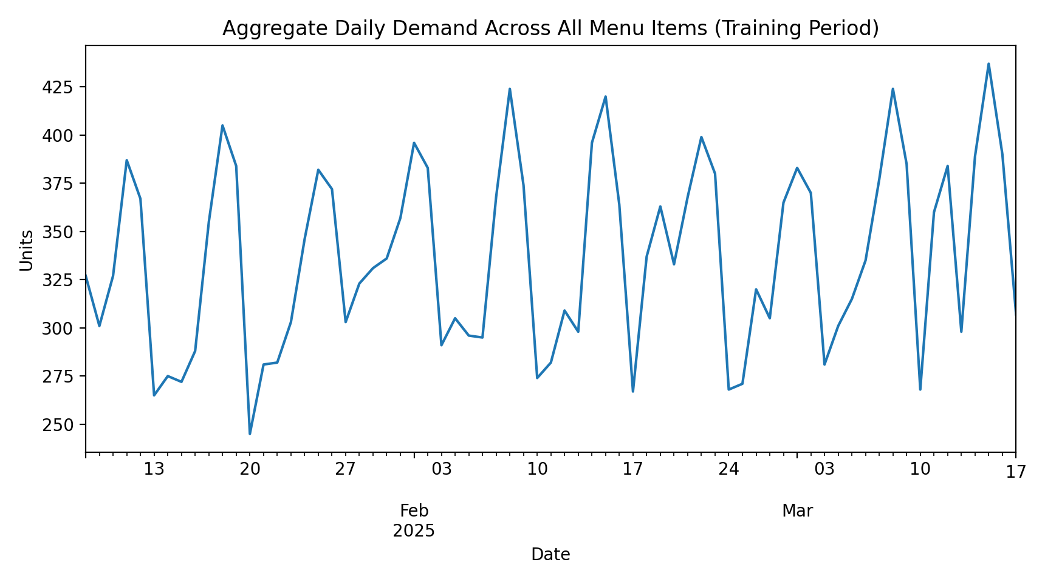
Figure 1. Aggregate daily demand across all menu items during the training period.

7. Forecasting Methodology

7.1 Baseline model
The baseline forecast uses the item-level demand from seven days earlier as the forecast for the current day. This approach is simple, transparent, and consistent with traditional heuristic planning in operations environments where managers rely on last-week behavior.

7.2 AI-based model
The AI model is a Random Forest regressor. It was selected because it is robust on small-to-medium tabular datasets, captures nonlinear effects, and requires less tuning than a deep-learning model.

Input features used by the Random Forest:
- item_id
- day_of_week
- is_weekend
- lag_1
- lag_7
- rolling_3
- rolling_7
The final model uses 250 trees, maximum depth 10, minimum leaf size 2, and a fixed random seed for reproducibility.

7.3 Forecast-accuracy results
Metric | Baseline | AI-RF
MAE | 5.0714 | 3.8017
RMSE | 6.3460 | 4.9204
The AI model reduced MAE by 25.0% and RMSE by 22.5% relative to the baseline.
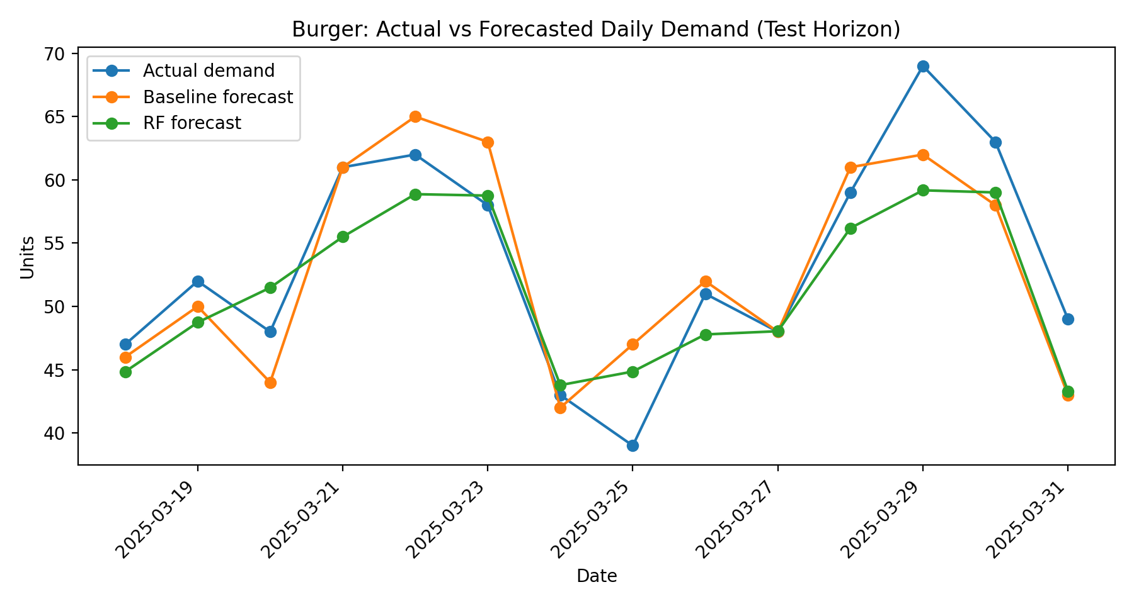
Figure 2. Example forecast comparison for Burger in the 14-day test horizon.

7.4 Feature importance
Feature | Importance
lag_7 | 0.3987
rolling_7 | 0.3239
day_of_week | 0.0966
rolling_3 | 0.0608
item_id | 0.0580
lag_1 | 0.0560
is_weekend | 0.0060
Lag-7 and rolling-7 were the most influential variables, which is consistent with a weekly service-demand cycle.

8. Inventory Optimization Logic
A simplified newsvendor-style policy was used because the project involves perishable products and a single daily ordering decision. For each item and day, the system computes an order quantity using the forecast mean and an uncertainty buffer:
Order Quantity Q = max(0, μ + zσ)
Here, μ is the forecasted demand, σ is the item-level demand standard deviation estimated from training data, and z is derived from the critical ratio shortage_cost / (shortage_cost + holding_cost). This keeps the decision policy simple, transparent, and aligned with the SRS requirement for a single-period inventory policy.
Perishability is handled through age buckets. Each item has a shelf life of either 3 or 4 days. Inventory is consumed using a first-expire-first-out logic, and expired units are counted as waste before new orders are added.

9. Simulation Procedure
- Load the test-horizon demand and the forecast generated by the chosen method.
- For each item and day, calculate the order quantity from the newsvendor-style rule.
- Discard expired stock from the oldest age bucket.
- Receive the new order into the freshest inventory bucket.
- Meet demand from the oldest remaining stock first.
- Record sales, stockout units, waste units, and ending inventory.
- Repeat for all items over the 14-day test horizon.

10. Results and Performance Evaluation

10.1 Supply-chain KPI comparison
Metric | Baseline | AI-RF
Total Demand | 4950.0000 | 4950.0000
Total Sales | 4950.0000 | 4950.0000
Total Ordered | 5986.0000 | 5831.0000
Fill Rate | 1.0000 | 1.0000
Stockout Rate | 0.0000 | 0.0000
Food Waste % | 0.0074 | 0.0036
Inventory Turnover | 78.9834 | 94.9966

10.2 Interpretation of the KPI results
- Both policies achieved a fill rate of 1.00 over the test horizon. In this synthetic setting, both approaches were conservative enough to avoid lost sales.
- The AI-RF policy required 155 fewer ordered units than the baseline policy, indicating tighter alignment between ordered inventory and realized demand.
- Food waste percentage fell from 0.74% to 0.36%, which is a meaningful reduction for a perishable-food operation.
- Inventory turnover improved from 78.98 to 95.00, showing that the AI-based policy moved more sales per average unit of inventory held.
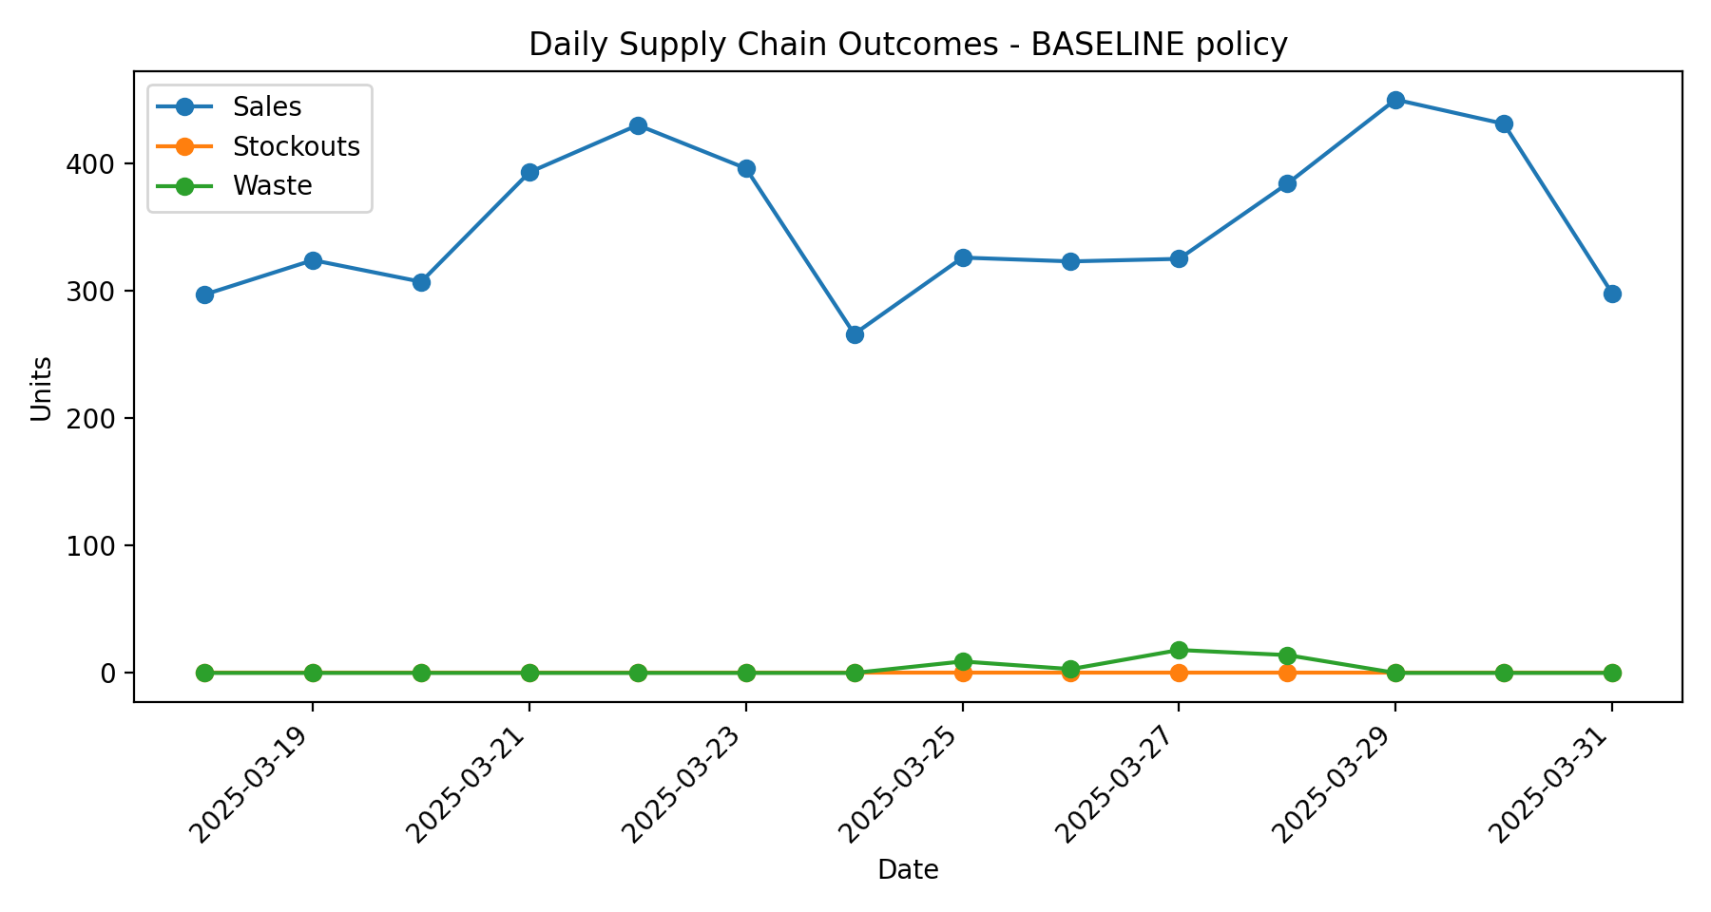
Figure 3. Daily sales, stockouts, and waste under the baseline policy.
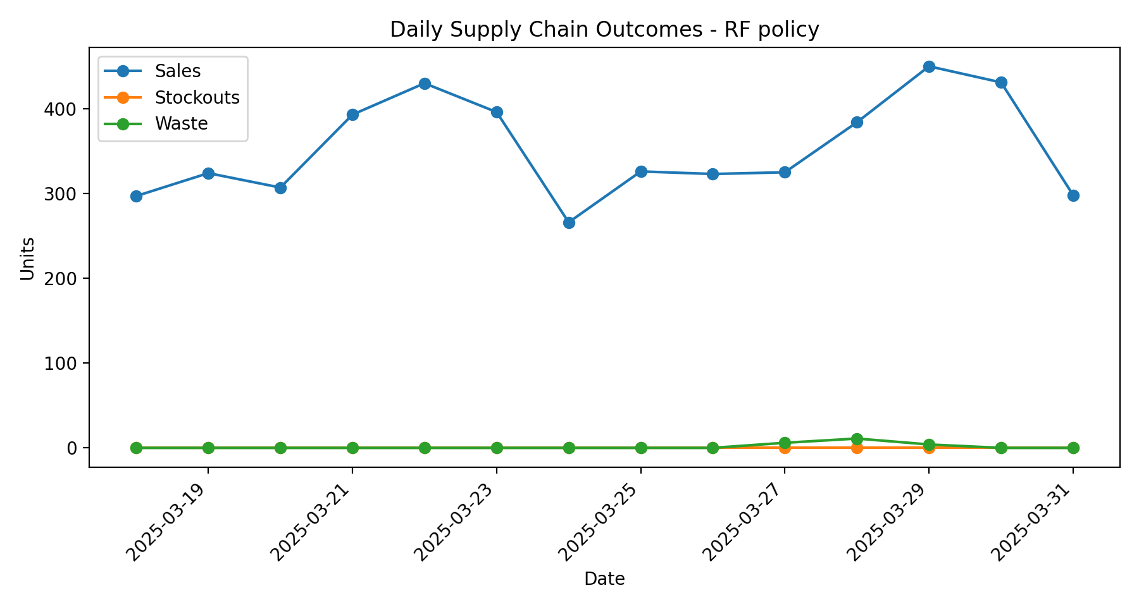
Figure 4. Daily sales, stockouts, and waste under the AI-RF policy.

11. Managerial Insights
- A lightweight AI model can improve ordering quality even when the operating environment is simple and the dataset is small.
- For perishable products, better forecasts do not only improve forecast accuracy; they also translate into lower waste and better inventory productivity.
- A decision support system can remain useful without full real-time platform integration. Daily planning is already enough to generate measurable supply-chain benefits.
- The combination of a transparent forecast and a transparent replenishment rule is practical for managers, because the model outputs are easy to explain and audit.

12. Validation Against System Requirements
Requirement from SRS | Implemented? | Evidence in prototype
Accept historical demand data as input | Yes | Synthetic dataset CSV and data loader
Generate baseline demand forecast | Yes | lag-7 baseline forecast
Generate AI-based demand forecast | Yes | Random Forest regressor
Implement a single-period inventory policy | Yes | Newsvendor-style order rule
Simulate daily operations | Yes | 14-day inventory simulation
Compute fill rate, stockout rate, waste %, inventory turnover | Yes | KPI tables and CSV outputs
Produce graphical outputs | Yes | Forecast and daily outcome figures

13. Limitations and Future Improvements
- The dataset is synthetic rather than collected from a live restaurant.
- The prototype assumes independent menu-item demand and fixed lead time.
- No weather, promotions calendar, holiday effects, or delivery-zone features were added beyond simple synthetic signals.
- The current inventory policy is single-echelon and does not model supplier capacity or delivery delays.
- A future version could include real point-of-sale data, multiple locations, and a dashboard interface for managers.

14. Conclusion
This project delivered a full prototype for AI-based demand forecasting and inventory optimization in a food delivery supply chain. The implementation remained faithful to the submitted proposal and SRS by keeping the scope focused: one restaurant, daily demand planning, a baseline model, one AI model, a simple replenishment policy, and KPI-based evaluation. Despite this intentionally manageable scope, the results show that AI-based demand forecasting can materially improve operational outcomes by lowering ordered volume, reducing food waste, and increasing inventory turnover while maintaining service levels.

15. Reproducibility and Code Package
The submitted code package includes the dataset generator, the main experiment script, metrics tables, simulation output files, figures, a requirements file, and a README with setup instructions. Running the project requires only standard Python data-science libraries.

Appendix A. File List
- src/generate_synthetic_data.py
- src/run_project.py
- data/synthetic_food_orders.csv
- outputs/forecast_metrics.csv
- outputs/supply_chain_metrics.csv
- outputs/feature_importance.csv
- outputs/simulation_baseline.csv
- outputs/simulation_ai_rf.csv
- outputs/forecast_comparison_burger.png
- outputs/daily_outcomes_baseline.png
- outputs/daily_outcomes_rf.png
- requirements.txt
- README.md

Appendix B. Core Code Snippets

Synthetic data generation logic
for item_name, base_demand, price_factor, item_id in items:
for i, date in enumerate(dates):
dow = date.dayofweek
trend = 1.0 + 0.0018 * i
weekend_boost = 1.08 if dow in [4, 5, 6] else 1.0
promo = 1.18 if (i % 21 in [6, 7]) else 1.0
noise = rng.normal(0, 3.5 + 0.05 * base_demand)
demand = (base_demand + level_shift) * weekly_pattern[dow] * trend * weekend_boost * promo + noise

Feature engineering and model inputs
df['lag_1'] = grp['demand'].shift(1)
df['lag_7'] = grp['demand'].shift(7)
df['rolling_3'] = grp['demand'].shift(1).rolling(3).mean()
df['rolling_7'] = grp['demand'].shift(1).rolling(7).mean()
feature_cols = ['item_id', 'day_of_week', 'is_weekend', 'lag_1', 'lag_7', 'rolling_3', 'rolling_7']

Inventory order rule
crit_ratio = shortage / (shortage + holding)
z = normal_z_from_service(crit_ratio)
order_qty = int(round(max(0, forecast_mean + z * residual_sigma)))

References
- Baron, O. (2010). Managing perishable inventory. Encyclopedia of Operations Research and Management Science.
- Hess, A., Saboury, A., and Ukkusuri, S. (2021). Real-time demand forecasting for an urban delivery platform. Transportation Research Part E.
- Shi, J., Zhang, H., and co-authors (2022). Application of the model combining demand forecasting and the data-driven newsvendor problem. Computers & Industrial Engineering.
- Vairagade, N., Logofatu, D., Leon, F., and Muharemi, F. (2019). Demand forecasting using Random Forest and Artificial Neural Network for supply chain management.

