**Problem 1:**

#include <stdio.h>

main()

{

printf("Name: Shadman Ahnaf ID: 23103065\n");

int a;

printf("Enter marks: ");

scanf("%d", &a);

(a>=90 && a<=100) ? printf("A"):

(a>=84) ? printf("B"):

(a>=80) ? printf("B-"):

(a>=76) ? printf("C+"):

(a>=70) ? printf("C-"):

(a>=65) ? printf("D+"):

(a<=60) ? printf("D"):

(a<=59 && a>=0) ? printf("F"): printf("Invalid");

return 0;

}

**Output:**

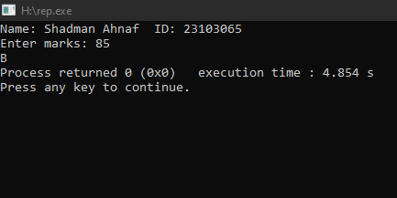

**Problem-2:**

#include <stdio.h>

int main() {

float unit, total, surcharge = 0.20;

printf("Name: Shadman Ahnaf ID: 23103065\n");

printf("Enter the electricity unit: ");

scanf("%f", &unit);

if (unit <= 50) {

total = unit * 0.50;

} else if (unit <= 150) {

total = 50 * 0.50 + (unit - 50) * 0.75;

} else if (unit <= 250) {

total = 50 * 0.50 + 100 * 0.75 + (unit - 150) * 1.20;

} else {

total = 50 * 0.50 + 100 * 0.75 + 100 * 1.20 + (unit - 250) * 1.50;

}

total += surcharge * total;

printf("Total Electricity Bill: %.2f\n", total);

return 0;

}

**Output:**

