Problem 1:

#include <stdio.h>

#define size 5

int main() {

int arr[size];

printf("Name: Shadman Ahnaf ID:23103065\n");

printf("Enter the elements:\n");

for (int i = 0; i < size; i++) {

scanf("%d", &arr[i]);

}

printf("Array:\n");

for (int i = 0; i < size; i++) {

printf("%d ", arr[i]);

}

printf("\n");

return 0;

}

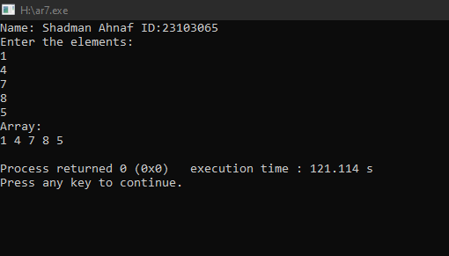

Problem 2:

#include <stdio.h>

int main ()

{

int array[100]={10,20,30,40,50},i,position, value,n;

printf("Name: Shadman Ahnaf ID:23103065\n");

printf("Enter elements number : ");

scanf("%d",&n);

printf("Enter the index position to input : ");

scanf("%d",&position);

printf("Enter value to input : ");

scanf("%d",&value);

for (i=n;i>=position;i--)

{

array[i+1]=array[i];

}

array[position]=value;

for (i=0;i<=n;i++)

{

printf("%d\n",array[i]);

}

return 0;

}

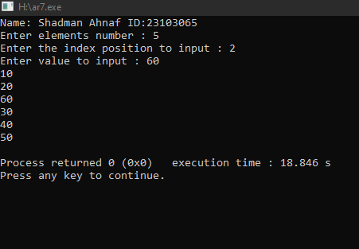

Problem 3:

#include <stdio.h>

int main() {

int numbers[5]={1,2,3,4,5};

int sum = 0;

printf("Name: Shadman Ahnaf ID:23103065\n");

printf("The Array is= ");

for (int i = 0; i < 5; i++) {

printf("%d", numbers[i]);

}

printf("\n");

for (int i = 0; i < 5; i++) {

sum += numbers[i];

}

printf("Sum of the numbers = %d\n", sum);

return 0;

}

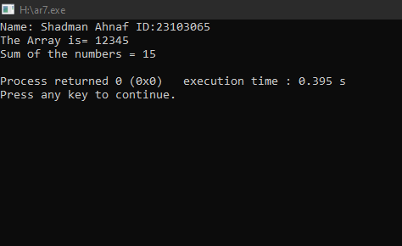

Problem 4:

#include <stdio.h>

#define size 5

int main() {

int numbers[size];

int sum = 0;

printf("Name: Shadman Ahnaf ID:23103065\n");

printf("Enter %d numbers:\n", size);

for (int i = 0; i < size; i++) {

scanf("%d", &numbers[i]);

}

for (int i = 0; i < size; i++) {

sum += numbers[i];

}

printf("Sum of the numbers = %d\n", sum);

return 0;

}

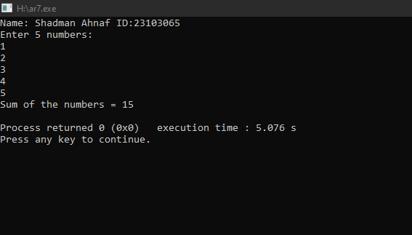

Problem 5:

#include <stdio.h>

int main() {

int N;

printf("Name: Shadman Ahnaf ID:23103065\n");

printf("Enter the number of elements: ");

scanf("%d", &N);

int numbers[N];

int sum = 0;

printf("Enter %d numbers:\n", N);

for (int i = 0; i < N; i++) {

scanf("%d", &numbers[i]);

sum += numbers[i];

}

float average = (float)sum / N;

printf("Entered numbers: ");

for (int i = 0; i < N; i++) {

printf("%d ", numbers[i]);

}

printf("\n");

printf("Sum of the numbers = %d\n", sum);

printf("Average of the numbers = %.2f\n", average);

return 0;

}

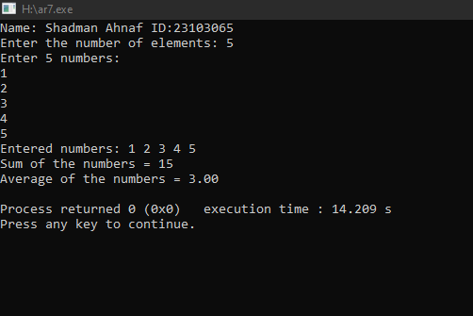

Problem 6:

#include <stdio.h>

int main() {

int numbers[5];

printf("Name: Shadman Ahnaf ID:23103065\n");

printf("Enter 5 elements:\n");

for (int i = 0; i < 5; i++) {

scanf("%d", &numbers[i]);

}

int max = numbers[0];

int min = numbers[0];

for (int i = 1; i < 5; i++) {

if (numbers[i] > max) {

max = numbers[i];

}

if (numbers[i] < min) {

min = numbers[i];

}

}

printf("Maximum element: %d\n", max);

printf("Minimum element: %d\n", min);

return 0;

}

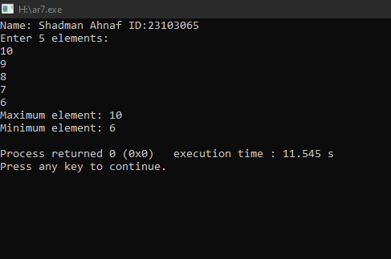

Problem 7:

#include <stdio.h>

int main() {

int size = 5;

int numbers[size];

printf("Name: Shadman Ahnaf ID:23103065\n");

printf("Enter %d elements:\n", size);

for (int i = 0; i < size; i++) {

scanf("%d", &numbers[i]);

}

printf("Positive numbers: ");

for (int i = 0; i< size; i++) {

if (numbers[i]> 0) {

printf("%d ", numbers[i]);

}

}

printf("\n");

printf("Negative numbers: ");

for (int i = 0; i < size; i++) {

if (numbers[i] < 0) {

printf("%d ", numbers[i]);

}

}

printf("\n");

return 0;

}

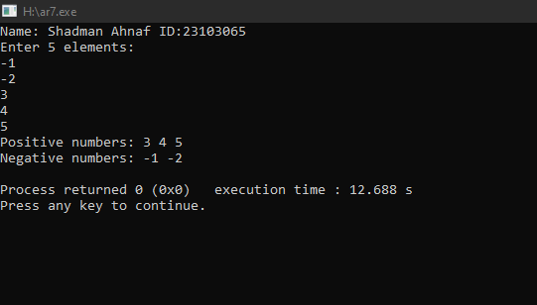

Problem 8:

#include <stdio.h>

int main() {

int size = 5;

int Array1[size];

int Array2[size];

printf("Name: Shadman Ahnaf ID:23103065\n");

printf("Enter %d elements for the source array:\n", size);

for (int i = 0; i < size; i++) {

scanf("%d", &Array1[i]);

}

for (int i = 0; i < size; i++) {

Array2[i] = Array1[i];

}

printf("Source Array: ");

for (int i = 0; i < size; i++) {

printf("%d ", Array1[i]);

}

printf("\n");

printf("Copied Array: ");

for (int i = 0; i < size; i++) {

printf("%d ", Array2[i]);

}

printf("\n");

return 0;

}

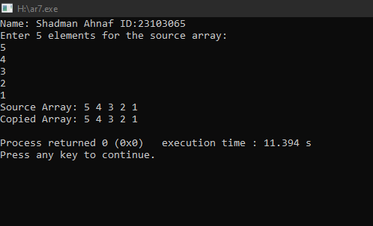

Problem 9:

#include <stdio.h>

int main() {

int size = 5;

int numbers[size];

printf("Name: Shadman Ahnaf ID:23103065\n");

printf("Enter %d elements:\n", size);

for (int i = 0; i < size; i++) {

scanf("%d", &numbers[i]);

}

for (int i = 0; i < size - 1; i++) {

for (int j = 0; j < size - i - 1; j++) {

if (numbers[j] > numbers[j + 1]) {

int temp = numbers[j];

numbers[j] = numbers[j + 1];

numbers[j + 1] = temp;

}

}

}

printf("Sorted Array: ");

for (int i = 0; i < size; i++) {

printf("%d ", numbers[i]);

}

printf("\n");

int largest = numbers[size - 1];

printf("Largest element in the array: %d\n", largest);

return 0;

}

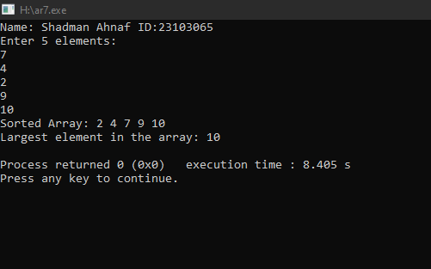

Problem 10:

#include <stdio.h>

int main() {

int size = 5;

int numbers[size];

printf("Name: Shadman Ahnaf ID:23103065\n");

printf("Enter %d elements:\n", size);

for (int i = 0; i < size; i++) {

scanf("%d", &numbers[i]);

}

int largest = numbers[0];

for (int i = 1; i < size; i++) {

if (numbers[i] > largest) {

largest = numbers[i];

}

}

printf("Largest element in the array: %d\n", largest);

return 0;

}

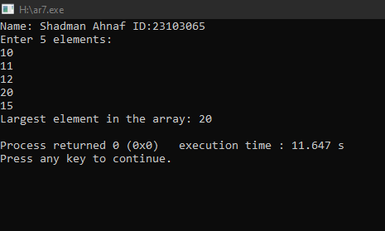

Problem 11:

#include <stdio.h>

int main() {

int size = 5;

int numbers[size];

printf("Name: Shadman Ahnaf ID:23103065\n");

printf("Enter elements:\n");

for (int i = 0; i < size; i++) {

scanf("%d", &numbers[i]);

}

int largest = numbers[0];

int secondLargest = numbers[0];

for (int i = 1; i < size; i++) {

if (numbers[i] > largest) {

secondLargest = largest;

largest = numbers[i];

} else if (numbers[i] > secondLargest && numbers[i] != largest) {

secondLargest = numbers[i];

}

}

printf("Second largest element in the array: %d\n", secondLargest);

return 0;

}

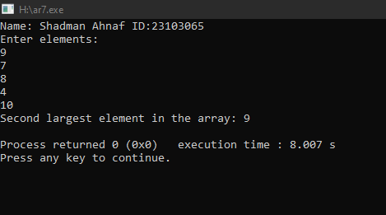

Problem 12:

#include <stdio.h>

int main() {

int size = 5;

int numbers[size];

printf("Name: Shadman Ahnaf ID:23103065\n");

printf("Enter %d elements:\n", size);

for (int i = 0; i < size; i++) {

scanf("%d", &numbers[i]);

}

int Negative = 0;

int Even = 0;

int Odd = 0;

for (int i = 0; i < size; i++) {

if (numbers[i] < 0) {

Negative++;

}

if (numbers[i] % 2 == 0) {

Even++;

} else {

Odd++;

}

}

printf("Total negative numbers in the array: %d\n", Negative);

printf("Total even numbers in the array: %d\n", Even);

printf("Total odd numbers in the array: %d\n", Odd);

return 0;

}

