**Problem 1:**

Solution:

#include <stdio.h>

main ()

{

float a,b,c,d,e;

printf ("Shadman Ahnaf ID: 23103065\n");

printf ("Enter five subject mark : ");

scanf ("%f%f%f%f%f", &a, &b, &c, &d, &e);

float total = a + b + c + d + e ;

float avg = total/5;

float percentage = avg;

printf ("Total mark is %.2f\nAverage %.2f\nPercentage %.2f%%",total, avg, percentage);

return 0;

}

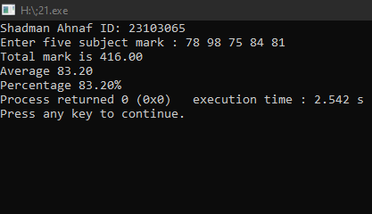

**Problem 2:**

Solution:

#include <stdio.h>

main ()

{

float a,b,c;

printf ("Shadman Ahnaf ID: 23103065\n");

printf ("Enter Principal : ");

scanf ("%f",&a);

printf ("Enter Time (in years) : ");

scanf ("%f",&b);

printf ("Enter Rate of Interest(%%) : ");

scanf ("%f",&c);

float simple_interest = (a * b * c) / 100;

printf ("Simple Interest is %.2f",simple_interest);

return 0;

}

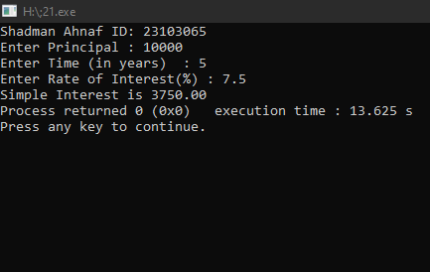

**Problem 3:**

Solution:

#include <stdio.h>

main ()

{

int a,b,c;

printf ("Shadman Ahnaf ID: 23103065\n");

printf ("Enter the minute : ");

scanf("%d", &a);

int hours = a/60;

int minutes = a%60;

printf ("The following minutes is equivalent to %d hours %d minutes",hours, minutes);

return 0;

}

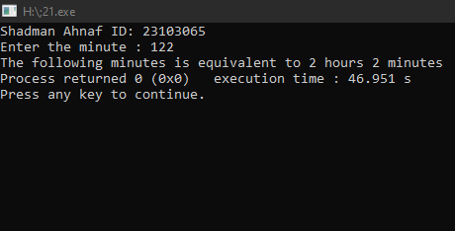

**Problem 4:**

Solution:

#include <stdio.h>

main ()

{

int a,b,c;

printf ("Shadman Ahnaf ID: 23103065\n");

printf ("Enter the days : ");

scanf("%d", &a);

int year = a/365;

int month = (a%365)/30;

int days = (a%365)%30;

printf ("The following days is equivalent to %d years %d months %d days",year, month, days);

return 0;

}

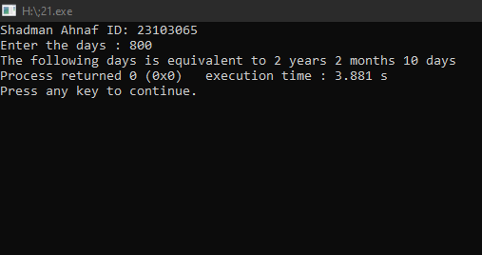

**Problem 5:**

Solution:

#include <stdio.h>

#include <math.h>

main ()

{

printf("Shadman Ahnaf ID : 23103065\n");

float b,number;

printf ("Enter a number : ");

scanf("%f",&number);

b = sqrt(number);

printf ("The square root of the following number is %.2f",b);

return 0;

}

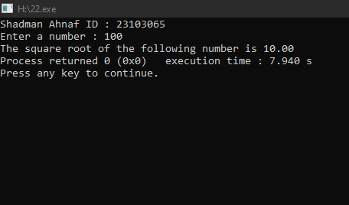

**Problem 6:**

Solution:

#include <stdio.h>

int main() {

printf ("Shadman Ahnaf ID : 23103065");

float distance, fuel, mileage;

printf("Enter the total distance traveled (in km): ");

scanf("%f", &distance);

printf("Enter the amount of fuel consumed (in liters): ");

scanf("%f", &fuel);

if (fuel > 0) {

mileage = distance / fuel;

printf("The mileage of the bike is %.2f km/l.\n", mileage);

} else {

printf("Invalid input! Fuel consumed must be greater than zero.\n");

}

return 0;

}

