Problem 1:

#include <stdio.h>

void main()

{

float angle1, angle2, angle3;

printf("Name: Shadman Ahnaf ID: 23103065\n");

printf("Enter the three angles of the triangle: \n");

scanf("%f %f %f", &angle1, &angle2, &angle3);

if (angle1 + angle2 + angle3 == 180)

{

printf("Valid triangle.");

}

else

{

printf("Not a valid triangle.");

}

return 0;

}

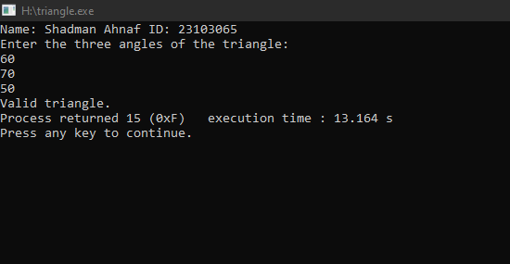

Problem 2:

#include <stdio.h>

int main() {

char alphabet;

printf("Name: Shadman Ahnaf ID: 23103065\n");

printf("Enter an alphabet: ");

scanf("%c", &alphabet);

if (alphabet == 'a' || alphabet == 'A')

{

printf("%c is a vowel.\n", alphabet);

} else if (alphabet == 'e' || alphabet == 'E')

{

printf("%c is a vowel.\n", alphabet);

} else if (alphabet == 'i' || alphabet == 'I')

{

printf("%c is a vowel.\n", alphabet);

} else if (alphabet == 'o' || alphabet == 'O')

{

printf("%c is a vowel.\n", alphabet);

} else if (alphabet == 'u' || alphabet == 'U')

{

printf("%c is a vowel.\n", alphabet);

} else {

printf("%c is a consonant.\n", alphabet);

}

return 0;

}

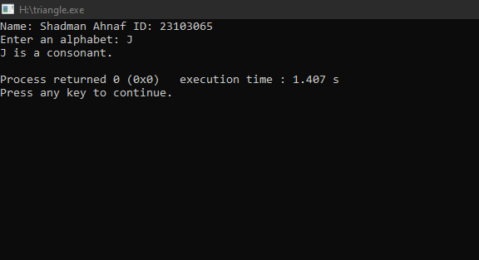

Problem 3:

#include <stdio.h>

void main() {

int maths, physics, chemistry, total;

printf("Name: Shadman Ahnaf ID: 23103065\n");

printf("Enter the marks obtained in Maths: ");

scanf("%d", &maths);

printf("Enter the marks obtained in Physics: ");

scanf("%d", &physics);

printf("Enter the marks obtained in Chemistry: ");

scanf("%d", &chemistry);

total = maths + physics + chemistry;

if (maths >= 65 && physics >= 55 && chemistry >= 50 && total >= 180) {

printf("Eligible for admission to the professional course.\n");

} else if (maths + physics >= 140) {

printf("Eligible for admission to the professional course.\n");

} else {

printf("Not eligible for admission to the professional course.\n");

}

return 0;

}

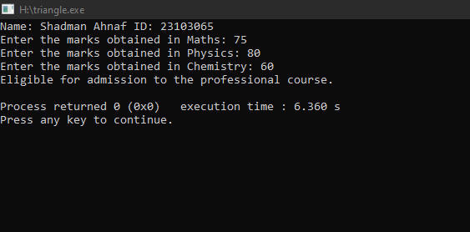

Problem 4:

#include <stdio.h>

void main(){

int temperature;

printf("Name: Shadman Ahnaf ID: 23103065\n");

printf("Enter the temperature in Celsius: ");

scanf("%d", &temperature);

if (temperature < 0) {

printf("Freezing weather\n");

} else if (temperature >= 0 && temperature <= 10) {

printf("Very cold weather\n");

} else if (temperature > 10 && temperature <= 20) {

printf("Cold weather\n");

} else if (temperature > 20 && temperature <= 30) {

printf("Normal in temperature\n");

} else if (temperature > 30 && temperature <= 40) {

printf("It's hot\n");

} else {

printf("It's very hot\n");

}

return 0;

}

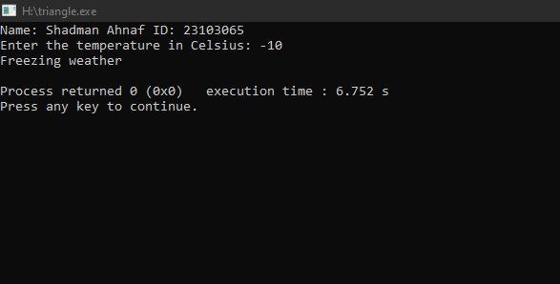

Problem 5:

#include <stdio.h>

int main() {

float basicS, grossS, hra, da;

printf("Name: Shadman Ahnaf ID: 23103065\n");

printf("Enter the basic salary: ");

scanf("%f", &basicS);

if (basicS <= 10000) {

hra = 0.2 \* basicS;

da = 0.8 \* basicS;

} else if (basicS <= 20000) {

hra = 0.25 \* basicS;

da = 0.9 \* basicS;

} else {

hra = 0.3 \* basicS;

da = 0.95 \* basicS;

}

grossS = basicS + hra + da;

printf("Gross Salary: %.2f\n", grossS);

return 0;

}

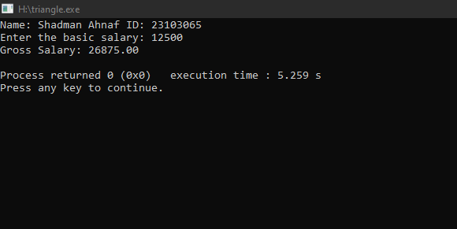

Problem 6:

#include <stdio.h>

int main() {

float unit, total, surcharge = 0.20;

printf("Name: Shadman Ahnaf ID: 23103065\n");

printf("Enter the electricity unit: ");

scanf("%f", &unit);

if (unit <= 50) {

total = unit \* 0.50;

} else if (unit <= 150) {

total = 50 \* 0.50 + (unit - 50) \* 0.75;

} else if (unit <= 250) {

total = 50 \* 0.50 + 100 \* 0.75 + (unit - 150) \* 1.20;

} else {

total = 50 \* 0.50 + 100 \* 0.75 + 100 \* 1.20 + (unit - 250) \* 1.50;

}

total += surcharge \* total;

printf("Total Electricity Bill: %.2f\n", total);

return 0;

}

