#include <stdio.h>

int main(void)

{

int i=1;

while (i!=21)

{

printf("Shadman Ahnaf %d\n",i);

i++;

}

}

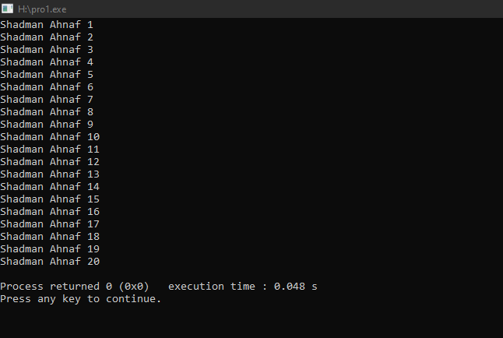

#include <stdio.h>

int main(void)

{

int i=1;

do

{

printf("Shadman Ahnaf %d\n",i);

i++;

}

while (i!=21);

return 0;

}

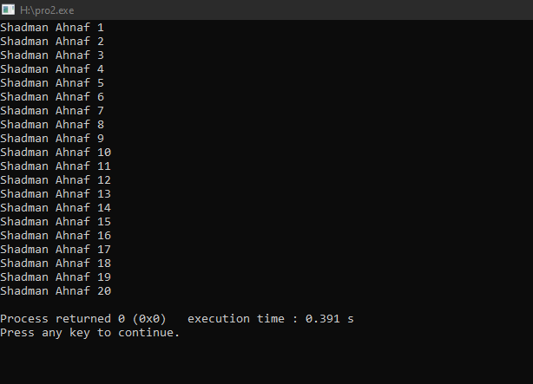

#include <stdio.h>

int main(void)

{

int i=1;

printf("Name: Shadman Ahnaf ID: 23103065");

while (i!=11)

{

printf("%d\n",i);

i++;

}

}

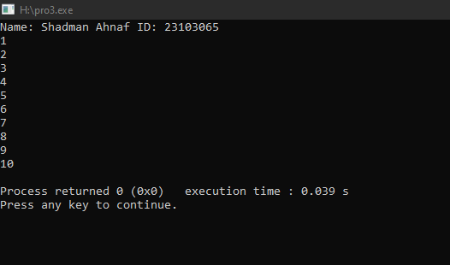

#include <stdio.h>

int main(void)

{

int i=1;

printf("Name: Shadman Ahnaf ID: 23103065\n");

do

{

printf("%d\n",i);

i++;

}

while (i!=11);

}

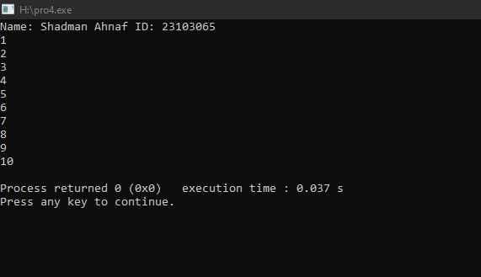

#include <stdio.h>

int main(void)

{

int i;

printf("Name: Shadman Ahnaf ID: 23103065\n");

for (i=1; i!=11;i++)

{

printf("%d\n",i);

}

}

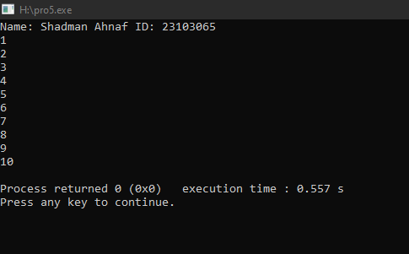

#include <stdio.h>

int main(void)

{

int sum = 0;

printf("Name: Shadman Ahnaf ID: 23103065\n");

for (int i = 1; i!=11; i++) {

sum += i;

}

printf("Sum: %d\n", sum);

return 0;

}

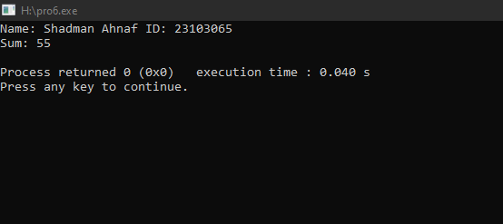

#include <stdio.h>

int main() {

int i = 1;

int sum = 0;

printf("Name: Shadman Ahnaf ID: 23103065\n");

while(i != 11) {

sum += i;

i++;

}

printf("Sum: %d\n", sum);

return 0;

}

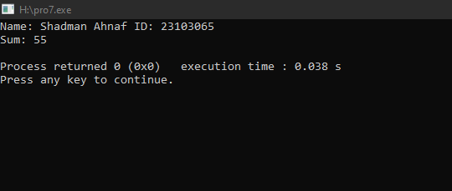

#include <stdio.h>

int main() {

int i = 1;

int sum = 0;

printf("Name: Shadman Ahnaf ID: 23103065\n");

do {

sum += i;

i++;

}

while (i!=11);

printf("Sum: %d\n",sum);

return 0;

}

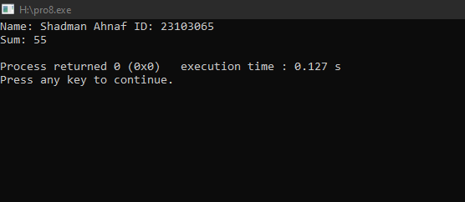

#include <stdio.h>

int main() {

printf("Name: Shadman Ahnaf ID: 23103065\n");

for (int i = 1; i>0; i++)

{

printf("%d",i);

}

return 0;

}

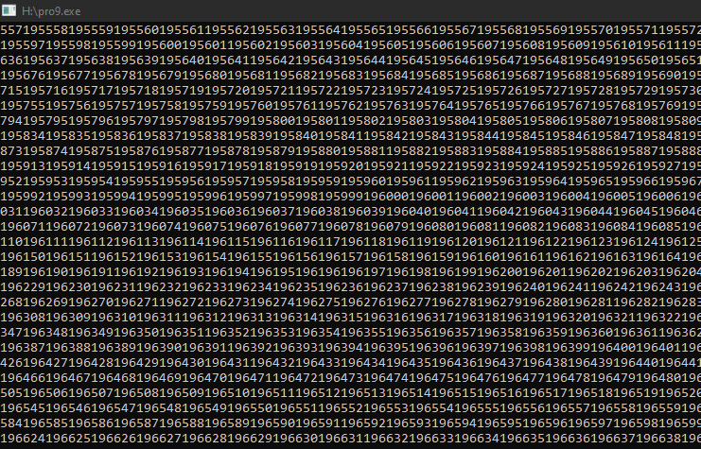

#include <stdio.h>

int main() {

printf("Name: Shadman Ahnaf ID: 23103065\n");

int num,sum=0;

scanf("%d",&num);

for (int i = 1; i <= num; i++)

{

sum += i;

}

printf("Sum=%d",sum);

return 0;

}

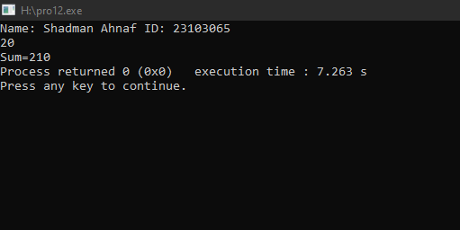

#include <stdio.h>

int main() {

int n;

printf("Name: Shadman Ahnaf ID: 23103065\n");

printf("Enter a number: ");

scanf("%d", &n);

printf("Even numbers up to %d:\n", n);

for (int i = 1; i <= n; i += 2) {

printf("%d\n", i);

}

return 0;

}

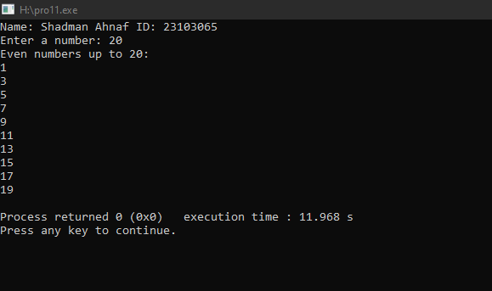

#include <stdio.h>

int main() {

int n,sum = 0;

printf("Name: Shadman Ahnaf ID: 23103065\n");

printf("Enter a number: ");

scanf("%d", &n);

for (int i = 2; i <= n; i += 2)

{

sum += i;

}

printf("Sum of even numbers from 1 to %d: %d\n", n, sum);

return 0;

}

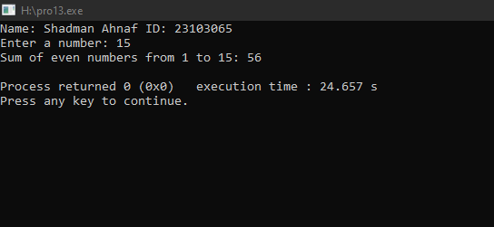

#include <stdio.h>

int main() {

int n,sum = 0;

printf("Name: Shadman Ahnaf ID: 23103065\n");

printf("Enter a number: ");

scanf("%d", &n);

for (int i = n; i != 0; i--)

{

printf("%d\n",i);

}

return 0;

}

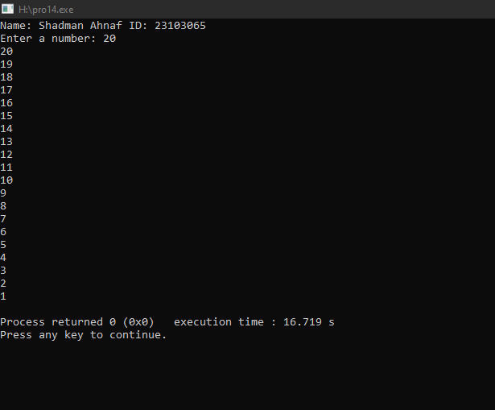

#include <stdio.h>

int main() {

int i=1;

printf("Name: Shadman Ahnaf ID: 23103065\n");

while (i<=100){

if (i%7==0)

{

printf("%d\n",i);

}

i++;

}

return 0;

}

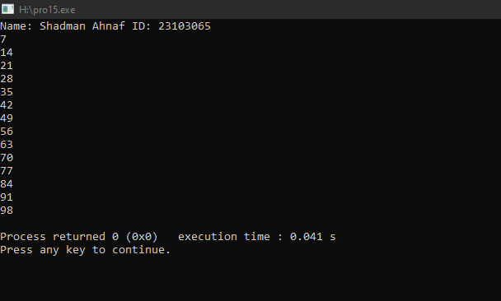

#include <stdio.h>

int main() {

printf("Name: Shadman Ahnaf ID: 23103065\n");

for (char c = 'a'; c <= 'z'; c++) {

printf("%c ",c);

}

return 0;

}

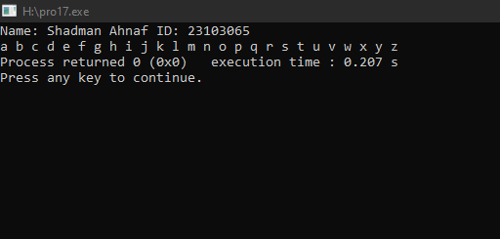

#include <stdio.h>

int main() {

int num,count = 0;

printf("Name: Shadman Ahnaf ID: 23103065\n");

printf("Enter a number: ");

scanf("%d", &num);

if (num == 0) {

count = 1;

}

else {

while (num != 0) {

num /= 10;

count++;

}

}

printf("Number of digits: %d\n", count);

return 0;

}

