Shadman's API

No-Code Web Automation & API Generation Platform

Product Requirements Document

Project | Shadman's API
Course | CSE226.1 (Vibe Coding)
Faculty | NbM
Author | Shadman Shadid Zim
Document Date | July 26, 2026
Repository | github.com/Shadman-Shadid-Zim/VibeCodingScraper

Executive Summary
Shadman's API turns any website interaction into a reusable, chat-driven API. A user records themselves doing a task once (searching, filling a form, adding to cart, booking a flight search); the platform captures every step, lets them mark each field as a Variable (AI-filled per request) or a Constant (always the same), and thereafter anyone can run it by typing a plain-language request. The core achievement is a single, generic automation engine that handles the wide variety of UI patterns different sites use - without writing per-site code. Four live demos, a marketplace with a 10% platform commission, secure per-user logins, and manual access-granting are all working and verified.

1. Overview & Architecture

1.1 What it is
A no-code platform that converts a one-time browser recording into an automation any non-programmer can re-run in plain English. Recording replaces writing a scraper; a chat interface replaces writing input-handling code.

1.2 The problem
Automating a repetitive web task normally means writing and maintaining custom code for every single website - inaccessible to non-programmers and brittle even for developers. Shadman's API removes the coding requirement entirely and, crucially, makes the engine generic enough to handle new, differently-built sites without a developer patching it each time.

1.3 System architecture
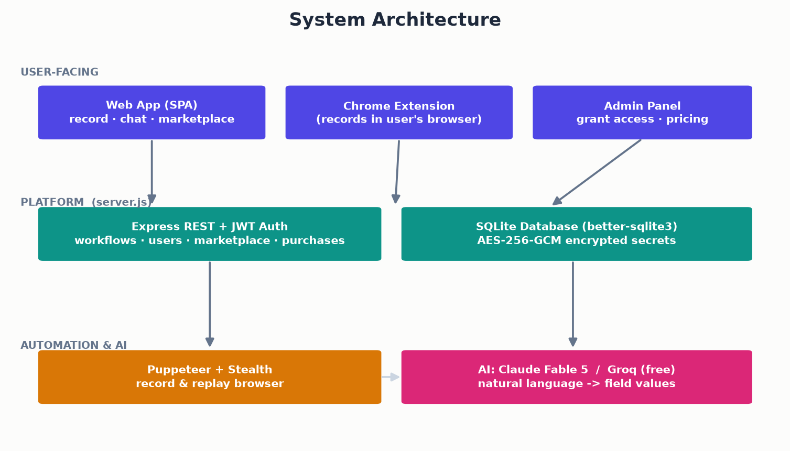
Figure 1 — Three-layer architecture: user surfaces, the Express/SQLite platform, and the automation + AI engine.
The backend is a single Node.js/Express application backed by SQLite. Recording happens either via a headful Puppeteer browser or a Chrome extension. A dual AI provider (Claude Fable 5, or free Groq as fallback) translates natural-language requests into field values.

2. How It Works
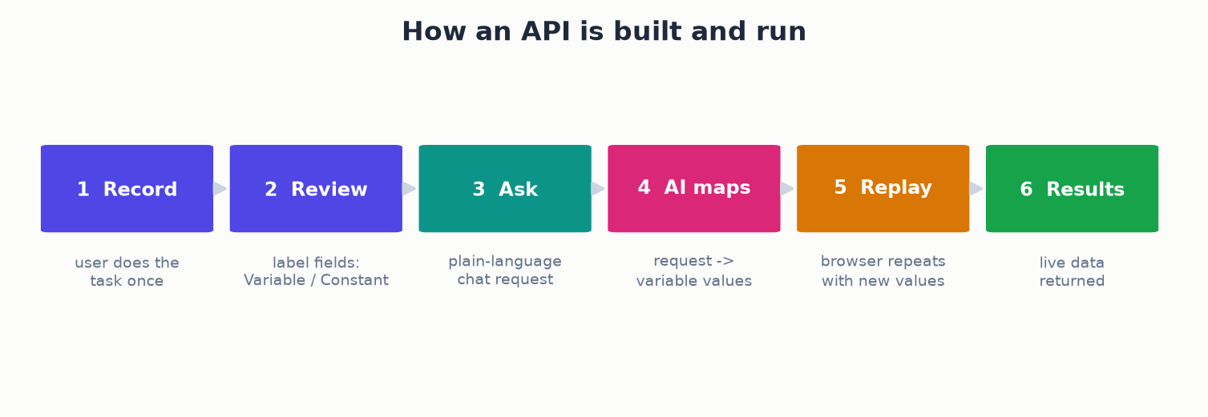
Figure 2 — The record → review → ask → map → replay → results pipeline.
The user records the task once and labels each captured field as a Variable or a Constant. To run it, they describe what they want in a sentence; the AI maps that onto the Variables (matching by meaning, not exact wording); the replay engine repeats the recorded steps with the new values substituted, and returns the live results.

3. Generic Interaction Coverage
The engine recognises a small set of standards-based interaction types rather than site-specific code. Each type handles multiple real-world UI variants - native HTML controls and modern accessibility (ARIA) patterns alike - so the same engine drives Google Forms, Daraz, Rokomari and Trip.com unchanged.
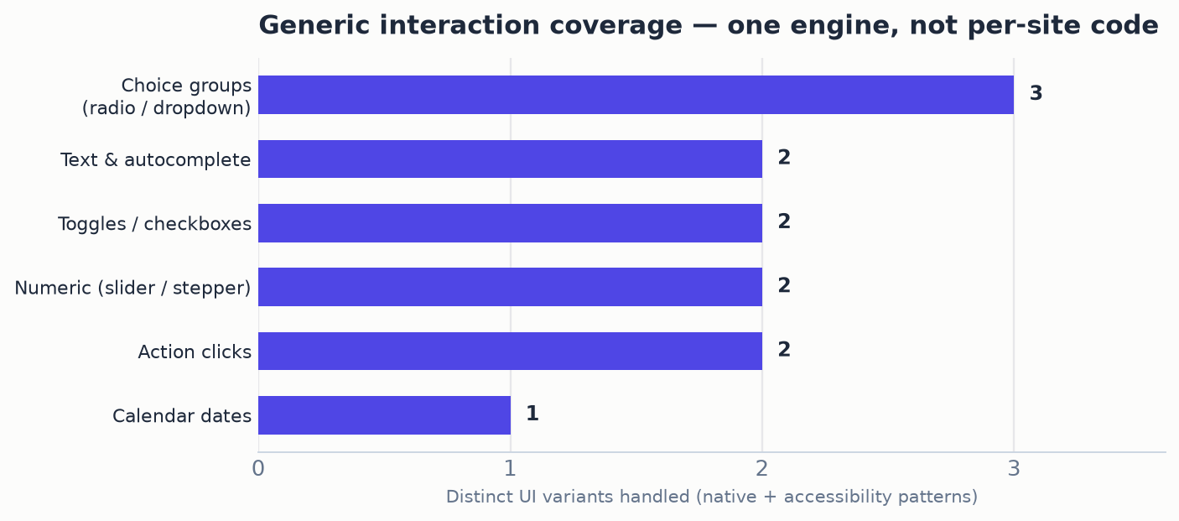
Figure 3 — Distinct UI variants handled per widget family. One engine, generalised across sites.
Interaction type | What it covers
fill / autocomplete | Text fields, and typeahead pickers that commit a live suggestion
choice | Radio/checkbox groups — native, ARIA role=radio, and text-mode menus
toggle | On/off checkboxes — native, ARIA role=checkbox, and label-for (hidden input) patterns
slider / stepper | Range inputs, and +/- quantity steppers (passenger counts, cart qty)
date | Accessible calendar pickers, matched by the cell's accessibility label
action | Optional buttons (Add to Cart, Submit) run only when the user asks

4. Development Progress
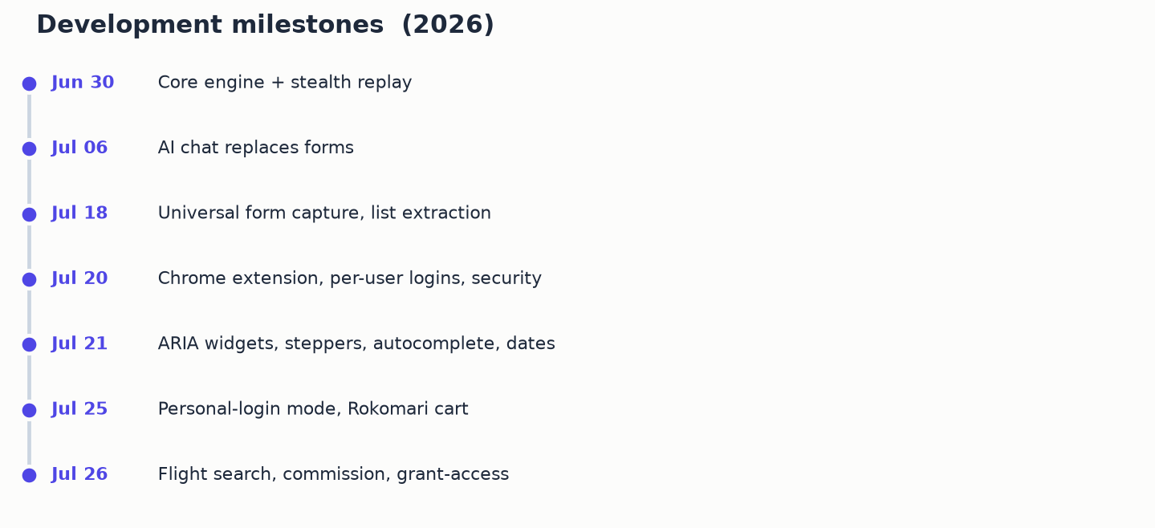
Figure 4 — Milestone timeline from core engine to the current feature set.
Each milestone broadened a class of real-world behaviour: from the core record/replay engine, through the AI chat interface and universal form capture, to the Chrome extension, security hardening, generic ARIA-widget support, personal-login mode, and finally the marketplace economy and reliable flight search.

5. Verified Working Demos
Four end-to-end automations are built and independently verified — each varies its inputs from the original recording and returns correct live results with zero warnings.
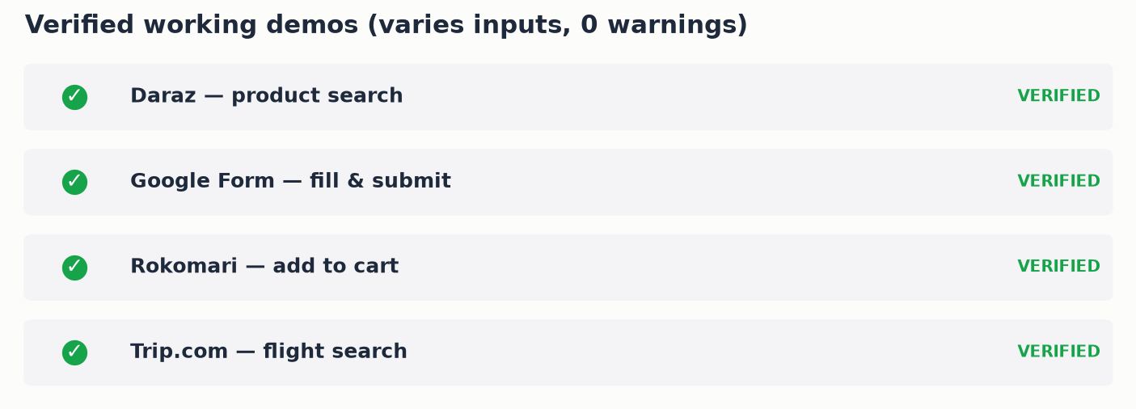
Figure 5 — Four verified demos spanning search, form automation, an e-commerce action, and flight search.
API | Example request | Demonstrates
Daraz | search for colgate toothpaste | Product search, varies by request
Google Form | course BUS101 by Dr Sen, satisfactory effort | Variable vs Constant + AI matching + choices + submit
Rokomari | add himu to cart | An AI-gated action on a logged-in session
Trip.com | flight from Dhaka to Dubai on Aug 10 | Flight search: city->airport-code, date, class, passengers

6. Marketplace & Monetization
Creators can publish an API for sale. The seller sets the price they wish to receive; the platform adds a 10% commission, and the same final price is shown to both seller and buyer.

Figure 6 — Transparent 10% platform commission, shown identically to both sides.
- Owner-only manual access grant: give a specific Gmail account access to a specific API instantly (e.g. after an out-of-app bKash payment) — the same effect as a purchase, free and immediate.
- Subscription plans (free / monthly / yearly) gate usage; the owner can grant a plan manually.
- Payment collection remains manual (bKash) in the current phase; the platform displays and reconciles the correct amounts.

7. Security & Privacy
- Stored site-login passwords are encrypted at rest (AES-256-GCM) and scrubbed from any client response, including to a workflow's own buyers.
- Captured session cookies deliberately exclude third-party identity providers (Google, Facebook, Apple, Microsoft) so a user's own account login is never swept up or shared.
- Personal-login mode: for forms that force a real Google sign-in, the login lives only in a private browser profile on the owner's own machine — never in the shareable workflow, never sold.
- Admin actions (granting plans or API access) are enforced server-side, not merely hidden in the UI.

8. Known Limitations
- Fully custom, non-accessible widgets (no ARIA, no native control, no parseable label) cannot be automated - there is no signal to key off. Encountered with ShareTrip's flight SPA, which is why flight search uses Trip.com's directly-rewritable results URL instead.
- Sites behind hardened bot protection (Cloudflare on Skyscanner, GoZayaan, Google Flights) are blocked.
- File uploads (e.g. a resume on a job form) cannot be automated - the file picker is skipped and the user is prompted to attach the file themselves.
- The free Groq model is weaker at nuance; deterministic safety nets (e.g. 'from X to Y' direction parsing, action keyword matching) cover the critical cases. Adding a Claude key upgrades all AI to Fable 5.

9. Roadmap
- Publish the Chrome extension to the Chrome Web Store for real multi-user distribution.
- Integrate automated payment collection and creator payouts (currently manual bKash).
- Expand generic coverage for additional interaction patterns as new sites surface them.
- Seller earnings dashboard (sales, revenue after commission).
- Continue hardening bot-detection resistance within ethical/ToS boundaries.

