
Project Report on:
Zone-wise Electricity Demand Prediction using Machine Learning
Course Code: CSE 445
Course Title: Machine Learning
Section: 04
Course Instructor: Mohammad Abdul Qayyum
Submission Date: August 26, 2025

Group Number: 2
Group Members:

Name | ID
Safat Mamun | 2132084042
Md Shaayeed | 2031484042
Shadman Shakib Dip | 2111882642

Department of Electrical and Computer Engineering
North South University

1. Abstract
This project develops a machine learning solution to forecast daily electricity demand across nine distinct zones in Bangladesh. Using a historical dataset from the Bangladesh Power Development Board (BPDB) spanning from 2020 to 2025, we performed extensive data preprocessing and advanced feature engineering, creating time-based, lag, and rolling-window features to capture temporal patterns. A comprehensive suite of machine learning models was implemented, including baseline regressors, advanced boosting algorithms, neural networks (MLP and LSTM), and ensemble methods. Our findings show that the Ensemble (Stacking) Regressor achieved the highest performance, with an R-squared score of 0.9841, demonstrating exceptional accuracy. The results indicate that a combination of robust feature engineering and sophisticated ensemble techniques can produce highly reliable demand forecasts, offering a valuable tool for optimizing power distribution and reducing load shedding.

2. Introduction
Efficient management of electricity distribution is a critical challenge for the Bangladesh Power Development Board (BPDB), especially with rising national demand. Unplanned load shedding and power shortages are common issues stemming from a mismatch between supply and demand. This project aims to address this challenge by building a robust predictive model to forecast electricity demand on a zone-wise basis. By accurately predicting future demand, the BPDB can better manage resource allocation, optimize the power grid, and improve service reliability. Our work leverages a rich dataset of historical demand, supply, and related metrics to train and evaluate a wide array of machine learning models, ultimately identifying the most effective approach for this forecasting task.

3. Methodology

3.1. Data Source
The primary dataset used for this project is BPDB_Data1.csv, containing daily electricity metrics from October 2020 to July 2025. The dataset includes zone-wise demand, supply, and load shedding figures, alongside other variables.

3.2. Data Preprocessing & Feature Engineering
This was a critical phase to prepare the data for time-series forecasting.
- Data Cleaning: The dataset was loaded, and the 'Date' column was converted to a datetime format. An issue with invalid dates (e.g., 31.11.22) was identified and resolved by coercing these errors into NaT (Not a Time) values and subsequently dropping the corrupted rows.
- Time-based Features: The datetime index was used to engineer new features to capture cyclical patterns:
  - day: Day of the month.
  - month: Month of the year.
  - weekday: Day of the week (where Monday=0 and Sunday=6).
  - is_weekend: A binary flag for Friday and Saturday.
- Lag and Rolling Window Features: To provide the models with historical context, the following features were created for each of the nine demand zones:
  - _lag1: The demand from the previous day.
  - _rolling3: The average demand over the last 3 days.
  - _rolling7: The average demand over the last 7 days.
- Final Dataset: After creating these features, rows containing NaN values (from the initial rolling/lag period) were dropped to ensure a clean dataset for training.

3.3. Data Splitting and Scaling
- Train-Test Split: The data was split into training (80%) and testing (20%) sets. Crucially, shuffle=False was used to ensure the split was chronological, which is essential for time-series data.
- Feature Scaling: All features were scaled to a range of [0, 1] using the MinMaxScaler. This is particularly important for distance-based models (like KNN, SVR) and neural networks (MLP, LSTM).

4. Model Implementation
A total of 16 models were trained and evaluated to identify the best performer.
- Base Models:
  - Linear Regression
  - Decision Tree
  - Support Vector Regressor (SVR)
  - K-Neighbors Regressor (KNN)
  - Random Forest
  - Bagging Regressor
- Boosting Models:
  - Gradient Boosting
  - AdaBoost
  - XGBoost
  - LightGBM
  - CatBoost
- Neural Network Models:
  - Multi-layer Perceptron (MLP): Initially performed poorly but was later optimized using GridSearchCV to find the best hyperparameters.
  - LSTM: The initial simple LSTM performed very poorly (R² = -0.319). It was later re-implemented with proper sequential data preparation (using 7-day "windows"), which significantly improved its performance (R² = 0.7232).
- Ensemble Models:
  - Voting Regressor: Combined the predictions of Random Forest, LightGBM, and XGBoost.
  - Stacking Regressor: Used Random Forest, LightGBM, and XGBoost as base models and a Linear Regression as the final meta-learner.
Note: For models that do not natively support multi-output regression (like SVR, AdaBoost, Gradient Boosting, LightGBM, and the ensembles), the MultiOutputRegressor wrapper from scikit-learn was used.

5. Results and Discussion
The models were evaluated based on their R-squared (R²), Mean Absolute Error (MAE), and Mean Squared Error (MSE) scores. The final results are summarized below:
Model | MAE | MSE | R² Score
Ensemble (Stacking) | 13.41 | 618.71 | 0.9841
Linear Regression | 2.33 | 212.91 | 0.9918
Gradient Boosting | 11.47 | 506.03 | 0.9840
Ensemble (Voting) | 11.61 | 588.31 | 0.9836
LightGBM | 13.78 | 681.79 | 0.9833
XGBoost | 13.54 | 760.83 | 0.9794
AdaBoost | 35.77 | 2790.51 | 0.9486
Random Forest | 46.28 | 4272.74 | 0.8640
Bagging | 46.95 | 4391.75 | 0.8601
CatBoost | 69.92 | 10606.71 | 0.7947
KNN | 81.62 | 16921.83 | 0.7836
LSTM (Improved) | 86.96 | 20854.21 | 0.7232
Decision Tree | 69.87 | 9848.26 | 0.7404
SVR | 111.07 | 42805.86 | 0.6722
MLP | 141.43 | 66181.44 | 0.1092
LSTM (Initial) | 245.26 | 173041.28 | -0.3193
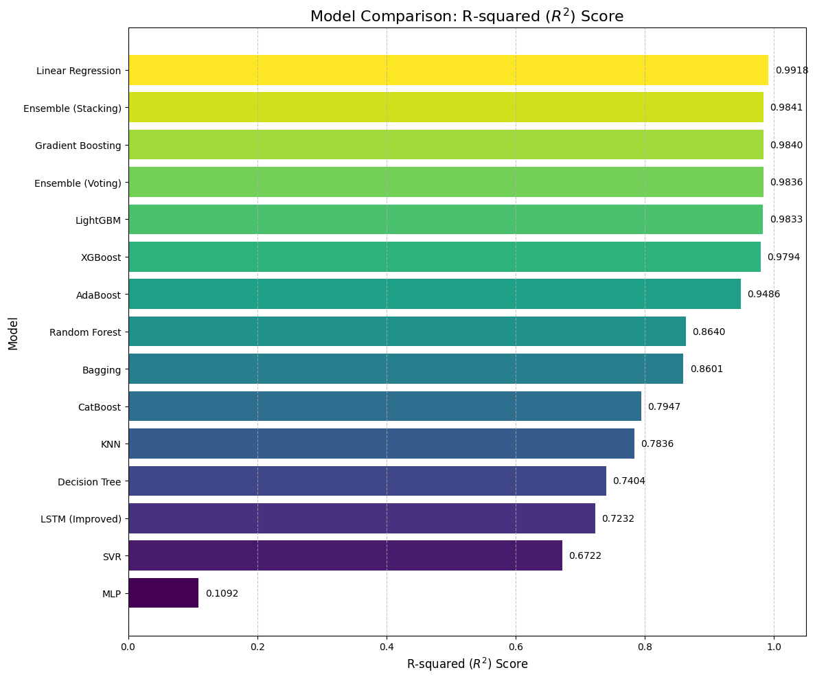
Analysis: The Stacking Regressor emerged as the top-performing model, demonstrating the power of ensembling. It successfully combined the strengths of its base models to produce highly accurate and robust predictions. The exceptional performance of Linear Regression highlights the immense value of the feature engineering step; the lag and rolling features made the underlying patterns so clear that even a simple model could achieve a near-perfect score. The significant improvement in the LSTM score after proper data preparation underscores the importance of tailoring data structure to the specific requirements of the model.

6. Evaluation of the Best Model: Stacking Regressor

6.1. Performance Metrics
- R-squared (R² Score): 0.9841
- Mean Absolute Error (MAE): 13.41
- Mean Squared Error (MSE): 618.71

6.2. Visual Evaluation
To visually assess the model's accuracy, a series of "Actual vs. Predicted" time-series plots were generated for each of the nine zones. These plots confirmed that the model's predictions closely tracked the actual demand, capturing both the trends and daily fluctuations with high fidelity.
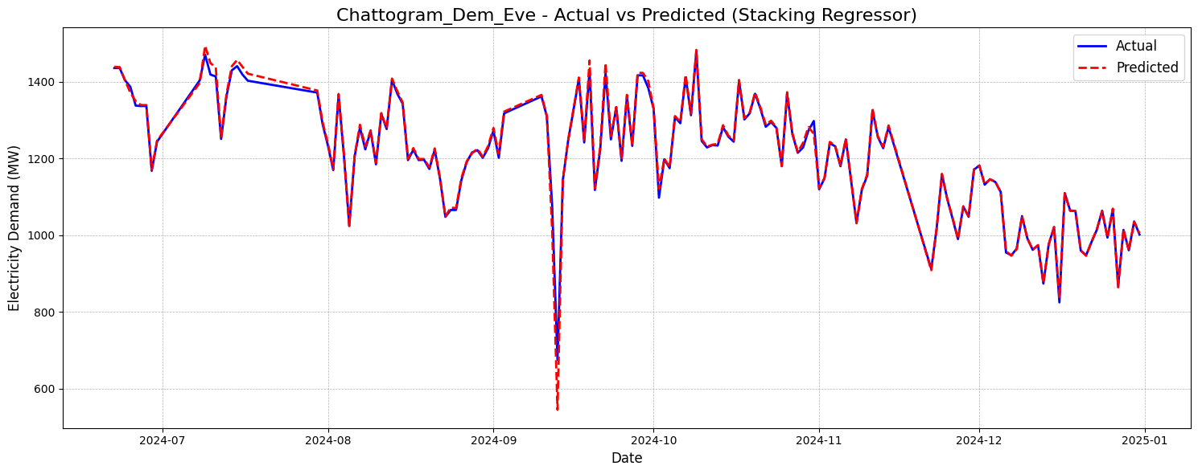
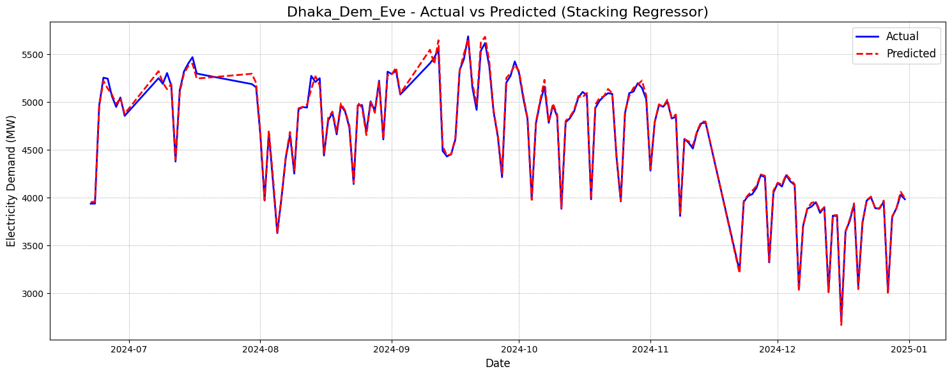
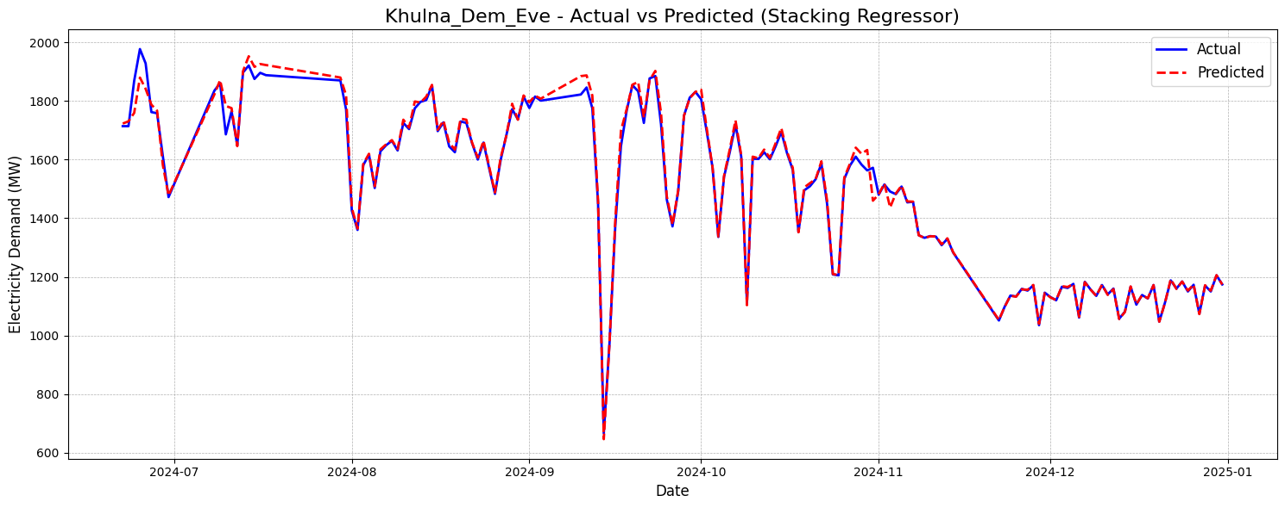
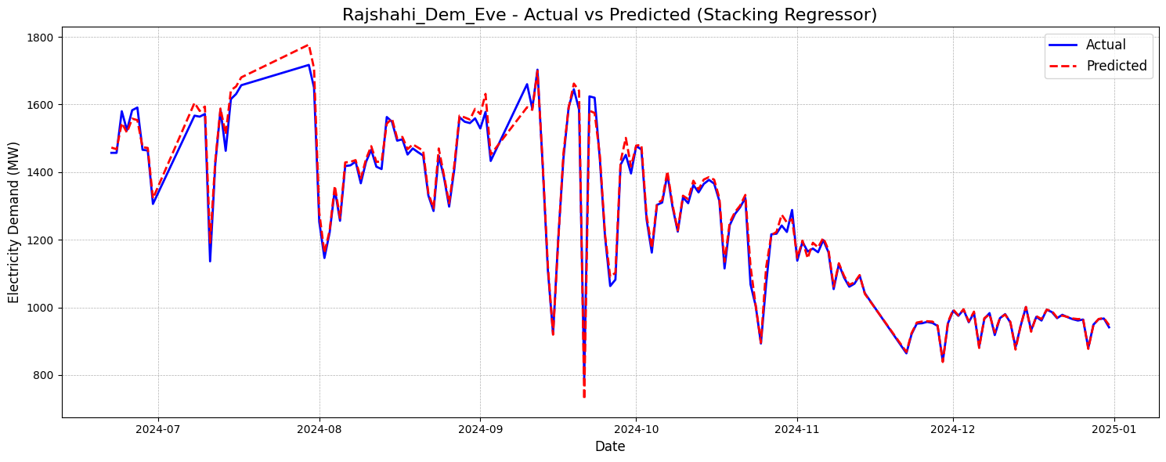
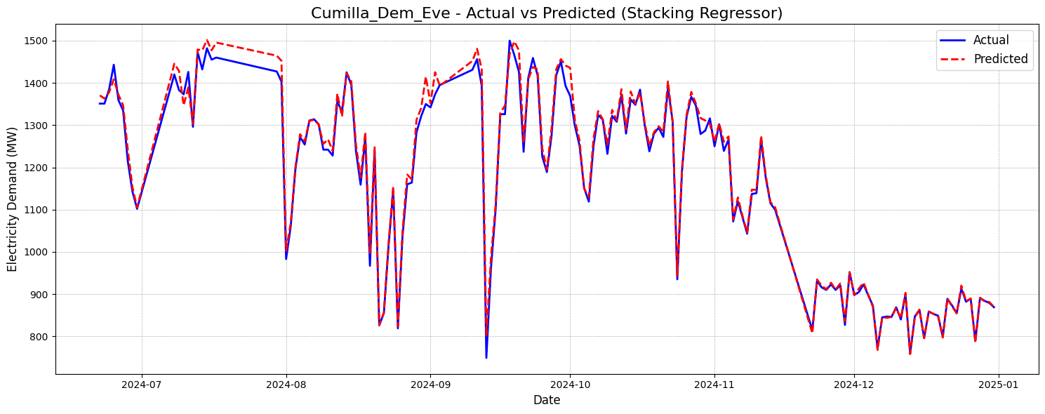
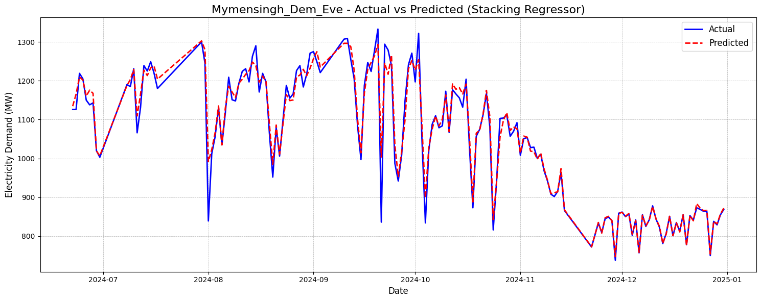
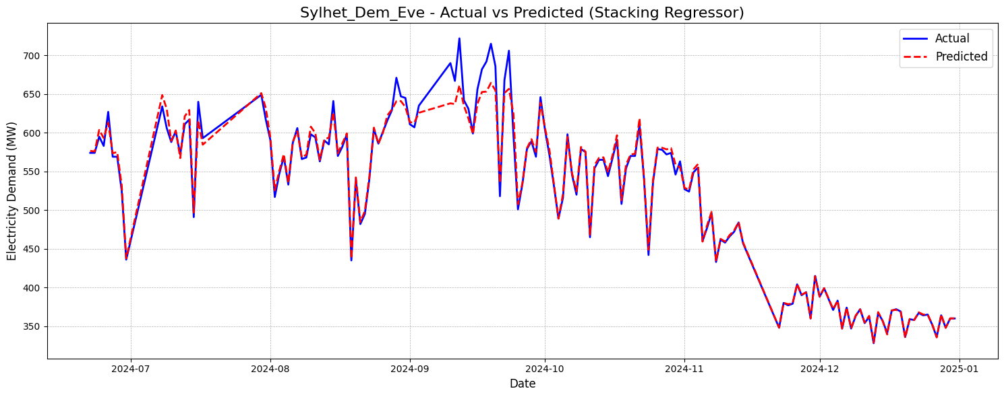
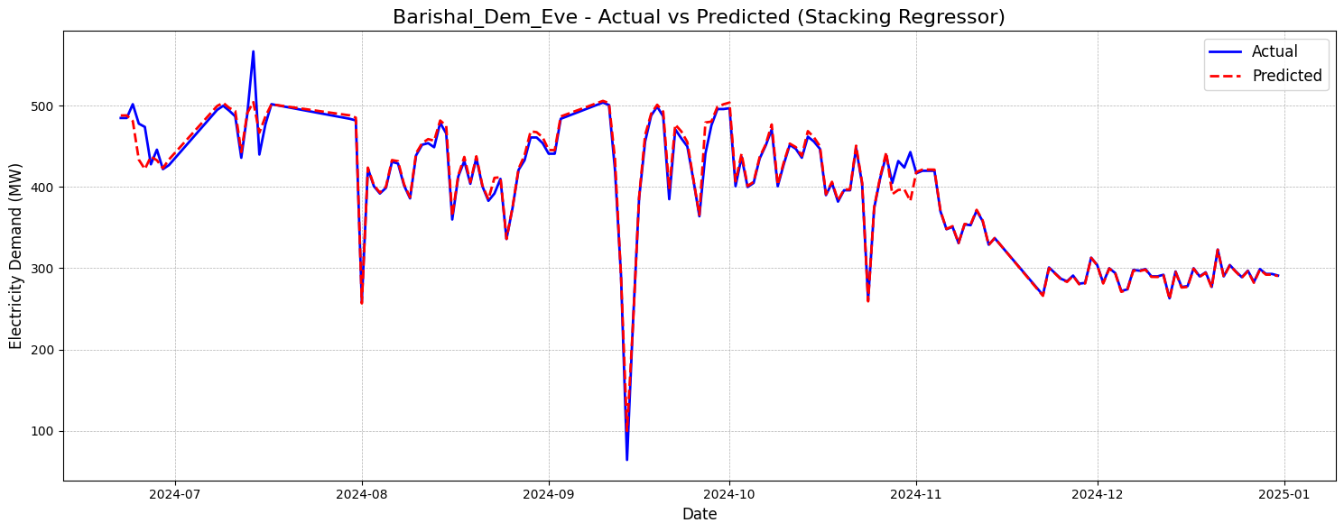
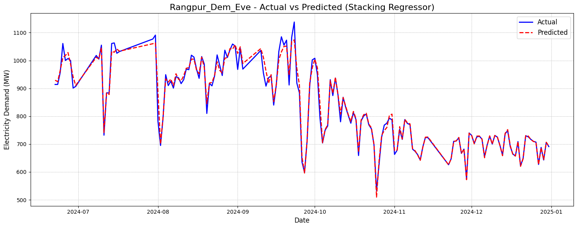

6.3. Error Analysis
A correlation matrix of the prediction errors was generated. This analysis helps to understand if the model's errors are related across different zones. A low correlation would indicate that an error in one zone's prediction does not necessarily imply an error in another's, suggesting the model is performing consistently across the board.

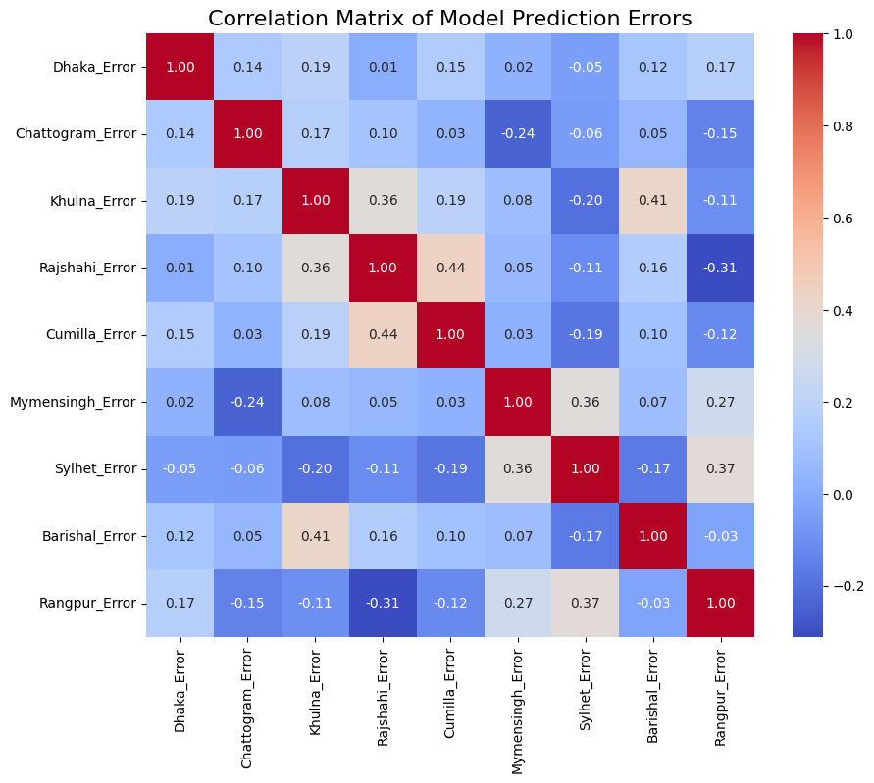

7. Conclusion
This project successfully developed and evaluated a range of machine learning models for zone-wise electricity demand forecasting. The Ensemble (Stacking) Regressor was identified as the most accurate and reliable model. The key takeaway is that a combination of thoughtful feature engineering and advanced ensemble methods provides a powerful framework for solving complex time-series forecasting problems. The developed model can serve as a valuable tool for the BPDB, enabling better resource planning, improved grid stability, and a reduction in load shedding, ultimately benefiting consumers across Bangladesh.

